Scientific Inquiry 2: Asking Questions

Science is formalized speculation backed up by equally formalized observation and experimentation

Hypothesis
Has to be testable, so it can be refuted or supported. Relationship between two variables.
Gives direction to data collection.
Shows relationship without describing relationship _ influenced by _

Problems: undirected fact-gathering is a common problem & does not answer a question,

Null Hypothesis: nothing happens, no relationship between variables.

Observations vs Hypothesis
Patients in beds that are nearest to the entrance respond better to treatment than those at the other end of the room | Why do patients in beds nearest to the entrance respond better to treatment  Alternative hypothesis  Hypothesis 1: Patients are distributed based on severity of illness  Hypothesis 2: Patient care is dependent on location  Hypothesis 3: Patient response is dependent on location

Predictions
Written as “if, then” statements. Designed to test your hypothesis. If my hypothesis is supported, then if I change this, I should observe that”
Explains the relationship set out in your hypothesis.
Hypothesis #1: There is a correlation between high predator areas and areas where there are groups of whelks.
Prediction #1: Whelk’s group as protection from predators
Hypothesis #2: There is a correlation between areas with high wave action and areas where there are many groups of whelks
Prediction #2: Whelk’s group as protection from waves.

Scientific Inquiry 4: Hypotheses and Predictions

Random Variation/Noise/Individual variation
Individual subjects in our sample differ from each other for reasons OTHER than the ones we are interested in.

Cofounding Variable
- Variable you didn’t account for, outside influence that changes variables you are investigating
- Ex. Environment, height,
Example:
Question: does lack of exercise lead to weight gain?
Hypothesis: Exercise influences weight gain?
Prediction: increased exercise leads to weight loss; decreased exercise leads to weight gain
Independent variable: exercise
Dependent variable: weight gain
Experiment: quantify exercise levels and weight gain in 200 people

Reduce effects
- Randomly assign to different treatments
- Draw samples without bias from the population
- Introduce controls to account for confounding variables (eg. Control for age by only measuring 40 year olds)
Simpsons Paradox
A trend appears in different groups of data but disappears or reverses when these groups are combined
Ex. Hazard with uncritically pooling data without considering important confounding variables.

Myths
- Does not matter how you collect your data, there will always be a statistical fix
- If you collect lots of data something interesting will come out. QUANTITY IS NO SUBSTITUTE FOR QUALITY.

Scientific Inquiry 5: Observational vs Experimental
Observational Study Experimental Manipulation Study
Investigator studies naturally occurring variation to look for the effect of one factor on another. | Investigator does something to the study system then measures the manipulation on the subject

Ex. Hypothesis: Long tail streamers influence male attractiveness
Prediction: Males with long tail streamers are more attractive.
Observational Study Experimental Manipulation Study
Band birds to keep track, measure tail length & body size, track mating habits and mating success, observe evidence that supports hypothesis. | Catch and band birds, assign each bird to one of three treatment groups, cut off streamers then glue back on –length unchanged (control), cut off part of streamer to make it short, cut off streamer then glue it back on along with length from treatment 2, observe for mating success.

Observational Study
Pros:  - Less handing/ work  - Ensures biologically relevant findings that are accurate to what is really happening in nature  - Reduces unexpected effects of experiment (risks that occur if you manipulate the subject) | Cons:  - Confounding variables may affect your study if there is another variable not accounted for. Factor C independently effects both A and B  - Correlation does not imply causation  - Reverse causation. Ex. Recreational drug habit likely to cause stress or stress is likely to cause habit.

Lab or Field?
PROS:
Easier to control conditions, focus on factors of interest without variation due to uncontrolled factors (eg. Temperature, daylight, food supply)
Reduce between-individual variation caused by natural setting (feeding plants and animals the same quality and quantity of food).
Easy to observe and record (captive and wild)
CONS:
Do not experience many of the stressors of everyday life in the field
Difficult to extrapolate lab results

Random Variation
Experimental design is about removing (controlling for) variation due to factors that we are not interested in (random variation or noise), so we can see the effects of the factors of interest.
Replication
- Take same measurements on a number of different subjects so that we can draw conclusions.
Simple Random Sampling
- If you can list all members of a population of interest, then you can independently and randomly select a fixed number of them to be in the sample.
Dependent vs Independent Variable
- What we are interested in measuring  - Ex. Bacteria Growth rate | - The factors you are manipulating/changing  - Ex. Insertion of a gene
Control
- Groups in an experiment or study that is used as a benchmark to measure how other tested subjects have done.
Classic control: no manipulation occurs to the control, it is left in normal conditions
Positive control: control is manipulated with an expected outcome
Negative control: control is manipulated, but it is expected to have no outcome.
Example:
- Group experiences the experimental manipulation but ends up with an unchanged streamer length
- Group experiences the experimental manipulation ending with a shortened streamer length
- Group experiences the experimental manipulation ending with an elongated streamer length
Warts Example
Hypothesis: a novel treatment for warts in humans produces better results than the currently used treatment
Warts: Classic Control
Experiment 1: measure the clear-up rates of warts on patients given the novel treatment and compare them to patients given the no treatment.
Experiment 1: tests that the novel treatment produces a beneficial effect on clearing up warts, compared to taking NO action.

Warts: Positive Control
Experiment 2: measure the clear-up rates of warts on patients given the novel treatment and compare them to patients given the currently used treatment (positive control)
Experiment 2: tests that the novel treatment produces a beneficial effect on clearing up warts, compared to the CURRENTLY USED treatment

Warts: Two Controls
Experiment 3: Measure the clear-up rates of warts on patients given the novel treatment and compare them to patients given the currently used treatment (positive control) AND no treatment (classic control)
Experiment 3: would test that the novel treatment produces a beneficial effect for removing warts, compared to using either the current or no treatment.

Effective controls
- Manipulations between controls need to be carried out in random order, you introduce “time of measurement” as a potential confounding factor.

Study Design 5: Collecting Data and \

Independent variable: proposed CAUSE of change (predictor)
Dependent variable: proposed outcome (outcome)
Example:
How is bacterial growth rate affected by gene insertion and/or temperature?
Variable A: Growth rate
Variable B: gene insertion
Variable C: temperature
Variables that respond to the changes are the DEPENDENT VARIABLES.

How does Variable X respond to changes in Variable Y and Z.
Independent & dependent variables can be either
Categorical Variables Continuous Variables
- Subdivided in categories that name distinct entities into which subjects are assigned  Ex. Species (dog).  ORDINAL  Nominal scale: collection of categories into which subjects can be assigned; categories are mutually exclusive, with no intrinsic value to them (ex. Vegetarian, vegan, omnivore) | Measured (provide a score for each individual), can take on a great range of values on the measurement scale, and have a natural order to them  Ex. Age, size, hormone dosage.  INTERVAL
Tail Streamer Example
Body size=continuous
Tail length= continuous (ratio)
Tail group= categorical (ordinal)

Replication
- Deal with variation, taking same measurements again can eliminate variables.
- Replicates must be independent of each other (not from the same family)
- Involve making the SAME manipulations and taking the SAME measurements.
Pseudoreplication
- Occurs when subjects are NOT independent of each other (but you treat them as if they were)
Ex. Shared enclosure (nest boxes, cages), common environment (forest vs urban), relatedness

Factors affecting an Experiment’s power
- Effect Size
- The magnitude of the effect of one factor on the variable that we are measuring.
Ex. Difference between means of two categories (eg. two dog breeds)
Slope of the relationship between two continuous variables (eg. Daily exercise and pug weight)
- Random Variation- in the population. Variation that cannot be accounted for.
- Number of replicates – increasing sample size
Studying Design 6: Experimentation
Important Terms
Factors: Controlled independent variable(s): the general types or categories of treatments | Levels: the number of treatments within a factor
Replication: the number of “subject” “objects” or “individuals” sampled | Randomization: randomly allocating experimental subjects to experimental treatments, where any subject is equally likely to end up being allocated to any of the treatments.

Randomized Factorial Design
Independent Dependent
Does plant feed affect tomato plant growth?
Factors= one (plant feed)
Levels= two – none (control) and fertilizer
Replication = 80 individuals (40 plants per level)
Plant Feed
Yes (fertilizer) | No (control)
N=40 | N=40

Completely Randomized Factorial Design
- Run two separate experiments
Investigating the effects of plant feed on plant growth & investigating the effects of insecticide application on plant growth.
Insecticide application factor
Yes (fertilizer) | No (control)
N=40 | N=40

Plant Feed
Yes (fertilizer) | No (control)
N=40 | N=40

- Run one experiments with two treatment and one control
One treatment investigates the effects of plant feed on plant growth
Another treatment investigates the effects of insecticide application on plant growth
Both treatments use the same control to compare

Cultivation type
Insecticide | Fertilizer | Control
N=40 | N=40 | N=40

- Run one combined experiment, simultaneously investigating both plant feed and insecticide application on plant growth
Ex. Does insecticide application influence tomato plant growth?
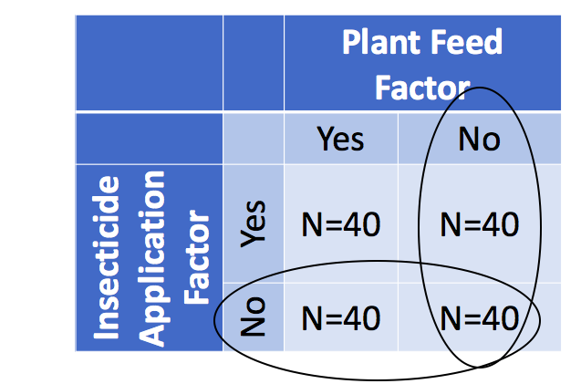
Problems with adding more factors: DOUBLE THE # of replicates, harder to interpret interactions between two factors.
Blocking
Space: Can’t fit all tomato plants in 1 greenhouse, need two different ones.
Problem: differences between conditions in greenhouse 1 and 2 that influence growth – adding noise.
Solution: Allocate equal numbers of each treatment to each greenhouse, note which greenhouse the plant is grown in.
Time: measurements are carried out at different times. Allocate equal numbers of each treatment to time 1 and time 2, note which time period the plant is grown in.
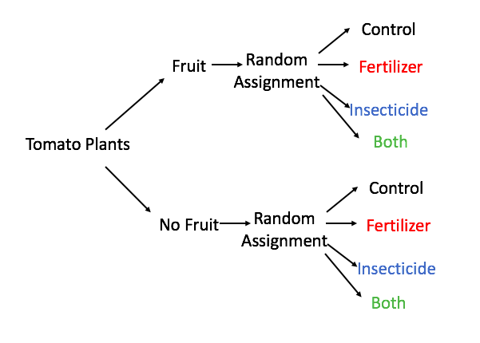
Blocking Cons
Not recommended for high-drop-out rates (missing values_ because some treatment groups may not be represented in some blocks –leading to incomplete-block designs.

Blocking Alternative: Covariates
- Deal with between-subject variation
- Record the age of each plant at the start of the experiment.
By statistically removing some between-individual variation in age, we increase power of study to detect treatment effects (fertilizer or insecticide on growth)

Data Collection, Management & Summaries
Data collection
- Id numbers for each subject
- Factors/Treatments/Levels (if any)
- Dependent variables
- Independent variables
- Block group (if any)
Other data to record? Cofounding Variables
- Age, date, time of day, temperature, sex, size, weight
Spreadsheets
Columns =variables
Rows =observations (replicates)
Cells= data (values)

Common spreadsheet mistakes
- Including units in cell
- Notes in margin
- Using formatting (merging cells to make spreadsheets look good)
- Fill in zeros (computer will think cell is missing data

