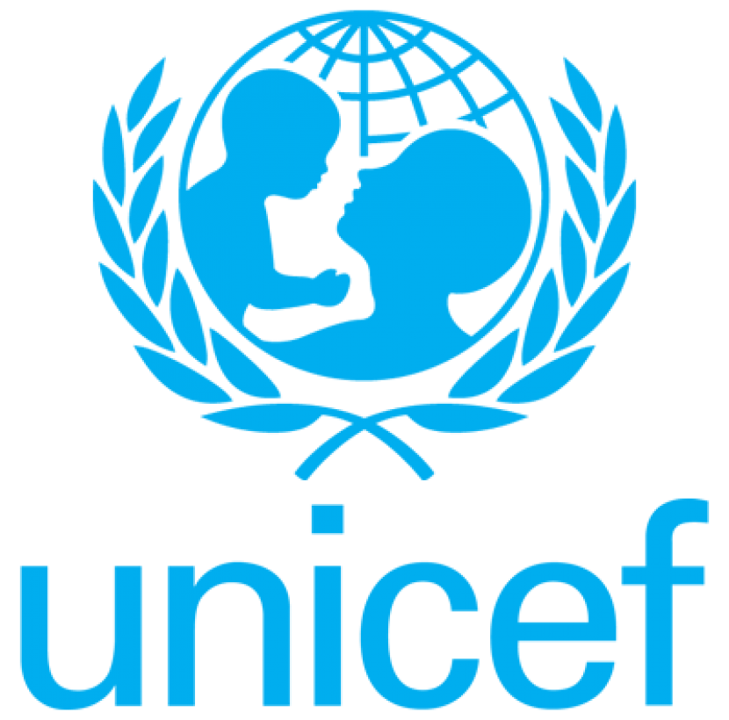
Memoranda
To: Suzan Last, Executive Engineering Director
From: James Park, Project Engineer
Date: January 19, 2018
Subject: Report on Project Water Cart as the Solution to Education Crisis in Central Africa

Low Level of Education in DR Congo and Uganda
UNIDAD (United Nations International Data Analysis Department)’s report in 2017 shows that children receiving education in DR Congo and Uganda are respectively 35.6% and 43.3% lower than the UNICEF Education Goal for Africa proposed in 2010. 43% of children in the age between 7 and 13 in DR Congo and Uganda were not able to attend school regularly as a direct result of water shortage. 88% of the group not attending school regularly traveled over 15 km to fetch water every day, which correlated to a lower school attendance rates among this group. Further research from UNIDAD reported that a stable water system will increase education attendance rate by 39%, which will exceed the target education level in DR Congo and Uganda. Because of this, Project Water Cart, a water infrastructure that uses non-motorized vehicles to transport water, can implement water system in the region and increase education attendance levels in DR Congo and Uganda to the projected level.

Overview of Project Water Cart
As seen in Figure 1, the water cart is made from wooden from eight wooden pieces, two pairs of 12-inch tires, and a hyperthermoelastic band that unwinds to create energy for vehicle.

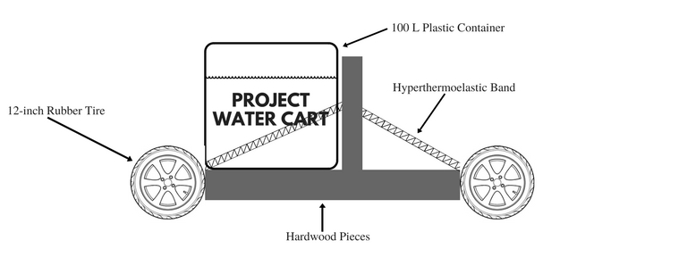
Figure 1: Diagram of a Water Car

Project water cart has three main components:
- Wooden Frame
- Rubber Tires
- Hyperthermoelastic Band.

Wooden Frame and Rubber Tires
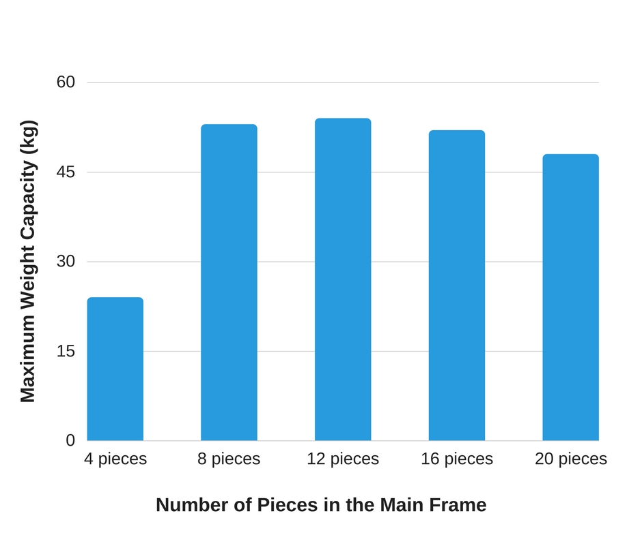
The wooden frame of the water cart consists of eight hardwood pieces of length 175 cm and radius of 10 cm and a single 100 cm wooden stick. As seen in Figure 2, using eight wooden pieces of 175 cm is sufficient to transport up to 100L of water over 20 km, while requiring minimal manufacturing process. The cart operates on four 12-inch rubber tires commonly found in Central Africa.
Figure 2: Capacity of Wooden Frame Compared to Number of Pieces

Hyperthermoelastic Band
Hyperthermoelastic band is the source of energy for the water cart. As shown in Table 1, hyperthermoelastic band is capable of storing two million Joules of energy which is sufficient to carry 50 kg of weight over a distance of 20 km.

Table 1: Analysis Between Conventional Elastic and Hyperthermoelastic
 | Conventional Elastic Band | Industry Elastic Band | Hyperthermoelastic Band
Maximum Potential Energy Stored (J) | 5.5 | 13.5 | 2,004,300
Maximum Distance Travelled Carrying 50kg (km) | 0.00025 | 0.0012 | 23.50
Average production time (s/unit) | 0.50 | 0.45 | 153.10

Impact of Project Water Cart on Education Crisis
Project water cart aims to provide stable water infrastructure to DR Congo and Uganda, and to achieve the following:
- Increase education level among children of age between 7 and 13
- Increase economic activities in the region
- Reduce environmental pollution from gasoline-based vehicles.
Implementing the water cart will reduce workload of children in the region, which directly correlates to increased education attendance according to the report from UNIDAD. Project water cart also provides functioning mode of transportation to the region which will increase economic activities and reduce pollution from motorized vehicles in the region.

Economic Cost of Project Water Cart
Project Water Cart is estimated to cost 24.2 million USD for implementation in DR Congo and Uganda. Table 2 shows that ground water pipe is estimated to cost 242.6 million USD, which is over 10 times the cost of Project Water Cart. The UNICEF Budget Report in 2018 shows that 30 million USD is allocated towards social welfare and education for DR Congo and Uganda. This funding is only sufficient for implementing Project Water Cart.

Table 2: Estimated Cost Between Project Water Cart and Ground Water Pipe
 | Project Water Cart | Ground Water Pipe
Manufacturing Cost (in million USD) | 20.5 | 135.7
Transportation Cost (in million USD) | 2.2 | 28.6
Implementation Cost (in million USD) | 1.5 | 78.3
Total Cost (in million USD) | 24.2 | 242.6

Water Cart as a Solution to Education Crisis
As seen in UNIDAD’s education report, the education levels in DR Congo and Uganda are direct results of insufficient water infrastructure in the region. Stable water infrastructure is projected to benefit education rates as well as economic activities and public health of the region. By approving Project Water Cart, the UNICEF is providing a functioning water infrastructure to the community and is one step closer to providing equal education opportunity to every child.

