Using Systematics to Determine the Evolutionary Relationship Between Five Mammalian Species and Ursus americanus Subspecies

Abstract

Cladograms or phylogenies are a visual representation of a hypothesized evolutionary relationship between species by studying the relationships between taxa. The relationship between five mammalian species were compared using molecular and morphological cladograms. The molecular cladogram was generated using mitochondrial cytochrome b genes. A cladogram was also used to determine the relatedness of the six subspecies of American black bear species using cytochrome b genes. The principles of phylogenetics were then applied to the black bear cladogram to determine if the bear species were different enough to be considered subspecies and which, if any, were at risk of extinction. The Eastern bear was found to be the most at risk due to isolation along the Atlantic coast from similar subspecies. Conservation measures such as breeding the Eastern and Cinnamon subspecies along the Atlantic coast would improve genetic diversity and reduce the risk of speciation.

Introduction
Cladograms or phylogenetic trees, are a useful tool in systematics to hypothesize the evolutionary relationships between species or the relatedness of species (Reese et al., 2014). Cladograms group taxa hierarchically into taxa groups, or clades, as determined by their similar morphological characteristics (Stone, 2003). Clades can also be grouped by molecular similarities. Cladograms show the relationship of evolution between species (Biology Department, 2018). Cladograms show evolutionary information by separating the clades based on shared and unshared characteristics (Reese et al., 2014). The cladogram that is considered the most likely hypothesis of the evolutionary relationship is the one that is the most parsimonious, meaning it shows the least evolutional events (Biology Department, 2108).
Phylogenetic systematics uses the relationship between taxa to study evolution (Biology Department, 2018). Phylogenetics compares both physical and molecular characteristics to establish relationships between species. Morphological systematics compares observable characteristics of species, including both derived and ancestral. Molecular systematics compares the genetic makeup of species, including nucleotide sequences in genes and proteins (Reese et al., 2014). Due to morphological systematics comparing the observable characteristics and not differentiating between derived and ancestral characters, it can be difficult to determine the evolutionary relationship of closely related species. Another problem with phylogenies is the inability to account for unrelated species that exhibit the same characteristics due to convergent evolution (Reese et al., 2014).
Systematics can be used to determine the evolutionary relationship of subspecies by comparing the evolution of shared derived characteristics. Using morphological systematics, a subspecies can be found by comparing how the shared-derived characteristics differ between species (Biology Department, 2018). Molecular systematics can be used to find the evolutionary relationships of subspecies by comparing the nucleotide sequences in orthologous genes and finding the points of mutations that lead to newly evolved traits (Nadler, 1995). Morphological systematics can be advantageous when a derived characteristic evolves steadily over time in a species. The disadvantage of morphological comparisons is when comparing species with little to no observable differences, or very closely related species. Molecular systematics is advantageous when evaluating closely related species with few observable physical differences (Nadler, 1995). The disadvantage of molecular systematics is that the nucleotide sequences being compared must be aligned to establish homology. This requires nucleotide sequences of the same orthologous genes must be available from all studied species (Nadler, 1995).
Comparing the similarities in the nucleotide sequences, ecologists are able to determine how closely related species are. Systematics can enable identification of a species at risk of extinction or extirpation by determining the closeness of relationships between species and the population sizes. Evaluating the isolation and abundance of the species can lead ecologists to determine if the species is at risk (Reese et al., 2014). Once at risk, conservation biologists can attempt to find ways to recuperate the species.
The research goal for part 1 is to hypothesize the evolutionary relationship between a domestic dog (Canis familiaris), Virginia possum (Didelphis virginiana), domestic horse (Equus caballus), domestic cat (Felis catus), and white-tailed deer (Odocoileus virginianus) using morphological and molecular data. The research goal of part B is to determine if the populations of American black bears (Ursus americanus) in North America are different enough to be considered subspecies and determine which population is most at risk for extinction and extirpation. It is also to test the hypothesis that the bears moved to the islands during glacial periods. The black bear populations being studied are the Olympic (Ursus americanus altifrontalis), Eastern (Ursus americanus americanus), Queen Charlotte (Ursus americanus carlottae), Cinnamon (Ursus americanus cinnamomum), Kermode/Spirit (Ursus americanus kermodei), and Vancouver Island (Ursus americanus vancouveri). Using molecular systematics, a cladogram will be generated to determine which subspecies is most in need of conservation efforts. The null hypothesis is that there is no difference between the species of black bears. The purpose of this lab is to identify how evolutionary information of species and subspecies can be used to understand how they evolve over time and how to mitigate risk using conservation efforts.

Methods
A morphological cladogram was generated to compare five mammalian species. A domestic dog (Canis familiaris), Virginia possum (Didelphis virginiana), domestic horse (Equus caballus), domestic cat (Felis catus), and white-tailed deer (Odocoileus virginianus) were compared using a lizard as the outgroup. Twelve morphological traits were compared for each of the species. The twelve traits were as follows: if and where the nasal connects with the maxilla/premaxilla in dorsal view of the skull, the length of the maxilla relative to the overall skull length, if the skull had a sagittal crest or keel, if the magnum foramen exited the skull directly posterior, the presence and size of the incisors, the presence and position of sharp canines, the number of teeth (grouped as less than 20, between 20 and 40, and greater than 40), the length and type of tail (long, short, or prehensile), differentiation of teeth and type (molars or carnassial), type of diet (herbivore, omnivore, or carnivore), position of feet when walking (plantigrade or digitigrade), and their activity period. The traits were evaluated by examining skulls of the five mammalain species in the lab. After creating a polarized character matrix, a cladogram was constructed by hand of the five species. The accepted cladogram was the most parsimonious.
The molecular cladogram was constructed by comparing three mitochondrial cytochrome b protein (cytb) from each of the five-mammalian species. The cytb for each species was found on the NCBI website (www.ncbi.nlm.nih.gov/taxonomy). The cytb used had lengths of 379 amino acids for the dog, horse, cat, and deer, and 382 amino acids for the possum. The cytb for the dog was found under Canis lupus familiaris. The cytb sequences were saved as FASTA file and run through the ClustalW program. The resulting cladogram was generated using the genetic analysis program ClustalW on the European Molecular Biology website (http://www.ebi.ac.uk/Tools/msa/muscle/).
The black bear cladogram was constructed using molecular information found on the NCBI website (www.ncbi.nlm.nih.gov/taxonomy). The six subspecies of Ursus americanus were the Olympic (Ursus americanus altifrontalis), Eastern (Ursus americanus americanus), Queen Charlotte (Ursus americanus carlottae), Cinnamon (Ursus americanus cinnamomum), Kermode/Spirit (Ursus americanus kermodei), and Vancouver Island (Ursus americanus vancouveri). Cytochrome b gene (cytb) found in mitochondrial DNA with 719 base pairs were evaluated for each bear. The Queen Charlotte, Vancouver Island, Kermode, and Cinnamon all had three cytb records to compare, the Eastern had two, and the Olympic had only one. The results were saved as a FASTA file. The cladogram was then generated by running the FASTA file through the genetic analysis program ClustalW on the European Molecular Biology website (http://ww.ebi.ac.uk/Tools/msa/muscle/).
Some additional information was needed to properly assess the similarities between the black bear species. Information regarding the habitats and population densities were found through peer reviewed journals. Other key pieces of information such as the fur color, size, and various other physical traits were found through online search engines.

Results
The cladogram comparing the morphological characters exhibited by the five species shows some clear trends in the evolutionary timeline of the species from a common ancestor. The cladogram generated from the morphological characters hypothesizes the evolutionary timeline of the five-mammalian species in which the horse, deer, cat, and dog all share a more recent common ancestor than the possum as seen in Figure 1. The cladogram shows that the horse and deer likely shared a more common ancestor than the remaining three mammalian species. The cat and the dog also exclusively share a common ancestor. This cladogram is the most parsimonious with 23 dividing traits.
Lizard | Cat | Dog | Horse | Deer | Possum
 | Felis catus | Canis familiaris | Equus caballus | Odocoileus virginianus | Didelphis virginiana

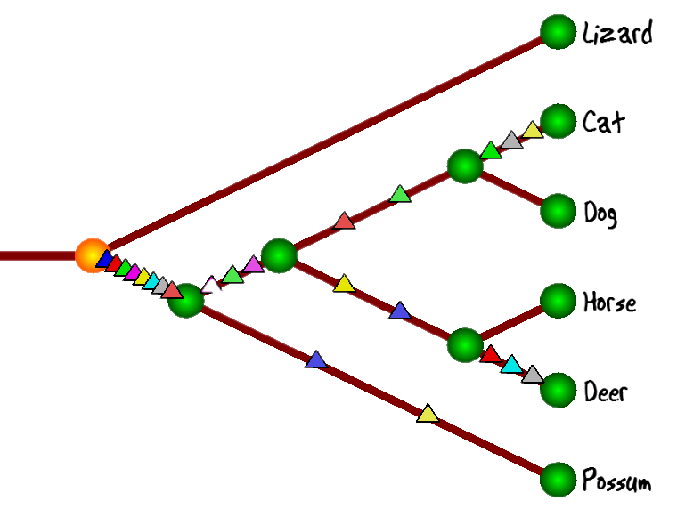

Figure 1: Morphological cladogram hypothesizing the evolutionary relationship between a dog, cat, horse, deer, and possum with a lizard outgroup

The computer-generated cladogram of the five-mammalian species using molecular systematics shown in Figure 2 shows the horse and the cat are sister groups sharing a recent common ancestor. The possum shares a less common ancestor that the horse and cat but is still genetically closer to the horse/cat than the dog or deer are. The deer and dog appear to share the least common ancestor with the other three species.
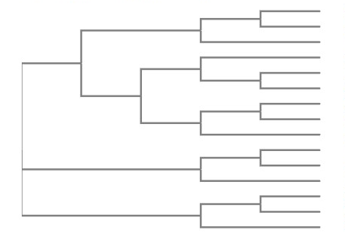
Possum (Didelphis virginiana)
Possum (Didelphis virginiana)
Possum (Didelphis virginiana)
Horse (Equus caballus)
Horse (Equus caballus)
Horse (Equus caballus)
Cat (Felis catus)
Cat (Felis catus)
Cat (Felis catus)
Dog (Canis lupus familiaris)
Dog (Canis lupus familiaris)
Dog (Canis lupus familiaris)
Deer (Odocoileus virginianus)
Deer (Odocoileus virginianus)
Deer (Odocoileus virginianus)

Figure 2: Computer generated cladogram using mitochondrial cytochrome b genes showing the evolutionary hypothesis for a possum, horse, cat, dog, and deer from a common ancestor

The computer-generated cladogram of the black bear species shown in Figure 3 reveals that there are three major lineages of the initial cytb. Two of the branches show little evolution. The top branch shows large amounts of evolution. Each branch is associated with at least two bear species. The Eastern and Cinnamon are sister groups sharing a recent common ancestor and are only found in one lineage. The Kermode appears three times under two different lineages. On the bottom branch, the Kermode and Vancouver Island are sister groups sharing a recent ancestor. The Vancouver Island is also a sister group of the Queen Charlotte along the second lineage. The Olympic only appears within the third lineage between two Kermode bears. The cladogram shows close relationships between the Cinnamon and Eastern, Kermode and Vancouver, and the Vancouver and Queen Charlotte bears.
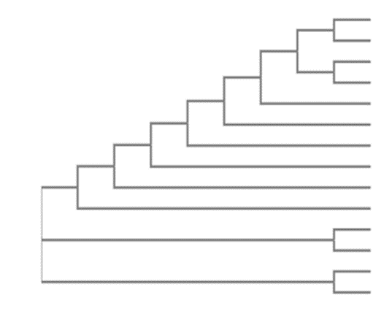
Cinnamon (Ursus americanus cinnamomum)
Eastern (Ursus americanus americanus)
Cinnamon (Ursus americanus cinnamomum)
Eastern (Ursus americanus americanus)
Kermode/Spirit (Ursus americanus kermodei)
Olympic (Ursus americanus altifrontalis)
Kermode/Spirit (Ursus americanus kermodei)
Vancouver Island (Ursus americanus vancouveri)
Queen Charlotte (Ursus americanus carlottae)
Queen Charlotte (Ursus americanus carlottae)
Queen Charlotte (Ursus americanus carlottae)
Vancouver Island (Ursus americanus vancouveri)
Vancouver Island (Ursus americanus vancouveri)
Kermode/Spirit (Ursus americanus kermodei)

Figure 3: Molecular cladogram of North American black bear species including Eastern, Olympic, Queen Charlotte, Cinnamon, Kermode, and Vancouver Island subspecies comparing mitochondrial cytochrome b genes

Discussion

Part 1
The morphological and molecular cladograms show different evolutionary relationships between the species. The morphological cladogram hypothesizes the cat and dog share a recent common ancestor with the horse and deer, and the possum shares no recent common ancestor with the four species. This differs from the molecular cladogram which hypothesizes the cat and horse evolved from a common ancestor more recently than the remaining species. The difference between the cladogram and cladogram is likely due to convergent evolution.
The molecular cladogram best predicts the associated evolutionary relationship between the species. Mitochondrial genes are used as a genetic clock to determine the rate of evolution within a species due to fast mutation rates (Lee & Ho, 2016). By comparing three cytb from each species, the cladogram has a high level of accuracy. Comparing morphological features results in some degree of failure due to convergent evolution which is overcome by comparing cytb.

Part 2
The black bear cladogram shows three major lineages of subspecies based on the cytb. The Kermode, Queen Charlotte, and Vancouver Island all derive from multiple lineages. The species therefore are not fully differentiated but have undergone some separate evolution which agrees with the refugia hypothesis. The null hypothesis was rejected based on the cladogram because there is evidence that the subspecies are significantly different.
The cladogram shows that certain species are more closely related than others. The cladogram shows three major lineages based on the cytb. The subspecies all evolved along the third lineage and can still breed but show significant differences in traits. They are considered subspecies. The significant differentiation within the species allows the null hypothesis to be rejected. This suggests that they are unique subspecies of the Ursus americanus.
The cladogram shows a split into 3 major lineages. The sister groups of Kermode and Vancouver Island in the first lineage, and Vancouver Island and Queen Charlotte in the second lineage suggest close and isolated relationships from the remaining subspecies. All of the subspecies evolved from the third lineage suggesting no isolation. The Eastern and Cinnamon sister groups share the most recent common ancestor of the lineage. The isolated subspecies in lineage one and two reappear in lineage three suggesting that they continued to intermittently breed with the other subspecies. This evidence supports the hypothesis of the bears retreating to the islands during glacial periods. These results are supported by a study performed by Byun et al. (1997) that also concluded that there is molecular evidence of a glacial refugium within American black bear subspecies.
The cladogram seems accurate in regard to the evolutionary relationship between the subspecies. Molecular systematics are more effective than morphological when determining the differences of subspecies and closely related species by comparing orthologous genes (Nadler, 1995). The different physical traits are likely due to habitat differences. A morphological cladogram would likely produce less accurate results than the molecular cladogram. Due to vastly different habitats as described by the Biology Department (2018) the morphological traits that evolved are not a clear indicator of species relatedness. The island bears are semi-isolated. The Vancouver Island is found only on Vancouver Island, BC. The Queen Charlotte is found on the Queen Charlotte Islands and Alaska. The Kermode is found along the central coast of British Columbia. The Olympic is distributed along the pacific coast of central BC through to Northern California and inland to Idaho. The Cinnamon and Eastern bears are continental. The cinnamon bear can be seen in Idaho, western Montana, and Wyoming. The Eastern bear is found Montana to the Atlantic coast, as well as in southern Alaska through to the Canadian Atlantic coast. The habitats of each of the bear populations differ and those differences affect the morphological traits derived for each subspecies (Byun, Koop, & Reimchen, 2008).
All of the subspecies are facing increased risk of becoming endangered or extirpated due to loss of habitat (Biology Department, 2018). Conservation efforts should target the Eastern subspecies because the expansion of humans reduces the area occupied by the bears and risks segregating populations. Due to the far-reaching habitat area and lack of overlap between subspecies, the Eastern bear population at the Atlantic coast is under the greatest risk of extirpation or speciation as the habitats become segregated form the west due to human activity. Segregating habitats may cause the populations to develop different traits, which over time result in divergent evolution of the subspecies (Reese et al., 2014). Divergent evolution can eventually lead to full speciation of the Eastern bear subspecies. If this occurs, the new species of bear would be unable to breed with the remaining subspecies of black bear which could potentially lead to extinction.
Phylogenetics can lead conservation efforts to help conserve the subspecies that is least closely related to the parent species or identify closely related suitable breeding partners (Reese et al., 2014). Breeding closely related subspecies that are normally found near the area can reduce the risk of extinction and improve genetic variability. Given the location and the similarities on the cladogram, mating Eastern populations with Cinnamon subspecies would grow the population without drastically affecting the species diversity. A larger population with greater genetic diversity is more resistant to disease and less likely to experience genetic drift (Reese et al., 2014).
Phylogenetics are important to determining the relationships between species and subspecies. It can use morphological or molecular data. Cladograms provide a hypothesis starting point for evolution of species. The morphological and molecular cladograms of the mammalian species provided very different evolutionary hypotheses. The cladogram comparing the subspecies of bears showed evidence that, during glacial periods, the bears took refuge on the islands and have since expanded across North America. The Eastern bear is the only subspecies found on the Atlantic coast, making it vulnerable to speciation and isolation. Conservation efforts should be made to mitigate the risk by breeding Eastern and Cinnamon bears improving genetic diversity and reducing isolation.

References

Biology Department. 2018. Foundations of Biology II: BIOL 1104 Laboratory manual winter
term 2018.
Carleton University Press, Ottawa, ON.

Byun, A. S., Koop, B. F., & Reimchen, T. E. (2008). North American Black Bear mtDNA Phylogeography : Implications for Morphology and the Haida Gwaii Glacial Refugium Controversy Author ( s ): S . A . Byun , B . F . Koop , T . E . Reimchen Published by : Society for the Study of Evolution Stable URL : http: Society, 51(5), 1647–1653.

EMBL-EBI. MUSCLE. Retrieved February 28, 2018, from
http://www.ebi.ac.uk/Tools/msa/muscle/

Lee, M. S. Y., & Ho, S. Y. W. (2016). Molecular clocks. Current Biology, 26(10), R399–R402. https://doi.org/10.1016/j.cub.2016.03.071

Nadler, S. a. (1995). Advantages and disadvantages of molecular phylogenetics: a case study of ascaridoid nematodes. Journal of Nematology, 27(4), 423–432.

National Center for Biotechnology Information. Taxonomy Database. Retrieved February 28,
2018, from http://www.ncbi.nlm.nih.gov/taxonomy

Reese, J.B., L.A. Urry, M.L. Cain, S.A. Wasserman, P.V. Minorksy, R.B. Jackson, F. Rawle, D. Durnford, C. Moyes, S. Walde & K. Wilson. 2014. Campbell Biology: Canadian edition. Pearson Canada Inc,. Toronto, ON.

Stone, J. R. (2003). Mapping cladograms into morphospaces. Acta Zoologica, 84(1), 63–68. https://doi.org/10.1046/j.1463-6395.2003.00131.x

