CARDIOVASCULAR TOXICOLOGY

OVERVIEW AND IMPORTANCE
- CVD= leading cause of death in western societies 33-40% of all-cause mortality.
- #1 cause is Coronary heart disease
- any risk due to occ/env factors = significant consequences across the population
- involved in o2, glucose and other nutrient transports to tissues
- waste transport from tissue to excretory organs
- chemicals that impair blood or displace o2 from hemoglobin can cause an acute lack of o2 = anoxia and therefore localised
- chemical exposures that cause changes to CV tissues and their processes may also cause vasculotoxic responses in the microvascular component of multiple organ systems

THE HEART
- 4 CHAMBERS – right and left ventricle , right and left atrium
- large veins – superior and inferior vena cava bring venous blood from body - right a –right v
- blood then – lungs to be aerated then – left a
- then – left v – body thru aorta and branches
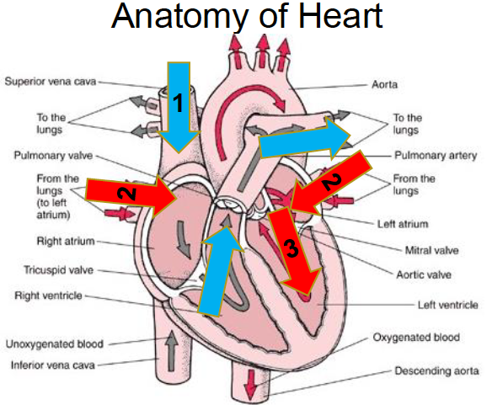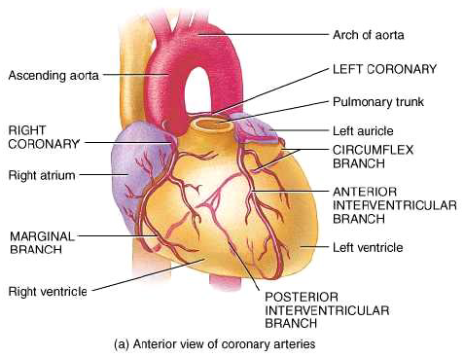

ANATOMY OF THE HEART
- 3 layers of the walls (both atria and ventricles)
- endocardium – internal layer, immediate contact with blood
- myocardium – intermediate layer, contractile
- epicardium – external layer, serous membrane, pericardial sac in which the heart lies

BASIC CV function
- The heart + heart vessels = maintain precise control of blood pressure and critical tissue perfusion

BASIC MYO STRUCTURE
- Single nucleus
- Under autonomic control
- Syncytium – coordinated contraction
- All cardiac cells contract together – skeletal – selective recruitment of motor units
- High o2 demand
- Myocytes do not regenerate
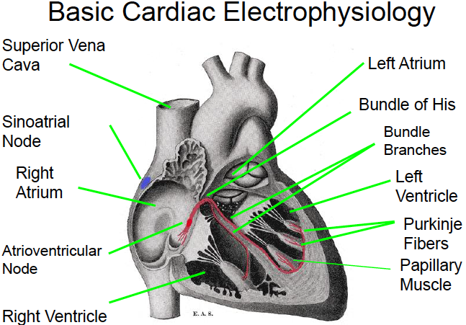
- Read PAGE 12

HEART DISEASE
- General term include coronary artery disease , heart failure and angina
- #1 killer in developed nations

MAJOR DISORDERS OF THE CV SYSTEM
- atherosclerosis
- hypertension
- myocardial infarction (heart attack)
- stroke
- IHD – ischemic
- VHD – valvular
- RHD – rheumatic
- CHD – congenital
CORONARY ARTERY DISEASE
- Occurs when the coronary arteries that supply the heart muscle become blocked
- Partially blocked = angina
- Fully blocked= heart attack
CONGESTIVE HEART FAILURE
- Heart hasn’t failed but its not doing an efficient job
- Due to injury or reduction of function of heart muscle
- can be due to arteriosclerosis, hypertension, MI, rheumatic fever or birth defect
- right side takes blood from body to lungs
- if failing, blood backs up into veins and signs of edema
- left side takes blood from lungs to body
- if failing, the blood is not pumped effectively
STROKE
- blood vessel in brain blocked by atherosclerosis = the tissue supplied by the artery dies
- embolus – travelling blood clot
- #3 killer and leading cause of long term disability
- READ PAGE 21
CVD RISK FACTORS
- MAJOR RISK FACTORS – age (M45+, F55+), smoking, hypertension, diabetes, dyslipidemia (LDL/HDL), family history of premature CHD, obesity.
- EMERGING RISK FACTORS – depression, anger, homocysteine, markers of inflammation (c-reactive protein), environmental exposures, Thrombogenic factors and genetic factors.
CHRONIC CVD due to OCC/ENV FACTORS ARE DIFFICULT TO STUDY
- High background prevalence of :
  - Known personal risk factors with very strong associations
  - Emerging risk factors with varying strengths of association
  - Epidemic – diabesity
- With OCC/ENV factors, chemical effects must be teased out from physical and psychosocial factors
- Difficult to identify appropriate control groups
- Health worker effect
- Diff btn persons in various occ
- Diff socioeconomic status
- Adversely affected persons more prone to loss to follow-up
- Attrition may be due to disability, early retirement or change to an unexposed occupation
MANY EXPOSURES OCCUR IN MIXTURES: eg TOBACCO SMOKE
- smoke Includes: CO, CN, PAHs, nicotine, particulates, metals, acrolein, others
- particulates include: metals, organic carbon, sulfate, nitrate, elemental carbon
- chronic effects: endothelial injury, altered lipid profiles, smooth muscle proliferation
- acute effects: vasoconstriction & spasm, thrombogenic on platelets.
CHEMICAL EXPOSURE AND HEART DISEASE
- benzene: increased arrhythmogenesis in animals. Arterial hypertension, ectopic beats, conduction defects and repolarization disturbances in workers
- phenol and ethanol as solvents associated with heart disease
- link between carbon disulfide and atherosclerosis
- butadiene and atherosclerosis in cockerels
- styrene-butadiene and atherosclerosis in black workers
MANIFESTATIONS OF CARDIAC DYSFUNCTION
- arrhythmias (flutters and fibrillations)
- cardiomyopathies (deterioration of the function of myocardium): caused by ischemia, hypertension, inflammation, valve defects, systemic metabolic disease
- organism effects : poor tissue perfusion, accumulation of fluids in inappropriate locations, organ failure, death
MEASURING TOXICITY AND ALTERATIONS OF CV FUNCTION
- Physiological function
- EKG/ECG for early indication
- Telemetry and photo-sensor for heart rate
- EM or doppler ultrasonic for systemic arterial blood flow/pressure
- Echocardiography for cardiac output
- Clinical chemistry
- Enzyme release, creatine phosphokinase, lactate dehydrogenase, troponin. Etc
- Blood gas, proteins, lipids, electrolyte imbalance
TYPES OF CARDIAC TOXICITY
- Direct
- Thrombosis and infarction
- Inflammation (myositis, endocarditis, vasculitis)
- Downstream tissue/organ effects
CARBON MONOXIDE
- Most common cause of fatal occ inhalation
- Exposures: vehicle exhaust, combustion powered appliances, faulty heating systems, smoke, methylene chloride
- 200x affinity for hgb and 50x affinity for myoglobin than O2
- Binds to cytochromes and mitochondria
- Sticky platelets
- Increased cholesterol deposition
15% infarction, 4-6% arrhythmias, 2-4% decreased stamina probability
NITRATES AND DINITROTOLUENE(EXPLOSIVES)
- Causes vasodilatation (headache)
- Associated with vasospasm, angina, infarct and sudden death
- Long term exposure: non-atheromatous sclerosis, dysplasia
ISCHEMIC HEART DISEASE
- Mechanisms: coronary atherosclerosis and stenosis, plaque disruption and thrombosis
- Manifestations: silent ischemia, angina, myo infarct, sudden death

BASIC VASCULAR FUNCTION
- Arteries, veins and capillaries: conduct blood to tissues and transport O2, nutrients, wastes, drugs and chemicals
- Lymphatics: return interstitial tissue fluid to blood
VASCULAR SMOOTH MUSCLE CELLS
- Vasoconstriction and dilation
- Synthesis of connective tissue
- Release of growth factors and cytokines
- Migration and proliferation

INFLAMMATORY DISEASES ACCELERATE PLAQUE BUILD UP AND INSTABILITY IN BLOOD VESSELS – AHTHEROSCLEROSIS
- Blood vessels harden and are destroyed due to fat deposits
- Major cause of IHD, MI and stroke

POLLUTION AND HEART DISEASE
HEALTH EFFECTS OF PARTICLE POLLUTION
- Respiratory: chronic bronchitis, asthma, coughs, sneezing, decrease in lung function, airway inflammation.
- Cardiac: heart attack, cardiac arrhythmia, changes in heart rate and variability, premature death
PEOPLE WITH LUNG AND HEART DISEASES, CHILDREN AND OLDER ALDUTS ARE AT GREATER RISK.

DOES AIR POLLUTION CONTRIBUTE TO HEART DISEASE?
- CVD kills 1 million people/yr in the US in the US alone (40% of all deaths)
- Rate declined in 1960 but is rising
DAILY MORTALITY AND PARTICULATE EXPOSURE
- Connection between daily mortality and ambient air concentrations of PM10 and PM2.5
- Associated with IHD, CHF, Arrhythmias
- Heart failure =10% of CV deaths and 30% of CV deaths by PM exposure
- 60K/350K deaths are due to PM
EFFECTS OF PM ON CV
- disruption of autonomic nervous system activity = decreased heart rate
- arterial vasoconstriction
- cardiac arrhythmias
- MI
- Exacerbation of ST-segment
- Increased generation of CRP, white cell count and plasma viscosity

TRY TO FIND INDEPTH UNDERSTANDING AND RESEARCH FOR 68 – 83

NICKEL, PM2.5 AND CVD
- Causes alteration of heart rate and heart rate variability in mice
- May cause oxidative stress and damage to the SV endothelium
- Alterations in progenitor cells ability to repair air damaged endothelium
- Leads to atherosclerosis development and advancement
- Ni is an important component responsible for PM2.5 induced CV effects
- The reduced capacity of endothelial repair may partially explain the connection
EPC- Endothelial progenitor cells
- Reformation, regeneration and repair of blood vessels and endothelium
- Angiogenic factors
- Combo

