BUSI 2400

Chapter 1 – IT for Business and Business Professionals
Why IS Matters
- Information systems are important in our daily lives
- Organizations that ignore the impact of technology and information systems when conducting business will likely risk the business itself
- Organizations and individuals must keep up with these rapid technology changes or risk becoming obsolete
- Moore’s Law – a law that postulates computing power (as measured by the maximum number of transistors in an integrated circuit) roughly doubles every 18 months
- Information Technology (IT) – the branch of knowledge that deals with the uses of hardware, software, and networks to convert, store, protect, process, transmit, and retrieve information. It is especially relevant to organizations for increasing efficiency, cutting costs, and enabling closer customer/employee interactions, resulting in better profits
- Knowledge Work – the intellectual activity that people perform upon data, information, and knowledge to discover business options

What is an Information System?
- Information System (IS) – an organized collection of people, information, business processes, and information technology designed to transform inputs into outputs to achieve a goal. Businesses use information systems to leverage the human ability to achieve business goals through the timely and appropriate application of technology, and the timely delivery of appropriate and useful data, information, and knowledge
- An information system is more than a computer
- Information systems enhance work, decision making, problem solving, communicating, and coordinating

Data, Information, and Knowledge
- The core of any system is the data we process that turns it ultimately into information, and knowledge
- The flow of data and information to create knowledge is what creates value in organizations
- Data Information Knowledge Continuum – the model of the evolution and hierarchy of data going to information, then to knowledge
- Data – raw, unorganized facts, numbers, pictures, and so on that has to be organized in a way that business professionals can use to make sense
- Knowledge – created when a person combines information with judgment. Creating and adding economic value relies on the use of knowledge. It can be explicit or tacit
- Wisdom – an extension of the data to knowledge continuum that enables business leaders to perceive the underlying meaning and nuances of a business situation and ensures that knowledge from all relevant perspectives, disciplines and sources is considered in the final decision
- Knowledge Management System (KMS) – systems that provide tools for working with both tacit and explicit knowledge
- Technology is a key enabler, but it is still mostly up to humans to take data and information and turn it into knowledge and wisdom

IS versus IT
- IT is simply a collection of tools:
- hardware
- software
- connectivity
- IT enables individuals or businesses to achieve their goals

The Productivity Zone
- IT is simply an enabler to achieving a goal
- The productivity zone is created at the intersection of people, processes, and technology
- The design of the information system accounts not just for the optimal technology, but also incorporates elements of human design to accommodate how people will use the system
- By applying equal weight to all 3 of the elements, businesses can achieve superior productivity and enhance their competitive advantage
- For businesses, this can mean increased efficiency and greater profits

The Internet
- Internet – the global network of co-operating computer networks that use the same rules for sending and receiving information
- Internet has become an integral part of personal and business lives due to:
- communication
- information
- commerce
- Communication – sharing data, information, and knowledge with others using tools such as email, telephone, instant messaging, file sharing, central databases, and in-person meetings
- Another key to generating business value for any organization and to increasing personal productivity is the ability to both make information available
- World Wide Web – a collection of Internet software applications and standards that allows the transfer of text, images, audio, and video, the Web makes it easy to publish information in a variety of wats so that is accessible to business professionals and trading partners of a business
- Information Overload – the situation where people re overwhelmed by the amount of information available on the Web
- Commerce – the buying and selling of goods and services
- E-Commerce – the use of information systems, technologies, and computer networks by individuals and organizations to create business values

What’s in IT for Me?
- IT is involved in our everyday life
- IT is not only an enabler for you as a student or as someone who is working, but also a major source of entertainment and enjoyment
- It would be impossible to be a fully functioning professional today and not use personal productivity tools or have a basic understanding of the Internet

IT is Fundamental for Your Career
- You cannot work effectively in any knowledge intense profession today without superior systems
- E.g. accounting, marketing, human resources, finance
- ICT (Information and Communication Technologies)
- Information and Communications Technology Council (ICTC)

What’s in IT for an Organization?
- Systems calculate and compile data to understand customer behavior
- Very important to online stores that need to capture as many dollars per visit as possible
- Organizations use IT to increase efficiency and reduce costs

Business Organizations and the Business Environment
- Business – an organization with one or more people who decide on one or more goals to pursue, work together to locate and organize resources, and create processes to achieve the desired goals. It involves producing goods and services and selling them to generate economic value. It includes financial, commercial, industrial, and human considerations
- Many different factors drive the selection of business goals
- Business Environment – a company’s complex collection of political, economic, social, and technological factors that organizational leaders must consider when making decisions regarding goals, organizational forms, and the creation of business value. Includes the macroeconomic variables of the market the company operates in, the nature of the industry, competitors, customers, and suppliers
- Businesses now rely on IS more than ever before to respond to these factors
- Organizations rely on digital information to gain competitive advantage to respond quickly to opportunities
- Organizations use advanced IS such as decision support systems (DSS) and enterprise resource planning (ERP) systems

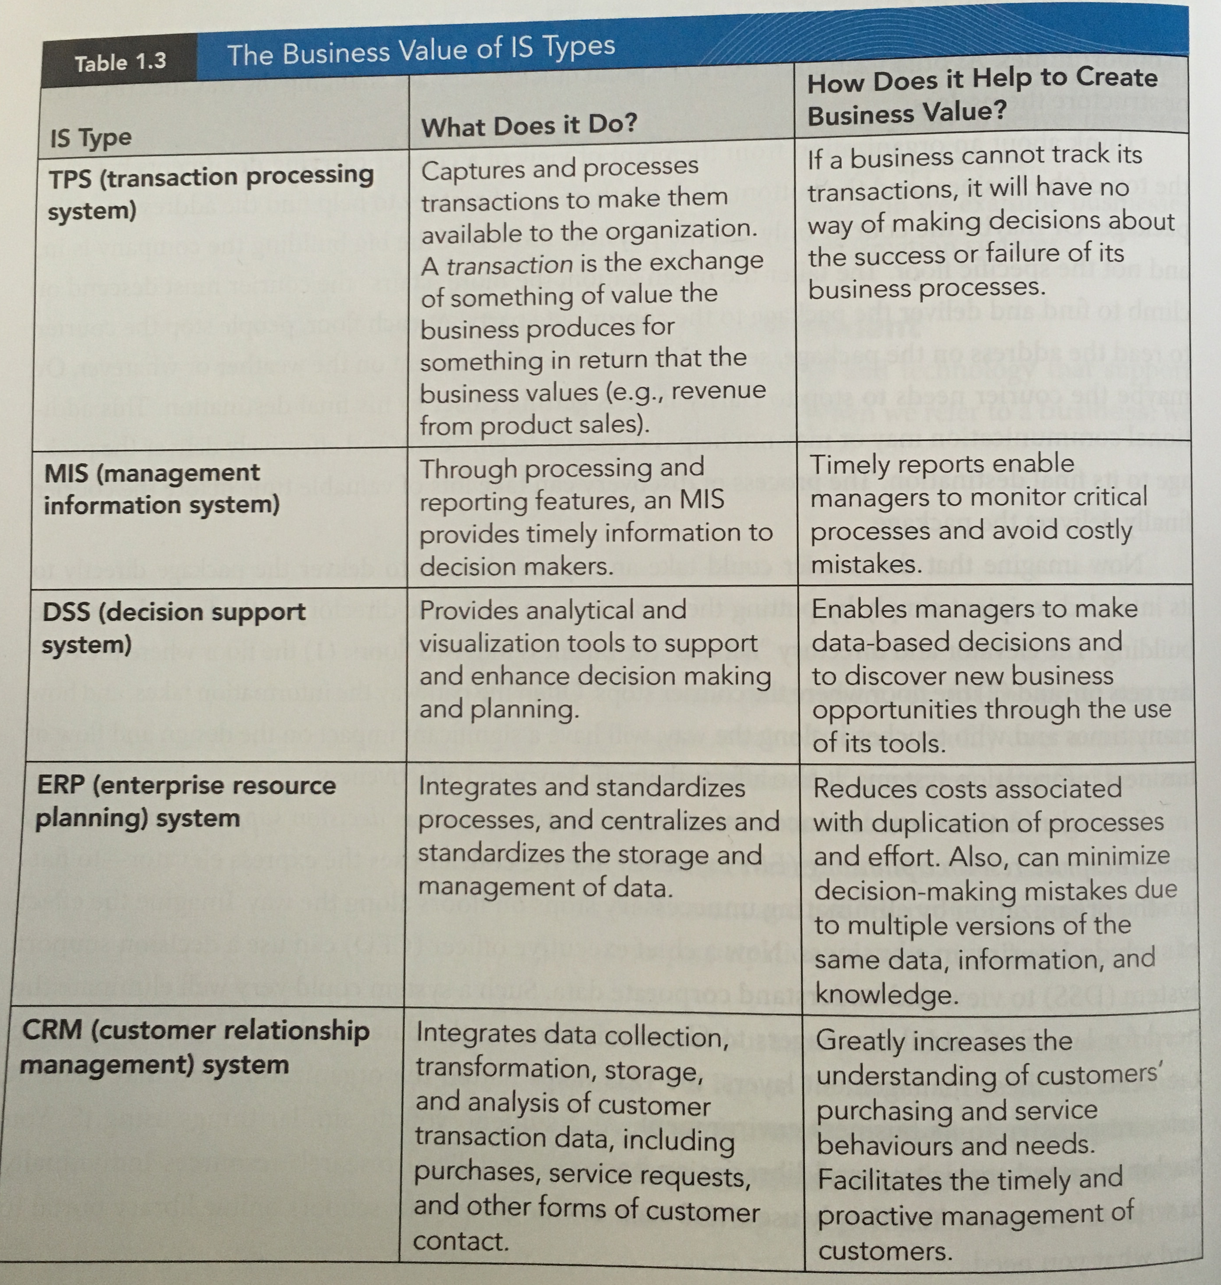
Types of IS found in Business

Ethics in IT
- Organizations collect a massive amount of data about customers, clients, suppliers, products, and more
- The ethical handling and safeguarding of information is only one area where ethics influence organizations and their handling of IT

Copyright and Piracy
- One of the biggest plagues of the software industry is piracy
- Copying any protected software, which the license clearly does not permit, is an unethical practice
- Hurts the costs of software in the marketplace
- Does not encourage innovation
- Diminishes opportunities for IT professionals

Patent Violations
- If you use someone else’s work, you should pay for it, and almost every developed nation has its own patent codes, arrangements, and royalty requirements
- To use someone else’s invention without paying is not only unethical, it is also theft of intellectual property

Reverse Engineering
- Used most often to find out how another manufacturer created a product, and then attempting to learn from this to either make a better one or find a way to replicate it to avoid infringing on copyright or paying royalties on a patent
- If the process is used as an educational tool then there are no ethical dilemmas

Spam and Privacy Codes
- Consumers and businesses hate spam mail
- Organizations continue to use it as a marketing tactic
- Criminal organizations use it in phishing schemes
- The ethical dilemma is not the practice of sending promotional email itself; it is seeking permission to do so rather than collecting or buying email addresses where individuals have not provided their consent

Security Breaches
- Intrusions or security breaches resulted in the loss or disclosure of valuable personal information
- A privacy breach is a serious matter and must be taken seriously

Competitive Intelligence
- A common practice in businesses
- Competitors want insight into what others in the industry are doing so they can respond to the market and maintain market share
- Examples:
- have someone pose as potential customer to get pricing information
- hire head hunter to solicit interest for a non-existing job so employees will disclose confidential plans
Hiring Practices, Equity, Equal Opportunities
- Demand for talented professionals with the right skills outstrips supply
- Attracts immigration of qualified professionals to fill that demand

Green IT
- The environment is obviously a major global concern of every citizen of every country
- IT is a contributor to environmental damage
- Promote recycling and reduce consumption to create a more sustainable global IT industry

What’s in IT for Society?
The Global World
- Globalization – the phenomenon of modern businesses expanding into markets worldwide and distributing work across the glove to minimize costs and provide the convenience of doing business 24/7. IT and the Internet are significant enablers of globalization
- Paying more attention to things like multilingual capability in customer facing systems
- Expansion of English as a dominant language of global commerce
- Increasing universal technology standards and professional mandates

Characteristics of the Digital World
- Much of the current globalization of business and business’s worldwide reach is due to the use of the Internet and internet related technologies
- Technology has flattened organizations and the world has also become flatter
- The flattening of the world caused by these forces has brought countries and individuals closer together for interpersonal relationships, as well as for business ventures

IT and the Economy
- ICT sector is a major contributor to the economies of the world
- ICT sector is a source of 4.8% of Canada’s GDP
- ICT sector grew 2.7% from 2007 to 2008
- The trend of technology intensification has asocial impact, creating both have and have not nations
- Digital Divide – the social impact of technology intensification, creating both have and have not parties (whether individuals, groups, or nations). Those that can afford technology have easy access and those that cannot are left behind

The Darker Side of IT
- New types of crime have no only been enabled by IT, but created by IT

Identity Theft
- One of the more common cyber crimes
- When a perpetuator uses the personal information of an individual, which include name, address, birthdate, social insurance number, to fraudulently present themselves as that individual
- A person’s identity can be stolen by someone taking mail or soliciting information by phone

Internet Fraud
- Phishing – criminals sending fraudulent emails posting as legitimate organizations for the purpose of obtaining important information that can be used for a variety of purposes

Espionage
- Spoofing and sniffing are ways of gaining access to network traffic to access the information being transferred on these networks
- Individuals: gain personal information
- Organizations: spy on organizations and gain access to confidential and proprietary information

Sabotage and Extortion
- A perpetuator could copy something confidential and hold it for ransom
- Gain access to a network and prevent any other person’s access to it until their demands are met

Cyber Terrorism
- A large scale form of Internet crime
- Cyber Terrorism – the premeditated, politically motivated attack against information, computer systems, computer programs, and data which result in violence against noncombatant targets by sub national groups or clandestine agents
- Denial of Service (DoS) – occurs when a network or networks are intentionally overloaded to the extent that they can no longer function
- Viruses and worms are also used for cyber terrorism

Chapter 2 – Technology Essentials
The Components of IT
- All IT (computers, mobile phones) are limited to the following capabilities:
- accepting and storing information
- performing mathematical calculations
- applying logic to make decisions
- retrieving, displaying, and sending information
- consistently repeating the above actions many times
- The power of IT comes from the fact that it does these things amazingly well
- Hardware – the electronic and mechanical components of a computer that can be seen and touched, such as the computer monitor
- Software – the set of instructions that direct the hardware
- Network – a fundamental component of information technology (IT) that helps computers connect with one another. Increases the power of IT devices by allowing business professionals to share resources, including hardware, software, and information. Can be a local area network (LAN), a metropolitan area network (MAN), a wide area network (WAN), or even the internet
- Platform – an IT platform consists of hardware, software, and network technology

Hardware
- Hardware components represent the physical (hard) parts of a system
- When it comes to hardware, IT devices share a common set of system components
- 6 basic IT hardware categories:
- input
- memory
- output
- communications
- processing
- storage

Processing Hardware
- Processing hardware directs the execution of instructions and the transformation of data using transistors
- A transistor is an electronic switch that can be either on (represent by 1) or off (represent by 0)
- A tiny chip made up of transistors is called a microprocessor
- A microprocessor contains of the components that make up the central processing unit (CPU)
- Clock speed is the speed of the CPU when you are performing as task on your PC
- clock speed is measured in megahertz (MHz), millions of cycles per second
- recently measured by gigahertz (GHz), billions of cycles per second
higher clock speeds translate into faster performance
- Computer Hierarchy – a means of categorizing computer technologies based on processing power
- processing power often corresponds to the computer’s physical size
- Embedded Processors are programmable chips built into products to make them “smart”
- Grid Computing – combining the processing power of several computers by networking them together
- each member of a grid is called a node
- each node contributes to the power of the grid

Memory
- Memory temporarily locates data and instructions before processing
- long term memory helps you keep track of facts
- short term memory is only for items that you need to remember for a relatively short time
- Computers have long term memory (ROM) and short term memory (RAM) stored on chips
- memory capacity is measured as the number of bytes the ROM and RAM chips store
- capacities of memory devices range from thousands (kilobytes) to millions (megabytes) and billions (gigabytes)
- Read Only Memory (ROM) – hardware that stores instructions and data that only special devices can alter. In a computer, it holds the instructions used to control the startup processes. The data in ROM is permanently stored there
- Random Access Memory (RAM) – hardware that stores data only until it is no longer needed, or until the computer is shut down. The CPU can access any item stored in RAM directly (randomly)

Input Hardware
- Input hardware provides the interface used for data entry into a device
- The choice of input device should be tailored to the task to be performed
- Input devices such as keyboards, mouse, scanners, digital cameras

Output Hardware
- Output hardware provides the interface used to retrieve information from a device
- Output devices convert IT processed information into a usable form
- When choosing output devices, business professionals are primarily concerned with the quality and speed of the output
- “paperless society” and “paperless office”

Storage Hardware
- Storage hardware stores data, information, and instructions for the long term
- Examples: computer hard drive, CDs, DVDs, USB, external hard drives
- Storage is not only a concern for individual business professionals, it is also a major concern for businesses

Communications Hardware
- Communications hardware connects one IT device to another
- Network Interface Card (NIC) – provides the physical connection between a computer and a local network
- Modems – wired and wireless, allow you to connect to a remote network over a telecommunications line, such as telephone or cable TV service
- a modem converts (modulates) the digital signals going out from your computer into an analog signal appropriate for the connection medium used
- modem speeds are measured in bits per second (bps), affect knowledge work activities

Software
- IT devices help you with your knowledge work activities and contribute to creating business value
- Software is the information that specifies how a hardware devices should work with other data, information, and knowledge
- 3 categories of computer software:
- system software
- application software
- middleware

System Software
- System Software – includes any software required to control the hardware components and to support the execution of application software. System software includes the operating system and utility software
- Operating System (OS) Software – a piece of system software that coordinates and handles the details of working with the computer hardware. It frees the user from the responsibilities of input/output device management, memory management, file handling, multitasking, and process optimization. It also forms the base over which application software is run
- The OS software performs 2 main tasks:
1. Managing the hardware and software resources of the computer
2. Providing a stable and consistent interface between application programs and the hardware
- Utility Software – provides additional tools that can be used to maintain and service the system; for example, antivirus software and disk partition tools, among others
- users often add utilities such as file management software and security programs
- a firewall application

Application Software
- Application Software – a complete, self-contained program or set of programs for performing a specific job; for example document preparation, electronic spreadsheet, presentation, and email clients
- Productivity Software – software used by nosiness professionals to work with data, information, and knowledge more effectively and efficiently; for example, document preparation software, electronic spreadsheet software, and database management systems

Middleware
- Middleware – software that links applications that use dissimilar software or hardware platforms
- Middleware is essential when an organization is implementing new types of software that need to communicate with existing systems

Open Source Software
- Open Source Software – program and software code (programming instructions) that is freely available for downloading over the internet
- developed by a community of developers that interested in the subject matter of the software and want to share their work with others
- often free or have very low cost

Connecting Over Networks
- Networks are everywhere
- Humans are networking maniacs
- Social networks link people through family relationships, friendships, acquaintances, and business contacts
- A computer network consists of network nodes that represent computer hardware and the network users
- Computer network requires 4 primary components:
1. Data that computers share on the network
2. Special hardware
3. Software that allows computers to communicate and share the data
4. Communication media to link the computers together

Computer Networks
Network | Size | Purpose | Examples
PAN (private area network) (private) | Covers a very small space that ranges from the size of a human body to a small office | Communication among computer devices in close proximity | PAN allows your MP3 player to connect to a wireless headset, your PDA to “sync” with your PC
LAN (local area network) (private) | Within the immediate location or building | Share files, resources, servers, and other hardware among the members of an organization | Common LANs include university computing labs, small office or household networks, and a wireless hotspot (WLAN)
MAN (metropolitan area network) (private/public) | Ranges in size from a few blocks to an entire metropolitan area | Provides data and voice transmission typically at high speeds (=100 Mbps) | A university may use a MAN to connect LANs across campus; many city libraries use MANs to support centralized cataloguing and searching of resources
WAN (wide area network) (private/public) | Over a large geographic area | Share data, information, and resources among units of an organization distant from one another | A WAN connects various university MANs/LANs to share research; a corporate network uses a WAN to link national and international locations
Internet (public) | Worldwide | Share data and information with all stakeholders in the organization, as well as with the general public | The Internet is the largest public WAN; sometimes known as a global area network (GAN)

Network Categories
- How much geography the physical size of the network covers
- 2 extreme sizes:
- local area network (LAN)
- wide area network (WAN)

Network Hardware
- Forming a network requires a number of devices for making network connections as well as for managing data transmission over the network
- 3 basic categories of network hardware:
1. Hardware to connect a device to a network
- hardware that connects computers or other devices to a network
- a physical link that forms a network connection is known as a carrier or communications medium
2. Specialized hardware for handling network traffic
- devices that help coordinate the data traffic on a network
- a bridge is a device that lets you connect to networks or break a large network into 2 smaller, more efficient networks
- a router connects, translates, and then directs data that cross between 2 networks
- a hub serves as a central connection point for cables from the devices on the network
- a repeater is sometimes needed to strengthen or amplify signals that are sent along a long transmission route
- a wireless access point (AP) is a special bridge that connects between wireless devices and a wired network
3. Specialized computers that control the network and the delivery of data on the network
- servers manage the various functions of the network
- a file server is a fast computer that requires a large amount of Ram and storage space

Network Software
- Network software is divided into operating system software and application software
- Network operating system software manages network functions and the flow of data traffic over a computer network
- Network application software provides the instructions that allow for the creation of data and for this transformation to fit appropriate protocols for transmission over a network
- Protocol – a standard set of rules that allows the communication of data between nodes on a network

The Internet
- Any computer network that connects several networks together is an internet
- The single largest and most popular internet in the world is known as the Internet

What Makes the Internet Possible?
- The foundation technology that makes the Internet possible is the adoption of standard protocols
- The Internet uses the TCP/IP suite of packet switching protocols
- a general, nonproprietary set of communication rules
- Several international organizations provide committees that discuss and propose Internet standards
Accessing the Internet
- Internet Service Provider (ISP) – services that purchase the expensive equipment needed to connect to the Internet and then provide connections for customers to use vial dial up or cable
- Internet access requires software
- Wi-Fi – the popular name for the 802.11 standards for wireless network access
- A hotspot refers to any public space within which a wireless device can connect

Internet Applications
- While the creation of and the ability to access the Internet were revolutionary in themselves, it is now what can be done with the Internet that is remarkable

Voice Over Internet Protocol (VoIP)
- Voice Over Internet Protocol (VoIP) – to make calls anywhere in the world and by pass traditional switched telephone networks
- When first introduced, packets were sometimes lost or delated along the network, making conversations choppy
- Popular: Skype
- Businesses can use VoIP to reduce costs

Cloud Computing
- Cloud Computing – computing over the Internet; the term cloud is used as a synonym for the Internet
- Simply means computing over the internet
- Cloud computing is used for applications, technical infrastructure, security, data storage, and various technical platforms
- Advantages:
- reduced costs
- scalability on demand
- accessibility
- increased collaboration
- Especially beneficial for small or medium sized businesses that do not want to invest in technology and the resources to manage it
- Software as a Service (SaaS) – a way companies acquire enterprise systems without purchasing or building them; essentially, renting software
- Utility Computing Services – provides services hosted on servers, which can be accessed from anywhere
- Application Service Provider – an online technology company that develops and delivers software tools on the Internet
The World Wide Web
- Internet is synonymous with 2 of its most popular applications:
- World Wide Web (WWW)
- electronic mail

Basic Components of the World Wide Web
Client/Server Networks
- Uniform Resource Locator (URL) – specifies a unique address for each page that indicates the location of a document
- into your browser or clicking a hyperlink
- Client/Server Network – a network of computers that request services (clients) and computers that provide services (servers)

Web Browsers
- Web Browser – a software application that allows you to easily navigate the Web and to view the content that you find there
- A browser will let you request, either by typing a URL or clicking a hyperlink

Hypertext Transfer Protocol (HTTP)
- A client and server communicate with each other through messages
- Hypertext Transfer Protocol (HTTP) – comprises the set of rules for exchanging messages on the World Wide Web
- HTTP governs both the request for a file and the transmission of the requested file
Hypertext Markup Language (HTML)
- Hypertext Markup Language (HTML) – the primary language for creating webpages
- Not a true programming language
- Browser software interprets HTML instructions through the use of tags (interspersed with content)

Search Technologies
- The World Wide Web foundation is founded by Tim Berners Lee
- founded to figure out how big the Internet really is
- Search Engines – users access an HTML form based web page that allows them to enter their specific search criteria to a greater or lesser extent
- To search the Web and compile location data in their databases, most Internet search engines use either special software called Web crawlers, human submissions, or a combination of the 2

Internet Security
- Internet security is seen as a serious issue around the world
- Both individuals and enterprises can be victims of Internet crime
- Example: Koobface worm family, Self XSS

Ensuring Security
- One frame work for Internet security is known as the CIA triad
- CIA Triad – an acronym for Confidentiality, Integrity, Availability
- Confidentiality: the ability to hide information from unauthorized viewing
- Integrity: ensuring that data is not changed and represents the original secure data
- Availability: ensuring that data is available to those who need it, when they need it
- McCumber Cube:
- takes the concept of the CIA triad and extends it
- each individual cube within the larger cube can be analyzed with respect to security
Disaster Recovery
- Disaster Recovery Plan (DRP) – allows an organization to resume operations after a major event that interrupts normal business processes
- events include: data corruption, software bugs, network failures
- disaster recovery plan is IT-focuses and is often a subset of a business continuity plan
- Business Continuity Plan (BCP) – a plan put in place to address problem prevention, response to crises, resumption of business activities, recovery of losses, and restoration of systems and processes
- Reliable data storage and consistent back up procedures are essential in maintaining data integrity

Meaningful Applications of Technology
- Technology is meaningless unless it has a function and creates a benefit
- For businesses: benefit is creation of value and competitive advantage
Collaboration
- One of the most important applications of technology

Groupware
- Groupware – collaborative software that enables communication between team members and helps them to share data, information, and knowledge
- e.g. Blackboard, Google Docs
- Key feature: ability to store documents that can be worked on and shared with several people

Intranets
- Intranet – a private, organization wide computer network that is typically based on Internet protocols
- The use of intranet has moved beyond the goal of paper reduction to support automated internal transactions, as well as to improve communication, teamwork, and knowledge management

Instant Messaging (IM)
- IM is an online communications service that allows users to communicate in real time over the Internet
- 2 main categories of IM applications:
- public
- enterprise (EIM)
- Public IM: Skype, MSN messenger, Yahoo messenger
- EIM systems provide features such as restricted access, and security precautions such as encryption
- IM can also be used for communicating with customers
- Risks of using IM include a rise in needless interruptions and distractions, potential security problems, and increased workplace gossip

Virtual Meetings
- As a business professional, you may need to conduct a meeting but may not be able to attend in person
- Use of web meeting tools
- Participants are given a URL, meeting code, or password so they can attend the meeting

Chapter 3 – Managing and Using Data
- Data and information are as vital to an organization as water is to people
- An organization likes to get the data and information that it needs when it wants it
- A business counts on its IS to deliver accurate data and information

Data, Information, and Knowledge
- Data – raw unorganized facts, numbers, pictures, and so on
- Information – data that have been organized and made useful
- Knowledge – created when experience and judgment are combined with information
- Applying knowledge is how business people create and add value to organizations

Lifelong Knowledge Creation
- To be a successful business professional, you must always strive to create or acquire new knowledge
- Explicit Knowledge – knowledge that is readily codified
- Tacit Knowledge – knowledge that you gain through experience, insight, and discovery
- There 2 types of knowledge are complementary halves of a lifelong knowledge creation process

Knowledge Work Activities
- Kid and Lego analogy
- Steps you went through are referred to as work flows and the outcome of your efforts as the work product

Discovery: Finding Data, Information, or Knowledge
- Discovery – finding data, information, and knowledge relevant to a task, problem, issue, opportunity, and so on
- Begin with an idea of what to look for
- Reflect on where information related to the task may exist
- Retrieve relevant data from those various sources and assess its value to the decision at hand

Analysis: Investigating and Examining the Available Data, Information, and Knowledge
- Analysis – the phase of problem solving that involves examining and looking at the details of available data. Helps to answer questions and gain initial insight prior to doing more in-depth transformation and synthesis
- Breaking down the whole into its more discrete parts to better understand how it works
- Perform analysis such as:
- process mapping
- quality assurance
- performance testing
- Once you complete the analysis, put it into the appropriate organizational context, and make a decision or recommendation
- have now created knowledge

Transformation: Organizing Discovery Results
- Transformation – knowledge work that requires you to use the results of your analysis to deepen your understanding of the data and information
- Information technology can help you transform data regardless of who did the discovery and analysis work
- Spreadsheets and databases are effective tools for organizing and storing information

Synthesis: The Sum of the Parts
- Synthesis – creating wholes from parts. In knowledge work activities, it facilitates the interpretation of trends and patterns leading to conclusions and recommendations. In problem solving, the results of analyses are typically synthesized to develop potential solutions for a problem
- The essential element of synthesis is in knowing which parts, when combined, will create higher total value when the value of the parts themselves
Communication: Sharing Analysis with Others
- Communication – ability to share your analyses, ideas, and solutions with others
- Even if you work for yourself, you still need to communicate effectively with your customers
- Information systems and technology can allow you to share the meaning behind the message

Summary of Knowledge Work Activities
- To be successful and continue to be successful, businesses must do knowledge work
- Knowledge work activities are only part of the larger picture of a rational decision making and problem solving process
- Decisions and solutions often lead to important changes in the business
Knowledge of Work Activity | Manager’s Request | Helpful IT Tools and Activities
Discovery | Find our company’s and our competitors’ weekly sales data | Use data from check out/point of sale (POS) terminals, search tools (Google), and Web searching
Analysis | Compare eh sales data for the first week of May to similar data from our company for the previous 2 months | Import the data into a database or spreadsheet application, and use its features and tools to organize the data. Find the previous months’ data and import these as well
Transformation | Identify any trends in the data by week, month, and day of the week, indicate how our company’s results compare with our competition and withy the industry as a whole | Use the data analysis tools in the spreadsheet application to examine the data from different aspects. Consider what your analysis of the data revealed and combine this with your knowledge of your company’s goals to add focus to your analysis. Search the Web for other analyses of your company, industry, and competitors. Integrate this with your interpretation of the sales data
Synthesis | Given your analysis of our company’s relative success or failure, suggest ways to capitalize on our strengths and overcome our weaknesses | With analysis in mind, obtain feedback about specific company products and services
Communication | Present your findings and suggestions to management | Import your spreadsheet data into presentation software. Add the insights gained from Web meeting
Decision Making and Problem Solving
- To truly create business value, a company needs to decide how to best apply the information it has gathered
- Rational Decision – a choice that a person or group of people or organization makes about what actions to take (or not to take) in a given situation. Decision making usually occurs, however, as part of a larger problem-solving process
- Some decisions may be routine, whereas some are more difficult, involving ethical considerations

Classifying Decisions by Type
- Structured Decision – a decision that can be programmed, it is routine or repetitive, and the necessary data are complete and certain
- Semi-Structured Decision – a decision that is not fully structured but still can be attained with the use of information, reasoning, and partly objective thinking to some extent
- Unstructured Decision – a decision that is characterized by uncertain data or information and for which there may be no known method of arriving at a solution

Using Information in Decision Making
- Rational Decision Making is about: using information to reduce uncertainty in the outcomes of your decisions
- In general, uncertainty complicates the decision making process and underscores why information systems are so important to businesses
- Less uncertainty due to more complete information can lead to better decisions
- Another important element of good decision making is what to do when you receive new information

How to Make More Informed Decisions
- In every decision you make in life, you should always carefully consider the characteristics of the information on which you are basing your decision

Information Evaluation Criteria
Information Characteristic | Example
Complete | Your new project team member’s mobile phone is 555-1212. Is this enough information? Maybe, but you may also need an area code
Accurate | You check your printed course schedule and find out that your Intro to IS class meets at 11pm. You suspect the schedule is wrong
Reliable | You receive an unsolicited email offering you a share in millions of dollars if you will help this person transfer money out of his home country. You realize this is a frequent email scam, and is therefore, unreliable information
Timely | When deciding what to wear, a forecast of yesterday’s weather is recent information, but it could be worthless if today’s weather is different than yesterdays. timely information includes recent information, but also requires that the information arrive close enough to the decision to be useful to the decision maker

The Decision Making Process and Problem Solving Tools
- Initially, decision making requires you to engage in knowledge work activities so that you can make an effective choice about some issue or challenge
- Not all decisions are the same with regard to the structure or uncertainty present in the decision making environment
- To make the best decision, you need to carefully consider the quality of the data, information, and knowledge and put it into proper context
- The quality of the final output of this process will likely be based on the quality of the inputs
- Problem – a state that exists when a person or organization faces an opportunity or fails to meet the desired goals, needs, or expectations
- The current situation often results from a past series of events, or lack of events, that did or did not happen
- Problem Solving – a series of steps or a process (logical sequence of activities) taken in response to some event or activity
- Selection Criteria – factors that you think are important and relevant to solving the problem
- In a sense, before you can rank your solutions, you may have to rank your criteria
- IADD – Investigate, Analyze, Do, Decide
- 3 levels of decision:
- tactical
- operational
- strategic
- Tactical Decisions – made by the person doing the actual work, based on appropriate guidelines or policies
- Operational Decisions – short term decision by a company in lieu of long term strategies at the time of acquisition of company assets
Databases: The Primary Data Storage for Organizations
- Data re important and often abundant
- The primary technology used to store, manage, and allow efficient access to data is the database
- Database – consists of interrelated data that are stored in files and organized so that computer programs can quickly and easily access specific pieces of data
- Database Management System (DBMS) – a collection of software that allows users to create, manage, and work with a database
- A database and a DBMS make up a database system
- People who create and manage database are known as database administrators (DBA)
- Business professionals who need to access the database typically do so through other application software that can connect to the DBMS and query that database it manages

The Data Hierarchy
- Data Hierarchy – organizes stored data in increasing levels of complexity, from the bits used to store data (lowest level) up to the entire database structure (highest level)
- A specific combination of bits represents each data is known as a character
- A combination of characters representing a data item is known as a field
- The next higher level of the data hierarchy stores collection of fields known as records
- At the next level up, the data hierarchy assembles records into a collection called a table or file
- Using a database system to organize data provides several advantages:
- the organization of the data is independent of any one software application. This allows all applications to access the data in a standard manner
- the organization of the data reduces data redundancy; a DBMS may need to store only one record of data for a particular product
- the DBMS can include features for maintaining the quality of the data, handling security, and synchronizing access by simultaneous users
- the database system allows for capabilities such as improved data access, allowing different views of the data for different users, and report generation

Relational Data Model
- Relational Data Model:
- database store information about entities
- use these defined relationships to store the connections between the entities
- Relational Database Management System (RDBMS) – a software application that lets business professionals work with and manage relational databases
- The relational data model stores data in one or more tables, corresponding to entities
- Primary Key is a field that has a unique value for each record
- Foreign Key is when a second table uses the primary key of one table as a reference field in its table
- The primary method for accessing and using data in an RDBMS is a query
- Query is a method for asking a question of a database
- Structured Query Language (SQL) provides general rules for formulating the queries of relational databases
- With 1 or more SQL queries as basis, organizations can create forms and reports to simplify data entry and reporting for their employees

Designing a Relational Database
Data Modeling
- Data Modeling – the process of analyzing the data required by the processes or an organization to support it both operationally and strategically
- Data models are often the first, high level step in designing a relational database

Entity Relationship Diagram and Logical Data Model
- Entity Relationship Diagram and Logical Data Model (ERD) – first step in logical data modelling and provides a high level view of the logical data model
- Logical Data Model (LDM) – a representation of an organization’s data, which focuses on documenting the business requirements aspect of data
- The ERD indicates the entities and relationships for the data that the IS will store
- The LDM then translates the ERD into a diagram of the tables in the database
- ERD and LDM are not separate, define steps, but done at the same time with the result being the detailed logical data model

Data Flow Diagram
- Data Flow Diagram (DFD) – a traditional IS model that depicts how data move or flow through a system
1) external entities that send input or receive output from the system
2) processes that show activities that move or transform data
3) data stores that usually correspond to tables in the data model
4) data flows (arrows) that connect the components
- 3 data stores indicate the need to store various data items
- The DFD uniquely identifies all of the components with a number

Storing and Accessing Data, Information, and Knowledge
- Databases are not the only, nor necessarily the best, form of storage for all business needs

A comparison of database and data warehouse technology
 | Database | Data Warehouse
Supported Activity | Operational (transactions) | Analytical (knowledge work)
Response Time | Fast response time (seconds) | Can be slower (minutes, sometimes hours)
Age of Data | Mostly data for current transactions | A lot of historical data
Scope | May support a limited area within the organization | Should provide view of entire organization
Data Variability | Mostly dynamic, changes often | Most static, infrequent changes
Source | Transactions from operational domain; business rules | Combined from multiple sources (including operational databases)
Data Model | Based on business rules of operational application | Aligns with overall business structure

Data Warehouses
- Data Warehouse – a means of storing and managing large amounts of data for information access, typically composed of data from one or more transaction databases
- Consists of transaction data
- Data Mart – extracts and reorganizes subject area specific data to allow business professionals to focus on a specific subject area
- Data warehouses often provide support for organizing multidimensional data
- Organize data so businesses can more easily identify trends
- Retrieving data organized in this way is sometimes referred to as slicing and dicing (cutting off portions of the data until the needed information is obtained)
- Businesses access and use a data warehouse for 4 main reasons:
1. Automatic production of standard reports and queries
2. Queries against summary or detailed data
3. Data mining in detailed data
4. Interfacing with other applications and data stores
- Data Mining – a set of techniques for finding trends and patterns in large sets of data

Business Intelligence
- Business Intelligence (BI) – a process that enables business leaders to make better decisions for gaining competitive advantage through the intelligent use of data and information in decision making
- BI is a key corporate information strategy
- enables business leaders to make better decisions
- translate into increased profitability
The Stages of Business Intelligence
Stage | Description
1. Data Sourcing (Acquisition) | Mining data and information from text documents, databases, images, media files, and web pages
2. Data Analysis (Organization) | Producing useful knowledge from the collected data and information, using tools such as data mining and text/image analysis techniques
3. Situation Awareness (Analysis) | Culling and relating the useful facts and knowledge, while filtering out irrelevant data
4. Risk Assessment (Analysis) | Identifying decision options and evaluating them based on expectations of risk and reward
5. Decision Support (Decision) | Using interactive software tools to identify and select intelligent decisions and strategies

Using IT to Support Business Intelligence
- To enable businesses to reach intelligent decisions, data and information must go through several stages
- Stages:
1. Organizations get data from multiple sources
2. Ensure relevant analysis
Types of DSS
Type of DSS | Descriptions | Examples
Communication Driven DSS | Focuses on communications, collaboration, and shared decision making | Conferencing tools ; online bulletin boards and chat facilities; email; meeting support applications
Data Driven DSS | Emphasizes access to and manipulation internal company data, and sometimes external data | Executive information systems (EIS); geographic information systems (GIS); OLAP-enabled data warehouses
Document Driven DSS | Focuses on retrieval and management of unstructured documents | Document management systems (DMS); search services; tools for working with oral, written, and video documents
Knowledge Driven DSS | Provides special problem solving tools that help decision making by suggesting or recommending actions to users | Expert systems( ES); artificial intelligence applications, data mining tools
Model Driven DSS | Emphasizes access to and manipulation of a model | Financial, statistical, optimization, and simulation models
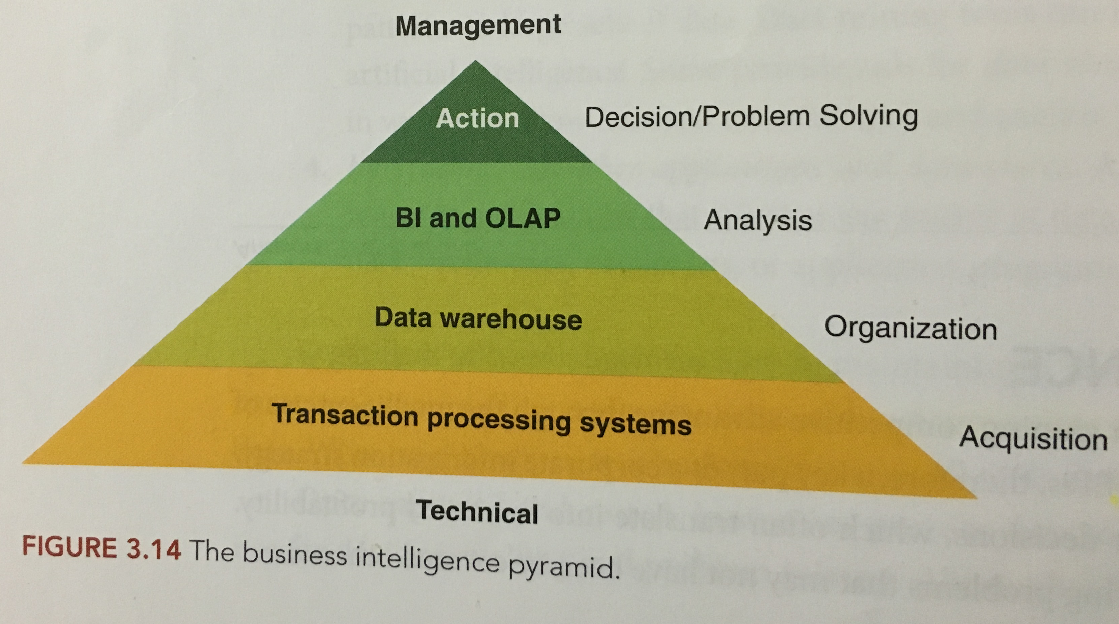

Decision Support Systems
- Decision Support Systems (DSS) – a software system that provides analytical and visualization tools to support and enhance decision making and planning
- 5 types of DSS
- Model-driven DSS use data and parameters to help decision makers analyze a situation, but are not usually data intensive
- Financial models: use financial mathematical models and financial data to support financial decision making
- Statistical models: use statistics and probability to describe or forecast possible scenarios
- Optimization models: incorporate relatively certain data into a mathematical model of a situation; solving the model helps to find the “best” solution
- Simulation modeling: a technique for conducting experiments hat test possible outcomes resulting from a quantitative model of a system
Knowledge Management Systems
- Most difficult to store and share
- Knowledge Management (KM) – how the company recognizes, generates, manages, and shares knowledge
- Groupware – collaborative software which supports teamwork with technologies that enable communication and sharing of data and information
- Benefits of knowledge management are difficult to calculate
- An effective KM program:
- allow business professionals to streamline the value chain
- increase employee morale
Collaborative Software Categories
Communication Tools | - Facilitate the sharing of information and data with tools that enable people to send messages, documents, files, and data between each other
Conferencing Tools | - Provide a more interactive facility for the sharing of information  - At a minimum, can provide real time text discussion and a common “whiteboard” that each participant can edit  - Can also enable voice and/or video using special equipment or computer networks  - Some organizations build special facilities for conferencing supported by these tools
Collaborative Management Tools | - Can help to manage and facilitate the activities of a team  - Can provide shared workspaces to store and share work products that group members may modify  - May overlap with project management systems to keep the group aware of a project’s status

Management Information and Document Management Systems
- Management Information Systems (MIS) – a software information that provides timely information to decision makers through processing and reporting
- Generate 3 types of reports:
- periodic reports
- exception reports
- demand reports
- Executive Information Systems (EIS) – a system designed to provide summary information about business performance to those making higher level strategic decisions
- Document Management Systems (DMS) – an information system (IS) for entering, tracking, routing ,and processing the many documents used in an organization

Business Intelligence Tools
- Dashboard – a common way of organizing and presenting business intelligence or related information sources; the purpose of a dashboard is to provide critical information to business users at a glance
- Balanced Scorecard – a popular type of dashboard that includes both financial and non-financial performance measures in the context of financial, customer, internal business process, and learning and growth perspectives. Each of these has objectives, measures, targets, and initiatives associated with them, which are equally weighted. The purpose of the balanced scorecard is to measure an organization’s actions against its strategic direction
- Visual Analytics – extends a dashboard by enabling a user to examine data in depth, reorganize it dynamically, and change information parameters to do “what if analysis”

Chapter 4 – Enterprise Systems
Information Systems that Support Business Activities
- There are many ways to understand what businesses do to create value
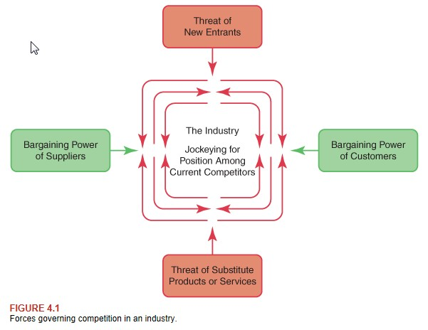

Building an Understanding of the Value Chain
- Value Chain – a connected series of activities, each of which adds value or supports the addition of value to the firm’s goods and services
- 5 Components of Value Chain:
- inbound logistics: receiving, warehousing, and inventory control of raw materials required to create a product or service
- operations: the value creating and often proprietary activities that transform the raw inputs into the final product and can include R&D, manufacturing and product design elements
- outbound logistics: the activities required to get the finished product to the customer, including packaging, warehousing, and order fulfillment
- marketing and sales: all activities associated with defining and securing target market interest, getting buyers to purchase the product, including working with distributors, retailers, or online channels, and activities like competitive analysis, advertising, and pricing decisions
- service: maintain and enhance the product’s value, including customer support, repair services warranty, and recall
- Adding Value – ensuring that, as an organization moves through the value chain, value is added at each step, thereby increasing the value of the end product or service to the end customer. As such, if a step does not add value, it should ne eliminated
- Value chain components can be classified into primary and secondary activities:
- primary activities: those directly related to the production and distribution or the organization’s products and services
- support activities: value chain activities that an organization conducts in support of or expansion of the business value created by the primary activities

Functional Information System
- Functional Information System (FIS) – an information system (IS) with a focus on the activities of a single functional department of an organization that is used to improve the efficiency and effectiveness of that department

Workflow Management System
- Workflow – the steps, organizational resources, input and output data, and tools needed to complete a business process
- Workflow Management System (WMS) – supports activities that several departments of the organization may carry out by supporting and automating workflows
- A WMS typically provides tools for modeling the steps of the process
- A WMS leads to several benefits:
- misplaced or stalled work is often reduced
- managers can focus more time on business decisions rather than on tracking work
- WMS requires formal documentation of all procedures, more analysis and tighter control of the processes often result
- Business Rule – a statement that defines or constrains some aspect of the business; it is intended to influence and, sometimes, enforce the behavior of the business. Business rules are often found as part of policies and procedures, laws, or guidelines

Transaction Processing Systems
- Business transactions are often one of the most critical of the core activities an organization performs
- Transaction – an exchange of goods or services between 2 or more parties (businesses, individuals, or a combination of the 2) that creates a relationship between the parties
- Transaction Processing Systems (TPS) – an information software system that enables transactions and captures and processes transaction data to make them available to the organization
- ACID:
- atomicity: a transaction must be unequivocally completed
- consistency: all unchanging properties of data must be preserved
- isolation: each transaction should execute independently of other transactions that may occur at the same time on the system
- durability: the characteristics of a completed transaction should be permanent

Supply Chain Management
- Supply Chain – a network of facilities and distribution options that perform the functions of procurement of materials, transformation of these materials into intermediate and finished products, and the distribution if these finished products to customers
- Supply Chain Management (SCM) – a set of methods that a business employs to manage the materials, information, and finances as they move in a process from supplier to manufacturer to wholesaler to retailer to consumer. IS are essential for efficient management of the supply chain
- SCM systems seek to optimize the supply chain to create business value and competitive advantage

Enterprise Resource Planning
- Enterprise Resource Planning (ERP) – an information system that integrates and standardizes processes and centralizes the storage and management of a business’ data with the goal f increasing operational efficiencies in business processes
- ERP sets out to link these various applications and ensure their compatibility via common data processing and storage
- A benefit of an ERP system:
- streamline business processes
- companies want to get orders to customers faster and at less cost
- receive sales revenue quicker
- Disadvantage of ERP:
- system can become incredibly complex and difficult to manage as it grows
- ERP systems need to be customized for the specific business processes and rules that it is supporting

Enterprise Systems that Support the Value Chain
- Some IT systems are specific to particular parts of the value chain or specific organizational functions
- Enterprise Systems – large scale applications deployed across the organization that support specific business units or functions; they are another way that an organization might apply IT to its value chain

Strategic Deployment of Enterprise Systems and Technologies
- IT can be used to support just about anything inside an organization
- 4 ways a business can derive benefit by applying IT to support the organization and its processes:
1. Supporting the value chain
2. Automating
3. Informating
4. Gaining a competitive advantage

Comparing IT Strategic Tactics
Tactic | Scope | Benefits
Support of Value Chain | Organization wide | - Views organization as a system with need for integration of components and activities  - Allows a focus on enabling value adding activities  - Helps to fit IT applications and infrastructure to organization
Automating | Process/Transaction | - Allows for cost reduction, efficiency, quality, and consistency
Informating | Process/Transaction | - Allows for knowledge and learning of core competencies
Competitive Advantage | Organization wide | - Connects automating and informating of processes to organizational strategy

- Competitive Necessity – the need to keep up with competitors in order to stay in business

The Role of IS Governance and Leadership in Creating Sustainable Business Value
- Outsourcing – hiring another company to perform work that could otherwise be done in house
- Often referred to as Business Process Outsourcing
- The reduced process cost helps the business offer a lower price for its products or services, thus improving competitiveness
Enterprise Risk Management
- All businesses face threats and risks
- cannot be eliminated completely, only anticipated and minimized
- Value is maximized when management sets strategy and objectives to strike an optimal balance between growth and profit goals and the inherent risks associated with these activities
- Businesses cannot anticipate or plan for all risks and threats
- When creating and implementing a business strategy, a business must attempt to identify, address, and eliminate elements of risk before they threaten its success
- Enterprise Risk Management (ERM) – a process started by an entity’s board of directors, management, and other personnel, applied in a strategic setting and across the enterprise, to identify potential events that may affect the entity and to manage risk to be within its risk appetite
- 4 overlapping categories of business objectives for focusing on risk assessment and management:
- strategic: high level goals, aligned with an supporting its mission
- operations: effective and efficient use of its resources
- reporting: reliability of reporting
- compliance: compliance with applicable laws and regulations
- Compliance – reduces risk through policies and processes

Applying the Risk Framework
- Apply the ERP framework to address enterprise risk:
- first identify and categorize potential risks
- assess risks and threats using 2 criteria: impact and likelihood
- decide whether or not the risk is acceptable
- Businesses should manage applicable risk before it evolves into high impact/high probability risk

Risk Reduction Method
Risk Response | Action
Risk Transfer | Move the risk to someone who is more able to deal with it
Risk Deferral | Postpone exposure to the risk until circumstances are more favorable or resources are available to address the risk
Risk Reduction | Either reduce the probability of the risk occurring or lessen the impact
Risk Acceptance | Realize that some risks are unavoidable and make sure that contingency plans are in place
Risk Avoidance | Eliminate the possibility of the risk occurring; however, that may close the doors on some business opportunities as well

Risk Transfer
- Organizations can use outsourcing to transfer risk
- Outsourcing can shift risk outside of an organization to another business that may be better quipped to mitigate risk
- In Sourcing – the strategic decision made by a business to bring various services or functions back-in-house, or keep them in-house, rather than globally source them

Risk Deferral
- Many companies pursued new systems to ensure long term stability

Risk Reduction
- Reduce risk by enabling disaster recovery
- Many companies developed disaster recovery plans to address what to do should the organization be faced with an event causing significant business risk
- A disaster recovery plan is a subset of a business continuity plan that concerns primary IT resources, such as data
- A business continuity plan addresses problem prevention, response to crisis, resumption of business, recovery of losses, and restoration of systems and processes

Risk Acceptance
- Not all risks can be transferred, deferred, proactively reduced, or avoided
- Organizations must accept some risks
- Without risk, there is no chance of a greater return
- Even though the level of risk is acceptable, it is prudent to have a contingency plan in place should something unexpected occur
- Roll Back Strategy – involves being able to reverse every action that took place to make the change happen such that everything is returned to its original state with no damage done

Risk Avoidance
- Its human nature to avoid risk at all costs
- Organizations avoid risk through implement controls

Control and Controls
- Implementing controls is not only a way of avoiding risk, but it may end up up providing a control advantage through IT
- Control Advantage – the strengthening of internal controls and compliance through the application of IT based controls to business processes, policies, and procedures
- Businesses generally base control around 3 key concepts:
1. Control is a process that runs throughout the organization
2. Control influences how people behave at work
3. Control can only provide reasonable, not absolute, assurance of achieving objectives
- Controls – specific actions, including policies and procedures, designed to ensure the achievement of business objectives
- Internal Control – a process effected by an entity’s board of directors, management, and other personnel, designed to provide reasonable assurance regarding the achievement of objectives in the following categories:
- effectiveness and efficiency of operations
- reliability of financial reporting
- compliance with applicable laws and regulations

- 3 broad types of controls:
- preventive controls are designed to prevent increased exposure to risk by stopping some action or process before it occurs
- detective controls reduce risk by discovering when preventive controls have failed and providing notification that action must be taken
- corrective controls aim to remedy the situation and try to keep it from recurring

7 categories of specific internal control process:
- Segregation of Duties:
- jobs do not span lines of control that would allow mistakes or fraud to go undetected
- Authorization:
- prevent scope creep and cost overruns in various situations, such as major projects or operations management
- Security:
- application developers should log in separately to the development and production databases
- ID Code:
- track the login IDs and activities of all users
- creates an audit trail that organizations can follow to ensure proper controls are in place and working
- Verification:
- can confirm that the application is accomplishing e-commerce functions
- monitor return of merchandise counts to ensure that the new system is sending customers what they ordered
- Control Totals:
- help detect fraudulent actions
- Supervisory Review:
- consist of ordering an item calling customer service, returning the item, receiving credit for the item, and documenting the process

Chapter 5 – Creating Business Value

Business Organization and Business Processes
- Business Strategy – a broad based formula that lays out how a business is going to compete, what its goals should be, and what plans and policies will be needed to carry out those goals
- The purpose of an organization can be defined as where mission, vision, and values meet to create opportunities for strategic action
- Michael Porter states that “strategy is a broad based formula for how a business is going to compete, what its goals should be, and what plans and policies will be needed to carry out those goals”
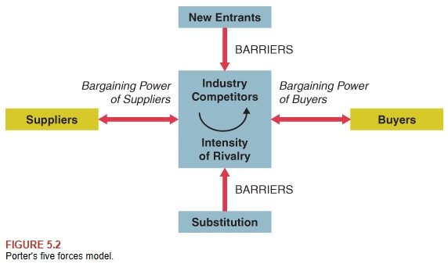

- The intensity of competitive rivalry in any industry or service sector can be attributed to forces that define that industry
- If the industry is attractive and there are fewer barriers to entry, then more competitors will enter the industry, thereby increasing competition
- If there are barriers to entry, it will be harder for new competitors to gain entry

Businesses as Open System
- Open Systems Model – a technique for viewing a business as an open system with a boundary, environment, inputs, outputs, processes, feedback, and decision makers. The model indicates that a business operates by transforming inputs into outputs and by constantly interacting with its environment
- 2 significant components of business environment:
- stakeholders
- boundaries

Stakeholders and Boundaries in the Business Environment
- Different businesses face different business environment
- Stakeholder – a person or entity that has an interest in and an influence on how a business will function to succeed. May be external or internal relative to the organization
- may be internal (within the organization boundary) or external (in the environment) relative to the system
- influence is an important part of the definition of a stakeholder
- influence may be actual or potential, great or small
- Organizational Boundary – the separation between a business system and its environment. Business systems must keep an open boundary to their environment to allow for receiving inputs and to produce outputs
- businesses must remain open to their environment
- an open boundary primarily allows a business to receive inputs and to produce outputs
- aware of the environment so it can take steps to remain competitive by responding to opportunities or threats
- business needs external information to run its operations or processes on a daily basis
- Environmental Scans –

How Businesses Organize to Create Value
- All business organizations possess structures that organize information, responsibility, and authority
- Functional Structure – a business organized according to functional areas instead of product lines. Functionally organized businesses can be economically efficient but can lack flexibility, and it may be difficult to communicate between functional areas
- Decentralized Structure – decision making authority is pushed down the organizational structure and shared with many lower level employees. Decentralized organizations have fewer levels of management with wide spans of control, giving employees more freedom of action. Decentralized structures can be more efficient than centralized structures because they require fewer managers
- Matrix Structure – a form of business organizational structure that blends the functional and decentralized organizational structures. Frequently uses teams of employees to accomplish work
- Teams are an important part of business

Organizational Form | Advantages | Disadvantages
Functional | - Economies of scale through efficient use of resources  - Significant technical expertise found in the functional areas  - Clear chain of authority and communications within a function | - Poor communication and coordianation between functional areas  - Relatively inflexible or slow to respond to change in the business environment  - Employees may focus on functional area goals rather than organizational goals
Decentralized | - Faster response and greater flexibility  - Greater communication and coordination between organizational units  - Greater development of breadth of managerial skills | - Duplication of resources and efforts across organizational units  - Technical knowledge not as in depth relative to functional organizational form  - Less direct control by upper management
Matrix | - Increased flexibility and responsiveness to business needs and environmental changes  - Enhanced problem solving, cooperation, communication, and resource sharing  - Decision making occurs lower in organization and closer to customer | - Frustration due to dual lines of authority and responsibility  - Increased need for coordination between functional areas consumes time and resources  - Potential for goal conflict between functional and decentralized components of matrix

Business Process
- Business Process – a series of steps that an organization needs to perform to transform inputs to their main outputs (products and services)
- Michael Hammer and James Champy: business process is a collection of activities that takes one or more kinds of input and creates an output that is of value to the customer
- A process is often shown as input process output
- a process receives inputs, undertakes some action, and then produces output
- processes are all around us
- There are hundreds of processes involved in running a business
- link together and interact with one another to achieve various goals
- processes can be incredibly complex and layered
- A sub process is one or more tasks that accomplish a significant portion or stage of a process
- IGOE – inputs, guides, outputs, and enablers
Examples of Input
Input Type | Description
Data, information, and knowledge | Raw facts, summarized data, information derived from research, and expert knowledge relevant to a business’s goals
Labor | People hired to carry out all or part of the essential business processes or supporting functions
Raw Materials | The “ingredients” from which the company makes its products
Capital | The money that businesses need to operate
Technology | Available in many forms, and greatly extending beyond PCs and software applications

- Inputs are resources needed to start a process
- Outputs are the results of the process
- Enablers arte a special kind of input or resource that facilitates a process
- Feedback – a special kind of output created by a business process that is then returned to the system (fed back) to control the system’s future inputs, processes, and outputs
- include information such as error or failure rates, processing speeds, process costs, and information on approvals and controls required in the process
- monitor the efficiency and effectiveness of a given process
- Business Process Reengineering (BPR) – the study of business processes with the objective of changing these processes to be more efficient and better support an organization’s objectives and strategy
- Goals of BPR:
- reduce costs
- increase throughput and speed
- increase quality and service
Innovation and Competitive Necessity
- All organizations today focus on improving results all the time
- Continuous Improvement – the ongoing effort to improve products, services, and/or processes. Improvements may involve increasing quality and/or reducing costs
- Continuous Learning – strives to innovate and redefine the future
- Competitive Advantage – the advantage businesses obtain over their competitors by increasing the quality of insight, speed of execution, and cost competitiveness of the organization
- Competitive Advantage = Quality of insight + Speed of execution + Cost competitiveness
- Innovations must be doable if they are to have value to the organization, and this equation can help guide a company’s efforts to be innovative

Automating to Do Things Faster
- Automating – using technology instead of business professionals to perform tedious or repetitive tasks. By automating, a business my complete a task with more speed, economy, consistency, and possibly accuracy
- By automating, a business can also complete tasks with more speed, economy, consistency, and possibly accuracy
- When automating a process, a business first tends to apply technology to do the same things as before, but with greater efficiency and accuracy

Informating to Do Things Better
- Informating – recognizing that executing business processes also creates new data and information, an organization may then use this new data to improve its decision making and to change or improve the process itself
- In most cases, companies derive informating and automating benefits from some of the same applications of IT

Transforming to Gain Competitive Advantage
- For profit companies: to achieve a sustainable competitive advantage that results in high profits
- For public sector: to provide services efficiently, effectively, and at the lowest possible cost
- Transforming – using information technology to help a business acquire or continue a competitive advantage over its competitors by adjusting how the company does business
- Transformative changes are usually not incremental improvements, rather are extraordinary leaps of competitive prowess that involve taking advantage of new technologies to invent new wats of doing business
- A company gains a cost advantage when it delivers the same benefits to customers as its competitors, but at a lower cost
- A company gains a differentiation advantage over its competitors when it delivers superior benefits to customers

Collaboration and Co-opetition
- Collaboration is required in the workplace for an organization to be successful
- Co-opetition – a new term emerging in the business literature and practice of global commerce that implies that organizations can collaborate in one endeavor, while they compete in other areas. In other words, this is a business strategy that realizes the benefits of both co-operation and competition
- Co-opetition should not be confused with collusions, price fixing m or other kinds of practices that are not truly collaborative or transparent
- Collaboration and co-opetition are options to creatively address these competitive gaps by letting each party focus on what they are good at and then cooperating where necessary to create sustainable competitive advantage

Corporate, IT, and Project Governance
- Corporate Governance – the leadership and management of a business re directly accountable to its owners for the proper operation and financial control of the organization
- Effective governance is a critical enabler for success
- One of the primary responsibilities of board members/governors is to appoint the chief executive of the organization who reports to them

IT Governance
- IT Governance – the distribution of decision making rights and responsibilities among enterprise stakeholders, and the procedures and mechanisms for making and monitoring strategic decisions
- The CIO must ensure proper and secure use of all the organization’s information resources, and particularly the organization’s compliance with privacy laws and regulations in which it operations

Project Governance
- IT as a function is heavily project oriented
- Project Management – the application of knowledge skills, tools ,and techniques to project activities to meet project requirements
- Project Portfolio Management (PPM) – selecting projects that are good strategic fits for the company (doing the right projects)
- An organization must seek a balance to make sure that the methodologies do not oversimplify what are clearly strategic processes

Professional Codes of Conduct and Practice
- A major part of good governance is understanding what the ethical and appropriate governance practices are to apply
- Codes of Conduct – codes that are relevant in terms of what is and is not acceptable and ethical behavior
- These codes are often in place in organizations with high risk profiles

Chapter 6 – Managing IS Projects and Creating IS Solutions

Critical Pre-Development Questions
- To support a complex organization, employees often need complex information systems
- The more complex a system, the more difficult it can be to build, buy, and manage
- Before implementing a new system, an organization needs to address 4 critical questions:
1. What are we planning and why?
2. Is the project feasible?
3. Should we build or buy/lease?
4. If we build, should we do it in house or outsource it?
- These are “pre-development” questions, because they happen before an organization decides to start an IS project

What are we Building and Why?
- An organization can plan to improve the performance of its business processes by automating, informating, and transforming
- Look for ways an IS could add value to its new or existing products and services
- Understand its high level system requirements and also the business case for why it makes sense to build the system

Is the Project Feasible?
- Feasibility Study – a detailed investigation and analysis of a proposed development project to determine whether it is technically and economically possible
- also known as the business case
- A project is feasible if the required technology is available
- An organization can determine technical feasibility by examining potential solutions and evaluating these solutions based on its capabilities and the capabilities of any technology partners it may choose to work with
- A project is financially feasible if the organization can pay for the project and the project presents a sound investment of the organization’s limited resources
- To determine financial feasibility, an organization must show that it can afford to build or buy an information system, and that the IS will financially benefit the organization
- Organizations uses several common financial measures:
- return on investment (ROI)
- net present value (NPV)
- internal rate of return (IRR)
- payback period

Should we Build or Buy/Lease?
- An organization usually chooses 1 of 3 primary option for obtaining an IS:
1. Buying
- saves time and cost over building
- need to make adjustments, by compromising its ultimate list of preferred requirements with the actual capabilities of the existing system
2. Leasing
- using software as a service (SaaS), as available in cloud, or using an application service provider (ASP)
- involves a pay as you go approach based on transaction volumes or usage
- vendor is responsible for maintaining and updating it
3. Building
- ensures the best matching of an ID with an organization’s requirements
- best for obtaining a sustainable competitive advantage (not easily copied if they are custom built)
- can be a long and costly process

Development Choice | Advantages | Disadvantages
Buying | - Generally faster and less costly than building an entire system from scratch | - Little or no competitive advantage; may need to compromise on some feature  - Dependent on vendor for product updates
Leasing | - Lowest cost and fastest to put in place  - Vendors are in charge of maintenance and updates  - Does not require an in house IS staff | - No competitive advantage  - Little to no control over system features  - Dependence on vendor for entire system  - Can get locked into an undesirable contract
Building | - Most likely to provide a competitive advantage  - Retain complete control over system  - Customization of the system to specific requirements | - Longest time and higest cost to put in place  - Requires IS staff with time and development knowledge

Buy or Lease: Which System/Vendor Should we select?
- Follow the organization’s approved procurement process
- Request for Information (RFI) – when an organization acquires an IS, it may issue an RFI to gather information about a product, service, and/or vendor capabilities
- generally sent to as broad a range of vendors as possible
- An RFI is followed by a RFP
- Request for Proposal (RFP) – a document that initiates a bidding process for potential vendors. An RFP provides very specific and detailed requirements for respondents to answer to determine the suitability of their proposed offering
- The purpose of an RFP is twofold:
- to determine the suitability of the vendor’s offered products or services in relation to the proposed IS requirements
- to gather bids from qualified vendors for price comparison
- Upon receipt of the RFP resp0onses, an organization begins the evaluation and selection process
- Vendor Management – the management, control, and monitoring of third party providers or suppliers to the organization. It is the role of the vendor manager to keep vendors apprised of what is happening in the organization, including any new requirements for vendors
- Contract Compliance – adhering to the terns if the agreements

Build: Should we Develop In-House or Outsource?
- In House Development – using one’s own staff to do the work required to develop a new system or product
- Outsource – hiring another company to perform work that could otherwise be done in house
- When the outsourcing company is located primarily in a foreign country, this is known as offshoring
IS Development Source | Advantages | Disadvantages
In house Development | - Firm retains complete control of the project  - Process builds internal knowledge through learning and experience | - Generally higher development time and costs  - Distraction of in-house IS staff from other duties
Outsourcing | - High level of skill and expertise  - Internal staff provides project oversight, which is less time-intensive than full development  - Generally lower time and costs | - Firm loses some control of project since it is necessary to give outsourcer some decision making authority  - Internal staff has less opportunity to build experience  - Requires good contracts, oversight, and vendor management

- Technical Acquisition – occurs when a company possessing a desired technology is purchased by another organization so that the acquiring company can own and use the technology of the acquired company. It is an alternative to builds or lease/buy options when acquiring an IS

The Stages and Importance of the System Development Life Cycle (SDLC)
- System Development Life Cycle (SDLC) – the common term used for the stages and activities of system development
- The SDLC is composed of processes that occur from the beginning stages of a system to the end of its useful life when the system is retired and likely replaced with something new
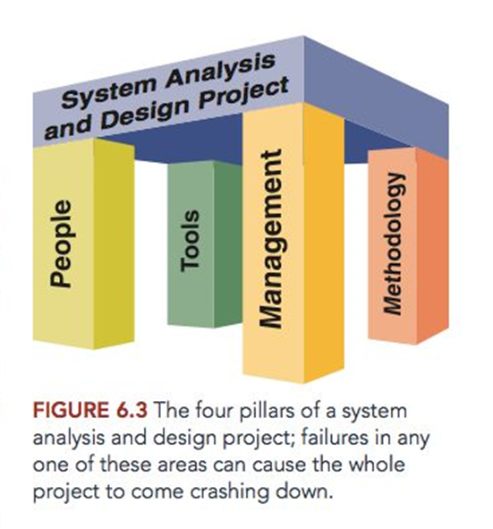

- 4 distinct pillars impact an IS project:
1. You need the right people with the right skills
2. They must have the right tools
3. Have the right methods to build the system
4. You need to manage the process carefully to ensure success
- The SDLC is associated with a set of activities within both the project team and the development team
- Diagrams typically show the phases or steps of the traditional SDLC as flowing from one to the next from top to bottom, similar to a waterfall
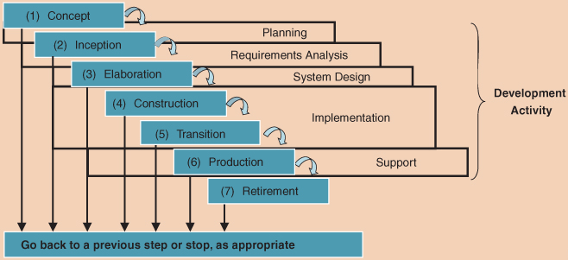

- SDLC Process:
1. Concept
- an organization must foster an environment that can improve its bottom line. Ideas to gain competitive advantage or reduce sots must be collected, documented, and initially evaluated. The ideas with the most potential and merit advance to the next stage, inception, for further analysis and planning
2. Inception
- begins when an organization has the idea to build an information system. The focus is on understanding the problem to be solved or the opportunity to be addressed and planning the project. Early interactions with stakeholders of the system take place at this time to complete the feasibility study or business case required to be approved to proceed to the next phase of the SDLC, elaboration
3. Elaboration
- in this phase, the project team finalizes the requirements for the system and the project plan, and designs the system architecture. The team also creates conceptual models of the systems and subsystems
4. Construction
- during this phase, the team builds the initial running system. The team usually implements core functionalities first, and then incorporates additional features
5. Transition
- at this time, the team finalizes the system, tests it, and puts it in place. In addition, the team completes the final training of users and management of users during the transition
6. Production
- once the system is up and running, the organization must continuously monitor, maintain, and evaluate it. The organization must also keep users of the system up to date with the latest modifications and procedures
7. Retirement
- at some point, the system may lose its value to the company. This phase often marks the concept of a new system to replace the obsolete one. The old system may retain some usefulness as it is phased out over time by the replacement system

Managing an IS Project
- Project Management – the application of knowledge skills, tools, and techniques to project activities to meet project requirements
- For IS Development, a project manager simultaneously oversees 3 main project elements:
- the scope of the project
- the resources needed
- the time to complete it
- Project scope defines what the project should accomplish
- Resources can include people, equipment, material and money
- Time estimates consider project activity times and how they depend on each other
- Management of these elements is always a balancing act
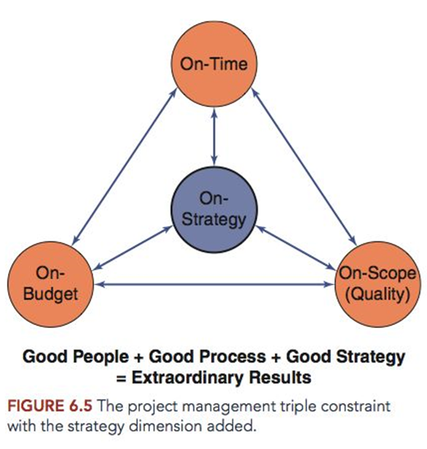

Overview of Project Management Tasks
- Project management activities may occur as early as the concept phase
- Normally begin at the point at which the organization has approved a project proposal and selected it to be executed as part of their project portfolio
- A project has a beginning and an end, whereas the SDLC is a continuous stream of activities over time
- Even though a project finishes when the system is complete and released to production, the SDLC activities continue until the system is retired
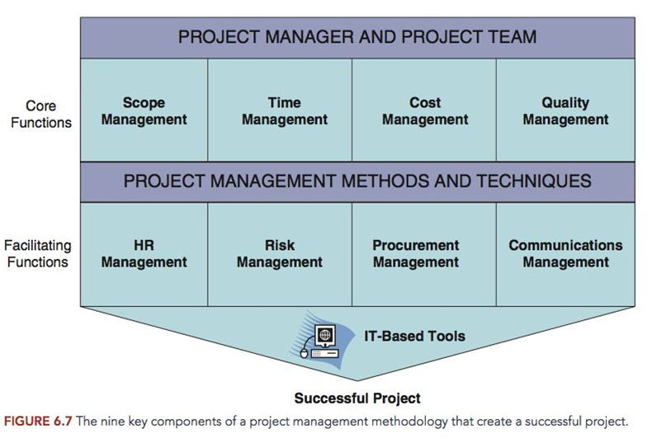

- 4 core functions lead to specific project objectives:
1. Scope management – identifying and managing all the tasks required to complete a project
2. Time management – estimating the duration of the project, developing an acceptable schedule, and managing the project to ensure timely completion
3. Cost management – preparing a budget and managing the costs of the project to stay within budget
4. Quality management – ensuring that the finished project satisfies its defined goals
- Project management integration includes the development of the project plan, execution of the plan, and the coordination of changes to the plan as they occur

Project Time Management
- Main activities of project time management:
- define activities – identify the activities required to produce project deliverables
- sequence activities – identify and document relationships between project activities
- estimate activity resource – estimate the type and quantity of material, people, equipment, or supplies required by each activity
- estimate activity duration – approximate the number of work periods needed to complete individual work activities with estimate resources
- develop schedule – analyze activity sequences, durations, resource requirements, and schedule constraints to create the project schedule
- control schedule – monitor the status of the project to update project progress and manage changes to the schedule baseline
- Gantt Chart – provide a standard format for displaying the results of the first 4 time management activities
- lists the project activities in a calendar format
- horizontal bars correspond to start and finish dates
- patterns or colors on the bars represent various categories of activities
- arrows show when the start time of one or more activities depends on the completion of an earlier activity

Project Risk Management
- Every IS project contains an element of risk
- Risk Management – recognizing, addressing, and eliminating sources of risk before they threaten the successful completion of a project
- Project risk management falls into 2 main categories:
1. Risk assessment
2. Risk control
- The first step in risk assessment is to identify potential risks
- After obtaining a list of potential risks, next is to assess these risks
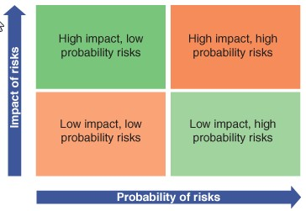
- To manage risk effectively, a project manager directs a team member to allocate each risk to an identified owner

Common Areas of Project Risk
Project Risk | Description
Feature Creep | As the project progresses, user requirements may increase beyond the team’s ability to handle them within the original project scope
Requirements gold plating | A project has more and perhaps unnecessary requirements than are really needed and that are additional to those envisioned during inception
Short changed quality | If a project is rushed, corners are often cut in areas such as testing, documentation, and design tasks
Overly Optimistic Schedule | Setting an overly optimistic schedule can cause abbreviations in critical planning and design tasks, as well as put undue pressure on team members
Inadequate Design | When not enough time is allocated to design, the quality of the design can suffer
Silver Bullet Syndrome | This occurs when a project team latches on to a new practice or technology and expects it to answer all of their problems
Research Oriented Development | This occurs when a design attempts to push the boundaries of what is technically feasible in too many areas
Weak Personnel | This occurs when the skills and knowledge of the team members are not up to the project tasks
Friction with Customers | This can be caused by perceived lack of cooperation on one side or the other or personality conflicts

Risk Response Action
Risk Response | Action
Risk Transfer | Move the risk to someone who is more able to deal with it
Risk Deferral | Adjust the plan schedule to move some activities to a later date when the risk might be lessened
Risk Reduction | Either reduces the probability of the risk occurring or lessen the impact; for example, increase staffing resources on the project
Risk Acceptance | Accept the risk and then ensure that the contingency plans are in place
Risk Avoidance | Eliminate the possibility of the risk occurring; for instance, use alternative resources or technologies

Program Management
- Program – the set of instructions in a computer language that follows an algorithm to carry out a desired task
- Program Management – managing several related projects together. Essentially the same as managing a single project, but across multiple project teams
- Programs are often created because there are dependencies between projects

Project Management Office
- When organizations are very project focused, they may have one or more project management offices (PMO)
- Depending on the size of the organization and projects approved, one or more PMOs may exist
- There may be an enterprise PMO (ePMO) that monitors all projects in the organization

Project Management Software
- Project Management (PM) Software – designed to support and automate project management and decision making tasks
- PM software classified into 3 levels:
- low level packages
- mid level software
- high level software
- Program Evaluation Review Technique (PERT) Chart – schedule and manage the tasks within a project
- Advantage of PERT is that it clearly shows the sequence and dependencies between tasks
- An important use of the PERT chart is to identify the critical path

The Importance of Stakeholders
- The attitude of a powerful stakeholder toward a project can dramatically affect the project’s eventual success or failure
- Stakeholder Analysis – the portion of the feasibility study that includes the evaluation of stakeholder opinions and attitudes about a project
- begins with a list of stakeholders
- consider whether the team can expect resources from the stakeholders
- attempt to identify each stakeholder’s attitude toward the project and any risks
A Typical IS Project Team
- IS Development projects require teams with the following roles:
- project sponsor
- ensures that the project goals correspond to the organization’s business objectives
- senior executive or someone in a position of authority
- consider strengths and weaknesses of both the business and the teams
- identify opportunities and threats both internal and external to the organization
- understand financial aspects of the project, manage risks and planning needs
- project manager (PM)
- demands knowledge of methods an techniques to ensure delivery of the project on time and on budget
- ability to communicate project goals and requirements to the project team and coordinate the workflows of everyone on the project team
- primary liaison with the project sponsor and the project steering committee and PMO
- account management
- project team works as outsourcer
- responsible for sales and service of the project team
- provide initial point of contact to the client and communication with client
- architecture and design
- ensure any proposed system is architecturally sound, fits in with existing or desired technical infrastructure, and meets technical goals and standards
- may be responsible for providing a well-designed user interface
- analysts
- provide the methods and processes to translate high level requirements in their particular area in to lower levels of detail that can be turned into code by programmers
- system analyst deals with technical requirements
- business analyst deals with process and system design
- database analyst handles the data mapping, data dictionary, data structures
- developers
- creates the system by coding and deploying the technical infrastructure of the system and programming it to perform required tasks
- requires knowledge of both hardware and software to function
- specialists
- handles unique aspects of the project
- client interface
- internal or external customer of the team’s organization
- ensure the successful completion of the project
- define system requirements, negotiate contract terms, and maintain oversight of the teams as the project progresses
- may supply resources to the project team
- Subject Matter Experts (SME) – a group of specialists working on a project who handle unique aspects of the project for which they are uniquely qualified
- Project Steering Committee (PSC) – a committee that oversees large and complicated IS projects. Its responsibility is to ensure the project and organizational goals are met, required resources are provided, contingencies are managed, and expected benefits are realized

Standard IS Methodology
- Methodology – a set of procedures that provides a framework for both the management and technical processes of an information systems (IS) project
- Selecting a methodology that matches a project’s needs helps to ensure the successful completion of the development project

Why do Organizations Need an IS Methodology
- Build and Fix Model – a methodology whereby developers create a system based on a set of requirements and then test and debug it with little attention to any pre-project analysis or developmental design
- those who knew simply did
- Systems designed under the build and fix model often did not fully satisfy customer requirements

The Traditional IS Methodology: The Waterfall Model
- Waterfall Model – a model with a designed set of phases, where a new phase begins only after acceptably completing the preceding phase, causing development activities to move downstream through the phases in a formal, detailed manner
- defines a set of phases, and a new phase begins only after acceptable completion of the preceding phase
- If developers discover mistakes or other problems, they then return to a prior phase
- The idea is that if things are done right in each phase, there will be little or no need to move back upstream to an already completed phase
- The waterfall model is a document driven and highly structure process
- Weaknesses:
- only effective when users can express their exact needs
- sequential nature of the waterfall process can delay progress

Modern IS Methodologies
- Evolutionary Model – a model whereby developers first investigate, specify, and implement an important core part of the system with minimal functionality, and then the team tests and evaluates this version of the system to plan for the next version
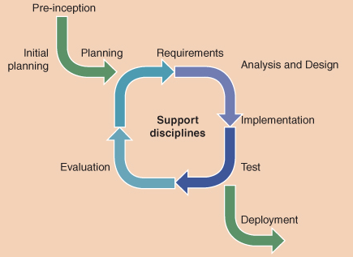

- Prototyping – the initial version of a system, which is continually revised to reach a final product
- this process can help team members and users better understand the requirements
- One problem with an evolutionary model is that developers often neglect to create a well-defined set of documents
- Agile Development – a methodology whereby the team develops software in short development cycles or increments to allow for continuously changing requirement
- Evolutionary and agile development methodologies are an attempt to reduce the somewhat constricting formality of the pure waterfall approach
IS Modeling
- Model – a simplified representation of something real, such as a building, weather pattern or information system, that business professionals can manipulate to study the real item in more detail

UML Diagrams
- Unified Modelling Language (UML) – a very popular modelling tool that works particularly well for developing object oriented systems
- The purpose of UML diagrams is to show multiple views of a system
- The set of UML diagrams is known as system model
- A UML model describes the purpose of the system, but not how to implement it
- Commonly used UML diagrams: class, object, use case, state, sequence, activity

IS Development Tools
Integrated Development Environments (IDEs)
- Integrated Development Environments (IDEs) – allows developers to complete several programming tasks within the same software application instead of using separate software packages
- The typical IDE includes a text editor to allow the user to write program code, a file system to store programs, a compiler to translate the program into machine language, and debugging tools to find and correct errors
- Example: Microsoft visual studio and eclipse

Modeling Tools and Code Generators
- Using graphic diagrams in modelling systems is an important activity in information system development
- Code Generation – allows a developer to use graphical diagrams to define a system’s components and how they are related, and then to automatically create programming statements to implement the logic described by the diagrams

Authoring Software Categories
Category | Description | Representative Software
Database (DBMS) | Allows developers to build and manage the databases that are a key part of most IS | Oracle Database, MS Access
Web Development | Provides tools for developing web pages and applications  Ranges from simple HTML editors to full-blown IDEs | Macromedia Dreamweaver, WordPress
Animation/Video | Provides tools for developing animation and video components | Macromedia Flash, Shockwave, QuickTime
Graphics | Allows users to format and edit visual content | Adobe Photoshop
Audio Content | Allows users to format and edit audio content | Adobe Audition, Wavepad

CASE Tools
- Computer Aided Software Engineering (CASE) – the use of computer based support in the software development process
- support the creation and maintenance of the many documents, diagrams, and data
- One common error is to focus on managing the software tools rather than the content of the project itself
- Another common problem is known as the silver bullet syndrome
- occurs when there is an overreliance on the tools for the success of the project, while neglecting the other pillars of a development project
- End User Development – IS development that is carried out by non IT personnel; this is possible because IS development tools have become so advanced

Chapter 7 – E-Commerce
- All organizations must have a business model
- Organizations can now create business relationships and carry out transactions either completely or partially online through e-commerce

E-Commerce Defined
- Advances in technology, product variety, and consumer demand have brought an accompanying change in retailing strategy
- Ubiquitous rail and cheaper and more available airline transportation brought new and rapid possibilities for order fulfillment, expanding possible markets available
- Telephone call center has changed the definition of customer service (assume speaking with someone local, even those they might not be)
- Disintermediation – the elimination of the so called “middle man”
- E-Commerce – the use of information systems, technologies, and computer networks by individuals and organizations to create business value

Beyond the Basic Definition
- This general definition of e-commerce therefore includes all types of computer networks

Types of E-Commerce Transactions
Transaction | Description
Business to Consumer (B2C) | Online equivalent of the retail store as well as other services
Business to Business (B2B) | Electronic exchanges between companies
Business to Government (B2G) | Online sales to government agencies, as well as electronic payment of taxes
Consumer to Government (C2G) | Electronic payment of taxes as well as purchase of various types of licenses
Consumer to Consumer (C2C) | Use of online auctions like eBay and similar other sites

E-Commerce and Products: Physical and Digital
- Divide products into 2 categories:
- physical
- digital
- Physical products include anything that requires an actual shipment of the item from a central distribution point to the buyer
- Consumers can receive digital products directly over the Internet or other computer networks
- Difference between both products are the delivery process
- A computer network can transmit information about the order, but cannot ship the actual physical good
- A return process may not even be applicable to a pure online business
- Streaming – allows you to purchase the right to view the product, but not to physically download it

E-Commerce Business Models
- Story of e-commerce does not only involve questions of how a digital product or service is supplied
- E-Commerce Business Model – a business model that combines a specific type of website with a successful revenue model that produces profits for the website owner
- Assets include:
- websites
- virtual worlds and goods
- videos
- audio files
-podcasts
- e-books
- blogs
- Having a great e-commerce business model will not generate a profit if it is not associated with a website that brings in customers or visitors
- Internet competition is fierce and growing daily, even for incumbents with long histories of past success
- Specialization is beginning to occur, which is a sign the market may be maturing quickly
- While none of the e0commerce business models is particularly complicated, they do not always interact easily with each other
- Too much complexity in a business model may defeat business success
Websites Classified by Purpose
Website Type | Purpose | Business Model
Portal | Provides a gateway to many other websites | Advertising, affiliate
Search Engine | Finds websites that contain a word or phrase | Advertising, affiliate, informediary
Brose or Search and Buy | Sells goods and services | Merchant, informediary, manufacturer direct co-operative
Sales Support | Provides information on a product before or after the sale | Community, informediary
Information Service | Provides news, information, and commentary | Subscription, community affiliate
Auction | Facilitates sales between third parties | Brokerage
Travel | Sells travel tickets and tours | Merchant, brokerage, co-operative
Special Interest or Services | Provides information, product sales and support, and contacts between visitors | Community, merchant, affiliate, informediary, advertising
Group Buying | Aggregators of discounted offers from merchants, often run as a “daily deal” or similar | Merchant/brokerage, affiliate, advertising

The E-Commerce Advantage
- The use of private computer networks to carry out transactions between buyers and sellers started well before the Internet arrived
- These networks created significant early e-commerce advantages in the worldwide economy
- The Internet has only expanded this movement and globalized it further through standardized technologies and lower costs
- Frictionless Economy 0 the transactional ability of the consumer to move from thought to action

Breaking through the Information Clutter
- Information Density – the quality and quantity of information about products and services of interest to the buyer
- The ability of buyers to obtain almost endless amounts of business information also creates new business challenges
Online Advertising
- The challenge of attracting attention to your site can be partially solved online using the same method as it often used offline – advertising
- Examples:
- Google AdWords (paid advertising to key searches by consumers)
- cost per clichapter
- ck (CPC)

Search Engine Optimization
- All search engines use a technology called spiders to crawl the Web and catalogue its content (includes your own website)
- gets labeled and ranked
- Ensure your site uses technologies that are easy to search
- avoid too much use of Flash or embedded video
- creating lots of links between your site and others
- make good use of meta tags and content density to appear that it offers lots of information and value

Partnering and Traffic Trading
- Complementary business partners in the off-line world target a similar (or even the same) market as you, but with different products and services, or perhaps different price points and features
- Mass Customization – the ability to create custom products or services on demand
- Personalization – a marketing message that a business customizers for each potential customer’s interests, based on his or her searching, browsing, and buying habits
- Personalization of this nature is often only possible because you previously shared information with the website through a registration or sign up form, or through data you provided to purchase items from the site

Web Usage and Statistics
- Pay attention to how visitors find your site/use your site
- Software programs containing time frames

E-Commerce Competitive Difference
- E-commerce dramatically affects competition between organizations in a number of interesting ways:
- reducing barriers to market entry
- preventing any company from “owning” the market
- enhancing collaboration/alliances
- multiplying market niches
- changing marketplace drivers
- Co-Operative Website – websites where owners of comparable assets (such as vacation properties) co-operate by advertising together
- Niche Markets – a market that serves the needs of a small group of consumers who are seeking very particular products or services. E-commerce has proven to be superior to almost any existing form of marketing in serving these markets

E-Commerce and Organization Strategy
- Technology advances normally require adaptation, and often changes in organization strategy
- E-Commerce Strategy – a general plan for how a business is going to use computer networks and information systems to compete in a global marketplace
- Building a meaningful e-commerce strategy requires 2 different vies of an organization’s strategy:
- what it wants to do (conceptual strategy)
- how it will do it (technology strategy)
- An important strategy many companies are using is to connect their online Web strategy to their existing CRM systems to create an integrated one-to-one marketing experience for customers
- Other e-commerce strategies:
- virtual showrooms
- increased channel choices
- wider component choice
- use of mobile technology

M-Commerce
- Possibly the largest new channel for many businesses is the use of mobile devices on wireless data networks to access the Internet
- Mobile Commerce – the use of laptops, tablets, mobile telephones, and PDAs to connect to the Internet an Web to conduct many of the activities normally associated with e-commerce
- Firms now have 2 way interaction with customers through these mobile devices and in new ways that can enable entire new applications

Benefits and Limitations of E-Commerce
Benefits and Limitations of B2C E-Commerce
 | Benefits | Limitations
Consumer | - Lower prices  - Shopping 24/7  - Greater searchability of products worldwide  - Shorter delivery time for digital products  - More sharing of information with other consumers  - Improved customer service | - Delay in receiving physical products, plus shipping charges  - Slow download speeds in areas without high speed internet  - Security and privacy concerns, especially with the rise of phising (a scam intended to gain private information for fraudulent use)  - Inability to touch, feel, smell, try out, or try on products prior to purchasing  - Unavailability of micropayments for purchases of small cost products
Business | - Expansion of marketplace to global proportions  - Cheaper electronic transactions  - Greater customer loyalty through customized web pages and one to one marketing  - Expansion of niche marketing opportunities  - Direct communications with customers through website, often resulting in better customer service | - Increased competition due to global marketplace  - Ease of comparison between competing products drives prices down  - Customers want specific choices and will not accept substitutes  - Customers control flow on information instead of companies

B2B Transactions and Business Models
- Divide B2B transactions into 2 types:
- spot buying
- strategic sourcing
- Spot Buying – you buy at market prices determined by supply and demand from someone you do not know
- Strategic Scouting – forming a long term relationship with another company
- Strategic sourcing often relies on a one-to-one business model
- One-to-One Marketing Model – when 2 companies collaborate to create a trading relationship that is good for both parties
- Company Centric Business Model – a model where a single company dominates the market, either when accompany is a seller to many other companies (one-to-many) or is a buyer from many companies (many-to-one)
- With one to many model, seller often provides a Web-based private sales channel through a private network, called electronic data interchange (EDI) or through a protected form of Internet called extranet
- Because many to one model provides a single buyer with products that it needs to carry on business, this is a part of the procurement process
- E-Procurement is when using e-commerce with the procurement process
- Exchange Model – a model where many companies use an exchange to buy and sell from each other through spot buying transactions
- 2 categories of exchange:
- vertical
- horizontal
- Vertical exchanges meet the needs of a single industry, such as retailing
- Horizontal exchanges deal with products and services that all companies need, regardless of the industry

Using B2B E-Commerce to Improve Supply Chain Efficiency
- A supply chain is a system of organizations, people, technology, activities, information, and resources involved in moving a product or service from supplier to customer
- it is a network of facilities and distribution options that performs the functions of procurement of materials, transformation of these materials into intermediate and finished products, and the distribution of these finished products to customers

Traditional Procurement Process
- For procurement to occur between businesses, there must be an information flow between the entities in addition to the flow of goods
- Involves 3 key elements:
1. The purchase order
2. The invoice
3. The receipt of goods

Using E-Commerce to Improve the Procurement Process
- Replaces the proper documents in traditional procurement systems
- Employees can quickly compare the digital files with far fewer errors and less opportunity for fraud
- Interorganizational System (IOS) – a networked information system used by 2 or more separate organizations to perform a joint business function
- help create 24/7 communications between organizations and their suppliers and customers
- enables paperless transaction
- 2 most common forms of IOS use today:
- EDI
- extranets
- Electronic Data Interchange (EDI) – a web-based, private sales channel through a private network or an extranet that links trading partners while keeping others out
- allows the exchange of information between 2 computer applications
- works due to a set of agreed-upon message standards that allow both applications to understand and process the exchanged data
- save unnecessary recapture of data, which leads to faster data transfer, fewer errors, and a more streamlined business process
- use EDI for automating existing processes
- help reduce costs, improve quality and speed of services
- Extranet – a protected form of the Internet that is usually an extension of an intranet between business partners

1st Generation E-Commerce Technologies: Establishing a Web Presence
- Static Content – fixed information, such as company information, online marketing, and electronic versions of company brochures
- Web Presence means the business has established its existence on the World Wide Web by creating a set of pages that users can access
2nd Generation E-Commerce Technologies: Providing Interaction
- Dynamic Content – information on a web page that may change depending on a number of factors such as the time or date, user profile, or browser location
- Cookie – a small text file that is placed on users’ hard drives by an e-commerce website to store useful data between visits to the site
- Scripting Language – a high level computer language that another program interprets when executed
- Server Side Programming – programs that run on the server in response to browser requests

3rd Generation E-Commerce Technologies: Supporting Transactions
- Secure Gateway Provider – a company that provides a network to process encrypted transactions from a merchant’s website
- Secure Socket Layer (SSL) – protocol that allows a client and a server to communicate in a way that prevents eavesdropping, message forgery, or tampering

4th Generation E-Commerce Technologies: Transforming Processes
- eXtensible markup language (XML) – organizes data based on meaning rather than how the data should appear
- Web Service – an Internet application that obtains or processes data from a requesting application and then delivers the data back in XML format as a response
- Service Oriented Architecture (SOA) – infrastructure to support full scale use of Web services

Chapter 8 – Web 2.0, Social Media, and Online Trends

- Web 2.0 was first coined by Tim O’Reilly (founder of O’Reilly Media)
- Web 2.0 – a term that represents what most people refer to as the interactive web – that is, moving from a passive site that basically displays information to a site that permits interaction with visitors or users
- User Generated Content (UGC) – the content of most social media sites is provided by users, and thus is referred to as user-generated, in the form of blogs, conversation threads, videos, and so on
- Semantic Web – a next generation (but not separate) web that makes information sharing and exchange easier by focusing on content, searchability, and interpretability at a technical level

Defining Social Technologies and Utility
- Technologies that find their center in the psycho social fundamentals of human interaction truly constitute social media technologies
Common Categories of Social Media
Site Type | Current Examples
Blogs:  - Allow people to author stories and share opinions  - Frequently implemented by companies looking to increase transparency by sharing relevant insight into company or industry trends and operations | - Blogger  - Wordpress  - Blogspot  - Tumblr
Wikis:  - Foster knowledge sharing  - Large organizations often implement Wikis to create a fluid set of principles or practices for everyone to see | - Wikipedia  - Wikileaks
Social Bookmarking:  - Allows users to save and share web pages, images, or rich media to a globally accessible website  - Helps users discover relevant and interesting media pertaining to various subjects | - Reddit
Social Networking Sites:  - Enable users to connect with friends, entertainers, brands, and business professionals  - Some platforms, like Tagged, focus on specific niches, such as friend discovery | - Facebook  - MySpace
Social Updating Services:  - Offer short and pointed social updates  - Allow viral sharing through succinct information, media, and link sharing | - Twitter  - Yammer
Virtual Worlds:  - Allow users to create and nurture virtual avatars  - Enable users to interact and develop relationships within these platforms | - The Sims Online  - Second Life
Social Endorsement/Rating Sites:  - Allow for patron to patron promotion and information sharing of real world restaurant and business experiences  - Allow for patron to business reviews of service and product offerings | - Yelp  - TripAdvisor
Media Sharing Sites:  - Generate viral proliferation by sharing rich media across a global public audience | - Flickr  - YouTube
Geo-Location:  - Allows users to earn status and badges while businesses collect real time social data by sharing geo-location information | - Foursquare
Forums:  - Encourage knowledge and experience sharing focused on specific topics | - IGN boards

Social Utility
- Social Utility – what people get out of social media sites, suggesting that people only spend time on sites that are useful to them by contributing to their happiness or social satisfaction, or creating social opportunities for them
- to invest time on a site, you need to feel like you get a return of you will go elsewhere
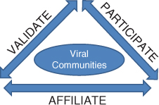
- 3 Pillars of Sociability – a social psychology concept that humans have a need to affiliate, participate, and be validated by others, social networking sites allow people to do this online

Affiliation
- 1st step
- Ensure that users want to be affiliated with your group
- Underlying psychological driver: the need to belong
- Trigger in your target user the desire to be affiliated with your site
- Figure out where your target user congregates and go to them
- Explains the massive fragmentation and specialization that is now occurring in social media sites

Participation
- Once new users have made the leap to wanting to join your site, you must help them understand the rules of participation
- Every group has both spoken and unspoken rules
- There are more subtle codes in groups
- Effective community managers must find wats to help make participation socially safe
- Invitational Design – most successful social networking sites use this method to allow users to welcome new people into the group and make it safe for them to learn and master the norms of the community
- The best sites encourage play and discovery and make the site design intuitive

Validation
- How to validate the user’s ongoing social experience, thereby constantly reinforcing the social utility of your website
- Each user has a different level of social comfort, involvement, and confidence

Design and Usability
- Esthetic and usability are critical components to building a successful interactive media site
- A site has to look good and be attractive to users, while also functioning well and being intuitively obvious to users
- Social Transparency – the principle that states that a site should mimic real-life social interactions, be attractive, and be easy to use
- the social elements of your technology design must intuitively map to the same ways that the social interactions take place off line
- if you make it easy to navigate, people will use it; if you don’t, they won’t
- Close working relationships between developers and designers need to be established to help each discipline maximize its contribution during the site development phase
- Companies can no longer afford to code first and then visually integrate good design
- best sites do both concurrently wand rapidly
- Successful sites also normally employ a minimalist design perspective that simply says that everything must matter and be just a short click away

Legal and Ethical Framework for Social Media
- The same legislations that applies to off-line advertising and competitions will apply to online competitions in whichever jurisdiction you operate in
- Unique laws and regulations apply when your social media involve children specifically or being a “minor”
- Most jurisdiction have some form of industry self-regulation around advertising in particular
- One principle of privacy law that is almost universally found in various jurisdictions in the notion of “informed consent:
- collect information only when it’s required and for a specific purpose
- use the information only for the purpose it was collected for initially
- inform the user of the privacy policies and codes that apply in advance of collection
- ensure there is a clear and unambiguous agreement from the user for the collection

Technology Implications and Costs
- When you think about social computing websites from a technology perspective, several obvious issues arise:
- sheer cost of accumulating and storing all of this often multimedia intense content
- Running a site oriented toward interactive media requires significant bandwidth and massive amounts of storage to keep it all instantly available and properly tagged and indexed
- Web 2.0 sites are more expensive to create and run than traditional websites
- Compression Technologies – technologies that help reduce the costs of storage and transmission of material on the Internet
- Developers who know how to code and implement systems that efficiently handle large amounts of information are in demand

Ignorance is NOT Bliss
- The same costs associated with hosting a social website are involved in its use
- Limiting social media usage within an organization is seen by many experts as an unfortunate stance that has several potentially negative consequences:
- about company’s corporate culture (lacks trust in employees)
- fails to recognize the way in which work is viewed as an ongoing activity to be woven into a 24 hour period
- fail to recognize multi-tasking as norm
- plain ignorant
- limiting employee’s exposure to new technologies doesn’t make business sense
- many employees will find a way to get around the ban and access the sites anyway

User Generated Content
- An essential ingredient that most experts agree is fundamental to most social media applications is the concept of user-generated content
- True social sites focus on providing the context in which users generate content themselves, rather than providing the actual content
- Participants in social media sites must register, identify themselves, and decide how to present themselves
- Good psychology suggests that before you affiliate with a group, you must discover and trust its social motives and intentions
- Participating Identity – the identity social media users create that demonstrates their willingness to participate in the site and allows them to create and post content
- Self-Regulating Community – an online community where members report conduct they feel is outside the group norms to a moderator who is responsible for drawing the inappropriate behavior to the attention of the member or removing or restricting the member’s privileges

Finding Content
- To make your own content useful to other users, you must label or tag it
- Tagging – a way to make content useful to other users that involves associating keywords with the content to make it searchable so other users can locate it and interact with it
- Folksonomy – a cloud tag derived through collaborative tagging and comparing and coalescing how other users tag the same or similar content
- Viral Social Interactions – when something that is funny, unusual, shocking, interesting, or newsworthy almost instantly spreads online from its origins to nearly every corner of the world

User Generated Content and Brand Risk
- Having something good about your business go viral would be wonderful
- Schadenfreude – drawing happiness from others’ misery or misfortune
- Online Social Strategy – a strategy adopted by companies that are using social media to their advantage. Part of this strategy needs to address the risks of undertaking any kind of online social campaign that might backfire
- Companies need to make sure they monitor the online messages being posted about their enterprise or organization
- Mashup – an increasingly popular use of social media where users re-combine 2 or more ads, websites, or other digital marketing materials from a company to create a new ad, website, or marketing message
- Brandstorm – a situation where a traditional brand faces an online storm of negative publicity that can quite literally damage its value overnight
- Indirect messages, whether based on fact or fiction, are increasingly more potent than any equivalent direct message from the company itself, and this can put brands at risk

Search Engine Optimization (SEO) on Social Sites
- The practice by which websites streamline their code and emphasize keywords and concepts that are relevant to their industry or internal goals
- By enacting SEO techniques on a regular basis, websites are able to guarantee that search engines will position their content higher in search results
- As you socially enable your site, users become a more dominant force in the creation of and tagging of content on your site
- Site Audit – a strategy of search engine optimization where a site is reviewed to see if there are areas where the re-positioning of pages or content, changes in tagging consistency or weighting, or other types of changes can help increase your site’s search engine ranking

Creating Business Utility Using Social Media Tools and E-Marketing
- Direct Marketing – marketing messages that are sent directly form the company to the consumer
- moved companies into a new phase of computer enabled marketing where the 2 disciplines began to work more closely in tandem
- creation of mostly passive websites
- slow beginning of basic online marketing techniques such as email lists
- Consumers began to realize the power of interacting online, and began to demand that companies operate with a view to how they wanted top access product and service information and buy online when and how they wanted
- Indirect Sources of Information – communication about products that do not come directly from the company, such as product and ranking review sites, word of mouth, and so on

Harnessing the Power of Social Media
- Platform Plays – general purpose social media sites that attempt to appeal to very broad audiences
- Micro Markets – purpose built social media sites (forums or groups) designed to meet a specific need that emerge as a market matures
- Media Transparency – ensuring that your brand and advertising message are coherent and consistent

The Social and Business Impacts of Web 2.0
- As social patterns change and people spend more time online, they are not seeing or responding to advertising the way they used to
- The Internet changed everything
- people stop buying and reading newspaper
- listen to Internet and satellite radio

Social Business Models

