Social Psychology
Attitudes (Chapter 7)

Components of Attitudes;
- Affect
- Cognition
- Behaviour

Dual attitudes
- Automatic attitudes
  - (innate?)
  - Gut level evaluation formed by reflex
- Deliberate attitude
  - Reflective, formed after deliberation

Attitude measurement
- Self-report measures
  - Single-item measures
    - Single-item rating scales (i.e. favourability scale)
    - Single-item scales with analogical formats (i.e. opinion thermometer)
- Attitude scales
  - Likert ratings
  - Osgood semantic differential

Problems with self-report:
- Social desirability/norms
- Lack of awareness/access
- Lack of knowledge about a topic

Bogus Pipeline: If participants are told they are being monitored by a lie detector, they are more likely to give truthful answers

Observational measures:
- Overt behaviour
- Nonverbal cues
- Physiological reactions
  - Galvanic skin response (GSR)
    - Skin conductance; bidirectional
    - We just know that they react strongly to something, so it measures an affective reaction, but cannot determine direction
  - Facial electromyograph (EMG)
    - Muscle activity
    - Positive attitude: increased activity in the zygomatic muscles
    - Negative attitude: increased activity in the corrugator muscles
    - This activity cannot be measured via the naked eye but can through electrodes placed in the right positions

Implicit measures:
- Work stem completions
  - Sometimes we can draw inferences from how people complete work fragments
- Stroop tasks
  - Colours and words (the word red being the colour blue – RED)
  - When a concept is activated, it is difficult to think of something other than what is activated – will take longer to identify ANGER if person is not angry
- IAT
  - Look in textbook bc I am confused
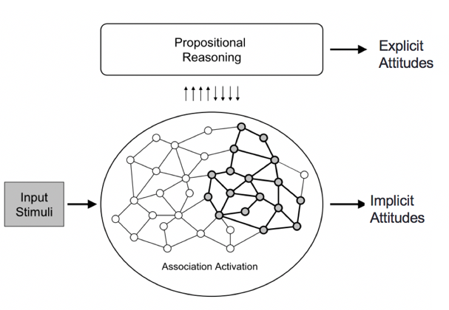
https://implicit.harvard.edu/implicit/demo/

Attitude towards self
- Explicitly positive / implicitly negative = defensive self-esteem
- Explicitly positive / implicitly positive = stable self-esteem

Attitudes and Behaviour
- When and how does our attitude determine our behaviour?

The theory of Planned Behaviour (Ajzen and Fishback, 1980)

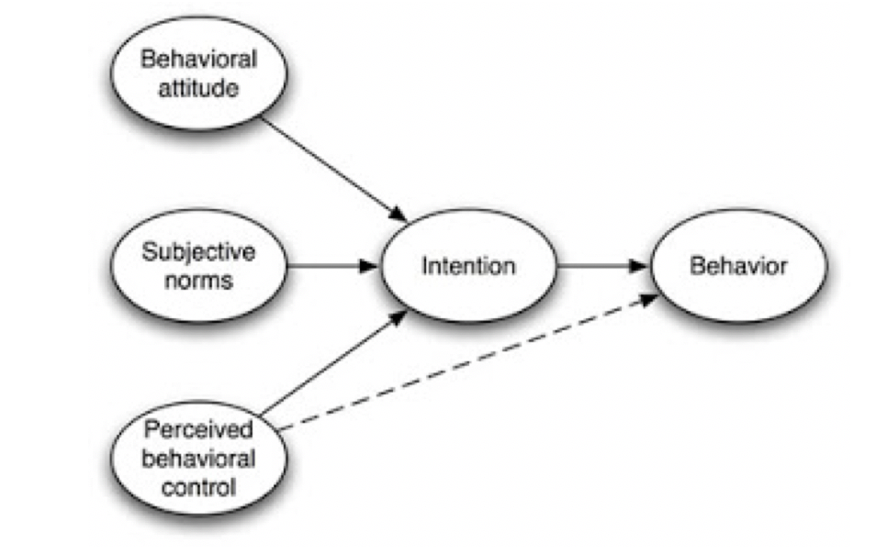

Moderators of Attitude-Behaviour Relation
- Minimize other influences on behaviour
  - Competing pressures
    - Additional factors such as social norms, habits, other attitudes, personality characteristics, situational factors, etc. must also be taken into consideration
  - Multiple-act criteria
    - A person’s attitude towards an object doesn’t need to be related to any single behaviour that may be performed with respect to the object
    - Should be related to the overall pattern of their behaviours
  - Principle of aggregation (i.e. environment)
    - A set of multiple measurements is a more stable and representative estimator than any single measurement
- Measurement of attitude
  - Attitudes specific to behaviour (i.e. use of birth control pill)
- Attitude strength/accessibility
  - Strength may include intensity, knowledge, importance
  - Often defined in terms of accessibility
  - Greater accessibility related to;
    - Direct experience
    - Degree to which one has participated in behavioural activities related to an object
    - Personal importance
    - Degree to which one believes that an attitude object is salient to one’s personal needs
    - Self-awareness
- Individual differences
  - The self-monitoring scale
    - High self-monitors aim to be the right person for the situation
    - Low self-monitors aim to be themselves in each situation
    - Low self-monitors exhibit behaviour that more strongly reflects their attitudes

Subjective norms
- beliefs about other people’s attitudes
- Could include scripts about how appropriate behaviour is in that situation
- More influential for high social desirability behaviours
- More influential for people we care about

Perceived behavioural control
- The ease with which people believe they can perform the behaviour

Cognitive dissonance theory
Common sources;
      - Attitude-behaviour discrepancies
      - Decision making
Focal cognition;
I smoke

Dissonant cognition;
Smoking causes cancer

Dissonant cognition;
I don’t want to get cancer

Avenues of dissonance reduction
- Decrease dissonant cognitions
  - Change behaviour
  - Change attitudes
- Increase consonant cognitions
  - i.e. acquire new information
- Minimize importance
  - i.e. smoking doesn’t really even give you cancer ; I don’t care if I get cancer ; smoking relaxes me
- Indirect tactics
  - Self-affirmation
  - Distraction; relaxation

Research on cognitive dissonance
1 . Induced compliance (insufficient justification)
- (Festinger and Carlsmith, 1959)
- Attitude-discrepant behaviour
- Perceived free choice
- Insufficient justification
  - Get paid insufficient amounts for a behaviour that goes against your attitude
- Relation to the “over justification effect”
  - Get paid for something you already like
2 . Post-decision dissonance: Justifying difficult decisions
- (Brehm, 1956) – “consumer testing” study, women rated appliances
- Post decision dissonance at “post-time”
3 . Effort justification: Coming to like what we suffer for
- Initiation rites
- (Aronson and Mills, 1959)
- Had to say embarrassing things in a group as a hazing

Over-justification effect,
external justification for activity may undermine intrinsic motivation

Midterm #1 – Social Psychology
38 multiple choice questions with 4 possible answers each
4 short answer questions (12 points)
Three types of questions
- Test knowledge taught in class
- Test understanding of concepts
- Tests ability to distinguish between concepts or apply knowledge
Text: Chapter 1, 3, 5, 6, 7

Material not covered on midterm;
- Syllabus questions
- History of social psych
- Research that has not been replicated or concepts that the discipline is currently unsure about
- Facial feedback hypothesis and corresponding studies

