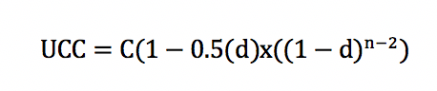
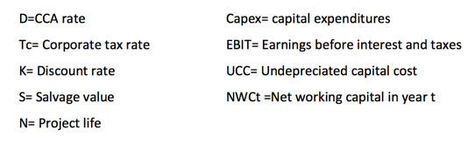
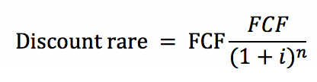
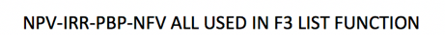
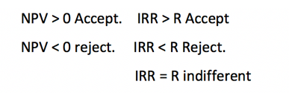
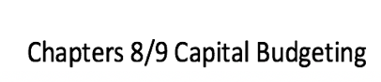
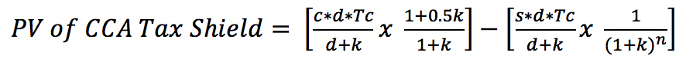
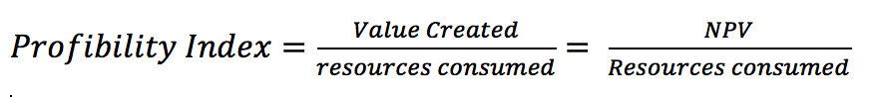
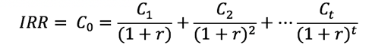
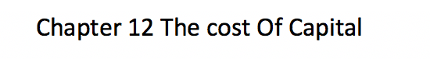
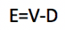
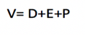
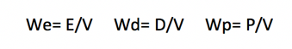
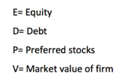
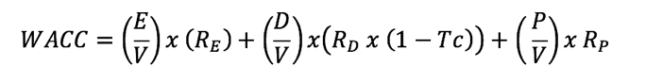
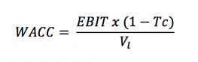
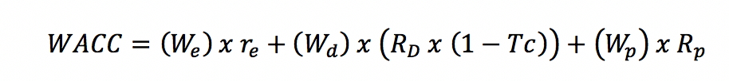
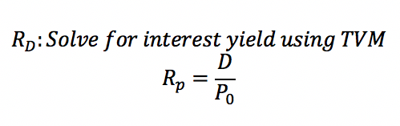
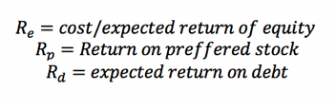
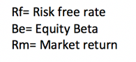
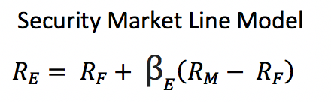
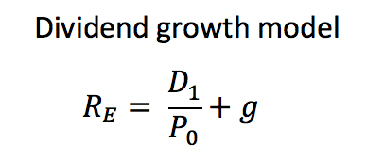
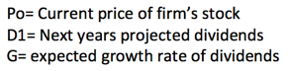
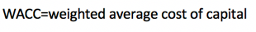
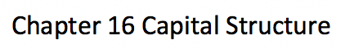
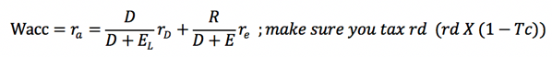
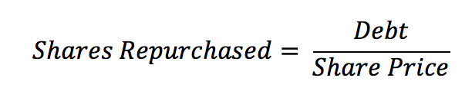
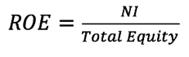
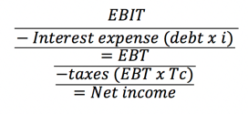
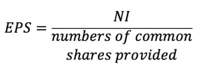
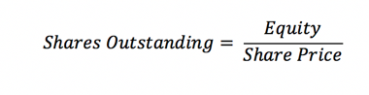
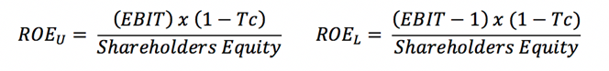
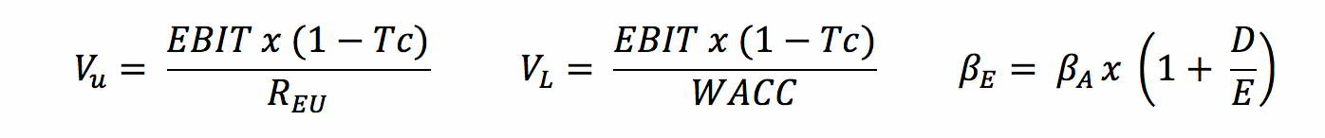
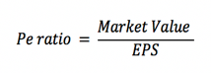
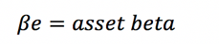
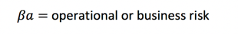
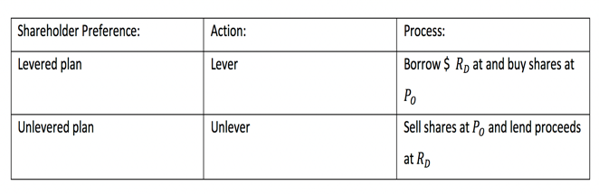
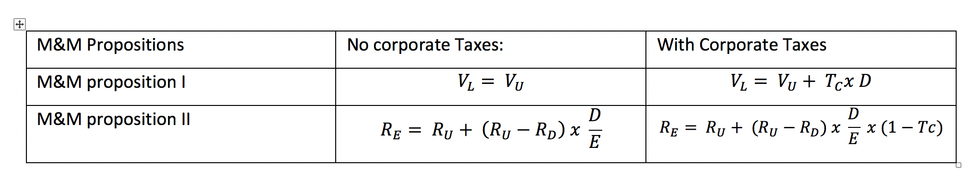

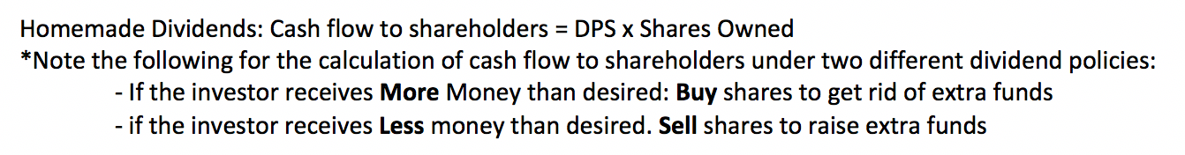
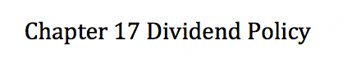

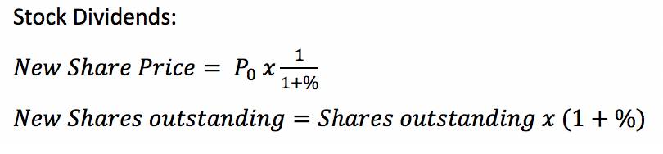
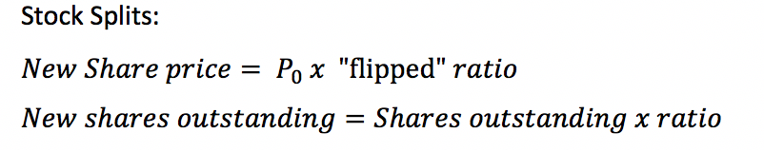

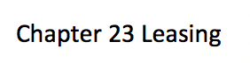

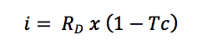

***AFTER TAX IS CALCULATED BY C (COST, RATE OF COST. CAN BE NUMBER OR PERCENT) X (1-Tc) c -(1-Tc)
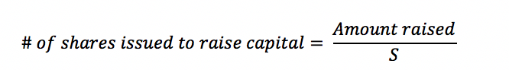
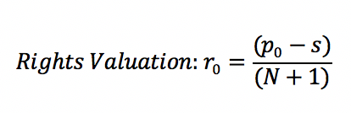
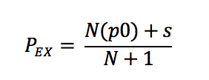
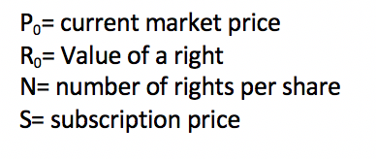
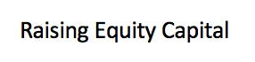
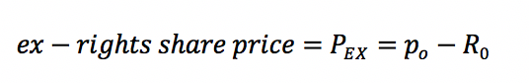
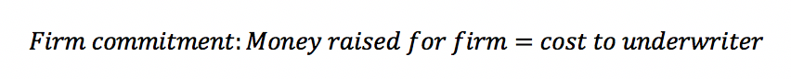

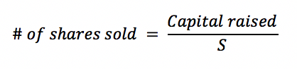
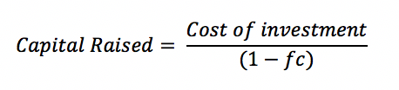
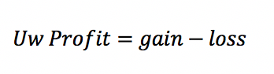
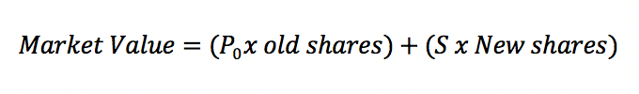

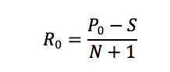
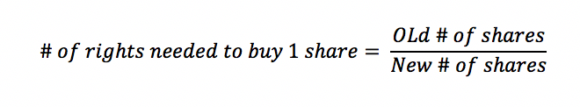

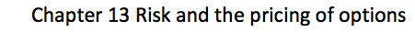

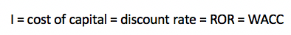
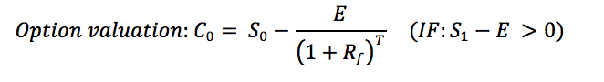

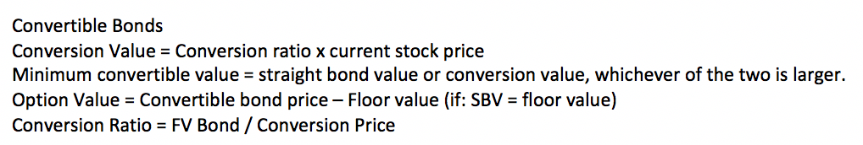
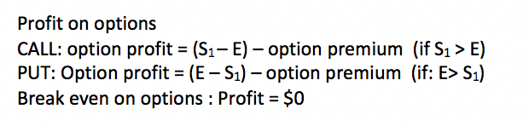

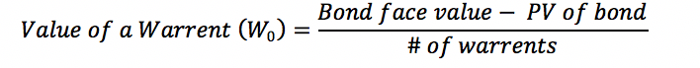
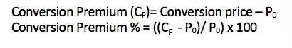

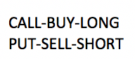
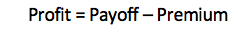
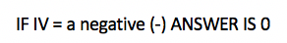
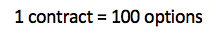

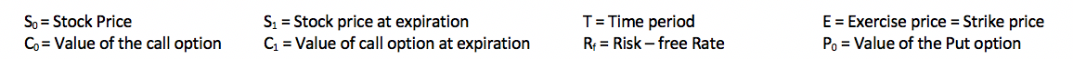

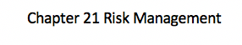

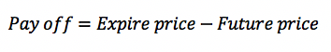

Chapter8/9. A merchandising company is considering opening a new retail store. The initial investment will be 600k and the expected operating cash flow is expected to be 120k for the first 4 years followed by 240k for the next 3 years. The corporate tax rate is 30% . if the required rate of return is 8%. Q1 what is the discounted pay-back period? Answer Step 1: list 1=-600k 2…5=120k 6…8=240k Step 2: TVM F3- i=8%. PBP=5.26
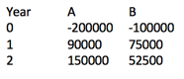
Chapter8/9. A firm is evaluating two mutually-exclusive projects, A and B. the following data has been provided for analysis to the right. The firms WACC is 15%. Q1.What is the cross over rate for the projects? Answer. Step 1: combine cash flow into list (A-B) Step 2: TVM-F3- i=? solve for IRR = 6.53%
Chapter 8/9. A new project requires an initial investment of $50000 and will generate after-tax cash flows of $7000 per year for the following 8 years. What is the IRR of the project? List. 1= -50000, 2=7000…8=7000. TVM F3. I=0. IRR
Chapter 8/9. Sunning inc is considering buying a six-year project to improve its production efficiency. Buying a new assembly machine for 500k is estimated to result in 135k in annual pre-tax cost savings. The machine has a CCA rate of 30% per year, and it will have a salvage value of 50k. the machine also requires initial inventory of 20k which will be recovered at the end of the project. If the tax rate is 40% and the discount rate is 10%. Q1 What is the PV of the CCA tax shield? Answer: Use PVCATTS formula (c=500k,d=30%,t=40%,k=0.1,s=50k,n=6) = 134714. Q2. What is the NPV of the machine purchase? Answer: Step 1. PVCATTS formula to solve for 134714 or from previous question. Than list function. 1= -500000 + 134714 – 20000 = -38526. 2..6= 135k x 1-0.4 = 81000 7= 81000+50000+20000= 151000. TVM – F3- I=10%. NPV= 7004. Q2. What is the CCA claimed during the first 2 years of the project?
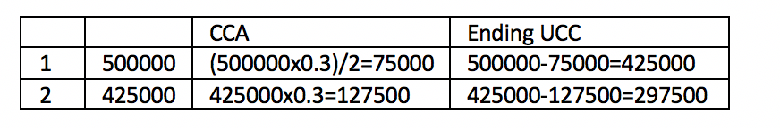
Answer 500000 x 0.3 / 2 = 75000. 500000 – 75000 = 425000.
425000 x 0.3 = 127500. 425000 – 127500 = 297500.

Chapter 8/9 A manufacturing firm wants to invest in a new project which involves the purchase of a new machine to increase its production efficiency. This machine has an initial cost of 100k and there will be a 50k install charge. The machine is expected to operate for 3 years and will have a salvage value of 50k. the firm’s sales will be 90k and costs are 45k. the firms tax rate is 40% and the cost of capital is 10%. Q1What is the present value of the operating cash flow. Ignore CCA Answer step 1. OCF formula to solve for 27k. ((10000x9)-(10000x2+25000) x (1-0.4) step 2. TVM f2 n=3, i=10, pv? Pmt=-27k fv=0. Pv =67145. Q2 what is the NPV? Answer list. 1=-100k + -50k. 2/3=27k. 4= 50k+27k. TVM F3 i=10% NPV=-45289 therefor reject
Chapter 12. the common shares of MILL industries has a beta of 1.10. the most recent dividend on the firm’s stock was $2.20 per share and the dividends are expected to grow at 5% per year indefinitely. There are 5,000,000 common shares outstanding with a book value of $28.50 per share. Is the current market value of MILL being 160mil, Q1 what’s the firms cost of equity? Answer. Step 1 calc dividend (D1). Dividend growth rate = $2.20 x (1+0.5)=$2.31. Step 2. Calc current price of firm’s stock(p0). 160mil/5mil = $32. Step 3 solve for cost of equity Dividend growth model formula = 2.31/32 + 0.05 = 12.22%
Chapter 12. the disc company has 1mil common shares outstanding. The book value per share is $40 and the beta of the company’s stock is 1.20. the firm has 20k bonds outstanding. The common stock currently sells for $60 per share. The bonds were issued at par and there are 20 years left to maturity. The bonds are currently selling at 90 and pay an annual coupon rate of 10%. The company also has 300k 8% preferred share outstanding which pay annual dividends. The market price of each preferred share is $120. The risk-free rate is 3% and the expected return on the market is 9%. Disc has a corporate tax rate of 40%. Q1. What is the cost of equity for DISC? Answer. Security beta line model formula to solve for 1.02 or 10.2%. Q2 what is the Required rate of return on the preferred shares of DISC? Answer RRR formula to solve for 0.0667 or 6.67%. Q3. What proportion of DISCS capital structure is financed with common equity? Answer. WACC Formula to solve for 52.6%
Chapter 12. the Cress corporation issued 50000 12-year 7.8% coupon bonds two years ago. The bonds are currently selling for 108. If the tax rate is 35% Q1 what is the after-tax cost of debt for the firm? Answer. First solve for PV. “quote”/100 x par. 108/100 x 100 = 1080. Step 2: Solve for pmt. 7.8% x PAR = 78. Coupon bond semi-annual so 78/2 = 39. Step 3 use F2 solve for i. n = 12-2=10x2=20. I=? pv = -1080, pmt= 39, fv= 1000. I=6.69. step 4. Calculate after tax, 0.0669 x (1-0.35) = 4.35%
Chapter12 Tran limited has 210000 common shares of stock currently outstanding. The market price is $36 per share. Today the firm paid a dividend of 1.593 per share. The dividend is expected to grow at 4% the firm also has debt comprising of 6000 outstanding bonds. The bonds pay a 7% coupon and each has a $1000 face value. The bonds pay interest annually and mature in 4.89 years. The bonds are selling for 100. The company’s tax rate is 34% Q1. What is trans cost of equity capital? Answer: Step 1: solve for d1 = 1.593x1.04=1.6567 Step2: dividend growth model formula. = )1.6567/36 )+0.04 = 6.602% Q2 What is trans after tax cost of debt? Answer: Step 1 TVM-F2 n=4.89,i=?,pv=-1000, pmt=70, fv = 1000, i=7% Step 2: rd x (1-tc) = 0.07 x (1-0.34) = 4.62% Q3. What is the WACC? Answer: Wacc formula. E= 36 x 210000 = 7.56m. D = 1000 x 6000 = 6m. V = 7.56 +6 = 13.56.
Chapter 12 ABC has a target debt-equity ratio of 1.50. its WACC is 12% and the tax rate is 40%. ABC’s cost of equity is 18% Q1. What is ABC pre-tax cost of debt
Answer: Wacc formula to solve for rd. 0.12 = ((1/2.5)x0.18)+(1.5/2.5)x rd(1-0.4). --- 0.12 = 0.72 + 0.36rd.--- 0.048/0.36 = rd. rd= 13.33%
Chapter 23 a science-based company is considering leasing a new electronic microscope. This is considered “high tech” equipment which would costs 2mil and qualifies for a 30% CCA rate for tax purposes. The lease term would be four years with payments of 600k per year. It is expected that by the end of the lease, the technology in the equipment would be obsolete and therefore it would not have any value after that time. The company has a cost of equity of 12%, a tax rate of 33% and can borrow funds at 8%.Q1 what is the correct discount rate to use when calculating the NAL for the equipment? Answer. Use formula for i. 0.08 x 1-0.33 = 5.36%. Q2 what is the present value of the after-tax lease payments? Answer BED MODE> TVM. F2. N=4, i=5.36 pv=? Pmt= 600000(1-0.33) fv=0. Pv= 1489422.56. Q3 what is the NAL for the equipment? Answer Cost- PVCATTS- pv of salvage – pv of lease pmts. 2mil-545711 – 0 – 1489402.56 = $-35113 Q4 what is the break-even lease payment. Answer NAL=0=2mil-pvcatts (545711). Solve for x. 2mil-545711 = 1454289. Step 2. N=4 i=5.36 pv=1454289 pmt? Fv=0. PMT =392522. Step 3 apply tax. 393522/1-0.33 = 585853
Chapter 23 Axon gas inc. is deciding to lease or buy a new refinery system for oil exploration. The system will provide 600k in cost savings each year for the next 5 years. The system has a capital cost of 5.5m and the company’s tax rate is 34%. The system will be in a CCA class with a rate of 25%. It is expected that the systems salvage value at the end of the lease will be 500k. the lease contract calls for annual payments of 1240000 per year and the company’s cost of borrowing is 9%. Q1 what is the NAL. Should the firm buy or sell? Answer NAL formula. Find values for formula. Step one solve for discount rate or i. formula above. 0.09x(1-0.34) =0.0594 Step 2 PVcatts to solve for 1236992. Step 3 solve pv of salvage. TVM-f2-END- n=5,i=5.94 pv=? Pmt=0 fv=500000, pv=374688 Step 4 Solve for pv after tax payments. TVM-F2-BEG n=5,i=5,94,pv=? Pmt=818400 fv=0 pv=3658142. (payments is calculated by payments x tax rate). Step 5 plug into NAL formula. 5500000-1236992-374688-3658142=230178. Q2: What would the lease payments have to be if Axon was indifferent to leasing or buying the equipment? Answer Step 1: 0=5.5m-1236992.374688-x, x = 3888320. Step 2 TVM-F2-BEG n=5,i=5.94,pv=3888320 pmt=? Fv=0 pmt=869865
Chapter 16. Microlink (ML) is a non-profit organization and does not pay taxes. The company has no debt and there are currently 4mil shares outstanding. The current share price is $2.50. the firms senior management is proposing a capital restructuring where 30% of the value of the firm would be borrowed and proceeds would be repurchase equity. Microlink has an EBIT of 1mil and cost of debt is 8%. What will be the EPS of the firm if the proposal is implemented? Answer Step 1. Ebit = 1mil – interest. Value = 2.5 x 4mil. Debt = 0.3x value. Interest= debt x 0.08. EBIT=1mil-240k=760k. no taxes NI = 760000 Step 2. 4mil – (3mil/2.5) = 1.2 Step 3. 4mil – 1.2 mil = 2.8 mil. Step 4 760000/2.8mil = 0.2714. Q2 what is the break-even EBIT between the current and proposed capital structure. Answer ** means calc ebit so that EPSl=EPSu. Ebit/4mil = (ebit-240k)/2.8mil. 2.8milEBIT = 4milEBIT-(9.6 x 10^11). -1.2milEBIT=-9.6x10^11. EBIT = 800000 Q3. Assuming Microlink pays a tax rate of 35%, what is the break even EPS? Answer: Ebit to solve for NI =800000-800000(0.35)=520000. Step 2: EPS formula 520000/4000000 = 0.13 share
Chapter16 Gem stones INC (GSI) is currently generates perpetual EBIT of 1mil per year. The unlevered cost of capital is 12%. The firm has 2mil in par debt at a cost of 8%. There are currently 500k shares outstanding in the firm and the corporate tax rate is 40%. Assume no personal taxes or bankruptcy costs. Q1.What would be the value of the GSI if it had no debt in its capital structure? Answer Vu. EBIT x (1-tc) / ru. 1mil x (1-0.4) / 0.12 = 5mil. Q2 what is the current value of the GSI? Answer M&M prop 1 with taxes. 5mil +( 0.4 x 2mil) = 5.8 mil. Q3 what is the cost of equity for GSI? Answer:M&M prop 2 with taxes. 0.12+(0.12-0.08) x (2mil/3.8mil) x (1-0.4) = 13.26 Q4 what is the weighted average cost of capital for the GSI? Answer: use WACC formula. (3.8m/5.8m) x 0.1326 + (2m/5.8m) x (0.08 x (1-0.4)) = 10.34% OR alternate formula. EBIT(1-Tc)/Vl. 1mil x (1-0.4) / 5.8 mil = 10.34%
Chapter 17 Hazel in is expected to pay cash dividends of $100 per share at the end of one year and $100 per share at the end of the second year. The dividend at the end of the second year is a liquidating dividend and the firm will cease to exist after that time. Investors require a 12% return on the stock. There are currently 100 shares outstanding. The firm is considering an alternative dividend policy that will pay out $120 per share in cash dividends at the end of the first year. Under this alternative plan, any shortfall in funds will be raised by issuing new equity. There are no taxes, no transaction costs, and no other market imperfections. Q1What will be hazels stock price after the alternate dividend plan is adopted? Answer TVM-F2- n=n, I =12, pv=? Pmt=100 fv=0. Pv=169.01 Q2 under the alternate dividend plan what is the cash dividend Hazel will pay to the shareholders at the end of the second year? Answer 169.01 = (120/ (1+0.12)^1) + (D2/ (1+0.12)^2). 169.01 = 107.1429 + (D2/ 1.2544). 169.01 – 107.14 = D2/ 1.2544. 61.87= D2/1.2544. D2= 77.61
Chapter17 Scrub inc has determined that due to market conditions, the firm will only be able to operate for the next two years. Scrub is currently an all-equity firm and will pay a cash dividend of 8.80 per share at the end of the nest two years followed by a liquidating dividend of 16.94 per share at the end of the second year. There are 25000 shares outstanding and you currently hold 100 shares. The required return on the firm’s stock is 10%. Ignore taxes and market imperfections. Q1 if you were to use homemade dividends to generate equal dividends over the next wo years, how many shares would you need to buy or sell in your first year? Answer Step 1: List- 1=0,2=8.8,3=16.94. Step 2: TVM-Fs-1=10% NPV=22. Step 3 TVM-F2- n=2 i=10 pv=-22 pmt=? Fv=0 pmt=12.67 Step 4. Decide to sell at t=1, investors want more cash flow Step5: 12.67-8.8=3.87 Step6: 3.87(100)=387 Step 7: TVM-F2 n=1 1=10 pv=? Pmt=0 fv=16.94 pv=15.40 Step8:387/15.4=25.19
Chapter 14 The X-sound company is proposing a rights offering. Currently there are 240000 shares outstanding at the market price of $80 per share. If the financial manager has determined that there will be 60000 new shares issued at $60 Q1what will be the new market value of X-sound? Answer. Market value formula. =(80x240000)+(60 x 60000), = 22.8M
Chapter 14 the Clint corporation has announced a-rights offering to raise 60m for a new investment project. Currently there are 4800000 shares outstanding at 60 per shares. The subscription price has been set at 50 per share. Q1 how many shares must be sold to raise the required capital? Answer Use # of shares formula. 60 / 50 = 1200000 Q2 how many rights will be needed to buy a new share? Answer # of rights formula. 4800000/1200000= 4.0 rights Q3 What is the value of a right? Answer Value formula = 60-50 / 4+1 = $2 Q4 what is the ex-rights share price Answer use PEX formula. Either one. 60-2=58.
Chapter 14 a firm needs to raise 20m to finance a new expansion of their facility. New equipment will be sold via a right offering with a subscription price of $28 per share. If the firms underwriters will charge a spread of 8% Q1 how many shares need to be sold? Answer Step 1: Capital raised formula = 20m / (1-0.08) = 21739130.43. Step 2: # of shares sold formula = 21739130.43/28 = 776397.5154 = 776398
Chapter 14 The apple Co. and Orange Co. have both announced IPO’s on their stock at 30 per share. One of these IPO’s is undervalued by 9 and the other IPO is overvalued by 5 per share but you have no way of determining which is under or overpriced. You plan to purchase 1000 shares of each firm. If an issue is underpriced it will need to be rationalized by the market and you will receive 40% of your order. Q1 what will be your expected profit from this investment? Answer Expected profit formula. = (1000x0)0.4-(1000x5) = 1400
Chapter 13 You purchased a call option for $3.50. the call option has an exercise price of $13.25. at expiration, the stock price was $21.45 per share. What was your profit/loss? Answer call option profit formula. (21.45-13.25)-3.5 =4.7 Q2 you sold the call option Answer -21.45-13.25 + 3.5 = -4.7
Chapter 13 A share of TFL corp. is currently trading for $7. The stock does not pay dividends. A European call option with a maturity of 6 months and a strike price of $8 is currently trading at $0.75 while the corresponding put option is currently trading at $1.50. ignore the taxes. Q1 You are long on 2 call options and long on 1 put option. If the stock price at maturity is $8 per share, what is your profit? Answer Call option s₁ = E .At the money. Step 1: Call option profit formula. (8-8)-0.75 = -0.75. 2 options so -0.75 x 2 = -1.50. Step 2 Put option profit formula (8-8)-1.50 = -1.50. Add profits. (-1.50 + -1.50) = -3.00. Q2 the option will be “out of the money” when: Answer The stock price is less than $8.00 Q3. What is the intrinsic value and the time value of the put option, respectively? Answer IV formula for Call = 8 – 7 = 1. TV formula for the call = 1.50 – 1 = 0.50
Chapter 13 A $1000 face value bond with 30 warrants is currently selling at par. The bond matures in 15 years and pays coupons annually at 11%. Each warrant allows the holder to purchase two shares of stock. Bonds without warrants have a market yield of 12%. Q1 what is the value of one warrant? Answer Step 1 (pv of a bond) TVM F2 n=15 , i=12, pv=?, pmt=110 fv=1000 pv=931.89. Step 2 Warrant value formula. 1000-931.89/30 = 2.27
Chapter 13 A new semi- Annual 8% convertible bond has a conversion price of $50 per share. The yield on non-convertible bonds is 9% and there are 20 years to maturity on the bond. If the bond current market price is $55 per share, Q1what is the minimum value of the convertible bond? Answer Step 1 – Conversion ratio – 1000 / 50 = 20 Step 2 conversion value formula. 20 x 55 = 1100
Chapter 13 A convertible bond can be exchanged for common shares of an issuing firm at a price of $5 per share. The convertible has a coupon rate of 5% which is paid annually and there are 5 years to maturity. Similar non-convertible bonds of equivalent risk are currently priced to yield 8% per year. The current share price of the firm’s common stock is $4.50 Q1 what is the conversion premium? Answer Conversion premium formula, 5-4.5 = 0.50. Q2 what is the minimum value of the convertible bond? Answer Conversion value formula. (1000/5) x 4.5 = 900. Q3 if the convertible is trading in the market for $959, what is the value of the option? Answer Option value formula. 959-900 = 59.
Chapter 13there have been many rumours about a new firm called Spot Inc. this speculation is causing the stock price to be quite volatile. Given this situation, you decide to buy a one-month put option contract and a one-month call option contract on Spot stock with an exercise price of $15. You purchased the call at a quoted price of $0.20 and you purchased the put at a quoted price of $2.10. Q1 what will be your total profit or loss on these options positions if the stock price is $4 on the day both options expire? Answer Call s₁ < E out of money. Payoff = 0. Profit =0-0.20 =-0.2 x 100 = - 20. Step 2 Put E > S₁ in the money. Payoff = 15-4 = 11. Profit = 11-2.10 = 8.90 x 100 = 890. Total profit = 890 – 20 = 870
Chapter 21 A future contract is available on cocoa and consists of 10 metric tons of cocoa for each contract. If you purchased a September 2014 futures contract with a futures price of $1500 per metric ton. Q1 what would be your profit / loss if the expiration price is $1550 per metric ton? Answer Payoff formula = 1550 – 1500 = 50 per ton. Apply the metric tons and # of contracts = 50 x 10 x 1 = $500
Chapter 21 Macey grows and exports cocoa. Her latest crop was partially ruined in a storm, so now she needs to purchase 20 tons of cocoa in three months to meet her prior contractual obligations. Macey wants to hedge against price changes in the commodity market. Each futures contract comprises of 10 metric tons of cocoa. The current quote for a futures contract is 1447 per ton. Q1Accordingly Macey should do what? Answer Buy 2 contracts. Total value of contracts = 1447 x 2 = 2894. 2894 x 10 = $28940
Chapter 21 Eve sold 10 future contracts on copper at a price of $0.8063 per pound. Contracts on copper are set at $25000 pounds. Q1 what is the amount of eve’s profit / loss if the price on the maturity date is $0.8104? Answer Sell formula = (10) (25000) x (0.8063-0.8104) = -1025 sold for loss.
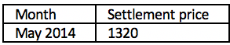
Chapter 21 On February 20th you decided to sell two futures contracts. The details regarding the contract are provided in the chart beside. If the settlement price in may 2014 was $1435 per ton Q1 what was the amount of profit earned from this trade? Answer Sell Formula = (2)(10) x (1320-1435) = -2300. Sold for a loss.
Chapter 24

