Chapter 1: Introducing Management

1.1 Describe the current workplace environment in Canada

Working Today
Talent
-People and their talents are the ultimate foundations of organizational performance
Intellectual Capital: the collective brainpower or shared knowledge of a workforce that can be used to create value.
Intellectual capital = competency x commitment

Todays workplaces are dominated by knowledge workers: someone whose mind is a critical asset to employers

Diversity
Workforce Diversity: describes differences among workers in gender, race, age, ethnicity, religion, sexual orientation, and able-bodiedness.

Prejudice: the display of negative, irrational attitudes toward members of diverse populations – causes diversity bias
Discrimination: actively denies minority members the full benefits of organizational membership
Prejudice -----> Active Discrimination
Glass ceiling effect: an invisible barrier limiting career advancement of women and minorities

Globalization
Globalization: the worldwide interdependence of resource flows, product markets, and business competition
-Countries and people are increasingly interconnected in news, employment markets, business dealings etc.
-Employees have to worry about being outsourced by workers in other countries at lower costs.
-Globalization offers both opportunities and challenges.

Technology:
-Constantly test our talents for better or worse.
-We live and work in a technology driven world dominated by instant messaging, social media, E-commerce, etc.
-Everything can be achieved virtually from running a business, sharing vital information, or holding meetings.
- Employers doing online searches on job applicants

Ethics
Ethics: set moral standards of what is “good” and “right” in one’s behavior.
-Commit a white-collar (financially motivated) crime and you will be punished.
- Ethics can be found in many parts of organizations such as
- Ethical leadership, respect for sustainable development of the natural environment
- Protection of consumers through product safety and fair human rights practices in production.

Careers:
-Can be tough to find first job as a graduate or when the economy is down
-Helps to utilize online job searches, social networking and to pursue internships.
-Should be willing to prosper in any of the 3 options: Independent contractor, Part-time temp or Full time core worker.
A portfolio worker: has up-to-date skills that allow job and career mobility

1.2 Identify the characteristics of an organization

Organizations
What is an organization?
Organization: a collection of people working together to achieve a common purpose
-Enables members to perform tasks beyond the reach of individual accomplishment.
-All organizations share the same purpose – provide goods or services to customers / clients

Organizations as Systems:
-Organizations are Open Systems: transforms resource inputs from the environment into product outputs.
-External environment is both the supplier of resources and the source of customers

Organizational Performance
-To perform well, organization must utilize its resources and serve its customers well.
Productivity: the quantity and quality of work performance, with resource utilization considered
Performance effectiveness: an output measure of task or goal accomplishment
Performance efficiency: an input measure of resource cost associated with goal accomplishment

Changing Nature of Organizations
Several ways in which organizations are changing in todays world:
- Emphasis on teamwork
- Importance of networking
- Focus on Speed
- Priorities on sustainability

1.3 Describe the dynamic forces that make up the general environment, who are the important organizational stakeholders, and what competitive advantage encompasses

Organizational Environment
Dynamic Forces and the General Environment
General Environment: composed of economic, legal-political, technological, and natural environment conditions
-The general environment of organizations consists of all external conditions that determine managerial decision making
- Economic Conditions --------------> Economic growth, unemployment rate, disposable income
- Legal – Political Environment ----> Laws and regulations, political trends
- Nature Environment ---------------> Recycling infrastructure, sustainability
- Technological Environment ------> IT systems, internet access
- Socio – Cultural Environment ----> Education system, health / nutrition values

Sustainable Business: both meets the needs of customers and protects the well-being of our natural environment
Sustainable Innovation: creates new products and production methods that have reduced environmental impact

Stakeholder and the Specific Environment:
Specific/Task Environment: includes the people and groups with whom an organization interacts
Stakeholders: persons, groups, and institutions directly affected by an organization
Value creation: the creation of value for and satisfying needs of stakeholders

Competitive Advantage
Strategic Positioning: occurs when an organization does different things or in different ways from its major competitors.
Competitive Advantage: allows an organization to deal with market and environmental forces better than its competitor
-If an organization does specific tasks extremely well they will have advantage in the market place known as comp. adv.
Competitive Advantage can be achieved through: lower costs, higher quality, better service, better flexibility.

Environmental Uncertainty
Environmental Uncertainty: a lack of complete information about the environment, makes decision-making harder.
- Difficult to analyze environment conditions and harder to deal with stakeholders needs.

Organizational Effectiveness
A common indicator of management success in dealing with complex and changing environments is:
- Organizational effectiveness: sustainable high performance in using resources to accomplish a mission
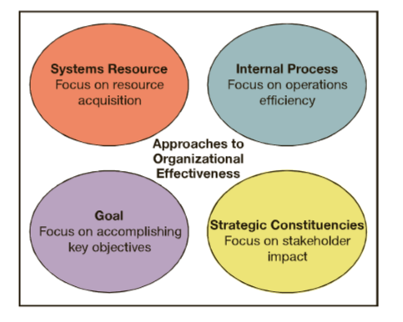

1.4 Identify who managers are and explain what they do

Managers in the New Workplace
What is a Manager?
Manager: a person who supports, activates, and is responsible for the work of others
-Responsible not just for their own work, but for the overall performance accomplishments of a team or department.

Levels of Managers
Top Managers: guide the performance of the organization as a whole or of one of its major parts
- Pay special attention to external environment, alert for long-run problems and opportunities
Middle Managers: Oversee the work of large departments or divisions
- Work with top managers/coordinate with peers to develop ‘nd implement action plans to accomplish objectives.
Team Leaders: Report to middle managers and supervise non-managerial workers
- Create building blocks for organizational performance

Department Head, Supervisor --------> Regional Manager, Plant Manager --------> Chief Executive, President

Types of Managers:
Line Managers: directly contribute to producing the organizations goods or services
Staff Managers: use special technical expertise to advise and support line workers
Functional Managers: responsible for one area such as finance or marketing
General Manager: responsible for complex, multifunctional units

Managerial Performance
Accountability: the requirement to show performance results to a supervisor
Effective Managers: successfully help others achieve both high performance and satisfaction in their work

Quality of Work Life (QWL): the overall quality of human experiences in the workplace
-Offers such things as fair pay, safe working conditions, room to grow and progress in career.

Changing Nature of Managerial Work
Upside-down pyramid: operating workers are at the top, serving customers, while managers are at the bottom.
-Managers at the bottom are not just to give orders, but to mobilize and deliver the support others need to do their jobs

1.5 Describe the management process and how managerial skills and competencies are learned

Functions of Management
Management is the process of planning, organizing, leading, and controlling the use of resources to accomplish goals.
-All managers are responsible for the four management functions:

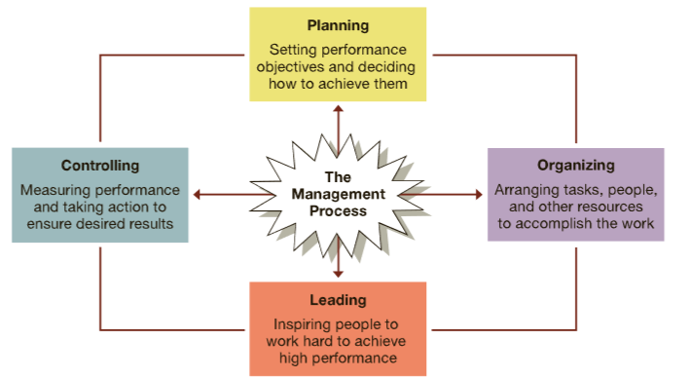

Managerial Agendas and Networks
Agenda Setting: Develops action priorities for accomplishing goals and plans
Networking: The process of creating positive relationships with people who can help advance agendas
Social Capital: A capacity to get things done with support and help of others

Essential Managerial Skills

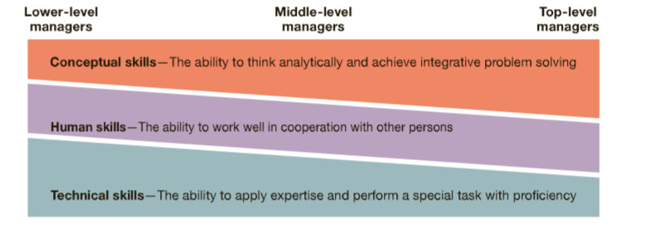

Chapter 2 – Management Learning: Past to Present

2.1: List the characteristics and principles of each of the three classical management approaches

Classical Management Approaches
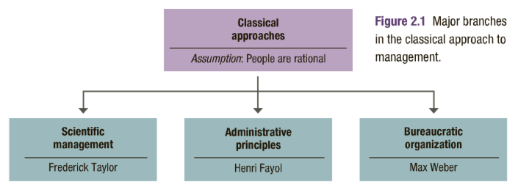
- Classical Approaches share a common assumption: people at work act in a rational manner that is primarily driven by economic concerns.

Scientific Management – Fredrick Taylor

-Taylors goal was to improve the productivity of people at work. Taylors approach is known as
Scientific Management: emphasizes careful selection and training of workers and supervisory support, includes:
1. Develop for every job a science that includes rules of motion, standard work implements, proper working conditions.
2. Carefully select workers with the right abilities for the job
3. Carefully train workers to do the job and give them the proper incentives to cooperate with the job “science”
4. Support workers by carefully planning their work and by smoothing the way as they go about their jobs.

Motion study: the science of reducing a task to its basic physical motions

Administrative Principles – Henri Fayol
- Fayol derived 14 principles from his own experiences: (5 included)
1. Division of Labour – specialization of work will result in continuous improvements in skills and methods
2. Authority understanding
3. Discipline
4. Unity of Command – each employee should only have 1 manager
5. Unity of Direction

-He also identified 5 rules or duties of management, which he believed could be thought.
1. Foresight – to complete a plan of action for the future
2. Organization – To provide and mobilize resources to implement the plan
3. Command – To lead, select, and evaluate workers to get the best work towards the plan
4. Coordination – To fit diverse efforts together and to ensure information is shared and problems solved
5. Control – To make sure things happen according to plan and to take necessary corrective action
Bureaucratic Organization – Max Weber
Bureaucracy: a rational and efficient form of organization founded on logic, order, and legitimate authority.
The defining characteristics of weber’s bureaucratic organization are as follows:
- Clear division of labour - jobs are well defined, and workers become highly skilled at performing them
- Clear Hierarchy - Authority and responsibility are well defined for each position
- Formal rules and procedures – written guidelines direct behaviour and decisions in jobs
- Impersonality – Rules and procedures are impartially and uniformly applied
- Careers based on merit – Workers are selected and promoted on ability, competency and performance.

- Disadvantages include: excessive paperwork, slowness in handling problems, resistance to change

2.2: Describe the principles of the various behavioural management approaches

Behavioural Management Approaches
- The behavioural approaches maintain that people are social and self-actualizing. People at work are assumed to seek satisfying social relationships, respond to group pressures, and search for personal fulfillment
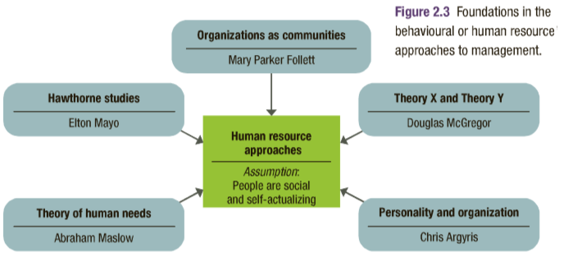

1. Organizations as Communities: - Mary Follett
- Her work was an important transition from classical thinking into behavioural management
- Believed that making every employee an owner in a business would create feelings of collective responsibility.

2. The Hawthorne Studies – Elton Mayo
- Initially had a scientific management perspective and sought to determine how economic incentives and physical conditions of the workplace affected the output of workers
- Later studies directed research attention toward better understanding human interactions in the workplace

Lessons of the Hawthorne Studies
-These studies helped shift the attention of managers and researchers away from the technical and structural concerns of the classical approach and toward social and human concerns as keys to productivity.
-Shed light on notions that people’s feelings, attitudes, and relationships with co-workers affected their work, and that groups were important influences of individuals.
-The Hawthorne Effect: the tendency of persons singled out for special attention to perform as expected.
-The Human Relations Movement: suggested that managers using good human relations will achieve productivity
-Organizational Behaviour: the study of individuals and groups in organization

3. Theory of Human Needs – Abraham Maslow
Described a “need” as a physiological or psychological deficiency a person feels the compulsion to satisfy, suggesting that needs create tensions that can influence a persons work attitudes and behaviours.
- Maslow’s theory is based on two underlying principles:
- Deficit principle: a satisfied need which is not a motivator or behaviours
- Progression principle: the 5 needs exist in a hierarchy of prepotency.

- Claims that people satisfy these 5 needs in sequence, the deprived need dominates individual attention and determines behaviour until it is satisfied. Then the need above it is activated and the sequence continues.
- Theory implies that managers who understand and help people satisfy their needs at work will achieve productivity.

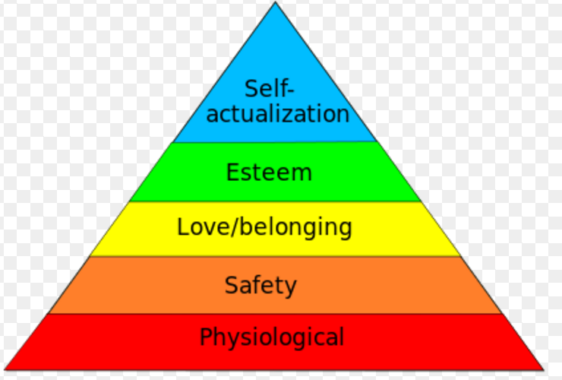

4. McGregor’s Theory X and Theory Y
- Managers should give more attention to social and self-actualizing needs of people at work
- Claimed managers should shift their views of human nature from assumption of Theory X --> Theory Y

Theory X: Assumes people dislike work, lack ambition, act irresponsibly, and prefer to be led with no say.
Theory Y: Assumes people are willing to work, like responsibility, and are self-directed and creative
A self-fulfilling prophecy: Occurs when a person acts in ways that confirm another’s expectations

- Theory Y thinking is consistent with developments in the new workplace and its emphasis on employee participation, involvement, empowerment, and self-management.

5. Argyris’s Theory of Adult Personality
- Concludes that some practices, especially those influenced by the classical management approaches, are inconsistent with the mature adult personality.

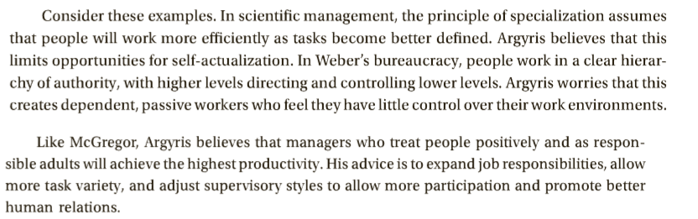
2.3 Explain the foundations of modern management thinking

Modern Management Foundations

Quantitative Analysis and Tools

Management Science and Operations Research: Use quantitative analysis and applied mathematics to solve problems
-Typical quantitative approach to managerial problem solving proceeds as follows:
- A problem is encountered and is then systematically analyzed
- Appropriate mathematical models and calculations are applied
- An optimum solution is identified

Operations Management: The study of how organizations produce goods and services
-Uses quantitative approaches and applied math to examine how organizations produce goods/services most efficiently.

Organizations as Systems
- Operations management tries to understand an organization as a system of interrelated parts that function together to achieve a common purpose. This includes the roles of subsystems, or smaller components of a larger system.
System: A collection of interrelated parts working together for a purpose
Subsystem: A smaller component of a larger system
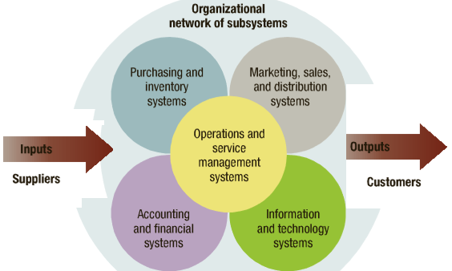

Contingency Thinking
Modern Management attempts to identify practices that are best fits with the demands of unique situations. This req:
Contingency Thinking: tries to help managers understand situational differences and respond to them in ways appropriate to their unique characteristics.
- There is no expectation that one can or should find the “one best way” to manage in all circumstances.

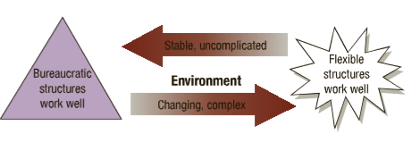

Quality Management – Edwards Deming
Total Quality Management (TQM): Managing with an organization-wide commitment to continuous improvement, product quality, and customer needs.

Continuous Improvement: Involves always searching for new ways to improve work quality and performance
ISO certification: Indicates conformity with a rigorous set of international quality standards

Knowledge Management and Organizational Learning
Knowledge Management: The process of using intellectual capital for competitive advantage from other organizations.
Learning Organization: A learning organization is continuously changes and improves, using the lessons of experiences

- Organizations can learn from sources such as: Their own experience, suppliers, customers, past-partners.
- Criteria for learning organizations tend to display the following characteristics:
1. Mental Models – everyone sets aside old ways of thinking
2. Personal Master – Everyone becomes self-aware and open to others
3. System Thinking – Everyone learns how the whole organization works
4. Shared Vision – Everyone understands and agrees to a plan of action
5. Team Learning – Everyone works together to accomplish the plan

Evidence-Based Management
Evidence Based Management: Involves making decisions based on hard facts about what really

High-Performance Organization: Consistently achieves excellence while creating a high-quality work environment. Are:
- People-oriented
- Team-oriented
- Information-oriented
- Achievement-oriented
- Learning-oriented

Chapter 3: Global Dimensions of Management

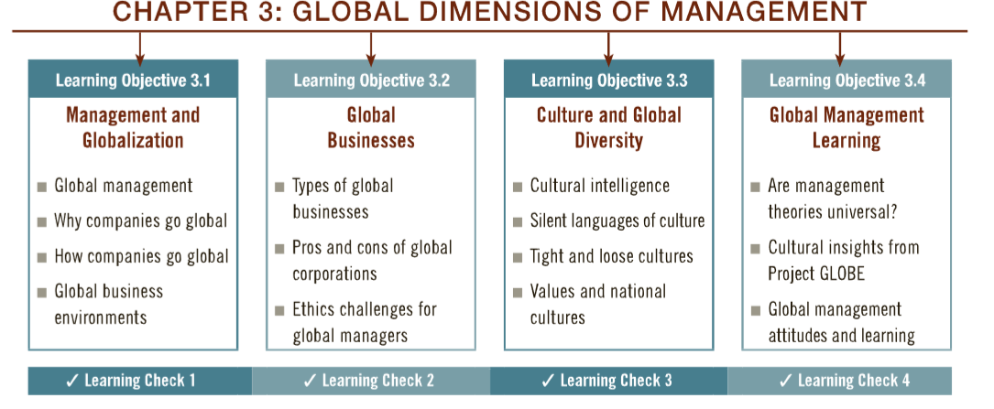

3.1 Explain what the management challenges are in going global

Management and globalization
- Key concepts in the challenges of globalization:
- Global economy
- Globalization
- International management
- Global manager

-Global economy: Resource supplies, product markets, and business competition are worldwide, rather than local

-Globalization: The process of growing interdependence of these components in the global economy

A black swan: A large-scale event or occurrence that goes beyond what is normally expected of a situation and is extremely difficult to predict

-Global Management: Management in organizations with business interest in more than one country

Global manager
- Informed about international developments
- Transnational in outlook
- Competent in working with multicultural people
- Aware of regional developments in a changing world

-Global businesses
- Conduct for-profit transactions of goods and services across national boundaries

-Reasons why businesses go global:
- Profits, customers, supplies, capital and labour

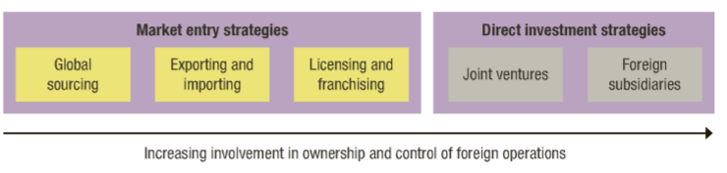

Market entry strategies

Global sourcing: Materials or services are purchased around the world for local use
Exporting and Importing:
- In exporting, local products are sold aboard to foreign customers
- In importing, the goal is selling in domestic markets of products acquired abroad
Licensing and franchising
- In a licensing agreement, a local firm pays a fee to a foreign firm for right to make or sell its products
- In franchising, a fee is paid to a foreign business for rights to locally operate using its name/branding/methods.

Direct investment strategies
Joint Ventures and Strategic Alliances
Foreign Direct Investment: Building, buying all, or buying part ownership of a business in another country
Insourcing: A job creation through foreign direct investment
A Joint Venture: Operates in a foreign country through co-ownership by foreign and local partners.
A Global Strategic Alliance: A partnership in which foreign and domestic firms share resources and knowledge for mutual gains

Foreign Subsidiaries
A Foreign Subsidiary: A local operation completely owned by a foreign firm
A Greenfield Investment: Builds an entirely new operation in a foreign country

-Criteria for choosing a joint venture partner
- Familiarity with your firm’s major business
- Strong local workforce
- Future expansion possibilities
- Values its customers
- Strong local market for partners own products
- Good profit potential
- Sound financial standing

Global Business Environment----->Complications in the global business environment

Legal and Political Systems
- Political Risk: The potential loss in value of a forgiven investment due to instability and changes in host country
- Political-risk analysis: Tries to forecast political disruptions that can threaten the value of a foreign investment

Trade Agreements and Trade Barriers

- Local legal systems: complex and unfamiliar laws can create problems
- World trade organization: resolves trade and tariff disputes among countries
- Most favoured nation status: gives a trading partner most favourable treatment for imports and exports
- Tariffs: taxes governments levy on imports and exports
- Protectionism can complicate global trading relationships

Regional Economic Alliances
- NAFTA – North American Free Trade Agreement: linking Canada, U.S, and Mexico in an economic alliance
- EU – European Union: a political and economic alliance of European countries (links 27 countries)
- SADC – Southern Africa Development Community

3.2 Define what a global business is and what things it undertakes

Global Business

Types of global businesses
- Global corporation (MNC): Multinational corporation with extensive business operations in more than one foreign country

- Transitional Corporation: An MNC that operates worldwide on a borderless basis without being identified with one national home.
-Global firms hold 1/3 of the world’s productive assets, control 70% of world trade but only attain 2% of employment

Pros and Cons of Global Corporations

Host country benefits of multinational corporations
- Larger tax base
- Increased employment opportunities
- Introduction of new industries
- Technology transfers
- Development of local resources

Host country complaints about multinational corporations
- Excessive profits
- Domination of local economy
- Interference with local government
- Disrespect for local customers

Ethical issues for multinational corporations
- Corruption: illegal practices that further one’s business interest
- Sweatshops: Employing workers at low wages for long hours and in poor working conditions
- Child Labor: Full time employment of children for work otherwise done by adults
- Sustainable Development: Meeting current need without compromising future needs

3.3 Explain what culture is and how it impacts global management

Culture and Global Diversity
Culture: A shared set of beliefs, values, and patterns of behaviour common to a group of people
Culture Shock: The confusion and discomfort a person experiences when in an unfamiliar culture
Ethnocentrism: The tendency to consider one’s culture superior to others

Cultural Intelligence
- Cultural intelligence: The ability to accept and adapt to new cultures

Values and National Cultures
Ecological fallacy: Assumes that a generalized cultural value applies equally well to all members of the culture

Power Distance: The degree to which a society accepts unequal distribution of power
Individualism-Collectivism: The degree to which a society emphasizes individuals and their self-interest
Uncertainty Avoidance: The degree to which a society tolerates risk and uncertainty
Masculinity-Femininity: The degree to which a society values assertiveness and materialism
Time Orientation: The degree to which a society emphasizes short-term or long-term goals

3.4 Explain the benefits of developing global management skills

Global Management Learning
Comparative Management: Studies how management practices differ among countries and cultures

Global management attitudes and learning:

-Managers with Ethnocentric Attitudes: believe the best approaches are found at home and tightly control foreign operations
-Managers with Polycentric Attitudes: respect local knowledge and allow foreign operations to run with substantial freedom
-Managers with Geocentric Attitudes: are high in cultural intelligences and take a collaborative approach to global management practices.

Intercultural Competencies: Skills and personal characteristics that help us be successful in cross-cultural situations
- Define globalization and discuss its implications for international management.
- List five reasons why companies pursue international business opportunities.
- Describe and give examples of global sourcing, exporting/importing, franchising/licensing, joint ventures, and foreign subsidiaries.
- Discuss how differences in legal environments can affect businesses operating internationally.
- Explain the goals of the WTO.
- Discuss the significance of regional economic alliances such as NAFTA, the EU, and SADC.
- Differentiate a multinational corporation from a transnational corporation.
- List at least three host-country complaints and three home-country complaints about MNC operations.
- Give examples of corruption, sweatshops, and child labour in international business.
- Define sustainable development and explain what international businesses might do to make it a priority.
- Explain how ethnocentrism can create difficulties for people working across cultures.
- Differentiate between low-context and high-context cultures, and monochronic and polychronic cultures.
- Answer this question: “Do management theories apply universally around the world?”
- Identify the major components in Project GLOBE’s model of cultural differences.
- List and explain three global management attitudes.
- Describe the concept of global organizational learning.
Chapter 13: Information and decision making

13.1 Understand the role of information in the management process

Information, technology and management
-What is useful information?
Data: Raw facts and observations
Information: Data made useful for decision making
Analytics: Involves systematic gathering and processing of data to make informed decisions.
- Information drives management functions such as planning, organizing and leading.
- Characteristics of useful information
- Timely
- High quality
- Complete
- Relevant
- Understandable

Information Systems and Business Intelligence
Key to managerial performance is, Information technology: Helps us acquire, store, and process information
- Given the great power of technology today, information systems are necessary
Business Intelligence: The process of mining information systems to extract data that are most useful for decision makers
- Helps by sorting and reporting data in organized ways to help decision makers detect digest and deal with patterns.

Information Needs in Organizations
- Managers use intelligences information to deal with customers, competitors, suppliers, agencies, etc.
- Organizations also send vast amounts of public information to stakeholders and external environment for their image
- Ability of IT to gather and move information quickly within an organization can be a great asset to decision making

How Information Technology Is Changing Organizations

Management Information Systems: Use IT to collect, organize, and distribute data for use in decision-making.
- Helps people perform best by having available the right information at the right place/time.
- IT helps break down barriers within organizations, by allowing various departments to communicate and coordinate

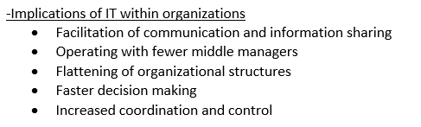
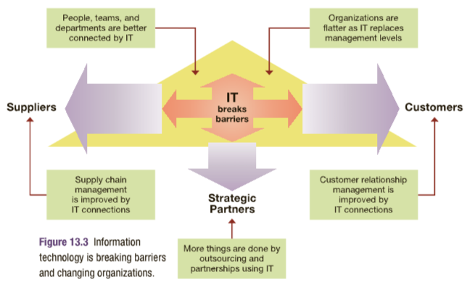

13.2 Understand how managers use information to make decisions

Information and managerial decisions
Managers as Information Processors
- Managers job in todays IT-oriented organizations can be depicted as a nerve centre of information flows.
- Managers are technically information processors, receiving information, gathering it, and giving it

Managers as Problem Solvers
Problem Solving: Involves identifying and taking action to resolve problems
- Success in problem solving depends on using information to make good decisions

Problem-solving approaches or styles
- Problem avoiders: Inactive in information gathering and solving problems
- Problem solvers: Reactive in gathering information and solving problems
- Problem seekers: Proactive in anticipating problems and opportunities and taking appropriate action to gain an advantage

Systematic versus intuitive thinking
- Systematic Thinking approaches problems in a rational, step-by-step, and analytical fashion
- Intuitive Thinking approaches problems in a flexible and spontaneous fashion
- Multidimensional Thinking applies both intuitive and systematic thinking
- Effective Multidimensional Thinking requires skill at strategic opportunism:
- Strategic Opportunism: focuses on long term objectives while being flexible on short term problems

Types of Managerial Decisions

-Programmed decisions
- Apply solutions that are readily available from past experiences to solve structured problems
- Structured problems are the ones that are familiar, straightforward, and clear with respect to information needs
- Best applied to routine problems that can be anticipated

-Non-programmed decisions
- Develop novel solutions to meet the demands of unique situations that present unstructured problems
- Unstructured problems are ones that are full of ambiguities and information deficiencies
- Commonly faced by higher-level management

-Crisis decision making
- A crisis involves an unexpected problem that can lead to disaster if not resolved quickly and appropriately
- Rules for crisis management:
- Figure out what is going on
- Remember that speed matters
- Remember that slow count, too
- Respect the danger of the unfamiliar
- Value the skeptic
- Be ready to “fight fire with fire”

Decision environments:
- Certain Environments: Offer complete information about possible action alternatives and their outcomes
- Risk Environments: Lack complete information about action alternatives and their consequences, but offer some estimates of probabilities of outcomes for possible action alternatives
- Uncertain Environments: Information is so poor that probabilities cannot be assigned to likely outcomes of known action alternatives
13.3 Understand the steps in the decision-making process

The decision-making process
- Begins with identification of a problem and ends with evaluation of implemented solutions

Step 1: Identify and define the problem
- Focuses on information gathering and information processing. This stage focuses on finding and defining the problem and what a decision should accomplish. Three common mistakes in this critical step are:
- Defining the problem too broadly or narrowly.
- Focusing on symptoms of the problem rather than the causes.
- Choosing the wrong problem to deal with at a certain point in time.

Step 2: Generate and evaluate possible solutions
- Information should identify alternative courses of actions, and their anticipated consequences.
Criteria for evaluating alternatives
- Benefits
- Costs
- Timeliness
- Acceptability
- Ethical soundness

Step 3: Decide on a preferred course of action
- Classical Decisions Model: Managers act rationally in a certain world.
- For structured problems with complete information and consequences provided managers make: Optimizing Decision: Gives the absolute best solution to the problem

- Behavioral Decision Model: Describes decision making with limited information and bounded rationally
- Managers make Bounded Rationality: Their decisions are rational only within the boundaries set by the available information and known alternatives which are both incomplete.
- This model assumes that people act only in terms of what they perceive about a given situation.
- Satisfactory Decision: Person chooses the first satisfactory alternative that comes to their attention.

Step 4: Implement the Decision
- The ways that steps 1,2,3 are accomplished has a powerful impact on how decisions get implemented.
- Lack-of-participation Error: A failure to involve in a decision the persons whose support is needed to implement it

Step 5: Evaluate Results
- If the desired results are not achieved, corrective action should be taken.
- Involves gathering data to measure performance results and compare them against goals.

Spotlight Questions: Test the ethics of a decision by exposing it to scrutiny through the eyes of family, community members, and ethical role models

13.4 Understand the current issues in managerial decision-making

Issues in Managerial Decision-Making
Heuristics: Strategies for simplifying decision-making and are helpful, but can also cause common decision making errors.

-Types of heuristics for simplifying decision making
- Availability Heuristic
- People use information “readily available” from memory as a basis for assessing a current event or situation
- Representativeness Heuristic
- People assess the likelihood of something happening based upon its similarity to a stereotyped set of occurrences
- Anchoring and Adjustment Heuristic
- People make decisions based on adjustments to a previously existing value or starting point
- Framing error
- The tendency to evaluate and resolve a problem in the context in which it is perceived (positively or negatively)
- Confirmation Error
- The tendency to focus only on information that confirms or is consistent with decisions we just made.

- Escalating Commitment
- The tendency to increase effort and apply more resources to pursue a course of action that isn’t working.

Creativity in Decision-Making
- Creativity: The generation of a novel idea or unique approach that solves a problem or crafts an opportunity
- Design Thinking: Unlocks creativity in decision making through a process of experiencing, ideation, and prototyping
- Creativity is more likely when decision makers are highly motivated

Individual versus Group Decision-Making

Advantages of Group Decisions:
- Make greater amounts of information, knowledge, and expertise available to solve problems
- Expand the number of action alternatives that are examine
- Help to avoid tunnel vision and consideration of only limited options
- Increase commitments of members to work hard to implement the decision they have made together

Disadvantages of Group Decisions:
- May be social pressure to confirm to a decision you don’t agree with
- Decision making takes longer

When group decisions making works:
- Individuals lacks expertise or information
- Problem is unclear and hard to define
- Time is sufficient for group involvement

Ethical decision making
- How would I feel if my family found out about this decision?
- How would I feel if this decision were published in the local newspaper?

Ethical decision making
Considering the ethics of a proposed decision may result in better decisions and prevention of costly litigation

- Ethical decisions satisfy the following criteria:
- Utility
- Rights
- Justice
- Caring

-----------------------------------------------------MIDTERM-----------------------------

Chapter 5 – Entrepreneurship and Small Business Management
- Angel investor: a wealthy individual who is willing to invest a portion of this wealth in return for equity in a new venture.

- Business plan: a plan that describes all the details necessary to set the direction for a new business and to obtain the necessary financing to operate it.

- Corporation: a legal entity that exists separate from its owners.
- Debt financing: involves going into debt by borrowing money from another person, a bank, or financial institution and repaying it over time with interest.

- Entrepreneur: a risk-taking individual who takes action to pursue opportunities and situations others may fail to recognize as such or may even view as threats.

- Entrepreneurship: describes strategic thinking and risk-taking behavior that results in the creation of new opportunities.

- Equity-based crowd funding: involves new ventures going on-line to sell equity stakes in their businesses to crowds of small angel investors.

- Equity financing: involves exchanging ownership shares in the business to outsiders in return for outside investment monies.

- Family business: a business that is owned and financially controlled by family members.
- Family business feud: occurs when family members have major disagreements over how the business should be run.
- First-mover advantage: exploiting a market niche or entering a market before competitors.
- Franchise: a business owner sells to another person the right to operate the same business in another location, under the original owner’s business name and guidance.

- Initial Public Offering (IPO): an initial selling of shares of stock to the public at large.
- Internet Entrepreneurship: is the use of the Internet to pursue an entrepreneurial venture.
- Limited Liability Corporation: a hybrid legal form of business combining advantages of a sole proprietorship or a partnership with the liability advantages of a corporation.

- Necessity-based entrepreneurship: takes place because other employment options don’t exist.
- Partnership: formed when two or more people agree to contribute resources to start and operate a business together.
- Small business: commonly defined as one with 100 or fewer employees, that is independently owned and operated, and that does not dominate its industry.
- Social Enterprises: have a social mission to help make lives better for underserved populations.
- Sole proprietorship: an individual or a married couple pursing business for a profit.
- Succession plan: a formal statement that describes how the leadership transition and related financial matters will be handled when the time for changeover arrives.
- Succession problem: involves transferring leadership from one generation to the next.
- Venture capitalists: companies that pool capital and make investments in new ventures in return for an equity stake in the business
Chapter 6: Planning processes and Techniques

6.1 Explain why and how managers plan

Importance of Planning:
When planning is done well, it creates a solid platform for the other management functions: organizing, leading and controlling.
- Planning to set the direction: Decide where you want to go, and decide how to best go about it

The Planning Process:
Planning should focus attention on objectives that identify the specific results or desired outcomes that one intends to achieve.
- Planning is an ongoing process, often being done during a busy and demanding work setting
- Planning should result in being well implemented so that objectives are accomplished.
1. Define your objectives
2. Determine where you stand with objectives
3. Develop premises regarding future conditions
4. Analyze alternatives and make a plan
5. Implement the plan and evaluate results

Benefits of Planning:
- Benefits of planning help with external pressures such as government regulations, or changing technologies
- Benefits of planning help with internal pressures such as new structures, greater diversity, etc.

Planning improves focus and flexibility: An organization with flexibility is willing to change and adapt to shifting circumstances.

Planning improves action orientation:
- Keeps future visible as a performance target and reminds us that the best decisions are often those made before events force problems upon us.
- Helps to avoid Complacency Trap: Being carries along by the flow of events

Planning Improves Coordination and Control
- When plans are coordained among people and subsystems, there is greater likelihood that their combined accomplishments will advance performance for the organization

Planning and Time Management: Most of us have experienced the difficulties of balancing available time with our many commitments and opportunities. It is easy to lose track of time and fall prey to what is considered “time-wasters”
- Do say “NO” to requests that divert you from what you really should be doing
- Do prioritize what you will work on in terms of importance and urgency
- Don’t become calendar bound by letting others control your schedule

6.2 Describe the types of plans managers use

Types of Plans Used by Managers:
Managers use a variety of plans as they face different challenges in the flow and pace of activities in organizations. In some cases, the planning environments is stable and quite predictable. In others, it is more dynamic and uncertain. Different needs call for different types of plans.

Long-Range and Short-Range Plans
- Long-range plans look three or more years into the future (Top management)
- Intermediate-range plans cover 1-2 years into the future
- Short-range plans cover less than a year into the future (Lower management)
Without a sense of long-term direction, people can end up working hard and still not achieve significant results.
Even top managers now face the reality that internet time keeps making the “long range of planning shorter and shorter

Strategic and Tactical Plans

Strategic Plans: Identifies long-term directions for the organization
- Begins with vision: Clarifies the purpose of the organization and expresses what it hopes to be in the future, and it involves deter, determining the goals and objectives that will be pursued in order to accomplish that vision.
- Even though strategic plans are long term, they are also dynamic

Tactical Plans:
- Are developed and used to implement strategic plans. They tend to be intermediate-term plans that specify how the organization’s resources can be used to put strategies into action.
- In business, tactical plans often take the form of functional plans that indicate how different components of the enterprise will contribute to the overall strategy. Such functional plans might include:
- Production plans
- Financial plans
- Marketing plans
- Human resource plans

Operational Plans

Operational Plans: Describe what needs to be done in the short term and in response to different situations. They include both standing plans such as policies and procedures that are used over and over again, and single-use plans such as budgets that apply to one specific task or time period.

Policies and Procedures:
- A policy: communicates broad guidelines for making decisions and taking action in specific circumstances. Organizations operate with lots of policies, and they set expectations for many aspects of employee behaviour.
- Procedures or rules: Describe exactly what actions are to be taken in specific situations. They are stated in employee handbooks often called SOP’s (Standard Operating Procedures)
*Whereas a policy sets a broad guideline, procedures define precise actions to be taken.

Budgets: Single-use plans that commit resources for specific time periods to activities, projects or programs.
Managers are expected to achieve work objectives while keeping within the allocated budget.
All budgets link planned activates with resources needed to accomplish them.
- Budgets are useful for tracking and controlling performance
- Zero-Based Budget: Allocates resources as if each budget were brand new rather than gradually increasing a previous budget each year and encountering budgeting problems.

6.3 Identify and describe the various planning tools and techniques

Planning Tools and Techniques: The benefits of planning are realized when the foundations are strong
Forecasting
- Planning in business and our personal lives often involves
Forecasting: The process of predicting what will happen in the future
Although useful, all forecasts should be treated cautiously, they are planning aids, not substitutes.
- Forecasts only rely on human judgement and can be wrong
Contingency Planning:
The more uncertain the planning environment, the more likely the one’s original forecasts and intentions may prove inadequate or wrong.
Contingency Planning: Identifies alternative courses of action that can be implemented if circumstance change
- Can’t prevent crises from occurring, but when things do go wrong, there’s nothing better to have in place than good contingency plans.

Scenario Planning:
A long-term version of contingency planning called Scenario Planning: involves identifying several alternative future scenarios or states of affairs that may occur. Plans are made to deal with each should it actually happen.

Benchmarking:
- Uses external and internal comparisons to plan for future improvements
- The purpose of benchmarking is to find out what other people and organizations are doing very well, and then plan how to incorporate these ideas into one’s own operation.
- One benchmarking technique is called Best Practices: Things people and organizations do that help that achieve superior performance.

Use of Staff Planers
In many organizations, staff planners are employed to help coordinate and energize planning. These specialists are skills in all steps of planning process, as well as in the use of planning tools and techniques. They can bring focus and expertise to accomplish important, often strategic, planning tasks.
- One risk is a tendency for a communication gap to develop between staff planners and line managers.

6.4 Explain how to implement plans to achieve results

Implementing Plans to Achieve Results
- Plans are words with promises attached. These promises are only fulfilled when plans are implemented so that their purposes are achieved.

Goal Setting and Goal Alignment
- Systems help people find problems before they can interfere with performance.

Goal setting
- The way goals are set can make a big difference in how well they do in pointing people in the right directions and inspiring them to work hard. The following are guidelines are starting points go from “no goals” to “great goal”:
- Specific – Clearly target key results and outcomes to be accomplished
- Measurable – Described so results can be measured without ambiguity
- Attainable –
- Referred to – goals need to be referred to regularly to keep people focused on task at hand
- Timely – due date

Goal Alignment
- Important to make sure that goals and plans are well integrated across the many people, work units, and levels of an organization as a whole. Goals set anywhere in the organization should ideally help advance its overall mission or purpose.
Hierarchy of Goals or Objectives: Lower level objectives help accomplish higher level objectives.

Management by Objectives:

Management by Objectives (MBO): A process of regular communication in which a supervisor works with subordinated to jointly set performance objectives and review results accomplished.

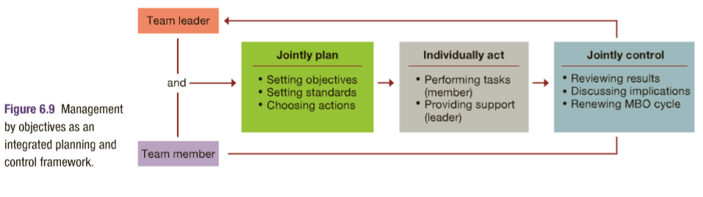

Performance Objectives in MBO: Three types of objectives may be specified in an MBO contract.
- Improvement Objectives: Intentions for improving performance in a specific way (EX/ Reduce quality reject by 10%)
- Personal Development Objectives: Pertain to personal growth activities, often those resulting in expanded job knowledge or skills

One of the more difficult aspect of MBO is the need to make performance objectives as measurable as possible.

MBO pros and cons:
Avoid: Tying MBO to pay, focusing too much attention on easy objectives, too much paperwork.
Advantages: MBO focuses on supervisors helping subordinates with objectives, also focuses on most important tasks

Participation and Involvement:
Participatory Planning: Includes the persons who will be affected by plans and those who implement them.
- When people participate in setting goals, they gain motivation to work hard to accomplish them.
- The role of participation and involvement in the planning process is shown below.

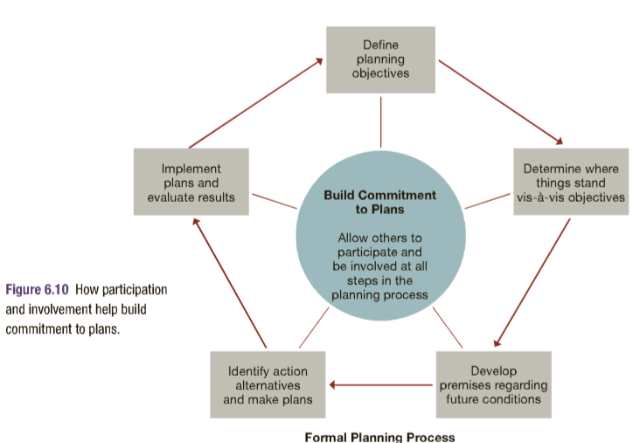

Chapter 7 – Strategy and Strategic Management

7.1 Describe what is strategic management

Strategic Management:
- Strategic management is the continuous planning, monitoring, analysis and assessment of all that is necessary for an organization to meet its goals and objectives.

Competitive Advantage: the ability to do something so well that one outperforms competitors
- Typical sources of competitive advantage include:
- Cost and quality
- Knowledge and speed
- Barriers to Entry
- Financial resources
- Technology

In order to avoid competitors of duplicating their success story, firms goal is to create:
Sustainable Competitive Advantage: the ability to outperform rivals in ways that are difficult or costly to imitate.

Strategy and Strategic Intent:
Strategy: a comprehensive plan guiding resource allocation to achieve long-term organization goals.

A strategy helps ensure that resources are used with consistent strategic intent: (all energies toward long term goal)
Strategic intent: focuses and applies organizational energies on a unifying and compelling goal.

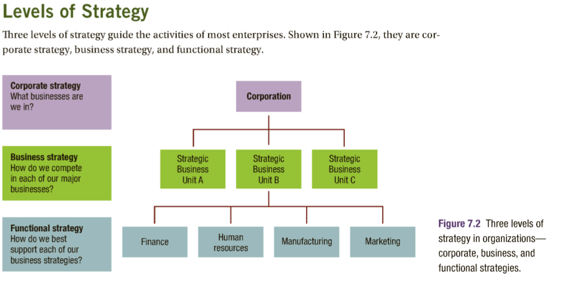
Levels of Strategy

Corporate-Level Strategy – Sets long-term direction for the total enterprise
Business-Level Strategy – Identifies how a division or strategic business unit will compete in its product domain.
Functional Strategy – Guides activities within one specific area of operations

The Strategic Management Process

S.A – S.F – S.I
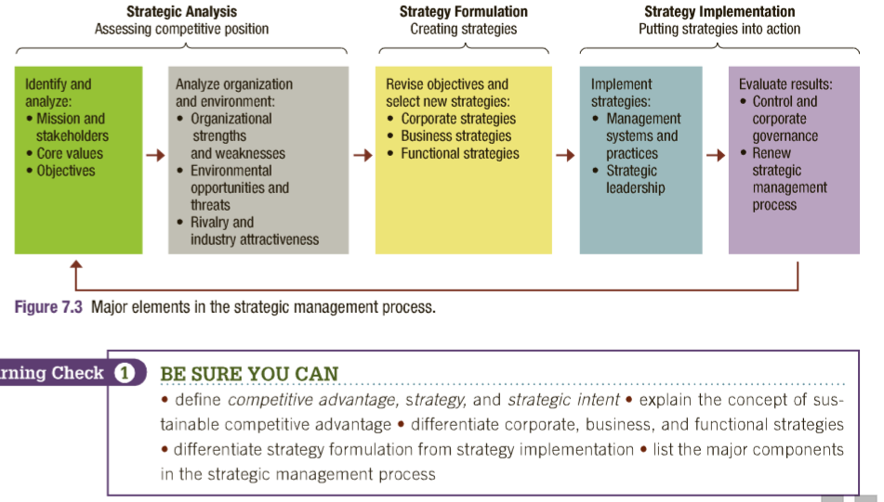

7.2 Identify the essentials of strategic analysis

Essentials of Strategic Analysis

Analysis of Mission, Values, and Objectives:
- The strategic management process beings with a review and clarification of mission, values, and objectives
- A Mission statement expresses the organization’s reason to existence in society

Missions and Stakeholders –
- A clear sense of mission helps managers keep organizations on track and use resources with strategic intent.
- A clear sense of missions also helps managers inspire the support and respect an organizations stakeholder
A Strategic Constituencies Analysis: assesses interest of stakeholders and how well the organization is responding to them

Core Values – are broad beliefs about what is or is not appropriate behaviour
Organizational culture – the predominant value system for the organization as a whole

Objectives
Operating objectives: direct activities toward key performance areas. Turn sense of mission into specific perf. Targets:
- Profitability
- Cost efficiency
- Product quality
- Customer efficiency, etc.

SWOT Analysis of Organization and Environment
Analyze the organization and its environment using a technique known as:
SWOT Analysis: examines organizational strengths and weaknesses and environmental opportunities and threats

Organizational Strengths and Weaknesses –
A core competency: a special strength that gives an organization a competitive advantage

Organizational weaknesses: the goal is to identify things that inhibit performance and hold the organization back from fully accomplishing its objectives.
Environmental Opportunities and Threats:
Opportunities may exist as possible new markets, a strong economy, weaknesses in competitors, and emerging technology.
Environmental threats may be such things as the emergence of new competitors, resource scarcities changing customer tastes, new government regulations, etc.

Analysis of Rivalry and Industry

Porter’s Five Forces Model:
- Industry competition
- New entrants
- Substitute Products or Services
- Bargaining power of suppliers
- Bargaining power of customers

Industry Attractiveness
The five competitive forces constitute what porter calls the “industry structure” and it establishes the industry’s attractiveness or potential to generate long term returns.
An unattractive industry: one in which rivalry among competitors is intense, and suppliers and buyers are very powerful in bargaining over price and quality.
An Attractive industry: less existing competition, low bargaining power among suppliers and buyers

7.3 Identify the various corporate strategies and explain how each is formulated

Corporate-Level Strategy Formulation
- The CEO and the senior management team in a business focus on corporate level strategy formulation
- Goal is to plot overall direction of the organization in the competitive setting of its industry

Grand or Master Strategies
- The choice of corporate level strategies generally begins with grand or master strategies. These are growth, stability, renewal, and combination strategies.

Growth Strategy:
Growth strategy: involves expansion of the organization’s current operations in things like total sales, or market share.
- It is possible to get caught in an “expansion trap” where growth outruns an organization’s capacity to run effectively

Stability:
- Stability strategies: try to maintain an existing course of action without major changes
- Stability is sometime pursued when an organization is performing well, already operating at capacity, or when the environment appears stable or exceptionally risky.

Renewal Strategy
Try to solve problems and overcome weaknesses. They often cut size and rearrange operations to improve performance.
- Can be difficult to chose this option, seems like an admission of failure
- Liquidation: business operations cease and assets are sold to pay creditors

Combination Strategy
Combination strategies: to pursuer one or more of the strategies at the same time

Growth and Diversification Strategies

- Growth through concentration is growth within the same business area
- Growth through diversification is growth by acquisition of or investment in new and different business area
- Growth through vertical integration: growth by acquiring suppliers or distributors

Restructing Strategies
- Restructing changes the mix or reduces the scale of operations
Turnaround strategy tries to fix specific performance problems
Downsizing strategy decreases the size of operations

Divestiture: sells off parts of the organization to refocus attention on core business areas.

Global Strategies
- Globalization strategy: adopts standardized products and advertising for use worldwide
- A multi-domestic strategy: customizes products and local advertising to best fit local needs
- A transitional strategy: seeks efficiencies of global operation with attention to local markets

Cooperative Strategies
- Strategic alliance: organizations join together in partnership to pursue an area of mutual interest
- Co-opetition is the strategy of working with rivals on projects of mutual benefit

E-Business Strategies
- An e-business strategy: Strategically uses the internet to gain competitive advantage
- A B2B Business Strategy: Uses IT and web portals to link organizations vertically in supply chains
- A B2C business strategy: uses IT and web portals to link businesses with customers

Strategic Portfolio Planning
- Portfolio planning: approach seeks the best mix of investments among alternative business opportunities
- The BCG matrix: analyzes business opportunities according to market growth rate and market share

7.4 Identify the various business strategies and explain how each is formulated

Business-Level Strategy Formulation
Competitive Strategies
- Porter’s model for making choices among possible competitive strategies

Differentiation Strategy
- A differentiation strategy: offers products that are different from the competition
- To succeed w/ this strategy, an organization must have strengths in research-development, marketing /advertising

Cost Leadership Strategy
A cost leadership strategy: seeks to operate with low costs so that products can be sold at low prices
- Success with this strategy requires: a continuing search for innovations that increase operating efficiencies

Focus Strategy
A focus strategy: Concentrates on serving a unique market segment better any anyone else.
A focused differentiation: strategy offers a unique market product to a special market segment
A focused cost leadership: strategy seeks the lowest costs of operations within a special market segment
Strategic Incrementalism:
- Strategic incrementalism: makes modest changes in strategy as experience builds over time
- An emergent strategy: unfolds over time as managers learn from and respond to experience

7.5 Identify and describe some current issues in strategy implementation

Strategy Implementation

Management Practices and Systems
- In order to put strategies into action, the entire organization and all of its resources must be mobilize for support
- A strategy requires supporting structures, and a good allocation of tasks and workflow designs
- Poor management practices hinder strategy implementation in a number of way:
- failures of substance: reflect inadequate attention to the major strategic planning elements.
- Failure of process: reflect poor handling of the ways in which strategic management is accomplished
- Lack of participation error: a failure to include key persons in strategic planning

Corporate Governance
- Corporate governance is the system of control and performance monitoring of top management.

Strategic Control
- Strategic control: makes sure strategies are well implemented and that poor strategies are scrapped or modified

Strategic Leadership
- Strategic leadership inspires people to continuously change, refine, and improve strategies and their implementation
- Responsibilities include:
- A strategic leader has to be a guardian of trade-offs
- A strategic leader needs to create a sense of urgency
- A strategic leader needs to make sure that everyone understands the strategy
- A strategic leader needs to be a teacher

Chapter 8: Organization Structures and Design

8.1 Describe organizing as a management function
Organizing as a Management Function 256-275
- Organizing: arranges people and resources to work toward a goal

What is Organization Structure?
- The way in which various parts of an organization are formally arranged is usually referred to as the:
- Organization structure: a system of tasks, reporting relationships, and communication linkages

Formal Structure
Organization Chart: describes the arrangement of work positions within an organization
Formal Structure: The official structure of the organization
- Division of labour
- Communications channels
- Levels of management, etc.

Informal Structures
- Informal structures: the set of unofficial relationships among an organization’s members
- Social network analysis: identifies the informal structures and their embedded social relationships that are active in an organization (who talks to who)

- These are both essential for organizational success. Especially true for changing times when formal structures fail.
- Informal structures also have disadvantages: can be susceptible to rumour, inaccurate information, divert work away from objectives.

8.2 Understand, describe, and sketch the traditional organization structures
Traditional Organization Structures
- Departmentalization: the process of grouping people and jobs into work units
- Result in three major types of organization structures:

Functional Structures
- People with similar skills and performing similar tasks are grouped together into formal work units
- Members share expertise, interests, and responsibilities.
- Advantages - Efficient use of resources, high quality problem solving, clear career path within functions
- Disadvantages - The functional chimney problem: lack of communication and coordination across functions

Divisional Structures
- Groups together people working on the same product, in the same area, with similar customers, or on the same processes.
Product Structures – groups together people and jobs focused on a single product or service
Geographic Structures – groups together people and jobs performed in the same location
Customer Structures – groups together people and jobs that serve the same customers or clients
Process structures – groups jobs and activities that are part of the same process
- Work process: a group of related tasks that collectively creates a valuable work product
- Advantages: More flexibility, improved coordination across departments, clear points of responsibility.
- Disadvantages: increase costs through the duplication of resources across divisions

Matrix Structures
- Combines the functional and divisional structures
- Attempts to gain advantages and minimize the disadvantages of both
- Used by having permanent teams that cut across functions to support products, projects, or teams
- Advantages – Team members work closely together to share expertise and information in timely manner.
- Better cooperation across functions
- Increased flexibility
- Better performance accountability
- Improved strategic management

- Disadvantages – The two-boss system is susceptible to power struggles, both leaders might flex their authority
- Team meetings may take a lot of time

8.3 Understand the newer types of organization structures

Horizontal Organization Structure

Team Structures:
- Team structures: use permanent and temporary cross-functional teams to improve lateral relations
- Cross-functional team: Brings together members from different functional departments
- Project Teams: Convened for a particular task or project and disband once it is completed.

Advantages of team structures – help eliminate difficulties with communication and decision making
Improve speed and quality of decisions in many situation

Disadvantages of team structures – Conflicting loyalties for persons with both team and functional assignments
Issues of time management and group process

Network Structures
- Uses information technologies to link with networks outside suppliers and service contractors
- Advantages: Operating can happen with fewer employees and less complex internal systems. Cost-competitive
- Disadvantages: Complicated to control and coordinate the network of contracts and alliances

Boundaryless Structures
- Eliminates many of the internal boundaries among subsystems and external boundaries with the external environment,
- Internal to the organization teamwork and communication replace formal lines of authority
- Externally, the organization needs are met by a shifting mix of outsourcing contracts and operating alliances.

A virtual organization – Uses IT and the internet to engage a shifting network of strategic alliances

8.4 Describe organizational designs that are changing the workplace
Organizational Designs
- The process of choosing and implementing structures to accomplish the organizations mission and objectives
- The goal is to achieve the best fit among structures and the unique situation faced by each organization

Mechanistic and Organic Designs
- Bureaucracy is a form of organization based on logic, order and legit use of formal authority

Mechanistic Designs – centralized, with many rules and procedures, a clear-cut division of labour, narrow spans of control, and formal coordination. (organizations with more mechanic designs are highly bureaucratic)
- Work best for organizations doing routine tasks in stable environments

Organic Designs – decentralized, with fewer rules and procedures, open division of labour, wide spans or control, and more personal coordination
- Adaptive organization: operates with a minimum of bureaucratic features and encourages worker empowerment and teamwork
- Organic designs work well for organizations facing dynamic environments that demand flexibility in dealing with changing conditions

Subsystems Design and Integration
- A work unit or smaller component within a larger organization

Differentiation: the degree of difference between subsystems in an organization
Integration: the level of coordination achieved between subsystems in an organization

Trends in Organizational Design
- The complexity and change in the characteristic of today’s environment has prompted more and more organizations to shift toward horizontal structures and organic designs.

Flat structures –
Chain of command: Links all persons with successively higher levels of authority
Span of control: The number of subordinates directly reporting to a manager
- Trend: organizations are cutting unnecessary levels of management and shifting to wider spans of control

More Delegation and Empowerment – all managers must decide what work they should do themselves and what should be left for others
- Delegation: the process of distributing and entrusting work to other persons
- If done well, delegation leads to empowerment: allows other to make decisions and exercise discretion in their work
- Trend: managers are delegating more, and empowering people to make more decisions

Decentralization with Centralization –
Centralization: the concentration of authority for most decisions at the top level of an organization
Decentralization: the dispersion of authority to make decisions throughout all organization levels
- Trend: delegation, empowerment, and horizontal structures are contributing to more decentralization in organizations, at the same time, advances in IT are allowing for adequate centralized control if anything goes wrong.

Reduced Use of Staff –
Staff positions – provide technical expertise for other parts of an organization
- Trend – organizations are reducing the size of staff. They are lowering costs and increasing efficient by employing fewer staff personnel and using smaller staff units.

Chapter 11: Leadership and Communication

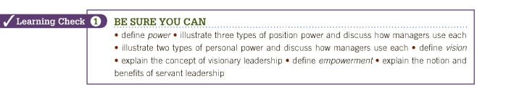
Power: the ability to get someone else to do something you want done or to make things happen the way you want.

Position Power
- Coercive power: the capability to punish or withhold positive outcomes as a means of influencing other people.
- Legitimate power: the capacity to influence other people by virtue of formal authority, or the rights of office.
- Reward power: the capability to offer something of value –– a positive outcome –– as a means of influencing the behaviour of other people.

Personal Power
- Expert power: the capacity to influence the behaviour of other people because of one’s knowledge and skills.
- Referent power: the capacity to influence the behavior of other people because they admire you and want to identify positively with you.

- Vision: refers to a future that one hopes to create or achieve in order to improve upon the present state of affairs.
• Visionary leadership: describes a leader who brings to the situation a clear and compelling sense of the future as well as an understanding of the actions needed to get there successfully.

- Leadership: the process of inspiring others to work hard to accomplish important tasks.
- Servant leadership: leadership based on a commitment to serving others, to helping people use their talents to full potential while working together for organizations that benefit society

- Empowerment: the process through which managers enable and help others to gain power and achieve influence within the organization.

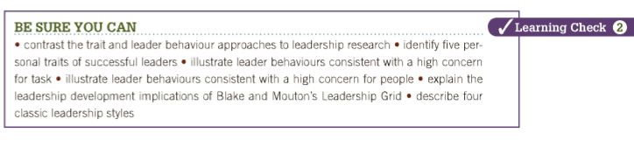
---------------------------------------------------------------------------------------------------------------------------------------------------------------
Leadership style: the recurring pattern of behaviors exhibited by a leader.
Autocratic Style: A leader acts in a unilateral, command-and-control fashion
Human Relations Style: A leader emphasizes people over tasks
Laissez-faire style: displays a “do the best you can and don’t bother me”
Democratic style: emphasizes both tasks and people”
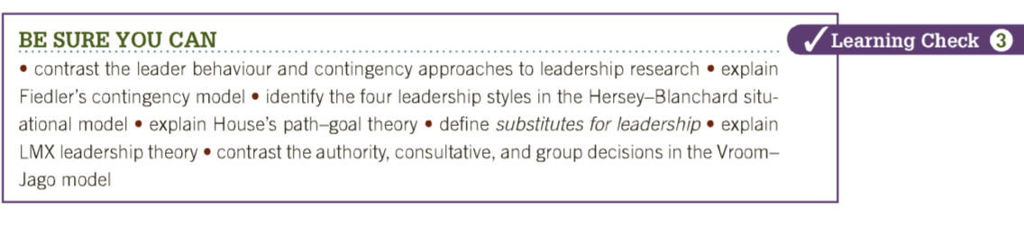
Contingency Approaches to Leadership
Fiedler’s Contingency Model:
-The least-preferred co-worker scale (LPC): used in Fiedlers contingency model to measure a person’s leadership style
- Proposed that good leadership depends on a match between leadership style and situational demands

Hersey-Blanchard Situational Leadership Model
-Suggests that successful leaders do adjust their style based on the maturity of followers.
Delegating, Participating, Selling, Telling

Path-Goal Leadership Theory
Suggests that an effective leader is one who clarifies parts by which followers can achieve both task-related and personal goals
-Directive leadership, Supportive leadership, Achievement-oriented leadership, Participating leadership

- Contributed to Substitutes for leadership: Aspects of the work setting and the people involved that can reduce the need for a leader’s personal involvement.

Leader-Member Exchange Theory
This theory recognizes that in most leadership, situations people fall into “in groups” – privileges, access to information
and “out groups” – Excluded from benefits

Leader-Participation Model
Leadership success results when the decision-making method used by a leader best fits the problem being faced

-Authority decision: the leader makes the decision alone and then communicates it to the work group.
control, and acts in a unilateral command-and-control fashion.

-Consultative decision: the leader makes the decision after asking group members for information, advice, or opinions.
-Group decision: is made by the group with the leader’s support as a contributing member.

Personal Leadership Development
- Charismatic leader: a leader who develops special leader-follower relationships and inspires others in extraordinary ways.

Transactional and Transformational Leadership
- Transactional leadership: Uses tasks, rewards, and structures to influence and direct the efforts of other
- Transformational leadership: Inspirational and arouses extraordinary efforts and performance

Emotional intelligence: the ability of people to manage themselves and their relationships effectively.
Gender similarities hypothesis: holds that males and females have similar psychological properties.
Interactive leadership: leaders are strong communicators and act democratic and participative with followers.

Moral Leadership
Moral leadership: leadership by ethical standards that clearly meet the test of being “good” and “correct.”
- Integrity: in leadership is honesty, credibility, and consistency in putting values into action.
- Authentic leadership: activates positive psychological states to achieve self-awareness and positive self-regulation.

Drucker’s “old-fashioned” Leadership
- The plain hard work it takes to be a successful leader

- The Communication Process
Communication: an interpersonal process of sending and receiving symbols with messages attached to them.

Effective Communication
• Effective communication: the intended meaning is fully understood by the receiver.
• Efficient communication: occurs at minimal cost

Persuasion and Credibility in Communication
Persuasive communication: presents a message in a manner that causes the other person to support it.
Credible communication: earns trust, respect, and integrity in the eyes of others.

Communication Barriers
- Communication channel: the medium through which a message is conveyed from sender to receiver.
- Non-verbal communication: takes place through such things as hand movements, facial expressions, body posture, eye contact, and the use of interpersonal space.
- Mixed message: occurs when a person’s words communicate one message while his/her actions, body language, appearance, or situational use of interpersonal space communicate something else.
- Filtering is the intentional distortion of information to make it appear favourable to the recipient.

- Improving Communication
- Active listening: the process of taking action to help someone say exactly what he or she really means.

Feedback: the process of telling others how you feel about something they did or said or about the situation in general.

Proxemics is the use of space in communication: (chair sitting beside you or across the table from you)

Channel richness: the capacity of a channel or communication medium to carry information in an effective manner.

Electronic grapevine: use electronic media to pass messages and information among members of social networks.

Management by wandering around (MBWA): involves dealing directly with subordinates by regularly spending time walking around and talking with them about a variety of work-related matters.

Ethnocentrism is the tendency to cons

