ECOR 1010 – Introduction to Engineering

NAME
Assignment #1
Assignment Title: Engineering Reporting
TO Marking TA:
Name:
Email: [Email]

Lab Section: L3
Room: ME 2256 – Carleton University

FROM:
Email: [Email]
Student Number: [Email]

Number of Figures and Tables (Including handwritten ones): 3 Tables, 5 Figures
Last Date and Time of Revision: 24 September 2016 @ 9:41PM

Introduction
In this laboratory, an analysis of transportation via an airplane and two road vehicles was carried out to identify the most efficient means of transporting passengers from Halifax to Vancouver by evaluating each vehicle’s fuel consumption, carbon dioxide emission and number of trees to offset carbon dioxide per year. This investigation was prompted by the claims of the manufacturers of these vehicles asserting that their own vehicle is more energy efficient. With our ever-growing population and need for more efficient modes of transportation, engineers are searching for means to transport people while minimizing energy consumption as well as the emission of toxic gases. This is because there is need to secure the environment and ensure the safety of future generations.

Materials and Methods
Based on the collected data in table 1 and 2 of the appendix, the fuel consumption and cost in total and per person was calculated as well as the CO₂ produced during the entire journey in total and per person. The travel time and also the number of trees that would offset the CO₂ emitted per person was also calculated (Assuming full capacity). After analysing these data, the claims between the manufacturers would then be examined to see who is right.

Results
According to the information in table 3 of the appendix, the BlueSky E-1010 aircraft model uses 760.3 L of fuel per 100km throughout the journey and each person in the plane is estimated to have used up to 3.04 L of fuel per 100km. In total, the cost of the fuel for the aircraft is $29 280 and $117.10 per person. The CO₂ produced by the E-1010 aircraft is about 91 400 kg in total and 365.60 kg per person. It takes the plane 5.89 hours to get from Halifax to Vancouver and about 16 trees are required to offset the CO₂ produced by the aircraft. The sedan car uses 6.27 L of fuel per 100 km in total and 1.57 L per person. The total fuel cost for the sedan car to travel the distance is $390.20 and $97.55 per person. The CO₂ emitted by the sedan car is about 857 kg in total and 214.20 kg per person. The sedan car takes 138.80 hrs to reach its destination and about 9 trees are required to offset the CO₂ emitted. The minivan uses 8.27 L of fuel per 100 km in total and 1.18 L per 100km in person. The total fuel cost for the minivan is $514.60 and $73.52 per person. The CO₂ emitted by the minivan is about 1130 kg in total and 161.50 kg per person. It also takes the minivan 138.80 hours to reach Vancouver, however, only about 7 trees are required to offset the CO₂ emitted.

Discussion
From the results in table 3 of the appendix, it can be seen that the aircraft has the highest fuel consumption, fuel cost and CO₂ emission in total and per person. It also requires the largest number of trees to offset the CO₂ emission. However, it has the shortest travel time. The sedan car has the lowest fuel consumption, fuel cost and C0₂ emission in total but the minivan has the lowest fuel consumption, fuel cost and CO₂ emission per person. It also requires a lesser number of trees to offset the CO₂ emission. Based on this, it can be said that the automobile manufacturer is right in his claims as travelling by car consumes less fuel and produces fewer carbon dioxide emissions. However, the validity of this claim is affected by the assumption that the maximum range of the airplane is the distance it can travel without using its reserve fuel as it is uncertain that the airplane uses all of the fuel available.

Conclusions
Based on the analysed data above, it can be concluded that the minivan is the most energy efficient vehicle.

APPENDIces- Figures and Tables

Table 1: “BlueSky” model E-1010 airplane specifications.
Aircraft model | Max. no. of seats | Max. range* | Max. takeoff weight | Max fuel capacity** | Cruise speed @ 35,000 feet ***
E-1010 | 250 | (Km) | (Kg) | (kg) | (Km/h)
E-1010 | 250 | 4 755 | 67 775 | 32 389 | 897

Table 2: Useful Information
Automobile fuel price | 1.07 | $/L
Fuel density (aircraft and automobile) | 0.80 | kg/L
Aircraft reserve fuel | 10.70 | %
Automobile average speed | 87.00 | km/hr
Aircraft fuel price | 0.81 | $/L
Automobile CO2 emission | 2.35 | kg/L
Airplane CO2 emission | 3.16 | kg CO2/kg Fuel
Halifax to Vancouver distance by car | 5 816 | km
CO2 fixed by the average tree per year | 50.0 | lb CO2/tree/year

Table 3: Calculation Summary Table

 | Fuel Consumption L/100 km | Fuel Cost for the vehicle to travel the distance ($) | Fuel Consumption per person: 100% occupied seats L/100 km | Fuel Cost per person: 100% occupied seats ($) | CO2 Emission (kg) |  | Total Travel Time (hr) | Total Travel Time |  | No. of trees to offset CO2 emission /yr/person
 |  |  |  |  | Total | per person: 100% occupied seats | Total Travel Time (hr) | hr | min | No. of trees to offset CO2 emission /yr/person
E-1010  250 passengers | 760.3 | 29 280 | 3.040 | 117.1 | 91 400 | 365.6 | 5.890 | 5.000 | 53.00 | 16
Car– Sedan 4 passengers | 6.270 | 390.2 | 1.570 | 97.55 | 857.0 | 214.2 | 138.8 | 138.0 | 51.00 | 9
Minivan 7 passengers | 8.270 | 514.6 | 1.180 | 73.52 | 1 130 | 161.5 | 138.8 | 138.0 | 51.00 | 7

Figure 1. Jet fuel monthly price in Canada ($/L)
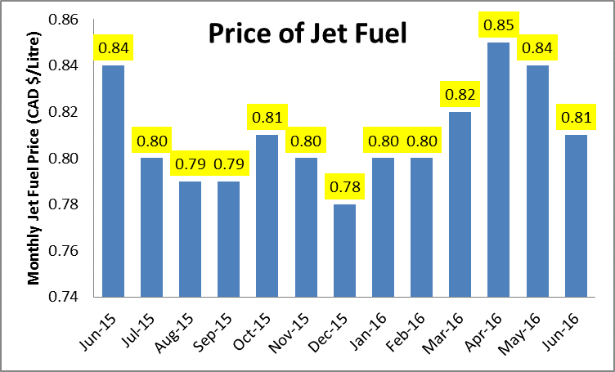

Figures 2 - 5. Some Calculations
2.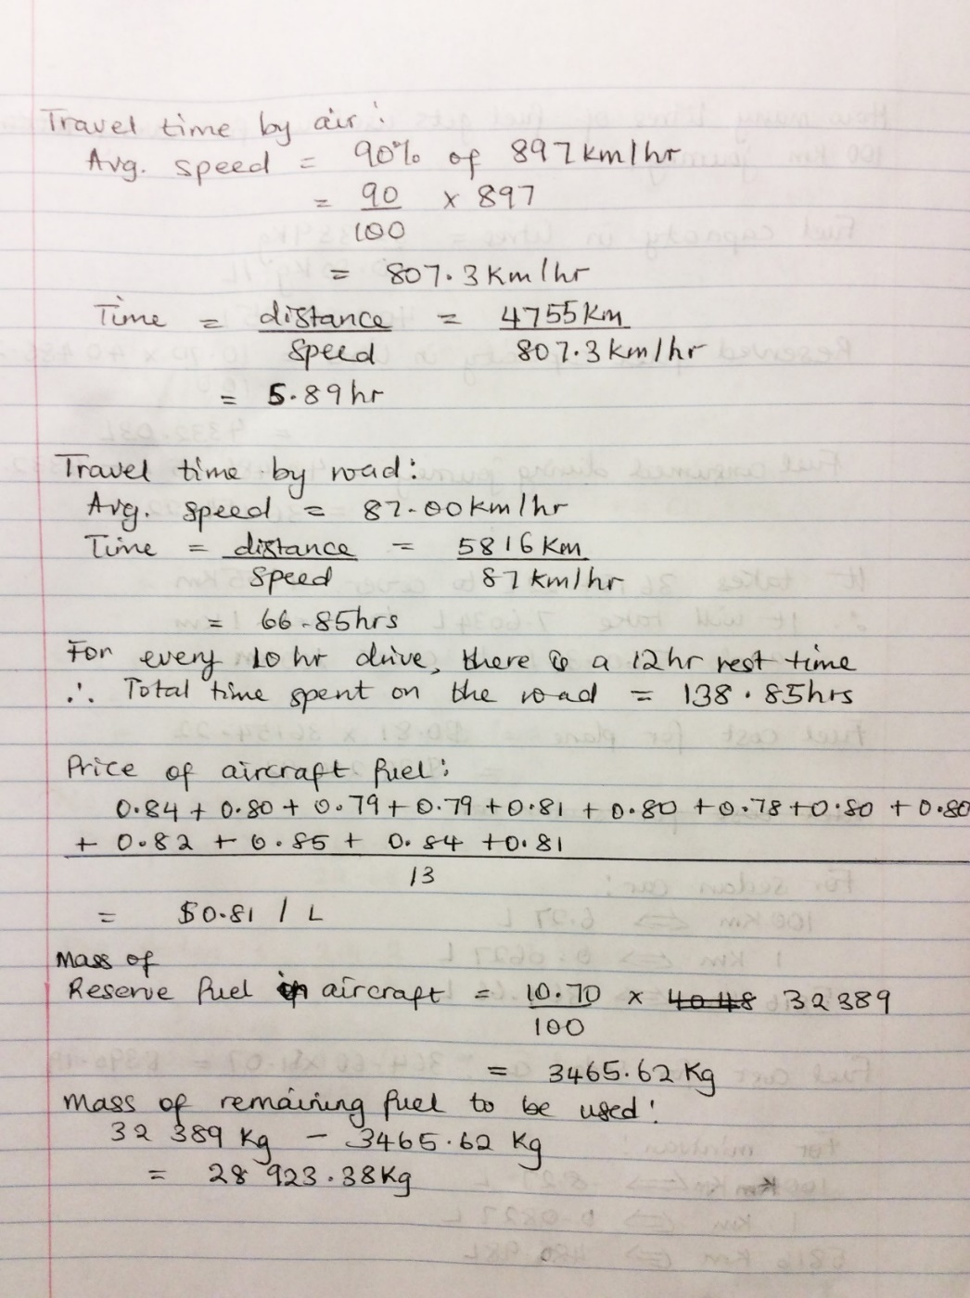
3.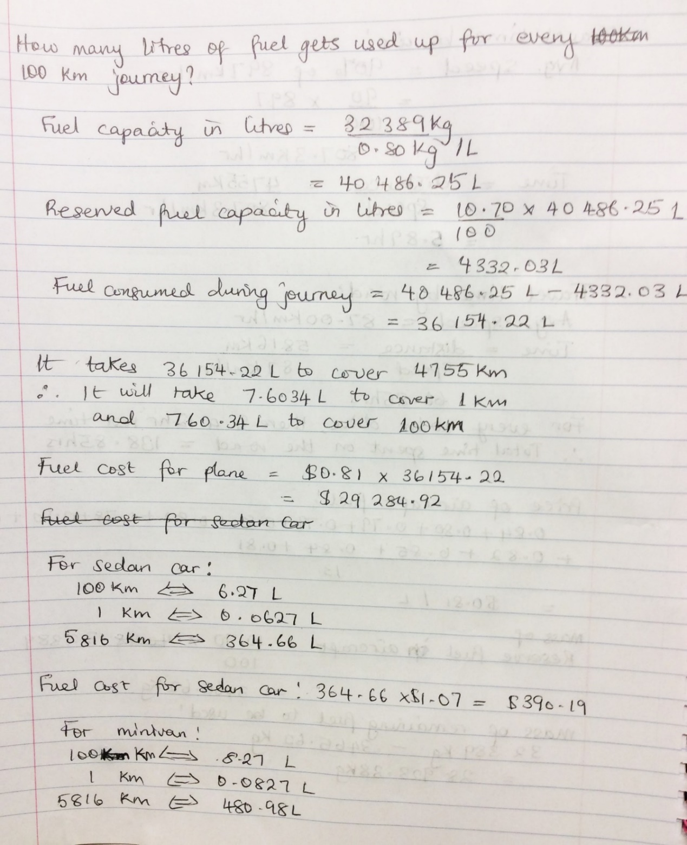
4.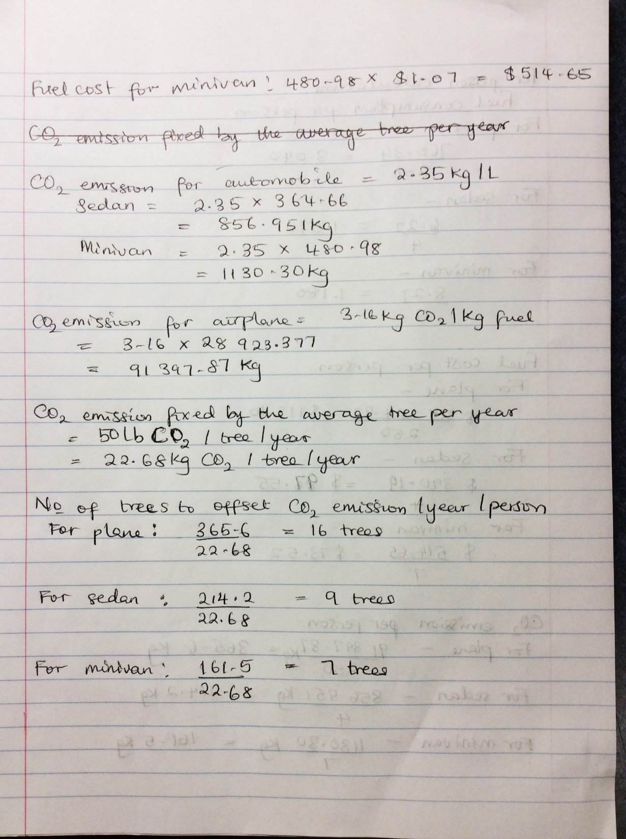
5. 

