ECOR 1010 – Introduction to Engineering

My name
Assignment 2
Assignment Title: Unit Conversions, & Introduction to CAD
TO Marking TA:
Name: Mahmoud Elessawy
Email: mahmoudelessawy@cmail.carleton.ca

Lab Section: 17
Room: 2256 – Carleton University

FROM:
Email: myemail@carleton
Student Number: 123456798

Number of Figures and Tables (Including handwritten ones): ...

Last Date and Time of Revision: 2018

Introduction
As an engineer, it is important to be comfortable with conversions between different units comfortably. Here, there are three pumps with different units. The goal is to find which pump has the greatest efficiency and which has the least efficiency.

Materials and Methods
The three pumps were converted into different units by using the conversion table provided and previous knowledge in the SI unit system. Pump 1 required conversions for change in pressure from lb•f/in² to N/m², input power was converted to J/s and then values were entered into the efficiency formula then multiplied by 100%. Pump 2, the input power was converted to watts, the volume flow rate was calculated as a product of the cross-sectional area and the average velocity. The change in pressure was found by subtracting the change in mm of Hg, then converted to pascals before inserting values into efficiency equation. Pump 3 required the volume flow rate to be converted to m²/s. The change in pressure was calculated by converting atm to psi, finding the difference then converting to pa. Input power was converted to watts, then all values were inserted in the efficiency formula.

Results
The results show that Pump 3 has an efficiency of 63 %. Pump 2 has an efficiency of 35 % and Pump 3 has an efficiency of 7.2 x 10⁻⁷ %. The surface area of the model created in part 2 is 6.5153189e+02 INCH^2.

Discussion
Pump 3 has the best efficiency because a perfect efficiency is 100%, pump 1 has an efficiency of 7.2 x 10⁻⁷ %, pump 2 has an efficiency of 35 %, pump 3 has an efficiency of 63 %. Since 63 % is the closest to 100 %, it is the most efficient and since 7.2 x 10⁻⁷ % is the furthest from 100 %, it is the least efficient.

Conclusions
Overall, the order of the pumps from most to least efficient is pump 3, pump 2 and pump 1.

APPENDIces- Figures and Tables
Figure 1
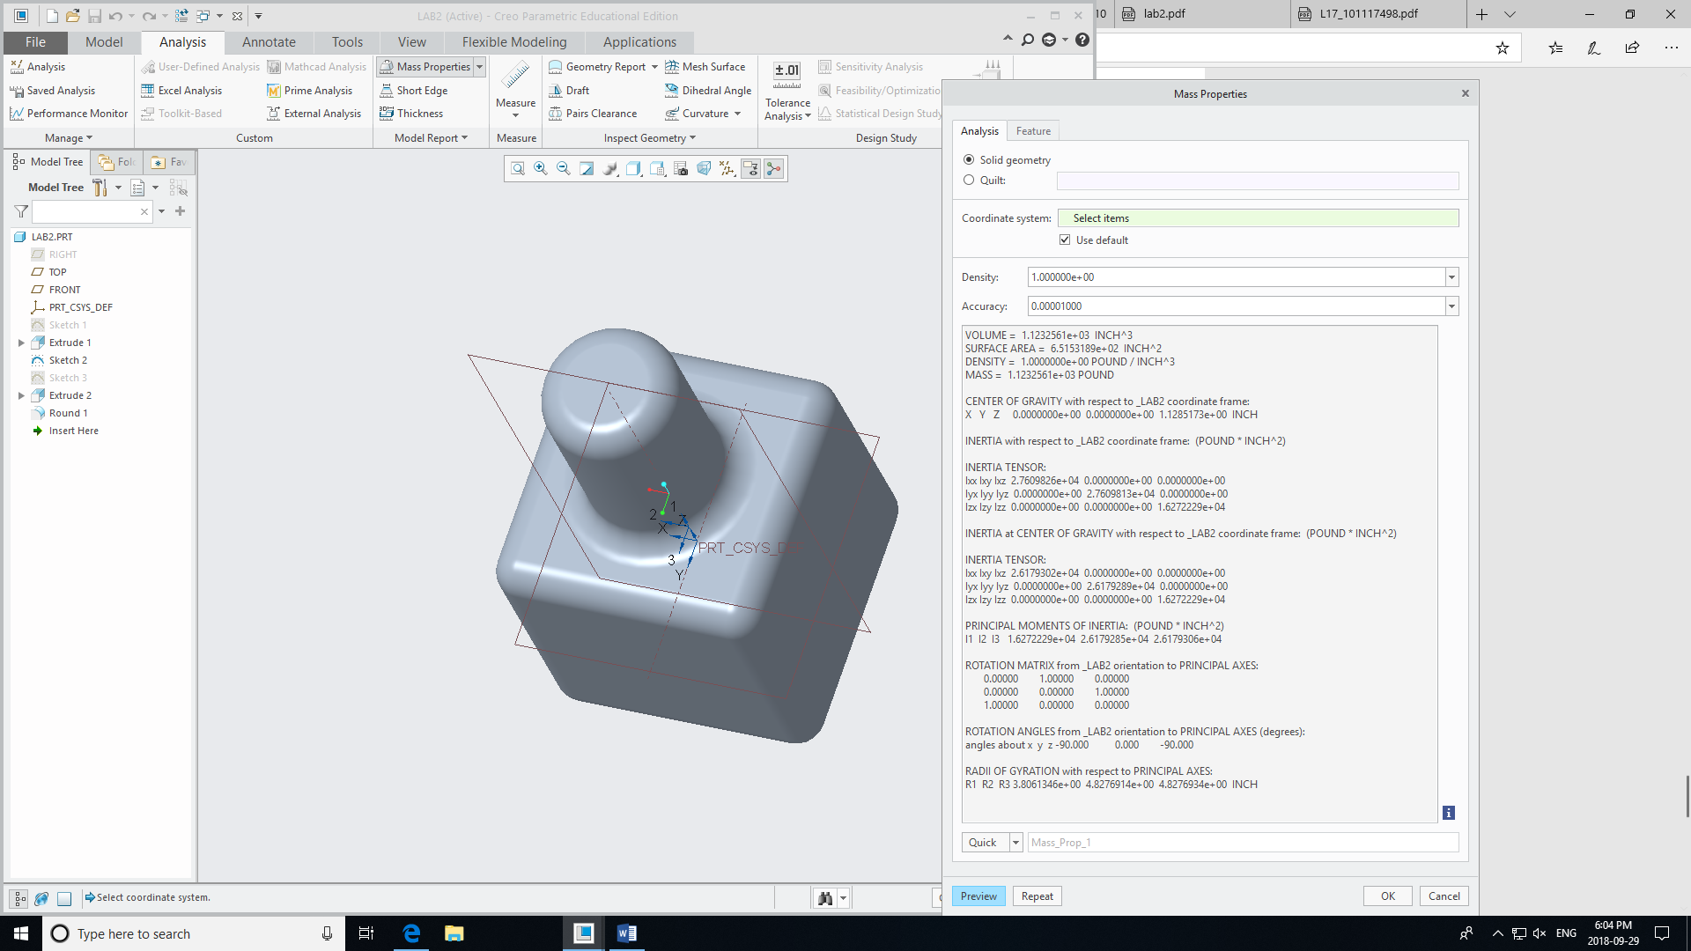

Figure 2
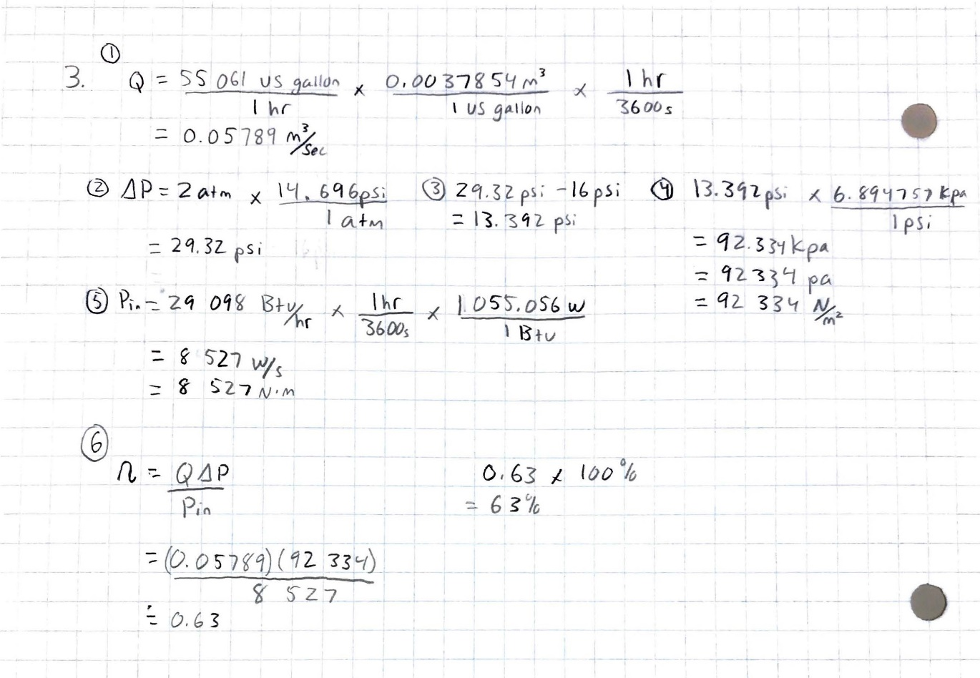

Figure 3



