ELEC 3605 – CARLETON UNIVERSITY ASSIGNMENT 3

Question 1
Correct
Mark 1.00 out of 1.00
Flag question

Question text
Find the equivalent capacitance between terminals x and y.
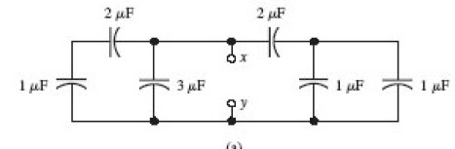
Select one:
a. 3.22 uF
b. 6.98 uF
c. 4.67 uF
d. 1,45 uF
e. 7.78 uF

Feedback
Your answer is correct.
The correct answer is: 4.67 uF

Question 2
Correct
Mark 1.00 out of 1.00
Flag question

Question text
Determine the total equivalent capacitance between terminals x and y.
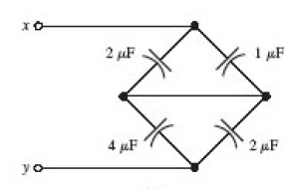
Select one:
a. 9 uF
b. 5.8 uF
c. 2 uF
d. 6. 35 uF
e. 2.5 uF

Feedback
Your answer is correct.
The correct answer is: 2 uF

Question 3
Correct
Mark 1.00 out of 1.00
Flag question

Question text
For the following inductor network determine the equivalent inductance as seen at the terminals given L1=10 H, L2=20 H and L3=30H.
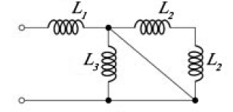
Select one:
a. 50 H
b. 40 H
c. 10 H
d. 20 H
e. 30 H

Feedback
Your answer is correct.
The correct answer is: 10 H

Question 4
Correct
Mark 1.00 out of 1.00
Flag question

Question text
A dc voltage of 8 V is applied to a 2 H inductor at t = 0, starting with an initial current of zero.
(a) Determine the current at t = 12.4 s.
Answer:

Feedback
The correct answer is: 49.600

Question 5
Correct
Mark 1.00 out of 1.00
Flag question

Question text
b) Calculate the stored energy (J) at t=12.4 s.
Answer:

Feedback
The correct answer is: 2460.160

Question 6
Incorrect
Mark 0.00 out of 1.00
Flag question

Question text
For the circuit shown below:
a) What is the correct expression for phasor Vs¯Vs¯
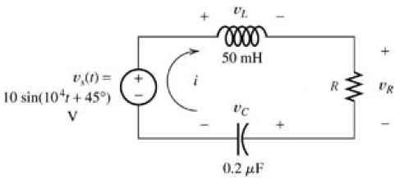
Select one:
a. Vs¯=102√∠−45∘Vs¯=102∠−45∘
b. Vs¯=10∠−135∘Vs¯=10∠−135∘
c. Vs¯=10∠45∘Vs¯=10∠45∘
d. Vs¯=10∠−45∘Vs¯=10∠−45∘
e. Vs¯=10∠135∘Vs¯=10∠135∘

Feedback
Your answer is incorrect.
The correct answer is: Vs¯=10∠−45∘Vs¯=10∠−45∘

Question 7
Correct
Mark 0.45 out of 0.50
Flag question

Question text
Given R=39 ΩΩ find the phasor I¯I¯ in polar form.
b) Calculate the peak magnitude of I¯I¯.
Answer:

Feedback
The correct answer is: 0.256

Question 8
Correct
Mark 0.50 out of 0.50
Flag question

Question text
b) Calculate the phase of phasor I¯I¯ (deg).
Answer:

Feedback
The correct answer is: -45

Question 9
Correct
Mark 0.45 out of 0.50
Flag question

Question text
c) Calculate the peak magnitude of phasor VL¯VL¯.
Answer:

Feedback
The correct answer is: 128.205

Question 10
Correct
Mark 0.50 out of 0.50
Flag question

Question text
c) Calculate the phase of VL¯VL¯ (deg)
Answer:

Feedback
The correct answer is: 45

Question 11
Correct
Mark 0.50 out of 0.50
Flag question

Question text
c) Calculate the peak magnitude of VR¯VR¯.
Answer:

Feedback
The correct answer is: 10

Question 12
Correct
Mark 0.50 out of 0.50
Flag question

Question text
c) Calculate the phase of VR¯VR¯. (deg)
Answer:

Feedback
The correct answer is: -45

Question 13
Correct
Mark 0.45 out of 0.50
Flag question

Question text
e) Calculate the peak magnitude of VC¯VC¯.
Answer:

Feedback
The correct answer is: 128.205

Question 14
Correct
Mark 0.50 out of 0.50
Flag question

Question text
c) Calculate the phase VC¯VC¯. (deg)
Answer:

Feedback
The correct answer is: -135

Question 15
Correct
Mark 1.00 out of 1.00
Flag question

Question text
f) Which statement is true with respect to the operation of this circuit?
Select one:
a. Its a series resonance circuit at a frequency of 10 kHz
b. Its not in resonance
c. Its a parallel resonance at a frequency of 1.59 kHz
d. Its a parallel resonance at a frequency of 10 kHz
e. Its a series resonance at a frequency of 1.59 kHz

Feedback
Your answer is correct.
The correct answer is: Its a series resonance at a frequency of 1.59 kHz

Question 16
Correct
Mark 0.80 out of 1.00
Flag question

Question text
Consider the circuit shown in the figure below . Suppose that Vs¯Vs¯ = 2308 ∠0∘∠0∘ Vrms, R=250 ΩΩ, L=0.5 H, and C=5 μμF.
a) Find the power delivered by the source (P kW),
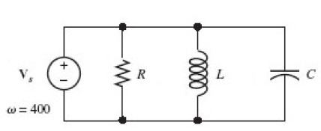
Answer:

Feedback
The correct answer is: 21.3

Question 17
Correct
Mark 1.00 out of 1.00
Flag question

Question text
b) Find the reactive power delivered by the source (Q: kVAR).
Answer:

Feedback
The correct answer is: 16.0

Question 18
Correct
Mark 1.00 out of 1.00
Flag question

Question text
c) Find the apparent power (S: kVA)
Answer:

Feedback
The correct answer is: 26.6

Question 19
Correct
Mark 1.00 out of 1.00
Flag question

Question text
d) Find the power factor seen by the source. (0 to 100%)
Answer:

Feedback
The correct answer is: 80.000

Question 20
Correct
Mark 1.00 out of 1.00
Flag question

Question text
e) The power factor is:
Select one:
a. lagging
b. leading

Feedback
Your answer is correct.
The correct answer is: lagging

Question 21
Correct
Mark 1.00 out of 1.00
Flag question

Question text
A balanced Wye-connected three phase source has line to neutral voltages of 423 RMS. The source is to be applied to a wye-connected load composed of three 38 ΩΩ resistances.
a) find the line to line voltage magnitude
Answer:

Feedback
The correct answer is: 732.658

Question 22
Correct
Mark 1.00 out of 1.00
Flag question

Question text
b) If this 423 Vrms source is applied to a wye-connected load composed of three 38 ΩΩ resistances, find line current magnitude (RMS).
Answer:

Feedback
The correct answer is: 11.13

Question 23
Correct
Mark 1.00 out of 1.00
Flag question

Question text
c) If this 423 Vrms source is applied to a wye-connected load composed of three 38 ΩΩ resistances, find the total power delivered (kW).
Answer:

Feedback
The correct answer is: 14.13

Question 24
Correct
Mark 1.00 out of 1.00
Flag question

Question text
A delta connected source delivers power to a delta connected load as shown in the figure below. The line-to-line voltage at the source is 422 Vrms . The load impedance is ZΔ=9+3jΩZΔ=9+3jΩ. The line impedance is ZL=1+2jΩZL=1+2jΩ.
a) Find the magnitude of the line current IaAIaA (A rms)
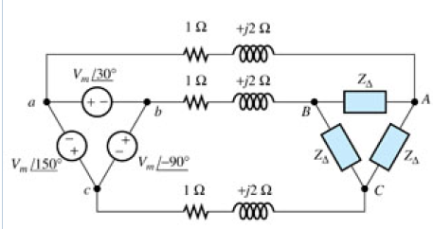
Answer:

Feedback
The correct answer is: 48.73

Question 25
Correct
Mark 0.90 out of 1.00
Flag question

Question text
a) Find the phase of the line current IaAIaA. (Phase deg)
Answer:

Feedback
The correct answer is: -36.8699

Question 26
Correct
Mark 0.80 out of 1.00
Flag question

Question text
b) Find the magnitude of VABVAB the line-to-line load voltage, (V rms)
Answer:

Feedback
The correct answer is: 266.90

Question 27
Correct
Mark 0.50 out of 1.00
Flag question

Question text
b) Find the phase of VABVAB (deg).
Answer:

Feedback
The correct answer is: 11.565

Question 28
Correct
Mark 1.00 out of 1.00
Flag question

Question text
c) Find the magnitude of the load phase current IABIAB (A rms)
Answer:

Feedback
The correct answer is: 28.13

Question 29
Correct
Mark 1.00 out of 1.00
Flag question

Question text
c) Find the phase of IABIAB (deg)
Answer:

Feedback
The correct answer is: -6.8699

Question 30
Correct
Mark 0.80 out of 1.00
Flag question

Question text
d) Find the total power delivered to the load (kW)
Answer:

Feedback
The correct answer is: 21.37

Question 31
Correct
Mark 0.70 out of 1.00
Flag question

Question text
e) Find the power lost in the line. (kW)
Answer:

