Managing Individual Performance

LECTURE 1
READING Peter Drucker Managing Oneself
READING 2 O’Reilly Working smarter and harder
The overall results of the study show that it is the interaction of motivation and general cognitive ability that most strongly predicts early career success for the MBA graduates

Managing Human Capital
- Effective Managers
  - Behaviours
  - Motivation
  - Skills (THCP)
- Conceptual skills. The mental ability to coordinate all of the organization’s interests and activities.
- Human skills. The ability to work with, understand, and motivate other people, both individually and in groups.
- Technical skills. The ability to use the tools, procedures, and techniques of a specialized field.
- Political skills. The ability to enhance one’s position, build a power base, and establish the right connections.
Traits
- enduring characteristics that describe a person’s behaviour.
Perception
- the process by which individuals organize and interpret their impressions to give meaning to their environment.
Behaviour
- A response of an individual to an action, environment, person, or stimulus.
Skill
- the ability to demonstrate a system and sequence of behaviour that is functionally related to attaining a performance goal
To develop interpersonal skills (A systemic approach)
  - understand the skill conceptually
  - practice the skill
  - get feedback on how well performing the skill
  - integrate the skill into behavioral repertoire
  - Self-Awareness, communication, leading, motivating, teamwork, problem solving
David Kolb (CRAA)
- Learning model: balanced learning is dynamic, it is practice.
- Flexibility allows you to learn in any situation
- Organizations need people who learn differently
- Practice learning styles which aren’t your dominant learning style
- You need to balance your style with the team you work with and if you start dominating the conversations you are NOT balanced
  - Concrete experience
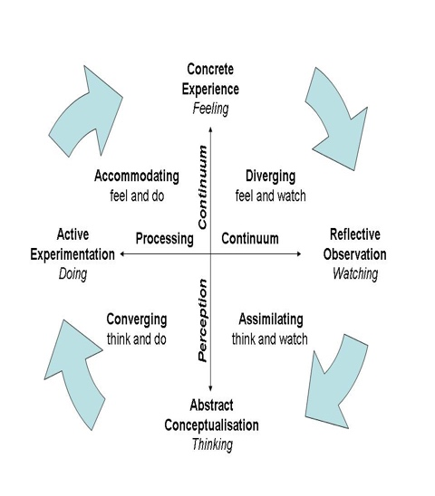
  - Reflection observation
  - Abstract conceptualization
  - Active Experimentation
Comprehensive learning
Genuine vs. calculated human interaction – a fine line!
ACCOMMODATING, DIVERGING, CONVERGING, ASSIMILATING PG 20 IN TEXT

10 Step Learning Plan
- Self-assessment exercises
- Skill concepts
- Concept Quiz
- Behavioural Checklist
- Modeling Exercise
- Group Exercises
- Summary Checklist
- Application Questions
- Reinforcement Exercises
- Action Plan

LECTURE 2
READING 1 Kilduff and Day (AMJ do chameleons get ahead?)
READING 2 Hamal G (First let’s fire all the managers)

Self-Awareness
- In what areas do I most need to improve my self-awareness?
- Specific ways to develop your self-awareness
- Leaders with more self-awareness are more likely to adopt a sustainable leadership style within an organization
- Need solicit feedback from others
- Need to have reflection either public or private
Interpersonal Needs (FIRO-B)*****
- 3 interpersonal needs (CIA)
  - Inclusion
  - Control
  - Affection
- Expressed vs. Wanted
- Deficient/Ideal/Excessive
- Overall high scores? Jobs that require a high level of human interaction
- Implication for how you communicate and job design
- It is important to line up tasks that are congruent with their needs as a manager*** empowerment in connection to job design and if you want to motivate and empower people you need to have tasks and jobs in which are congruent with them as people

Assertiveness
- Passive Individuals
  - Avoid conflicts, sublimate needs, satisfy others, may be bullied
- Aggressive Individuals
  - Domineering, pushy, self-centered
- Assertive Individuals
  - Open, self-expressive, stand up for rights, promote others to do the same
- Passive/aggressive = not productive in business
- Passive aggressiveness doesn’t allow you to resolve things
- Need to know when to use which style of assertiveness, it is important to remember that not all managers will respond the same to same situations and people will react differently as well
Self-Monitoring (networking issues)
- Refers to an individual's ability to adjust his or her behaviour to external situational factors
- Better at self-assessment
- Kilduff and Day (1994).
    - 139 MBA students
    - Cross company promotions
    - Internal promotions
    - Early promotion is of critical importance in shaping corporate careers.
- High self-monitoring is beneficial, but there can be negative to being too high, as you will be perceived as fake
The Big 5 (CANOE)
- Contentiousness
- Agreeableness
- Neuroticism
- Openness to experience
- Extraversion
- *** by understanding your employees personality dimensions you will have a better understand of why they react in the ways they do and sometimes even in accordance with interpersonal skills you will be able to handle it appropriately
Type A personality
- Impatient, restless, competitive, aggressive, under time pressure, always attempting to accomplish several things at once
- Competitiveness Scale
  - Superiority Competitiveness
  - Mastery Competitiveness
- *CAN POSSIBLY BECOME A SOCIAL PROBLEM IN THE WORKPLACE
Locus of Control
- The extent to which you believe that forces beyond your control are responsible for what happens to you
- Workplace interventions
- It is important because as a manager it is most likely you have an internal locus of control and sometimes people have external
  - To motivate internals you should delegate them and let them figure out the objective and letting them manage themselves when with an external you should set benchmarks with many opportunities for them to check in and ask for clarification
Tolerance of Ambiguity
- The tendency to perceive ambiguous situations as desirable (Budner, 1962).
Narcissism
- The tendency to be arrogant, have a grandiose sense of self-importance, require excessive admiration and have a sense of entitlement

Core self-evaluation
- The degree to which an individual likes or dislikes himself, whether the person sees himself as capable and effective, and whether the person feels that he is in control of his environment or powerless
Values
- Terminal Values (ends)
- Instrumental values (means)
- Evidence of the instrumental values are adhered to even when they are not convenient to them
- Values lead you to see the world in a certain way. This leads you to believe different things to be true.
- Your values are separate from your beliefs.
- THINK ABOUT BABY BOOMERS AND DIFFERENT GENERATIONAL CORE VALUES AND MAJOR EVENTS IN THEIR LIVES AND WHY IT CHANGES THEIR PERCEPTION OF THE WORKPLACE
Attitudes
- Positive or negative feelings concerning objects, people, or events.
Self-Management: The process of influencing yourself to achieve your goals. (VMGPI)
- Clarify values.
- Develop a mission
- Set goals
- Plan to achieve
- Implementation
The Planning Process (MSGSIE)

Job Satisfaction****
- Individual productivity: The evidence suggests that the link between an individual’s job satisfaction and their productivity is slightly positive.
- Organizational productivity: The link between satisfaction and productivity is much stronger when we look not at individuals, but the organization as a whole.
- Organizational citizenship behavior (OCB): When employees feel that their employer is behaving fairly, they are more satisfied, and will then engage in OCB.
- Job satisfaction and customer satisfaction: Job satisfaction leads to better treatment of customers, which leads to greater customer satisfaction.
- The reason why organizations are investing so heavily in human capital because it has been shown that this CREATES VALUE.
(connected to motivation and empowerment, by having individual productivity increases and organizational productivity then there becomes this sense of organizational citizenship behavior which inhibits people to want to do more for the organization because they feel empowered by their work.)

LECTURE 3

The Communication Process
- Any verbal or nonverbal behaviour that is perceived by another person
- Good communicators are not only good at talking, but also listening, people who facilitate communication
- Sender – Message – Channel – Message – Receiver
Noise
- Incongruent verbal and Nonverbal- Nonverbal will be taken more seriously and will be more significant than the verbal
- Environmental noise
  - Distractions
  - Poor connection
  - Competing Stimuli
  - Competing Needs
- Sender noise
  - Ambiguous intentions [e.g., feelings]
  - Different meanings (average US word = 28 definitions) Acronyms or lingo
  - Incongruent verbal and non-verbal messages
  - Attitude
- Receiver Noise
  - Poor listening
  - Evaluate & judge speaker
  - Lack of trust in speaker
Feedback
- Take initiative – ask.
- Don’t be defensive
- Summarizing statements
- Check out underlying assumptions
- Be aware of nonverbal feedback
- Ask questions to clarify
- Need a mechanism to gauge and quantify nonverbal feedback from a group
Storytelling
- Story: the telling of a happening or connected series of happenings, whether true or fictitious; account; narration.
- According to Denning (2011) there are four key elements in storytelling: (STPD)
  - Style: Find your own style. Try to keep it basic, embrace your style
  - Truth: stick to the truth. People try to persuade listeners, don’t waste your time.
  - Prep: What are your main objectives for telling the story. What do I want the audience to do. Nothing is worse than a story that goes nowhere.
  - Delivery: ‘talent’ is where this is most recognized. The way people tell stories is vital. It is almost like a performance.
Clarity
- Use multiple channels
- Be complete and specific
- Take responsibility to ensure you communicate clearly (Strengths and Weakness)
- Be congruent
  - Verbal = nonverbal
- Simplify your language
  - Avoid acronyms and lingo
Credibility
- Know your topic
- Establish mutual trust
- Share relevant information
- Be honest
- Be reliable
- Be warm and friendly
- Be dynamic
- Appropriate self-disclosure
Communication Emotion
Frequent source of difficulty in relationships
- Repress, Deny, Distort or Disguise
- Byron (2008)
  - Theoretical paper
    - Neutrality effect
    - Negativity effect
Active or Passive Listening
- Listening is a BASIC FUNDAMENTAL SKILL
- Hearing (physical process) is not the same as listening (mental process)
- Passive Listening is Very very difficult.
- Active or empathic listening: requires that the listener try to understand the speaker’s own understanding of an experience without the listener’s own interpretive structures intruding on his or her understanding of the other person. (IEAR)
  - Intensity
    - Stay focused, give space.
  - Empathy
    - Understand the context, communicate non-verbal.
  - Acceptance
      - Avoid judgement
  - Responsibility for completeness (facts & feelings)
      - Ask questions, paraphrasing.
- Passive listening is barely listening. AKA hearing. It is a physical activity and not a mental activity.
- People that are really good at actively listening may not be stars, but they will figure it out how to do what you want them to.
Listening Style (TRAC)
- Listening styles (def) ‘‘attitudes, beliefs, and predispositions about the how, where, when, who, and what of the information reception and encoding process’’ (Watson et al., 1995, p. 2).
- Four styles of listening orientations that individuals habitually orient toward, especially in novel situations (Imhof, 2004).
  - Relational Listening: when we listen to others we tend to focus on what it tells us about our conversational partners and their feelings
  - Transactional Listening: involves wanting speakers to remain on task and “get to the point”
  - Critical Listening: focus a lot of attention on the details and the accuracy and consistency of the speaker’s message
  - Analytical Listening: means listening to gather information and tend to think carefully about what we hear and respond with
- Listening without judgment: huge key is asking questions that are neutral and seek more information and more in-depth conversations
- Not asking questions makes speakers think people are making judgment
Understanding Non-Verbal Messages
- Definition: All interpersonal messages and responses not expressed through linguistic means.
- Approximately 2/3rds of all communication is nonverbal.
- Interpreting nonverbal messages requires you to read in clusters.
- Cultural differences are key
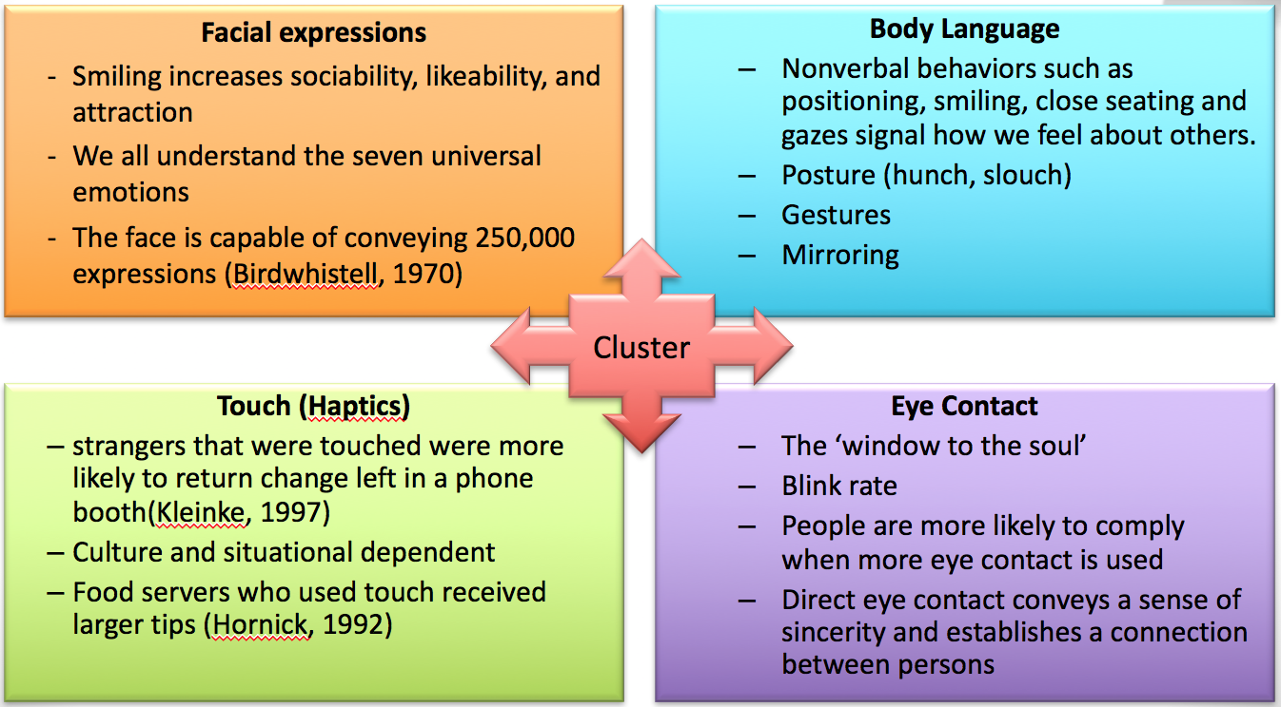
- Categories
  - Kinestics (body language)
  - Oculesics (use of eyes)
  - Haptics (use of touch)
  - Vocalics (paraletics)
  - Chronemics (use of time)
  - Olfactics (use of smell)
  - Objectics (use of objects)
  - Proxemics

Before you talk, Communicate
- Proxemics
- Personal space
- Tactile communication
  - Attention.
  - Affection.
  - Greetings
  - Departures
  - Support.
- Objectics
Vocal (Paralanguage)
- Use of voice to extend meaning beyond the basic content in your message.
- Pitch- high or low
- Volume- loud or soft
- Tone- harsh or gentle
- Articulation- clear
- Speed- fast or slow
- Stress Patterns- which words you make important
- Vocal Quality- what makes you sound like you
- Rhythm- smooth or jerky
- Road Blocks- unneeded words, phrases, or sounds
- Pauses- the breaks you take between words or phrases
Time(Chronemics)
- Definition: How humans perceive, structure and use time as a communication system
  - Interest and affection
  - Power and status
  - Intentions
- Culture dependent
- Online Chronemics
  - Social chat, email
The Grapevine
- Adds structure and reduces anxiety
- Make sense of fragmented information
- Organize coalitions
- Signal status
- The grapevine rarely transmits unimportant information
  - New bosses, relocation, realignment, layoffs, promotions

LECTURE 4
READING
Chapter 9 - Topic Integration ***************
****** KNOW HOW TO APPLY THIS****************
Goal setting is closely related to several management/OB topics: planning, motivation, leadership, delegating, and performance appraisal. Possible linkages for discussion:
- Planning. Management by objectives (MBO) operationalizes an organization’s planning system. MBO links organizational goals, divisional goals, departmental goals, and individual goals into a unified and coordinated system through development of a hierarchy of goals. The use of goal setting, therefore, improves an organization’s planning efforts.
- Motivation. One of the more well-known motivation theories is Locke’s goal-setting theory. Locke argues intentions, expressed as goals, act to direct and increase an employee’s efforts. Locke proposes motivation is enhanced when individuals have specific and difficult goals and feedback on their progress toward those goals.
- Leadership. The link between goal setting and leadership is evident in discussions of initiating structure or task-oriented behavior. The leader who exhibits high initiating structure defines and structures a subordinate’s role and helps him or her set work-related goals.
- Performance Appraisal. Performance appraisal requires some standard against which performance can be evaluated. Goals can provide that standard.

Three Danger Signals of Ability Degeneration
- Taking refuge in a specialty
- Focusing on past performance
- Exaggerating aspects of the leadership role

Performance = Ability x Motivation (Effort)
Ability = Aptitude x Training x Resources
Motivation = _________________________________

Motivation****(IDP)****
- Definition: The intensity, direction, and persistence of effort a person shows in reaching a goal********************
    - Intensity: How hard a person tries
    - Direction: Where effort is channeled
    - Persistence: How long effort is maintained
- Douglas McGregor- How managers motivate
  - Theory X: People are inherently not motivated, little to no amibtion
  - Theory Y: Employees are inherently motivated
- Extrinsic Motivators:
  - Things that are not the actual task
  - Intrinsic Motivators:
- The best indicator of strong motivation is persistence. If someone gets a bad grade, do they continue to work hard?
- Modern managers now focus on how to bring individuals motivation out
- Praise is a great extrinsic motivation. The threat of extrinsic motivator
- Intrinsic are viewed as more important, but extrinsic is still important

Reinforcement vs Punishment
- Operant Conditioning
  - A type of conditioning where desired voluntary behavior leads to a reward or prevents punishment
- Reinforcement: increases the likelihood of a certain behavior
  - Positive Reinforcement: Following a response with something pleasant (giving you a treat)
  - Negative Reinforcement: the termination or withdrawal of something unpleasant (taking away homework)
    - Punishment – decreases the likelihood of a certain behavior
    - Positive Punishment: Causing an unpleasant condition in an attempt to eliminate an undesirable behavior (beating you)
    - Negative Punishment: the removal of something pleasant after the behavior (taking away your laptop)
- Extinction
  - Eliminating any reinforcement/punishment that is maintaining a behavior
  - Schedules of Reinforcement
- Using punishment will take away from creativity, because it restricts behavior

Theories of Motivation (CRITQUE BECAUSE THEY ARENT PROVEN)
- Basic Idea: If you want to motivate someone find out what they need and offer it as a reward or consequence.
  - Only an unfulfilled need will motivate
Maslow
- Lower Order Needs
  - Physiological
    - Includes hunger, thirst, shelter, sex, and other bodily needs
  - Safety
    - Includes security and protection from physical and emotional harm
  - Higher Order Needs
  - Social
    - Includes affection, belongingness, acceptance, and friendship
  - Esteem
    - Includes internal esteem factors such as self-respect, autonomy, and achievement; and external esteem factors such as status, recognition, and attention
  - Self-actualization
    - The drive to become what one is capable of becoming;
    - includes growth, achieving one’s potential, and self-fulfillment
Herzberg
- Herzberg: Hygeine – You have satisfiers and motivators, not a great motivation theory. Need to know it has hygiene factors and motivators.
- Base pay is needed but it won’t keep on motivating people. Big problem is that it is linked to satisfaction which is not exactly motivation.
McClellend (Dominant Needs) (*******) (NPAA)
- Need for Power; The need to influence and lead others, and be in control of one’s environment
  - (+) Socialized Power
    - Seek to make things better for others/ Use power to empower others
  - (-) Personalized Power
    - Impulsive / Personal dominance / Dictator-like
- Need for Affiliation: Desire for friendly/close interrelationships
  - (+) Affiliative interest
    - Concern for relationships but not at expense of goals
    - Can still give negative feedback or make tough decisions
  - (-) Affiliative assurance
    - Seeking approval at all costs
    - Avoids issues or conflicts that threaten relationship
- Need for Achievement: Need to accomplish goals, excel, and strive continually to do things better
    - Take calculated risks
    - Task-oriented
    - Personal responsibility for success/failure

(EXPLAIN ON AN EXAM IN REALATION TO A JOB IVE HAD) JOB ANALYSIS****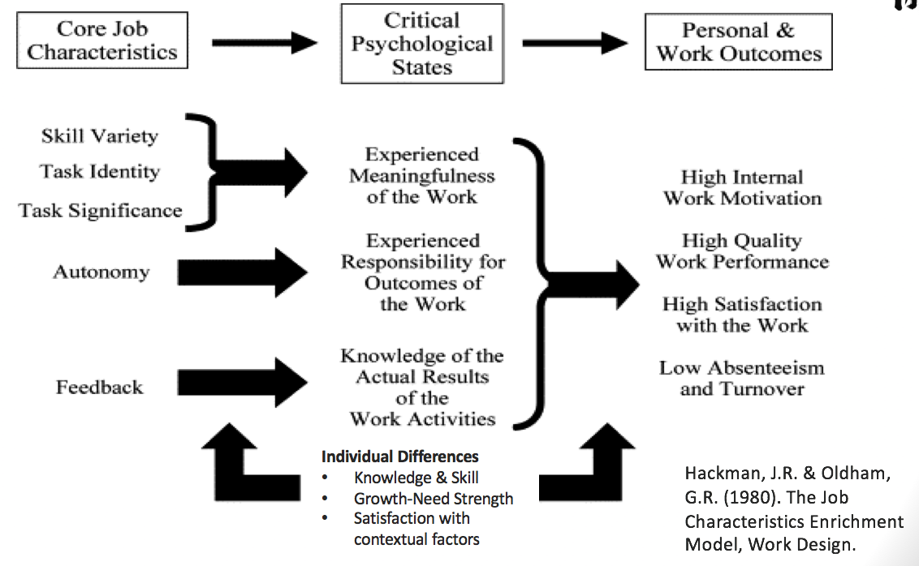

Content (Needs) Theory: Adelfer
- ERG – Core Needs Groups
- Existence: (water n food) Not getting their asses beat. Talking about his ability to live with himself.
- Relatedness: (love n belongingness) You would do the same for others as they would for you. Go the extra because you know your peers are going to do the same thing.
- Growth: (Self-actualization) Don’t be like him, makes people think about what they want to be
Process Theories of Motivation
- Need to understand where motivation falls apart, process is where persistence falls apart
- Self-Efficacy (social cognitive theory): An individual’s belief that he or she is capable of performing a task.
  - The higher your self-efficacy the more confident you are in your ability to succeed in a task
    - Enactive mastery: practice
    - Vicarious modeling: showing a relatable model to the person
    - Verbal Persuasion
    - Arousal: excite people
    - Self-fulfilling prophecy: party animal will come out

Expectancy Theory
- Expectancy
  - The belief that effort is related to performance
  - Effort and Performance Link
- Instrumentality
  - The belief that performance is related to rewards
  - Performance and Rewards Link
- Valence
  - the value or importance an individual place’s on a reward
  - Rewards and Personal Goals Link

- Effort and performance: is there a link between if you work hard, will it benefit them?
- Performance and Rewards: Because you are better, does this make you closer to your rewards?
- Rewards: Do those rewards connect with their personal goals?
A goal is the object or aim of an action, for example, to attain a specific level of proficiency, usually within a specified time limit. ***********************
- Learning Goals: focused on new knowledge, skills and attitudes.
- Performance Goals: focused on the outcome
- Proximal Goals: short term goals
- Distal Goals: long term primary goals
- Absolute Goals: fixed standards
- Normative Goals: relative to the attainment of others
Goal Setting Theory

LECTURE 5
READING Executive Coaching: A Review and Agenda for Future Research (PBPCS)
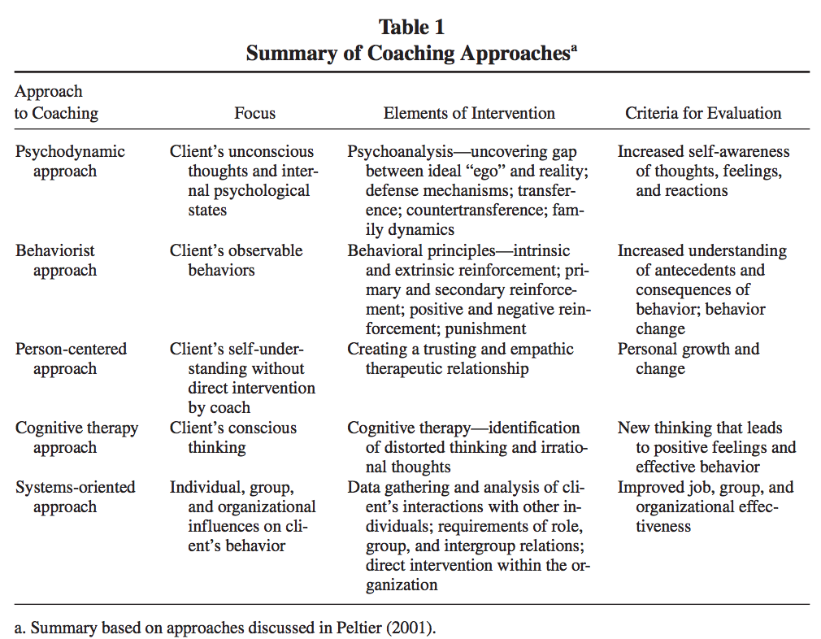

Phases of the Coaching Relationship (DFPE)
- Although there may be some variance in how coaches tailor the process to meet the unique needs of executive clients, the literature highlights a sequence of four major activities that occur in coaching relationships: data gathering, feedback, implementation of the intervention (coaching), and evaluation.
- Data Gathering
- The first phase of the executive coaching relationship typically focuses on setting the foundation for the coaching relationship and defining the executive’s developmental goals (Saporito, 1996). There are two major steps in this phase. The first step involves establishing a relationship with the executive, which involves sharing mutual expectations of the coaching relationship and discussing the parameters of the relationship (e.g., confidentiality, norms of behaviors in coaching sessions, etc.) (Feldman, 2001). In the second step, the coach gathers data about the executive and the organization. It is in this stage that the coach may obtain 360- degree feedback through the use of surveys or interviews. At this stage, coaches may also conduct assessments of executives’ personality, leadership style, values, and attitudes. Data may be obtained from the executive, personnel records, members of the top management team, organizational employees, and/or board directors (Kilburg, 2000; Winum, 1995). Information gathering may include work issues (e.g., politics and interpersonal relationships) and nonwork issues (e.g., family and personal goals) (London, 2002).
- Feedback ***
- In this phase, the coach presents the results of the data collection to the executive client. The objective of this phase is to assist the executive in digesting the feedback and to facilitate the discussion of the executive’s strengths and areas for improvement in job performance. The coach may have to help the client overcome resistance to feedback and analyze whether Feldman, Lankau / Executive Coaching 837 change is supported by organizational goals and culture (London, 2002). The feedback sessions may range from 2 to 3 hours to 2 or 3 days; they may be limited to the client or may include key stakeholders in the organization (Sztucinski, 2001). At the end of this phase, the coach and executive often identify together the specific behavioral objectives of the coaching intervention.
- Periodic Coaching Sessions ***
- In this third phase, coaches work with clients in structured sessions to monitor and reinforce developmental activities, to modify developmental plans, and to discuss ways of overcoming barriers to change (Feldman, 2001). The executive’s superior or the human resources director may be included in some of the sessions to review progress and obtain support for developmental activities (Tobias, 1996; Winum, 1995). Because coaches come from very different backgrounds and have very different approaches to the coaching process (see below), the approach to these sessions is often nonstandardized and idiosyncratic.
- Evaluation
- Once the regular coaching sessions conclude, coaches may follow up with executives to assess the impact of the coaching relationship. Coaches may collect data from clients on their learning experiences and how coaching affected their effectiveness in the organization (London, 2003). If the coach’s services are paid for by the organization, the human resources department may conduct an independent evaluation of the consultant’s effectiveness with the executive or assess whether the executive’s performance has improved since the coaching relationship terminated.

Feedback
Positive vs Negative Feedback
- Essential for motivating employees
- Positive feedback
  - Readily accepted.
  - complacency
- Negative feedback
  - Objective vs. subjective
  - Status and credibility
- Focus on specific behaviours
- Keep the feedback impersonal
- Keep feedback goal-oriented
- Make your feedback well-timed
- Ensure understanding
- If negative, make sure the behaviour is controllable by the recipient
- Tailor the feedback to fit the person

Coaching Counselling and Mentoring

Coaching: The process of equipping people with the tools, knowledge, and opportunities to develop themselves and become more effective (Peterson and hicks)
- Deals with performance issues (skills and abilities)
  - Determine the source of the problem
  - Demonstrate a positive regard
  - Seek ways to improve performance
  - Create a supportive climate
  - Influence behaviour changes
    - Breaking up large complex tasks
    - Reward small wins
    - Collaborative decision making
    - Modeling
  - Be supportive and FOLLOW UP!************
  - Provide meaningful feedback (exhibit 2)******

Executive Coaching:
“A short to medium term relationship between an executive and a consultant designed to facilitate learning and move the executive from excellent performance to peak performance”
- one-on-one counseling about work related issues;
- 360-degree feedback on executives’ strengths and weaknesses as its starting point; and
- purpose is to improve managers’ effectiveness in their current positions.
Steps
- Data gathering
- Feedback*****
- Periodic Coaching Sessions****
- Evaluations

Counselling
- Helping with an emotional problem to resolve it or help the person cope with it (may be linked to performance issues).
  - Facilitate problem recognition and solutions
    - Clarify thoughts and feelings
    - Listening skills are critical
  - Demonstrate a positive regard
  - Create a supportive climate
    - Maintain confidentiality
  - Be supportive, provide reassurance and FOLLOW UP!
    - Work within Employee Assistance Programs
  - Provide meaningful feedback (exhibit 2)
Separate how their feeling about things and what is going on.
  - Things could be snowballing in their mind that the personal
- In order to demonstrate positive regard, take the deadline/stress off the table and show them they are what matters. (when profs say they don’t care about a deadline I just want you to be okay and feel better, when rob gave the two extensions)
- Maintaining confidentiality is paramount, make sure they know what you will talk to other people about. Don’t go behind their back when you think you have to tell other people.
- Following up is even more important when it comes to personal issues.

Mentoring
- Long term focus – helping another employee achieve their career goals
  - Formal vs. Informal Mentoring
  - Potential Benefits
  - A more connected workforce
  - Tacit knowledge transfer (learning culture)
  - Staff retention
  - Supporting equity programs
  - Increased productivity
  - Supports leadership succession planning
- A good mentorship program should be flexible and adaptable to a company’s culture
- A good mentor is a valuable asset…a bad mentor is dangerous for the company and the individual.

LECTURE 6
READING WHY EMPLOYEES DO BAD THINGS: MORAL DISENGAGEMENT AND UNETHICAL ORGANIZATIONAL BEHAVIOR*************

Creative Decision Making
First you need to acknowledge the problem
- Managers typical response to handling problems
- Problem Avoiders ignore signals that a problem exists, when you choose not to see problems, they pile up a bunch.
- Problem solvers react to a defined problem, prevents you from stressing about what might happen. You have to have confidence in your ability to handle and prioritize your time. You have to know what is important
- Problem seekers look for problem to solve before negative results occur, problem seeking: prevents you as a manager from getting blindsided. However, it can make you look pessimistic and create stress.

Brainstorming
- Fostering creativity
  - Be willing to absorb the risks of failures to allow freedom to experiment
  - Be able to live with half-developed ideas
  - Know when to stretch normal policies for the greater long-term good
  - Be a good listener
  - Don’t dwell on mistakes
  - Trust your intuition
  - Be enthusiastic and invigorating
  - Creative ideas only matter if they actually take hold. If there is no criticism, then the idea won’t take hold. There has to be rationale behind the criticism.
  - Individual brainstorming is an effective way to come up with starters.

The Rational Problem Solving Process
1. Identify the problem
  - find the problem
  - define & analyze the problem
2. Generate Alternatives
3. Evaluate and Choose
  - reality testing
  - decision making
4.Implement and Control

Ethical Decision Making
Ethics
  - Association of Certified Fraud Examiners recently estimated that businesses globally suffer annual losses of $2.9 trillion as a result of fraudulent activity (2010).
  - Laws should reflect ethical principles but they may not always be up to date or cover important areas for decision makers.
ETHIC ARTICLE WILL BE ON THE EXAM!!!!!!!!!!!
WHEN GETTING PEOPLE TO DEVELOP THEIR ETHICAL DECISION MAKING

Ethical Climate
- Ethical Climate: The shared perception of what I correct behaviour, and how ethical situations should be handled in and organization (Victor & Cullen, 1987, p.51).
- Ethical leadership is defined as, ‘‘the demonstration of normatively appropriate conduct through personal actions and interpersonal relationships, and the promotion of such conduct to followers through two way communication, reinforcement, and decision making’’(Brown et al., 2005, p. 120).

Moral Disengagement
- Propensity to Morally Disengage: an individual difference in the way that people cognitively process decisions and behavior with ethical import that allows those inclined to morally disengage to behave unethically without feeling distress
8 Interrelated Cognitive Mechanisms (MEADDDDA)
- Moral justification – it’s for the greater good.
- Euphemistic labeling – be a team player
- Advantageous comparison – make one behaviour look good by comparing it with one that’s even worse
- Displacement of responsibility – my boss said it was ok.
- Diffusion of responsibility – less likely to take responsibility when more people are around, they assume others are responsible or action has already been taken
- Distortion of consequences – the victimless crime, eliminate evidence of the damage they cause to others
- Dehumanization – they are not worth the same moral consideration
- Attribution of blame – it is a crime to let a sucker keep his money

Steps for making ethical decisions
- Identify the ethical issue or problem.
- List the facts that have the most bearing on the decision.
- Identify anyone who might be affected by your decision and how.
- Explain what each affected person would want you to do about the issue.
- List three alternative actions and identify the best and worst case scenario for each alternative, anyone who would be harmed by this choice (and how), any values that would be compromised by selecting this alternative, and any automatic reasons why this alternative should not be selected (legal issues, rules, etc.).
- Determine a course of action.

Support for Ethical Decisions (What to do when you need to make an ethical decision)
- Ethical Guideposts: guidelines to help you when your decision gets foggy.
  - Understand ethical policies
  - Anticipate the unethical conflict
  - Think before you act
  - Consider all consequences
  - Seek others opinions
  - Don’t allow yourself to become isolated
  - So what you truly believe is right
- Ethical Screening: refers to the process of running a contemplated decision through an ethics test.
  - Gather the facts
  - Define the ethical issues
  - Identify the affected parties
  - Identify the consequences
  - Consider your character and integrity
  - Think creatively about alternatives
  - Check your intuition
  - Prepare to defend your actions
- Principles for Ethical Decision Making: allows decision makers to evaluate various options for ethical decisions
  - Reliability
  - Transparency
  - Dignity
  - Fairness
  - Citizenship
  - responsiveness
- Tests for Ethical actions: serves as a test for evaluating ethical decisions
  - Legality
  - Fairness
  - Visibility
  - Generality
  - Legacy

Ethical = provide all information accurately that another needs to make the best choice
Unethical = prevents others from having all accurate information needed, so that they make a choice they would not have made with all the accurate information decline a choice they would have made if they had all the accurate information
How can you detect unethical communication?
- Any change in normal behaviors
- Vagueness, uncertainty
- Reticence
- Lack eye contact
- Less plausible
- Speech errors

LECTURE 7
Politicking
Power
- The capacity that A has to influence the behaviour of B so that B acts in accordance with A’s wishes
- Personal Power Bases
    - Expertise
    - Information
    - Charisma
    - Association
    - Dependency
    - Favorable impression
    - Politicking Skills
- Position Power Bases (ARCE)
  - Authority (Legitimate)
  - Reward
  - Coercive
  - Legitimate

The key to understanding power is dependence
Key to dependency:
-Importance: How important is it
-Scarcity: How difficult would it be
-Non Substitutability
Positional power bases will benefit short term goals, and personal ones will create lasting change and take longer

What is Politicking
- Any attempt to influence the distribution of advantages and disadvantages within your organization
  - Departmental budgets
  - Space allocations
  - Project responsibilities
  - Salary and promotions
- Garbage Can vs. Political Model (don’t worry too much about dis)
  - Organizational Decisions
  - Why do we have politics?
  - Differing goals, values, and interests
  - Limited resources
  - Ambiguity of decision making
- Is politicking dysfunctional?
  - What are potential costs versus benefits of political action (winning the battle to lose the war?
- “Power is effective when held in balance.”

Political Skill
- Reasoning
- Friendliness
- Coalitions
- Bargaining
- Higher authority
- Assertiveness
- Sanctions
Guidelines
- Frame arguments in terms of organization goals
- Develop the right image
- Utilize social networking
- Gain control of resources
- Become indispensable
- Be visible
- Get a mentor
- Develop powerful allies
- Avoid tainted members
- Support your boss
Persuasion
- The conscious manipulation of face-to-face communication to induce others to take action.
  - Pesuadee’s feel they are acting of their own accord within the goals and guidelines set for them
- Persuasion Strategies
  - Credibility
  - Logical reasoning
  - Emotional appeal
  - Clear logic
  - Social proof
  - Ingratiation
  - Tailor your message
Tactics for Persuasion
Tactics to improve persuasive results:
- Active Facilitative
(e.g. being organized and prepared, stating views with conviction, providing information, taking the initiative, paraphrasing)
- Passive Facilitative
(e.g. doing nothing, being patient, let others talk themselves into it)
Tactics which inhibit effectiveness:
(Seldom used deliberately)
- Active Inhibiting
(e.g. being unorganized, being unwilling to negotiate, creating win/lose situations, criticizing, giving advice too soon, being aggressive or pushy)
- Passive Inhibiting
(e.g. withholding information, not paying attention to details, being ambiguous, failing to give recognition, withholding support, failing to ask opinions or for support, allowing others to define your position)
Active
Being organized and prepared is the best thing you can do. Being persuasive
Make people feel like they have all the information they need to make the decision
Taking initiative is important because
Paraphrasing
Passive

LECTURE
8 (in class guest speaker most information was transferred to LECTURE 7-9)
READING AUTHENTIC LEADERSIP
“Musicians must make music, artists must paint, poets must write if they are to ultimately be at peace with themselves. What humans can be, they must be. They must be true to their own nature” (Maslow, 1970, p. 22, original emphasis). This quotation from Maslow reflects a central premise of the authentic leadership literature that truly authentic leaders must lead, but they must do so in a way that honors their core values, beliefs, strengths — and weaknesses. This assumption of authentic leadership theory that people in organizations can effectively lead, and follow, in a way that enables them to express their own unique identity and style, has created a sense of excitement among leadership scholars and practitioners. We hope that this review will provide a road map for further advancing authentic leadership theory, research, and practice, and thereby enable organizations to more fully realize the elevated levels of sustained and veritable performance that a leadership process grounded in authenticity has the potential to provide.

LECTURE 9
READING Resisters at Work: Generating Productive Resistance in the Workplace
This paper illuminates the dynamics of resistance within two organizations. It shows how the work of resisters generates a process of accommodation and makes resistance productive. This paper illustrates that contenders, despite different initial agendas, can still find modalities that serve their diverging interests. The study of the two resisting enclaves provides insights into the power of objects of resistance produced by enclaves, which influenced top management’s decision as did the intrinsic quality of the claims advanced and the quality of the enclave members. The objects of resistance permit the temporary realignments and reversals of power relations that, to some degree, invert roles and responsibilities and make resistance truly effective. This paper also shows that resisting work includes a mix of compliance (acting within a given system of power, offering solutions, assuming de facto managerial roles) and outright confrontation. Accommodation of resistance is produced by this skillful work and by this mix, and it is all the more accepted by top managers because it allows them to move forward in the face of intra-organizational cultural tensions that could otherwise be very disturbing confrontations.

Authentic Leadership (SABPRTIMP)
- Leaders who know who they are, know what they believe in and value, and act on those values and beliefs openly
- A pattern of leader behavior that draws upon and promotes both positive psychological capacities and a positive ethical climate, to foster greater self-awareness, an internalized moral perspective, balanced processing of information, and relational transparency on the part of leaders working with followers, fostering positive self-development
  - self-awareness: having the capability to make decisions on your actions and your current actions, being able to shift and change to be aligned with your moral compass/desires
  - balanced processing: checking all facts before making an informative decision
  - relational transparency: not withholding any information with the person to ensure you are showing your true colours
  - internalized moral perspective: lead by example (will someone take that extra time for themselves or will they do the right thing, basically hold youself to the high standard you expect others too)
- the best way to get somebody interested in you, you have to know who you are
The Moral Foundation of Leadership
- “Management is doing things right, Leadership is doing the right thing” – Drucker, Peter
  - Truth telling
  - Promise keeping
  - Fairness
  - Respect for the individual
Followers
- Ineffective followers may be more of a handicap to an organization than ineffective leaders
- QUALITIES*
  - Manage themselves well
  - Committed to a higher purpose other than their own
  - Build their competencies and build their skill development for maximum impact, they connect to weaknesses
  - Courageous, honest and credible they will challenge the status quo if needed
- If you want to get people to change and you want to lead people, you must have to be able to follow, if you cannot follow you cannot lead

Nature vs. Nurture
- Great person theory
  - Intelligence
  - Emotional Intelligence
  - Experience
  - Personality
  - Gender
  - Age
- Great Opportunity Theory
  - Seating arrangement
  - Random selection* (the problem with mental models)
  - Followers readiness
PHASES IN LEADERSHIP QUALITY AND STYLES
- After WWII
  - After WWII they still believed leaders looked a specific way so they looked for specific male oriented traits to fit their leaders.
- Leadership Behavior
  - Basic Premise: specific behaviours differentiate leaders from non-leaders.
  - Task Oriented behaviors (a.k.a. initiating structure or Production-oriented – the defining and structuring of roles, emphasizes the technical aspects of the job
  - Relationship Behaviours (a.k.a. Consideration or Employee-oriented) – job relationships that reflect trust and respect, emphasizes interpersonal relationships
  - ***THIS WAS ONLY FOCUSING ON LEADING AND NOT FOCUSED ON THE FOLLOWERS**** CRITIQUE
- Hersey-Blanchard Situational Leadership Theory
  - **Basically the first model to include followers in the leadership theory’s
  - Transactional Leadership: Motivating followers in the direction of established goals by clarifying role and task requirements.
  - DO NOT NEED TO MEMORIZE, JUST BASIC UNDERSTANDING
Able and
willing
Able and
unwilling/
apprehensive
R3
R4
Unable and
willing
Unable and
willing
Unable and
unwilling/
insecure
Unable and
unwilling/
insecure
Moderate
High
Low
Task behaviour
Leader Behaviours
Selling
Telling
Delegating
Participating
(Low)
(High)
S4
S3
S2
S1
(High)
Follower Readiness
R2
R1
Relationship Behaviour

- House Path-Goal Theory (important)
  - Understand the characteristics and how they connect to the leader behaviors
  - Essentially during the “Path” people experience obstacles and you need to
    - Define Goals, Clarify Path, Remove Obstacles and Provide Support
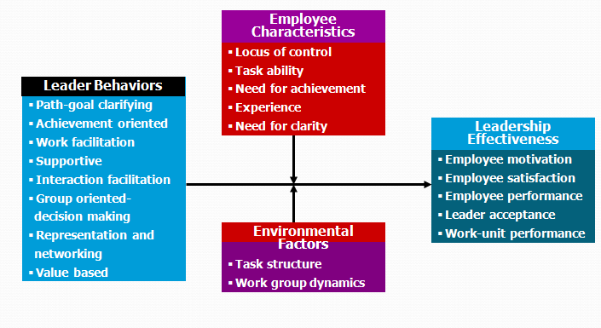
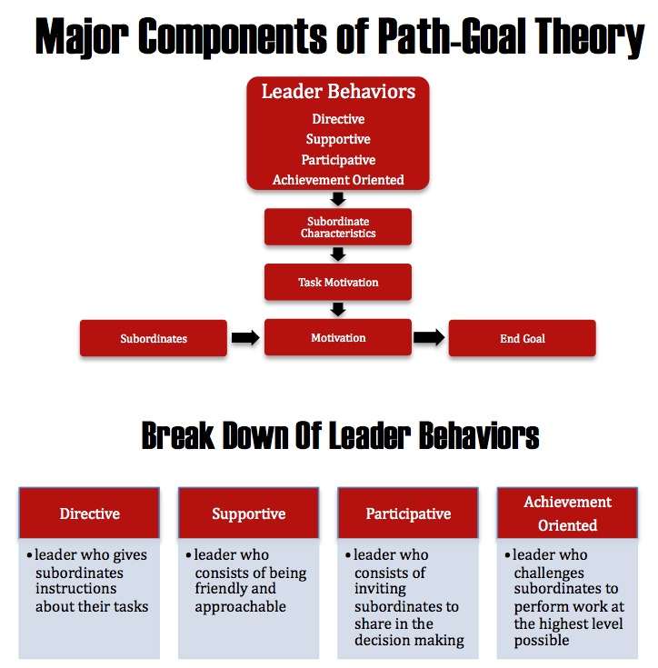
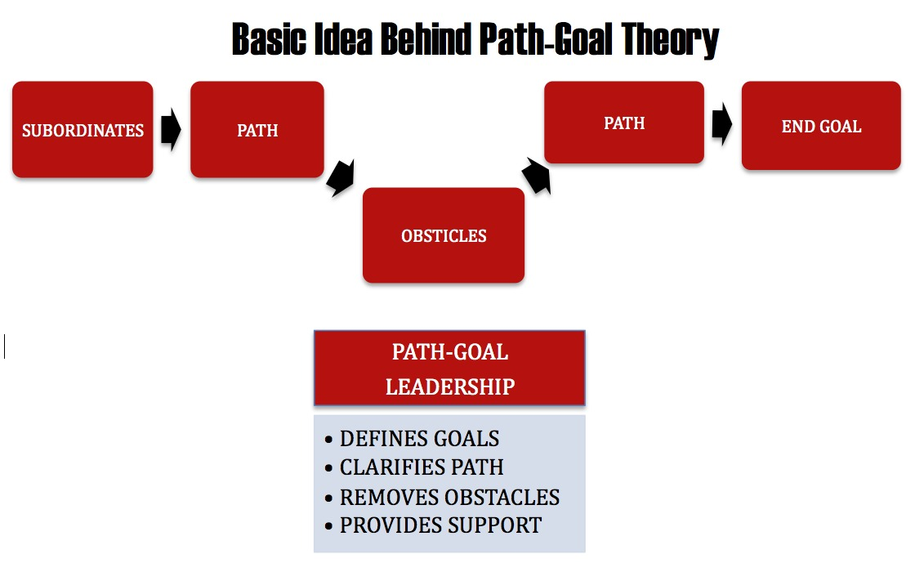

Empowerment
- Providing freedom for people to do what they want to do (pull), rather than getting them to do what you want them to do (push)
- There are five dimensions of empowerment:
  - Self-efficacy is the feeling that one has the capability to perform a specific task successfully.
  - Self-determination is a feeling that one has a choice to voluntarily and intentionally pursue a task, rather than being forced to do so.
  - Personal consequence is the conviction that through one’s own actions, one can influence outcomes.
  - Meaning is a perception of intrinsic value in the activity.
  - Trust is confidence that one will be treated fairly and equitably, and that those holding authority or power positions will not harm or injure them.
- Power vs. Empowerment
- Lack of Empowerment Negative Consequences
  - Powerlessness
  - Helplessness
  - Alienation

What does Engagement Look like?
Trait Engagement  (Positive views of life and work) | State Engagement  (Feelings of energy, absorption) | Behavioral Engagement  (Extra-role behavior)
Proactive Personality | Satisfaction (Affective) | Org Citizenship Behavior (OCB)
Autotelic Personality | Involvement | Proactive/Personal Initiative
Trait Positive Affect | Commitment | Role Expansion
Conscientiousness | Empowerment | Adaptive
- Consequences.
  - Job satisfaction
  - Commitment
  - Turnover
  - OCB
  - Performance

Delegation
- Begin with the end in mind
- Identify boundaries
- Specify level of initiative
- Allow participations
- Match authority with responsibility
- Provide adequate support
- Focus accountability on results
- Be consistent
- Avoid upward delegation
- Clarify consequences
- ***CHEESY VIDEO, not really relevant to exam**
Managing Change
- Planned Change
  - Organizational Development: A planned system wide effort, managed from the top with the assistance of a change agent, that uses behavioral science knowledge to improve organizational effectiveness.
  - **Change agents: People or groups who act as catalysts and assume the responsibility for managing change activities.
  - Organizations are constantly changing, as a business in current market times, by not changing your business strategy, your business WILL be left behind
Lewins 3 step change model
- Unfreeze-moving-refreezing
- (just know this was the traditional way of looking at change)
- how changing factors and resisting factors are pushing against one another to meet at the status quo
Resistance to Change
- PEOPLE HATE CHANGE
- Why do we resist change?
  - Fear of the Unknown
  - Selective Perception
  - Lack of Information
  - Habits
  - Resentment toward the Initiator
  - Threat to Power Maintenance
  - Structural Stability
  - Organizational Culture and Norms
- Traditional Resistance Perspective: Most people resist change that doesn’t jingle in their pockets!
Vs.
- Productive Resistance Perspective: resistance as an authentic expression seeking positive solutions for the organization, rather than as underlings’ reactive response to managerial power.
  - WE NEED TO LOOK FOR PRODUCTIVE RESISTANT PERSPECTIVE PEOPLE (CONNECTED TO THE READING)
THE CHANGE CURVE
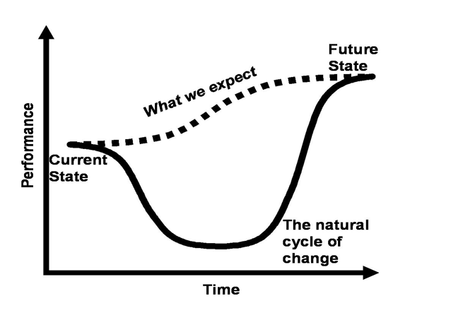
valley of despair, connected to robs example of the government IT change and how people thought it would go well and it went really shitty

just shows the reality of change

