Week 8 - Place,packaging,progamming, and partnerships

Distribution: -The way in which a product ( or service) is made available to consumers.
-Distribution channels provide the link between suppliers and buyers

Manufacturer-Wholesaler-Retailer-Customer

Travel trade intermediaries
- Tour operators/wholesalers
- Retail travel agencies
- Online travel agencies
- Others
*Corporate travel managers
*Incentive travel partners
*Convention and meeting planners
*(Direct booking)

Distribution mix strategy
Factors influencing decisions regarding the distribution mix strategy and the selection of channel members:
- Market coverage - How much is desirable?
- Costs - Direct channels have overhead costs (e.g., salaries), indirect channels have fees/commissions, plus servicing costs
- Positioning/image - Intermediaries can influence product image
- Motivation of intermediaries - May not always be compatible with your goals
- Characteristics of product - Expensiveness, frequency of purchase, etc.
- Economic concentration - Fewer competing options means more power
- Customer preferences
- Control criteria - How much control to be ceded?

Packaging: The combination of related and complementary services into a single-price offering

Package types
- All-inclusive package: Include all, or nearly all, trip elements
- Escorted tour: Predetermined itinerary, tour manager/guide accompanies, often all-inclusive, sometimes with some independent options
- Fly-drive, fly-cruise, fly-rail, and rail-drive packages
- Accommodation and meal package
- Event package (e.g., World Cup)
- Package with special interest programming (e.g., hobbies)
- Local attraction/entertainment package

History of all-inclusives
- 1950, Gérard Blitz invented all-inclusive concept with Club Med by offering $40 trips to Balearic Islands, including transport, food, accom., entertainment
  - US Army tents, 36hr trip
- Could barely keep up demand for new “vacation villages”
- Informal escapes from “civilization”
- First “luxury” (i.e., concrete) village in ’65; CM became large multinational
- Growth, around 100 sites by late ‘80s
- Then decline

Packaging: Benefits for Tourist
- Convenience
  - However, miss out on planning stage
- Cost savings
- Easy budgeting
  - Especially all-inclusive resort/cruise
- Peace of mind, quality assurance
  - “Confidence good”
- Special interests

Packaging: Benefits for business
- Increase business in off-peak periods
- Enhance appeal to particular and/or new target markets
- Easier business forecasting
- Partnership opportunities with other businesses
  - Associates product with travel demand generators (reasons for travel). Who travels to stay in a hotel?

Components of successful packages
- Includes demand generators (e.g., attractions, reduced prices, etc.)
- Value
- Quality
- Well-planned
- Unique access to something special
- Profitable
  - Are higher-value customers being displaced?

Programming: Key benefit
Programming: Developing special activities, events, or programs to increase customer spending, or to give added appeal to a package or other hospitality/travel service
- Can make product more enticing and/or bring back prior guests
- Publicity
- Many packages include some programming, but the two concepts exist independently as well

Roles of packaging and programming
- Smoothes patterns of business
  - Creating more consistent demand levels
- Improves profitability
  - Repeat usage, new business, increasing per capita spending, etc.
- Helps market targeting
  - Packages and programs to target specific segments
- Makes individual elements more attractive
- Creates synergy, in which the sum is greater than its parts

Partnerships
- Cooperative marketing efforts by separate entities
  - May be short-term or long-term
- May be...
- In same business (e.g., airlines code-share)
- In related business (e.g., frequent flyer points from car rentals, hotels)
- Non-related (e.g., McDonald’s Monopoly, TED/Marriott)

Partnerships benefits
- Access to new markets
- Sharing facilities/costs
- Increased marketing budget
- Enhanced image
- Access to partner’s expertise

Week 9 - Pricing

Price : the amount of money charged for product/service

Setting prices
Internal factors
- Marketing objectives
- Marketing mix strategy
- Costs
- Organization for pricing

External factors
- Nature of market and demand
- Competition
- Other environmental factors

Marketing Objectives(targeting, positioning)
- Survival - Getting through tough times. Inventory fixed, so reduce prices
- Current profit maximization - Achieve greatest possible immediate profit
- Market share leadership - Achieve largest footprint in market with low prices
- Product quality leadership - Charging high prices, consistent with high quality of product
- Other:
  - Prevent competition
  - Publicity

Marketing mix strategy
- Marketing mix strategy - Consistency between the Ps
  - Sometimes other Ps dictate price, sometimes vice versa
- Costs
  - Fixed/overhead
  - Variable
  - Total (Fixed + Variable)
- Cost subsidization
  - Additional guaranteed external funding
- Organizational considerations
  - Revenue management - Forecasting demand to optimize profit.
- Cross-selling (other products sold to guest by company), Upselling (offering higher priced alternatives)
- Market and demand
- Consumer perceptions of price/value
  - Based on needs, motivations ... and differ between segments
  - Price vs. Value
- Price-demand relationship
- Price elasticity of demand - How responsive demand will be to price changes
  - % change demand / % change price = price elasticity
  - Influential factors:
    - Unique value effect (something special)
    - Substitute awareness (what are my options)
    - Business expenditure effect (not my cash)
    - End-benefit effect (proportion of total cost)
    - Total expenditure effect (it adds up)
    - Price quality effect (if it’s so expensive it must be good)
    - Hidden fees (what?!)
- Price elasticity of demand - How responsive demand will be to price changes
  - % change demand / % change price = price elasticity
  - Influential factors:
    - Unique value effect (something special)
    - Substitute awareness (what are my options)
    - Business expenditure effect (not my cash)
    - End-benefit effect (proportion of total cost)
    - Total expenditure effect (it adds up)
    - Price quality effect (if it’s so expensive it must be good)
    - Hidden fees (what?!)
- Competitors’ prices
- Other factors: E.g., economy
Pricing Approaches
- Cost-based pricing: Applying a standard markup
  - May include labour costs too
  - Easy...but doesn’t account for demand or competition
- Target profit pricing: Aiming for specific profit level
- Value-based pricing: Rooted in customers’ (incl. segments’) perceived value
- Going-rate pricing: Based on competition

Product Strategies
New product
- Prestige pricing: Establish luxurious, exclusive image
- Market-skimming pricing: High price in inelastic market
- Market-penetration pricing: Gain market share
Existing product
- Product-bundle pricing: Packaging with discount
- Price-adjustment strategies:
  - Volume discounts
  - Time-of-purchase discounts
  - Discriminatory pricing: Difference prices for different customers

Revenue management
Revenue management: A type of discriminatory pricing designed to maximize revenue/profits. Different rates used in association with projected demand levels.

Dynamic pricing: Continually adjusting prices in response to market conditions
- Best Available Rate (BAR) pricing: Different rates for different nights
- Rate parity: OTAs prohibiting hotels from offering lower rates

Pricing psychology
- Pricing endings
- Promotions(temporary)
- Value-pricing(permanent)

Week 10-Promorion and Communications
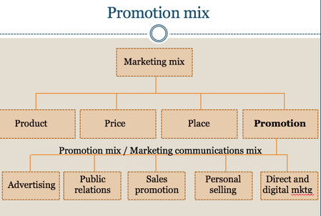

New realities
Consumers are connected and informed
- Mass marketing more narrow segments
- New/changing forms of media
- Many channels and parts of promotion mix, so must be consistent
  - Need for integrated marketing communications: Clear, consistent, and compelling message
- Not just awareness, image. Rather, customer engagement and relationship.
  - Target specific segments, and know how to speak to them

Developing effective communications

Identify target audience
- Target audience may be:
  - Potential buyers vs. current users
  - Small vs. large segment
  - Etc.
- What/how/when/where will be said

Determine com. objective
- Purchase or…
  - Education, positioning, etc.
- Buyer readiness stages
  - Awareness - Achieving name recognition (top-of mind)
  - Knowledge - Sharing product knowledge
  - Liking - Enhance positive feelings toward product
  - Preference - Build preference by highlighting value, quality, etc.
  - Conviction - Solidify favorable attitudes
  - Purchase - Final push to purchase

Design the message
- Message content
  - Rational - Product benefits
  - Emotional - Excitement, guilt, etc.
  - Moral - Ethics
- Message structure
  - Leave something unsaid?, how much to cover, order to cover factors
- Message format
  - Will depend on media used
  - Colors, actors, etc.

Select com. channels
- Personal: Two or more people communicating directly
  - Talking, phone, email, etc.
  - Also eWOM - Social media, online reviews, etc.
- No personal
  - Mass media (newspapers, websites, billboards, etc.)
  - Atmospheres - Designed environments to reinforce image
  - Events (press conferences, tours, etc.)

Select message source
- Credible
  - Expertise, trustworthiness, likability
  - Celebrities, cartoon characters, etc.

Collect feedback
- Recall
- Opinions (including change)
- WOM
- Purchase

The promotion tools
- Advertising: Paid, non-personal presentation and promotion of product by sponsor
- May signal legitimacy
- Efficient, mass reach
- May be expensive
- Impersonal, relatively unpersuasive

2. Public relations: Building good relations with the public through positive publicity, image building, managing negativity; through third party
- Large reach like ads, but more credibility

3. Sales promotion: Short-term incentive to encourage product purchase
- Coupons, contests, free goods, etc.
- “Buy now”
- Quick response, but short-term gain

4. Personal selling: Personal presentation to make sales, build customer relationships
- Adjust to buyer’s needs
- Build relationship
- Costly

5. Direct and digital marketing: Engaging directly with targeted individual customers
- Customized
- Allows for interactive dialogue
- Build relationships

Advertising
- Setting objectives
  - Inform: Good when introducing new product
  - Persuade: Good when competition increases
  - Remind: Mature products
  - Be sure product can live up to expectations being set
- Setting budget
  - What you can afford, %sales, match competition, or meet objective
  - Depends on: Product life cycle stage, competition, etc.
  - Strategic (brand awareness/image) vs. tactical (immediacy)
- Creating message
  - Clutter - Ads must be entertaining, interesting
    - Maybe to point of being “advertainment”
    - Product placement
  - Message strategy
    - Show customer benefits
  - Message execution - What’s said, how said
    - Slice of life example
    - Lifestyle
    - Musical
    - Celebrity endorser
    - Etc.
  - Consumer-generated messages
  - Selecting media
    - Reach (% market), frequency, impact of particular medium (suitable image, access to potential buyers)
    - Media types: Newspapers, TV, direct mail, radio, magazines, etc.
    - Media vehicle (e.g., which TV show)
      - Max exposure / dollar within segment
    - Timing (continuous or pulsing)
  - Evaluating effectiveness
    - Research - Rating, recall
    - Change in awareness
    - Sales (tough to measure)

Public relations
- In past, sometimes marketing component overlooked
- New opportunities via social media
- Inexpensive
- Major activities include placing newsworthy info into media, corporate communication, lobbying, etc.
- Attract publicity - unpaid media coverage
  - Often with press release
- Crisis management

Public relations process
- Conduct research
  - Need understanding of company, product, external trends
- Establish marketing objectives
  - Build awareness, credibility, sales, etc.
- Choose target audience
- Choose PR message and vehicle
  - Print/multimedia, events, public service, etc.
- Implement plan
  - Reach out to media
- Evaluate results
  - Exposure/coverage, awareness or attitude change, sales benefit

Sales promotion
- Set objectives
  - Introduce new product, increase market share, reward loyal customers, etc.
  - Ideally contributing to long-term demand, not just short-term gain
- Types
  - Samples, packages, coupons, premiums (free or low cost goods), loyalty programs, contests, etc.

Week 11 – People
Internal Marketing
- Internal marketing: Marketing to the firm’s employees
- Objective is to enable employees to deliver satisfying products to customers
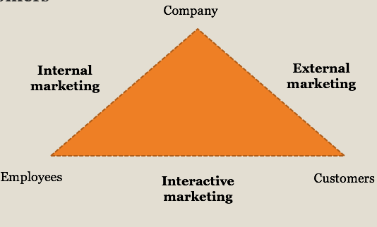
- Remember, services are inseparable – produced and consumed simultaneously – so employees are part of the product
- Employers have limited control over employee-customer interactions, and bad service can ruin everything else

Service profit Chain

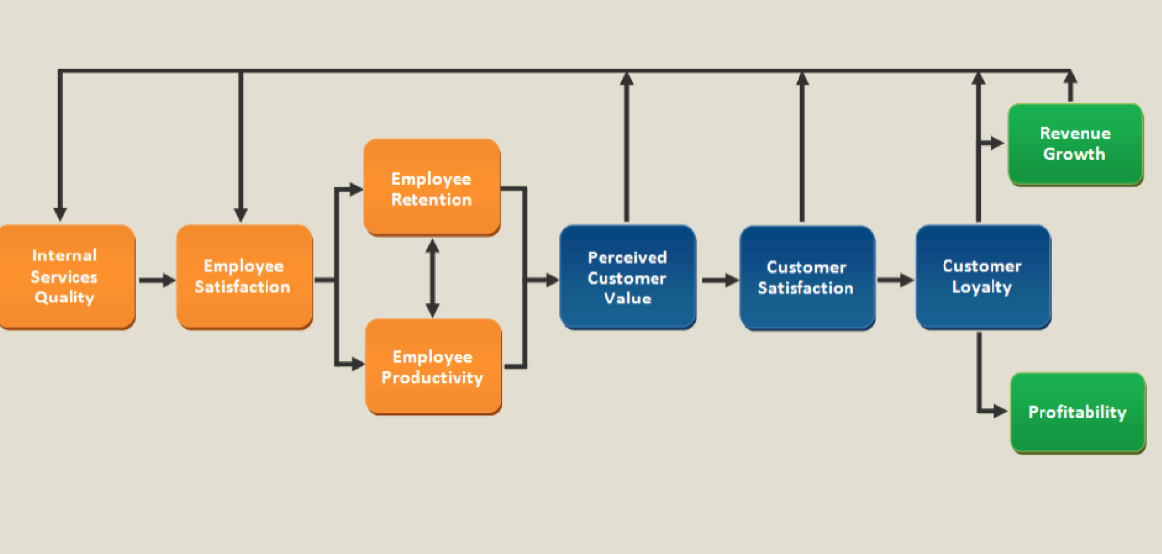
Internal marketing process

1.Establish service culture
- Organizational culture: Pattern of values and beliefs that establishes guidelines for behavior
  - Daniel’s new job tip: Get a feel for your new company’s culture; don’t get fired on your first day
- Service culture: System of values and beliefs in organization emphasizing notion that customer service is a primary concern
  - Hiring, training, incentives, complaint resolution, empowerment (giving employees decision-making authority; people live up - or down - to your expectations)
  - Employees take ownership of problem
  - Management should demonstrate customer contact behaviour
- Reasons for a lack of employee empowerment
  - Employees not granted authority
  - Middle managers resent customer-contact employees taking this duty/authority
  - Employees not appropriately trained
  - Employees feel not paid enough
  - Employees scared to take authority

- Nonroutine transactions will become increasingly important / common, as tech covers routine side (e.g., wake-up calls)
- Organizational chart:
  - Traditional: Everyone looking to please his/her boss
  - Service-oriented: Customers first, then customer-contact employees, … , management last
    - Focus on serving the customer

2. Develop marketing Approach to HR management
- Attract and retain the right people
  - Target employee segments
  - Design benefits accordingly: salary, transportation, retirement plan, health insurance, etc.
  - Soft and hard skills
  - Turnover is expensive
    - But who are you retaining long-term?
- Teamwork / Coworker support
- Training: Initial, continuous, cross

3.Spread marketing info to employees
- Communication with employees
  - E.g., about promotions, events
  - E.g., through daily briefings, newsletters
- Firsthand experience
  - With meal, room, event, etc.

Service failure

- Service failure: Failure to meet customer expectations
- Customers then expect…
  - Quick resolution
  - Apology/politeness
  - Ownership of issue
- Service recovery: Turning dissatisfied customers into satisfied customers
Reasons:
- Management doesn’t know what customers expect
- Service quality standards too low
- Service-performance gap
- Inconsistency with advertising, other forms of promotion (i.e, making expectations too high)
Common types:
- Too slow
- Poor quality (e.g., food)
- Employees uninformed, uncaring, impolite

Service failure: Types of complainers
- Passives
  - Won’t complain, even if good reason to
  - May feel not worth trouble, or nothing will be done
  - May not know how to complain
- Voicers
  - See complaining as positive action for customer and company, as it allows chance to improve (long-term) and recover (short-term)
  - May lead to service recovery
- Irates
  - Spread negative WOM
  - May switch to competitor
- Activists
  - Enjoy the confrontation
  - May complain to third parties
  - May make unreasonable compensation demands
  - Negative WOM
- Terrorists
  - Become obsessed with complaint and company’s inadequate response
  - Spread negative eWOM on Facebook, etc.

Service failure: Types of complaints
- Concurrently
  - At time of service failure
  - Optimal time for customer/company
- Subsequently
  - Later by email, telephone, etc.
  - Details may be exaggerated over time
- Third-party
  - E.g., consumer protection body, tourist board, etc.
- Negative WOM
  - E.g., Friends, family, etc.
- Online
  - TripAdvisor, etc.

Service failure: Managing failures
- Encourage complaints
  - E.g., Comment cards, emailed surveys, etc.
  - Can identify issues for improvement
- Treat customers fairly
  - Outcome fairness (compensation)
  - Procedural fairness (policy and procedures for handling)
  - Interactional fairness (empathy, politeness, honesty)
- Service recovery paradox
  - Customers who experience service failure and then service recovery may become especially loyal
- Serial complainers
  - May use database to discourage future complaints

SERVQUAL
- Measures customers’ service expectations and perceived performance relative to…
  - Tangibles: Physical facilities, staff appearance, etc.
  - Reliability: Performing service dependably, accurately
  - Responsiveness: Prompt service
  - Assurance: Staff knowledge; conveying trust and confidence
  - Empathy: Degree of caring
- Two separate measures, then subtracted (Perceptions – Expectations = Quality)

Week 12- Direct and Digital Marketing

SERVQUAL
- Measures customers’ service expectations and perceived performance relative to…
  - Tangibles: Physical facilities, staff appearance, etc.
  - Reliability: Performing service dependably, accurately
  - Responsiveness: Prompt service
  - Assurance: Staff knowledge; conveying trust and confidence
  - Empathy: Degree of caring
- Two separate measures, then subtracted (Perceptions – Expectations = Quality)

Traditional direct marketing
- Direct marketing: Direct communications with targeted individual customers or customer communities to obtain an immediate response and build customer relationships
- If not relevant and beneficial to customer, efforts will be ineffective and annoying
- Relies on customer database
  - Segment and target customers
  - Learn about customers
  - Data mining: Exploration and analysis of a database to discover meaningful patterns

Relationship marketing
- Relationship marketing: Goal is to establish long-term relationships with customers
- Not for all customers, mostly high profit / frequency / potential growth
- May add…
  - Financial benefits (e.g., frequent flyer program)
  - Social benefits (building social bonds with customer; personalizing service/product to customer needs/wants)
  - Structural ties (e.g., altering procedures to allow some early check-in)
- Loyal customers help:
  - Increase sales (remember 80-20?)
  - Decrease marketing costs
  - Increase WOM
- Contrasts with transactional marketing, which is all about getting short-term sales

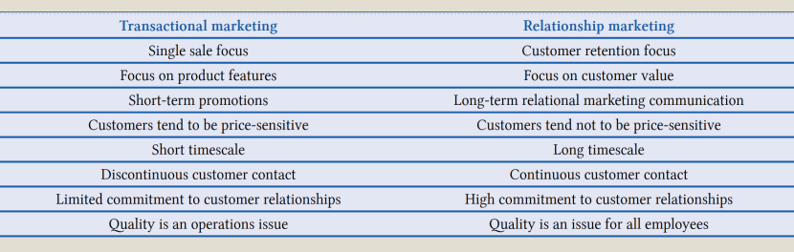
Loyalty
- Loyalty can be behavioural or attitudinal
- Attitudinal loyalty involves a psychological commitment to product, and a resistance to change
- Frequency of purchase ≠ complete loyalty

Loyalty programs
- Mostly financial-based
- May involve ancillary benefits (e.g., late check out)
- Goal should be to influence behaviour (e.g., increase purchases)
- “The loyalty program was a crucial reason why Marriott pursued Starwood.” Skift
- Shift towards immediacy

Common forms of traditional direct marketing
- Direct-mail marketing: Letters, catalogs, brochures, samples, DVDs, etc.
- Telephone marketing: Move towards opt-in model

Online marketing
Advantages
- Global reach
- Target ability
Disadvantages

- Security/privacy concerns
- Spamming
- Incomplete coverage
- Navigation troubles
- Ceding control to customer
- Depends on equipment of customer
- Lack of human touch
- Cost-effective
- Tracking
- Testing (e.g., A/B testing)
- Flexible (e.g., stop any time, instantly update)
- 24/7 availability
- Interactive
- Immediacy of transactions
- Gather info for databases

Online marketing : Websites
- Different purposes: Informational, purchasing, etc.
- Characteristics:
  - Informative
  - Engaging/“sticky”
  - Multimedia: Pics, video, etc.
  - Accessible (e.g., language)
  - Aesthetics, style
  - Intuitive navigation
  - Mobile-responsive
  - Can personalize dynamic content (e.g., prices)
  - (Purchase option)

Search Engines
- Search engine optimization: Designing a website so that search engines (e.g., Google) rank the site’s pages well (in organic results) when relevant keywords are searched
  - Content relevance
  - Incoming links
- Pay-per-click (PPC): Advertising, involving paying when ad is clicked
  - Keyword bidding
  - Majority of Google revenue

Other advertising
- Common types
  - Text
  - Banners
  - Image
  - Video
- Common sources:
  - Search engine
  - Social media
  - Random website (perhaps affiliate)
- Scan content for relevancy

Email Marketing
- Targeted, personalized
- Low cost
- Easy to measure
- Avoid being spammy

Video
- YouTube, social media, etc.
- May be made specifically for web, or for TV
- Partnerships (of some sort) with vloggers
- Viral: Online content that people pass on to others, leading to massive exposure
- Third party negative videos

eWOM
Blogs
- Company-created blogs
  - Is the content engaging?
- Partnering with bloggers
Reviews
- 385 million reviews
  - 255 contributions every minute
- 6.6 million businesses (hotels, restaurants, etc.)
- 70 million photos
Forums
- Created by company, about company
- Third party about company
- More generic

Social networks
- Cons
  - Still learning how to be effective
  - Results are hard to measure
  - Power ceded
- Pros:
  - Targeted
  - Personal
  - Interactive
  - Immediate
  - Cost-effective
  - Promote customer-brand engagement

Social networks ( or review sites )
- General:
  - Free market intelligence on your business and competitors
- Positive comments:
  - Very persuasive (credible)
- Negative comments:
  - Facilitate service improvements
  - Businesses should respond, but bring it offline
  - Can permit complete service recovery -- remember service recovery paradox?

Mobile marketing
- On-the-go
- Responsive sites / apps
- Don’t want to overdo it pushing content

Week 13- Future of Tourism Marketing
Online Marketing : video
- YouTube, social media, etc.
- May be made specifically for web, or for TV
- Partnerships (of some sort) with vloggers
- Viral: Online content that people pass on to others, leading to massive exposure
- Third party negative videos

Online Marketing : eWOM
Blogs
- Company-created blogs
  - Is the content engaging?
- Partnering with bloggers
Reviews
- 385 million reviews
  - 255 contributions every minute
- 6.6 million businesses (hotels, restaurants, etc.)
- 70 million photos
Forums
- Created by company, about company
- Third party about company
- More generic

Social networks
- Pros:
- Cons
  - Still learning how to be effective
  - Results are hard to measure
  - Power ceded
  - Targeted
  - Personal
  - Interactive
  - Immediate
  - Cost-effective
  - Promote customer-brand engagement

- General:
  - Free market intelligence on your business and competitors
- Positive comments:
  - Very persuasive (credible)
- Negative comments:
  - Facilitate service improvements
  - Businesses should respond, but bring it offline
  - Can permit complete service recovery -- remember service recovery paradox?

Mobile Marketing
- On-the-go
- Responsive sites / apps
- Don’t want to overdo it pushing content

Demographics: Boomers / silver hairs
- Age 60+ in world population:
  - 1950: 8%
  - 2013: 12%
  - 2050: 21%
  - China, India and US will each have over 100M by 2050.
- Age 65+ in Canada:
  - 1996: 12%
  - 2016: 17%
  - 2051: 25%
- Disposable income, fewer home responsibilities, more time
- Modern medicine keeping people healthier, living longer
- Soft adventure, bucket list, health/wellness, etc.

Demographics : Millennials
- Huge impacts on marketing strategy
- Digital, social, etc.
- How to talk to them/you (with emoticons?)
- Authenticity, experiences

Demographics: Emerging markets
- BRICS: Brazil, Russia, India, China, South Africa

Emerging Destinations
Old
- France, Italy, England, US, etc.
New
- Nicaragua, Gabon, Mongolia, Slovakia, Laos, etc. … outer space

Technology
- Mobile, social media
- Connected while travelling (or disconnecting)
- Real-time market intelligence; big data
- Robots
- “Conversational commerce”
  - AI, bots

Virtual and augmented reality
- Augmented reality: Live view of real world, supplemented by computer imagery
- Virtual reality: An immersive computer-generated environment
- Oculus Rift, Google Cardboard, etc.
- Various functions:
  - Advertising
  - Virtual worlds, communities
  - Planning, training
  - Attraction itself (e.g., supporting product)
  - A substitute?!

Behavioural trends
- Local, authenticity, experiences
- Health, wellness
  - Food, activities, lighting, medical tourism, etc.
- Sustainability
  - Environmental, economic, socio-cultural

REVIEW
- What are some examples of travel trade intermediaries?

- What are examples of (hypothetical) same business, related business, and non-related business partnerships for Air Canada?

- What are examples of cross-selling and upselling?

- What does it mean if a product has a high price elasticity of demand?

- What are the components of the promotion mix (aka marketing communications mix)?

- Define service culture

- Define service recovery paradox

- Describe difference between relationship marketing and transactional marketing

- Define search engine optimization (SEO)

