Week 7 chapter 6: Bond Definitions
Notice that the price of a bond decreases_ with increasing interest rate.
Bond Characteristics
- bond price fall when interest rates rise
- bond price rise when interest rates fall
- The sensitivity directly depends on two things: time to maturity and coupon rate
- All other things being equal, the longer the time to maturity, the greater the interest rate risk.
- All other things being equal, the lower the coupon rate, the greater the interest rate risk.
Default Risk
The default premium or _credit spread is the difference between the promised yield on a corporate bond and the yield on a Canada bond with the same coupon and maturity.
Examples:
Govn of Canada 10 years, 6% coupon, 6% yield.
Safe Corp 10 years, 6% coupon, 6.5% yield.
Risky Corp 10 years, 6% coupon, 10% yield.
    - The corporate bonds both have a higher yield than the Canada because of default risk.
    - Safe Corp has little risk of default and a small default 0.5%
    - Risky Corp has high default risk and thus a large default 4%
  - Bonds rated BBB and above are called investment grade bonds.
- Bonds rated BB and below are called speculative grade, high yield, or junk bonds.
Inflation and Interest Rates
- If pizzas cost $5.25 in 1 years’ time, what is the inflation rate?
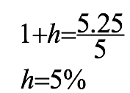
- What is the real rate of return if you invest your $100 today instead of buying pizzas immediately?
- In one year, your $100 grows into $115.50.
- How many pizzas you can buy with $115.50 in one year?
- 115.50¸5.25=2
- Your real rate of return is the percentage change in your buying power
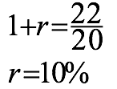
- Real Rates (r)
- Nominal Rates (R)
- Expected Inflation (h)
1+R=(1+r)´(1+h)
1+15.5%=(1+r)´(1+5%)
r =10%
Term Structure of Interest Rates
- The relationship between nominal interest rates on default-free, pure discount securities and time to maturity
- Determined by three components: the real rate of interest, the rate of inflation, and interest rate risk
- Maybe upward-sloping or downward-sloping
- Note: exclude effect of default risk, different coupons, etc.
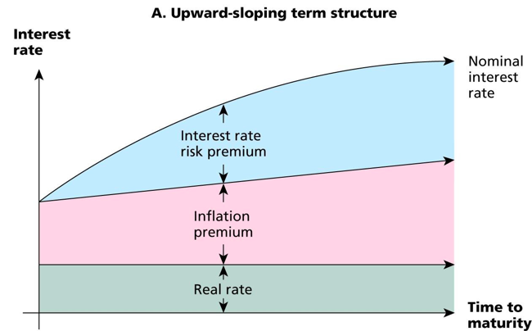
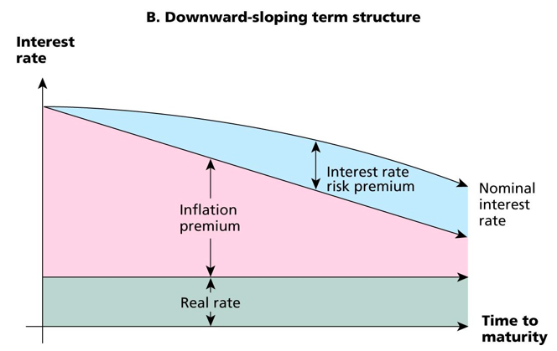
Yield Curve
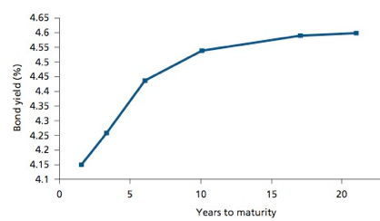
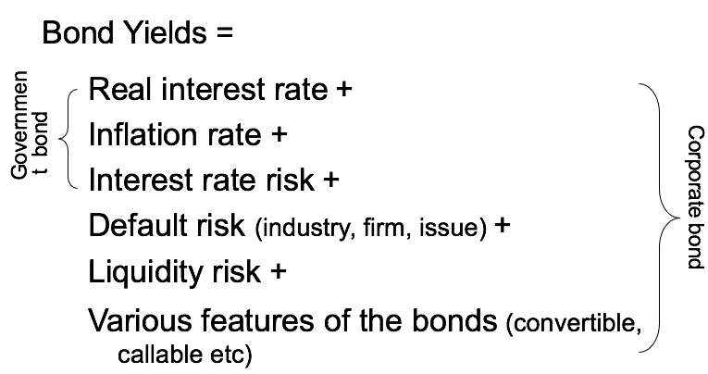
The Yield Curve and Discount Rates
- Term Structure: The relationship between the investment term and the interest rate
- Yield Curve: A plot of bond yields as a function of the bonds’ maturity date
- Risk-Free Interest Rate: The interest rate at which money can be borrowed or lent without risk over a given period.
The Yield Curve and Discount Rates
A risk-free cash flow of C_{n} received in n years has the present value. where r_{n} is the risk-free interest rate for an n-year term
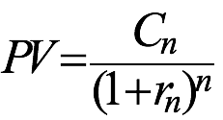
Present Value of a Cash Flow Stream Using a Term Structure of Discount Rates
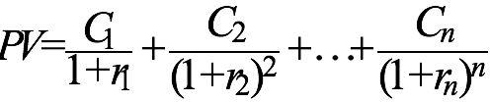
Interest Rate Determination
  - The Bank of Canada determines very short-term interest rates through its influence on the overnight rate.
  - Overnight rate: The rate at which banks can borrow cash reserves on an overnight basis from the Bank of Canada.
- If interest rates are expected to rise, long-term interest rates will tend to be higher than short-term rates to attract investors.
- If interest rates are expected to fall, long-term rates will tend to be lower than short-term rates to attract borrowers.
- Yield Curve Shapes
- Steep
Long-term rates are much higher than short-term rates
- Inverted
Long-term rates lower than short-term rates
Opportunity Cost of Capital or Cost of Capital
– The best available expected return offered in the market on an investment of comparable risk and term to the cash flow being discounted.
Chapter 11: Random Walk
- Security prices change without predictable trends or patterns.
- Stock prices seem to go up or down on any particular day, regardless of what has occurred on previous days.
- Therefore, one can’t use past patterns to predict future price changes.
- Random walk is a proof of market efficiency.
Efficient Market Hypothesis (EMH)
- Since all information is rapidly incorporated into the price of the stock, all stocks are correctly priced and no investor or issuer can earn “excess” returns.
Three Forms of EMH
- Weak form: market prices reflect all information contained in past market prices.
- Semi-strong form: market prices reflect all publicly available information.
- Strong form: Market prices reflect all known information.
Anomalies
- Evidence that seems inconsistent with the efficient market hypothesis
- The Small Cap Effect: investors in smaller companies have outperformed investors in larger firms.
- Book-to-Market Ratios: stocks with high ratios of book value of equity to market value have outperformed stocks with low ratios of book to market.
- Active portfolio management: some managers like Warren Buffet.
Measuring Returns
- The returns on an investment come in two forms:
- Income (dividend or interest payments).
- Capital gains (or losses).
- There are two ways to measure the total return on an investment:
- Dollar return = Dividend income + Capital gain
- Percentage return = Dividend yield + Capital gains yield

prem

Class 8 bond
Q: when face value 1000, pmt 50 3 years, 251 final payment r=15%
Two ways
1: CF function- C01=50,F01=3,C02=1251,F02 =1—i/r= 15%---calculate PV
2: general PV
PMT=50 FV=1201 (50+1201) i=15 N=4----calculate PV

Government-bonds
Corporation-stocks or shares

Definitions
- Primary market: part of the financial markets where the sale of new stock first occurs.
- Initial public offering (IPO): first offering of stock to the general public.
- Seasoned issue (SEO): sale of new shares by a firm that has already been through an IPO.
- Secondary market: part of the financial markets in which already issued securities are traded by investors.
Issuing stock
- Common stock
  - ownership shares in a publicly held corporation, without priority for dividends or in bankruptcy
- Preferred stock
  - stock that takes priority over common stock in regards to dividends and in bankruptcy, often without voting rights
Common Stock
  - Voting
    - Elect a board of directors
    - Vote on stockholder matters
    - Shareholder activism (exec. pay; independent directors, etc.)
    - Unequal voting rights
  - Dividends
    - At the discretion of the board of directors
  - Entitled to the firm’s residual cash flow in a liquidation
  - As owners, share in the fortunes of the firm
    - Can be risky investments
    - Limited liabilities
Preferred Stock
- Voting
  - Preferred stock generally does not carry voting rights
- Dividends
  - A stated dividend that must be paid before common dividends can be paid
  - Not a liability of the firm, can be deferred indefinitely
  - Cumulative – any missed preferred dividends have to be paid before common dividends can be paid
- A lot like debt
  - Stated dividends, credit rating, convertible, callable, sinking funds
Dividends
  - Periodic discretionary任意自由 cash distributions from the firm to shareholders.
    - no dividends (BlackBerry)
    - annual dividends (usually paid quarterly) (Banks)
    - special dividends (TSX Group, Microsoft)
  - represent that share of the firm’s profits which are
distributed.
  - alternatively profits can be retained in the firm and reinvested in its operations
Dividends and Taxes
- Dividend payments are not considered a business expense and are not tax deductible
- Dividends received by individual shareholders are partially sheltered by the dividend tax credit
- Dividends received by corporate shareholders are not taxed
- This reduces double taxation of dividends
Dividends
- Note that investors will accept low, or zero, current yields.
- Because Dividend reinvest in the firm, operate better, share price going up (higher future dividend)
- Probably pay next year (raising share price)
- Dividends
  - Note that investors will accept low, or zero, current yields.
  - Why?
    - Higher future dividends
    - Rising share prices
  - Dividend Yield = Dividend Payment
Current Stock Price
  - Weakness of dividend yield as a measure of stock return? Can you identify it?
Market Value
  - The amount investors are willing to pay today for the shares of the firm
  - Different from book value, which is the net worth of the firm according to its balance sheet
  - Depending on the earning power of the existing assets and the expected profitability of future investments
  - Forward-looking
1 Year
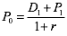

2 Year
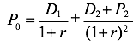
Dividend Discount Model (DDM)
value of a common stock by getting the PV of all its future cash flows.
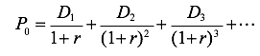
- Assume dividends are a perpetuity.
- There are some special cases:
  - Constant dividend
  - Constant dividend growth
  - Supernormal growth
- Constant Dividend (Zero Growth)
  - The firm will pay a constant dividend forever
  - This is like preferred stock
  - The price is computed using the perpetuity formula
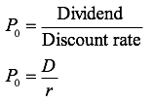
- Constant Dividend Growth
  - The firm will increase the dividend by a constant percent every period
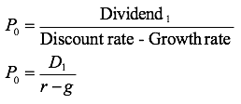
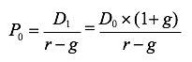
Implied growth rate
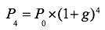

- Growth Rate
  - Historical Growth Rates of Earnings
    - Average growth rates
    - Use regression to link to business cycle
  - Fundamental Forecast
  - g = b x ROE (see a note on page 106)
  - b = plowback ratio (retention ratio)
  - ROE = Return on equity = NI / Equity
The higher the plowback ratio, the higher the growth rate

if paying all earnings out as dividends
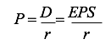
If retaining some earnings and investing in projects, which earn a higher return than the required return
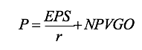
NPVGO: net present value of the growth opportunity

Price-Earnings (P/E) Ratio
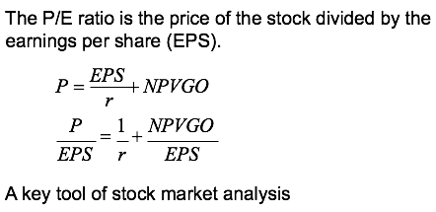

Supernormal Growth
  - Dividend growth is not consistent initially, but settles down to constant growth eventually
  - Non-constant growth
  - In this two stage model, a firm’s dividends are assumed to grow at a high growth rate for some period of time and then grow at a stable growth rate thereafter.
  - 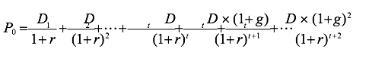

  - when its forever, calculate dividend first and

Chap 8
- Capital Budgeting Decision
  - Determines which fixed assets to buy
  - Determines whether to launch a new product or enter a new market
  - Capital budgeting decisions can determine the success of the business for many years.
  - If the NPV is positive, accept the project.
  - A positive NPV means that the project is expected to add value to the firm and will therefore increase the wealth of the owners.
  - Since our goal is to increase owner wealth, NPV is a direct measure of how well this project will meet our goal.

  - Internal Rate of Return (IRR)
  - IRR is simply the discount rate at which the NPV of the project equals zero.
  - You can calculate the rate of return on a project by:
  - Setting the NPV of the project to zero.
  - Solving for “r”.
  - Unless you have a financial calculator, this calculation must be done by using trial and error!
- Internal Rate of Return (IRR) vs NPV:
- The NPV Rule accept project if NPV > 0.
- IRR Rule accept project if IRR > the opportunity cost of capital.
  - i.e., if you can earn more on a project than it costs to undertake, then you should accept it!
- Advantage of IRR:
  - Knowing a return is intuitively appealing
  - It is a simple way to communicate the value of a project to someone who doesn’t know all the estimation details
  - If the IRR is high enough, you may not need to estimate a required return, which is often a difficult task
  - Generally leads to the same answers as the NPV method
- Disadvantage of IRR:
  - May result in multiple answers or no answer with
non-conventional cash flows
  - May lead to incorrect decisions in comparisons of
mutually exclusive investments

- IRR and Non-conventional Cash Flows
  - When the cash flows _ change sign more than once, there is more than one IRR.
  - When you solve for the IRR, you are solving for the root of an equation. When you cross the x-axis more than once, there will be more than one return that solves the equation.
  - If you have more than one IRR, which one do you use to make your decision?
- Conflicts between NPV and IRR
  - NPV directly measures the increase in value to the firm.
  - Whenever there is a conflict between NPV and another decision rule, you should always use NPV.
  - IRR is unreliable in the following situations
    - Non-conventional cash flows
    - Mutually exclusive projects
- Payback Advantages
  - Easy to understand
  - Adjusts for uncertainty of later cash flows
  - Biased towards liquidity
- Disadvantages
  - Ignores the time value of money
  - Requires an arbitrary cutoff point
  - Ignores cash flows beyond the cutoff date
  - Biased against long-term projects, such as research and development, and new projects

Discounted Payback
– Discounted payback is the time period it takes for the discounted cash flows generated by the project to cover the initial investment in the project.
- Although better than payback, it still ignores all cash flows after an arbitrary cutoff date.
  - Therefore it will reject some positive NPV projects.
- NPV is thus always preferable to discounted payback in evaluating projects!
- Decision rule: Accept the project if it pays back on a discounted basis within the specified time.
- Discounted Payback
Advantages
  - Includes time value of money
  - Easy to understand
  - Does not accept negative estimated NPV investments
  - Biased towards liquidity
Disadvantages
- – May reject positive NPV investments
- Requires an arbitrary cutoff point
- Ignores cash flows beyond the cutoff date
- Biased against long- term projects, such as
- R&D, and new projects
Profitability Index
  - Measures the benefit per unit cost, based on the time value of money
  - A profitability index of 1.1 implies that for every $1 of investment, we create an additional $0.10 in value
  - Mutually exclusive investments
    - Project A: cost $5 and $10 present value
    - Project B: cost $100 and $150 present value
    - Project A: PI=2 NPV=$5
    - Project B: PI=1.5 NPV=$50
Project A: PI=

Advantage:
- Closely related to NPV, generally leading to identical decisions
- Easy to understand and communicate
- May be useful when available investment funds are limited
Disadvantage
- May lead to incorrect decisions in comparisons of mutually exclusive investments

Chap 9

Capital Budgeting Terminology
- Capital Budget: A list of the projects that a company plans to undertake during the next period.
- Capital Budgeting: The process of analyzing investment opportunities and deciding which ones to accept.
- Incremental Earnings: The amount by which a firm’s earnings are expected to change as a result of an investment decision.
Relevant Cash Flows
- The cash flows that should be included in a capital budgeting analysis are those that will only occur (or not occur) if the project is accepted.
- These cash flows are called incremental cash flows.
- A project’s NPV depends on the extra cash flows it produces.
- You should:
  - Calculate the firm’s cash flows if it goes ahead with the project.
  - Calculate the cash flows if the firm doesn’t go ahead with the project.
  - Take the difference, which gives you the extra, or
incremental, cash flow of the project.

Incremental Revenue and Cost
- Factors to consider when estimating a project’s revenues and costs:
  - A new product typically has lower sales initially
  - The average selling price of a product and its cost of production will generally change over time
  - For most industries, competition tends to reduce profit margins over time
Relevant
- Opportunity Costs
- Side Effects
- Change in NWC
- Inflation
- Capital Cost Allowance (CCA)
Not Relevant
- Sunk Costs
- Financing Costs
Forecasting Incremental Earnings

- Operating Expenses vs. Capital Expenditures
  - Operating Expenses
  - Capital Expenditures
- Capital Expenses and Capital Cost Allowance
  - The cost of plant, property, and equipment is divided to be deducted when estimating earnings.
    - For tax purposes, the Canada Revenue Agency, requires the use of Capital Cost Allowance (CCA).
- Capital cost allowance (CCA): The Canada Revenue Agency method of depreciation for income tax purposes.
- CCA rate: The proportion of undepreciated capital cost that can be claimed as CCA in a given tax year.

- Half-year rule: A rule stating that, as assets may be purchased at any time throughout a year, it can be assumed that on average an asset is owned for half a year during the first tax year of its ownership.
- Undepreciated Cost of Capital (UCC): The balance, at a point in time, calculated by deducting an asset’s current and prior CCA amounts from the original cost of the asset.
Relevant cash flow
Recognize investments in working capital
NWC is a short term investment
It includes: cash, AR, inventories, and AP.
Most projects require an additional investment in working capital and result in cash outflows.
At the end of the project, when inventories are sold and accounts receivable are collected, the firm has a cash inflow.

Pro Forma Statements and CFs
- Computing cash flows – refresher
  - Cash Flow From Assets = OCF – net capital spending– additions to NWC
  - Operating Cash Flow = EBIT + depreciation – taxes
  - Capital budgeting relies heavily on pro forma accounting statements, particularly income statements.
Capital Cost Allowance
CCA is depreciation for tax purposes.
The depreciation expense used for capital budgeting should be calculated according to the CCA schedule dictated by the tax code.
CCA itself is a non-cash expense, consequently, it is only relevant because it affects taxes.
CCA is deducted from operating earnings before calculating taxes, which creates a tax shield.
CCA tax shield = DxT
D = depreciation expense (CCA)
T = marginal tax rate

Example
– X Co. has just bought a new bottling machine for
$100,000. Management estimates that the useful economic life of the machine is 4 years and that it will have a salvage value of $20,000. What is the depreciation expense for each of the next 4 years if the CCA rate is 20%?
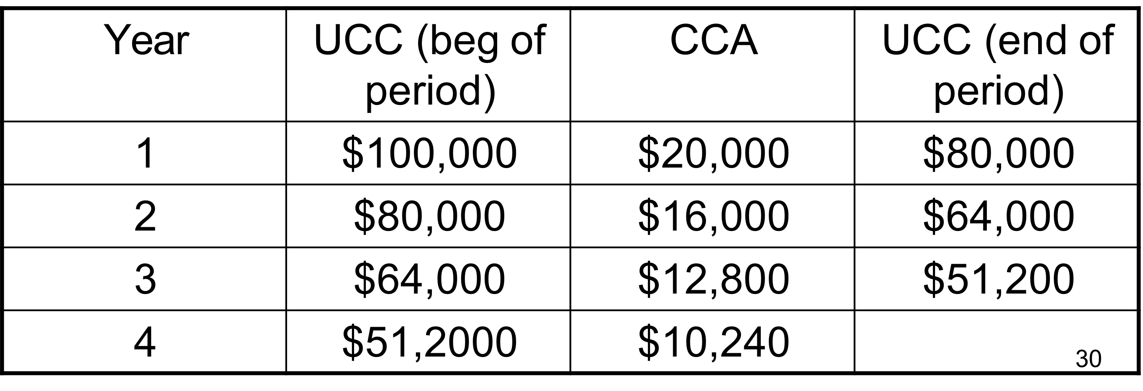
What if the half-year rule is in effect?
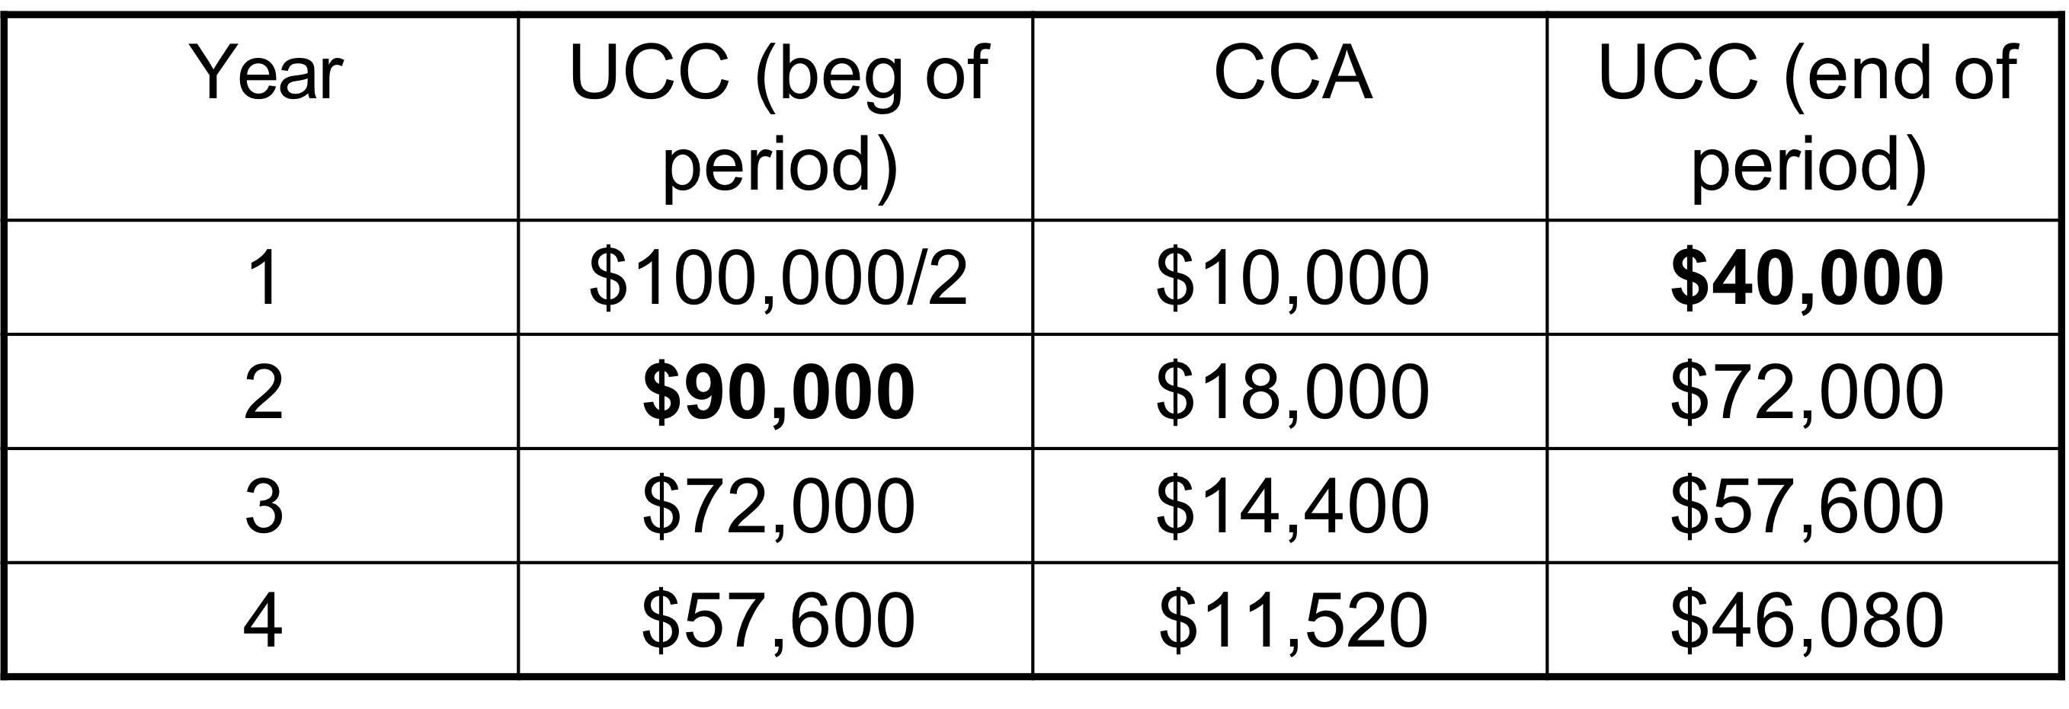

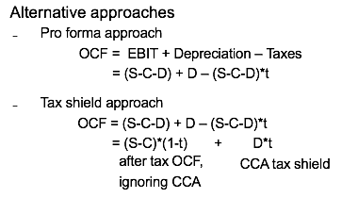

A Comprehensive Example
- As a product manager of AAA Brewing Company, you are in the middle of drafting a proposal to expand output by adding another bottling machine to the production line. The new machine can be purchased for $160,000. The specifications of the machine indicate a useful economic life of 5 years with an estimated salvage value of $50,000. Operating revenues are expected to increase by $100,000 per year while operating expenses will increase by
$50,000 per year.
The project requires $10,000 in NWC at the start, which will be recovered at the end. The machine falls in an asset class with a 30% CCA rate. The company is in the 40% tax bracket and has a cost of capital of 15%. Would you go ahead with the project?

Capital expense 160,000
SV 50000
Incremental revenue 100000 (increase every year)
50000 incremental cost
NWC 10000 (cash outflow)
Revered at end 10000
D=30%
Tax: 40%
Discount rate 15%

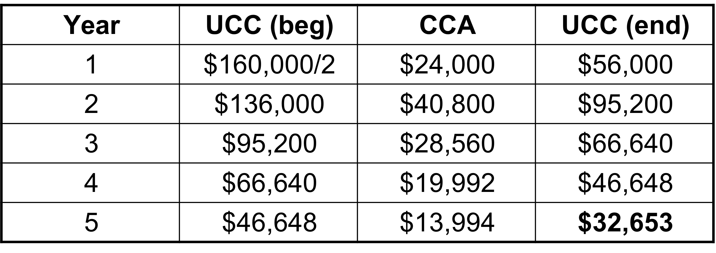
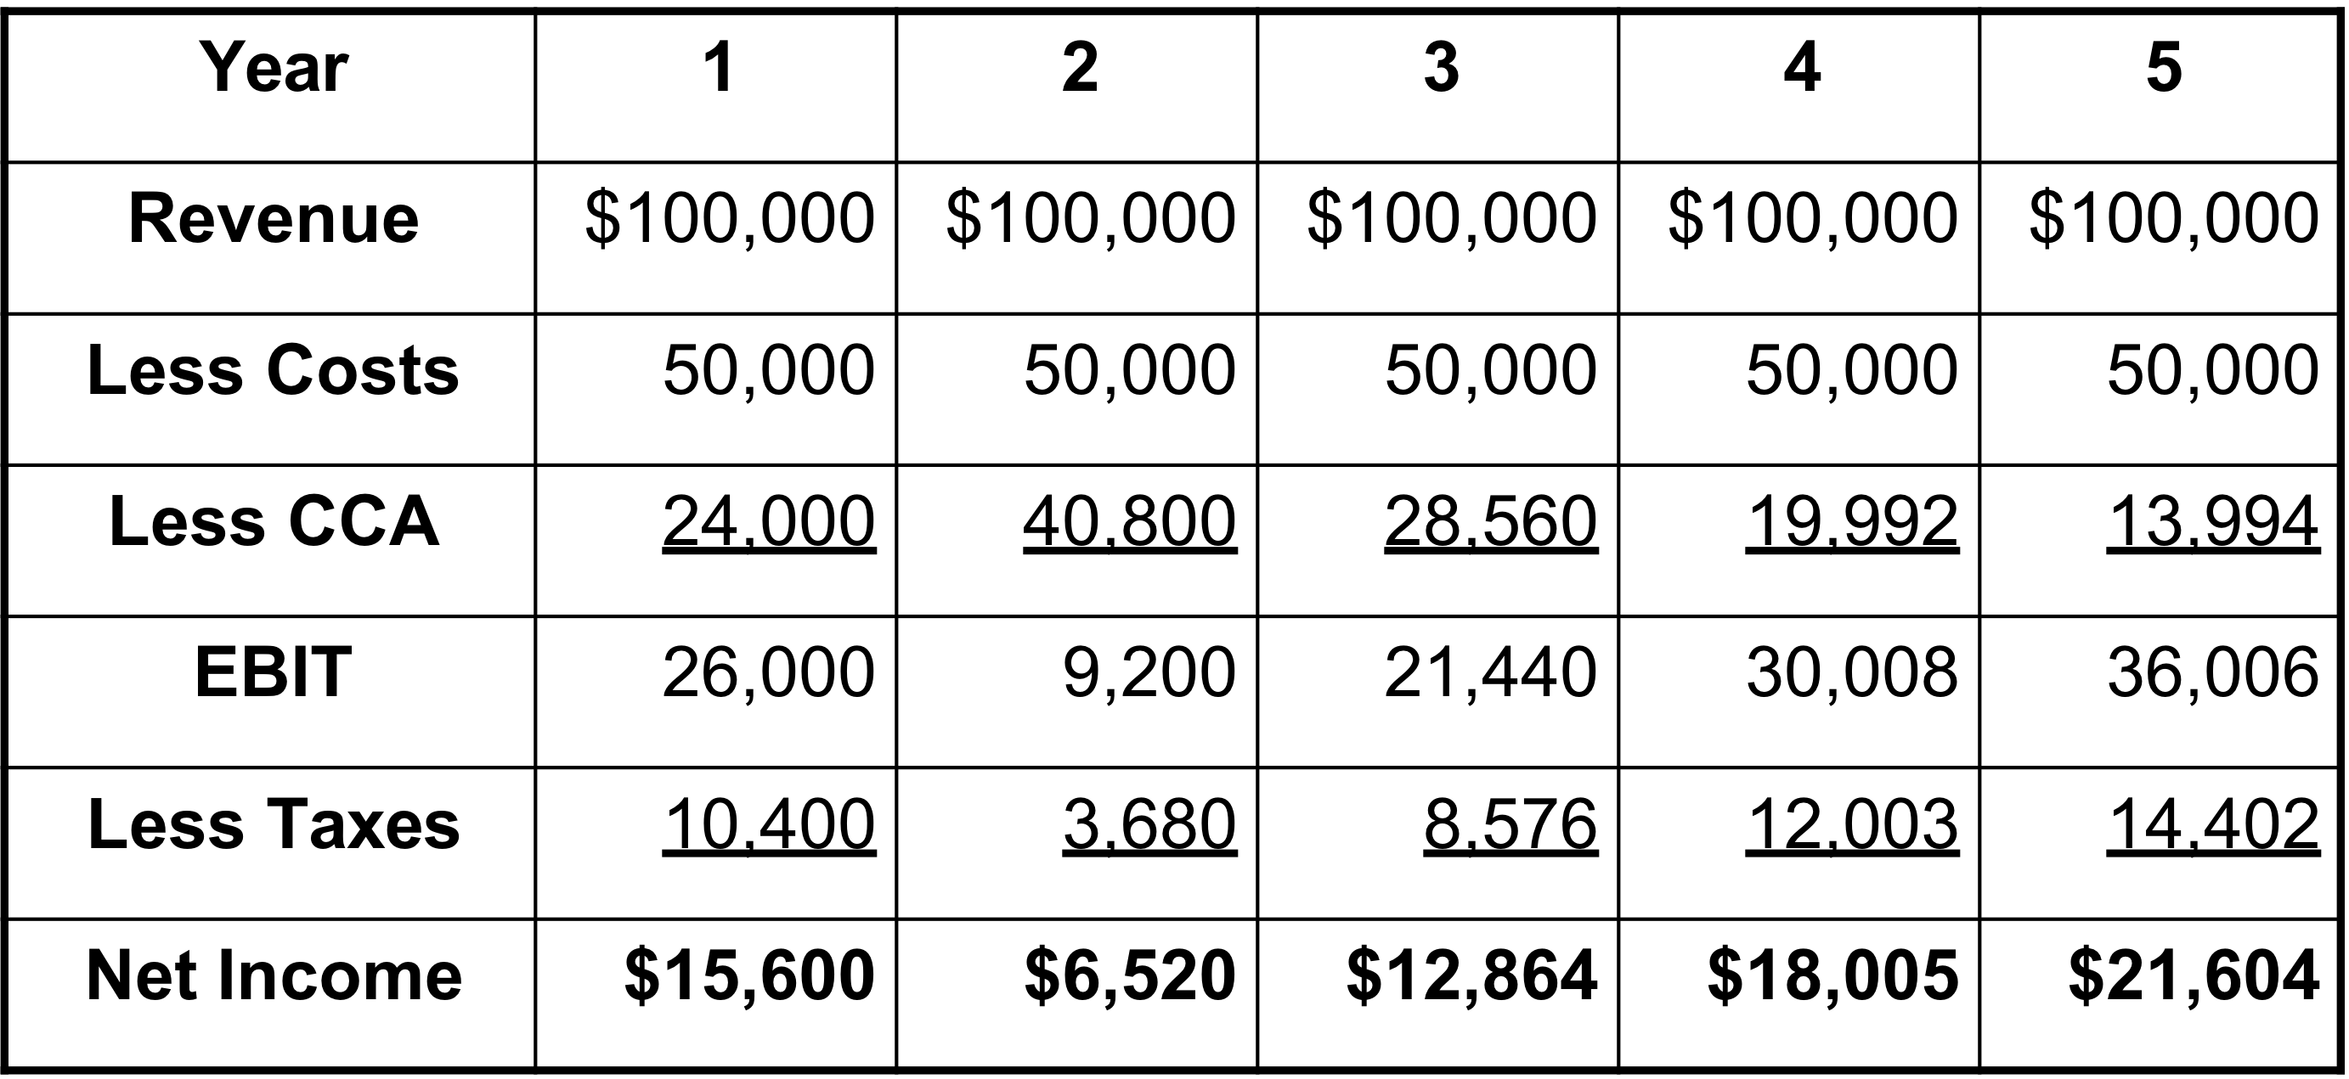

Pro forma approach
OCF=EBIT+depreciation-taxes
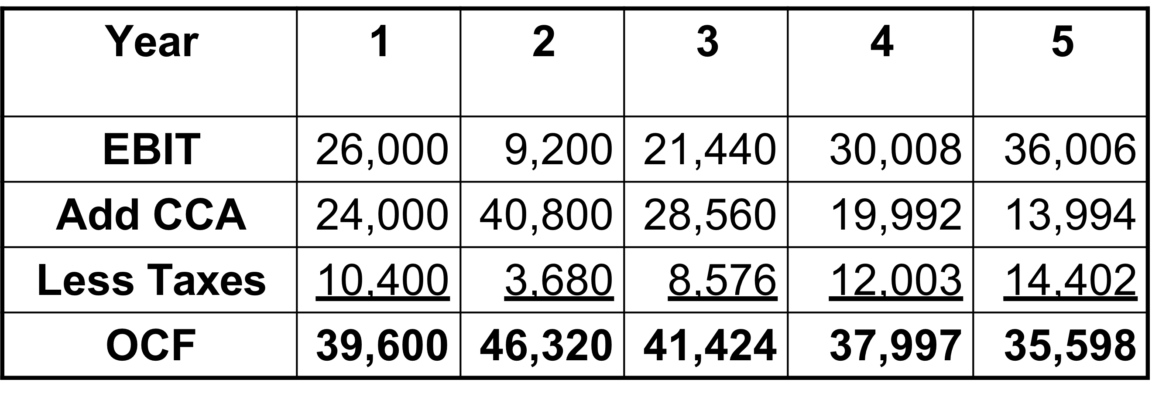

- Cash Flow from Assets
– CFFA = OCF – Additions to NWC – Net Capital Spending

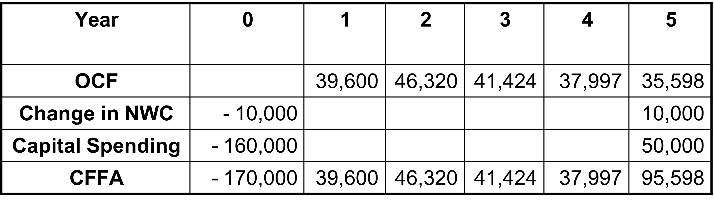

approach 2 Tax shield
- OCF = (S-C)*(1-t)+D*t
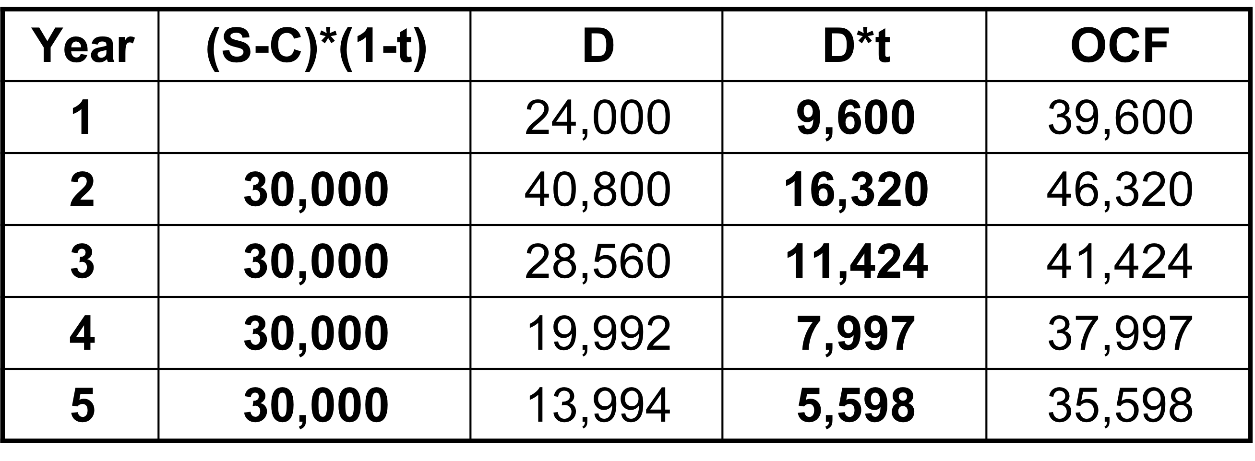

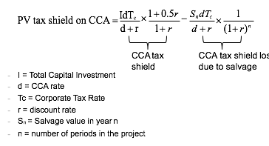

- What went wrong?
  - The CCA tax shield formula gives a different answer because it takes into account the tax impacts of buying and selling an asset beyond the actual life of the project.
  - Only if the UCC balance at the end of the project is equal to the estimated salvage value used in the formula will the brute force and tax shield formula methods give the same answer.
  - So long as we assume that the asset class remains open the CCA tax shield formula gives a more accurate answer.
  - If the asset class is assumed to close then you are forced to use the brute force technique.

Analyzing the Project
Sensitivity Analysis
  - A capital budgeting tool that shows how the NPV varies as a single underlying assumption is changed.
Scenario Analysis
  - A capital budgeting tool that shows how the NPV varies as a number of the underlying assumptions are changed simultaneously
- Break-Even Analysis
  - Break-Even
    - The level of a parameter for which an investment has an NPV of zero.
- Break-Even Analysis
  - Accounting Break-Even
    - EBIT Break-Even
– The level of a particular parameter for which a project’s EBIT is zero
Units Sold × (Sale Price - Cost per Unit) - SG&A - Depreciation = 0

Real Options in Capital Budgeting
- Real Option: The right, but not the obligation, to take a particular business action
- Option to Delay: option to time a particular investment, which is almost always present.
- Option to Expand: option to start with limited production and expand only if the project is successful.
- Option to Abandon: option for an investor to cease making investments in a project.

Chap 10 and 11
- Random Walk
  - Security prices change without predictable trends or patterns.
  - Stock prices seem to go up or down on any particular day, regardless of what has occurred on previous days.
  - Therefore, one can’t use past patterns to predict future price changes.
  - Random walk is a proof of market efficiency.
- Efficient Market Hypothesis (EMH)
  - Since all information is rapidly incorporated into the price of the stock, all stocks are correctly priced and no investor or issuer can earn “excess” returns.
- Three Forms of EMH
- Weak form: market prices reflect all information contained in past market prices.
- Semi-strong form: market prices reflect all publicly available information.
- Strong form: Market prices reflect all known information.
- Anomalies反常现象
  - Evidence that seems inconsistent with the efficient market hypothesis
  - The Small Cap Effect: investors in smaller companies
have outperformed investors in larger firms.
  - Book-to-Market Ratios: stocks with high ratios of book value of equity to market value have outperformed stocks with low ratios of book to market.
  - Active portfolio management: some managers like Warren Buffet.
In efficient markets, you can trust market prices
- You should be suspicious of any “simple” rule which explains why one type of security is cheap and another is expensive.
But do not overly believe in efficient markets
- An overly doctrinaire belief in efficient markets can paralyze the investor and make it appear that no research effort can be justified.
Rather than ask “Are markets efficient?”, we ask: “How efficient are markets?”

Returns
- Measuring Returns
  - The returns on an investment come in two forms:
    - Income (dividend or interest payments).
    - Capital gains (or losses).
  - There are two ways to measure the total return on an investment:
Dollar return = Dividend income + Capital gain
Percentage return = Dividend yield + Capital gains yield

- Percentage Return
  - It is generally more intuitive to think in terms of percentages than dollar returns
  - Dividend yield = Dividend income / Beginning price
  - Capital gains yield = (Ending price – Beginning price) / Beginning price
  - Total percentage return
= Dividend yield + Capital gains yield
= (Dividend income + Capital gain) / Beginning price

- Example
  - You bought a stock for $35 and you received dividends of $1.25. The stock is now selling for $40.
- What is your dollar return?
– Dollar return = 1.25 + (40 – 35) = $6.25
- What is your percentage return?
– Dividend yield = 1.25 / 35 = 3.57%
– Capital gains yield = (40 – 35) / 35 = 14.29%
  - Total percentage return = 3.57 + 14.29 = 17.86%

The t-bill portfolio is a safe holding.
  - Sure to get your money back from the government.
  - The price of the t-bill portfolio is quite stable and predictable because it is short term.
- The common stock portfolio is the riskiest.
  - No promise you will get your money back.
  - Price is uncertain and not easily predicted.
- The portfolio of long-term bonds falls between.
  - Most likely to get your money back at maturity.
  - However, the price of the holdings before maturity will be uncertain and not easily predicted.
- Return = Risk free rate + Risk premium

- Arithmetic Average Return
  - The return earned in an average year over a multiyear period.
  - “What was your return in an average year over a particular period?”
- Geometric Average Return
  - The average compound return earned per year over a multiyear period.
  - “What was your average compound return per year over a particular period?”

- Example
– Suppose you buy a particular stock for $200. The first year you own it, it falls to $100. The second year you own it, it rises back to $200. (no dividend paid)
- Arithmetic Average Return
= (-50% + 100%)/2 = 25%
- Geometric Average Return
= [(1-50%)x(1+100%)] ^{1/2}-1 = 0%

- Example
– You invested $100 in a stock five years ago. Over the last five years, annual returns have been 15%, -8%, 12%, 18% and -11%. What is your average annual rate of return? What is your investment worth today?
- Arithmetic Average Return
=(15%-8%+12%+18%-11%)/5 =5.2%
- Geometric Average Return
= [(1+R₁)x(1+R₂)x…x(1+R_{T})]^{1/T}-1
= [(1+15%)x(1-8%)x…x(1-11%)]^{1/5}-1

(calculate FV FV=pv(1+RG)year

Example
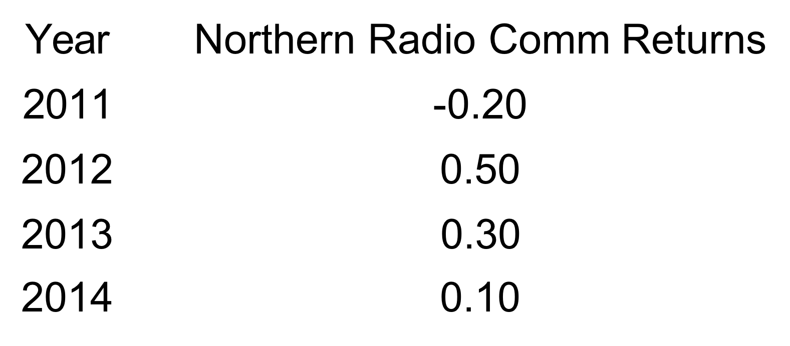
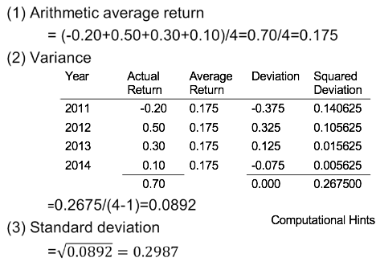
Higher standard deviation, higher risk
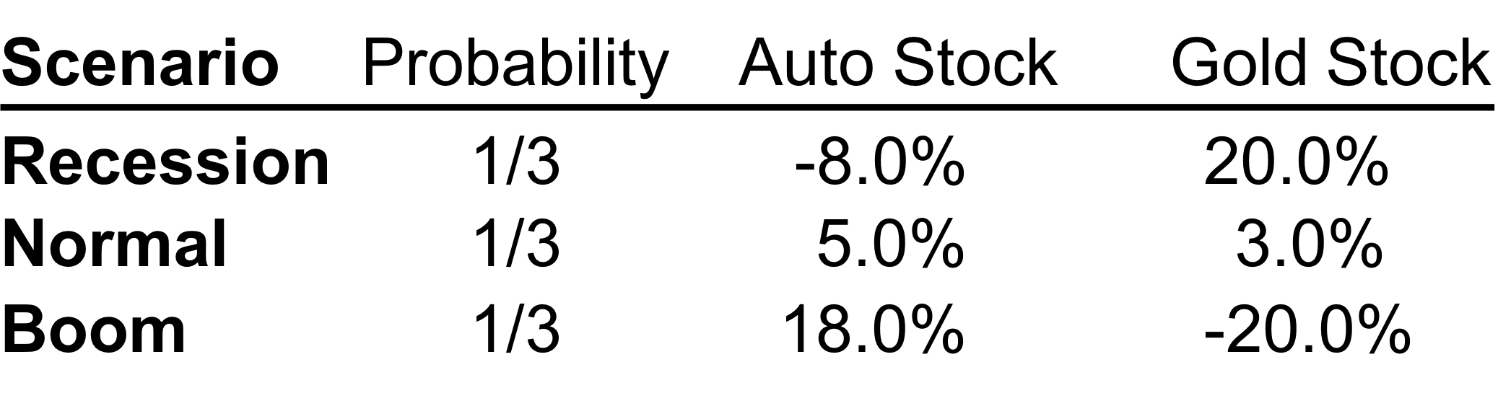
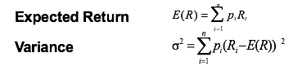
  - Return of the auto stock
-8% x 1/3 + 5% x 1/3 + 18% x 1/3 = 5%/{(1/3)*3}
  - Variance of the auto stock
(-8% - 5%)² x 1/3 + (5% - 5%)² x 1/3 + (18% - 5%)² x
1/3 = 0.011236
  - Standard deviation of the auto stock
=10.6%
根号下 0.011236
- Example (contd.)
  - Let’s say you have $10,000 and decide to put $7,500 in auto and $2,500 in gold.
    - First we need to calculate the expected return on this
portfolio for each of the scenarios.
  - The portfolio return will be the weighted average of the returns on the individual assets.
    - The weight will be equal to the proportion of the portfolio invested in each asset.
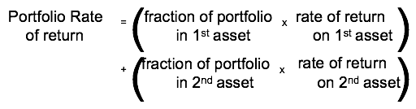
- Example (contd.)
Portfolio rate of return during a recession for these two stocks, 75% auto and 25% gold:
= (0.75 x -8%) + (0.25 x 20%)= -1.0%
Portfolio rate of return during a normal scenario for these two stocks, 75% auto and 25% gold:
= (0.75 x 5%) + (0.25 x 3%) = 4.5%
Portfolio rate of return during a boom for these two stocks, 75% auto and 25% gold:
= (0.75 x18%) + (0.25 x -20%)= 8.5%

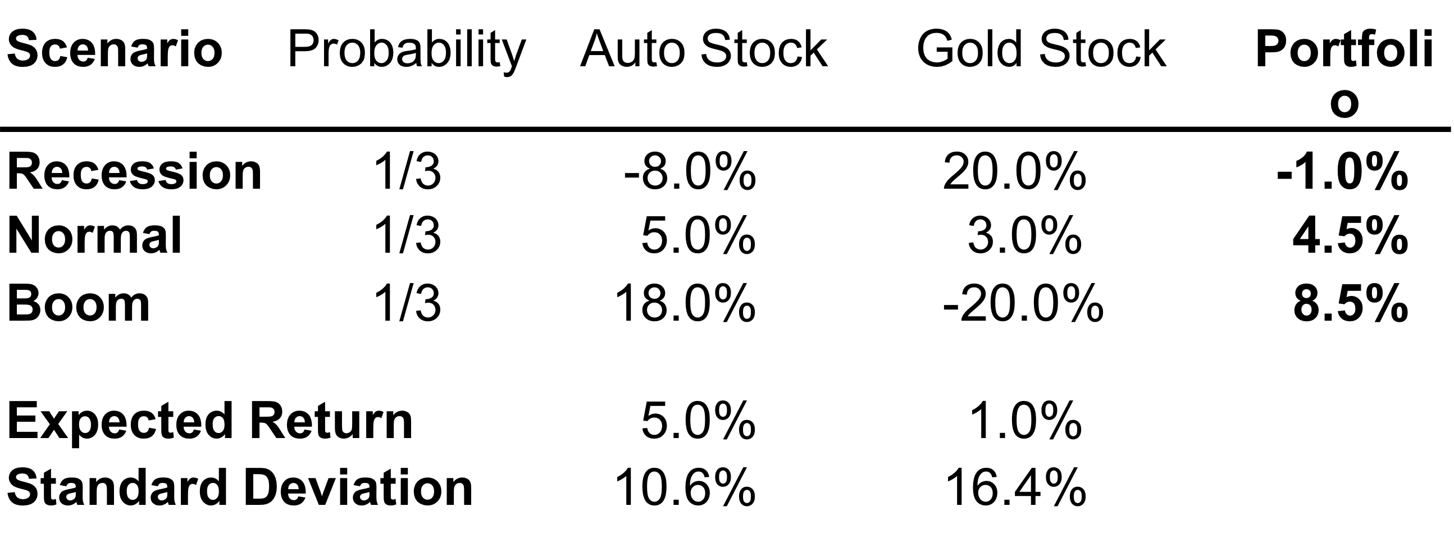
- Portfolio Return
  - Option 1:
-1% x 1/3 + 4.5% x 1/3 + 8.5% x 1/3 = 4%
  - Option 2:
5% x 0.75 + 1% x 0.25 = 4%
- Portfolio Risk
– Option 1: (-1% - 4%)² x 1/3 + (4.5% - 4%)² x 1/3 +
(8.5% - 4%)² x 1/3 = 3.9% ²

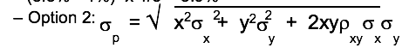
  - A measure of how closely two variables move together.
  - The correlation coefficient is always a number between
-1 and +1.
    - If r > 0, positively correlated; move in the same direction;
    - If r < 0, negatively correlated; move in the opposite direction;
    - If r = 0, uncorrelated; no relationship between the movement of one variable and the other.
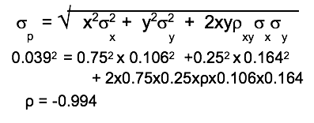
Risks and diversification
- Market Risk Versus Unique Risk
  - The risk which cannot be eliminated is known as
market risk (common risk)
  - The risk which can be avoided by diversifying is known
as unique risk (independent risk).
- Unique risk exists because of the perils which are peculiar to any one company.
    - The fewer the securities you hold, the more unique risk you are exposed to.

- Message 1:
  - Some risks look big and dangerous but are really diversifiable.
    - If a risk is a unique risk, reflecting perils specific to a particular company, investors can avoid that risk by combining it in a diversified portfolio with many other assets or securities.
    - From an investor’s perspective, unique risk need not
be a concern.
    - We use unique risk, unsystematic risk, and asset- specific risk (idiosyncratic risk), interchangeably.

- Message 2:
  - Market risks are systematic risks.
    - Diversified portfolios are not exposed to the unique risks of individual holdings.
    - However, they are exposed to uncertain events which affect the entire securities market or the entire economy.
    - These systematic factors include changes in interest rates, industrial production, inflation, exchange rates and energy cost.
    - When these systematic factors are favorable, investors do well and vice versa when they go the other way.
- Message 3:
  - Market risk can be measured.
    - We can measure how risky a stock is by comparing its price fluctuations to those of the market as a whole.
- Total Risk
  - Standard deviation or variance measures total risk.
  - Since we can eliminate firm specific risk through diversification we will not be rewarded for it (no risk premium).
  - Therefore we will not be rewarded for total risk, standard deviation is not a relevant risk variable.
  - We need to find a way to measure market risk, it is the only risk we will be rewarded for; the only risk for which we receive a risk premium.
- Systematic Risk
  - Market risk is measured by something we call Beta β.
  - We can measure a stock’s beta and use it to estimate the required return of the stock.
  - Beta is defined as the sensitivity of a stock’s return to the return of the market.
  - Sensitivity of a variable to another is a common statistical measure and statisticians have generated formulas to calculate betas, whether they are stocks or relationship of any other variables.

- Example
  - If the weights will be 50% of Inco and 50% of Royal Bank in your portfolio.
  - The beta of Inco is 1.47.
  - The beta of Royal Bank is 0.49.
  - What is the Beta of the portfolio?
b _{p} = w₁b₁ + w₂ b₂

- What does beta tell us?
  - A beta of 1 implies the asset has the same systematic risk as the overall market
  - A beta < 1 implies the asset has less systematic risk than the overall market
  - A beta > 1 implies the asset has more systematic risk than the overall market
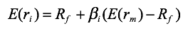
- Example
  - What is the expected return/required return for this investment:
    - Beta of 0.5
    - A t-bill returns 4%
    - The market returns 11%
E(r_{i} ) = R_{f} + b_{i} (E(r_{m} ) - R_{f} ) E(r_{i} ) = 4% + 0.5(11% - 4%) E(r_{i} ) = 7.5%

- Security Market Line (SML)
  - The graph showing the relationship between the market risk of the security and its expected return is called the Security Market Line (SML).
  - According to the CAPM, expected rates of return for all securities and all portfolios lie on the SML.
  - In equilibrium, all securities and portfolios must have the same reward-to-risk ratio and they all must equal the reward-to-risk ratio for the market.
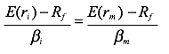

- Example
  - For example, you are looking at investing in security with a beta of 2.3 and at the same time a Bay Street analyst says you would get 16%. A t-bill returns 4% and the market returns 11%.
  - Should you buy the stock?
- Answer
– Expected return = 4% + 2.3 x (11% - 4%) = 20.1%.
  - An asset with a beta of 2.3 should yield 20.1%.
  - According to the analyst, this security is yielding only 16%.

- Answer (contd.)
  - Is this asset underpriced or overpriced?
    - It is overpriced.
    - (When the actual return is below the SML, it is overpriced, and vice versa.)
  - Should you buy the stock?
    - No one would buy it because the expected return is insufficient for the risk.

