supply chain: network of all entities involved in produce and deliver finished product to final customer. This includes sourcing raw materials and parts; manufacturing, producing, and assembling the products; storing goods; order entry and tracking; distribution; and delivery to the final customer. Flow of Products: (1) from the beginning to the final customer (2) Reverse Logistics Flow of Information: simplified supply chains utilize data from point-of-sale back to suppliers - real time info on sales reduces uncertainty and inventory levelsFlow of Funds: transferred in both directions along the supply chain (product return, compensation)
Supply Chain Stages: A typical supply chain may involve many different trading partners, called “stages”
Stages may include: Suppliers, Producers (manufacturers), Wholesalers/Distributors,Retailers, Customers
inbound direction toward the company, or the ‘‘focal firm’’, are called the ‘‘upstream’’ part of the supply chain. 2-1 outbound: from the ‘‘focal firm’’ are termed ‘‘down- stream.’’ 123 (sale-use)
Value Chain: Supply chains are under increasing financial pressure and stages that do not add value to the supply chain are quickly eliminated. -a supply chain is often called a value chain or a value network.
SMC Activities: 1- Coordination: coordinate the movement of goods, services, and funds through the supply chain. suppliers manufacturers distributors retailers final customers Coordination also involves the movement of funds through the supply chain as products are purchased and sold. - This includes various financial arrangements and terms of purchase between buyers and suppliers.
2- Information Sharing: requires sharing relevant information among members of the supply chain
e.g., sharing forecasts, point-of-sale data, planned promotional campaigns, inventory levels
3-Collaboration: jointly plan, operate, and execute business decisions as one entity
This is important for decisions that range from product design and process improvement to implementing business initiatives or following a particular business strategy. *For example, this may include collaborating on ways to - cut costs or - improve quality standards throughout the entire supply chain
Customer Focus (Pulled Supply Chain): final customer is the driving force of the supply (products PULLED)
The Service Supply Chain: Service Supply Chains *focus more on the interaction between the customer and provider *often rely on customers as the supplier of inputs *tend to be shorter than manufacturing supply chains*are often more like hubs than chains *do not have inventory as a buffer
SCM : *Supply Chain Management (SCM) is the design and management of flows of products, information, and funds throughout the supply chain. * SCM is about the collaboration between supply chain partners in a strategic effort to achieve superior competitiveness.
Logistics test! *The part of SCM that is concerned with managing the flow of products

Week2
1.Competitive Supply Chain: Three key characteristics
1-Responsiveness: The ability to move quickly to meet customer demands (is often described as ‘‘agility’’).
(demand-driven respond customer ‘‘demands’’—rather than forecast-driven. (customer-focused, more agile)
2- Reliability *uncertainty is the main reason why companies carry safety stock resulting in higher costs
such as uncertainty about supply *The best way to reduce uncertainty is by increasing reliability
- greatly improves reliability in supply chains is improved visibility. -Supply chain coordination and sharing of real-time data through information technology has permitted visibility to all entities in the chain.
3- Relationship Management: *SCM is management of relationships across networks of companies *In many industries, for example, the practice of ‘‘single-sourcing’’ is widespread.
advantages long-term and mutually beneficial.- such practices can improve quality, design, and overall responsiveness while reducing costs , consistent quality, tracking quality, short time
2.Trends in SCM: Globalization,Outsourcing ,Postponement,Technology,The Lean Supply Chain,Managing Supply Chain Disruptions,Supply Chain Security, Sustainability and the “Green” Supply Chain,Innovation
1Globalization: *The concept of the “Global Marketplace” became possible due to changes in:
*Information Technology *Transportation *Government Policies*Companies have benefited from a larger choice of product sources.*Consumers have also benefited greater product choices, higher quality, and lower cost.*Managing global supply chains has a number of challenges. -The distance factor *Reliability *Efficiency
2Outsourcing: *hiring a third party to perform a set of tasks for a fee -(more efficiently or home doesn’t have ability/technology to produce) *Increased Competitive Pressure -Main reason for outsouring: forces companies to focus on what they do best and outsource other activities -Core Competencies: create superior value by managing core competencies better than competitors
3Postponement: Companies are continually struggling to reach global markets, while providing local customization. *The French, for example, prefer top-loading machines while the British prefer front-loaders.
Postponement延期 *completion of the final product is postponed to the last possible moment when local demands are known *strategy to reach diverse geographic areas while still providing local customization

Week2: Marketing
The Marketing Function 1: linking the organization to its customers and is concerned with the “downstream” part of the supply chain. Three marketing tasks: 1 Identify what customers need and want 2create demand for a company’s current and new products 3continue to identify market opportunities
2: * complicated there is no single market for any given product or service.* challenge is distinguish markets, called market segmentation. - Mass Marketing iclicker (treats the entire market as a homogenous group Marketing plays a critical role as providing value to customers drives all actions of the organization and the supply chain.) it reduces costs through economies of scale but may miss large segments of the market with an offering that is too general. -Target Marketing (recognizes the diversity of customers and does not try to please all customers with the same product) *challenge identify the most effective market segments
Evolution of MarketingThree Perspectives: iclicker *The production concept *The selling concept *The marketing concept Two Eras: *Transactional Marketing *Relational Marketing
The Production Concept: *Large unfulfilled demand for products *Products easily sold *Challenge to sell at a price that exceeded the cost (Firms focused on products that could be made most efficiently as offering low-cost products in the marketplace automatically created demand.)
The Selling Concept: *Increased competition *Less unfulfilled demand 约等于 supply
*Mass production was commonplace (economics of scale) *Marketing used to persuade customers
(-e.g., advertising and personal selling -marketing was a function that was performed after the product was developed and produced. little attention to customers’ needs)
The Marketing Concept: *increased discretionary income (Customers would buy only those products that precisely met their needs) *greater product variety and customer selectiveness *increasingly global environment (needs began changing rapidly and were not immediately obvious) *the marketing concept developed to focus on identifying customers needs and keeping customers satisfied

Transactional Marketing VS Relational Marketing
Transactional: *companies focused on maximizing short-term transactions with their customers *sell existing products using promotional techniques
Rational: *focus on building long-term relationships *Involve marketing research (understand customer psychology) *focused retain current customers than to work to attract new ones
2 Customer: Individual end user (purchases made by an individual or household to satisfy personal needs) Organizational end user (purchases are made by an organization for employees to perform their jobs)
Customer relationship: Provides a minimal amount of product customization iclicker Products developed for the average customer Has large cost advantages – economic of scale
Customized Strategy: capitalizes on Info from Market segmentation and target markets, versions of product, high priced Niche strategy: target one segment, very precise meet needs, small firms because (1.no lot competition – blue ocean strategy, 2.less capital , small company has limitation, 3 special skills/ capability)
Micro-marketing (one to one): focus on individual customer with unique requirements – build brand loyalty
Customer Relationship Mgnt: uses automated customer transactions to gather data, (ERP software)
3 VOC: capture customer needs and preferences. Three levels of customer needs: Basic Needs: minimum customer expectations Performance Needs: differentiate one product from another Excitement Needs: are normally not known by the customer in advance, but they elicit delight over the product
QFD: translate general customer requirements into specific product characteristics
Customer service: three ways: An Activity (something a firm must do in order to satisfy customers (e.g. accepting product returns); occur at transactional level with limited opportunity to add value
A Set of Performance Measures objective measure of service performance (be percentage of orders delivered on time) A Philosophy Supply chain commitment to customers, consistent with Total Quality Management.
4 A channel of distribution is the way products and services are passed from the producer to the final customer Direct Channels the transaction is directly from the producer to end-user or final customer
Indirect Channels-intermediaries such as wholesalers and retailers are used to sell to final customers
-the external institutions assume much of the cost, burden, and risk. The manufacturer receives less revenue per unit than with the direct channel, but it also carries lower risk.
Distribution channel: Channel structure is not static静态 but is constantly changing to meet demands
Three influential factors 1Market coverage Objectives: It depends on (1) the size of specific market areas and (2) the intensity of coverage of specific geographic regions. Intensive distribution: the placement of a product in as many outlets or locations as possible 2Selective distribution:placement of a product or brand in a limited number of outlets within a specific geographic area 3Product characteristics High-value products require a direct and shorter supply chain.Highly technical products require product demonstration and are better suited for a direct channel. Highly perishable need delivered to markets fast due to short life cycle.

Week 3 operations management
Operations management (OM) :is the business function responsible for producing a company’s goods and services in an efficient and cost-effective way.
Transformation Role: OM converts inputs into finished goods and services human resources, such as workers, staff, and managers. facilities and processes, such as buildings and equipment materials, technology, and information. Outputs are the goods and services a company produces.
Manufacturing vs. Service Operations:Manufacturing Operations: physical and tangible goods that can be stored. most customers have no direct contact with the operation Service Operations: intangible products that cannot be produced ahead of time, customer is present during creation of the service
Impact on the Organization:.
Marketing: helps operations understand what customers want.must understand operations’ capabilities
Sourcing:helps operations understand material availability, sources of supply, and quality standards.
must understand operational requirements. Each company depends on other members of its supply chain.
In the upstream: part of its supply chain, a company depends on its suppliers for the delivery of raw materials.
If deliveries of these materials are late, or are of poor quality, production will be delayed.
On the downstream side: a company depends on distributors and retailers for the delivery of the product to the final customer. Sales suffer from downstream delays or products damaged in transport.
Poorly managed operations result in excess costs to other members of the supply chain.
2 product design
1.Idea Development (marketing, competitors, early supplier involvement, reverse engineering)
2Product Screening (viability of the product (i.e., the likelihood of success) based on the needs of each of the business functions.*Roughly 80% of ideas do not past the screening stage *A useful decision making tool at this stage is break-even analysis)3Preliminary Design and Testing (performance specifications translated into technical specifications)*Proto-types built and tested, and changes are made.*In service organizations, this may entail pre-testing the product on small groups of customers and refining the service concept accordingly.4.Final Design (specifications translated into production instructions)
Break-even
Total Cost = Fixed Costs + Variable Costs Total Cost = F + V_{C} Q where: F = fixed cost V_{C} = variable cost per unit Q = # of units sold Revenue = S_{P} Q where: S_{P} = selling price per unit F + V_{C} Q = S_{P} Q Solve for Q:

Example: VC $25 FC $15,000.
a) SP $30, number to break even? 25*#+15k=30*# b) sells 4,000 @$30 price profit? (30-25)*4k

1 DFM: design simplification Design simplification means reducing the number of parts and features of the product whenever possible. design standardization: refers to the use of common and interchangeable parts
2 product life cycle:Most products go through a series of stages of changing product demand called the product life cycle. There are typically four stages
3 Concurrent Engineering all functions work together simultaneously-Historically, product design was made sequentially.where an idea was developed and then passed on to each function for evaluation.
4. Remanufacturing.has enormous ..?.. and operational adventage benefits *uses components of old products in the production of new ones *is especially popular in the electronics industry, such as the production of computers and televisions

3 process design
developing a production process that can create the exact product that has been designed.
Two categories of processes: 1.intermittent process 2. repetitive process
two dimensions: Product volume , Degree of product standardization
Intermittent Process : used to produce a large variety of products with different processing requirements in lower volumes. *auto body shop or a healthcare facility *As different products have different processing needs, there is no standard route that all products take through the facility. *resources are grouped by function and the product is routed to each resource as needed. *Think about a healthcare facility. Each patient is routed to different departments as needed.
Repetitive Process:Are used to produce one, or a few, standardized products in high volume. Examples include an automobile assembly line or an automatic car wash. (Resources are organized in a line flow) *Repetitive processes tend to produce products in the later stages of the life cycle (the larger volumes are justified by a well-established market)*To produce a large volume of one type of product, these processes tend to be more capital-, rather than labor-intensive. (An example is ‘‘mass-production”)
The Continuum of Process Types: The two process categories can be further divided:
Intermittent processes can be divided into project processes and batch processes.
Repetitive processes can be divided into line processes and continuous processes.
project processes: one-of-a-kind products exactly to customer specifications. Examples include construction, shipbuilding, medical procedures, custom tailoring, and interior design. batch processes: The classes you take at the university use a batch process. (job shops)
line processes: They are also known as flow shops, flow lines, or assembly lines. Think of a typical assembly line that produces everything from cars, computers, television sets, shoes, candy bars, even food items.Continuous processes: Continuous processes operate continually to produce a very high volume of a fully standardized product. Examples include oil refineries, water treatment plants, and certain paint facilities. The products produced by continuous processes are usually in continual rather than discrete units such as liquid or gas. Also, these facilities are usually highly capital intensive and automated.For example, a bakery that produces breads, cakes, and pastries in batches may also bake and decorate cakes to order.

Facility Layout:physical arrangement of all resources within a facility.*Poor facility layouts -inefficiency and increased production cost.*Facility layout planning is made any time (a change in the arrangement of resources. -redesign of the operation a new product -the change in resources (new worker ,machine moved)
Four major layout types:
1. Fixed position: Used when a product cannot be moved during production, All resources come together at the product’s location, Challenge to schedule the timing and sequencing of different tasks
2. Process Layout: * It is best suited when (producing many different types of products in low volume
as seen in intermittent processes)* Here products have different processing needs (As a result resources are grouped by process) *Material handling costs are high as products have to be moved from one department to another. *The main objective is to minimize the cost of moving materials.
3.Product Layout Resources are arranged in sequence (efficient)*for repetitive processes.(Producing a high volume of one, or a few similar, products.) *Every product exactly the same. * minimize processing times
4. Cellular Layout Attempt to combine the efficiency of product layouts and the flexibility of process layouts
*items grouped into a product family according to processing requirements (may have similar shapes, sizes, process flows, or demand. ) *workstations arranged in small assembly lines called cells
Disadvantages of a Product Layout: *lack the flexibility-unable to produce variations of products. *workstations are highly dependent upon one another (quality problems or delays)
* LINE BALANCING IN PRODUCT LAYOUTS *Product Layout Objective -determine the sequence of tasks to be performed by each workstation *Consider-order of tasks -time required to perform each task -speed of the production process. This process is called Line Balancing.
process automation
Advantages: enhances speed ,production consistency, provides greater accuracy, repetition without worker fatigue, enables physically dangerous jobs, enables handling of jobs beyond human capabilities
Disadvantages: Initial cost can be very high *Many tasks cannot be automated
OM is responsible for producing product in a cost effective and effient way
The OM decision how the product or service will be produced – process design
Understanding the evolution of a product, from intro to maturity is known as – product life cycle

Week 4 Forecasting & demand planning part I
Forecasting vs. Planning
Forecasting is the process of predicting future events, and is what drives all other business decisions
Planning is the process of selecting actions and requires organizing resources in anticipation of the forecast.
Planning decisions: 1-Scheduling existing resource (An important aspect of planning is deciding how to best utilize existing resources (e.g., labor, facilities, capital) 2-Determining future resource needs (Organizations must determine what resources are going to be needed in the future (e.g., new facilities, new equipment, or expand to new locations) 3-Acquiring new resources (Plans must be made well in advance, and procedures to acquire new resources and capabilities put in place well ahead of time)
Demand management: influencing demand. *promotional campaigns*advertisements*offering incentives to sales staff and personnel *cutting prices
Impact on the Organization Marketing：estimates of demand, future trends, changes in consumer preferencesOperations：capacity planning, scheduling, inventory levels Sourcing：purchasing decisions, supplier selection Finance：assessment of financial performance and capital investment needs
Impact on SCM ： look at the demand of their immediate buyer not the final customer in the chain.-causes a mismatch between supply and demand -gives rise to the bullwhip effect
2 Trend: increasing or decreasing pattern over time. a straight line, or linear trend. exponential trend
Seasonality regularly repeats itself. Cycles: Cycles are patterns created by economic fluctuations. Examples include: recessions,Inflation
distinction between seasonality and cycles cycles do not have a predictable or repeating length or magnitude.
Qualitative: based on subjective opinions (manager, staff) called judgmental methods
Qualitative: mathematical modeling, objective and consistent,ande large amount of data

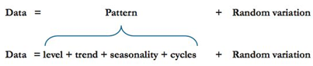
3 time series models
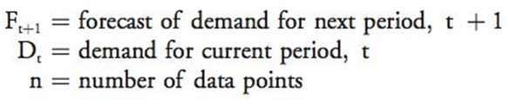
Mean:
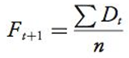
only appropriate for a level data pattern. forecasting stable and mature products.
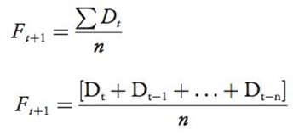
Moving Averages: a specified number, n, of the most recent data rather than the entire data set.
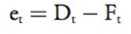
the oldest are dropped, and the number of observations used to compute the average is kept constant. only appropriate level data patterns. the advantage of being responsive recent observations.

Weighted Moving Averages
Exponential Smoothing: A forecasting model that uses a special weighted average procedure to obtain a forecast
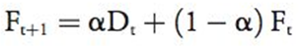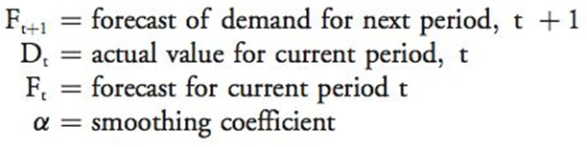
Example: forecast May 24 , actual 28 alpha of 0.70.
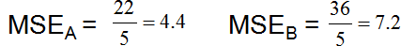
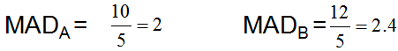
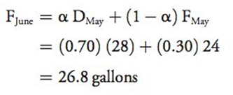
Starting Point: When using exponential smoothing for the first time we may not have a forecast for the current period. use ‘‘the naive method’’, which is using last period’s actual value to generate an initial forecast. Another is to average the last few periods—say the last three or four if change quickly,choose higher

Week 6 Time Series Models (Trend Adjusted Exponential Smoothing)
All previous models work only for a level pattern.
Forecast should be modified to account for a trend in the data
It is a simple modification of the exponential smoothing model we just discussed.
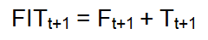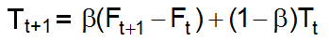
Where: FIT_{t+1} = forecast including trend for next period
F_{t+1} = unadjusted forecast for next period
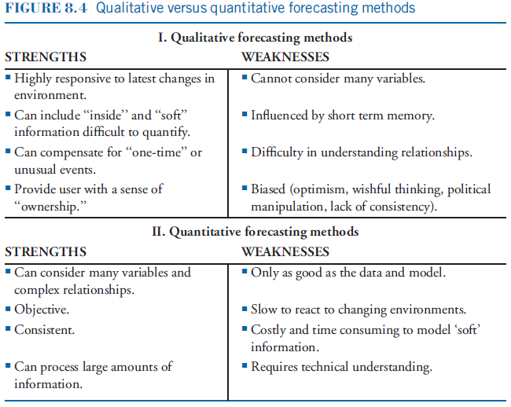
F_{t} = forecast for current period, t
T_{t+1} = trend factor for next period, t+1
T_{t} = trend factor for current period, t
β= smoothing constant for the trend adjustment factor (between 0 and 1)

Example α=0.3 and a β=0.4.
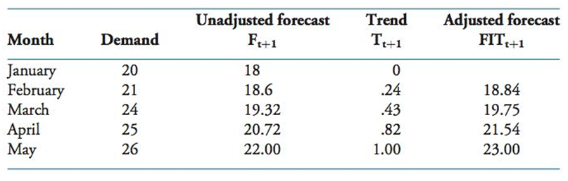
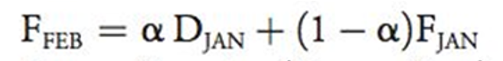

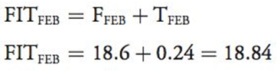
Ffeb=0.3*20 / (1-0.3)* 18= 18.6
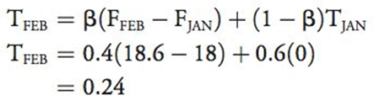

$F_{MARCH}=0.3×$21+(1-0.3) $×$18.6=19.32 $T_{MARCH}=0.4×(19.32-18.6)$+(1-0.4) $×0.24$=0.43 ${FIT}_{MARCH}=19.32+0.43=19.75$
Seasonality Adjustment
regularly repeating pattern. Examples include: we need to adjust our forecast
This percentage is called the seasonal index.
Step 1: Compute average demand for each season-total annual demand divided by the # of seasons
Step 2: Compute a seasonal index for each season-divide the actual demand for each season by the average demand for each year -average across years available
Step 3: Adjust the average forecast for next year -generate a forecast for next year using any of the methods we discussed and calculate average demand per season -use seasonal indexes to generate seasonally adjusted forecasts

Example forecast for next year to be 98,000 customers.
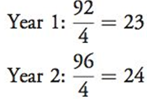
Step 1: Compute the average demand for each season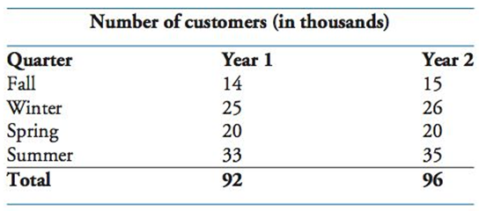
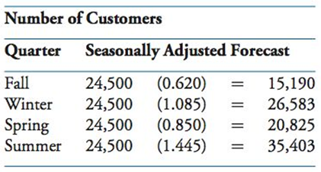
Step 2: Compute a seasonal index for each season
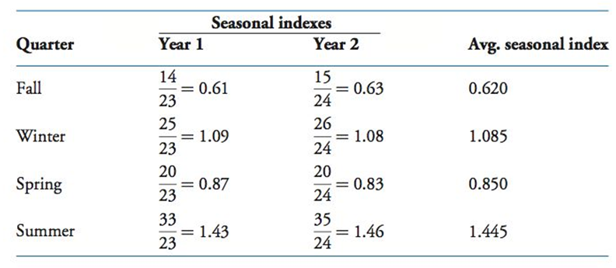

Step 3: The forecast for next year is 98,000, so the average demand is 24,500

Factors in Method Selection
1.Amount and type of available data:Sophisticated quantitative models, for example, may require large amounts of data, whereas simpler methods may not.
2.Degree of accuracy required:Sophisticated quantitative models may generate good forecasts, but they may be costly to develop. For example, forecasting paper clips or rubber ???
3.Length of forecast horizon:some forecasting methods are better suited for short-term forecasts, whereas others are better suited for long term.
4.Patterns in the data:As we already mentioned, it is critical to select a forecasting model that is appropriate for the identified patterns in the data.
Measuring Forecast Accuracy Forecast error is the difference between actual demand and the forecast
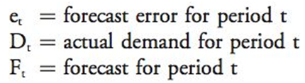

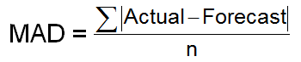
Two measures
1.Mean Absolute Deviation (MAD) MAD is the average of the sum of the absolute errors:

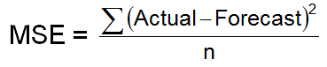
2.Mean Square Error (MSE) MSE is the average of the squared errors:

Example
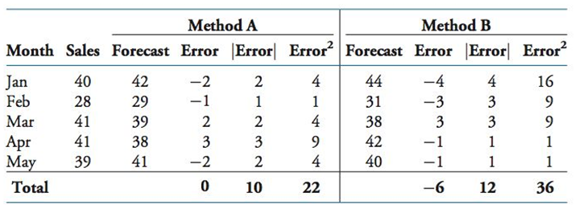
Types of Forecasting Methods
Qualitative based on subjective opinions *Such as managers, sales staff (called ‘‘sales force composite’’), or customers (called ‘‘intention surveys”). Quantitative *based on mathematical modeling *objective and consistent * can handle large amounts of data and uncover complex relationships

- Time Series Models
  - A time series is simply a listing of data points of the variable being forecast over time taken at regular intervals
- Causal Models
  - assume that the variable being forecast is related to other variables in the environment
  - For example, university enrollment may be related to ???
Collaborative Forecasting and Demand Planning
- Two common processes:
- Sales and Operations Planning (S&OP)
S&OP is a collaborative process for generating forecasts that all functional areas agree upon
2.Collaborative Planning, Forecasting and Replenishment (CPFR)CPFR is a collaborative process of developing joint forecasts and plans with supply chain partners

S&OP

CPFR
CPFR is a collaborative process of developing joint forecasts and plans with supply chain partners, rather than doing them independently. if they work together to bring value to their customers, share risks of the marketplace, and improve their performance.(Wal-Mart, Target, Black & Decker, and Ace Hardware)
Steps for Adoption of CPFR
Five-Step Process:
1.Create joint objectives 2Develop a business plan(e.g., forecasting needs, production schedules, key performance metrics, or ‘‘KPIs’’). 3 Create a joint forecast 4Agree on replenishment strategies
5.Agree on a technology partner to bring CPFR to fruition
Q1. Translating date about customer needs and preference into technical specification is known as Quality function development. Q4. Production, selling, marketing concept. QTranslating date about customer needs and preferences into technical specification is known as “Quality function development.” Q. A segment of a logistic channel might include: Warehouse. Forecast are critical to predicting future events, but they are rarely perfect. QThe process of preparing for future events is planning. QThe types of date pattern that emerges in times of economic fluctuation is Cycle Joint forecasting between supply chain partners is known as collaborating, for casing,QThe process of preparing for future events is planning. QThe types of date pattern that emerges in times of economic fluctuation is CycleQJoint forecasting between supply chain partners is known as collaborating, for casing, Most difficult forecast implements! Different member, different thinking and goal, value Shorter life cycle, potential is high Q. A segment of a logistic channel might include: Warehouse
Week 8: network and system design part 2
System Variation: Every system. variability in the amount of output processed.1.workers' performance2. equipment & facilities Problem 1.consumes resources 2.complexity uncertainty
Managing Process Variation: 1-reduce variation quality control methods use for this purpose.2-create buffers to deal with variation: placed before constraint, ensuring constraint never ‘‘starved.’’ placed behind the constraint prevent downstream failure to block the constraint’s output. 3-design more flexibility into the process to respond to the variation e.g., cross-training workers
Capacity Implications: maximum output by period of time.Different ways. -a healthcare clinic -patients seen -restaurants -customers served.-size or storage limit.hospital beds available. restaurant seats available.
Linked supply chain organizations need to match capacities
Two common measures: Design Capacity: maximum output by using temporary measures (overtime, overstaffing, use equipment maximum rate)Effective Capacity: maximum output -under normal conditions realistic work schedules,breaks, regular staff levels, machine maintenance
Bakery Example:200 cupcakes per day. peak periods—300 cupcakes. This is the maximum but cannot be sustained for any long period of time.
Design Capacity= Design Cap>Eff cap, Udesign=AO/design < Ueff=AO/eff
Effective Capacity=?
Capacity Utilization: needs to measure how well it is utilizing it. Capacity utilization indicates how much of capacity is actually being used
Computing Capacity Utilization:
process 100k orders in a single day, under maximum conditions, using overtime labor. process 70k orders per day under normal conditions.-processing 80k orders per day. capacity utilization? (always<100%)
Can more or equal to 199% (second)-Utilization effective =80/70 114.3% Utilization design = 80/100=80%
- current output of the warehouse is higher than effective capacity. operate only a short period of time.
A. Integration of supply chain processes: organizations r independent entities exist separately from other.
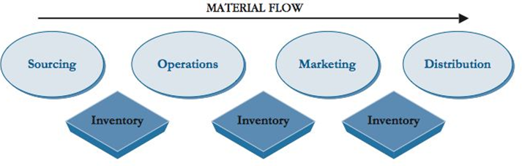
Three Stages: 1.Complete functional independence 2.Internal functional cooperation and coordination, but not across the supply chain 3.True supply chain integration
Stage 1. complete isolation of one another (also called the ‘‘silo’’ mentality).Stages 2 and 3:internal functional corporation and coordination, not across the supply chain-represent true SC inte
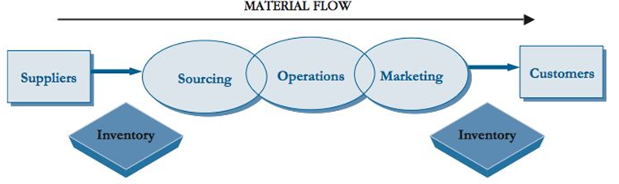
Vertical Integration Versus Coordination: Coordination may be easiest through vertical integration, (which involves ownership of upstream suppliers and downstream customers, the Dole Corporation owns pineapple farms ‘‘core competencies’’, less important activities outsourced.outsourced include: data network management, human resources, records archiving, and management of maintenance, repair, and operating (MRP) inventory items. The trend is even toward ‘‘virtual’’ where everything is outsourced.
B. Designing Supply Chain NetworksTwo : 1.Physical structure of network 2.Management of network
Physical structure of the network Iclicker
structure is defined by three elements:1.The number of companies that are part of the supply chain.
2.The structural dimensions of the network. (number of stages, how many members are in each stage.)3.The number of process links across the supply chain. (more process links that must be managed, the more complex
1.Physical Structure of the Network countless network structure types. factors (product type and its characteristics, number of available suppliers, availability of raw materials, ease of access to customers).
Innovative products-quick access to production facilities-few tiers but many members in each tier to provide quick production options—such as Nike or Sony.
2.Management of the Network Not all SC branches need managed equally. Management decide type of relationship for SC links.
(sourcing a standard part -commodity No need relation-build! This link managed a contractual way. In contrast, alliances and partnerships need to be managed differently.
Designing Segmented Structures:-Segmented SC manage varying customer requirement -‘‘one size fits all’’ cannot accommodate variations. -Each segment different SC structure. simple segmentation example Wal-Mart.（two structures: one for its fast- moving and slower-moving items. efficiency, and increased sales.）
Three-step segment approach 1. Identify key drivers of operational complexity. identifying what matters most to a customer group.quick time-to-market - fashion-oriented, short-lifecycle merchandise than to long-lasting, core products. Test! Variation is a challenge because it adds complexity and uncertainty to a process. Capacity available under normal conditions is called: effective capacity 2. Design differentiated supply chain segments tailored to address these unique complexities. -key drivers identified, a supply chain segment created.- require designing multiple supply chain segments to meet requirements. Note: The number of segments, not be too large and remain reasonable to manage, 5-6 (e.g., high priority customers vs. low priority customers, high variability vs. low variability).3. Create a customized end-to-end operational blueprint and performance metrics for each supply chain segment.
C. Enterprise resource Planning (ERP)-IT Enable SCM: Information technology (IT) enables communication, storage, and processing of data within and between firms.-Wal-Mart uses Retail Link, enables suppliers see exact number every shelf of every store. -better decisions, better managing their inventory -A wide variety of information is needed for SC to perform as a coordinated system.E.g. customer orders, inventory levels, delivery status, and production plans.-must also effectively flow within the organization and between members of the supply chain ERP) enabled sharing of information across the enterprise for better decision
Enterprise Resource Planning: -ERP are computer-based technology used to manage resources throughout the SC.(facilitate the flow of information inside the organization and manage connections between other members of SC.-business support system.-utilizes a central database allows department retrieve information
ERP Modules:-developed in components, modules, specific to each function or process.-ERP Modules: (Manufacturing, Finance, Human Resources, Supply Chain Management,Project Management
Customer Relationship Management (CRM))
ERP Configuration: 1.Fully Customized expensive, complicated, time consuming, can delay implementation2.Standardized “off-the-shelf” modules force changes in processes to accommodate the modules themselvs 3.Mix of Customized and Standardized
ERP Implementation: -typically too complex for in-house developers.-time can be significant and depends on
（the size of the business,the number of modules being implemented,the degree of customization
the scope of the changes, the flexibility of the organization to adapt to the change required)
four general steps 1.Map current business processes 2.Evaluate ERP vendors (identifying which vendor’s ERP modules most closely match the mapped organization’s processes) 3.Identify steps to efficiently unify modules with processes 4.Plan during implementation to further refine the unity between these two.

Week 9: Supply Chain Strategy part 1
Business Strategy: a plan defines long-term goals, how plans to achieve, how differentiate itself
Supply Chain Strategy: a long-range plan for the design all supply chain decisions support strategy.
1-Strategic Alignment:All organizational functions support strategy (Marketing,Operations,Distribution,Sourcing,Finance）in a synchronized manner.
2-Achieving a Competitive Advantage: provide companies with needed competitive advantage.
Two advantages 1.Cost-Productivity Advantage Economies of Scale: spread fixed costs over a volume Experience Curve: reduced due to experience from processing higher volume Efficient Supply Chain Network:increase efficiency & productivity 2.Value Advantage: Advantage comes from greatest perceived differential value (image and reputation 1.Identify “Value-Segments”:see which market segments place value on what product features, making create a differential appeal tailored to different segments. 2.Service: more difficult to replicate .seek differentiation and a competitive advantage. relationships with customers, delivery, after- sales support, financial packages, technical support, maintenance, and other similar services.

Competitive Advantage Matrix: Product value advantage (high-low) V product cost advantage H UL: Value advantage UR: cost and value advantage (most valuable )LL:Commodity (least value) LR:cost advantage
The least desirable place for a company to be on the matrix
SCM and Competitive Advantages: Improving Supply Chaincan provide a way for companies to achieve a cost-value advantage over competitors Reduce Supply Chain Costs: inventory, distribution, coordination Service Excellence:shorter lead times, just-in-time deliveries New Supply Chain Technologies
3-Building Blocks of Supply Chain Strategy:consider traditional business functions and impact on theSC
1-Operations Strategy: degree of product customization it offers (product positioning strategy)3 options:
Make-to-Stock: Produces finished products for immediate sale, in anticipation of demand
standardized in high volume (assembly line type operations, delivery lead time shortest,finished products in inventory, no customer involvement in product design) Customers gain speed of delivery, but lose the ability to customize.off-the-shelf retail clothing, soft drinks, standard automotive parts, or airline flights.
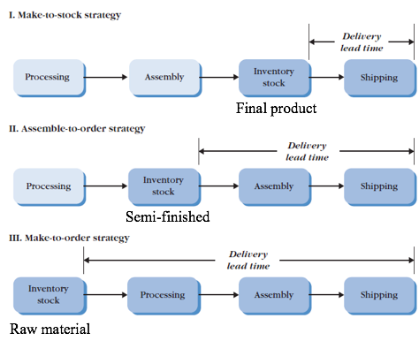
Assemble-to-order Strategy: partially completed and kept in a generic form, then finished when an order is received (standard components held in inventory, components can be combined to customer specifications. allows for many variations of the end product,Longer lead times than make-to-stock.low finished-goods inventory (computer systems, pre-fabricated furniture with choices of fabric colors).
Make-to-order strategy: infrequent demand.The product is made to customer specifications after an order has been received (provides for many variations of end product, lowest inventory level,longest delivery time
Product Positioning Strategies: (Pic)
2-Distribution Strategy plans to get its products and services to customers. channel intermediaries vs. direct sales to customers (historically used by Dell.) (market segmentation, analyze competition, Vary strategies)
3- Sourcing Strategy: which outsourced and which ones it will retain internally. Core Competencies (Activities with low strategic importance performed company are good options. Advantages: cost, expand into new markets/geographic areas, achieve technological capability) Outsourcing Risks: loss of control, dependency
4-Customer Service Strategy: how to meet the demands of its customers
Segment the market by volume and profitability
Week 10: Sourcing – Part 1
Sourcing: activities purchase goods and services from suppliers. (selecting suppliers ,negotiating contracts, acquisition Purchasing:process of buying goods and services, Involves supplier selection, negotiating contracts, buying Strategic Sourcing: seeks competitive advantage through sourcing opportunities,builds relationships
Commercial versus Consumer sourcing (clicker) Consumer Sourcing: many suppliers, buyer is final customer, small portion of supplier’s total business little ability to negotiate Commercial Sourcing: larger volumes purchased,specialized purchasing needs,number of suppliers limited,large sums of money , imbalance of power based on size of buyer versus supplier,involve buying contracts, legal, ethical, environmental, security
2—the sourcing function Supplier Selection- Existing vs. New Suppliers.Request for Quotation (RFQ), Request for Proposal (RFP), Request for Bid (RFB). Negotiate Contracts, Manage Process of Acquisition. combine requests from different users for same materials to lower costs (“Maverick buying” (internal users attempt to buy directly from suppliers and bypass the sourcing function,. acceptable occur occasionally.
Cost vs Price: determining fair price. Fixed Costs: do not vary with # units produced, taxes, insurance, overhead Variable Costs: vary directly with # units produced, materials, labor. Total Cost of Ownership (TCO): purchase price plus all other costs associated with acquiring the item
e.g., transportation, administrative costs, follow-up, expediting, storage, inspection and testing, warranty, customer service, and handling returns.
Bidding or Negotiation: determining how to award a contract to a supplier. Competitive Bidding: awards business to the most qualified bidder. most efficient for purchasing standard items, volume purchased is high, many qualified suppliers, criteria clearly define. Negotiation: communication process between two parties that attempts to reach a mutual agreement. best when working with suppliers on factors beyond the purchase (e.g., in product development) criteria cannot clearly defined, many criteria for supplier selection, new or technically complex products, few qualified suppliered, customized product.
Week 10-: Supply Chains Strategy – Part ii
Supply Chain Strategic DesignThe way a company competes in market is called a competitive priority.supply chain strategy must support competitive priority.
Five primary Competitive Priorities: Cost, Time, Innovation, Quality,Service
Competing on Cost:lowest price possible. Supply Chain Considerations: asset utilization, product and process standardization, product and total supply chain costs, inventory days of supply. Although efficiency and low cost are hallmarks of excellence, they cannot be achieved at the expense of service, innovation, or quality, if one of these is an element of the business strategy. Competing on Time: Customers demand short lead times E.g., United Parcel Service (UPS) competitive priority rapid-delivery ,on-time delivery. Can utilize: technology to speed up processes, flexible workforce for peak demands, system analysis to eliminate/combine processes. bar code technology to speed up processing and handling . Competing on Innovation: on developing “must have” products.Examples of such companies include Sony and Nike. Supply chains of these companies focus on: product design collaboration, Speed Competing on quality: have products and services known for their premium nature. issues of consistency and reliability is important. E.g., Porsche, General Electric
Two Important Aspects:Embed quality throughout supply chain-implementation of concepts such as TQM, Six SigmaProduct Traceability: trace a product from point of origin in the supply chain, through to the customer, and back down the supply chain in the case of returns. Pharmaceutica-safety
Competing on Service: Competing on service means that a company understands the dimensions that its target customers define as high service and has chosen to tailor their products to meet those specific needs.
Three important aspects: customer loyalty, consistency, reliability do not compete on cost
Why Not Compete On All Dimensions? cannot effectively compete on all dimensions, as they cannot be all things to all people. Successful companies focus on the strategically important dimensions Order Qualifiers: characteristics qualify company to participate in a particular market Order Winners: characteristic win orders
2- Strategic Considerations 3-Productivity as a Measure of Competitiveness
Small versus Large firms: Quantity Discounts: From purchasing larger quantities of goods. High Degree of Supply Chain Control: maintain a high control over the entire supply chain. Smaller companies can develop SC strategies within a particular market segment. When narrows to a particular market segment or region, companies not that small. Supply Chain Adaptability: Supply chain strategy is a dynamic process.The rate of change and the need for responsiveness, however, vary by industry. personal computer industry vs. aerospace industry Factors requiring adaptability: new technology, change scope /competitive position
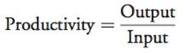
Productivity as a Measure of Competitiveness: measure of how well a company uses its resources
Total Productivity vs. Partial Productivity
Total productivity measure utilization of all resources combined, such as labor, machines, and capital. e.g.,
Interpreting Productivity: Productivity is a useful metric for evaluating competitiveness
Productivity can be: benchmarked against a standard. Consider a restaurant that measures productivity as either (a ratio of customer service to labor-hour versus a ratio of customer serviced to square footage)
The first measure looks at utilization of labor, whereas the second measure looks at utilization of space.

Week 11: Sourcing – Part ii
Sourcing and SMC: uncertainty on both demand and supply . (Demand uncertainty occurs when demand is unstable and difficult to predict. Supply uncertainty regasources of supply and their capabilities. Demand Uncertainty: Supply chain demand uncertainty varies depending on the type of product sourced
Two Categories of Products: Functional (low demand uncertainty) satisfy basic needs 1-food purchased in grocery stores 2-gas and oil for transportation and heating 3-household items from batteries to light bulbs Innovative:1-Include high fashion items. 2-Technology products-computer industry. (high demand uncertainty) Innovative products are purchased for other reasons Functional Product: satisfy basic functions or needs, stable and predictable demand, long life cycles supply chains are easy to manage, profit margins Innovative Products: purchased for innovation or status, highly unpredictable demand, short life cycles supply chains are more difficult to manage, higher profit margins
Supply Uncertainty: Stable (low supply uncertainty): sources of supply are well established E.g., sourcing apples, lumber Evolving Process (hig uncertainty): An evolving supply process is where sources of supply rapidly changing. alternative energy sources, certain organic food items, high-end computer technology.

Evolving Supply Process
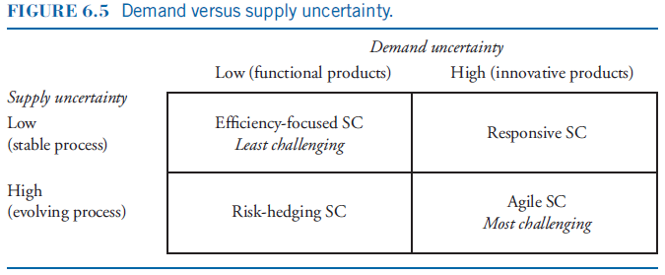
Efficiency: Least Challenging (These do not have high profit margins. The gains in these supply chains come from efficiency and elimination of waste.)
Efficiency-focused: low demand and supply uncertainty Responsive: innovative products with stable supply base, mass customization Risk-hedging: high supply uncertainty, high safety stocks, resource pooling Agile: high demand and supply uncertainty
Responsive: quickly respond to customer demands.Strategies such as postponement are effective test! A good example is the case of HP printers that are kept in generic form as long as possible. They are differentiated with country and language specific labels that are added at the last point in the system.
Risk-hedging: minimize risks of supply disruptions and inventory shortages. These supply chains typically rely on higher inventory safety stocks.
Agile SC: Most Challenging? most difficult to manage as they simultaneously must be responsive to an uncertain demand while using strategies to hedge risks to ensure there are no supply disruptions. use mass customization strategies on the demand side, carry higher safety stock and engag in resource pooling.
Single Versus Multiple Sourcing
Multiple Sources of Supply: traditionally considered best Pros: increases competition among suppliers
ensures supplier security Cons: arms-length relationship with buyer can result in variations between sources
Single Source of Supply:Benefits:1.splitting the order among multiple suppliers is costly as it does not permit consolidating purchase power. 2.single sourcing lowers freight costs 3.enables easier scheduling of deliveries
4. supplier may be more cooperative in addressing special needs knowing they are the only source.
Having a single source of supply is risky in practice： by relying on one supplier the buyer is vulnerable(such as a fire at a plant, a labor strike, or a work stoppage as the supplier’s supplier has a problem. One strategy companies should consider is to use a ‘‘portfolio’’ of a small number suppliers. ）These suppliers can be selected to create a balance of requirements. （some can be local for rapid deliveries others may be global but less expensive.）balance the risks of relying on a single supplier in case of supply chain disruptions. one buyer should not more than 20% or 30% of the totalbusiness, otherwise making the supplier highly vulnerable.
Global vs. Domestic Sourcing service industry,call centers, processing claim forms, or in software development.(takes advantage of cheaper labor, prominent with products with easily defined standards,higher fuel costs result in high transportation costs, virtual teaming can result in culture clashes and misunderstandings.It requires workgroups of individuals from different companies, different cultures and languages, to work together effectively. Benefits of Domestic Sourcing reduces transportation costs, the emphasis on sustainability and “green” has resulted in a push toward local sourcing, can monitor quality more closely, closer buyer-supplier relationships
Outsourcing:An important sourcing decision is whether to ‘‘outsource’’ certain aspects of the sourcing function. Companies may choose to outsource activities or tasks for many reasons:These include lower costs, access to technical skills, and the ability to free themselves of doing non-core activities.
Two Key Dimensions: Scope:degree of responsibility assigned to the supplier Criticality: importance of the outsourced activities
Dimensions of Outsourcing

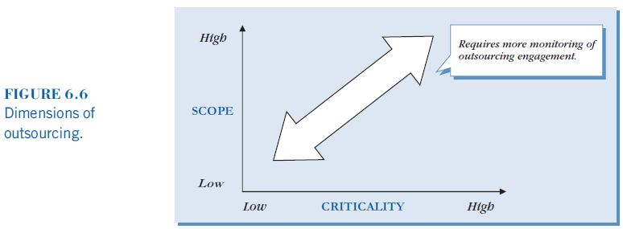

2-Electronic Auctions: Internet technology to conduct auctions as a means of selecting suppliers , determining aspects of the purchase contract. (determination of price, product quality, volume allocation to different suppliers, as well as supplier delivery schedules.
Advantages of E-Auctions:simplified comparison of supply sources, decreased error rate, market transparency
increased buying reach: reach as companies can tap into a much broader source of supply through the use of the Internet. reduction in ordering cycle time: process is automated and more efficient than the traditional method of sourcing such as issuing an Request for Proposal (RFP).
Disadvantages of E-Auctions unrealistic low bidders renegotiate after contract is awarded (may eliminate better suppliers). inclusion of suppliers in the e-auction who do not actually plan on participating,
but merely want to gather market intelligence.- may interrupt an existing good supplier relationship
Types of E-Auctions 1-Open Auction: Competing buyers can select items to place offers on, buyers can see competitive offers suppliers can keep submitting offers until a specified closing time 2-Sealed Bid Auction: submit one blind bid With forward auctions, bids increase in value, whereas in reverse auctions they decrease in value.
2-Sealed Bid Auction 3- Reverse Auction :one buyer and many suppliers (sellers) most common type. Suppliers place
decreasing bids. The bidding process is dynamic. Suppliers compete for the business by bidding against each other online. Suppliers are given information concerning the status of their bids in real time. the supplier with the
lowest bid is usually awarded the business.
E-Auction Criteria
1.clear understanding of market standards: in order to set appropriate expectations 2. specifications for goods or services well defined test! (avoid unrealistic low reader) including product characteristics, quality standards, …3. sufficient number of qualified suppliers (want to create some level of competition).Too few suppliers may not provide enough competition 4.the cost of the e-auction is justified by the savings in price. including software and training 5.clear rules for running the E-Auction e.g., selection criteria.A rule of thumb suggests that the number of suppliers participating in an e-auction should be between three and six.

here
Three Stages of E-Auction Process
1.Preparation (most important most time-consuming) (1.set product requirements 2 identify and prequalify suppliers 3. specify auction rules4.test and train participants on technology)2.The Auction Event.communication between suppliers and buyer 3. Follow-up -Some e-auctions have a ‘‘hard’’ closing time, which permits no extension of time, whereas other auctions permit time extension.-Today’s technology allows the buyer a variety of alternative approaches in terms of conducting auctions. For example, price visibility can be viewed in many ways, such as a rank order, by percentages, or by proportional differences. The technology also allows the ranks to be adjusted for non-price factors, such as differences in transportation costs, quality, or delivery time. -It also automates the buyer-supplier relationship, diminishing the potential of building a long-term relationship. Although e-auctions can provide large benefits in sourcing, companies should be selectivewhen using this sourcing approach
3-Measuring Sourcing Performance: software allows communicate with each other during the auction, software options can specify whether messages may be visible to other suppliers participating in the auction. In addition, technical assistance must be made available during the auction in case problems arise.
Not E-auction , (creating a long term relationship with suppliers)
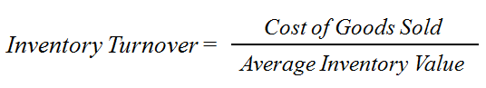
Measuring Sourcing Performance Inventory Turnover and Weeks-of-Supply are two common performance measures of the sourcing function Inventory Turnover : measures how quickly inventory moves
Inventory Turnover Example
Jenco Inc. produces dolls. Annual cost of goods sold is $8,000,000 and average inventory is $2,000,000. What is the annual inventory turnover?
Inventory Turnover =4

In general, the higher the inventory turnover rate the better the company utilizes its inventory.
There is no one number that is considered correct.(IMPORTANT!!)

In general, the higher the inventory turnover rate the better the company utilizes its inventory. However, there is no one number that is considered correct.
-Some companies need to turn their inventories over faster than others. For example, perishable items such as food or medicine need to turn over faster than machinery or commodity items. Also, certain industries have much higher inventory turns than others. For example, innovative products with short life cycles need to turn over very quickly or they may become obsolete.
-To get good guidelines on acceptable inventory turns it is important for companies to consider their industry standards as a benchmark of performance.
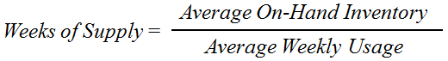
Measuring Sourcing Performance-2
Weeks-of-Supply- provides the length of time demand can be met with on-hand inventor

1-12 include chap 7 (more 60% post midterm 52 MC 6short answer
Forcasting – seaonality, constrains (output parallow)
Simple ratio of turnover

Weeks of Supply Example
annual cost of goods sold of $8,000,000 and average inventory is $2,000,000. How many weeks of supply are on-hand?
A large ‘‘weeks of supply’’ value means too much inventory is being held, whereas a value that is too low increases the chances of a stock-out or lost sales. Notice that the value of this metric depends on demand. Given that product demand often changes due to factors such as seasonality, managers need to consider that the best value of this metric will likely change throughout the year. As with inventory turnover, companies should benchmark this metric against industry best practices.

Week 6: Network and System Design part i
business process is an organized set of activities or steps with specified outcomes.Organizations and supply chains as a whole can be viewed as a collection of processes rather than components of departments or functions.every process has structural and resource constraints limiting its output output result of the process that produces it: An output can be a service or a tangible product. improve the output, improve process.
Example: Customer Service Process
Output: enhance the level of customer satisfaction by meeting their expectations.
This may involve a series of well-coordinated activities, such as (billing and invoicing, handling product returns
providing real-time information on promised shipping dates, product availability, etc.)
Managing Processes Across the Supply Chain two differing views
(1) transactional view :making supply chain processes efficient and effective based on quantitative metrics. achieved through supply chain network redesign to promote speed and eliminate redundancy by standardizing transactions to improve efficiency, and implementing better information technology
(2) relationship view is centered on managing relationships across the supply chain
This involves managing and linking-up processes across organizations of the supply chain.
2.Theory of Constraints (TOC) introduced by Dr. Eliyahu Goldratt in his book “The Goal”.Premise of TOC:( Every system has at least one constraint, constraint is anything prevents the system from being able to achieve its goal and is sometimes called the ‘‘bottleneck’’. Objective: Identify the constraint and restructure the organization to eliminate its impact. A constraint can be 1.equipment, which may be limited by how much it can produce. 2.-people, which may lack skills or simply processing capability. 3.-facilities, size,-can be stored.
2--A system cannot produce more than its “bottleneck”. Equipment: may be limited by how much it can produce People: may lack skills or simply processing capability Facilities: their size may limit how much can be stored Output is related to how system activities are linked. Activities can be linked: serially, in parallel
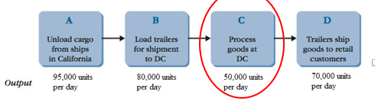
3--Consider the following distribution network:
It has a serial network structure, which is simply a series of processes.
What is the maximum number of units that this system can process in a day (24 hrs)?
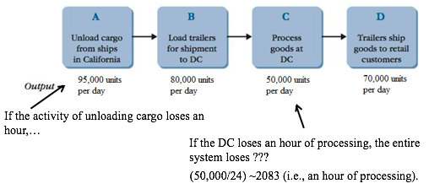
Maximum output per day = 50,000 units. If the DC loses an hour of processing, the entire system loses ???
(50,000/24) =2083 (i.e., an hour of processing).
4--It is critical to manage the constraints or bottlenecks in the system. The constraint must always be busy as time lost there is time lost in the entire system.
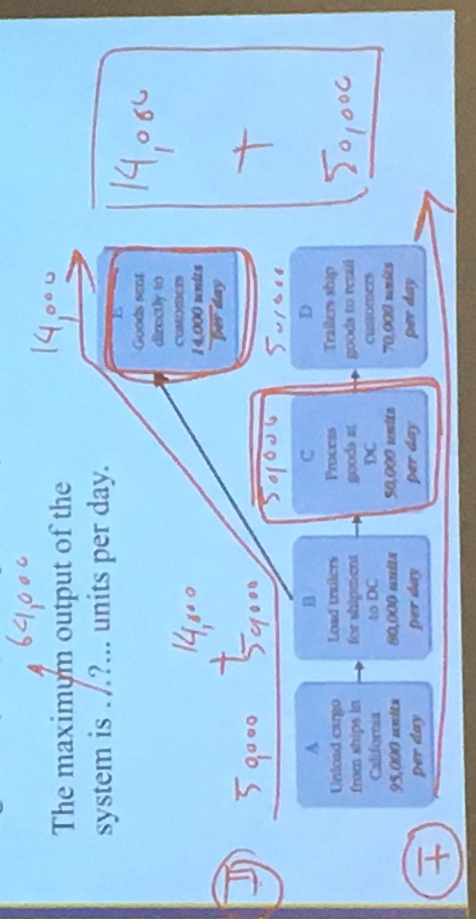
5--Imagine if the company spent money to increase the number of units that could be loaded and shipped onto the trailers going to the DC from 80,000 units per day to say 100,000 units per day. What would this accomplish? 80K-100k

Parallel Process Example
As part of restructuring the supply chain network, part of the unloaded cargo (14000 units/day) is diverted to a third party logistics (3PL) to ship directly to clients.
The amount was approximately 20% of 70,000 units per day, which was the average number of daily units needing to be processed. This was approximately 14,000 units per day. The result is shown in Figure 3.4. Notice what happens to the output. While the DC is still processing 50,000 units per day, 14,000 units are being sent directly to customers. This is happening in parallel and is enabling a total of 64,000 to pass through the system. The maximum output of the system is the new bottleneck, which is 64,000 units per day.
Steps in Constraint Management
1. Identify the constraint 2Exploit the constraint(Decisions must be made as to how best use the constraint and ensure that the constraint’s time is not wasted ) 3.Subordinate all other processes to the above decision
(This means align the whole system around the constraint.) 4.Elevate the constraint (If possible, increase capacity of the constraint (e.g. buying more capacity by outsourcing).5.When the constraint changes, return to Step 1 6.Engage in continuous improvement

d

