Simulation of a 1st-Order System

Course: SYSC 3600A
Date: 10/15/2018
Rongjie Chen
100906870
Due date: 10/29/2018

Summery
The objective of this lab is to understand how first order system response to a step input and how initial conditions impact the step response for a first order system. The initial condition are assume to be zero in the first part and none-zero in sec 2.5.
First order differential equations
The unit step function:
$u\left(t\right)=\left\{\begin{aligned}0,t<0 \\ 1,t≥0\end{aligned}\right.$ (1)
The 1st DE in this lab:
$\frac{dy(t)}{d(t)}=\frac{-y\left(t\right)+kx(t)}{τ}$ (2)
Table1 the explanation of the symbol
Output | y(t)
Input | x(t)
Static gain | $$k$$
Time constant | $$τ$$

Step response, static gain, and the “time constant”

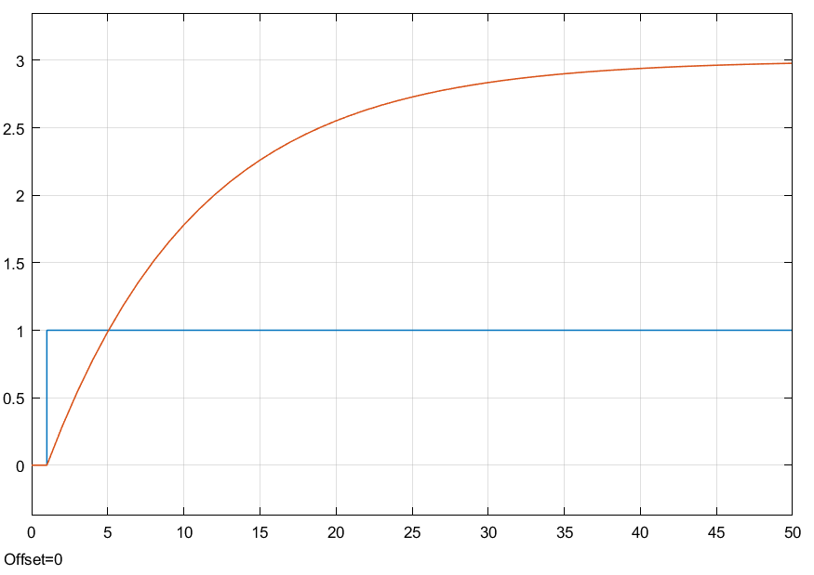
Figure 1: result integration of step function response to equation (2) at x (t) = u (t), k = 3, τ = 10 seconds, and y (t₀⁻) = 0.
The orange line in figure 1 represent the yield of the system, and the blue line display the system’s input information. The static gain k equal to the magnitude of the change in output at steady state divided by the magnitude of the change in the input. The output in the system will never reach k value, it will approach it as in figure 1. $τ$ is the time constant in this system, and it control the speed of the system to achieve the most extreme moving toward k value. The 2% settle time at t=40 (which $τ$ is 10) meaning the system reach about 98% to steady state after 4 time constant.
Response to a delayed input
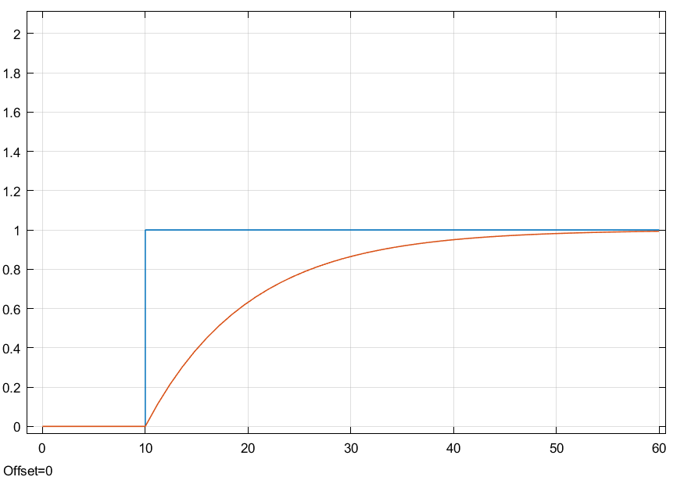
Figure 2: result integration of step function response to equation (2) at x (t) = u (t-10), k = 1, τ = 10 seconds, and y (t₀⁻) = 0.

Time delayed t_{d} equal to 10 in this case. The time deferral of the system make the output delayed by a similar time interim. The time had been delayed 10 seconds in figure 2, and the yield spoke of the system is delayed about 10 seconds.

Response to a delayed input
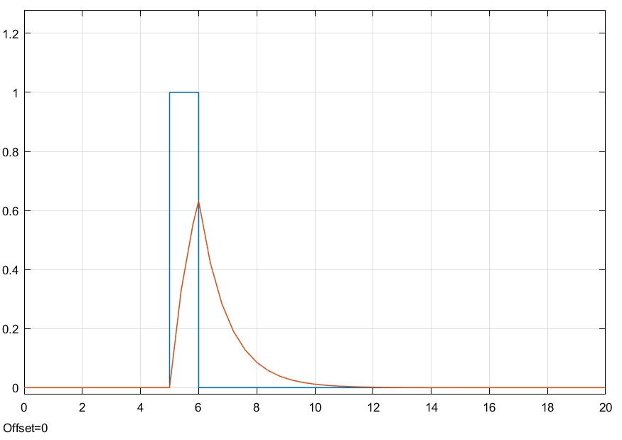
Figure 3: result integration of step function response to equation (2) at x (t) =u(y-5)- u (t-6), k = 1, τ = 1 seconds, and y (t₀⁻) = 0.
According to figure 3, there are two stage work in the diagram. The first stage at the time 5 to 6 seconds, the composite signal does not influence each other. After 6 seconds, two signal will influence each other.

Response when non-zero initial conditions exist
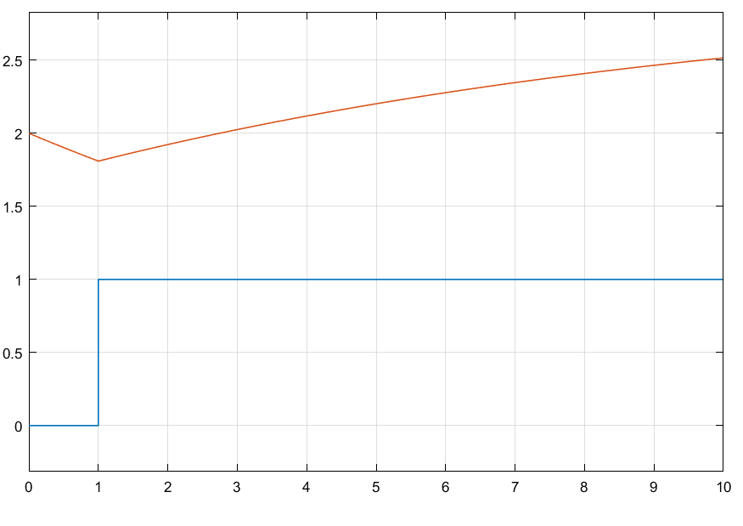
Figure 4: result integration of step function response to equation (2) at x (t) =u (t), k = 3, τ = 10 seconds, y (t₀⁻) = 2 and t₀ = 0.
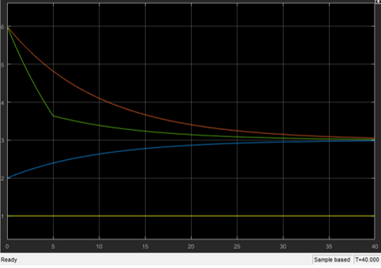
Figure 5: result integration of step function with 3 response.

According to figure 4, the k value starts at 2 and the orange output line started at 2 as well. The initial condition of the system is a constant which will affect the step response starts. According to figure 5, the initial state will affect the time that the system take to reach steady state.

Step response for the RC circuit and the mass-damper system
- Mass-damper
Stander first order equation form: $\frac{dy(t)}{dt}+a_{0}y\left(t\right)= b_{0}(t)$ (3)
Rewrite equation (2) in stander fitst order equation form:
$\frac{ⅆy_{\left(t\right)}}{ⅆ\left(t\right)}+\frac{1}{τ}y_{\left(t\right)}=\frac{k}{τ}x_{\left(t\right)}$ (4)
The mass-damper form:
$M\left(\frac{dy\left(t\right)}{dt}\right)+b=f(t)$ (5)
Again, rearrange equation 5), we got:
$τ= \frac{M}{b}$ (6)
$k= \frac{1}{b}$ (7)
- Mass-damper
From question 2, we got k=4, and $τ$=$\frac{2}{4}$ =$\frac{1}{2}$.
According to equation (7), b=$\frac{1}{k}$=$\frac{1}{4}$, and equation (6) M=$τ*b$ = (1/2) * (¼) =1/8;
- RC circuit
$\frac{d}{dt}e_{0} +\frac{1}{RC}e_{0}= \frac{1}{RC}e_{i}$ (8)
With $τ$ and k equal:
$τ=RC$ (9)
$k= 1$ (10)

$$\lim_{t →∞}{e_{0}}=1$$

$e_{0}=1$at t = ∞, because $e_{0}$ is an independent value, it does not depend on the value of R or C. this system is R and C control response time.

