CIVE 4303 URBAN PLANNING MIDTERM REVIEW OCT 2018
Lec – Midterm Review
- Land Use planning
- Land development
- Environmental planning
- Urban design
- Social planning
- International development
- Economic development
- Campus planning
- GIS and Analytics
- Civic engagement
- Housing and real estate
- Community development
- Heritage planning
- Project mgmt.
- Transportation planning bicycle, pedestrian, road, highway, all of above
Midterm subjects incl:
- Planning act
- Provincial policy statement
- Official plans
- Zoning by-laws
- Urban Planning Systems
- Municipal Class Environmental Assessments
- Land Division
- Site Plan Control
- Transportation planning/engineering
EX. Q1:
Describe and discuss the significance to urban planning of 3 of the following concepts:
- Mixed use centers
Mixed use centers are buildings that serve a variety of purposes such as housing, recreational activities, shopping, and have amenities. It is a type of commercial property that includes both commercial and residential space. An example would be a building that has apartments located above a series of stores or shopping center. There are several benefits to mixed use centers: they provide more housing variety and density, typically more affordable than a semi- or detached home; reduced distances between housing, workplace, retail businesses and other amenities; are a form of more compact development, land-use synergy; are typically in walkable, bike-able neighborhoods with increased accessibility to public transportation. Mixed use centers are a significant component of urban planning since they are the primary drive of mixed-use development for urban sprawl. They provide a solution to growing city populations and increased community engagement. Mixed-used zoning itself is an aspect that city planners must incorporate into urban development goals (?).
Types of contemporary mixed-use areas are: neighborhood commercial, urban residential/commercial, shopping mall conversion, retail district retrofit, and many more. An example of a mixed-use building here in Ottawa would be the Wellington street condominiums in Westboro that have banks and coffee shops located on the ground floor.

- An official plan does not discourage growth but is intended to encourage growth.
An Official Plan encourages growth by having subsections within its Strategic Directions that provide a framework for how to manage and encourage anticipated growth in a city. Official Plans are tools for planning public facilities and infrastructure, drafting zoning by-laws, and control of land subdivions.
Patterns of growth are analyzed based on employment opportunities, development projects, geography, and other factors. Growth is projected in data forms such as population, households, and employment. The Official Plan conveys that growth should be directed towards key locations with accessible amenities and transit, and for future development to be suited for accommodating growth. The ultimate goal of the Official Plan is to ensure that wherever growth happens to occur, it will be managed so that the city’s communities are eminently liveable via a focus on community design and caring for the quality of life of citizens. Sections that further describe how the city will promote growth include: Providing Infrastructure, Maintaining Environmental Integrity, and Building Liveable Communities, direct investments, transportation hubs, accessibility. Urban boundary is defined which encourages growth to those boundaries. It’s updated every 5 years to accommodate change like if the city is growing faster than anticipated. It encourages growth in existing communities by maximizing available infrastructures through the promotion of compact development.
This Official Plan provides guidance for consideration of land use changes, the provision of public works, actions of local boards, municipal initiatives, and the actions of private enterprise. It gives direction for implementing by-laws, guidelines for more detailed planning and the means for controlling growth so that the City's capacity to provide a healthy community environment is not exceeded.
The Plan identifies specific areas where new commercial and residential growth should be encouraged, stipulating that new development should facilitate transit use and pedestrian activity

- Public interest vs private interest
These interests are the foundation of a city plan since urban planning is a process where land use, transportation, infrastructure and buildings come together. In the approval process for any planning application, the municipality’s official plan is considered a guideline for zoning by-laws, public facilities, infrastructure. Public and private interests are considered in the decision-making process, the official plan, reference to longer term, public participation, physical/economic/and social health, the future, the public. The mechanisms leading to the rule of short-term financial profit (private interest) over long-term economic and social benefits (public interest). The value of the public good affects the value of the private good. The availability of public spaces (ex recreational, cultural) has a positive impact on the city’s economy by raising the price of real estate. More detailed evidence include the benefits of compact buildings for power consumption, decreased demand for health system services (due to overall healthy lifestyles), time savings from alternative to car transport (bikes, transit, walking).
Private interest: “I don’t want this bus route in my neighbourhood”
Public interest: “I want safe drinking water, a liveable community, be able to move more efficiently”

- Relationship of land severance to urban planning
Land severance is for creating and selling 1-2 lots, protect from inappropriate development, environmental planning & sewage. OP governs land severance, establishes compatibility, Planning Act and PPS, sewage water road flooding, zoning. Land severance is directly related to urban planning since it plays a part in building permits, property ownership and overall compliance with OP and PA.

- Shall be consistent with rule
Is a rule that is seen in conjunction with PPS, OP, challenge and how its applies, they’re consistent but not the same. Example: PPS states to protect agricultural land, but OP gives more info on how to do it. They are consistent but serve diff purposes and roles in context. When council prepares an OP, it shall be consistent with the PPS issued under the Planning Act. Shall be = non-negotiable. The “shall be consistent with” rule means that council is obliged to ensure that policies under PPS are applied as an essential part of the land use planning decision-making process. “Shall be consistent with” is a higher policy implementation standard focused on achieving policy outcomes MORE demanding than “shall have regard to”
EX Q2:
Answer (1) of following questions:
- You have just been hired by town of Greenfield as a municipal engineer. A new Official Plan has recently been prepared showing substantial growth over next 20 years. The Town Council requires information on future municipal services to prepare long-term budget estimates and decide on the phasing of new growth.
- How will Official Plan be of assistance?
- Explain the relationship between the Official Plan and the Zoning by-laws.

- The Official Plan will be of assistance because it provides a framework on how to promote, accommodate, and manage growth in a city. It will also help with planning the future municipal services, since the OP directs infrastructure and transportation management. Ultimately, the goals and objectives within the Official Plan will guide the management of growth in Greenfield over the next 20 years by informing and obtaining views of public, complying with policies and principles of land use planning, and being considerate of environmental issues that may arise. The OP aims to create and maintain liveable communities. Phasing and stages may be described in the Official Plan to further project the growth over the timeline of 20 years and to plan for it accordingly since the OP is reviewed and adjusted every 5 years. This can include addition of housing, shops, facilities, offices (employment), services that will be needed and land that can either be used or preserved based on the city’s goals and values.
- The Official Plan and the zoning by-laws are used together to optimize city planning. The Official Plan contains public facilities and infrastructure, controls land subdivisions, and essentially acts as a draft for zoning by-laws to use. The zoning by-laws then implement the objectives of the city’s OP and provide a legal way of managing land use and future development. The by-laws are what provide requirements/restrictions with respect to intensity of development, minimum setbacks, maximum heights, etc.

- You have just been hired by Mircha Associates, a multi-disciplinary company providing planning, engineering and environmental services. Your first project is for an established client of the firm, whose development application has been appealed. The site was formed by a community shopping center and gasoline station, both of which have been abandoned. The surrounding area includes some rental apartments, a place of worship, a seniors’ housing complex and a high school. The proposed redevelopment is mixed-use residential/commercial, including retail, a multiplex theatre, and condominium assisted housing. The municipality supports the application, but it is strongly opposed by some residents. The project is important to your client, so he asks that you prepare a comprehensive report in preparation for the upcoming hearing.
- What would you look for when you visited the site of the proposed re-development?
Hazards that should be avoided, surrounding buildings, protected viewpoints or heritage designated sites. It would also be important to note the natural elements around the site to establish what should be preserved, even incorporated into the development plan. The current road maps could also be observed to determine the main mode of transportation used in the area.
- What types of engineers would you consult and what contribution would each make?
- Civil Engineer because they would be able to assist in designing, planning, managing and creating reports on construction jobs. They would be able to also aid with design of certain infrastructure if needed, such as designs of water distribution systems or water treatment plants.
- Land surveyor this can be grouped with the role above, if the engineer is a registered land surveyor. They would definitely be needed to perform surveys and determine how the land can best be used; what it’s optimal for. They can also provide insight regarding potential future problems for the developer (if any), for example unstable bedrock.
- Environmental Engineer they would be able to assist with water treatment, sewage, preservation methods of land. They can also review the proposed projects and assist in evaluating its environmental impact.
- Transportation engineer this would potentially be needed if the proposed project involved the addition of transportation methods such as highways, additional roads, transit ways, etc. The transportation engineer could work alongside the civil engineer and city planner to determine the optimal methods to incorporate transportation within the proposed development area.

- List 10 pieces of information you would collect for the report and explain why each is important
- Population dynamics (feedback survey from residents) this is important if the development project is strongly opposed by some residents. Conducting a survey and determining the reasons why could help establish what can be altered in the design proposal (if it can be) or to see if there’s a compromise to come to. This could also help determine the most “popular” place for residents to spend their time, which can help the developer know where to allocate the most resources (ex, if the church is very popular & important to residents, the developer could incorporate a new place of worship to ensure needs are met)
“We cannot plan without understand the present situation and activities of the people, to forecast future activities”
- Nature (GIS data?) the type of natural features that are on the site such as geology, soils, bodies of water, environmentally sensitive areas, can help guide where the proposed multi-use center should be located. Appealing viewpoints should be reserved to encourage activity in the newly developed area. Understanding the natural make-up will help establish how to preserve certain resourceful lots of land too, ultimately aiming towards sustainability goals of the Official Plan). Hazards should be noted too, so that they can be avoided best as possible by the structure
- Geospatial Data using GIS or a geospatial database, land information can be obtained about the site. This can include road networks, trails, lakes, rivers, parks, heritage designated areas, etc.
- Transit and accessibility analyze the primary form of transportation in the area, establish what could be improved and what could make it more accessible. Accessibility is important especially to a multi-use center since it can be used by surrounding neighborhoods too and promote community engagement/activity. If vehicles are the main form, is there enough parking? How can this aspect be improved?
- Curb appeal/aesthetics if the site is not visually appealing, investment should be put into landscape architecture for the new development plan, since it would increase the value of real estate in the neighborhood hence helping the city’s economy, and would also promote growth towards that particular area. If there are aspects that are aesthetically pleasing, they can be noted to be preserved or relocated elsewhere on the new plan.
- Architecture if buildings in the neighborhood have a specific pattern, the new multi-use center would fit in better if it replicated similar architectural styles. It would also be important to note heritage architectural buildings that need to be conserved.
- Businesses and job market will there be a lot of businesses affected by the new development project? Determining if and where there are employment firms within the area will help understand the type of work people do and how to facilitate job security, accessibility, and even promote new employment opportunities.
- Dwellings knowing the number and type of dwellings currently in the area will help the developer adapt to something useful for the residents. The report can state that the multi-use center will have various types of residential units in addition to condo-assisted housing for the seniors, which would be a good way to highlight its benefits to the community.
- Prior data collected about the site via the city’s databases, data previously collected can include a lot of useful information, for example geotechnical reports, boring test results, documentation of any previous problems, etc. Having prior knowledge will ensure the new development has less problems and will know what to expect
- Zoning by-laws for the site where is the zone for the site, and what kind of buildings are permitted there? The street setbacks and maximum heights need to be known for the new dev project. Ensuring the new project complies with zoning bylaws as well as the objectives within the Official Plan is crucial.

Lec – Land Division
- Official Plans are approved by Provincial Govt and are tools for:
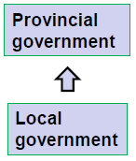
  - Planning public facilities and infrastructure
  - Drafting zoning by-laws
  - Control of land subdivisions

Zoning By-law | Official Plan
- Implements the objectives and policies of a municipality’s Official Plan  - Provides a legal way of managing land use and future development  - In addition to OP, protects you from conflicting and possible dangerous land uses in community  - Intensity of development (# of dwelling units per area)  - Can impose requirements for form of building on site, ex:  - Minimum setbacks  - Maximum heights | - Planning public facilities and infrastructure  - Drafting zoning by-laws  - Control of land subdivisions

Dividing up Land:
Dividing piece of land into 2+ parcels and offer 1 (or more) for sale = subdividing property. Provisions of Planning Act come into play.
If proposal involves creation of 1-2 lots, “land severance” is a possibility to seek for approval. Alternately, other means of subdividing land is to get approval of a plan of subdivision from authority ex. Minister of Municipal Affair and Housing (or a municipality).
Land severance = authorized separation of piece of land to form a new lot/parcel of land. If 2 parts are already split (ex. Road/railway) then consent is not needed.
Official approval required to ensure:
- Land severances are considered within established community planning framework
- New lots/new land uses don’t conflict with overall future planning goals of community
- Consideration is given to effects of division of land on the site, on the neighbours and on community
Severance application is evaluated against criteria:
- Conformity with OP and compatibility with adjacent uses of land
- Compliance with local zoning by-laws
- Suitability of land for proposed purpose (incl size and shape of lots being created)
- Adequacy of vehicular access, water supply, sewage disposal
- The need to ensure protection from potential flooding
Consent shall be consistent with Provincial Policy Statement

Subdivision approval ensures that:
- Land is suitable for its proposed new use
- Proposal conforms to OP and Zoning in community + provincial legislation and policies
- You + neighbours + community are protected from developments that can put strain on community facilities/services/finances
Ex. Of problems: water supply unusable, access road not maintained, lots are not on registered plan.
Registered Plan of Subdivision is legal doc that shows:
- Exact surveyed boundaries and dimensions of lots on which houses/building are to be built
- Location, width, names of streets
- Sites of schools or parks
- Does NOT show specific building locations (those are in zoning by-laws)
Plan must be:
- Surveyed by Ontario land surveyor
- In general conformity with municipal OP and provincial policies
- Approved by proper authority
- Registered in local land registry system
- “shall be consistent with” = council is obliged to ensure that policies of Provincial Policy Statement are applied as an essential part of land use planning decision-making process

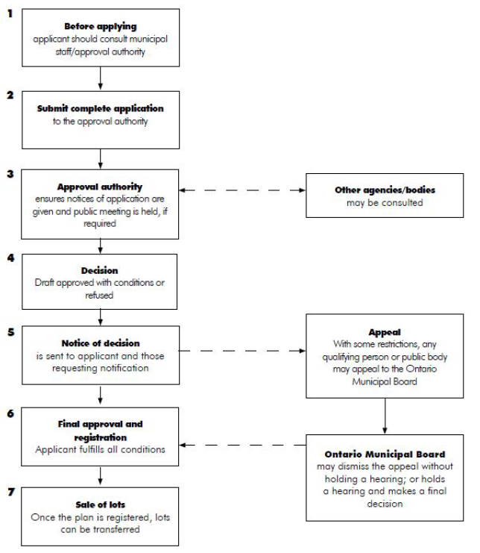
Subdivision Process:

Preparation of subdivision Plan:
- Assess demand (type of buildings, price ranges)
- Examine physical growth of municipality
- Consider carefully all the possible sites and select one that most satisfies requirements:
  - Accessibility
  - Availability of services
  - Quality and cost of land
  - Legal restrictions
- Obtain general survey of site
- Divide site into broad areas of suitability for building purposes
- Apportion the site into units for diff purposes for which site is to be developed
- Develop inter street pattern and name streets
- Sketch out lots
- Consult municipality and have plan examined
- Prepare final plan
- Study the siting of every building in subdivision
- Consider the alignment of utility lines (ex hydro, Bell, cable)
- Show landscaping
- Submit plan for final approval
Lec – Computers in Urban Planning and Mgmt
Where does the City get its data for the background analysis for OP?
- Computational aids
- Data handling and intelligent maps – GIS
- Computer-aided design including visualization tools
- Census
- Building permits
- Specific municipal studies vacant urban residential land survey (2016)
- Origin-destination survey for NCR (2011)
- Geospatial data collected over time
- Aerial photography
- Ontario Geospatial data exchange Ontario soil maps, Land info Ontario
- Environmental analysis VMT reduction, Air Quality
Lec – Intro to Official Plan
What is it?
- Where new housing, industry, offices and shops will go
- What services (roads, watermains, sewers and parks) will be needed
- What lands will be preserved from development because of greenspace, environmental and resource values
- Contains policies for those matters identified in Provincial Policy Statement and applications under Ontario Planning Act. Plan can contain guidance as to how City Council might position itself on other matters but can’t control what’s outside the authority of Ontario Planning Act
The Planning Act:
- Provincial Administration
- Local Planning Administration
- Official Plans
- Community Improvement
- Land Use Controls
- Subdivision of land
- Sets out the ground rules for land use planning in Ontario, describes how land uses may be controlled and by who
- A legislation passed by your elected provincial representatives to recognize the decision-making authority of municipal councils in planning
The purposes under the Planning Act incl:
- Promote sustainable economic development
- Provide for a land use planning system led by provincial policy
- Encourage co-operation and coordination amongst various interests
- Recognize decision-making authority and accountability of municipal councils in planning
Planning Act provides the basis for the City to:
- Prepare an Official Plan, using the Act as framework for objectives
- Establish streamlined planning process
- Regulate and control land uses through zoning by-laws
- Process applications to divide land into separate lots for development (subdivision or land severance)
- Establish site plan control area and process applications for new dev projects
Planning Act ensures the rights of local citizens to be notified about planning proposals to give their views to the City Council and to appeal decisions.

The Provincial Policy Statement:
- Sets out govt’s land use vision for how the landscape is settled, create built environment and manage land + resources over long term to achieve resilient communities
The “shall be consistent with” rule means that council is obliged to ensure that policies under PPS are applied as an essential part of the land use planning decision-making process. The OP is reviewed every 5 years. “Shall be consistent with” is a higher policy implementation standard focused on achieving policy outcomes MORE demanding than “shall have regard to”.
Contents of OP incl:
- Goals and objectives
- Policies and principles of land use planning
- Environmental issues
- Infrastructure and transportation
- Measures and procedures to attain the objectives of OP
- Measures and procedures for informing and obtaining views of public
- Phasing and stages
- IT CANNOT control matters outside authority of Ontario Planning Act ex: schools (city is req’d to consult with school boards)
Transportation Master Plan (TMP) comprehensive plan that sets out the City’s approach to managing and meeting the demand for transportation facilities (walking, cycling, transit and roads)
Infrastructure Master Plan (IMP) integrated planning and system mgmt. doc which coordinates the city’s efforts in meeting the demand for public water, wastewater, stormwater services
Greenspace Master Plan (GMP) characterizes and evaluates all components of greenspace in the city as a basis for a range of policies related to protection, acquisition and mgmt.
“the Planning Act requires all regional municipalities in Ontario to adopt Official Plans and to keep them up-to-date”. An OP is a municipal policy doc adopted under Planning Act. Challenges incl:
- Managing growth population, households, employment, activities
- Providing infrastructure
- Maintaining environmental integrity
- Creating liveable communities

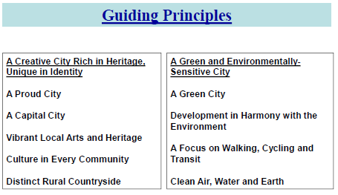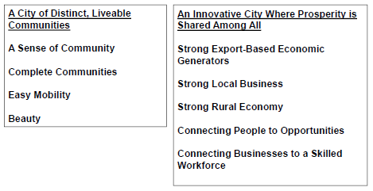
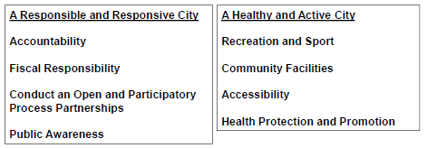
Process for Official Plan dev:
- Preparation
- Circulation to interested parties
- Modifications and changes according to recommendations
- Notice sent to the public to announce open meetings
- Get public feedback and modify accordingly
- Adoption of the official plan by council
- Approval by provincial govt
Lec – Intro to Zoning By-laws
Zoning by-law controls the use of land in community. States:
- How land can be used
- Where buildings and other structures can be located
- Types of buildings permitted and how they can be used
- Lot sizes and dimensions, parking req, building heights and setbacks from street

OP = future land use; Zoning by-law = day-to-day administration
Comprehensive Zoning by-law divides the municipality into different land use zones with detailed maps
Zoning by-laws are comprised of parts that work together w/ other layers:
- Set of rules for administering and interpreting the zoning by-law
- Regulations that apply on a broad, city-wide level
- Zones that are applied to each property in the city
- Maps that illustrate how the zones are applies to each property in the city
A Zoning by-law:
- Implements objectives of a municipality’s OP
- Provides legal way of managing land use and future development
- Protects you from conflicting and possibly dangerous land uses in community
- Can specify measures that reflect the effect of development on demands for public services and infrastructure (such as Floor Area Ratio (FAR) – area of all floors divided by gross site area)
- Section 34 of Ontario Planning Act limits the range of matters that can be addressed in a zoning by-law.
- All development must comply w/ provision of the zoning by-law
- Sometimes relief can be granted of minor variance through the Committee of Adjustment of Amendment granted by City Council
- Both above ^ should comply with policies of Official Plan

Zoning by-law Amendment: if you want to use or develop property in way that is not normally allowed. The zoning by-laws are evaluated by:
- Conformity to to OP and compatibility with adjacent uses of land
- Suitability of land for purpose
- Adequacy of vehicular access, sewage, etc
- Risk of flooding

Lec – Planning at the City of Ottawa (Erin O’Connell)
Land Use planning:
- Helps a community set goals for growth
- Manages change and growth
- Determining where land uses belong
- Balances interests
- Considers both neighborhood and city
- Tries to make the city a better for all
Types of Planners at the City incl:
- Policy
- Community Design
- Research and forecasting
- Heritage
- Development Review
- Transportation
- Transportation
- Environmental
- Parks
Some common urban issues:
- Population urban expansion, farmland lost
- Land use patterns need for a vehicle, separation of uses and people
- Transportation
Planning solutions:
- Greenbelt
- Infill and density
- New urbanism
- Transit
Lec – Planning Act and PPS (Intro to Planning in Ontario)
Professional Organizations:
- PEO Professional Engineers of Ontario
- P.Eng Registered Professional Engineers
- OPPI Ontario Professional Planners Institute
- RPP Registered Professional Planner
- CIP Canadian Institute of Planners
- MCIP Member of Canadian Institute of Planners
What role does the province play in Land Use Planning?
- Municipalities are created by the province
- Cities are given all their power and authorities by the province
- Establishes ground rules for land use planning in Ontario through the Planning Act
- The Minister of Municipal Affairs and Housing has the responsibility for overseeing and enforcing provisions of the Planning Act; ensures that the city carries out their responsibilities
Matters of Provincial Interest:
- Protection of ecological systems, agricultural resources, conservation mgmt. of natural resources
- Conservation of significant architecture, cultural/historical/archaeological/scientific interest
- Supply and efficient use/conservation of energy and water
- Efficient use of communication, transportation, sewage, water services and waste mgmt. systems
- Minimization of waste
Lec – Urban Systems Planning
Comprehensive Plan:
- Cover the entire urban area and all urban system components a long-time horizon of 20+ years
- All relevant goals are coveredall interests accommodated, deal with conflicting goals/objectives
- Goals include health, public safety, circulation, services /facilities, fiscal health, economic development, environmental protection
- Involves research incl:
  - Current situation
  - Forecast future growth and implications
  - Inter-dependencies
  - Resolve conflicts

