Experiment 4: Benzylidene Acetals as a Protecting Group for Sugars
Name:
Student ID:
Ta:
Section:
Date:
Introduction:
During part A of this experiment acetal groups are created on sugar molecules which creates “protected” glucoses molecules. The acetals groups are benzylidene acetals and are created specifically on the 4th and 6th carbons of the glucose, which prevents them from reaction with specific other molecules, thus protecting them against certain types of reactions. This is done by reacting methyl-α-D-glucopyranoside with benzaldehyde dimethyl acetal in a solution of tetrahydrofuran and 10-camphorsulfonic acid at reflux temperature by heating the mixture using a hot plate. The mixture is then neutralized, extracted, dried and filtered. The filtered product is then dissolved in hexanes to precipitate out the protected glucose molecule and vacuum filtered to get the final pure product.
The main reaction happens due to the protonation of carbonyl molecules, where acid is the proton donor, which will form a hemi-acetal (where the central acetal carbon is bonded to one alkoxy and one hydroxyl group) and then the reaction happens again to attack the hydroxyl group to form the full acetal making the final product: a protected benzylideneacetal. The reaction is done under reflux to allow for more energy for the reaction to occur while keeping the solvent (THF) completely in the reaction flask. The extraction is done with ethyl acetate, and dried using Na₂SO₄.
During the reaction process, a TLC is taken to watch the progress and make sure the reaction is complete, the refluxed solution is compared to the precursor product, to see if the reaction has completed. A second TLC is taken after the product is purified and is compared to the refluxed mother liqueur, and the starting solution. The visualization process was similar for the 2nd plate but the first plate needed to be dipped in sulfuric acid and heated to visualize the carbohydrate molecules.
Part B of the experiment involves the analysis of several types of sugars such as cola, milk, a solution of sucrose, and a solution of glucose, to test for the presence of reducing sugars. The test was done with Benedict’s solution, which when it encounters a sugar that has an unbound ketone or aldehyde, it will turn a shade of red. This is due to the copper sulfate in the Benedict’s Solution being reduced to form copper (I) oxide, thus giving it a red tint. Most monosaccharides are reducing sugar, such as glucose, but there are exceptions such as lactose, which can occur in open chain form which exposes the aldehyde groups to the Benedict’s solution.

Mechanism:
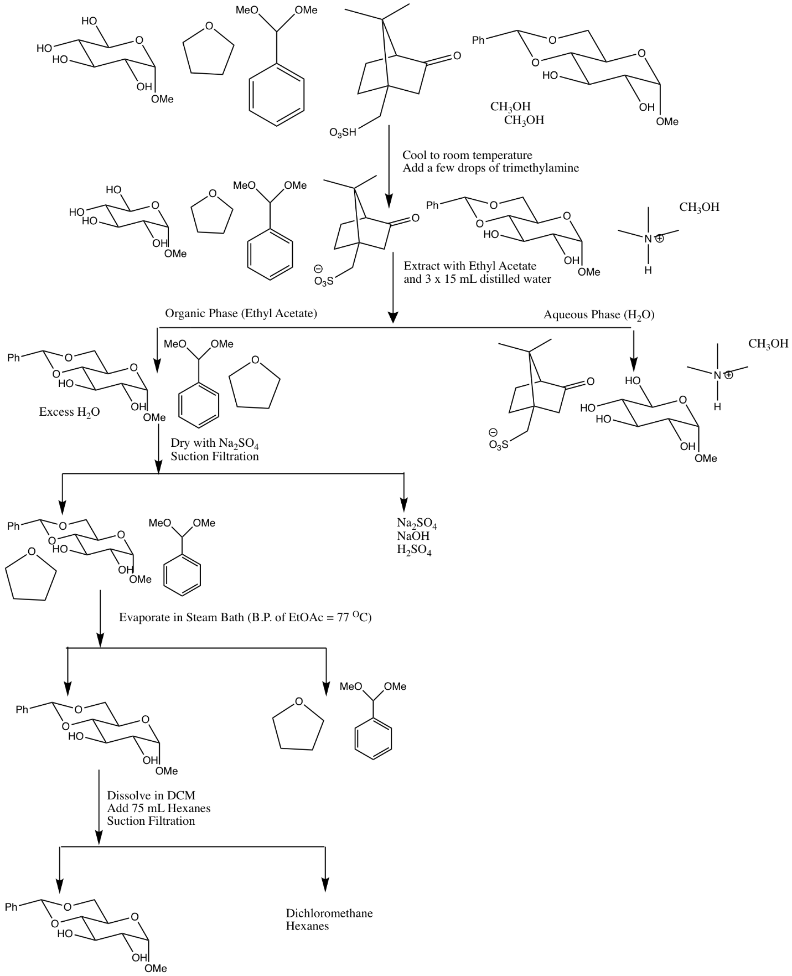

Table of Reagents:
Compound | Molecular Weight(g/mol) | Density (g/ml) | Amount (g or ml) | mmol | equivalents
Methyl-α  -D-glucopyranside | 194.18 | - | 0.5 | 2.6 | 1
Benzaldehyde dimethyl acetal | 152.19 | 1.014 | 0.7 | 4.7 | 1.8
10-camphorsulfonic acid | 232.30 | - | 0.1 | 0.43 | -

Procedure:
Refer to CHM2132 protocol as given on TopHat
Modifications/notes:
- Used coca-cola for part b step 4-6
- The reflux reaction was done for 60 minutes as the TLC indicated that the reaction was not complete
Observations:
Step | Observation
A-1 | Methyl-α-D-glucopyranside is a white crystalline powder.
A-2 | Both THF and the benzaldehyde dimethyl acetal were clear and had very strong odors, the 10-camphorsulfonic acid was also a white crystalline powder.
A-10 | Upon adding roughly 20 ml of hexanes a solid precipitate quickly formed
B-1/B-2 | Both sugars were white granular powders
B-3 | Milk is an opaque white liquid, it gives the appearance that something is suspended in water
B-4 | The coka-cola is a brown opaque liquid, that becomes clear if it is diluted
B-5 | Upon adding benedict’s solution to each liquid, they became blue and clear, and the coka-cola was slightly green
B-6 | The colour of the solutions quickly changed, milk, coke, and the glucose solution each turned red or orange. The sucrose solution did not change
B-7 | Adding HCl to sucrose created bubbles and turned the solution yellow.

Results/calculations:
Percent Yield Calculation:
Final Yield: 5.05 grams
Percent Yield=(n_{product}/n_{starting} )x100
n_{product}=5.05/228.29=0.022 mol
Percent Yield = 0.022 / (0.00257 + 0.00466) x 100
=304% yield
Sample TLC Calculation:
Rf = R_{spot}/R_{travelled}
Rf = 5.5/6.4
Rf= 0.859
TLC:
Discussion:
During part A of the experiment, a benzylidene acetal was created at the C4 and C6 alcohol groups on a Methyl-α-D-glucopyranside sugar. This is done first by protonating the alcohols using a solution of 10-camphorsulfuric acid and tetrahydrofuran as a solvent. The reaction was carried out on a hot plate for 60 minutes to increase the rate of reaction and a reflux was performed to prevent the tetrahydrofuran from evaporating. At the 45 minutes mark a TLC was taken to asses whether the reaction has completed or not, and in this case the reaction was not complete as there was still a visible spot at the lower Rf value on the reflux lane which indicated that there was still some starting material. The reflux was carried out for 15 more minutes and allowed to cool. The reaction solution was then neutralized using triethylamine in order to remove the acid from the solution during the extraction step. The extraction was carried out using ethyl acetate, which was then washed with water and removed using sodium sulfate. Gravity filtration is used to remove any crystals of sodium sulfate that are bonded with water, and the filtered solution is heated to evaporate all of the ethyl acetate. The solution was then washed with hexanes and DCM which precipitated the slightly polar benzylideneacetal. The mother liquor is then suction filtered to isolate the precipitate from the liquid. A second TLC was taken to asses the purity of the crystals, the solvent system for both TLCs was 3:7 hexanes:ethyl acetate. There were several issues with this part, which contributed to the incorrect, and impossible yield. Both TLC’s showed that there was still a little bit of starting material in the product crystals, which indicated that there are impurities and thus add to the total final mass. There was also a issue with time, where the final crystals did not have enough time to dry and gained a lot of mass due to presence of liquid solvents in the crystals.
Part B had a much higher rate of success, where all of the expected results were achieved. In this part, Benedict’s solution was used to test for the presence of reducing sugars, or sugars which had available ketones and aldehydes. These groups will reduce the copper and turn it into copper (I) oxide that precipitates out of the solution and gives it a brick-red colour. All monosaccharides are reducing sugars and some disaccharides and polysaccharides can also be reducing sugars if they can achieve a open chain form. The solutions that changed colour to red were glucose, coca-cola, and milk. This is consistent with the hypothesis and indicated that those 3 solutions contain reducing sugars. The sucrose solution did not change colour which indicates that it does not contain reducing sugars. If HCl is added to the sucrose, the glycosidic linkage between the glucose and fructose will break and create reducing monosaccharides which can then react with the Benedict’s solution and change the colour of the solution to yellow-red.
Infrared Analysis:

- This infrared analysis most likely corresponds to the initial benzaldehyde dimethyl acetal. This is due to several points matching the predicted IR values, such as the large peak on the left at around 3000, which corresponds to C-H bonds that are on the aromatic benzene ring. There is a concentration of peaks around 1000, which corresponds to the carbon-hydrogen bonds that are on the acetal methyl groups. The carbon-oxygen bonds of the acetal are also seen in this region. The last piece of evidence that indicates that this could be the benzaldehyde dimethyl acetal is that there is a series of small peaks between 1500 and 2000, which accounts for the C=C and C-C bonds in the benzene ring.
- This IR analysis most likely depicts 4,6 - O – benzylidene-alpha-D-glucopyranoside. This can be supported by evidence similar to the previous analysis, such as small peaks being present around 1600 which account for the C=C bonds and C-C bonds of the benzene ring, as well as several peaks close together around 3000 which account for the C-H bonds of the benzene ring. The large peak at 3400 represents the large amount of concentrated alcohol molecules, which are seen on the glucopyranoside. There is also a peak at 1600 which represents the C-C bond in the glucopyranoside.
References:
The mechanism was taken directly from TopHat Experiment 4, CHM2123. The original mechanism was created by Kathy McGilvray

