Chapter 2 - The Accounting Equation and Transaction Analysis
Blast from the past
Blast From The Past starts every chapter. If you can't complete the Blast From The Past question(s) without looking at your notes or the previous chapter(s) you likely don't have the necessary knowledge to do well. Go back and re-learn the previous chapters before you move forward.
Solutions to Blast From The Past questions are available at the end of every chapter so you can check your work, find your errors, and correct them.

BFTP2-1
Jason Deborn and Carlo Raponi own Tees Inc., a business that manufactures a line of designer t-shirts. They sell to wholesalers only. Jason and Carlo would like to expand the business and they plan to approach the bank for a loan. They know that the bank will want financial information. They have discussed how to make the financial information look as good as possible so they can get the maximum loan necessary to expand. When Jason and Carlo approach the bank a week later the bank tells them that the financial information must follow GAAP.
What business sector is Tees Inc. in? Explain.
What is a wholesaler and which business sector is it in?

Is the bank a stakeholder of Tees Inc.? Why do you think so?
If the bank is a stakeholder, what would be the bank's objective with regards to Tees Inc.?
If you were the banker, what qualitative characteristics would you want the financial information you receive to have? Why would you consider these qualities to be important?
What qualitative characteristic might Jason and Carlo be tempted to violate and why? What makes you think they might be tempted?
Explain to Jason and Carlo what GAAP is. Be specific!
The answers to these questions are from the knowledge you gained in Chapter 1!
Why is financial information important?
As you can see from the example of Tees Inc., both the preparers of financial information and the external stakeholders, the users, have objectives. The owners of Tees Inc. want a loan and they need to provide financial information to get it. The bank, an external stakeholder, wants financial information so it can decide on the amount of the loan as well as whether the loan, plus interest, will be repaid by the business. Both parties need financial information to meet their objectives.
How do businesses produce financial information that is useful?
Businesses are involved in thousands of business activities every day. These activities, when recorded, result in financial data. The problem is that financial data is not financial information. What's the difference? Information is the end product of data processing. Once data has been categorized, analyzed, and formatted for presentation purposes it becomes information which can be used for decision-making.
Let's look at an example to make this concept clearer. Ryerson University collects data on all students applying to Ryerson's programs. Ryerson has huge amounts of raw data including name, address, date of birth, age, gender, nationality, high school attended, high school courses taken, grades received in every high school course, etc. Ryerson also has all that information, and more, for students who are presently enrolled in programs as well as for all students who have graduated. This data is useless for decision-making unless it's processed. Once processed (categorized, analyzed, and formatted), the data becomes information that can be used for decision-making. For instance, the information could indicate that students from specific high schools or students with both calculus and advanced functions are more likely to graduate from Ryerson's Business Management program. The data, once categorized, analyzed, and formatted for presentation purposes, becomes information that can be used to make decisions, such as adjusting future entrance requirements to improve student pass rates.
In business, the process of changing financial data into financial information is carried out by the accounting system: an information system that collects, groups, and communicates a business's financial position, including its financial health and profitability. The end result of a business's accounting system is financial information in the form of financial statements. Financial statements tell a business's story, what it does and how well it does it. They provide a business’s financial performance, its current financial position, and its cash flows. External stakeholders use the financial statements to analyze a business and answer questions, which allow them to make decisions and meet their objectives.
But we're getting ahead of ourselves. How do businesses use accounting systems to turn financial data into financial information so that financial statements can be produced? They use GAAP: generally accepted accounting principles.
How does GAAP help turn financial data into financial information?
Remember that for data to be useful it must first be categorized or grouped. GAAP specifies (identify, spell out) the categories, called elements, that all business activities are divided into. These elements are then used to produce financial information and, eventually, the financial statements which external stakeholders analyze to make decisions.
Video - What are the financial reporting elements according to GAAP?
While watching this video you should be able to answer the questions which follow. That includes being able to list and define all of the elements as well as provide examples of each element. Note that each element has characteristics, things that must be true in order for a business activity to affect the element. Be sure to note down all of the characteristics that define each element.
https://www.youtube.com/watch?v=63Jl3GDSd0M
Videos: the content from the videos WILL BE tested in both the midterm and the final exam. In addition, the content from the videos WILL NOT be repeated in class (although you can ask your instructor questions about the content!) Complete the questions that follow each video so you have the knowledge necessary to move forward.

1. What is the purpose of the financial reporting elements?
2. List the five financial reporting elements.

3. What is the definition of the element assets? Provide a personal example.
4. What is the definition of the element liabilities? Provide an example of a liability that a business might have.
5. What is the definition of the element equity? List the two items that make up the element equity and define them.
6. How is equity, your wealth position, calculated?
7. What is the definition of the element revenues? Provide a personal example.

8. What is the definition of the element expenses? What expenses would you expect a courier business such as Federal Express (FedEx) to have?
Check your understanding
Check your understanding question: they appear throughout every chapter. Do them INDEPENDENTLY, without looking at your notes or the textbook. Can't do it? Then go back and learn the concept again. Solutions to the Check Your Understanding questions are available at the end of every chapter so you can check your work, find your errors, and correct them.

Check your understanding (CYU2-1)
A business purchases a computer. Which financial reporting element would the computer be categorized as and why? Be sure to explain WHY by listing the characteristics of the element and showing why a computer meets all of those characteristics.

Testing Tip!
Note that for a midterm or final exam you should be able to categorize the business activity into the correct financial reporting element but also be able to explain WHY it belongs in that element. Remember to use the characteristics of the element to support your explanation of why it belongs. For example, "Office Supplies are assets because they are owned by the business, they will be used to help run the business in the future, and they were purchased during a past event."

What is the interrelationship between the financial reporting elements?
Now that you understand the definition of the financial reporting elements we can look at the relationship between the elements. Remember that the elements are used by the accounting system to group financial data so that it can, eventually, produce financial information in the form of financial statements. The five elements and their relationship tie into the end product of the accounting system: the financial statements.
In Chapter 1 we noted that our focus would be on for-profit businesses, which are businesses whose purpose is to make a profit. How is profit calculated? We use the elements revenue and expense.
Revenues - Expenses = Profit
What the business earns (revenues) less the costs used, consumed, or incurred to earn that revenue (expenses) determines a business's profit.
Check your understanding (CYU2-2)
Financial information for three independent businesses is given below. Fill in the missing amounts.
 | Revenues | Expenses | Profit
Q1 | $132,450 |  | $15,368
Q2 |  | $239,600 | $9,355
Q3 | $249,000 | $201,300
How does profit tie into equity?
Recall from the video that profit less dividends is used to calculate retained earnings.
Retained Earnings = Profit - Dividends
You may also recall from the video that retained earnings is part of equity. (Be sure you understand the definition of retained earnings and why it is a part of equity.)
Equity = Owner's Capital + Retained Earnings
(Note: if you did not bother to watch the video it is highly recommended that you fix that now....go watch the video! This is VERY IMPORTANT!)
We can now see the relationship between revenues, expenses, and equity. When revenues increase equity increases because revenues increase profit and profit increases retained earnings, which then increases equity.
When expenses increase, equity decreases. Why? Because expenses reduce profit and a reduction in profit is a reduction in retained earnings, which is then a reduction in equity.
What else affects equity? Equity is increased by owner's capital, the amount that owners invest in the business. Equity is also decreased by dividends, which is the profit that is paid out to the owners. Since dividends decrease retained earnings and retained earnings is part of equity, dividends decrease equity.
The interrelationship of these elements can be shown in a flowchart.
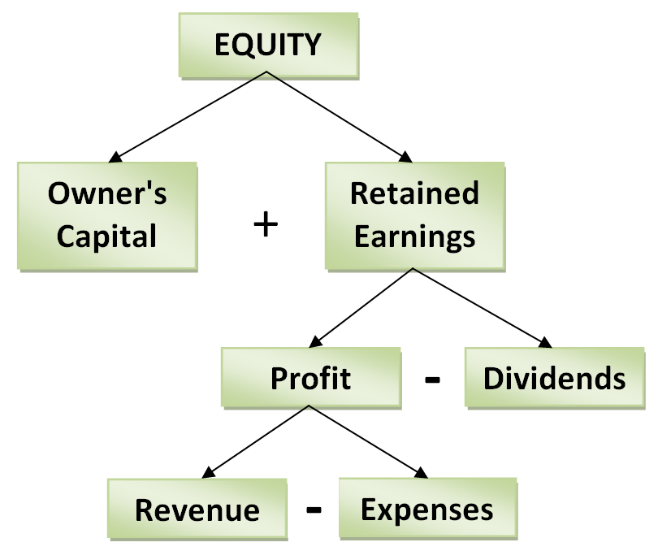
Why does an increase in expenses and dividends decrease equity? Because there is a negative sign in front of expenses and dividends....so they both decrease retained earnings, and therefore equity. The sign in front of the element indicates its effect on equity. When an element has no sign in front of it (such as revenue and profit) it has an implied '+' sign, which indicates its effect on equity is positive (an increase). Revenue and owner's capital, therefore, both increase equity.
Note that the above flowchart can also be shown as an equation:
Equity = Owner's Capital + Revenue - Expenses - Dividends

You can choose to use either the equation or the flowchart when solving questions.

Check your understanding (CYU2-3)
A new business has the following financial information available at the end of the year: revenues of $324,500, expenses of $298,400, and dividends of $7,000 were paid. In addition, at the start of the year, the owners contributed $250,000 to the business. What is equity at the end of the year for this new business? Show your calculations on the next page.
Equity is (insert your amount) $

Calculations (show your work):

How do assets and liabilities tie into equity?
Equity is equal to the wealth that is owed to the owners of the business by the business. What does this mean and how does it work?
Remember the separate entity assumption from Chapter 1? It says that ONLY the activities of a business are included in the business's financial information. It also says that the business is separate from the owners and the owners are separate from the business. Even though the owners OWN the business, the business has its own financial records, totally separate from the owner's financial records. Because a business is a separate entity the wealth that a business has is OWED to the owners BY the business. Note that this is from the business's point of view.
According to the previous video how is personal wealth calculated? By adding all your assets and subtracting all your liabilities. The left over, called the residual amount, is equal to the wealth that belongs to you, the owner of your personal wealth. A business is no different and it calculates its wealth in the same way; however, the wealth of a business is OWED to the owners BY the business.
Assets - Liabilities = Equity
Remember - equity is the wealth that the business owes to the owners. Note that, because this is a mathematical equation, we can switch it around to its more common format:
Assets = Liabilities + Equity
This means that everything a business OWNS (assets) is OWED either to third parties (liabilities) or the owners of the business (equity). Another way of thinking of this is that everything a business OWNS (assets) has CLAIMS against it by third parties (liabilities) or by owners (equity).
The above equation is called the basic accounting equation and we will be using it extensively throughout the remainder of this course.
Check your understanding
CYU2-4
Which of the following equations are variations of the basic accounting equation?
- Assets = Liabilities + Equity
- Liabilities = Assets - Equity
- Equity = Assets - Liabilities
- Assets - Liabilities - Equity = 0
- All of the above.
CYU2-5
Financial information for three independent businesses is given below. Fill in the missing amounts.
Assets | Liabilities | Equity
$212,800 |  | $64,200
 | $263,500 | $122,000
$149,000 | $85,400

Putting it all together!
Let's put all the equations and their interconnections together, starting with our understanding of profit and ending with the basic accounting equation.
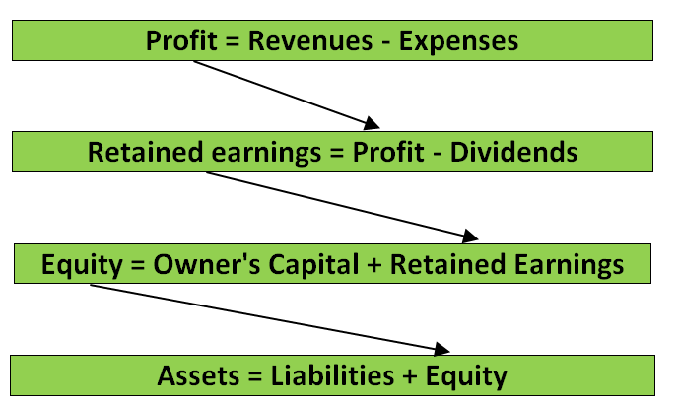
We can also flip this around, starting from the basic accounting equation and ending with profit.
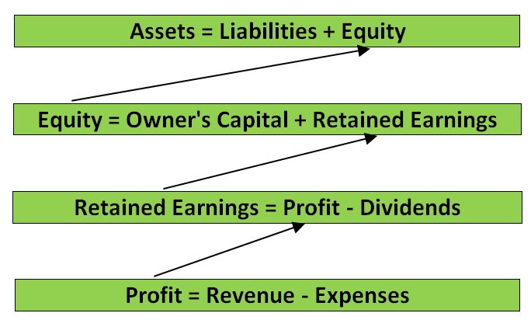
This can also be represented by a flowchart. Flowcharts have some important benefits:
- easier to visualize and memorize
- provides a guide for analysis of problems
- is a visual representation of a mathematical relationship
For that reason the interconnection of the financial reporting elements is provided, below, as a flowchart. This flowchart will also be used in the videos which follow and will be used, eventually, to analyze business transactions to record them in the accounting system.
Note: you are not required to use the flowchart. The above equations are exactly the same and can be used in the same way. The use of the flowchart is a personal decision for every learner and you should use what you feel comfortable with.
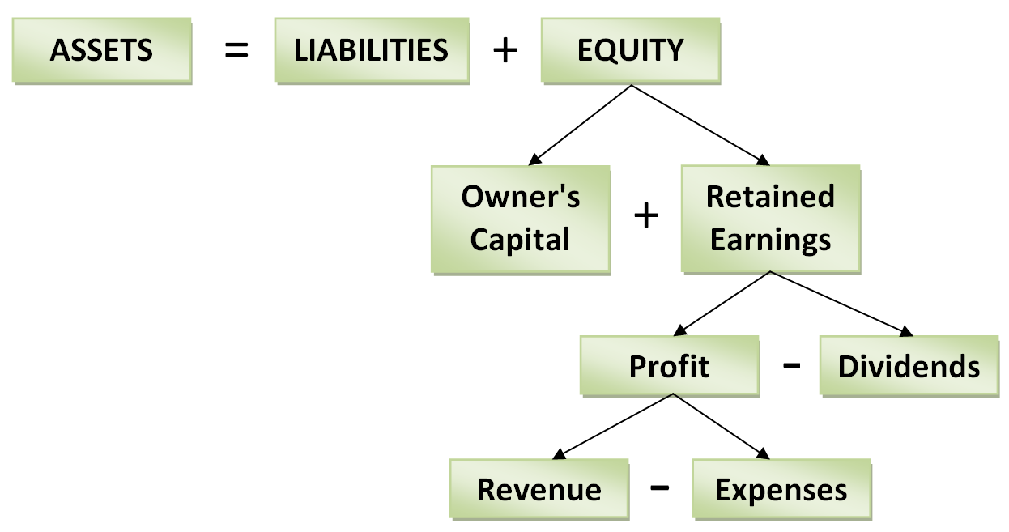
You can now see the interconnection between the five financial reporting elements. We can also show the interconnection by using one mathematical equation:
Both the flowchart and the mathematical equation, above, are called the expanded accounting equation. You can use either the equation OR the flowchart. What is key is your understanding of the interconnection between the five financial reporting elements. We will eventually use this concept to build the financial statements!
Video - Connecting Definitions and Equations
You already watched a video which listed and defined the financial reporting elements and you have seen how the elements interconnect. Connecting the definitions of the elements to the expanded accounting equation is important because, eventually, you will need to use these definitions to decide how business activities affect the equation. That decision is always based on the definition of the elements.
Before you watch the video see if you can answer the following question. Then, watch the video to see if you are correct.
Categorize each of the following descriptions into one of the following: assets, liabilities, equity, owners' capital, retained earnings, profit, dividends, revenues, or expenses. Note that some of these may apply to more than one element!
Description | Financial Reporting Element
Owed to third parties
Due to a past event
Owned
Used, consumed, or incurred
Profit kept in the business
Used, consumed, or incurred
Delivered a good
Owed to owners
Investment by owners
Help to generate revenue
Settled in the future
Has a future benefit
Earned by the business
Provide a service

Now watch the following video and check if you were correct.
https://www.youtube.com/watch?v=0mCh5xJRguY
Tying it all together: using the equation to solve for unknown numbers!
Now you have a good understanding of the accounting equations and the financial reporting elements used to develop the equations. The next step is to be able to use the equations to solve problems. The most common problems require students to solve for unknown numbers. Being able to solve these problems will help you to better understand the interconnections between the elements in the equations. Since the elements and their interconnection are the basis for recording business activities and producing financial statements, it is critical that you understand these concepts before you move forward.
Videos - Using the equations to solve for unknown numbers
After watching this video you should be able to use your understanding of the financial reporting elements and their interconnection to solve for unknown numbers.
Below are the questions that will be solved in this video. Research shows that students who attempt questions BEFORE they watch an instructor solve the problems are more likely to learn and retain their knowledge even if their answers are incorrect. Being wrong is a better learning experience than being right....or not trying at all.
BEFORE you watch the video attempt the questions below based on your understanding of the concepts so far and then watch the videos to see if you're correct.
Video Question 1
If expenses increase by $7,000, what happens to equity? Would it increase or decrease?

Equity will (increase, decrease) because _________________________________________.

Continued on the next page.
Video Question 2
Two owners of a business contribute $50,000 EACH to a business. During the year the business has costs of $89,560, paid dividends of $10,000, and earned revenues of $114,230. What is equity?
Equity is (insert your amount) $

Calculations (show your work):

Watch the video to see if you solved Questions 1 & 2 correctly.
https://www.youtube.com/watch?v=pnlgDi_4cP8
Video Question 3
At the beginning of the year a business has assets of $840,000 and liabilities of $485,000. During the year the business had costs of $889,560, paid dividends of $110,000, and earned revenues of $1,114,230. In addition, the assets increased by $89,200. What are total liabilities at the end of the year?
Liabilities are (insert your amount) $

Calculations (show your work):

Watch the video to see if you solved Question 3 correctly.
https://www.youtube.com/watch?v=KXCkk-jOda4
Testing Tip!
Note that for the midterm and final exam you will be asked to show your work (calculations). This is often worth marks (1 - 4, depending on level of complexity). If you do not show your calculations you will lose the calculation marks, even if your answer is correct.
Always show your calculations.
Question 4
At the beginning of the year ABC Company has total assets of $905,000 and total liabilities of $452,000. During the year ABC's total assets increased by $143,000 and their liabilities decreased by $143,000. What is equity at the end of the year?
Equity is (insert your amount) $

Calculations (show your work):

Question 5
The following information is provided for you. Calculate dividends for the period.
Total assets, end of period | $145,000
Total liabilities, end of period | $38,000
Owner's capital, end of period | $63,000
Retained earnings, beginning of period | $24,000
Profit for the period | $29,000

Dividends are (insert your amount) $

Calculations (show your work):

Watch the video to see if you solved Questions 4 & 5 correctly.
https://www.youtube.com/watch?v=QYdqoM7Hh1M
Practice using the equation to solve for unknown numbers!
Now that you have a good understanding of how to solve questions, you need to practise so that, regardless of the structure of the question, you recognize what you need to solve it and you are able to do so quickly.
Two questions have been provided, below. In every chapter moving forward questions on how to solve for unknown numbers will be part of the end of chapter Practice Questions.
Check your understanding
CYU2-6
A new business has the following financial information available at the end of the year: Revenues of $428,400, expenses of $314,200, and dividends of $9,000. In addition, at the start of the year, the owners contributed $550,000 to the business. By the end of the year the business had assets of $883,700. What are the liabilities at the end of the year for this new business?
Liabilities are (insert your amount) $

Calculations (show your work):

CYU2-7
Selected data, in random order, are available for TJM Company, below. This is their first year of operations (important information to solve the question!)
Solve for all the unknown amounts.
Total equity, beginning of the year | $0
Total expenses | 428,000
Total equity, end of year | ?
Dividends | 12,000
Total assets, end of year | 1,490,000
Owner's capital, end of year | ?
Total revenues | ?
Total liabilities, end of year | 997,000
Retained earnings, end of year | ?
Profit, during year | 61,000

Calculations (show your work):

How do we apply our knowledge of the elements and equations to business activities?
Recall that, in business, the process of changing financial data into financial information and then into financial statements is carried out by the accounting system. The first step in the accounting system is to collect and group the activities into the financial reporting elements and record them using the accounting equations. This is the first step in moving from financial data to financial information. Your current understanding of the financial reporting elements, their definitions, and the accounting equations is critical; however, you also have to understand another very important accounting concept: the double entry accounting system.
What is the double entry accounting system?
To explain this simply, let's go back to the basic accounting equation:
Assets = Liabilities + Equity
Note that this is a mathematical equation that includes an equal sign. Like all equations, any change must be reflected on both sides. We can demonstrate this using a simple example. Say you own 7 pens and 3 pencils. You therefore have the following equation:
10 = 7 + 3
You own all 10 writing tools so 10 on the left side is equal to your assets, what you own. The pens and pencils on the right hand side must be kept separate. Why? Because, even though you use both pens and pencils to write with, they have different characteristics (like liabilities and equity - both are owed but one is to third parties, the other to owners!) If you added pens and pencils together and just showed 10 = 10 you would be misleading the stakeholders who use your information for decision-making (because pens and pencils have different characteristics!)
Now, let's say you add 2 more pencils to your collection. What happens?
(10 + 2) = 7 + (3+2)

12 = 7 + 5
Notice that we added in 2 pencils TWICE, making a double entry: 2 are added to what you own on the left side of the equal sign and 2 are added to the total pencils on the right side of the equal sign. This shows you now have more pencils and you own more writing tools in total, your assets. After adding 2 on both sides the equal sign is still true: 12 does equal 7 plus 5!
This is a double entry system: you added the pencils in TWICE and showed different views of the same information!
The double entry accounting system is similar: everything is recorded twice AND the equation MUST be kept in balance at all times. Even though this is a straightforward concept in math, using pencils and pens, it's complicated in accounting because we have elements into which activities must be grouped. We have to use the elements' definitions to determine which elements are affected. But, it is similar in that every activity is recorded at least twice (although more complicated entries may affect multiple elements).

What about an accounting example?
Let's start with the effect on the basic accounting equation and then move to the expanded accounting equation.
Say you start your own business, Walk UR Dog, which offers dog walking services within your neighbourhood. You start the business by contributing $100 of your own money. How would you record this transaction in the double entry accounting system of the business? Remember, the separate entity assumption says that business activities must be kept separate from the owners so, even though you own the company, the business activities are recorded in the name of the business, not your own.
What is the process to analyze business activities?
The best way to analyze any business activity is to have a set of questions that you ALWAYS ask when analyzing any activity.
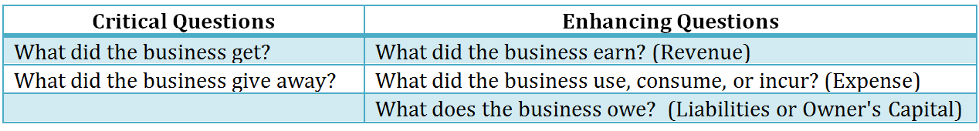
Again, keep in mind that you stand in the shoes of THE BUSINESS when you are asking yourself these questions because you are recording these events in the business's accounting system, not the owners. That point of view, the business's point of view, is very important.
Ask yourself the critical questions first. If there is still confusion about how the activity affects the financial reporting elements then use the enhancing questions to clarify your understanding.
How does Walk UR Dog record contributions by owners?
Let's go back to Walk UR Dog and start the process. Remember that you started the business by contributing $100 of your own money to the business. How would you record this activity in the double entry accounting system of the business? You start by analyzing the activity using the critical questions.
What did Walk UR Dog get? Walk UR Dog got cash of $100. What financial reporting element is affected by cash? Walk UR Dog now owns the cash, the cash has future benefit for the business since Walk UR Dog can buy things with it, and the event already happened in the past (contribution by the owner, you!) Assets would increase by $100.
Remember – you are analyzing transactions from the point of view of the business, not you!
What did Walk UR Dog give away? That's more difficult to determine and not at all clear. Let's move on to the enhancing questions to see if that will clarify our thinking.
What did Walk UR Dog earn? Nothing, because it has not done anything for a customer yet, so revenues are not affected.
What did Walk UR Dog use, consume, or incur? Nothing, because, again, it has not done anything yet, so expenses are not affected.
What does Walk UR Dog owe? Walk UR Dog owes wealth to the owner (you). Contributions by owners are recorded as an increase to owner's capital. Owner's capital is part of equity so equity increases by $100.
Let's go back to the critical question we could not answer: what did Walk UR Dog give away? It gave away ownership in the business, which is represented by owner's capital!
The effect of the transaction on Walk UR Dog's basic accounting equation is as follows:
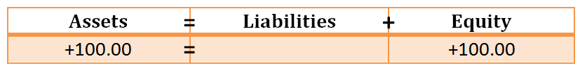
Does the recording of this business activity look any different using the expanded accounting equation? Yes, it does. By using the expanded accounting equation we can see the details of the transaction. Let's take a look.
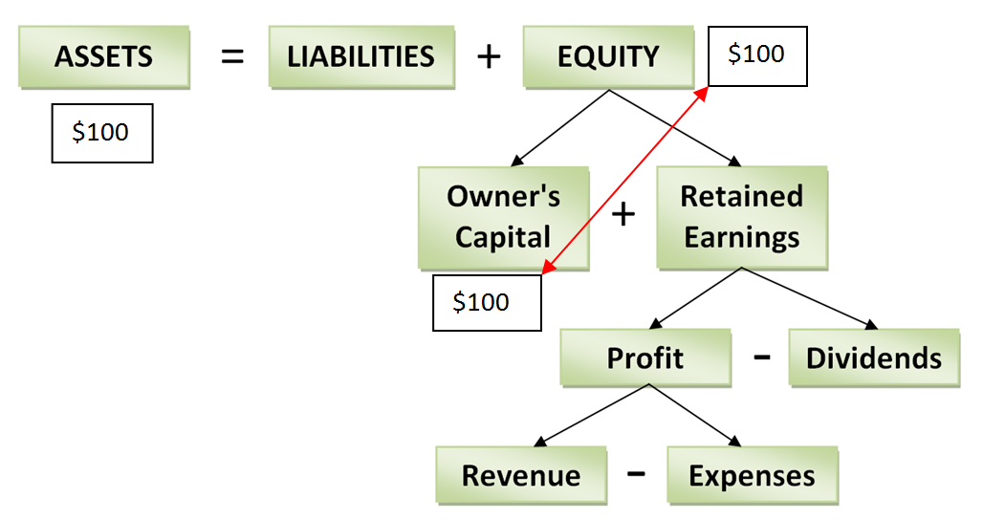
Owner's capital, defined as contributions by owners, increases. Since owner's capital plus retained earnings is equal to equity, an increase to owner's capital would increase equity. Assets increase because Walk UR Dog owns the cash and it will benefit the business in the future.
You can see that the flowchart is an excellent tool for analyzing activities but, if we want to record a large number of business activities all together, the flowchart will not work. Therefore, the flowchart should be kept for purposes of analysis only. In order to record the effect of transactions on the expanded accounting equation we can use a modified chart that would duplicate the interconnections shown in the flowchart of the expanded accounting equation.
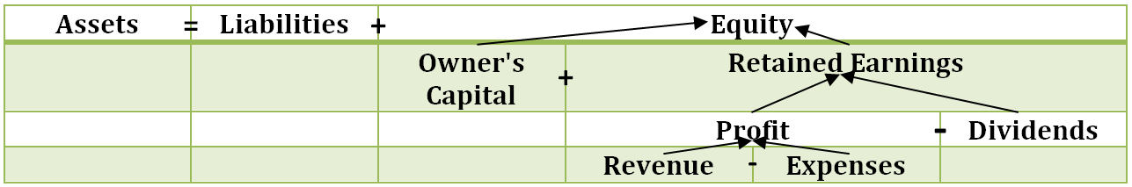
By using this chart we see the effect of the transaction on the expanded accounting equation. Below is the effect of this transaction as shown on the flowchart.
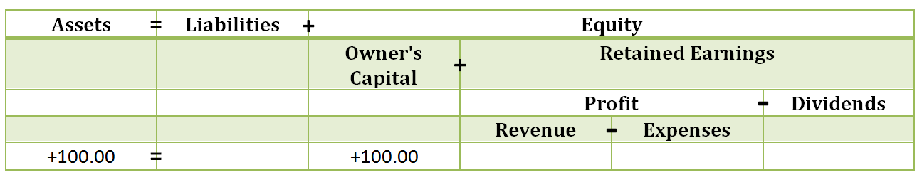
Notice that the above chart has the same information as the flowchart and, by flowing the effect of owner's capital, revenue, expenses, and dividends up to equity, you can be sure that the accounting equation, Assets = Liabilities + Equity, is in balance.
How does Walk UR Dog record purchases?
Let's continue with more examples from Walk UR Dog to show the effect of different types of business activities.
Walk UR Dog purchases a package of 120 Top Paw® Citrus Scented Poop Bags from Pet Smart for $23.39 plus HST (13%), a total of $26.45. The business pays cash for the bags.
What did Walk UR Dog get? It got poop bags which can be used for quite some time in the future. What financial reporting element is affected by something with future benefit? Assets. Walk UR Dog owns the bags, the bags will be used in the future to help run the business, and they were already purchased so this is a past event. Assets increase by $26.45.
What did the business give away? Walk UR Dog gave away cash, which we already know is an asset. In this case that asset will decrease because, now that $26.45 has been given to the store, it is no longer owned by the business and therefore no longer has any future benefit. Assets decrease by $26.45. Walk UR Dog simply traded one asset, cash, for another, bags.
Using the basic accounting equation we would record the following:
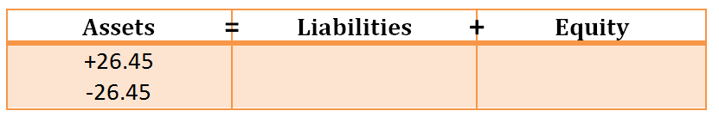
Using the expanded accounting equation we would see the same since this transaction does not affect any items under equity.
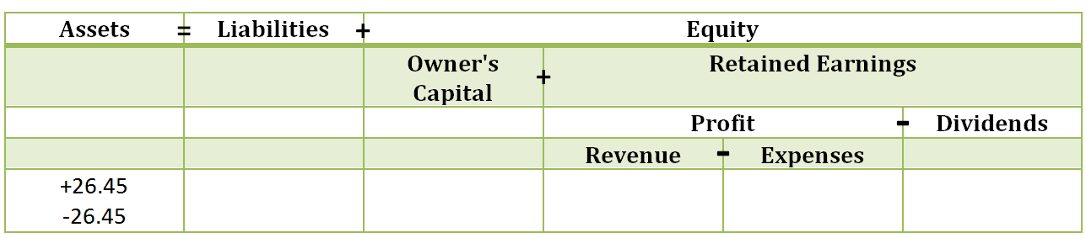
How does Walk UR Dog record the provision of a service?
Walk UR Dog has decided to offer two services: a half hour walk for $15 or a combined half hour walk and 15 minute play time for $20. Sandra, a neighbour, hires you to immediately walk her dog, Bella. Sandra pays you $15 cash when you return.
What did Walk UR Dog get? Walk UR Dog received cash, an asset (we already know why cash is an asset). Assets increase by $15.
What did Walk UR Dog give away? A service. How is a service recorded? This is a bit more complicated...so ask yourself the enhancing questions.
What did Walk UR Dog earn? It provided (past tense) a service to a customer so it has earned revenue. Revenues increase by $15.
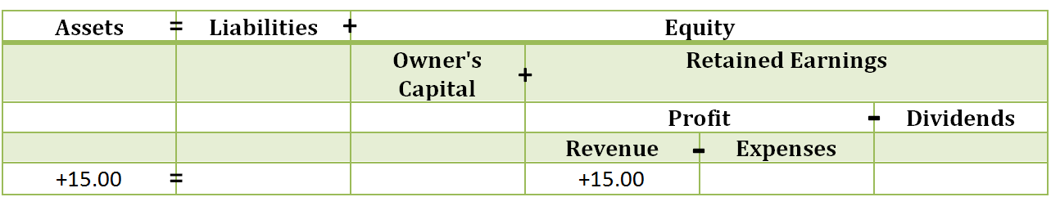
Notice that the recording of revenue affects equity: equity is increased by $15. Again, when an element under equity is affected we can flow it up the chart to see the effect on equity.
If we were to record this transaction using the basic accounting equation it would be recorded as follows:
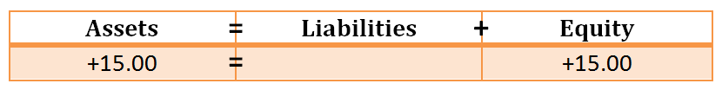
This is the same transaction but it does not show the details of what has happened to the element revenue.
How does Walk UR Dog record what it uses to provide a service?
During the walk Bella required the use of 4 poop bags. The bags cost $0.22 each (120 bags for $26.45 = $0.22 each). In order to earn revenue of $15 the business used 4 X $0.22 = $0.88 worth of poop bags.
Again, analyze the transaction using the critical questions followed by the enhancing questions if necessary.
What did the business get? That's not clear at all! Let's move on with the list of questions.
What did the business give away? Four poop bags were thrown away. The poop bags were recorded as an asset when they were purchased because they would benefit the company in the future. Now that they have been thrown away they no longer have a future benefit so the asset, poop bags, must decrease.
Let's move on to the enhancing questions.
What did the business earn? The use of the bags may be DUE to earning service revenue but their use is not revenue. Revenue can only be affected if the business has done something for a customer. No additional services were performed for the customer so there is no effect on revenues. (We did provide a service for the dog (stooping and scooping), but our customer is the dog's owner, not the dog.)
What did the business use, consume, or incur? The business used 4 poop bags in order to help earn service revenue, so Walk UR Dog has an expense. Expenses increase by $0.88.
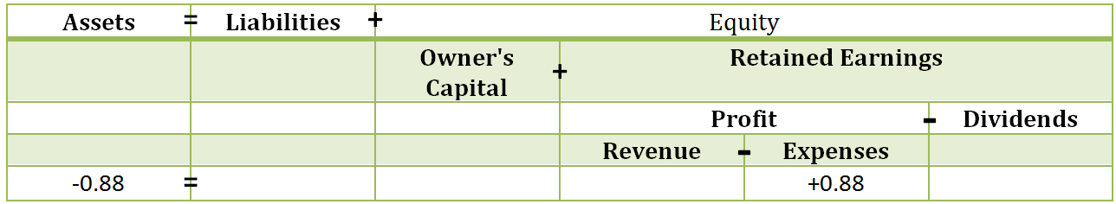

Wait....it looks like the equation is not working!! The effect under assets is NEGATIVE $0.88 but the effect under expense is POSITIVE $0.88! Have we made an error in recording this business activity?
No. The equation that must to be kept in balance is the basic accounting equation, Assets = Liabilities + Equity; therefore, you have to look at the effect on EQUITY to see if the equation is in balance. Expense has a negative in front of it, meaning that expenses reduce profit, retained earnings, and equity. An increase in expenses flows through as a decrease to equity.
Looking at the effect on the basic accounting equation we see the following:
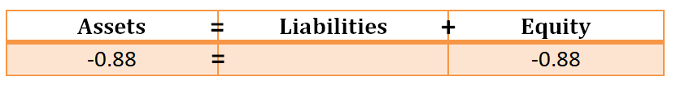
Remember, although it did not look like the equation balanced using the expanded accounting equation, flowing the expense up to equity shows that expenses decrease profit, which decreases retained earnings, which decreases equity. At the basic accounting equation level the entry balances!
How does Walk UR Dog record additional purchases?
To prepare for customers who purchase play time, you go to your local Pet Valu and purchase a selection of dog toys. It's surprising how expensive they are: six toys are $60.95, including HST (13%).
What did Walk UR Dog get? Dog toys, an asset owned and having future benefit for the business.
What did Walk UR Dog give away? Cash, which we already know is an asset. Walk UR Dog's assets decrease because cash is given away to Pet Valu.
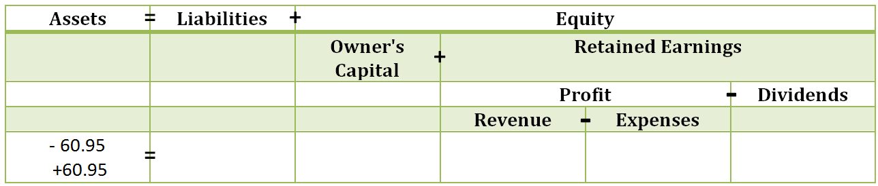
Once again, one asset (cash) has simply been traded for another (toys). We can’t tell from the chart, however, how much of our assets are composed of cash, poop bags, toys, etc. This will come in Chapter 3.
How can Walk UR Dog build the business?
For Walk UR Dog to build the business you need to advertise. Your mother has agreed to let you use her computer, printer, and paper so you create a flyer to advertise the services of Walk UR Dog and print up 500 copies. You spend the afternoon delivering the flyers around the neighbourhood. Your mother charges you $0.07 per sheet, for a total of $35.00. You check the cash position of Walk UR Dog: $100.00 - 26.45 + 15.00 - 60.95 = $27.60. Unfortunately Walk UR Dog does not have enough money to pay your mother immediately. She agrees that you can owe her until the business has grown and she won't charge you interest (thanks Mom!)
What did Walk UR Dog get? That's difficult to say. You could say Walk UR Dog got advertising but can we record advertising as an asset? To determine this check to see if advertising would meet all three characteristics of the element asset: owned, future benefit, due to a past event. Although advertising might benefit the business in the future (although you can't be sure of this) Walk UR Dog does NOT "own" advertising. Since advertising is not owned it does not meet ALL three characteristics so advertising cannot be recorded as an asset. Assets: no change.
What did you give away? Flyers, but what does that mean? It's unclear. Let's move on to the enhancing questions.
What did Walk UR Dog earn? Nothing, since it didn't do anything for a customer.
What did Walk UR Dog use, consume, or incur? Walk UR Dog used up all the flyers by delivering them to homes in the neighbourhood. The flyers were used to help generate future revenues: expenses increase by $35.00.
What does Walk UR Dog owe? The business owes your mother $35.00, an obligation due in the future that is a result of a past transaction. Liabilities increase by $35.00.
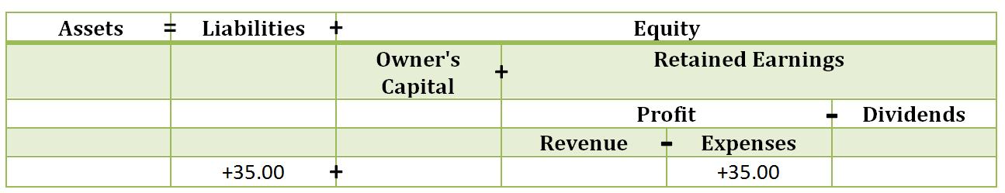
Wait a minute.....does this equation balance? Expenses decrease equity so equity would show NEGATIVE $35.00 but liabilities have increased because Walk UR Dog owns your mother $35.00. There is no effect on assets! Is this possible?

Let's see the basic accounting equation to ensure the equation balances:

Note that because the positive effect to liabilities and the negative effect to equity are both on the same side of the equation, the equation is in balance: assets are ZERO and the net effect on the left hand side of the equation is also ZERO (+35.00 - 35.00 = 0). The equation is still in balance.
Notice: business activities do not have to affect both sides of the equation but the overall equation must always be in balance. We have already seen two transactions which did not affect the right side of the equation – the purchase of the toys and the poop bags.
What's Walk UR Dog's financial position at the end of the week?
Let's look at all the business activities together to see the position of Walk UR Dog at the end of the week, first using the basic accounting equation and then the expanded accounting equation. Totals are given at the bottom of each chart in RED.
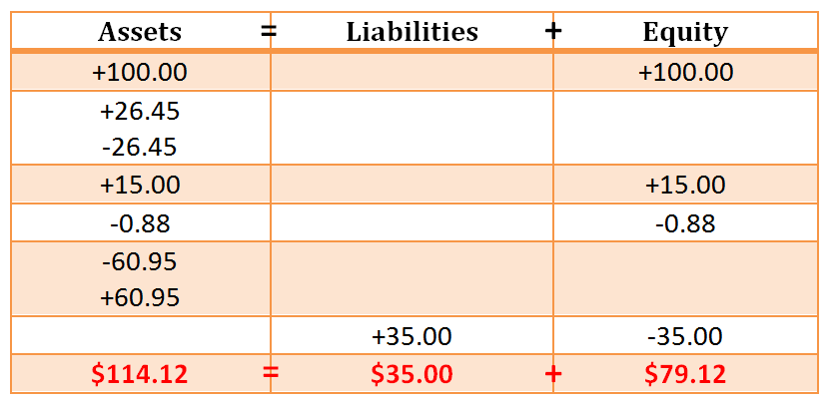
We can see that the equation balances, as it should. However, as a business owner, you can't make very many decisions based on this information. You can't even tell if there was profit in the first week because the details of revenues and expenses are not shown. All you can say is that Walk UR Dog owns $114.12 of assets and owes $35.00 to third parties (your mother) and $79.12 to the owner (you!) You also can’t tell how much cash you have, and how much of your assets are other things (poop bags and toys).
Now let's review the business activities using the expanded accounting equation:
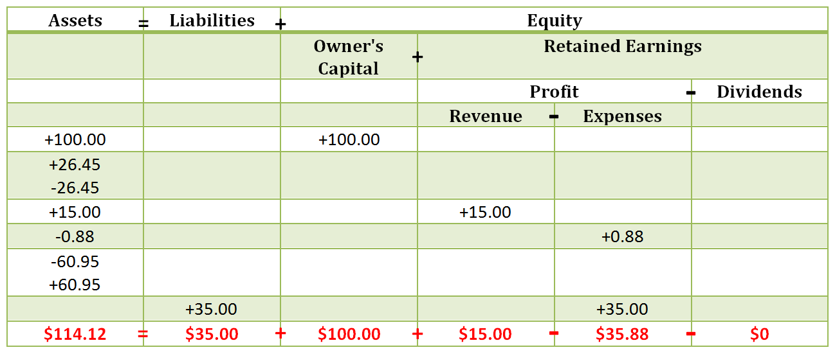
The expanded equation provides details to help you analyze Walk UR Dog's first week of activities. The business suffered a loss (revenues of $15.00 less expenses of $35.88 is a loss of $20.88). It's the first week of business though and advertising was only just sent out, so you are not too worried about the current loss position. It is important to note that the loss from operating the business has reduced equity: owner's capital was $100.00 but the business only owes the owner $79.12 because the loss reduced what is owed to the owner ($100.00 - $20.88 = $79.12). Losses clearly reduce the wealth that the business owes to the owners.
You can see that the expanded accounting equation provides more information for decision-making than the basic accounting equation; however, even more details are needed to help in decision-making. For instance, even though Walk UR Dog has assets of $114.12, what makes up those assets is unknown. In fact, Walk UR Dog can't even tell what its cash position is at the moment without doing manual calculations!
Any accounting system should provide information that is ready for use by decision-makers. Even with the expanded accounting equation there is still not enough information for decision-making purposes. What Walk UR Dog needs are individual accounts that Walk UR Dog can divide its financial reporting elements into. For example, an account called cash under the element assets could track only cash transactions so that Walk UR Dog would know its cash position immediately. Accounts are common subgroups of financial reporting elements that are used to accumulate (gather) business activities. For instance, assets could be divided into Cash and Dog Supplies. Doing so would allow you, the owner, to better understand your business and make decisions (like whether you need to borrow from your mother or not!)
But we're getting ahead of ourselves; accounts are part of the next chapter. For now let's continue to use the expanded accounting equation and the basic accounting equation to record the transactions.
Video - Using the equations to record business transactions
Before you watch the video see if you can answer the following question. Then, watch the video to see if you are correct.
Record each of the following business activities into the basic accounting equation AND the expanded accounting equation. Be sure to provide a total at the bottom of each column for both the basic and expanded accounting equation.
Item # | Description
1 | You invest $500 of your own cash to start the business.
2 | Borrow $250 from your parents to help start the business.
3 | Using a business credit card register a business name with Service Ontario, $60.
4 | Paid $150 (including HST) for supplies that will be used in the future.
5 | Received cash from customers for services provided, $1,450.
6 | Used up half of the supplies that you purchased previously.
7 | Paid the business credit card bill for the $60 you charged in Item #3.
8 | Paid dividends of $150 to yourself, the owner.

Assets | Liabilities  + | Equity

Continued on the next page.
Assets | Liabilities | Equity
 |  | Owner's Capital  + | Retained Earnings  -
 |  |  | Profit  - |  | Dividends
 |  |  | Revenue | Expenses

Watch the video to see if your answers were correct.
https://www.youtube.com/watch?v=tiU38d-ntjQ
Check your understanding (CYU2-8)
Below are 8 independent business activities. Indicate their effect on the basic accounting equation as well as the expanded accounting equation. USE the critical and enhancing questions to analyze each transaction before you record it. Be sure to include the indicator
(+ or -) and the amounts on the charts. Charts have been provided for you.
DO NOT provide a total at the bottom of each column as these business activities are independent of each other.
Trans # | Description
1 | Electricity of $80 is used at a factory but not yet paid for.
2 | A store purchases inventory for $1,200 cash.
3 | A business provides a service to a customer for $900 cash.
4 | Wages of $400 are paid to employees for work they completed.
5 | Interest cost of $15 is paid.
6 | Window cleaning services are performed for $60 cash.
7 | Dividends of $400 are paid to the owners of a business.
8 | Paid $184 for maintenance on a building's air conditioner.

Continued on the next page.
CYU2-8, continued
=
Assets | Liabilities  + | Equity

Testing Tip!
You must be able to analyze business transactions using EITHER the expanded accounting equation OR the basic accounting equation. Be sure to continue to practise both.
+
=
Assets | Liabilities | Equity
 |  | Owner's Capital  + | Retained Earnings  -
 |  |  | Profit  - |  | Dividends
 |  |  | Revenue | Expenses
Testing Tip!
Students often forget to ask themselves the critical and enhancing questions when they analyze business activities. They start to memorize how activities affect both the basic and expanded accounting equation. The problem is that, on the midterm or final exam, you may see transactions you have never seen before! If you don't have those critical and enhancing questions ready you will be guessing how to record those transactions....which will definitely lose you marks. Be sure you know and use the critical and enhancing questions to analyze every transaction.
Putting it all together!
The overall objective of GAAP (what does that stand for again?) is to provide financial information about a business that is useful to stakeholders for decision-making. GAAP provides the qualitative characteristics and underlying assumptions which, when followed, help to make the financial information useful. But business activities are data, not information. Data must be grouped, analyzed, and formatted for presentation purposes before it becomes information which can be used for decision-making. GAAP stipulates the categories, called elements, that all business activities are divided into, changing financial data into financial information and, eventually, into financial statements. By knowing the elements, their definitions, and their interrelationships, we can begin recording business activities into the account system. The outcome of this system is financial information which is useful for decision-making.
Going forward!
Any accounting system should provide information that is ready for use by decision-makers; however, we saw that even with the expanded accounting equation there was still not enough information for decision-making purposes. In Chapter 3 you'll be introduced to accounts, common subgroups of financial reporting elements that are used to accumulate (gather) business activities. With the addition of accounts the accounting system can be used to produce the financial statements that stakeholders use to better understand the business. This allows them to make decisions that will meet their objectives.

What do I need to know for a midterm or final exam?
What do I need to know for the midterm or final exam: a specific and detailed listing of what you need to understand from each chapter. Use this listing when you are creating your notes. In fact, the best way to use the listing is to put it at the top of a page, then answer it when you read the textbook and watch the videos. This will then give you study notes for the midterm and final exam.

- Explain why financial information is important for both preparers and users of financial information.
- Explain the difference between data and information and be able to provide an example.
- Explain what financial statements are, who uses them, and for what.
- List and define the financial reporting elements. Provide examples of each of the elements.
- Categorize business activities into the financial reporting elements.
- Explain the interrelationships between the five financial reporting elements. Be able to either draw the flowchart or provide all the necessary equations to demonstrate your understanding of the interrelationships.
- Use your understanding of interrelationships of the financial reporting elements (basic or expanded accounting equation) to solve for unknowns.
- Explain what the double entry accounting system is and provide an example.
- List the critical and enhancing questions used to analyze every business activity.
- Use the critical and enhancing questions to analyze business activities.
- Use the definition of the elements to support when business activities affect the element. For example, be able to explain why 1,000 poop bags should be recorded as an asset.
- Record basic business activities into the accounting system using both the basic and expanded accounting equation.
- Explain why increases in expenses and dividends are recorded as positives in the expanded accounting equation but negatives when recorded in the basic accounting equation.
- Analyze the accounting information prepared by a business to answer questions about the business's financial position and profitability.

Watch out for....
Watch out for....: Lists the most common errors that students make on the midterm and final exam. Pay attention to these and make sure you are not one of those students.

Students often forget to check if the accounting equation is in balance when they record a business activity. ALWAYS check to ensure you are recording the activity correctly by INPUTTING the equal sign on your chart! That way you will always know if your transaction is in balance.

Students sometimes don't use the double entry accounting system. For example, they receive cash from a customer so they record it under assets...but nowhere else! Be sure you use the double entry accounting equation to record all transactions.

Finally, make sure you recognize the difference between how you should record activities in the basic accounting equation (expenses are negative) compared to the expanded accounting equation (expenses are input as positive because increases to expenses flow up into the equation, which then causes equity to decrease!)

In Class Demo Questions
In Class Demo Questions are the questions that will be covered in class by your instructor. No lectures....just learning through problems. NOTE: if you have not read the chapter or watched the videos before class you will have difficulty following along in class! Solutions to the In Class Demo Questions will NEVER be released. The only way you will get the solutions is if you attend class or get them from a friend if you miss class.

ICDQ2-1
Categorize each of the following business activities into the correct financial reporting element. Use 1 for assets, 2 for liabilities, 3 for equity, 4 for revenue, and 5 for expense.
 | Description | Element
Q1 | Electricity used at a factory.
Q2 | A store's inventory.
Q3 | The profit a business made this year.
Q4 | Wages paid to employees for work completed.
Q5 | Interest that is due on a loan.
Q6 | Window cleaning services performed for a customer.
Q7 | Dividends paid to the owners of a business.
Q8 | An air conditioner in an office building.
ICDQ2-2
A student starts a lawn care business for the summer of 2018. Below is the financial data for the summer as well as a description of what the amounts relate to. This list is data until it's grouped and processed, changing it into financial information. It is KEY that you first categorize all the amounts into their appropriate elements for the business.
Continued on the next page.

Description | Amount | Element
Advertising costs | $150
Cash in bank (business) | $2,560
Cash in bank (personal) | $1,289
Equipment rental costs | $1,400
Gas costs (used) | $384
Container full of gas | $40
Customer payments | $3,500
Cell phone costs (business) | $216
Cell phone costs (personal) | $144
Money borrowed from parents to start business. | $500
iPad Air 2 purchased (personal) | $654
Money you put in to start the business | $750
Which data from the listing would not be included in the business's financial data and why? If this data was included which assumption would the business be violating? Explain why.

Profit is (insert your amount) $

Calculations (show your work):

Continued on the next page.

Equity is (insert your amount) $

Calculations (show your work):

Assets are (insert your amount) | $
Liabilities are (insert your amount) | $
Equity is (from previous question) | $

The basic accounting equation is __________________________________________.
Calculations:

ICDQ2-3
At the beginning of the year a business had assets of $140,000 and equity of $100,000. By the end of the year the business had total assets of $210,000 and liabilities of $85,000. During the year the business had new contributions by owners of $15,000, revenues of $162,000, and expenses of $149,000.
Provide the following and answer the questions that follow.
Beginning liabilities | $
Ending equity | $
Profit | $
Dividends paid | $

Calculations:

A. Did liabilities increase or decrease during the year and by what amount? What is one possible explanation for the change in liabilities?

ICDQ2-4
A business has assets of $148,000 and liabilities of $111,000 at the beginning of the year. At the end of the year total assets were $162,000 and equity of $69,000.
After analyzing the information, answer the questions that follow.
Calculations:

A. Did liabilities increase or decrease and by what amount?
Liabilities (increased, decreased) by $__________________.
B. What is likely to have caused the change in liabilities?
C. Did equity increase or decrease and by what amount?
Equity (increased, decreased) by $__________________.
D. What may have caused the change in equity? Give two possible reasons.

ICDQ2-5
You start business providing accounting services to small businesses. Record the following transactions into the basic accounting equation. Be sure to include both the indicator (+/-) AND the amount.
- Made a cash investment in your business of $2,500.
- Registered your business name with Service Ontario for $60 using a business credit card.
- Borrowed $3,000 cash from the bank.
- Purchased equipment for $3,000 using your business credit card.
- Rented office space for a month and paid your landlord $1,700 cash.
- Purchased supplies for $400, plus HST, cash.
- Provided services to customers and received $2,400 cash.
- Paid cash of $100, plus HST, to print flyers to advertise your business. You have not used any of them yet.
- Paid for the equipment you bought in Item #4.
- Paid a student $200 to deliver your flyers in your neighbourhood. All the flyers were handed out. (HINT: this is actually 2 transactions: use up the flyers, pay the student.)
- Paid $124 (HST included) for the use of your business phone for the past month.

Assets | Liabilities  + | Equity

ICDQ2-6
NOTE: this is a continuation of Walk UR Dog. Remind yourself of the transactions that have already occurred in the business by reviewing the following transactions and looking at the expanded accounting equation that was completed previously in the chapter.
- Contribute $100 cash to the business.
- Purchases a package of 120 Top Paw® Citrus Scented Poop Bags from Pet Smart for $23.39 plus HST (13%), a total of $26.45, paying cash.
- Sandra, a neighbour, hires you to walk her dog, Bella. Sandra pays you $15 cash when you return.
- During the walk Bella required the use of 4 poop bags. The bags cost $0.22 each (120 bags for $26.45 = $0.22 each) so you have used up 4 X $0.22 = $0.88 worth of poop bags.
- Purchase six toys for $60.95, including HST (13%) with cash. You will use them in the future.
- You owe your mother $35 for printing off flyers on her computer. You have delivered all the flyers in your neighbourhood (so you used them up!)
You are surprised at the amount of calls you have received on your cell phone because of the flyers you distributed to advertise Walk UR Dog's services: 19 people called for additional information and 11 people have hired your business to walk their dog. Two of those customers have asked for two walks a day and another three have asked for the play time option. In fact, you are now worried you will not be able to service all the customers.
After some research you discover that response rates for flyers is as high as 4.4%¹, so you are lucky only 12 customers signed up. You realize you should have done more research before delivering all those flyers - there is no way you can walk 11 dogs a day plus Bella. You ask your best friend, who lives next door to you, to join you in the business and she agrees. The two of you have now run the business for the last four weeks (in addition to the first week when you were on your own). The business activities for the last four weeks are provided below.
- Your best friend contributes $100.00 cash to the business.
- Seven (7) customers have their dogs walked once a day for 4 weeks at $15.00 per walk. This service is only provided on weekdays. Every day you and your friend collect the cash from your customers.
- Two customers have their dogs walked twice a day for 4 weeks at $15.00 per walk. This service is only provided on weekdays. Cash is collected at the end of every day.
- Three customers have their dogs walked once a day followed by play time for 15 minutes for 4 weeks at $20.00 per walk/play time. This service is only provided on weekdays. Again, cash is collected at the end of every day.
- You and your friend are shocked at the number of poop bags you use: approximately 145 bags per week! The remaining Top Paw® Citrus Scented Poop Bags are used up. Remember that they cost $26.45 originally but you have already recorded using up 4 (at $0.88) so you have now used up the remainder ($26.45 - 0.88 = $25.57 used up).
- You purchase 1,000 Bark+® Dog Waste Poop Bags from amazon.ca for $42.95 (free shipping) plus HST (13%) for a total cost of $48.55. Your mother pays for it and you will repay her at the end of the month, when the credit card bill arrives.
- You continue to use a lot of poop bags. By the end of the month there are only 428 of the 1,000 bags you bought from amazon.ca left! The remainder have been used up.
- You repay your mother for the $35.00 loan.
- During the month two of the toys are destroyed by one of the walk/play dogs. The cost of these 2 ruined toys is $60.95/6 * 2 = $20.32.
- You purchase 2 new toys for $11.99 each plus HST (13%) for a total cost of $27.10, paying cash.
- Your mother's credit card bill arrives and you pay her the amount owed for the Bark+® Dog Waste Poop Bags ($48.55 cash).
- Dog waste has become an issue. Neither family wants the waste in their garbage cans. You discuss this with your business partner and decide to buy a garbage can that seals well, locks, and has wheels. The simplehuman® 40 Liter Slim Plastic Step Can in Black from amazon.ca costs $50.00 plus $6.99 shipping and HST (13%), for a total cost of $64.40. Your mother gladly pays for it on her credit card and, at the end of the month, you still owe her as the charge has not, as yet, come through on her credit card.

ICDQ2-6, continued

- You and your friend open a business bank account at TD Bank® so there are better controls over cash. The plan has unlimited transactions for $14.95 (including taxes) per month. By the end of the 4 weeks you have received your bank statement and see that the bank has charged you the monthly fee and withdrawn it directly from the bank account.

Required:
Analyze each of the transactions using the critical and enhancing questions. Then record all the transactions into the expanded accounting equation.
The chart has been provided, including the opening activities that have already been recorded.

See the next page for the charts.
ICDQ2-6, continued
Note that you may not need all of the spaces provided.
=
Assets | Liabilities | Equity
 |  | Owner's Capital  + | Retained Earnings  -
 |  |  | Profit  - |  | Dividends
 |  |  | Revenue | Expenses
+100.00 |  | +100.00
+26.45
-26.45
+15.00 |  |  | +15.00
-0.88 |  |  |  | +0.88
-60.95
+60.95
 | +35.00 |  |  | +35.00
= | + | + | - | -

ICDQ2-6, continued
So what does the financial information tell you about Walk UR Dog?
Being able to record transactions is the first step in converting DATA into INFORMATION but what you DO with financial information is even more important. Remember that financial information is used to answer questions and guide business decisions. It is therefore very important to be able to read and understand what the financial information is telling you about your business.
Who are the stakeholders in Walk UR Dog? List the main internal and external stakeholders and what you think their objectives might be.
Producing financial information after 5 weeks of running Walk UR Dog satisfies which qualitative characteristic and assumption? Why do you think having financial information after just 5 weeks would be important to internal stakeholders? (Think about their objectives!)

ICDQ2-6, continued
What is your financial position at the end of the period? (Financial position is represented by the accounting equation: assets, liabilities, equity.) Would you consider your financial position good? Why or why not?
How profitable was Walk UR Dog over the period? If the business was profitable, what is it about this business that likely ensures its profitability?
Considering you have equal ownership of the business with your friend, how much equity does the business owe each of you? If you ended the business now, would you each receive that amount in cash? Explain why or why not.

ICDQ2-6, continued
What do you think might be some of the key characteristics about your neighbourhood that would contribute to the success of Walk UR Dog? Why do you think information about these characteristics is important to research before you started your business?

Practice Questions
PQ2-1
How is a business's wealth calculated? What is the effect of buying office supplies on the wealth of a business? Consider both when they are purchased for cash or purchased using a credit card. Be sure to support your answer with reasoning.
PQ2-2
The owner of a business contributes $12,000 to a business. During the year the business has expenses of $32,450, paid dividends of $2,000, and earned revenues of $41,200. What is equity at the end of the year?
Equity is (insert your amount) $

Calculations (show your work):

PQ2-3
Define the secondary business sector and name one industry that would be included in that sector.

PQ2-4
A student starts a lawn care business for the summer of 2018. Below is the financial data for the summer as well as a description of what the amounts relate to.
Description | Amount
Equipment rental costs | $850
Container full of gas | $32
Cell phone costs (business) | $30
Cash in bank (business) | $1,025
Cell phone costs (personal) | $120
Customer payments | $1,850
Cash in bank (personal) | $754
Advertising costs | $75
Money you put in to start the business | $150
New video games purchased | $296
Gas costs (used) | $138
Money borrowed from parents to start the business. | $150
After analyzing the above information, provide the following information.
Profit | $
Retained earnings | $
Equity | $
Assets | $
Liabilities | $
Continued on the next page.
PQ2-4, continued

What is the basic accounting equation for this business? ___________________________.

After paying off the loan, how much cash will the business have? ______________________.
If the business ended today, would the full amount of the equity be paid to the owner in cash? Why or why not?
Calculations (show your work):

PQ2-5
List the 2 critical questions and the 3 enhancing questions used to analyze every business activity before it is recorded. (Don't check out the chapter...do it from memory!)
Critical Questions | Enhancing Questions
1. | 1.
2. | 2.
 | 3.

PQ2-6
Using the critical and enhancing questions to analyze the below noted business activities: What did the business get? What did the business give away? What did the business earn? What did the business use, consume or incur? What does the business owe?
Be sure to support your choice of financial statement elements affected by using the definition of the element to explain. (See above, "How does Walk UR Dog record the provision of a service?" for an example of how to do this question.)
1. You invest $750 of your own cash into a business.
2. You borrowed $500 from your parents to help start the business.
3. Using a credit card you registered a business name with Service Ontario, $60.
4. Purchased supplies that will be used in the future for $250 using a credit card. You will not have to pay off the credit card until next month.
5. Paid cash for 500 business cards from Staples for $50 plus HST.
6. Received cash from customers for services provided, $1,450.
7. Used up half of the business cards during at the local Busker Fest in Mississauga.
8. Paid yourself dividends of $300.

PQ2-7
Using the analysis you developed in Question 6, record the business activities (repeated below) using the basic accounting equation. The chart is provided, below. Ensure the totals at the bottom of the chart equal!
1. You invest $750 of your own cash into a business.
2. You borrowed $500 from your parents to help start the business.
3. Using a credit card you registered a business name with Service Ontario, $60.
4. Purchased supplies that will be used in the future for $250 using a credit card. You will not have to pay off the credit card until next month.
5. Paid cash for 500 business cards from Staples for $50 plus HST.
6. Received cash from customers for services provided, $1,450.
7. Used up half of the business cards during at the local Busker Fest in Mississauga.
8. Paid yourself dividends of $300.
Assets | Liabilities | Equity
= | +

PQ2-8
Using the analysis you developed in Question 6, record the business activities (repeated below) using the expanded accounting equation. The chart is provided, below. Ensure the totals at the bottom of the chart equal!
1. You invest $750 of your own cash into a business.
2. You borrowed $500 from your parents to help start the business.
3. Using a credit card you registered a business name with Service Ontario, $60.
4. Purchased supplies that will be used in the future for $250 using a credit card. You will not have to pay off the credit card until next month.
5. Paid cash for 500 business cards from Staples for $50 plus HST.
6. Received cash from customers for services provided, $1,450.
7. Used up half of the business cards during at the local Busker Fest in Mississauga.
8. Paid yourself dividends of $300.

Remember - consider the critical and enhancing questions when analyzing the transactions.

Assets  = | Liabilities  + | Equity
 |  | Owner's Capital  + | Retained Earnings  -
 |  |  | Profit  - |  | Dividends
 |  |  | Revenue | Expenses
= | + | + | - | -

PQ2-9
Read the following scenario and choose the assumption that you think applies. Indicate if it has been VIOLATED (not followed) or FOLLOWED. Be sure to explain WHY you think that is true (which ties into the definition of the assumption)!
The owner of a business includes the name of every employee in the financial statement report. The report is 93 pages long.
PQ2-10
At the beginning of the year a business had liabilities of $31,800 and equity of $24,900. By the end of the year the business had liabilities of $25,300. During the year the owners contributed an additional $1,600 to the business, had revenues of $97,700 and expenses of $91,250. No dividends were paid during the year.
Calculate the following (note: you do not have to solve them in the order provided):
Assets, beginning of the year | $
Assets, end of the year | $
Equity, end of the year | $
Profit during the year | $

Calculations:

PQ2-11
What is the definition of the term stakeholder? Name 3 stakeholders of a business and indicate if they are internal or external stakeholders.

PQ2-12
Using the critical and enhancing questions, analyze the below noted business activities and record them using the basic accounting equation. The chart is provided, below. Ensure the totals at the bottom of the chart equal!
1. You contribute $7,500 of your own cash into a business.
2. The business obtains a loan of $2,500 from the bank.
3. Using a credit card you registered a business name with Service Ontario, $60.
4. Purchased supplies to help run the business for $750 using a credit card.
5. Provided services for customers worth $1,300, which was paid in cash.
6. Paid a dividend of $500 to the owner.
7. Paid $15 to buy a top ad on Kijiji for the next 7 days. The amount was paid by credit card.
8. Designed a flyer and printed off 2,000 copies at the local UPS Store for $0.05 per copy plus HST. Paid by credit card.
9. Paid a local teenager $100 cash to deliver the flyers to all the homes in the neighbourhood.
10. The Kijiji Top Ad expires.
11. Received and paid the credit card bill.
12. At the end of the period there was only $450 of the supplies left over. The remainder had been used to generate revenue.

The chart is on the next page.

PQ2-12, continued
+
=
Assets | Liabilities | Equity
= | +

What is the problem with using the basic accounting equation to provide stakeholders with information? (HINT: How much cash does the business have at the end of the period? Can you tell?)

PQ2-13
You have always been very good with a camera so you decide to start a business taking photographs at weddings. You already have all the equipment, collected over many years, so starting your own photography business will be inexpensive.
Using the critical and enhancing questions, analyze the below noted business activities for your new photography business. Record the activities using the expanded accounting equation. The chart is provided, below. Ensure the totals at the bottom of the chart equal!
1. You contribute $5,000 cash to the business.
2. The business gets a loan from a family member for $2,000.
3. Using a credit card you registered a business name with Service Ontario, $60.
4. Paid for $800 of supplies (including HST) with a credit card. The credit card bill will not come in until the end of the month.
5. Rented the smallest booth at the Canada Bridal Show. The show will take place on September 11, 12, & 13 at the Metro Toronto Convention Centre. The cost is $2,500 plus HST. Paid the amount using a credit card.
6. Had 1,000 glossy flyers printed to distribute at the Bridal Show at a cost of $700 plus HST. Paid the amount using a credit card.
7. Attended the Bridal Show and distributed all your flyers. You were able to get a large number of names to contact after the show.
8. At the show you spend $42 on food and drinks, paying cash. Since this was part of running your business you can record this as part of your business activities.
9. You are hired for 2 weddings, one on Saturday and the next on Sunday. Both couples have ordered the deluxe package for $2,000.
10. You attend the weddings and take all the photos. At the end of Saturday and Sunday each couple has paid you cash of $2,000.
11. You receive the credit card bill and pay for all the business expenses immediately.
12. At the end of the month you only have $600 of supplies left.
Remember - consider the critical and enhancing questions when analyzing the transactions.

The chart is provided on the next page.
PQ2-13, continued
Assets  = | Liabilities  + | Equity
 |  | Owner's Capital  + | Retained Earnings  -
 |  |  | Profit  - |  | Dividends
 |  |  | Revenue | Expenses
= | + | + | - | -
What is your financial position at the end of the period? (Financial position is represented by the accounting equation: assets = liabilities + equity.) Would you consider your financial position good? Why or why not?
This question is continued on the next page.

PQ2-13, continued,
How profitable was your business during the current month? Do you think you should continue with the business? Do you think the bridal show was worth the expense? (Hint: consider short term and long term.)
What do you think might be some key success factors for a business like this? What factors could cause the business to fail?

PQ2-14 is on the next page.
PQ2-14
Name any three of the qualitative characteristics from memory and define each of them.

PQ2-15
A business has assets at the end of the period of $520,000 and owner's capital of $100,000. Retained earnings at the beginning of the period are $150,000. Profit for the period is $80,000, and dividends paid during the period are $20,000. What are liabilities at the end of the period?
Liabilities are (insert your amount) $

Calculations (show your work):

PQ2-16
At the beginning of the period a business has assets of $362,000 and equity of $125,000. During the year the business earns revenues of $689,000, has expenses of $524,000 and pays dividends of $80,000. Assets at the end of the period are $402,000. What are liabilities at the end of the period?
Liabilities are (insert your amount) $

Calculations (show your work):

Did liabilities increase or decrease during the period? What are some possible reasons for this change?

PQ2-17
Are lenders like the bank external or internal stakeholders? What are the main objectives of lenders as stakeholders in a business?

PQ2-18 (Challenging Question)
Kelly Clark has been working at Staples as head cashier. She has for years heard her mother complain about the cleaning service she uses. Kelly knows she can do a better job so she has decided to start her own cleaning business. This business does not require a lot of start-up money because she will be using the cleaning equipment in the houses she cleans (e.g., vacuum). All she needs are cleaning supplies and a uniform. Kelly will use her own car to travel to and from her client's homes.
The following business activities took place during February of 2018.
1. Kelly starts the business on February 1, 2018 by contributing $1,000 cash. Her parents lend her an additional $1,000 to help her start the business.
2. Kelly uses a credit card to register her business name, Kelly Cleaning Services, with Service Ontario, $60.
3. Kelly has a personal bank account but she decides to open a bank account for the business at the local branch of the Bank of Montreal. She chooses the BMO Biz Basic™ Plan for $6.00 a month which allows her 7 transactions per month, to be charged that the end of every month.
4. Kelly purchases 2 pants and 4 shirts. She has the shirts embossed with her name. Total charge from Entropy Inc. is $200.00 plus HST. In addition, she purchases comfortable running shoes which she will only wear inside for $100.00 plus HST from Payless Shoes. She pays for all her purchases with a credit card.
5. Using a credit card Kelly purchases a selection of cleaning supplies from TSS Sanitation Supplies Limited in Mississauga for $500.00 plus HST.
PQ2-18, continued.
6. Using a free website service, Yola (www.yola.com) Kelly produces a website where clients can get an immediate quote based on the number of bedrooms and bathrooms. In addition, clients can book an appointment too. The website shows Kelly's availability for the upcoming 6 weeks. Kelly knows that convenience is important to the clients she wants to attract: young professionals.
7. Kelly reviews house prices in Oakville using www.realtor.ca for areas with house prices greater than $600,000. She develops a flyer and goes to the UPS Store to print off 2,000 copies for $0.05 each plus HST. She pays with a credit card.
8. Kelly delivers all of her flyers to homes in Mississauga.
9. Kelly will charge $25 per hour for her services, with a minimum time of 2 hours. She will leave a receipt on the kitchen counter at the end of every service call.
10. Kelly will use her own car and she can deduct the business portion of all her car expenses (gas, oil, insurance, license and registration, and maintenance and repairs)⁴. To help her track her business usage Kelly purchases MileIQ, an iPhone app which tracks mileage, for $60 including HST, using a credit card.
11. By the end of February Kelly has provided the following services in exchange for cash:
Week | # of homes | # of hours  (in total for week)
1 | 2 | 8
2 | 7 | 21
3 | 8 | 32
4 | 11 | 33
12. Kelly determines that, by the end of May, she has used up about 60% of her cleaning supplies. Online she sees that BMO has charged her the monthly service fee.
13. MileIQ tells Kelly she has travelled a total of 1,428 kilometers during the month with 1,113 for business purposes. Her total car expenses for the month, both business and personal, were $192, paid in cash.
14. Kelly now uses her cell phone 40% for business. Her phone plan costs $88.50 per month, plus HST, which was paid in cash.

PQ2-18, continued.
15. Kelly's credit card statement has arrived and she pays off the business charges immediately from the business bank account.
Required:
Record all the transactions using the expanded accounting equation and answer the questions that follow.
Assets  = | Liabilities  + | Equity
 |  | Owner's Capital  + | Retained Earnings  -
 |  |  | Profit  - |  | Dividends
 |  |  | Revenue | Expenses
More room | on next page.
= | + | + | - | -
How profitable was Kelly's business in February?
If Kelly worked 5 days a week, 8 hours a day for a whole year, less 4 weeks vacation, what would her projected revenues be?
Do a search for "cleaning lady" on Kijiji for Oakville and review the number of pages that are displayed. Can you think of any factors that might limit Kelly's business? What are some of the possible things Kelly could do to ensure her business is successful?

Solutions - Blast from the past
BFTP2-1
Jason Deborn and Carlo Raponi own Tees Inc., a business that manufactures a line of designer t-shirts. They sell to wholesalers only. Jason and Carlo would like to expand the business and they plan to approach the bank for a loan. They know that the bank will want financial information. They have discussed how to make the financial information looks as good as possible so they can get the maximum loan necessary to expand. When Jason and Carlo approach the bank a week later the bank tells them that the financial information must follow GAAP.
What business sector is Tees Inc. in?
Secondary sector as this business turns raw materials into products.
What is a wholesaler and which business sector is it in?
A wholesaler buys products in bulk from manufacturers, warehouses them, and then sells it to retailers. Wholesalers are in the tertiary business sector. The tertiary sector provides services to the general population as well as other businesses.
Is the bank a stakeholder of Tees Inc.? Why do you think so?
A stakeholder is an individual or group who either affects the business or is affected by the actions of the business. Since the bank will be deciding if it will lend money to Tees Inc., the bank affects the business's ability to expand. The bank is an external stakeholder, meaning it is outside of the business itself.
If the bank is a stakeholder, what would be the bank's objective with regards to Tees Inc.?
The bank's main objective is its decision to lend or not lend money to Tees Inc. If the bank does lend money then its objective is to be repaid the principal amount plus interest.
If you were the banker, what qualitative characteristics would you want the financial information you receive to have? Why would you consider these qualities to be important?
You would want the financial information to be faithful, relevant, timely, comparable, verifiable, and understandable. These qualities are important because they allow the bank to make an informed decision about whether or not to provide a loan to Tees Inc., the amount of the loan, and the interest rate that should be charged.
What qualitative characteristic might Jason and Carlo be tempted to violate and why? What makes you think they might be tempted?
Jason and Carlo might be tempted to violate the qualitative characteristic faithful, which ensures that financial information is complete, free of error, and neutral (unbiased). Jason and Carlo have discussed making the financial information look as good as possible in order to maximize the amount of the loan, which could indicate that they plan to bias the information. Biased in this case would mean that the financial information is unfairly slanted or geared to result in a favourable outcome, which would be to get a loan.
Explain to Jason and Carlo what GAAP is. Be specific!
GAAP stands for generally accepted accounting principles. GAAP is made up of all the qualitative characteristics (faithful, relevant, comparable, verifiable, timely, and understandable) and assumptions (separate entity, unit-of-measure, going concern, time period, historic cost, full disclosure). Preparers use GAAP, its qualitative characteristics and assumptions, as guidelines when preparing financial information for external stakeholders. By following GAAP the financial information is useful for external stakeholders' decision-making because it can be trusted.

Solutions - Check your understanding
CYU2-1
A business purchases a computer. Which financial reporting element would the computer be categorized in, and why? Be sure to explain WHY by listing the characteristics of the element and showing why a computer meets all those characteristics.
A computer is an asset because it meets all the characteristics of the element assets:
- ownership of the computer is transferred to the business as soon as it is purchased,
- the computer can be used to help the business run in the future,
- the event, the purchase, has already happened.
CYU2-2
Financial information for three independent businesses is given below. Fill in the missing amounts.
 | Revenues | Expenses | Profit
Q1 | $132,450 | $117,082 | $15,368
Q2 | $248,955 | $239,600 | $9,355
Q3 | $249,000 | $201,300 | $47,700

CYU2-3
A new business has the following financial information available at the end of the year: revenues of $324,500, expenses of $298,400, and dividends of $7,000 were paid. In addition, at the start of the year, the owners contributed $250,000 to the business. What is equity at the end of the year for this new business? Show your calculations.
Profit = Revenues - Expenses: 324,500 - 298,400 = 26,100
Retained earnings = Profit - Dividends: 26,100 - 7,000 = 19,100
Equity = Owner's capital + Retained Earnings: 19,100 + 250,000 = $269,100

CYU2-4
Which of the following equations are a variation of the basic accounting equation?
- Assets = Liabilities + Equity
- Liabilities = Equity - Assets
- Equity = Assets - Liabilities
- Assets - Liabilities - Equity = 0
- All of the above.
To understand this, replace assets with 10, liabilities with 7 and equity with 3.
- 10 = 7 + 3 (Assets = Liabilities + Equity)
- 7 = 10 - 3 (Liabilities = Assets - Equity)
- 3 = 10 - 7 (Equity = Assets - Liabilities)
- 10 - 3 - 7 = 0 (Assets - Liabilities - Equity = 0)
- All of the above.
CYU2-5
Financial information for three independent businesses is given below. Fill in the missing amounts.
Assets | Liabilities | Equity
$212,800 | $148,600 | $64,200
$385,500 | $263,500 | $122,000
$149,000 | $85,400 | $63,600

CYU2-6
A new business has the following financial information available at the end of the year: Revenues of $428,400, expenses of $314,200, dividends of $9,000. In addition, at the start of the year, the owners contributed $550,000 to the business. By the end of the year the business had assets of $883,700. What are the liabilities at the end of the year for this new business?
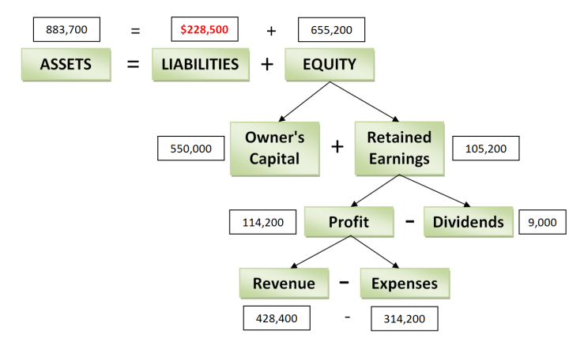
CYU2-7
Revenues - Expenses = Profit
Revenue - 428,000 = $61,000
Revenues = $489,000
Retained earnings = opening retained earnings + profit - dividends
Retained earnings = 0 + 61,000 - 12,000
Retained earnings = $49,000
Assets = Liabilities + Equity
$1,490,000 = 997,000 + Equity
Equity = 493,000

CYU2-7, continued
Equity = Retained Earnings + Owners' capital
$493,000 = $49,000 + Owners' Capital
Owners' Capital = $444,000
You can also do this in a chart format. The black numbers are given, the red numbers are calculated.
Assets beg | 0 | (new business)
Liabilities beg | 0 | (new business)
Equity beg | 0 | (new business)
Revenues | 489,000
Expenses | 428,000
Profit | 61,000 | Dividends | 12,000
 |  | R/E | 49,000
Assets end | 1,490,000
Liabilities end | 997,000
Equity end | 493,000 | R/E | 49,000
 |  | Owner's  Capital | 444,000

CYU2-8
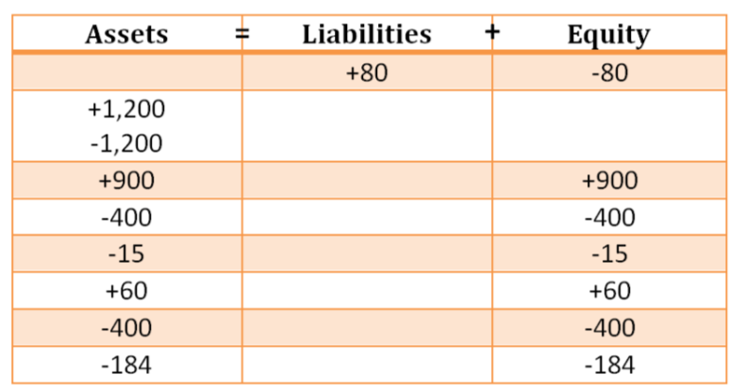
CYU2-8, continued
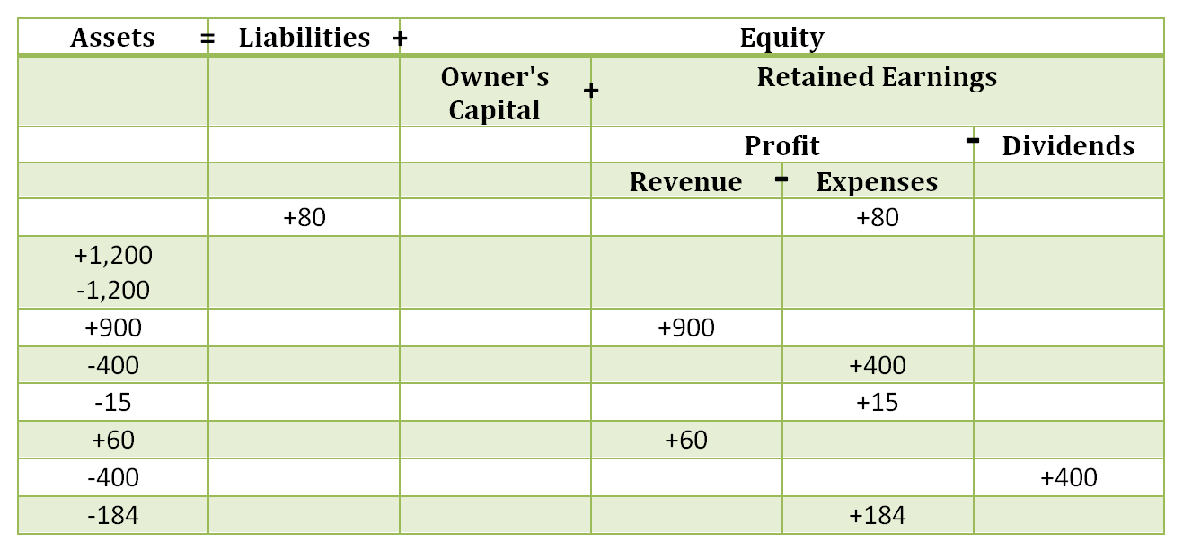

Solutions - Practice Questions
PQ2-1
The wealth of a business is calculated as assets minus liabilities. This is called equity in the basic accounting equation. There is no effect on wealth from buying office supplies. Office supplies are an asset because they are owned, they will benefit the business in the future and are due to a past transaction. If they are purchased for cash then assets go up (office supplies) and assets go down (the asset cash is gone). If they are purchased on credit then assets go up (office supplies) and liabilities go up because the business owes the credit card company at some point in the future and it is due to a past transaction.
PQ2-2
Revenue - Expenses = Profit so 41,200 - 32,450 = 8,750
Retained earnings = Profit - Dividends, so 8,750 - 2,000 = 6,750
Equity = Owner's capital + Retained earnings, so 12,000 + 6,750 = 18,750
PQ2-3
The secondary business sector takes raw materials and produces finished products. Some industries involved in that would be car manufacturers or construction. NOTE: students many list many other industries that would be applicable.
PQ2-4 Legend: A = assets, L = liabilities, E = equity, R = revenue, X = expenses
Description | Amount | Element
Equipment rental costs | $850 | X
Container full of gas | $32 | A
Cell phone costs (business) | $30 | X
Cash in bank (business) | $1,025 | A
Cell phone costs (personal)* | $120 | N/A
Customer payments | $1,850 | R
Cash in bank (personal)* | $754 | N/A
Advertising costs | $75 | X
Money you put in to start the business | $150 | E
New video games purchased* | $296 | N/A
Gas costs (used) | $138 | X
Money borrowed from parents to start business. | $150 | L
*Not categorized as they are personal expenses. Therefore, they must be ignored due to the separate entity assumption which says that business must be kept separate from the owners.
Profit = Revenue - Expenses, so 1,850 – (850 + 30 + 75 + 138) = 757
Retained earnings = Profit - Dividends, so 757 - 0 = 757
Equity = Owner's Capital + Retained earnings, so 150 + 757 = 907
Accounting equation: Assets = Liabilities + Equity, so (32 + 1,025) = (150 + 907)
After paying off the loan the company would have 875 (1025 - 150)
If the business ended today the full amount of equity, $907, would not be paid out in cash. This is because assets are made up of cash ($1,025 - $150) and a container of gas ($32). If the business ended today the owner would receive $875 plus the container of gas, which could then be used for personal purposes.
PQ2-5
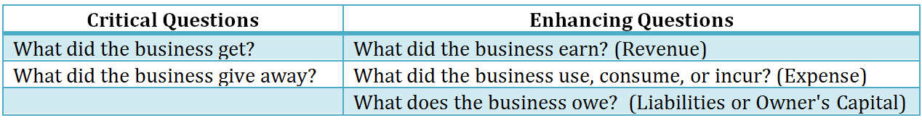
PQ2-6
1. You invest $750 of your own cash into a business.
What did the business get? Cash of $750, which is an asset because it is owned, has future benefit for the business and is due to a past transaction.
What did the business give away? Not clear.
What did the business earn? Nothing, as it has not done anything for its customers yet.
What did the business use, consume, or incur? Nothing was used or consumed to generate revenue yet so this does not apply.
What does the business owe? The business now owes Owner's Capital to the owner who invested in the business, $750 increase as it is owed by the business to the owner.

2. You borrowed $500 from your parents to help start the business.
What did the business get? Cash of $500, which is an asset because it is owned, has future benefit for the business and is due to a past transaction.
What did the business give away? Not clear.
What did the business earn? Nothing, as it has not done anything for its customers yet.
What did the business use, consume, or incur? Nothing was used or consumed to generate revenue yet so this does not apply.
What does the business owe? The business now owes a third party, your parents, cash in the future which is due to a past transaction. Liabilities increase by $500.

3. Using a credit card, you registered a business name with Service Ontario, $60.
What did the business get? A business name. Is it an asset? Yes, because having the name will help you run your business in the future, the name is now owned by the business and it is due to a past transaction. Assets increase by $60.
What did the business give away? Not clear!
What did the business earn? Nothing, as it has not done anything for its customers yet.
What did the business use, consume, or incur? Nothing was used or consumed to generate revenue yet so this does not apply.
What does the business owe? The business now owes a third party, the credit card company, cash in the future which is due to a past transaction. Liabilities increase by $60.

4. Purchased supplies that will be used in the future for $250 using a credit card. You will not have to pay off the credit card until next month.
What did the business get? Supplies. Are they an asset? Yes, because they will help you run your business in the future, they are owned by the business and it was due to a past transaction. Assets increase by $250.
What did the business give away? Not clear!
What did the business earn? Nothing, as it has not done anything for its customers yet.
What did the business use, consume, or incur? Nothing was used or consumed to generate revenue yet so this does not apply.
What does the business owe? The business now owes a third party, the credit card company, cash in the future which is due to a past transaction. Liabilities increase by $250.

5. Paid cash for 500 business cards from Staples for $50 plus HST.
What did the business get? Business cards. Are they an asset? Yes, because they will help you run your business in the future, they are owned by the business and it was due to a past transaction. Assets increase by $50 + HST of 13%.
What did the business give away? Cash to pay for the business cards. Cash is an asset (owned, future benefit, past transaction) but cash now decreases because cash was given to Staples.

6. Received cash from customers for services provided, $1,450.
What did the business get? Cash, which is an asset because it will help you run your business in the future, it is owned by the business and it was due to a past transaction. Assets increase by $1,450.
What did the business give away? A service...but what does that mean?
What did the business earn? The business earned $1,450 because it provided a service to its customers....the business did its jobs and completed them! Revenue increases by $1,450.

7. Used up half of the business cards during at the local Busker Fest in Mississauga.
What did the business get? They got advertising but is advertising an asset? Do we OWN advertising once it is sent out? No. Can we be sure about the benefit we will get from advertising? NO. Because it does not meet all three criteria of an asset we can't record advertising as an asset.
What did the business give away? We gave away our business cards, which are right now recorded as an asset. We have to reduce the asset for the amount that we no longer have because it no longer has future benefit and we don't own those business cards any more. Assets decrease by 50% of the asset we recorded in Item 5.
What did the business earn? Nothing, as it has not done anything for its customers yet.
What did the business use, consume, or incur? The business used up 50% of the business cards to help it generate revenue in the business so we record an expense of 50% of the cost of the business cards.

8. Paid yourself dividends of $300.
What did the business get? Nothing that I can see...so not clear, move on!
What did the business give away? Cash, which means the business no longer has the cash that was owned and had future benefit. Assets decrease by $300.
What did the business earn? Nothing, as it has not done anything for its customers yet.
What did the business use, consume, or incur? Nothing was used or consumed to generate revenue yet so this does not apply. (Dividends do not generate revenue so they are NEVER recorded as expenses!)
What does the business owe? Nothing as the dividends have already been paid so nothing is owed.

Our questions did not help us!! That is because dividends are an exception to the questions we have. Dividends are a distribution of the wealth we owe to the owners, and therefore do not fall under any of the above noted questions. Dividends are recorded as an increase in dividends and a reduction in equity through a reduction in retained earnings. To see the effect of dividends, be sure to check out the flowchart of the interrelationship between the elements.
PQ2-7
Assets | Liabilities | Equity
+750 |  | +750
+500 | +500
+60 | +60
+250 | +250
+56.50
-56.50
+1,450 |  | +1,450
-28.25 |  | -28.25
-300  = | + | -300
2,681.75 | 810 | 1,871.75

PQ2-8
Assets  = | Liabilities  + | Equity
 |  | Owner's Capital  + | Retained Earnings  -
 |  |  | Profit  - |  | Dividends
 |  |  | Revenue | Expenses
+750 |  | +750
+500 | +500
+60 | +60
+250 | +250
+56.50
-56.50
+1,450 |  |  | +1,450
-28.25 |  |  |  | +28.25
-300 |  |  |  |  | +300
= | + | + | - | -
2,681.75 | 810.00 | 750.00 | 1,450.00 | 28.25 | 300.00

PQ2-9
Full disclosure is violated because a list of employees is unlikely to affect the decisions of the external stakeholders and therefore should not be included in the report to external shareholders.

PQ2-10
Beginning Assets = Beginning Liabilities + Beginning Equity, so 31,800 + 24,900 = 56,700
Profit = Revenue - Expenses, so 97,700 - 91,250 = 6,450
Change in Retained earnings during the year = Profit - Dividends, so 6,450 - 0 = 6,450
Change in Equity = additional Owner's Capital + change in Retained earnings, so 1,600 + 6,450 = 8,050.
Opening Equity plus change in Equity = Ending Equity, so 24,900 + 8,050 = 32,950
Ending Assets = Ending Liabilities + Ending Equity, so 25,300 + 32,950 = 58,250
PQ2-11
Stakeholders are individuals or groups who either affect the business or are affected by the actions of the business. Students may choose different stakeholders but they must be able to determine if they are internal or external stakeholders and what the difference is.
Internal Stakeholders
Employee
Marketing manager
Company lawyer
Tax manager
Owners (sole proprietor)
External Stakeholders
Shareholders (of a corporation)
Governments
Customers
Suppliers
Creditors (banks)
Society/Community

PQ2-12
+
=
Assets | Liabilities | Equity
+7,500 |  | +7,500
+2,500 | +2,500
+60 | +60
+750 | +750
+1,300 |  | +1,300
-500 |  | -500
+15 | +15
+113 | +113
-100 |  | -100
-113 |  | -113
-15 |  | -15
-938 | -938
-300 |  | -300
10,272 | 2,500 | 7,772

What is the problem with using the basic accounting equation to provide stakeholders with information? (HINT: How much cash does the business have at the end of the period? Can you tell?)
The issue is that the summarized information stakeholders get from the basic accounting equation does not provide them with the details necessary to make decisions. For instance, it is not possible to determine the amount of cash on hand without doing manual calculations. We also do not know what the revenues or expenses are so we can't determine profit without manual calculations.

PQ2-13

Assets  = | Liabilities  + | Equity
 |  | Owner's Capital  + | Retained Earnings  -
 |  |  | Profit  - |  | Dividends
 |  |  | Revenue | Expenses
+5,000 |  | +5,000
+2,000 | +2,000
+60 | +60
+800 | +800
 | +2,825 |  |  | +2,825
+791 | +791
-791 |  |  |  | +791
-42 |  |  |  | +42
No Entry
+4,000 |  |  | +4,000
-4,476 | -4,476
-200 |  |  |  | +200
= | + | + | - | -
7,142 | 2,000 | 5,000 | 4,000 | 3,858 | 0

What is your financial position at the end of the period? (Financial position is represented by the accounting equation: assets, liabilities, equity.) Would you consider your financial position good? Why or why not?
Assets = Liabilities + Equity
7,142 = 2,000 + 5,142
It appears that my financial position is good since I do not have many liabilities. It is difficult to say if my financial position is good because I don't know, from this, what the makeup of my Assets and Equity is. I can only say that it appears to be good because my assets are high and my liabilities are low in relation to my assets.

How profitable was your business during the current month? Do you think you should continue with the business? Do you think the bridal show was worth the expense? (Hint: consider short term and long term.)
My profitability was poor as my revenues ($4,000.00) less my expenses ($3,858) results in a very low income ($142 over the last month).
My business is new and often businesses take 3 to 5 years to produce a profit. If you give up too early you have not given your business a chance to establish itself and start earning a profit based on the reputation of your service.
Was the Bridal Show worth it? Answers to this question may vary.
I think the Bridal Show was worth it over the long term if I get a good response rate from the people who attended the show. I need to track how many jobs I get from the people who met me at the Bridal Show and determine if, next year, it is worth it to attend.
What do you think might be some key success factors for a business like this? What factors could cause the business to fail?
NOTE: students may have different answers.
Key success factors: Quality of photos, price compared to other businesses offering bridal photography, my creativity with regards to the shots I take at the events and my ability to work well with all my customers.
Factors that may cause failure of the business: prices which are too high, don't do what my customers want me to do, inability to build relationships with my clients, poor quality photos.

PQ2-14
Students could choose any three of the qualitative characteristics. Note that the definition may use different words but the meaning must be similar and clear.
Quality: | Description:
Faithful | Truthful, meaning it is complete, free of error, and neutral (unbiased).
Relevant | Applicable or pertinent to your decision-making, helps you predict the future and/or confirm decisions you made in the past.
Comparable | Can compare the same business from year to year OR between two different businesses in the same industry.
Verifiable | Anyone looking at the information would determine similar amounts.
Timely | Information is provided quickly (as old information is less useful).
Understandable | Group and present information so it is clear and concise.

PQ2-15
Retained earnings end of period = retained earnings beginning + profit - dividends = 150,000 + 80,000 - 20,000 = 210,000
Equity end of period = owner's capital end of period + retained earnings end of period = 100,000 + 210,000 = 310,000
Assets end of period = liabilities end of period + equity end of period
520,000 = liabilities end of period + 310,000
Liabilities end of period = 210,000

PQ2-16
Profit = Revenue - Expenses, so 689,000 - 524,000 = 165,000
Equity beginning + Additional Owner's Capital + Profit - Dividends = Equity ending
125,000 + 0 + 165,000 - 80,000 = 210,000
Ending Assets = Ending Liabilities + Ending Equity
402,000 = Ending Liabilities + 210,000
Ending Liabilities = 192,000
Liabilities generally increase when the business makes purchases using credit or borrows money. Liabilities decrease when the business pays its debts, either to the credit card company or to the bank.
PQ2-17
Lenders are external stakeholders because they are outside the business (they don't work for the business). The main objectives of lenders as stakeholders in a business is whether they should lend money to the business, what amount to lend, and will the business be able to repay the principal and interest over the term of the loan.

PQ2-18
Assets  = | Liabilities  + | Equity
 |  | Owner's Capital  + | Retained Earnings  -
 |  |  | Profit  - |  | Dividends
 |  |  | Revenue | Expenses
+1,000 |  | +1,000
+1,000 | +1,000
+60 | +60
No Entry
+226 | +226
+113 | +113
+565 | +565
No Entry
+113 | +113
-113 |  |  |  | +113
No Entry
+60 | +60
+2,350 |  |  | +2,350
-339 |  |  |  | +339
-6 |  |  |  | +6
-152 |  |  |  | +152
-40 |  |  |  | +40
-1,137 | -1,137
= | + | + | - | -
3,700 | 1,000 | 1,000 | 2,350 | 650 | 0
How profitable was Kelly's business in February?
Revenue - Expenses = 2,350 - 650 = 1,700
If Kelly worked 5 days a week, 8 hours a day for a whole year, less 4 weeks’ vacation, what would her projected revenues be?
5 * 8 * 48 weeks * $25/hour = $48,000

Do a search for "cleaning lady" on Kijiji for Oakville and review the number of pages that are displayed. Can you think of any factors that might limit Kelly's business? What are some of the possible things Kelly could do to ensure her business is successful?
There are over 20 pages of cleaning services available but many of them are duplicates. Still, it does indicate that there is a lot of competition for customers.
Answers for the remainder of this question may vary.
Factors that might limit Kelly's business is if she does not provide the quality of services she promises and if competitors offer lower prices for similar or better services.
To ensure her business is successful Kelly could build relationships with her customers and make sure that her services are excellent. If she does this, lower prices by her competitors are less likely to negatively affect her business.

References
¹ Direct Marketing, DMA: Direct mail response rates beat digital, downloaded from http://www.dmnews.com/direct-mail/dma-direct-mail-response-rates-beat-digital/article/245780/ on August 18, 2015.
² Business Name Registration in Ontario, watched at https://www.youtube.com/watch?v=jH4zUwHuWoQ#t=117
³ Service Ontario at https://www.appmybizaccount.gov.on.ca/sodp/portal/osb/!ut/p/b0/04_Sj9CPykssy0xPLMnMz0vMAfIjCxLTU3My87Kt8ouT9Aryi0oSc_QKSpNyMpP1MvJzU_ULsh0VAfzzwt0!/ and click on "Search, register, renew your business and get a Master Business License"
⁴ Form T2125, Statement of Business or Professional Activities , downloaded from the Canada Revenue Agency, http://www.cra-arc.gc.ca/E/pbg/tf/t2125/README.html

