Week 3 – maintenance & reliability
Ontario Power generation:
- Nuclear power plant based in Pickering
- Required inspection every 10 years
- Powers 13% of province electricity
- 40,000 tasks related to inspection
Reliability: probability of machine or component will function properly for a specified amount of time.
- Used in % units
- Improving individual components
Maintenance:
- Set of activities involved with keeping system equipment in working order
- Increasing repair capability or speed
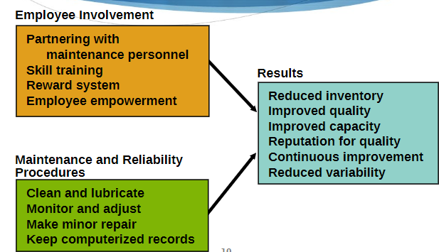
Maintenance management:

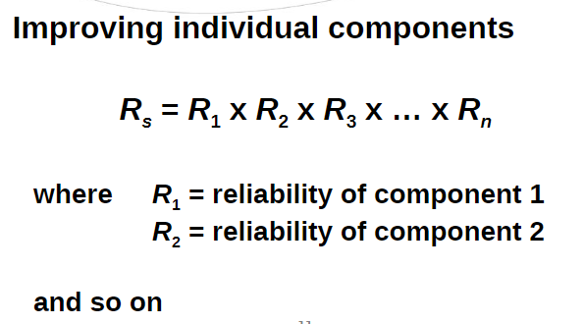
Reliability:
Ex: 99% reliability of 10 components
= 0.99¹⁰
= 90.43%
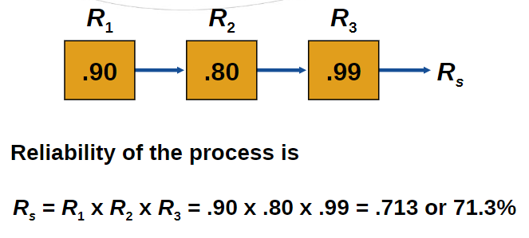

Product failure rate:
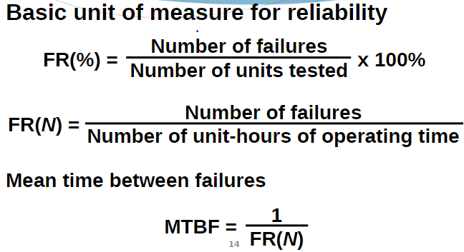

Redundancy:
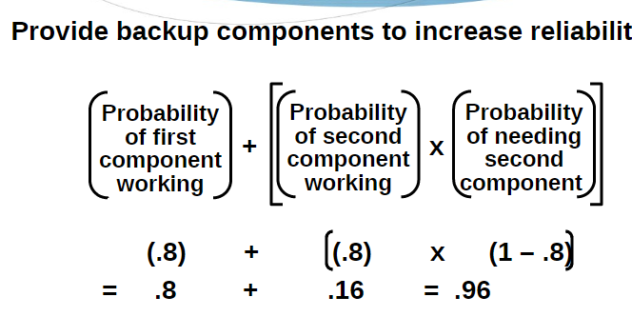
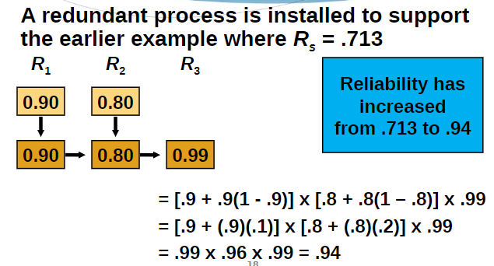
Maintenance:
- Preventive maintenance: routine inspection to keep facilities in good repair
- Breakdown maintenance: emergency or priority repairs on failed equipment
- High initial failure rates are known as infant mortality
- Maintenance failures cost inventory, morale and schedules
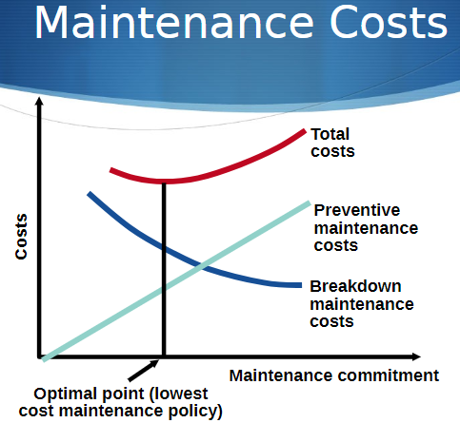

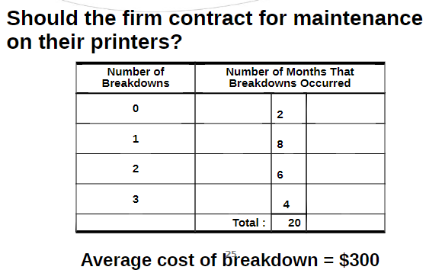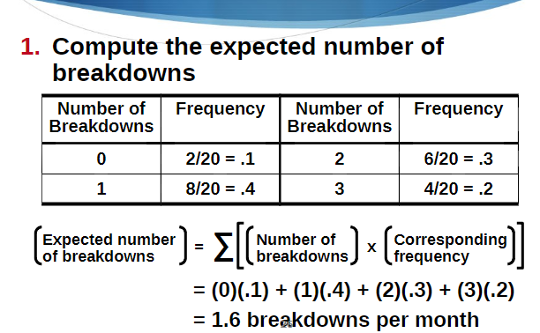
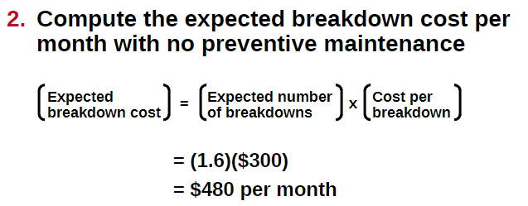
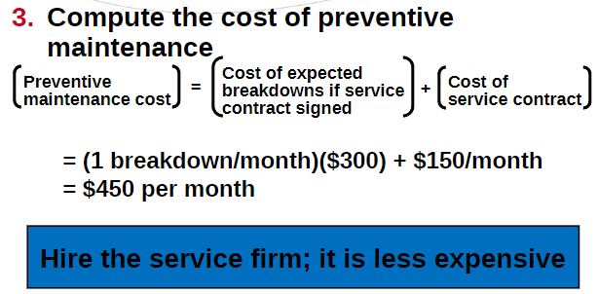
Increasing repair capabilities:
- Well trained personel
- Adequate resources
- Ability to establish repair plan
- Ability to do material planning
- Identify cause of breakdown
- Ability to design ways to extend MTBF
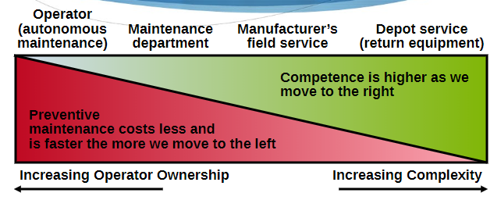
how maintenance is performed:
Total productive maintenance:
- Designing machines that are easy to operate and more reliable.
- Emphasizing total cost of ownership so that service/maintenance costs included.

Techniques enhancing maintenance:
- Simulations
- Expert systems: computers help find problems and suggest best solution
- Automated sensors: warn when machine is about to fail. Goal is to prevent failure and fix it before it fails.

