QMS 102 CRIB SHEET – TEST 1 FALL 2017 (FRONT)
www.EasyGradeTutorials.com

MEASUREMENT SCALES:

Nominal
Qualitative (Categorical data)

Quantitative (Numerical data)
Continuous/Discrete
Ordinal
Interval
Ratio

Nominal Data:
- No particular order or ranking to these categories
- Examples: marital status, sports, eye color, car brands, sports etc.
Ordinal Data:
- Natural order to category (one category is higher/better than another)
- Examples: letter grades, professional ranking, Olympic games medals etc.
Interval Data:
- Has units of measurement
- Quantitative/ must be numeric
- Can either be discrete or continuous
- The value of “0” does not mean there’s no amount of the characteristic being measured
- Examples: temperature, calendar dates etc.
Ratio Data:
- “0” means the absence of the characteristic i.e. 0= nothing
- May also be continuous or discrete
- Examples of discrete ratio: vacations taken in the past 10 years, number of DVDs you own, number of employees in a company etc.
- Examples of continuous: house sizes, gas prices, distance etc.

NOTE
- Continuous is measured (ex: height, distance etc.)
- Discrete is counted (ex: number of students, vacations in a year etc.)

STEM & LEAF
Stem rules | Leaf Rules
- Stem number should be between 6 and 13  - Consecutive numbers, or repeated numbers (may be repeated twice of 5 times)  - Must indicate stem units if not to be taken at face value  - Must be at least one leaf associated with first and last stems | - Each leaf value is the next single digit following the stem  - When stem repeated twice, 0-4 go for the first stem value, and 5-9 go to the second stem value  - No rounding off  - Ascending order  - No commas or dashes between numbers
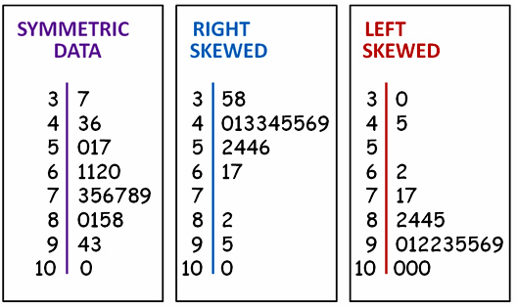
1- if mean < median, then skewness <0 (negatively skewed, skewed left)
2- if mean>median, then skewness>0 (positively skewed, skewed right)
3- if mean = median, then skewness=0 (symmetric).

QMS 102 CRIB SHEET – TEST 1 FALL 2017 (BACK)
www.EasyGradeTutorials.com

FREQUENCY DISTRIBUTION

- 5 to 10 classes
- Use notations (ex. and under)
- Close ended classes (lower and upper limits)
- Class width = Upper boundary- lower boundary (use “nice numbers”)
- “Nice Numbers” are 1, 2, 2.5 & 5 (multiplied/divided by 10 as needed)

Estimated class width = Highest value – Lowest value

Min number of classes recommended (which is 5)
**Imp for frequency distribution:

Weight (kgs) | Freq (F) | Relative Freq (RF) | Cumulative Freq  (CF) | Cumulative Relative Frequency (CRF) | Cumulative percentage  (C%)
20 and under 25 | 4 | 4/30= 0.133 | 4 | 4/30=0.133 | 0.133*100=13.3%
25 and under 30 | 13 | 13/30= 0.433 | 4+13= 17 | 17/30=0.566 | 0.56*100= 56.7%
30 and under 35 | 7 | 7/30= 0.233 | 17+7= 24 | 24/30=
35 and under 40 | 4 | 4/30= | 24+4= 28 | 28/30=
40 and under 45 | 1 | 1/30= | 28+1= 29 | 29/30=
45 and under 50 | 0 | 0/30= | 29+0= 29 | 29/30=
50 and under 55 | 1 | 1/30= | 29+1= 30 | 30/30=
Total: 30

Box-Whisker Plot:

To construct a box-whisker plot, we need 5 numbers:
- Minimum value
At least $≥$
At most $≤$
More that, greater than >
Less than <

- First quartile (Q1)
- Median (Q2)
- Third quartile (Q3)
- Maximum value

FENCES FORMULAS:

- IRF = Q3 + (1.5*IQR)
- ROF = RIF + (1.5*IQR)
- LIF = Q1 - (1.5*IQR)
- LOF = LIF - (1.5*IQR)

Suspect outliers: data values that lie between the inner and outer fences denoted as “o”
Outliers: data values that lie outside the outer fences denoted as “*”

*ADD ADDITIONAL NOTES BELOW:

Percentiles:
Rank= Half Round= $(n\left(\frac{k}{100}\right)+\left(\frac{1}{2}\right))$; where n is sample size, and k is the percentage

Half Round rules:

Round (2.3)=2.5
Round (4.8)=5
Round (6.7)=6.5

**Round .25 & .75 DOWN if k<50
**Round .25 & .75 UP if k>50

