Foundations of Biology: The cell
  - September 21st, Chapter

The cell

Cells are the simplest collection of matter that can live. Bacteria and archaea are prokaryotic cells. All other forms of life are composed of eukaryotic cells. Eukaryote means ‘true nucleus’ i.e. the membrane is contained in the nucleus(?). Eukaryotes are larger and show much more complexity than Prokaryotes. The cell must indulge in all manners of stimulus, and gas exchange, etc.… Therefore, cells must be large enough to be able to house, reproduce and such, but they also must be small enough to survive in the environment. Cell volume increases at a large rate than its surface area.

Question: Why are cells so small
Answer: The surface area to volume ratio. The surface area increases at a slower rate than the volume.

The smallest cells are the mycoplasma. They are mollicutes, which is a type of bacteria that has an absence of cell wall around the plasma membrane. So, they are very sensitive, therefore they connect ot a host. Which makes the, commensal. Genus Mycoplasma, no DNA homology with known bacteria. They have low guanine, cytosine content. And they exhibit no reversion to walled forms. And they are capable of self replication

Prokaryotic Cells

Prokaryotes are like eukaryotes in that they both have plasma membranes, they all contain DNA and ribosomes. The big difference is the absence of a internal membrane bound structure in Prokaryote. Prokaryote are also not surround by nuclear membrane. The membrane itself may be surround by a chemically complex cell wall. This cell wall is made from polysaccharides. The cell wall can be used for classifying the bacteria by the ‘gram-stain’. There are two types of these gram-stains. Gram-positive have simple walls, with a huge amount of peptidoglycan. Whereas gram-negative bacteria have less peptidoglycan and an outer membrane. Some prokaryotes have capsules surround the cell wall, this capsules traps water to prevent them from drowning and protect them from the outside world.

We associate bacteria with ill-health, however the thing is that <1% of bacteria cause any sickness in humans. Antibiotics work in one of these two walls
- To kill the bacteria - Bactericidal
- Cessation of bacterial growth (Stop from growing) – Bacteriostatic, which allows your immune system to catch up
Some bacteria are classified as ‘superbugs’ which is when they’re chemically resistant.

Sept 24th

Review

Prokaryotes have:
- Cell wall (micro plasma for example don’t have cell wall, so only some prokaryotes do)
- Capsule (some have it)

Cyanobacteria are amongst the first groups of bacteria to evolve. They obtain their energy through photosynthesis. Oxygen produced as a by-product accumulated. Oxidizing character of earth atmosphere increased.

Eukaryotes

When we look across eukaryotes we notice they’re more diverse than prokaryotes, and they have a greater functional complexity. They have huge number of internal membranes, which means they’re partitioned in functional compartments. Each compartment represents a discrete set of functions the cell needs to carry out. The 4 main functions are:
- Genetic control of the cell
- Manufacture, distribution, and breakdown of molecules
- Energy processing
- Structural support, movement and communication

Information in the cell is transferred in a strand of DNA. These information transfers occur in discrete regions of the cell.

In animal cells we have something call the centrosome which houses the “MTOC”. When you look at the MTOC in animal cells we can see that there are two centrioles, these two centrioles are not in plants.

Plant cells have a rigid cell wall, they have chloroplast which converts sunlight into energy, and also the central vacuole, it contains lots of water, and sometimes it also contains toxins. We also have plasmodesmata, which are channels between neighbouring cells that allowing communication/transportation (of molecules).

The nucleus contains most of the cell’s DNA. One important thins is that the DNA is a bunch of proteins, and the combination of the DNA and proteins is something called chromatin. Theses are a type of protein called histones. The nucleus makes messenger RNA (mRNA) which directs protein synthesis. It is surrounded by the nuclear envelope which is a double membrane (each a lipid bilayer), and it is perforated by pores. The ‘Nuclear Lamina’ which holds the shape of the nucleus. The ‘Nuclear Matrix’ which is a meshwork of proteins, it has many roles such as regulating gene transcription, and many more. The mRNA directs the ribosomes which are responsible for the protein’s synthesis. The ribosomes are needed for joining together the amino acids, the mRNA delivers the instructions on how to do this. The ribosomes are a mix of proteins and ribosomal RNA (rRNA), which is produced in the nucleolus. The nucleolus is the dark spot in the nucleus. The proteins and the rRNA assemble into a small unit that then exits the nucleus and assemble into a ribosome. Free ribosomes are the ones that are ‘suspended’. They’re typically involved in making proteins that function within the cytoplasm. Bound ribosomes are attached to the endoplasmic reticulum (ER) associated with the nuclear envelope and associated with proteins packed in certain organelles or exported from the cell. The endomembrane system is involved in the manufacture, distribution and transportation of macromolecules. The endoplasmic reticulum has two parts, smooth and rough. These two differ in structure and function. The smooth ER lacks any ribosomes, it is not involved in protein synthesis, instead it detoxifies drugs, alcohol and other harmful substances. And helps store calcium ions. The rough ER is called so because it has ribosomes. So it is involved in producing proteins that a destined for secretion, when it is finished this process it ‘buds them off’ like how weed buds can come off the leaf once they’re ripe. The Golgi apparatus serves as a molecular warehouse, products travel in transport vesicles form the ER to the Golgi Apparatus. One side of the Golgi have a different molecular composition than the other side. We think of the Golgi as this; one side is called the ‘cis face’ which always receives the product and the ‘trans face’ is the shipping dock. The products are then modified as they go from one side to the other.

Question: How do the transport pieces know where to put the products.
Answer: If a vesicle is coated with certain proteins, it will be taken to protein X. They are coated in sort of postal codes.

A lysosome is a membranous sac containing digestive enzymes. The enzymes and membrane are produced by the ER and transferred to the Golgi apparatus for processing. For example, if you’re an amibo, and you’ve digested acquired some food. The lysosome will fuse with this food and it will break it down into parts, so it can be sent to the proper parts. The membrane serves to safely isolate these potent enzymes from the rest of the cell. Our neurons are around 20 years old. The organs within these neurons are only a few weeks old, the organelles get ‘washed’ and renewed.

Vacuoles have a large range of functions. They mostly consist of water, organic, and inorganic compounds. They may have digestive function, they many contain toxins, and so on… Some protist have contractile vacuoles which help eliminate water from the protist.

The endomembrane system relies upon transport vesicles to successfully trafficking from one destination to another. To facilitate this transport vesicles are coated with specific proteins that designate their origin and destination.

Sept 26.

Review:

Endomembrane – compartments
The big overriding function is Genetic control which brings us to the nucleus, which has a double membrane system, the nucleus holds the DNA, the ribosomes does the transportation of the DNA.

The Endoplasmic Reticulum (ER) has a smooth ER which is responsible for lipids. And it also has a rough ER, which is responsible for creating Proteins. These lipids & proteins then get transported to the Golgi, and from there they get sent to their individual locations within the cell.

The mitochondria convert the chemical energy of food. Inside the membrane we find the mitochondrial matrix. This matrix contains Mitochondrial DNA, ribosomes, and many enzymes that catalyze some of the reactions of cellular respiration. Two mitochondria will often fuse to form one mitochondria, and sometimes this fused bond will be broken and they will divide. This happens for reasons unknown.
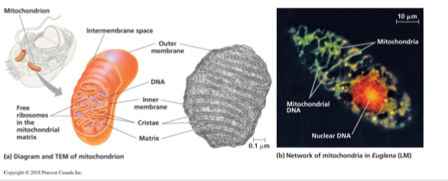

Plant cells also have mitochondria cells. Chloroplasts help plants create their own food because they are responsible for the synthesis. Chloroplast also have an outer and inner membrane, and between these two layers is a thin membrane space. The inner membrane is stroma and it contains chloroplast DNA, ribosomes, enzymes, a network of interconnected sacs called thylakoids, and each stack is called a granum. Mitochondrial and chloroplast were once their own living organisms, but with time they changed into dependant organisms.

Peroxisomes are specialized metabolic compartments bounded by a single membrane. It is unknown how they are related to other organelles. Some suggest they may be endosymbionts. A cell can produce peroxisomes through the endomembrane system. Their functions are
- Break fatty acid chains into smaller molecules which are then transported to mitochondria for fuel.
- Contain enzymes that transfer hydrogen to oxygen, which then generates water.

Microtubules are made of tubulin. They give the cell rigidity and act as tracks for organelle movement. The cell is full of the scaffolding of proteins, we refer to this as the cytoskeleton. This skeleton is constantly being built up and broken down.

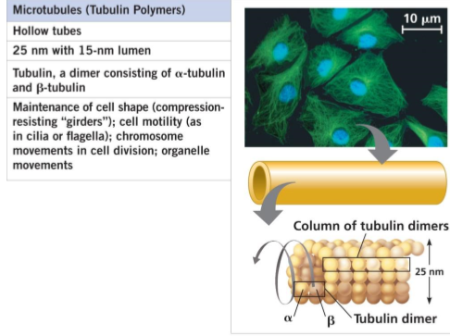

Microfilaments support the cells shape and are involved in mobility of the cell. They are produced from actin filaments.
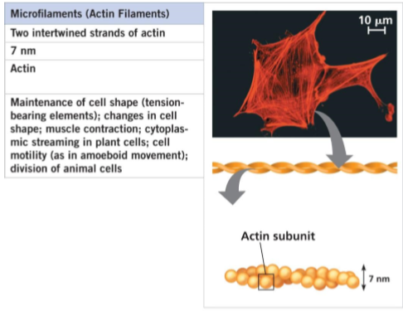
For more information on structural support, movement & communication view this video: https://www.youtube.com/watch?v=Hz0VlUVjYfI

Intermediate filaments reinforce cell shape and anchor organelles. These together with the other bit of the cytoskeleton help to do this reinforcing.
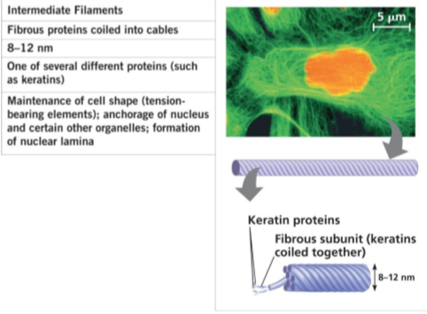

A flagellum longer than cilium propels a cell by an undulation, whip-like motion. Cilia work more like the oars of a crew boat. Although differences exist, flagella and cilia have common structure and mechanism of movement.

Some cell functions found in animal tissue:
- Tight junctions: prevent leakage or extracellular fluid across a layer of epithelial cells
- Anchoring Junctions: Flexible like junction which are anchored on plasma membrane
- Gap Junctions: are channels that allow molecules to flow between cells
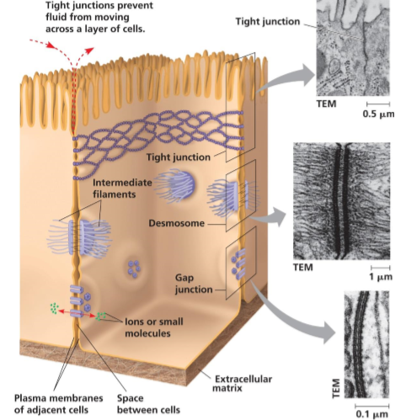

Some cell junctions found in plant tissues are
- Rigid cell wall: protects and provides skeletal support
- Plasmodesmata
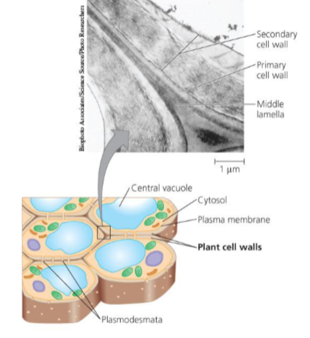

Animal cells synthesize and secrete an elaborate extracellular matric (ECM). Which helps hold cells together in tissues and protect/support the plasma membrane.

Sept 28th

Review:

Energy is what powers the cells to complete their functions. The mitochondria is the organelle that converts chemical energy into usable energy. Chloroplasts enable plants to make their own food. Endosymbiosis is that the mitochondria and chloroplasts were once free-living organisms, a long time ago these two got fused together and began a symbiotic relationship. They contain their own ribosomes, so they produce their own proteins. A plant cell cannot build a chloroplast, it arises from previous living chloroplasts. There’s one other component of energy, peroxisome. The peroxisome plays various roles, and they may also have undergone endosymbiosis. They cannot be produced by the cell, rather they arise from pre-existing ones.

When talking about support, the cytoskeleton is the meshwork of fibres. There are 3 types of these fibres.

Form and functions of the cell Membrane

Cystic fibrosis is the illness which affects lungs. Caused by a mutation in a gene which is for the protein cystic fibrosis transmembrane conductance regulator (CFTR). Which controls the thickness of the mucus in the lungs, normally you have one CFTR however if you have two then you develop CB. What happens is that the thicker than normal mucus incubates the bacteria which gets trapped in the lungs which then makes it difficult for the body to fight the bacteria.

Question: How long is the average lifespan of someone with CB
Answer: Around 38 years

Question: Is CB genetic
Answer: It is genetic yes

Question: How is it developed
Answer: You would think as we humans evolve, this would eventually disappear. However, it has not and prof. will explain why later in lecture.

Phospholipids, spontaneously self assemble. They are made mostly from unsaturated fatty acids, therefore they have kinds in them. Which prevents them from packing in too tightly. The fatty acids chains can be altered and changed based on the conditions in their surroundings.

The relationship between proteins is described by ‘fluid mosaic’. This relation is described by the relationship below:
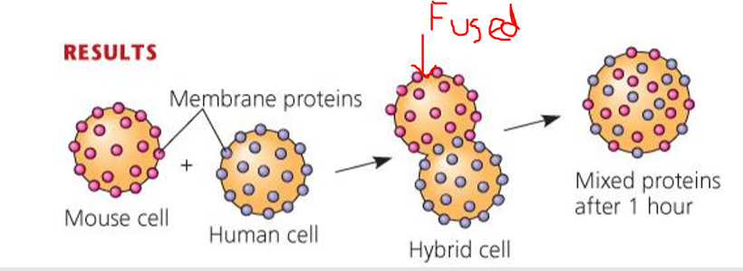
As can be seen the hybrid cell became fused into one and the mouse and human cells began to mix and move randomly.

Phospholipids in plasma membrane can move within bilayer. Most lipids and some proteins drift laterally. Sometimes the phospholipids flip-flop transversely.

Question: if you’re immune to HIV, do you have any other problems
Answer: It doesn’t seem so, no. CCR5 does not cause any issues.

Small molecules and ions move across the membrane in both directions:
- Sugars, amino acids, and nutrients must enter
- Metabolic waste products must leave
- O₂ is taken in for respiration; CO₂ is expelled
- Ion concentrations must be regulated
Selective permeability of a membrane depends upon lipid bilayer barrier, and the specific transport proteins embedded within.

Diffusion is the tendency of particles to spread out over available space. Particles diffuse down their concertation gradient:
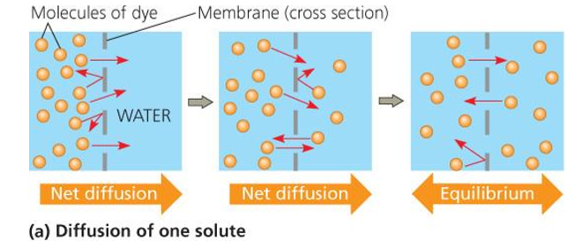

The concentration gradient itself represents potential energy for diffusion. E.g. O₂, CO₂

Molecules don’t have to small to passively diffuse. Steroids for example are large molecules capable of diffusion by dissolving in the bilayer.
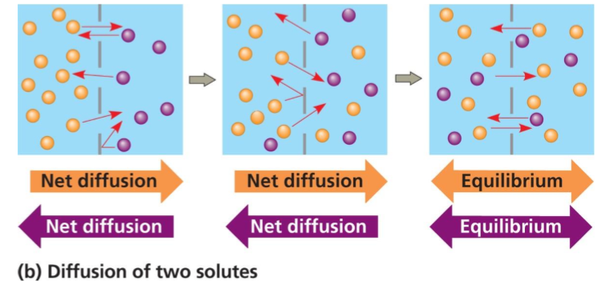

Tonicity is the ability of a cell to gain or lose water. It depends on the concentration of solutes of either side of the membrane. It’s this idea which is behind the idea of Gatorade. The story goes that the football coach notices that his team was sweating too much during their games, which means their losing electrolytes and water. So, he wanted something that would replace these two items. If you drop a cell in a hypertonic solution (tonicity is lower) the free water molecules move into the cell, and they’re going to draw the water molecules out and cause the cell to shrivel up.

Membranes are full of embedded proteins. That are responsible for transporting things. This doesn’t require energy it relies on concentration gradient. This process is called facilitated diffusion.

Sometimes cells must expend energy. When this is the case, a cell must expend energy to move a solute against its concentration gradient. TO summarize diffusion requires no energy, it only relies on the concentration gradient.
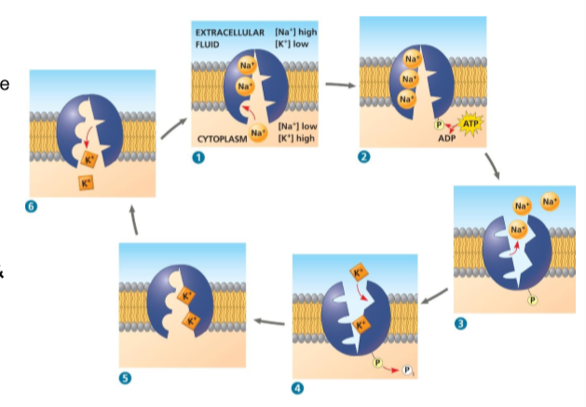

There is one other mode of transport, ‘co-transport’. Cotransport is when the active transport of a solute indirectly drives the transport of other solutes. Plants commonly use hydrogen ion gradient to drive active transport of nutrients.

Exocytosis is used to export bulky molecules such as proteins or polysaccharides. And Endocytosis are used to import substances useful to the livelihood of the cell. In both cases, the material to be transported is packaged within a vesicle. And Pinocytosis is when fluids are takin into small vesicles. Receptor-mediated endocytosis: uses receptors in a receptor coated pit to interact with a specific protein, initiating the formation of a vesicle. And lastly Phagocytosis: is the engulfment of a particle by wrapping cell membrane around it, forming a vacuole.

Oct. 1st

Review

Some proteins stay in one place, and some move in a directed manner. Fluid Mosaic refers to the liquids in the membrane, (the ‘fluid’ part of the name does). For a cell to carry out a function it must have a lot of diffusion, the import and export of items. And diffusion is caused by concentration gradient. Passive transport is the diffusion through the lipid transport. Facilitated diffusion is when the diffusion facilitated by the protein present. If you need to move something against its concentration gradient, we refer to this process as ‘Active Transport’ (ATP). Co-transport is described as secondary ATP. Fluid mosaic is the structure that facilitates the cell.

Cholera is an infection in the small intestine caused by Vibrio cholerae. It can lead to rapid dehydration, electrolyte imbalance and death.

V. cholerae produces toxins that interact with host CFTR, the exact same trans-membrane in cystic fibrosis. What happens it that it ends up pumping too much chloride ions into the small intensive, creating a salt-water environment. And your body can’t re-absorb it. Carriers of mutant CFTR genes benefited from resistance to cholera.

During the Bangladesh war of independence, many people got displaced, and ended up in refugee camps. 30% of these people contracted Cholera and a smart physician said stop using IV fluid to try and cure the illness (because it wasn’t working). He said, lets use re-hydration solutions instead, and this put a curb to the amount of people affected. In the absence of glucose, it will transport sodium. In the absence of sodium, it won’t transport glucose at all. However, if you have both present it will pump both glucose and sodium into the bodies.


