HLTA02 Lecture 1

Criticality

- Criticality can mean different things in different disciples

- To be critical in the context of the life sciences, including mathematics and statistics, means to challenge the one before – “how did you achieve that?”

- To be critical in the social sciences, it involves analytical thinking

- A critical social science perspective is rooted in social theory

- This perspective informs critical health studies and helps to consider the social and cultural construction of health and health care

Egocentric vs Sociocentric

- Egocentric (self, I) thought doesn’t consider the rights and needs of others, the point of view of others, the life experiences of others, etc.

- Sociocentric (social, more than one) doesn’t see the degree to which we have uncritically internalized dominant prejudices and stereotypes of our society or culture
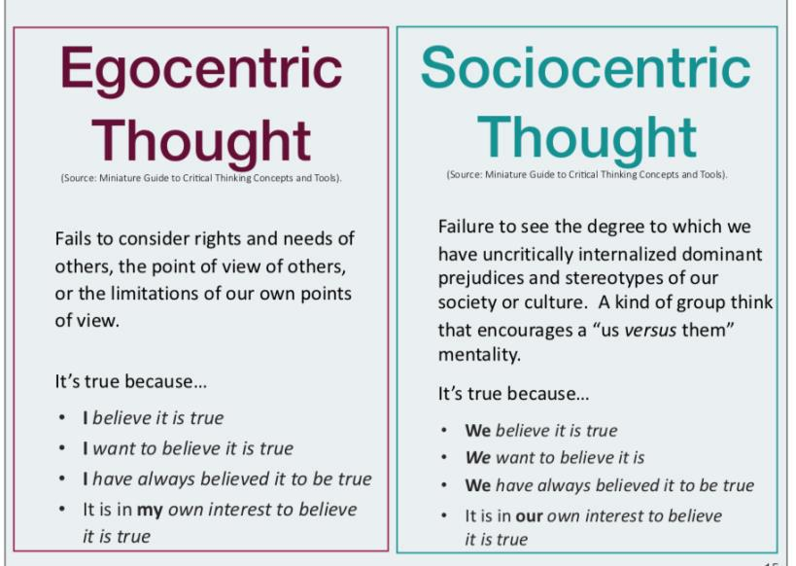

Attributes of a Critical Thinker

- A critical thinker is always interested in context, power dynamics, social relations (students & profs, mothers & fathers & their children) and commitment to fairness

- A critical thinker, in a social science perspective, demands some kind of knowledge and action
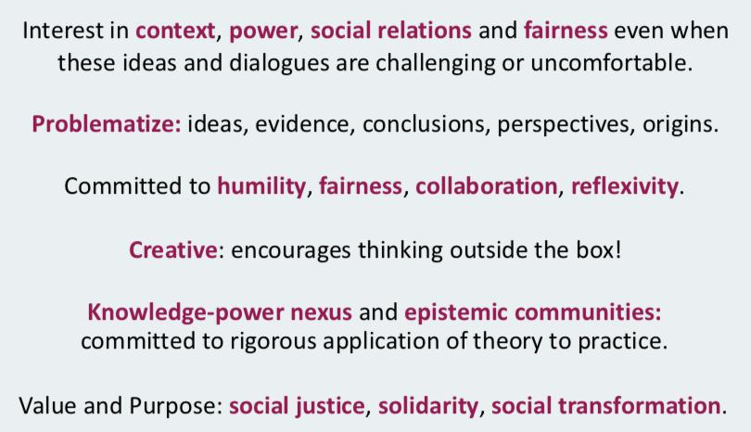

Epistemic Communities
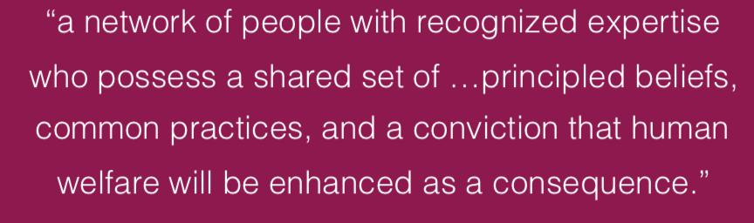

Health Sciences

- Health sciences are disciplines based around medicine, nursing, applicational therapy, speech pathology, etc

- There are also disciplines based around clinical specialties, such as paediatrics

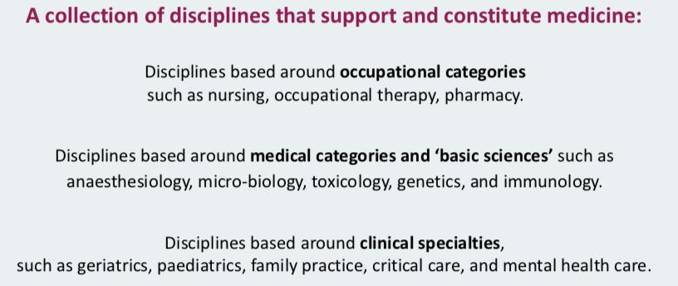

Health Studies

- Health studies is multi-dimensional and is concerned with all kinds of things such as health, illness, medicine, healthcare

- It considers cultural, social, political, historical

- It is multi-disciplinary, interdisciplinary and trans-disciplinary

- It is dependent on social sciences and humanities

- It recognizes that health is determined by many things and requires more than access to medicine or health care

- Mixed methods of research – both quantitative and qualitative
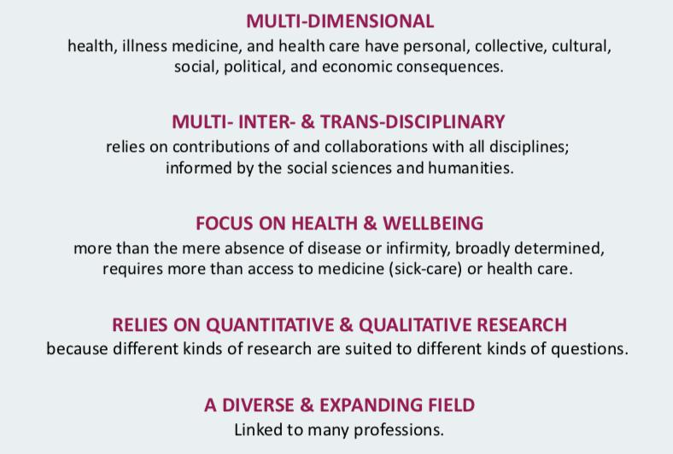

HLTA02 Lecture 2

- Health has many contested meanings such as the following:
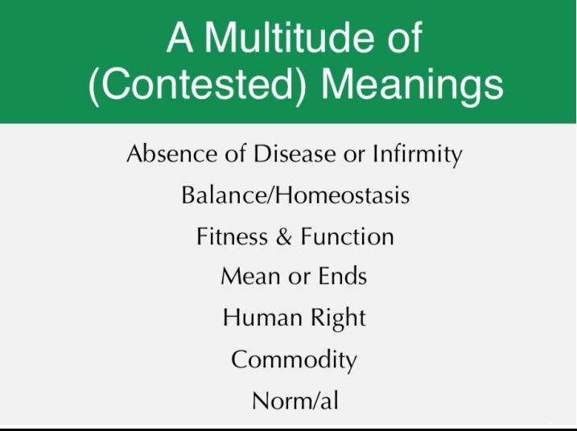

- There are three models of health!
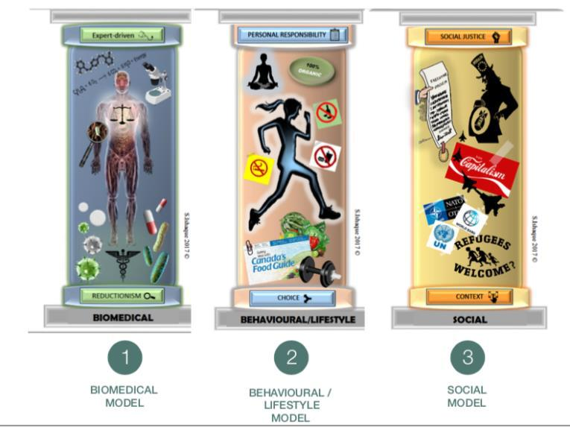

Biomedical Model

- Assumes a negative definition of health

- It assumes implicitly that health is the absence of disease

- It is deeply reductionist – it is essentially concerned with the way that organ X might affect a bodily system but for the most part it is very reductionist such that to identify disease, ill health, it does things like bloodwork, x-rays, it breaks the body down into mechanical parts that operate as a health. It reduces them down to a cellular, molecular level.
- Normal state ---^^ disease, trauma or health condition^^ ---- disabled state ---------- expert medical [ intervention ------- normal state

- Medicine is a deviation from a norm

- It adheres to something called the doctrine of specific aetiology which says that diseases have a singular cause.
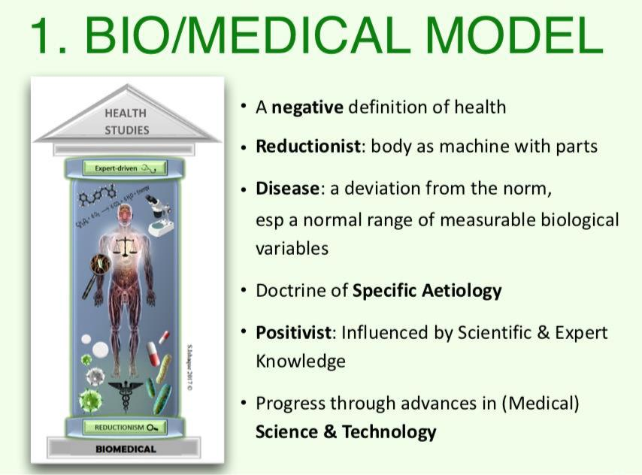

- Simplistic
- Med based definitions
- Focuses on the absence of disease
- Influenced by scientific or expert knowledge.
- Emphasizes personal and individual responsibility for health.

Iatrogenic Effects

- The concerns were largely at the time what they called the iatrogenic effects of medicine – the unintended consequences of this models use – Ivan Illych is an important writer in this regard. He argued that medicine robs us of our potential to cope and by doing things like medicalizing death, today in the west since the 20th century people used to die at home, since the emergence of western medicine, people now go to hospitals – death is fundamental to humans – but illych argued that we were robbing people from experiencing this human experience, death, and in so doing robbed us of our ability to cope with dying, death, sickness etc

Salutogenic Response: The salutogenic response proposed by Aaron Antonovsky who said that medicine always focuses on the disease, the sickness, the death, the dying. Health is about much more than death and disease. This idea that we needed to refocus on what causes disease but on what contributes to health, what facilitates health. In this school of models, there is an emphasis on relationship between health stress and coping.

Behavioural/Lifestyle Model

- Behavioural/lifestyle model

- It does not reject the biomedical model

- Rather they combine it from knowledge gained by psychology

- Health as fitness, wellness and that it is an individual choice

- The conceptualization of health are individual beliefs and behaviours, attitudes

- The model implicitly assumes that all of us are rational decision makers – this comes from economics – whose thoughts and cognitions inform our behaviour

- If we want to change, we must think differently

- We must make the choice to live well

- The focus therefore in terms of intervention is on changing individual thoughts and behaviours
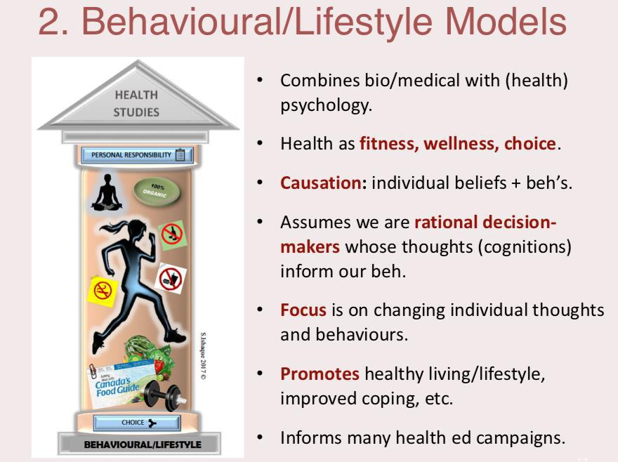

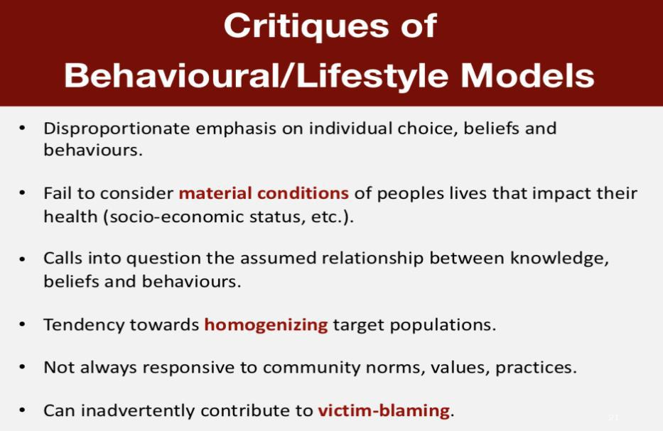

Social Model of Health

- The social models are referred to the societal models of health

- Concerned with the big picture and the embodiment of disease/health

- These models are typically aligned with human right approaches

- They see health, not just the mere absence of disease but it is more than, a positive definition, it advocates for improving both individual and public population health by not just addressing individual biology or altering individual behaviour – that that’s not going to fix health by doing more by addressing the social, political and so forth determinants that shaped your risk, exposure, etc
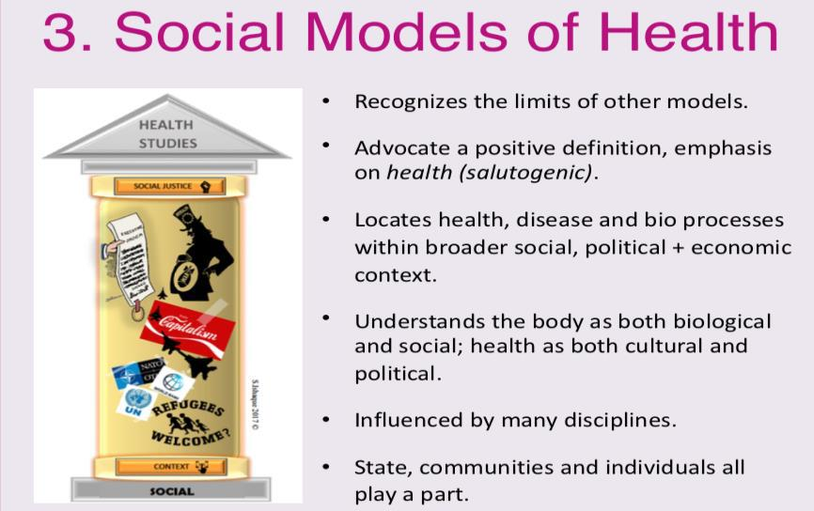

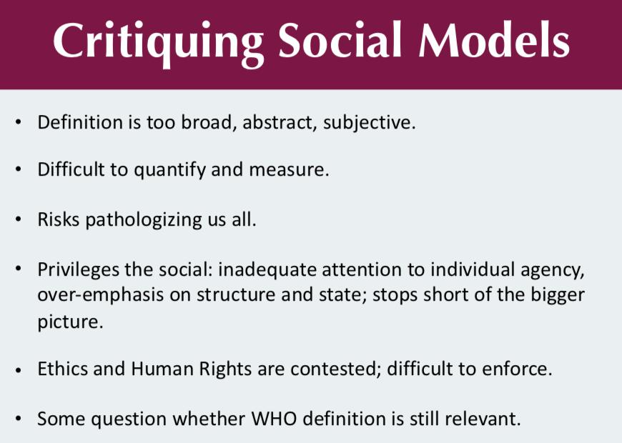

+

HLTA02 Lecture 3

Why Consider Health from a Historical Perspective?

- Help to us to explain why the world looks the way it does in terms of health, disease, etc. and what continues to shape it

Historical Analysis

- Two types of historical analysis:

- Social

- Materialist

Historical Materialism

- Proposed by Karl Marx

- He said there was a relationship between economic production, social institutions, and the everyday life of people

- He was concerned with the ways in which that power created a social stratification or hierarchy (the ladder) some people doing better off in the top and the people at the bottom who are poor

- The problem with Marx or of historical materialism approach is that spends too much emphasis on class issues and disregards socioeconomic status, ageism, a whole spectrum of identities of populations that can put them into some kind of hierarchy

Health/Determinants: Ancient Understanding

- Hippocrates is the “father” of Western medicine

- Ancient Greek physician and philosopher

- Had a far-reaching impact on medicine today

- Hugely influential in thinking about epidemics, prognosis, outright rejected the notion of the supernatural shaping health or disease, believed there was nothing supernatural about it

- The Hippocrates Corpus wasn’t written by Hippocrates, but the contents are all informed by Hippocrates.

Lasting Contributions of Hippocrates

- He was the first documented chest surgeon

- He is the one who established the language of Western medicine: relapse, convalescence and so on

- He believed that it was necessary to look for natural causes and this idea of balance – the notion of balance is very central to his understanding of health

- Living well means living in balance

- He emphasizes moderation

Disease: Imbalance of “Humors”

- Before Hippocrates, the diseases were considered supernatural

- All of the sickness that we see today would be attributed to divine things

- Humourism or humoral theory was dominant

- Each tradition had different humours

- Idea is that disease is called by some kind of humours

- 4 humors: blood, phlegm, black bile, yellow bile

- if any of this is present in your body, source of sickness

Humorialism

- seasons which affect the humours which are in your body

- represented by cold, dry, water, fire, hot, air, wet

- all those things might be related to your environment

- macrocosm (universe) and microcosm (body)

- all of it is subject to the same natural laws

- compared of the same material

- disorder in one causes disease in the other

- interconnected system

- within humoral theory that there were 4 key organs, your spleen, your brain, your liver and your heart

Theories of Disease Causations in Ancient Western Medicine

- Galen, as well as everyone else, never did any human dissection

- But he has our first anatomical drawings of men’s and women’s bodies

- His ideas dominated and shaped Western medicine and surgery for a very long period of time

- He emphasized this idea of hygiene for prevention

- He believed that there were three kinds of phenomenon that determined health/disease

- Physiology – “Thynges Naturall” earth, air, fire, water

- Pathology – “Thynges Ageynst Nature” sickness, causes of sickness, accidents

- External to the body – “Non-Naturalls” example, air, motion/rest, sleep/waking, diet/evacuation, retention, passions

The Miasmatic Theory of Disease Causation

- Foul air, or miasma, was the cause of disease

- At this time, there was no sense that invisible things moved about us such as tiny microscopic things we couldn’t see that cause disease

- Prevalent until the 19th century

- Miasma foul air could generate spontaneously but pollution from rotting organic matter

Evolving Theories of Disease Causation

- Miasmatic Theory of Disease Causation was dominant, in terms of the explanation of disease, until the 19th century

- Many people started to challenge it

- Considered the father of the study of disease patterns, John Snow

- Germ Theory is what replaces it

- The idea that infectious diseases are caused by pathogens – very tiny microorganisms such as viruses and bacteria

- John Snow during his adult life time living in London, there was an outbreak of Cholera

John Snow Mapping Cholera in London

- He started to think that it is linked to the water

- He begins to document places and overlays that map with positions of water pumps and he discovers that there is a pattern

Bodies in (western) Medicine

- Historically we see something called Cartesian dualism – this idea in medicine means that there is a mind/body split.

- It is a mechanical, reductionist approach, parts are uniform and decontextualized

Men’s Bodies

- Men’s bodies were the anatomical standard

- The superior

- Dominated by the mind/reason

- Aristotle compared men’s body to the perfection and divinity of fire

- Compared to women, less attention given to male genitalia and reproduction

Women’s Bodies

- Cold and wet indicating the imperfection of their bodies

- Aristotle compares women’s bodies to the imperfection and the corporeality of the earth

- Galen emphasized sameness, that we were all the same

- Emphasis on the womb

The Corpse in Western Medicine

- before the 17th century death is not at all medicalized
- by mid 19th century death is under the control of the doctors

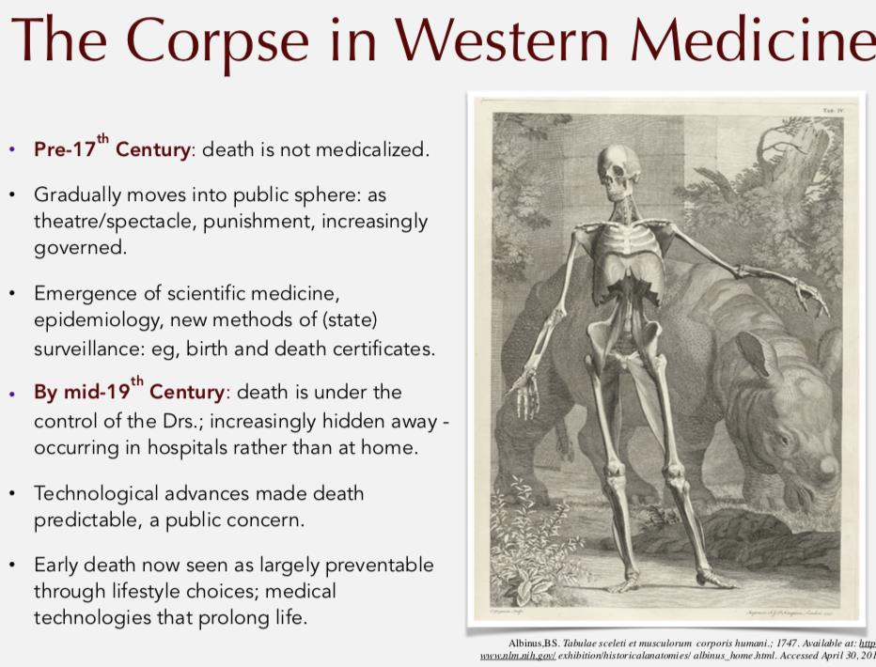

Lecture 4 HLTA02
Conceptualizing Threats to (Public) Health Part I: Ecology, Environments and Health

Lecture Notes

(From week 3: Conceptualizing Health Part II)
- Social models of health are popular (insufficient criticality) but we default to biomedical and behavioral/lifestyle models (simpler models)

Lay Perspectives
- Non-expert, public opinions
- Diverse and multi-faceted -> not naïve or unsophisticated
- Vary across time and space; across lifespan, genders, cultures, socio-economic status, communities, etc.
  - Nuanced definitions of health specific to culture, gender, etc.
- Lay perspectives are NOT privileged or prioritized in traditional biomedical models of health
  - E.g. A person cannot self-diagnose due to lack of expertise in medicine
- There is greater emphasis in social, behavior/lifestyle, psychosocial, and holistic models (discussed in text)

How does the young boy define health?
- (refer to lecture slide)

Voices of Multicultural Youth: Impact of urban neighborhood on health and well-being
- Published by Wellesley Institute
- Study used a qualitative design -> youths in high-risk communities describe pictures of their neighborhood
- Recognize how the youth provide nuanced, sophisticated and intelligent understanding health and well-being
- Such lay perspectives on health can radically change how public health programs are designed

Current Thinking About Health
- Technology is constantly changing our understanding of health/illness, health care, our relationship to our bodies, the way we live and die
  - E.g. Prosthesis, organ donation, new reproductive technologies, stem cell technologies, biomechanics
- “New Genetics” changing boundaries between ill/not ill
  - E.g. Screening and “disease in-waiting”
- Use of technologies for “enhancement” rather than for therapy raises new questions + boundaries of disease + patient-hood
- Technology has profound consequences when thinking about how health will be perceived in the future Models of Health
- Hereditary factors -> biomedical model
- Individual lifestyle factors -> behavioral/lifestyle model
- Social and community networks -> psychosocial (e.g. capitalism, colonialism)
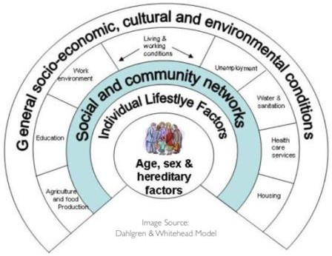
- Each model privileges health differently*

Threats to Health

Important Concepts
- Poverty: multi-dimensional phenomenon
  - a complex set of non-concrete deprivations -> more than just material deprivation
- two types of measuring poverty:
  - absolute poverty: absolute number of ppl living below a set defined threshold (USD$2/day); decreasing
  - relative poverty: gap that exists between the richest and the poorest; growing
- *learn to discern the distinction between terms
- Health inequality: disparities or differences in health status
  - E.g. People diagnosed with diabetes vs schizophrenia
- Health inequity: unjust differences in health status
  - E.g. ?

- Source of inequity lies in the body; not the presence of the fence?
- Does disability lie in diff types of bodies? Or social barriers against diff types of bodies?

- Minute Reflection
What do you think are the most significant threats to health today? What criteria inform your position?
  - How we define a priority in global health is shaped which model is used to define health
  - Focus on disease -> biomedical perspective, use of quantitative metric
  - Access to health care -> social perspective emphasizes structural roles

What/Who Determines What Constitutes a Threat?

Power and Ideology
“A school of thought or a shared set of beliefs or ideas. Ideologies exist in every society in the world. ‘The concept of ideology has a close connection with that of power, since ideological systems serve to legitimize the differential power held by groups. Power and Ideology are important in examining health because of the existence of widespread health inequalities.”
(Source: Warwick-Booth, Cross & Lowcock, 2013:303)
  - Ideology is closely related to difference in power held by groups
  - Diff societal structures (institutions, govt, etc.) have diff powers of status

  - Framing is done by decision makers, scientists, the media, etc.
    - Important in shaping how lay ppl conceptualize health issues -> cause of moral * (refer to text)
    - E.g. President Trump gave a speech at UN conference
Leaders of world are concerned with climate change; they believe collaboration of govts is the only way to begin solving issues related to climate change
    - Trump used an ideological frame that suits his financial, political interests and completely disregarded concerns with climate change
    - E.g. Vaccines are attributed to cause of autism in children -> media picked this up; the framing of this issue went way beyond scientific literacy -> in result, immunization rates plummeted
  - *How things get ideologically framed shapes what ppl see as a big threat to health

  - Definition of Health: diff models draw attention to diff kinds of problems + determinants; may obscure or neglect other priority issues
    - Biomedical model of health’s focus on cancer dismisses other societal structural causes of cancer
  - Levels of Determinant: focus on proximal/distal, biological/social…
o
  - Measurements Used: distribution, magnitude and severity of the threat
    - who and how many are affected, what outcomes, relative vs absolute, aggregate or disaggregate, etc.

Framing Threats to Health: The Role of Science & The Media
  - Scientific community: soundness of theory; quality of evidence; processes to vet/examine theory and evidence; communication of threats
  - Media: how the science is reported; what and who are prioritized in the re-telling; accuracy of the interpretation; how widespread is the coverage
    - Plays a huge part in shaping what gets taken up as a threat
  - Audience: scientific, statistical, methodological literacy; health literacy; timing and effective knowledge exchange and translation by experts; health literacy
  - *These frames collectively affect how ppl frame threats to health

Public Health Approaches to Conceptualizing Patterns/Threats

or DT (Notestein)
1. Demographic Transition
  - Demography: the study of human populations
  - Demographic transition (DT): a framework to describe and understand population change (1960s-1980s), patterns in the changes in birth and death rates

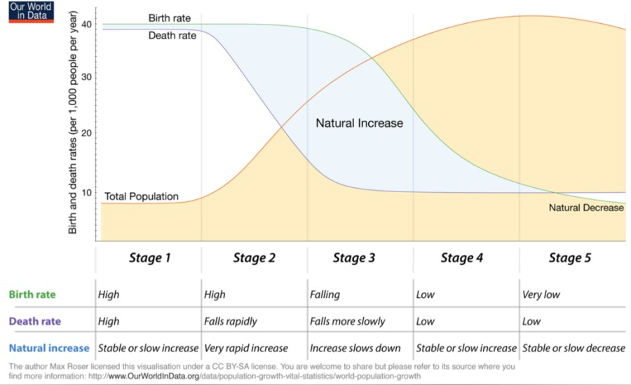

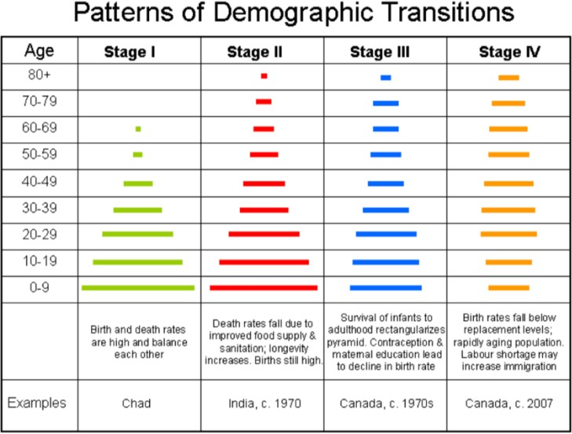
  - Study tip: how to read “population pyramids”
Argument -> as countries develop (rural to urban), they move from:

Stage 1: high birth & death rates (stable pop)
→ stage 2,3: period of rapid growth (high birth & low death rates)
→ stage 4,5: period of stable pop, low growth rate (low birth & death rates)

Based on historic patterns and trends in high- income countries of Europe, North America, Australia

Graph is also used for epidemiological transition

2. Epidemiological Transition

  - Epidemiology: “the study of the distribution and determinants of health-related states or events (including disease),
and the application of this study to the control of diseases and other health problems.” (Last, 2001)
    - It is not a study of changes in population
  - Epidemiological transition (ET) was proposed by Omran (1791), adapted by Wainwright (2009) et al.
  - Risk Transition (RT): shift from communicable to non-communicable disease as countries move from a developing to a developed economy
    - RT is the focus of epidemiological transition
  - Argument -> dramatic increase in pop growth rates related to advances in medicine and declining fertility rates
  - Conclusion -> increased life expectancy (LE), reduced fertility and RT is related to improvements in medicine and public health
    - E.g. Vaccines, improved sanitation, tech
  - Explains WHY patterns occur

Epidemiological Transition: Three Stages in Changing Patterns of Disease
- Age of Pestilence & Famine (Stage 1)
Typically, agrarian societies; economic under-development; high levels of illiteracy; low status of women; high mortality from communicable diseases and famine

- Age of Receding Pandemics (Stage 2)
Declines in mortality rate follow decrease in epidemics and famine; rapid decline in DR and consistently high BR

- Age of Degenerative & Man-Made Disease (Stage 4,5)
Fertility begins to decline as ppl live longer and die from NCD of affluence -> man-made diseases like CVD, cancer

Critiques of the Epidemiological Transition
  - Developmental stages are not necessarily sequential
    - Stages can overlap and be cyclical; transition is not uni-directional
  - Reversibility of changes in patterns of morbidity and mortality
    - Syphilis epidemic returned to UK for the second time despite availability of vaccines and other interventions
  - Changes are not always complete
    - diff diseases can co-exist in the same pop -> both CD and NCD
  - Reinforces stereotypes that ppl in developing countries only die of infectious diseases b/c they are less advanced
    - Neglection of chronic diseases in those countries
  - Doesn’t recognize inequities within societies and diffs in causes of death within pop
    - According to aggregate data, Canada is almost free from infectious diseases, but if we disaggregate the same data, TB rates remains high in Indigenous and other marginalized pops
    - There are hidden health inequities within Canada

  - Ebola outbreak in US -> risk to do business was too high, pulled out of US to save foreign works’ lives -> major effects on economy

3. McKeown Thesis
  - Retrospective study of Britain’s demographic transition focused on TB deaths
  - Findings -> immunization and medical therapies are the NOT primary cause of observed increased in life expectancy in Britain
  - Argument -> hypothesizes four factors that contributed to the decline in TB-related mortality during Britain’s
demographic transition:
- Improvements in nutrition and immunologic resistance
- Improvements in hygiene and the standard of living
- Increasing control of disease-causing microorganism
- Improvements in birth control

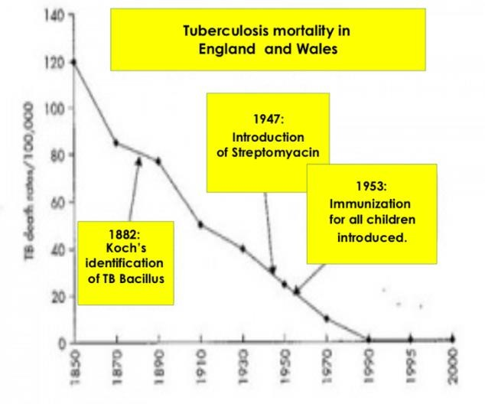
  - Massive decline in TB related deaths between 1850 to 1870 -> what are the causes attributed to this decline?

→ Koch identified TB Bacillus in 1882
  - Introduction streptomycin cannot be attributed to the fall because its development came after the increasing decline of TB deaths

  - Concluded that curative medicine was not the primary cause of decline in TB deaths

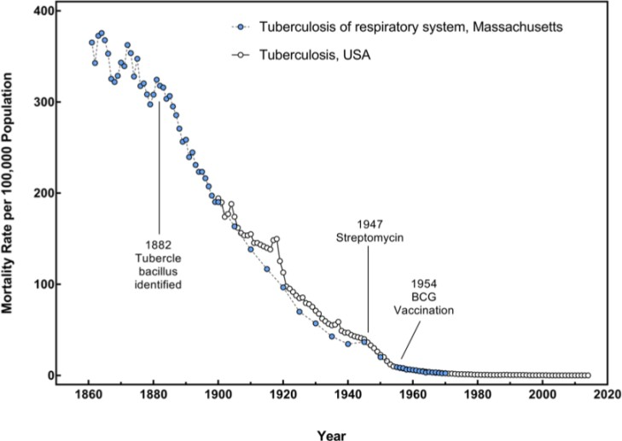

  - According to collected data, there are many other explanations for the demographic transition besides medical intervention to cure TB

Where Does This Leave us?
  - Patterns of disease outbreaks vary greatly from country-to-country and region-to-region
  - Many contribution factors, including economic and social development (upstream/distal factors), ideology, media, measurements, etc.
  - Certain conditions favor epidemics: poverty, conflict, catastrophes, displacement, patterns of migration, antibiotic access, use and resistance, etc

Lay Perspectives
- lay perspectives are non-expert opinions of the public.
- We tend to ignore lay perspectives as being naïve
- We thought people thought about there health back in the time of Hippocrates & John Snow is differing from what people think about there health these days.

Important concepts

- Poverty is a multidimensional phenomenon, a complex set of deprivations (with poverty can come isolation and stigma) more than material deprivation
- Health inequality- disparities in health status
- Health inequality – unjust differences
- Health inequality – differences in health
- Relative property - Gap between the richest and poor.

HLTA02 Lecture 5 Conceptualizing Threats to (Public) Health Part II: Ecology, Environments and Health

- Ecological Health – move from the subatomic level to the biosphere

- Planetary Health – newly emerging way of talking about health, fits with an ecological frame

- The ecological health framework extends to the sub-cellular level

- Through these mechanisms over time impact the individual at various levels at the organism from our organ systems down to cellular function

- Health geography views health in a holistic way or perspective that encompasses society and the focus being on the role of place, location, and geography

- The use of the word holistic (not talking about wellness and mindfulness, in this context, they are referring to holistic, all the things in the last slide

- Ecological fallacy is when we incorrectly presumptively conclude individuals based solely on the analysis of the group

- Food security or insecurity is that food according to the world food summit, definition regularly taken up in literature even if it is outdated, is when all people at all times have access to sufficient, safe, nutritious food to maintain a health and active life.

(From Week 4: Conceptualizing Threats to Health Part I)
- Social models of health are popular (insufficient criticality) but we default to biomedical and behavioral/lifestyle models (simpler models)

Proximal/Micro-determinants ----Causal Chain--→ Distal/Macro-determinants
?????

Hippocrates
“If you want to learn about the health of a population, look at the air they breathe, the water they drink, and the places
where they live.”
- Concerns about environmental threat to health have been around for a very long time

Anthropocene
- ANTHROPO (human) + CENE (describing “epoch” *pronounced ‘epic’ in geologic time)
- Paul Crutzen -> atmospheric chemist, Nobel laureate
- New period after or within the Holocene -> began approx. 10,000 years ago with the end of the last glacial period
o No need to memorize the geologic timeframe
- Earth’s most recent geologic period characterized by human-influence -> anthropogenic (human-caused)

effects
- Overwhelming evidence -> atmospheric, geologic, hydrologic, biospheres and other earth system processes altered by human activity

- This idea has become increasingly popular in the mainstream
- E.g. exhibition at AGO

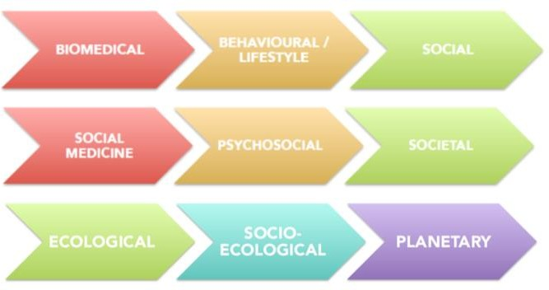
Different models of health focus on different threats to health

- focus of environmental threats to health involve three frameworks of health
- Ecological, socio-ecological, planetary

Ecological Models of Health
  - Ecology: study of interactions among organisms and their environment
    - Models date back to 1970s (Urie Bronfenbrenner)
  - Health = the ability of an organism to maintain balance with environment, relative freedom from pain and disability
  - Environments: chemical, biologic, physical, built, natural and socio-economic environments combine to create conditions that influence individual and pop health
    - Involves more than the natural environment*
  - All ecological models speak to complex web of causation
    - Complex Web of Causation -> more than specific etiology
    - Refer to pg. 32 of Warwick-Booth textbook
  - Emphasis on interaction and inter-relatedness
  - Nested (embedded) hierarchy: person → family → community → ecosystem → society → planetary levels

The Architecture of Life
  - There are connections between all these layers and ends
Subatomic particles → atoms → molecules → organelles → tissues → organs → organ systems → organism → pop →
community → ecosystem → biosphere

Homeostasis
  - Concept central to biology, physiology and taken up in ecological models of health, including planetary health
  - Balance -> maintaining stable (optimal) internal env
  - Human cells only function within very strict, narrow ranges
  - Balance: physiological mechanism enables cells to maintain optimal range; “reduce any change and return to the status quo”
  - The ecological health framework also extends to the sub-cellular level
  - Everything has an ecosystem that operates at a very particular way to maintain homeostasis

Example of Homeostasis
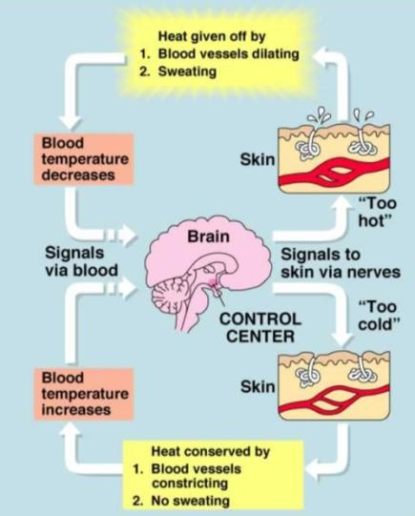
  - Thermoregulatory response: the process your body goes through when it reacts to external temp
  - *no need to memorize figure
  - The way body responds to change in temperature right down to the cellular level

Planetary Health
“…the achievement of the highest attainable standard of health, wellbeing, and equity worldwide through judicious attention to the human systems—political, economic, social—that shape the future of humanity AND the Earth’s natural systems that define the safe environmental limits within which humanity can flourish. Put simply, planetary health is the health of human civilization and the state of the natural systems on which it depends”

(Horon & Selinam 2015, p. 1921)

WHO on Climate Change
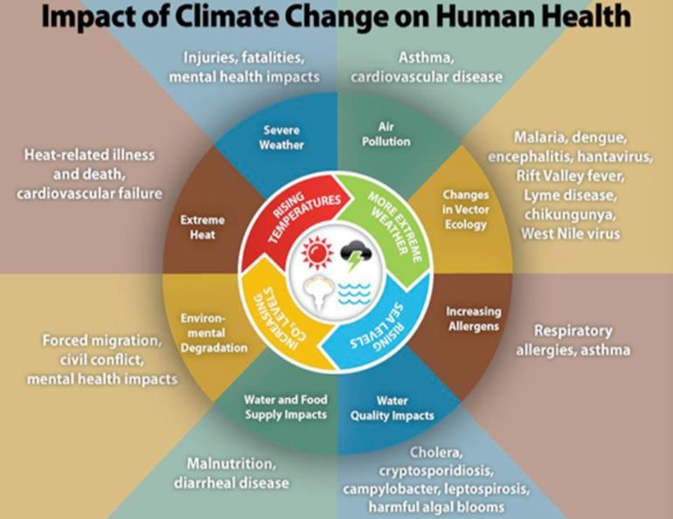
- Climate change impacts the social and environmental determinants of health -> clean air, safe drinking water, enough food, secure shelter, etc.
  - All determinants can be traced back to anthropogenic effects
- 1970-2004 -> global warming contributed to about 140,000+ excess deaths annually
- Climate-sensitive killers -> many significant CODs (cause of death) are highly climate- sensitive and expected to worsen
  - E.g. Diarrheal diseases, malnutrition, malaria
- Areas with weak health infrastructure are least able to cope
  - *there is disproportionate burden of impacts throughout the world
- Action areas: dramatic reductions in
greenhouse gas emissions through better transport, food and energy-use choices
- Climate change is NOT just about science -> it is deeply implicated in anthropogenic effect
- E.g. hurricane Florence

Who is at risk of climate change?
- Those living in poverty, women, children, elderly
- Outdoor workers and ppl living with chronic medical conditions
- Children are the most vulnerable due to long exposure to environmental risks
- Those living in megacities, small island developing state and other coastal, mountainous and polar regions
- Countries with weak health systems will be least able to prepare and respond

Disproportionate Burden
- Most vulnerable are disproportionately affected by the impacts of climate change
- E.g. those with disability cannot access cooling centers during heat waves

Complex Crisis: Climate Change, Food Insecurity, and Malnutrition
- Food security exists “when all people at all times have access to sufficient, safe, nutritious food to maintain a healthy and active life” (World Food Summit, 1996)
- Includes physical and economic access to quality foods that meet ppl’s dietary needs and their food preferences
- Health problems related to dietary excess, malnutrition, micro-nutrient deficiencies, and food born diarrhea
- *most contemporary thinking about food security is that food choices must also be culturally appropriate
  - E.g. President Bush the first did not do a good job with PR during incursions in Iraq -> President Bush the second did food-drops in remote areas so ppl can get food -> ham, which is not culturally appropriate to the pop in Iraq
  - US is the largest supplier of food aid in the world -> they send food to many places where there is famine
-> food is made from corn products that have no nutrient value -> does not target malnutrition issues

Malnutrition at a Glance
- Malnutrition = under-nutrition (wasting, stunting, underweight), inadequate vitamins/minerals, overweight and obesity, resulting in diet-related NCDs → leads to lifetime consequence on cognitive functioning
- Approx. 1.9 bill adults are overweight or obese; 462 mil are underweight
- 52 mil children under 5 are wasted, 17 mil severely wasted, 155 mil stunted
  - Wasting:
  - Stunting: preventing child physical development
- Approx. 45% of deaths among children under 5 are linked to under-nutrition largely in LICs and MICs
  - Ppl in developing countries account for 98% of the world’s hungry
- Approx. 852 mill ppl lack adequate daily nutrient intake, with approx. 3 bill lacking essential micro-nutrients (iodine, vitamin A, iron) -> problem for women
- *Burden of malnutrition is also not proportionately distributed -> inequity
Map displaying % of children under 5 yrs. who are stunted

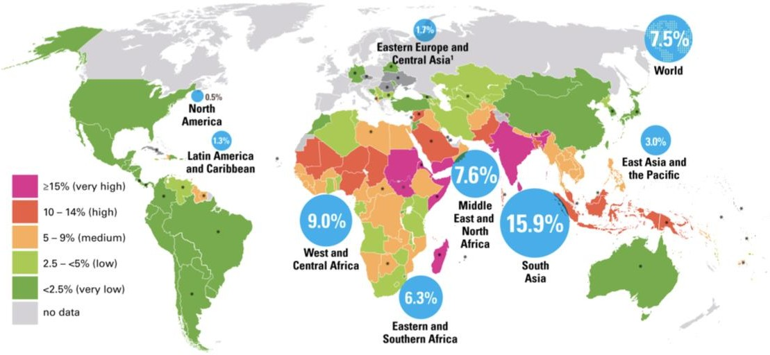
- In three regions, stunting affects 1 in every 3 children
- Global south -> Africa, South-east Asia, Middle east

Impact of Malnutrition
- Weight loss, low energy, muscle wasting, increased risk of fractures, increased risk of hospital admissions, confusion, infections, reduced independence, increased risk of falls, reduced mobility, low mood

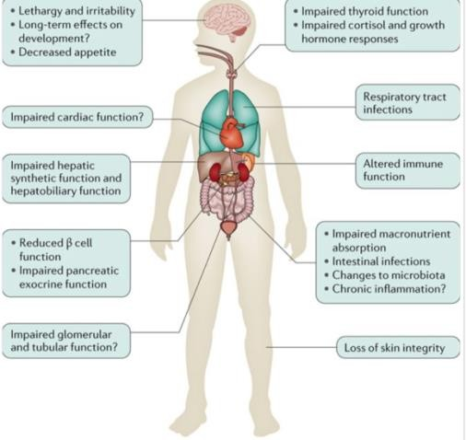
The Cost of Malnutrition
- Malnutrition costs $3.5 trillion/yr. to the global economy
- Undernutrition and micronutrient deficiencies cost up to $2.1 trillion/year
- The cost of obesity and overweight-related NCDs was estimated at USD 1.4 trillion in 2010
- Child and maternal malnutrition are by far the largest nutrition- related health burden in the world
- *women and children are most vulnerable to malnutrition
- Stunted cognitive development -> extends far beyond immediate effect

Food Insecurity and Climate Change (Refer to page 14 of lecture slides)
- Climate change affects other complex crises like malnutrition -> requires interdisciplinary approach to find solution
- Global pattern of inequity in global south
- Strong correlation (not causation) town climate change and food insecurity

Conclusions
- Evidence over the past 20 years indicates that climate change can be associated with adverse health outcomes
- Health professionals have an important role in understanding and communication potential health concerns related to climate change, as well as the co-benefits from burning fewer fossil fuels
(JANA, 2014)
- *We have the responsibility to raise awareness and use our privileged position to mitigate the adverse effects of climate change

Environment + Health***
- Geography: “study of the physical features of earth and its atmosphere, and of human activity as it affects and is affected by these, including the distribution of populations and resources, and political and economic activities.” (Source: Oxford Dictionary)
o
- Human geography: “branch of geography dealing with how human activity affects or is influenced by the earth’s surface”
(Source: Oxford Dictionary)

- Health geography: “sub-discipline of human geography; deals with interactions between people and the environment; holistic view of health with a focus on the role of place, location and geography” (Drummer, 2008)

- Environmental racism: “locating projects causing significant environmental effects in poor and marginalized neighborhoods, often where minorities live.”
(UNEP, 2017)
  - Response to this is environmental justice -> e.g. engage ppl in urban planning

- Environmental justice: “fair treatment and meaningful involvement of all people regardless of race, color culture, national origin, income, and educational levels with respect to the development, implementation, and enforcement of protective environmental laws, regulations, and policies.”
(EPA in AJPH, 2011)

- Ecological fallacy: when we draw conclusions about individuals based only on analysis of a group
  - “fallacy” is an error in reason; a false assumption
  - Potential problem if we rely exclusively on geographic data
  - Critical appraisal error

“Fence line Communities”
- Communities adjacent to a hazardous site, whether it’s a dump, refinery, chemical plant, pipeline or one of the
thousands of facilities permitted to operate in Louisiana
- There are many big polluters situated along the Mississippi River

- *marginalized pop are not always complete victims
- Ppl can be victimized but they still have the agency to act against injustice
  - E.g. concerned citizens of Norco revolted against their oppressors -> these marginalized pops can also be part of the solution to injustice
  - E.g. Aboriginal pops are often viewed as victims -> we never celebrate their strengths

Example 2: Norco & Diamond Community in Louisiana
- Segregated communities -> Norco 98% white; Diamond 100% African American
  - Communities were colonized by Germans who brought African slaves to the area to be used for labor
- 18th CE -> sugar cane plantation with African slaves as laborer’s
- No stranger to environmental damage -> 1973 and 1988 explosions at the Shell plant
- 1988 explosion reportedly released 159 mil lbs. of chemical waste into the atmosphere
- Communities are located between a chemical plant and a Shell refinery
- Concerned citizens of Norco formed in response to concerns about pollution and adverse impacts on health
- No strangers to peaceful mobilization and resistance! -> Because of the revolt
- 1811 German Coast Uprising -> part of one of the largest NA slave revolts
- 200-500 slaves marched peacefully -> retaliation by white militias was severe

Fence line: A Company Town Divided
*film related content will NOT be on the midterm
- What is the film’s main argument?
- What evidence does the film present to illustrate or support this argument?
- What disciplinary perspective discussed in class is the film most representative of? NOTE: you should be able to justify your answer by explaining how it reflects this disciplinary perspective. To do so you must be able to link key concepts related to the discipline to the film
- What model of health does the film appear to rely on? NOTE: You should be able to explain how it uses this model and provide evidence (examples) from the film about how it uses the model. TIP: If you need help, review your lecture notes on the models of health and the case of roundworm.

- New Orleans oiling company = Norco
- Despite what the Shell company states (e.g. Norco employees are healthier than the general pop; there is no scientific evidence that the company has a negative impact on the health of Diamond community) the residents in the Diamond community (esp. those by the fence-line) are at a high risk to developing various long-term illnesses due to exposure to Norco pollutants (respiratory diseases, cancer, birth defects, asthma, etc.)
- Database is misleading b/c some residents diagnosed with cancer will go out of the community for treatment and thus not included in the data
- The Bucket Brigade -> collect samples of air within the Diamond community to be sent to California where experts analyze the air samples to detect presence of toxic, harmful chemicals in the air
  - Teaches citizens to collect samples
- Benzene -> proven to cause cancer in humans, toluene,
- Shell argues that their business meets govt regulations and standards, not causing negative impacts on health of citizens -> they are not taking responsibility for the suffering of the marginalized pop
- Some residents are either ignorant or refuse to believe that they are living in unsafe environments
- Half of Diamond residents do not finish high-school, low SES
- Kids affected by asthma miss school days due to their condition -> under the social model, one would say that due to the illness, individuals lack education and thus compromising their future job opportunities -> low SES -> harder to relocate or move out of the polluted areas
- Shell and other company bought out some properties along the fence-line
  - Diamond community covers 4 streets -> Shell only chose to buy two streets that are predominately white neighborhoods?

- What disciplines are brought up here?
- Socio-ecological model?
- Biomedical model? -> concerns about chemicals causing long-term NCDs
- Behavioral/lifestyle model ->
- A lot of lay perspectives on the issue
- What accounts for the diff in perceiving the health status? White and African community have diff views

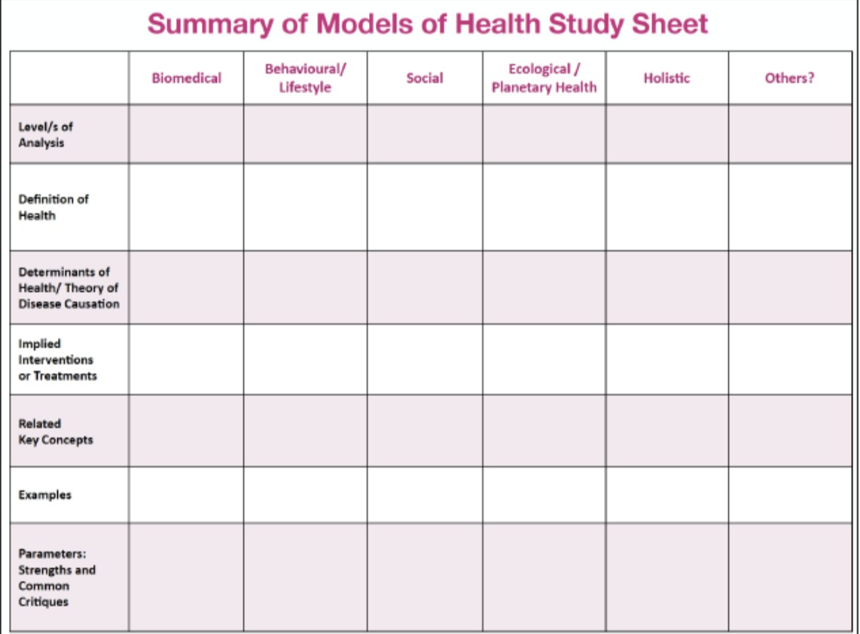

Discipline = e.g. psychology, geography
-Health studies are NOT a discipline, it’s just a large framework
-Framework/models = biomedical, social, lifestyle/behavioral… etc.

A discipline of health can be studied under diff models of health*

HLTA02 Lecture 6

Does Culture Impact Health?

- Culture shapes our assumptions about our bodies and the cause of illness

- Shapes our belief about what is appropriate care and when we should seek out such care

Does Culture Affect Health?

- In the Western view, biomedical is the dominant frame

- Emphasizes quantification, quality of evidence, scientific method, statistics, notions of objectivity, all inform western views of health

- Also tend to emphasize use of prescription, medicine, technology to target and treat specific illness

- Indigenous views “folk health sector” does not follow the biomedical model of health

Spiritual Healing

- Emphasis on healing rather than treatment

- Found through religious practice or rituals connected to nature, art, sport, music, etc.

HLTA02 Lecture 7

- Sociology is concerned with societal and social structures

- Typically, sociological theories can fall into two broad categories

- Consensus model of society

- Conflict model of society

• Sociological analysis can go from the micro level to the macro level

- The consensus view of society says that we all share common values norms and beliefs and this common ground helps us to maintain social order

- Very popular in the 1950s or so

- Social order is maintained by ppl acting in certain defined roles and performing certain functions for example prof teaching in university and student

- maintained by all of us doing hwat we are supposed to

- Illness is viewed as unnatural state of human body causing both physical and social dysfunction

- Role of physicians is to return us back to health so that we can get back to our role

- Make sure that the deviance is kept at a minimum, in this case in illness

- Talcott Parsons, very popular in 1950s-1960s

- The idea is that healthcare exists to restore and maintain social order

- Doctors in this context are considered socially beneficent, and their role is to return us to wellness

- They are always well intended; the doctor patient relationship assumes that it is harmonious and there is no power imbalance and no power dynamic

- The patient assumes the role of a sick person

- The sick role has four key components

- A sick person is exempt from performing their social obligations, they are not blamed for their condition, they must try to get better, they must put themselves into the hands of medical professionals

HLTA02 Lecture 10

- Health promotion

- All health promoters engage in all of these activities and they are doctors – believe in health promotion and go beyond that because they are working with many homeless patients, do work to help them get addresses including people who have disabilities

- Oppression, empowerment, critical consciousness

- Health promotion is a deeply contested field of practice in public health because of the degree to which those who call themselves or rely on health promotion, they are concerned with social justice or equity

- This notion first of oppression, any cruel or unjust treatment or exercise of authority or power against individuals

- This notion of empowerment, health promotion is debated because of the meaning of the word, empowerment is a process about how people and the community gain control of actions which affect their health, any way to gain control of their life and the kind of circumstances in which the live

- Not a lot of general agreement about how you do health promotion or if you even can

- The reason why you need empowerment is to overcome oppression, but that cannot happen if you are not critically conscious – social, political, economic – to know how to or engage in actions against oppressive structures in society

- Some branches more than others are very concerned with that

- A few more key terms

- Policies are plans and procedures that are developed and implemented by governments and agencies to achieve some goal

- Public policy refers specifically to any action chosen by public authorities to address certain problem or interrelated set of problems

- It is never neutral, polic is never value free or neutral

- A subset of public policy is health policy which isn’t the same as health care policy

- It is any policy that focuses on addressing various health related issues, it is not limited to hospitals, it could be private

- Adelaide Recommendations on Healthy Public Policy

- International conference on health promotion

- Health in public policy is any policy will have on health and then simultaneously thinks about how to change that policy to ensure it promotes not undermines health

- Phases of public health

- Relatively new phenomenon

- A couple of stages in public health

- Health promotion is somewhat aligned with public health

- In the USA health promotion is seen as being associated with health promotion

- In relation to public health in North American and Western Europe, in its earliest days 1840s or so called the sanitary phase, to be clean, there is a focus on environmental engineering in order to provide clean water and stuff in housing to improve sanitation of the public, if u think in these continents in this time were talking about heavy duty industrialization, lots of infectious disease, environmental engineering becomes a real priority

- By 1910, we kind of begin to realize we built running water, have toilets, cleaner homes, have soap but people not even surgeons are washing their hands, difficult campaign to convince surgeons to wash their hands, there’s an understanding that we built these things, we need to tell people to wash their hands and we enter into this phase of educating the public about things like cleanliness, personal behaviour, and it is a big development. Very specific to western philosophies. Notion that all of a

sudden that u have to wash your hands, we built the sinks and gave u soap, ur now responsible and if u get sick, it’s your fault

- By 1930 the education phase of public health gives way to the therapeutic phase, tremendous medialization in public health things like vaccinations and screenings of disease, we start to see real massive vaccinations campaigns and emergence of antibiotics, no longer just about sanitary structures, no longer enough to educate, we have to vaccinate small pox etc.

- By 1970s we move into a new phase which we are still in, new public health there is an attempt and lots of fighting intention to save health from extreme medicalization, there’s more to health than washing hands and vaccination, to address to increasing cost of health care provision, we see really distinct phases and health promotion comes shortly there after

- Ottawa Charger

- Many countries signed on to it, the meeting the conference of governments and signed in Ontario

- In 1986 the WHBO convenes this meeting, world leaders come up with this declaration (not legally binding but useful in that they set norms for governments to aspire to) how is health promotion defined in the Ottawa charter, this is not universally accepted today

- First it becomes about empowerment, argues that to research that state of complete wellbeing (no longer negative definition of health, more than absence of disease, applies a Salutogenic positive model of health, emphasizes health and wellbeing) to reach that ideal state, ur optimal health and wellbeing, individuals and groups must be able to change and cope with their environment, satisfy their needs, etc. what we start to see here is a real broadening definition of health, emphasis on Salutogenic and wellbeing and to expand the meaning of health, attempt to move towards holistic model of health, health is a resource for everyday living and not just the objective, how we get that matters, the process of making people healthy is important, argues that health is more than healthy lifestyles, health behaviour, health care, all of things are important it tries to be explicit here about who is responsible for that, its just not just individuals and administers of health

- Without peace, there can be no health

- Shelter, social determinants of health

- Stable ecosystem, education, food, income

- Embeds the notion that in order for us to work towards optimal health, we need social justice and equity

- Five HP Action Areas

- Charter proposes in order to achieve prerequisites to advance health, there are 5 hypes of actions

- Five core actions, the governments who signed this declaration, you need to:

- Healthy Public Policy – health in all policies in all sectors at all levels. All of them must accept some responsibility for health and the impact they have for good or worse.

- Create Supportive Environments – societies are really complex but they’re interrelated they must work together to care for each other and our shared natural environments

- Strengthening Community Actions – this notion of collective action this is very central to health promotion, not an individualizing response, to empower them, to create actions, to empower communities by giving them ownership and control of their endeavours. Participation for citizenship.

- Reorient Health Services – health promotion argues in the charter that our healthcare systems need to be reoriented, they need to be about more than just clinical medicine. Moving beyond the simple curative medicine. Thinking more broadly. Collaborate!
Focus on total needs of persons, not just injury/absence of disease and calling on health services to consider a different definition of health, and not just a negative

- Develop Personal Skills – never divorces any of its activities for them model, asking us to be consistent and apply this, choice is defined by many things, how do we empower people to engage and have more control over their health? We need to identify ways for individuals in order to improve the status of their health or their health potential

- One thing that isn’t listed is to still heal injuries

- Guiding HP Principles and Values

- Most health promotion, understandings and reimagining of theories and practice, first is that they tend to focus on upstream determinants of health, they are not ignoring micro individual, but they are always contextualizing. Two, they are very sensitive to victim blaming, pet peeve of health promoters, take a lot of objection to, health education does not always get this right.

- Equity is a concern, concerned with fairness and inequities and income and so on. Focus on Salutogenic models of health, all positive models.

- Deontological are those who are concerned with the rules and duties of what is right and good whereas the consequentialism is concerned with the outcomes of actions where the end justifies the means

- Beneficence – doing good, non-maleficence, justice

- Health promotions adds justice which causes debate

- The term model is being used to a visual representation of an understanding of health promotion

- Classified as either iconic or analogic good exam question

- Order is chronological

- Tannahill

- The most basic, it is iconic because it is not very theory driven

- Thought that the contention around health debate was silly

- Three things are required for health promotion

- Not complicated, just needs positive health education, prevention, health protection

- Caplan and Holland

- More complicated

- Quadrant model with the x and y axis

- On the y axis, the two extremes represent the model of society

- Analogic model, very theory driven

- Epistemology how we know the things we know

- Is it subjective (lay knowledge) or is it objective (scientific expert driven knowledge)?

