Human Genetics (September 10, 2018)

The Human Genome Project (HGP)
- First discussed in 1985
- Began in 1990 –estimated 15 years $3 billion
- Completed April 14, 2003
- 3-5% of budget committed to studying the ethical, legal, and social implications (ELSI) of human genome mapping

Major insights from human and model organism’s sequences
Technological advances:
- High throughput sequencing technologies (Alex Wong)

Biological:
- The human genome contains ~25,000 protein-coding genes (far fewer than predicted)
- The genome contains distinct types of gene organization
- # of proteins > # of genes (alternative splicing and post-translational modifications)

Heterogeneous distribution of genes (and exons)
Gene-rich regions:
- Chromosomal regions that have many more genes than expected from average gene density over entire genome

Gene deserts:
- Regions of >1 Mb that have no identifiable genes
- 3% of human genome is comprised of gene deserts

Regulation of gene expression, from gene to phenotype
- Chromatin Structure
- Initiation of transcription
- Elongation
- Pre-mRNA processing
- mRNA export
- mRNA stability
- Translation
- Protein stability
- Protein activity
Chromatin structure
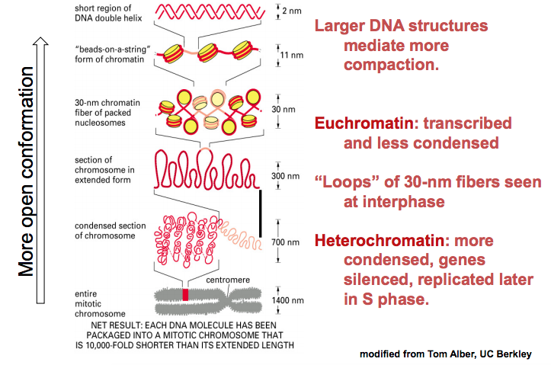

Initiation of Transcription
Sequence-specific transcription factors are modular
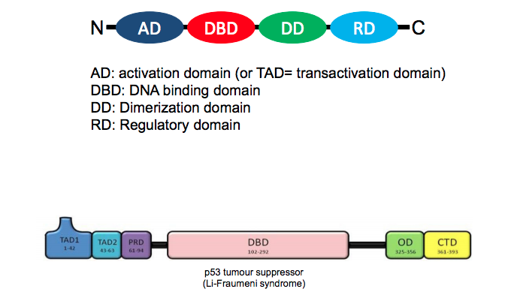

Organization of eukaryotic genes:
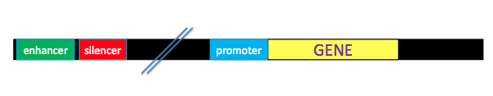
Activation of transcription: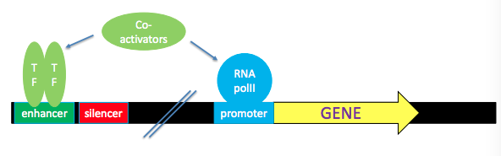
Transcriptional repression:
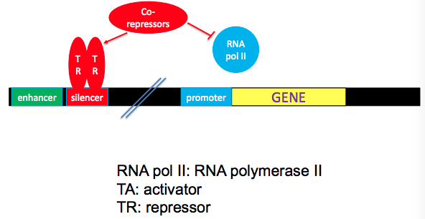

co-activators bring activators and RNA polymerase II into proximity:
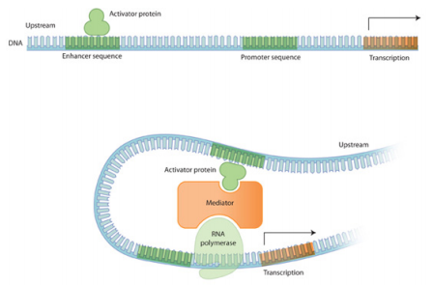
There may be multiple enhancers/activators that co-operate to regulate transcription:
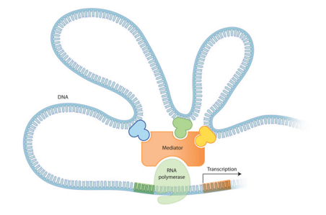

Levels of chromatin structure: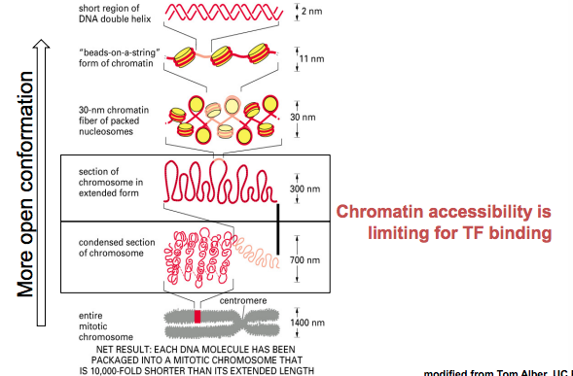
- Chromatin accessibility is necessary for transcription factors binding and transcriptional regulation
- Heterochromatin is rarely transcribed – facultative vs constitutive
Facultative heterochromatin: can be “opened up” through acetylation, the enzymes responsible are histone acetyl transferases (HATs)

The histone fold:
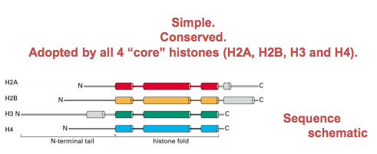

H3-H4 tetramer binds two H2A-H2B dimers to form the histone octamer:
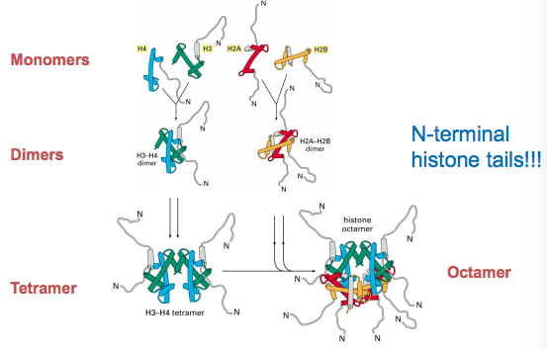

Examples of the “histone code” for H3/H4
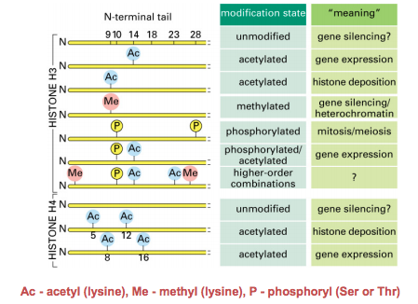

Site-specific histone modification:
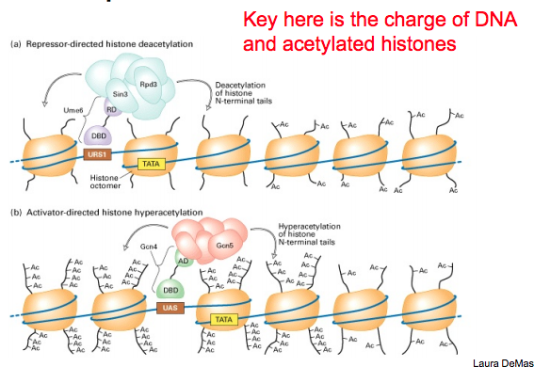

Simple model:
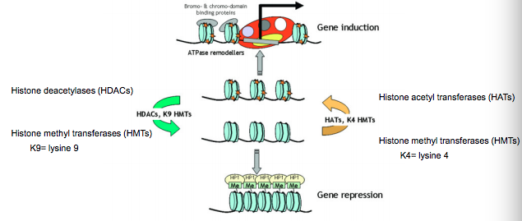

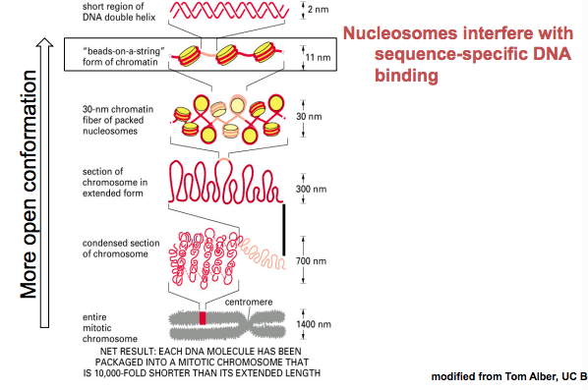

- Even nucleosomes get in the way
- Nucleosomes must be displaced and/or modified to permit the assembly of preinitiation complexes (PIC) etc.

Chromatin Remodeling Proteins:
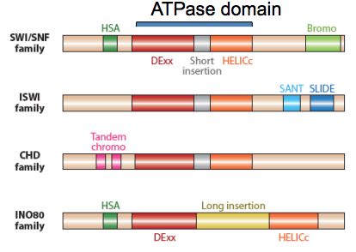

Diseases associated with chromatin remodeling ATPases:
- A variety of cancers
- X-linked intellectual disability
- Williams syndrome
- Cockayne syndrome

Chromatin assembly:
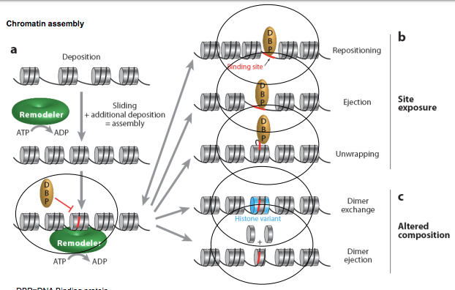

Chromatin-mediated control of transcription
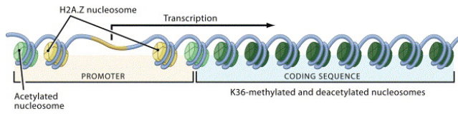
- Histone methylation, tied to transcription, prevents internal initiation
- H2A.Z; nucleosome-free regions at promoters

Stepwise assembly of Pol II transcription-initiation complex:
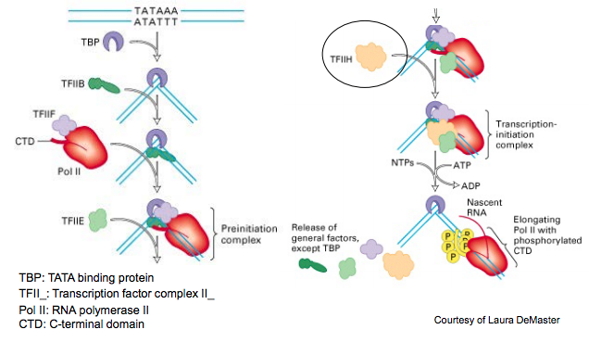

Transcriptional control requires still more proteins:
- RNA pol II (12 proteins)
- General transcription factors (23 proteins)
- Chromatin remodeling complex (15 proteins)
- Specific transcription factors (1000+ proteins)
- Mediator complex (30+ proteins)

Model for transcriptional activation: 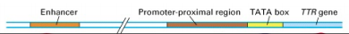

How do enhancers and promoters function together over long distances?

Layers of transcriptional controls:
- Amount/type of transcription factors in cells
- Post-translational modifications
- Access to chromatin

ELONGATION:
The role of CTD kinases in the transition from initiation to elongation:
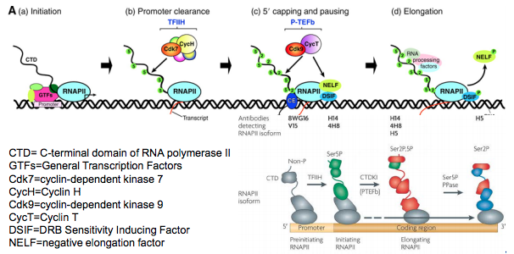

Transcription elongation:
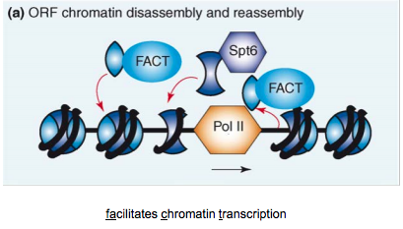

H3.3 is incorporated during transcription:
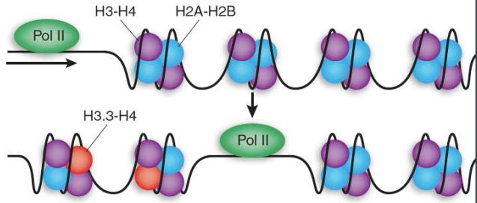

mRNA Processing:
Post-transcriptional Processes II: Pre-mRNA Polyadenylation
- Most cytoplasmic mRNAs have a polyA tail (3’ end) of a 50-250 Adenylates
  - A notable exception is histone mRNAs
- Discovered in 1971 (J. Darnell et al.)
  - Added post-transcriptionally by an enzyme, polyA polymerase(s)

3’ end cleavage


