Earth Final Exam

Life in The Ocean

System and Ecosystem

System – A network of relationships of elements or components that interact and influence one another; exchange of energy, matter.

Ecosystem – All living and nonliving entities that occur and interact in a particular area at the same time; includes abiotic and biotic components; energy flows and matter cycles among these components.

Organisms in Living systems

- They cannot create energy and cannot exist without it, so how do they live? They transform one kind to another: energy entering the system is processed and transformed
- Matter is recycled within ecosystem

Sources of Energy

- Sunlight
- Photosynthesis
- Earths internal Heat
- Chemosynthesis

Energy is converted to food.

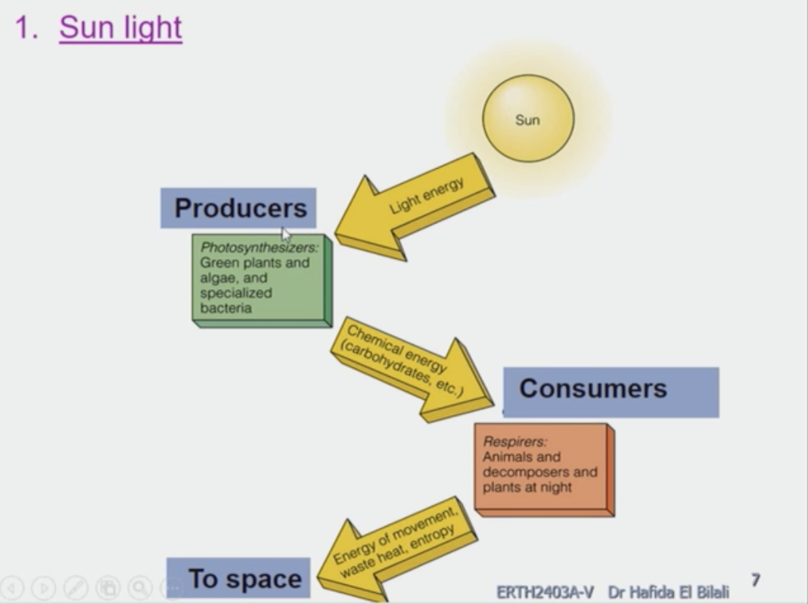

Energy stored by Photosynthesis

- Energy: sunlight
- Pigment: Chlorophyll

6CO₂ + 6H₂0 C₆H₁₂O₆ + O₂

C₆H₁₂O₆ is used for:
- Growth
- Repair
- Movement
- Reproduction
- Breakdown process yields some of the heat energy to space

Earths Internal Heat

Energy stored by chemosynthesis
- Energy: Oxidation of H₂S
- No light required

6CO₂ + 60₂ + 24H₂S C₆H₁₂O₆ + 24S + 18H₂0

Primary Production

- In Oceans by photosynthesis
- = Grams of carbon bound in organic matter per square meter of ocean surface per year
gC/m²/yr

Carbohydrates in Oceans
- 90-96% is produced by phytoplankton.
- 2-5% by seaweed
- 2-5% by chemosynthesis

- Conversion of solar energy to chemical energy by autotrophs

Gross primary production (GPP) = assimilation of energy by autotrophs

Net primary production (NPP) = energy remaining after respiration (available for heterotrophs)

When you take the GPP – respiration = NPP (used to explain which ecosystem converts solar energy to chemical energy faster and which are efficient in the conversion)

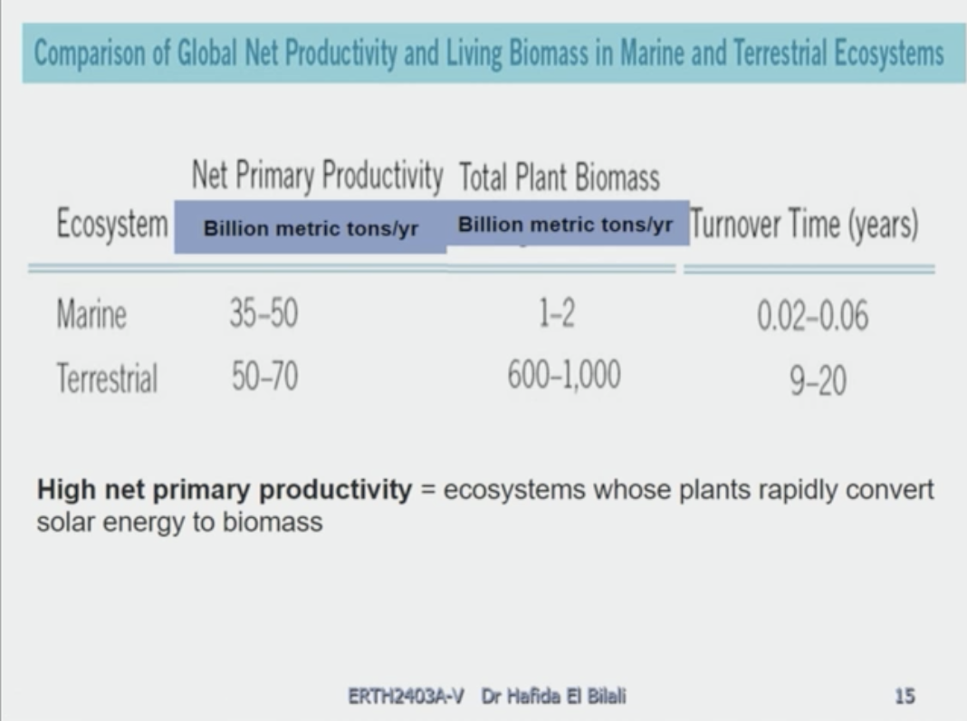

Trophic Levels

Energy passes among trophic levels: rank in the feeding hierarchy
- Producers
- Consumers
- Decomposers

- Primary producers (plants)
Autotrophs

- Primary Consumers (animals)
Heterotrophs – Herbivores

- Secondary to top consumers (animals)
Heterotrophs – Carnivores

- Decomposers (primarily bacteria)
Release nutrients for primary producers

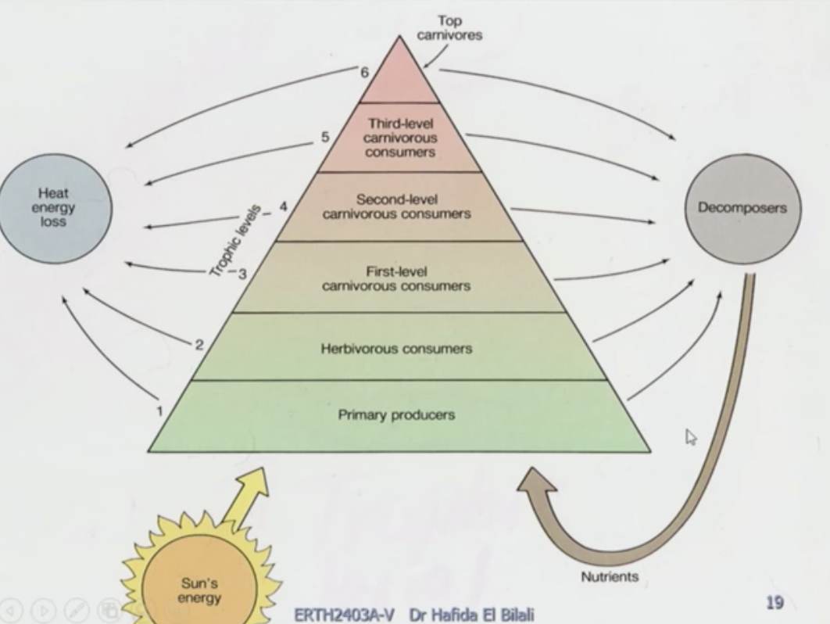

The first trophic level

Autotrophs – organisms that use solar energy for photosynthesis to produce sugars
- Green plants
- Cyanobacteria
- Algae (microscopic and macroscopic)

Chemosynthetic bacteria use the geothermal energy deep-sea hydrothermal vents to produce their food.

The Second trophic level

Primary consumers - organisms that consume producers

The third trophic level

Secondary consumers - organisms that prey on primary consumers.

Fourth trophic level

Tertiary consumers – predators at the highest trophic level; consume secondary consumers

Decomposers

- Break down leaf litter and other non-living material; fungi, bacteria
- Enhance topsoil and recycle nutrients

Organisms at lower tropic levels exist in greater numbers with greater energy content and greater biomass. Most energy is used up in respiration.

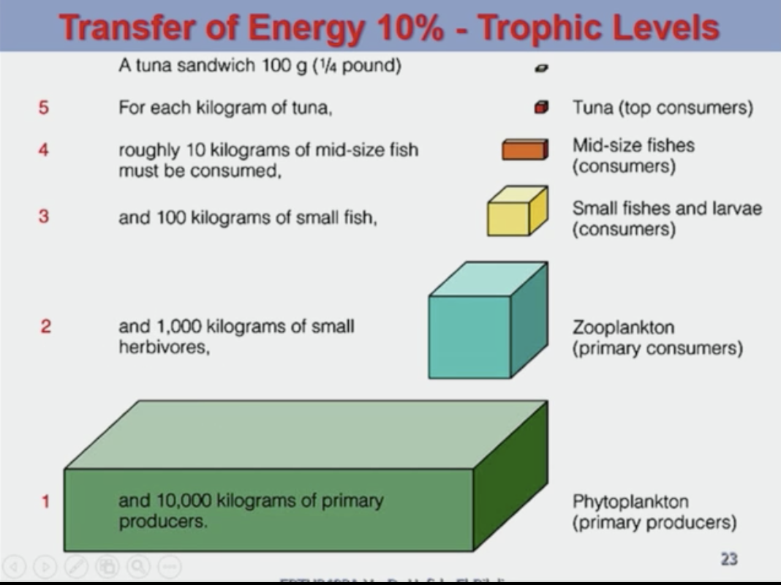

Food webs and Food Chain

Food webs – a visual map of feeding relationships and energy flow

Food chain – the relationship of how energy is transferred up the trophic levels.

Nutrients Circulate Through Biogeochemical Cycles

Nutrient cycle (biogeochemical) – the movement of nutrients through ecosystems;
Atmosphere, hydrosphere, lithosphere, and biosphere

Nutrients – elements and compounds required for survival that are consumed by organisms

Elements of Life
Major Components > 10⁵ ppm
- 99% of all living organisms
C
O
H
N

Macronutrients > 10³ ppm
- essential for life of marine organisms
Micronutrients < 10³ ppm
- Trace

Biogeochemical Cycles
- Carbon (c): respiration-photosynthesis; combustion of fossil fuels-excess release of co2
- Nitrogen (n2): 78% in atmosphere, nitrogen fixing bacteria

Physical and Biological Factors affecting Marine life

- Light
i)Photic: Euphotic – Disphotic
ii)Aphotic
- Temperature
i)Ectotherms: “cold blooded”; cannot regulate internal temperature- remains close to surrounding
ii)Endotherms: “warm blooded”; have stable internal temperature
- Salinity
- can damage cells
- influence buoyancy
- Dissolved Gasses
- Dissolved Nutrients
- pH
- Hydrostatic Pressure
- Diffusion
- Movement of molecules from area of high concentration to lower
- Osmosis
- Movement of water through a semi permeable membrane from high concentration to low concentration of water
- Isotonic: ocean salinity
- Hypotonic: Body more saline than ocean
- Hypertonic: Body less saline than ocean
- Limiting factors
Physical, chemical and biological characteristics that restrain population growth.

Marine Environments/Zones
- Littoral – intertidal (between high and low tides)
- Benthic – bottom zones

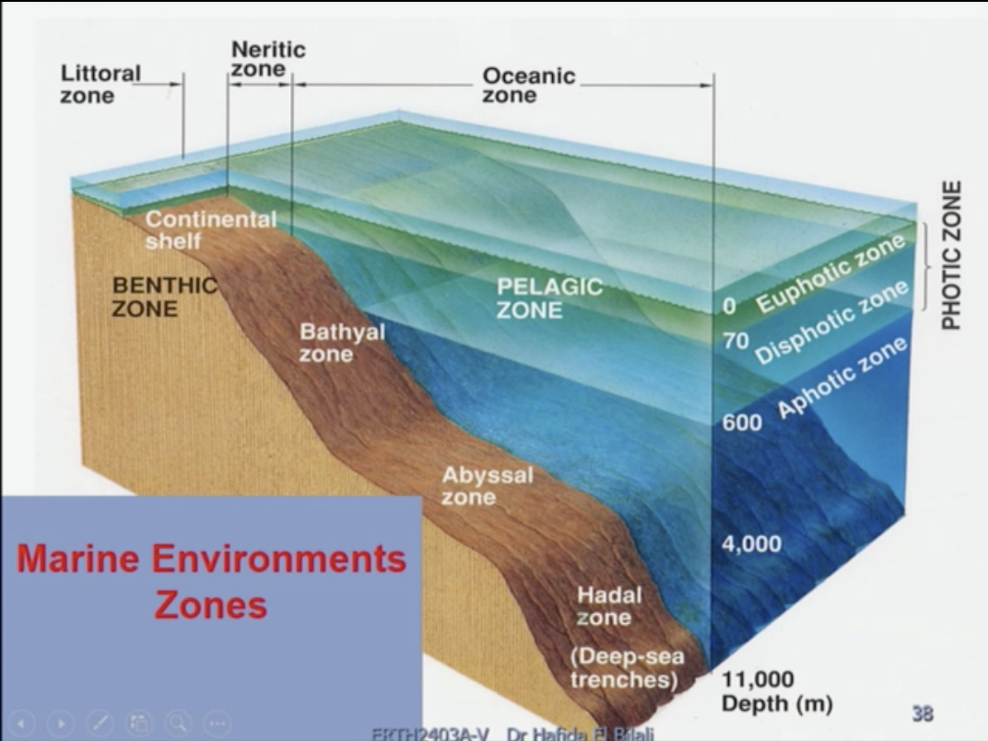

- Pelagic – water zones
Neritic: above shelf
Oceanic: all other ocean water

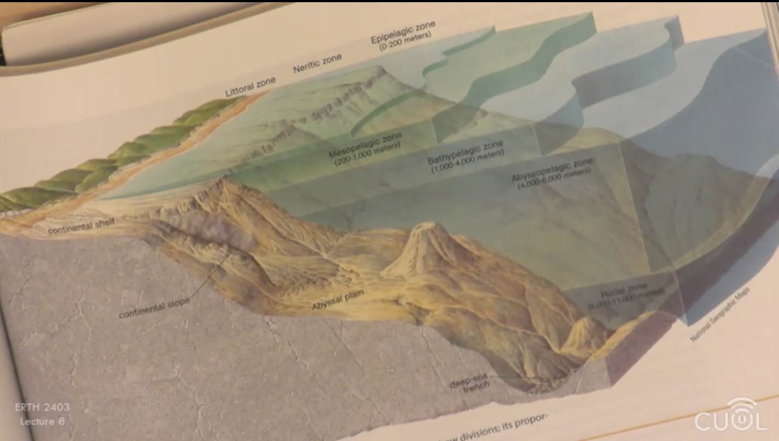

Marine organisms – Life in the Zones

- Pelagic; 2%
- Plankton: floaters-drifters
Phytoplankton: Autotrophic, Unicellular, produce food for 99% of marine animals
Zooplankton: Heterotrophic
Holoplankton: Entire lives as plankton
Meroplankton: Part of lives as plankton
- Nekton: Swimmers

- Benthic; 98%
- Epifauna: on substrate of seafloor
- Infauna: In substrate
- Sessile: Attached/immobile
- Mobile

Evolution leads to Earths Biodiversity
- Biological evolution= genetic change across generations
- Could be random or by natural selection
- Natural selection= trains that enhance survival and reproduction are passed on more frequently to next generations
Darwin and Wallace both proposed natural selection as the mechanism of evolution.

Classification of Organisms Taxonomy

Carlos Linnaeus developed basis of modern classification of organisms;
- Taxonomy: Systematic classification of organisms based on physical characteristics and genetic information
>Binomial Nomenclature
Genus
Species

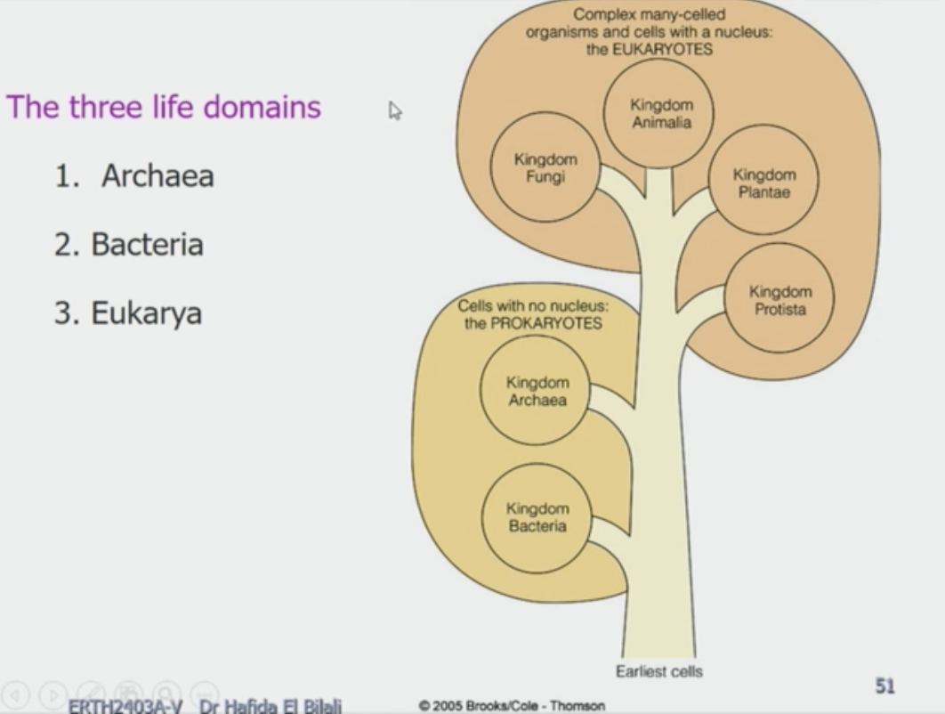

Prokaryotes
- Unicellular
- No nucleus
- Asexual Reproduction (slow evolution)
- Autotrophs
- Bacteria
- Archae

Eukaryotes
- Unicellular or multicellular
- Nucleus
- Asexual and sexual reproduction
- Autotrophs and heterotrophs
- Protista
- Fungi
- Plantae
- Animalia

Primary Producers

Phytoplankton & Seaweeds

- Microscopic (small) algae = phytoplankton
- Macroscopic (large) algae = seaweeds
- Photosynthetic bacteria

Bioluminescence

Luciferin + enzyme luciferase = light

Cyanobacteria = picoplankton

Limiting Factors of productivity

- Nutrients
- Light

Compensation Depth: Point where production (photosynthesis) rate = consumption (respiration) rate
- As light decreases, photosynthesis decreases

Latitudinal Distribution of Primary Productivity

- Polar: limiting factor = light
- Tropics: Limiting factor = nutrients
- Temperature:
i)Spring – no limiting factor
ii)Mid-summer – limiting factor: no nutrients
iii)Late summer – no limiting factor
iv)Winter – limiting factor: light

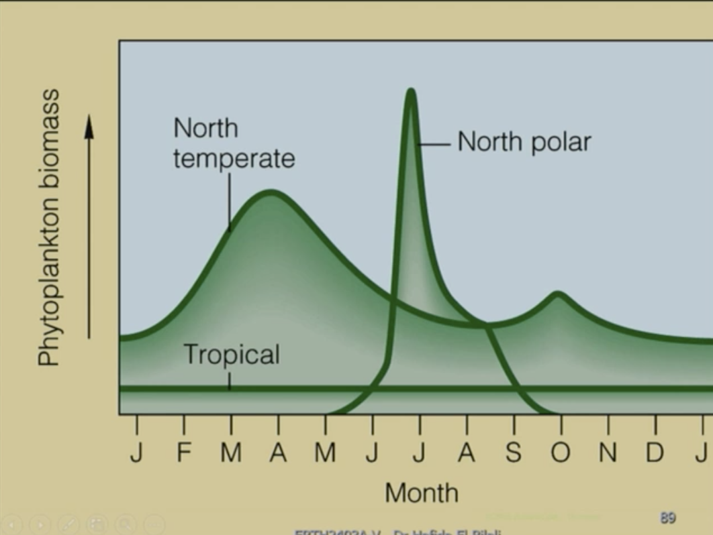

Cambrian explosion is due to increase of oxygen in the atmosphere (oxygenation event).

Invertebrates

- 90% of all living and fossil animals
- soft bodied
- no skeleton to support muscles
- most have exoskeletons

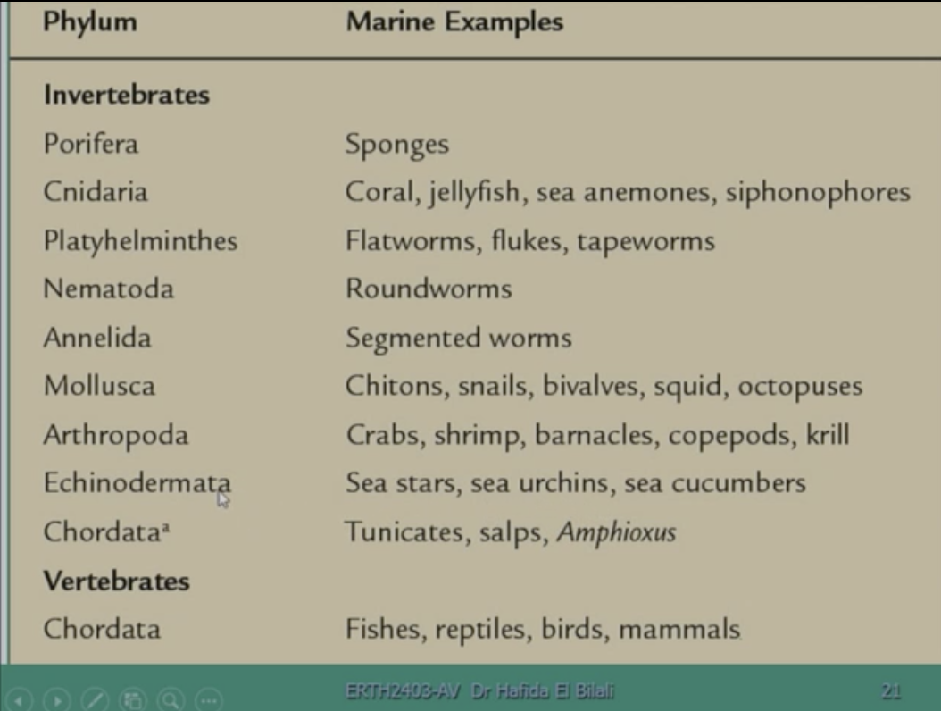

Porifera: have specules in their tissue

Cnidaria: Coral, jellyfish are examples of Cnidaria. Have nidoplasts.
Corals- vary in size; feed at night, solitary or colonial

Mollusca:
- Gastropoda – Stomach foot (snails)
- Pelecypoda (Bivalvia) – Hatchet foot (clams)
- Cephalopoda – head foot (squid)
- Most highly developed of invertebrates
- Advanced nervous systems: learn/remember
- Many with highly developed eyes
- Only one with exoskeleton >Nautilus

Echinodermata:
- Form most of benthic deep-sea biomass (with worms)
- Unique water vascular system; a complex of water-filled canals, valves, and projections used for locomotion and feeding.

Chordata (Invertebrates):
- Stiff dorsal notochord (like spine but not bony)
- Notochord embryonic only
- Amphioxus (genus); transitional between invertebrates and vertebrates (most primitive)
Chordata (vertebrates):
- Agnathids (no jaws); hagfish
- Chondrichthyes (cartilage not bone); sharks
- Osteichthyes (bony fish); in every marine habitat, lionfish

Three living groups (orders) of marine mammals:
- Cetacea – whales, porpoises, dolphins
Forelimbs: modified flippers, cigar shaped body, few hairs, elongate skull
Sonar is used by all whales
Odontocetes: toothed whales
Mysteceti: Baleen whales; filter feeders

- Carnivora – Seals, sea lions, walruses, sea otters
Pinnipeds: evolved from land bears, front flippers

- Sirenia – Manatees, dugongs

Some General Adaptations of marine mammals

- Streamlined body shape
- Flippers, flukes for propulsion
- Slippery skin and hair to reduce drag
- Endotherms (warm blooded fish; able to adjust body temperature)
- High metabolic rate
- Insulation fat
- Oxygen Retention
- Respiratory system modified to collect and retain volumes of oxygen
(endotherms need more O₂ and food)
- Huge blood volumes to store 0₂
- Large capillary mass in lungs
- Swimming muscles: myoglobin in tissues, uses anaerobic respiration
- Organs and muscles can be sealed off : to direct more blood to brain and heart, heart rate slows to reduce workload (use less oxygen)
- In some, rib cage flexible, collapses
- Conserve energy by swimming mode
- Swim > glide > swim
- Osmotic Adaptations
- No salt excreting glands
- Skin impervious to water
- Do not drink sea water, water comes from food
- Saline urine output from kidneys

Some General Adaptations to marine environment

- Temperature
- Temperate Zone: fluctuate seasonally
- In tropics and poles: less range
- Metabolic rate increases with increasing temperature
- Endotherms
- Regulate their body temperature
- Migrate because they tolerate broad temperature ranges
- Have high metabolic rates
- Need more food and oxygen (due to high metabolic rate)
- Mammals, seabirds, some large fish
- Ectotherms (Cold blooded organisms)
- Most marine organisms
- Internal and external temperatures are equal

- In the tropics/warm waters
- Higher metabolic rates
- Need more food and oxygen
- Move faster
- Mature earlier
- Have shorter life spans

- In high latitudes/cold waters
- Move slower
- Grow larger
- Mature later
- Live longer

- Exceptional Temperature adaptations
- Eg. Prolobus bacteria: tolerate 90 degree Celsius to 113 degree Celsius temperatures
- Fish are generally ectotherms:
Sharks can elevate muscle temperature to sustain elevated metabolic rate for long distance cruising

Light/Colour

Light in Ocean depends on:
- Suns angle: latitude
- Wave length-depth of penetration of the light
- Suspended particles: nutrients (nitrification on surface on water)

A. Plants – Photic zone (sunlight zone): plants which require sunlight can grow, where photosynthesis takes place.

- In coastal areas: suspended particles
- Tropics: clear water-deepest light penetration
- Some adaptations to deal with light:
Coccolithophores: > translucent to reduce light
> accessory pigments in seaweed
>Antarctic sponges: deep water silica spicules guide light
B. Animals

- Eyes: vary from large to none, placement on side or top of head
- Bioluminescence common in aphotic zone
- Bright colours in shallow tropics
- Drab in turbic coast
- Red or dark in deep water
- Defensive-dull and transparent
- Poison- bright fake eye spots
- Attraction-opposite sex
- Cryptic coloration: chromatophores in skin expand and contract to change colour; octopus
- Countershading: light underneath and dark on top; fish

Sound

- Lateral line system for sound = pores in skin – canals to bone run around eyes, over head and down sides connected to nerves
- Nerves detect pressure changes = sound
- Sonar in whales different from lateral line system

Pressure
- Deep sea: organisms adapted to particular depths; compact, no gas bladders
- Vertical Movers: birds and mammals, cephalopods
- Sharks: gases replaced by fats (no gas bladder)

*Salinity
- Euryhaline: broad tolerance
- Stenohaline: narrow tolerance
- Hypotonic: body less saline (marine fish); body and surrounding environment
- Hypertonic: body more saline (freshwater fish); body and surrounding environment
- Isotonic: Same salinity (most marine invertebrate); body and surrounding environment

Buoyancy
Organisms stay at required depths by various strategies:

- Gas bladders – kept
- Gas control in chambers (Nautilus)
- Oil droplets

Viscosity and movement

- Resistance to moving through viscous fluid (seawater)
- Shape important to reduce turbulence
- Smoother flow uses less energy

Migration

- Anadromous
- Live in marine waters
- Breed in fresh water
- Salmon

- Catadromous
- Live in fresh waters
- Breed in marine water
- American Eel

Schooling – Group Behaviours

- >2000 species of fish and squid etc.
- few to thousands move together
- same size, same direction, equal spacing
- Possible values of schooling
- Reduce ocean distribution to predators
- All not likely to be consumed
- May appear as single large entity
- Continuous motion may confuse

- Locomotion
- In eel like fish
- Muscle segments: myomeres
- Contract and relax alternately causing forward thrust
- In more advanced fish
- depends on caudal fin aspect ratio

Caudal fins
- Fin shapes are classified according to
aspect ratio = (fin height)²/fin area

- Low aspect ratio
- quick manoeuvrability
- lunge for prey and from predator
- high aspect ratio
- strong propulsion chase prey
- low manoeuvrability

- Muscle Fibre

- White muscle fibre
- Large
- Flat
- Fatigues easily
- Short energy burst
- Red muscle fibre
- Myoglobin: O₂ retention
- Smaller
- Holds energy for very long term
- Short strong bursts

- Fish – Individual swimming behaviour

- Lungers
- Low aspect ratio caudal fin
- Wait for prey
- Short burst of energy
- Mainly white muscle fibre
- Cruisers
- Chase prey for long distances
- Predominantly red muscle fibre
- Lunate and heterocercal caudal fins (high aspect ratio)

- Osmosis
- Water moves from higher concentration of water to lower concentration
- Water moves through semi-permeable membrane
- Fish either dehydrate (hypotonic) or burst with water (hypertonic) without osmo-regulation
- Chondricthyes (sharks etc) are more or less isotonic with seawater by producing urea in tissues

Marine Communities

Marine Organisms live in communities

- Organisms are distributed in the marine environment in groups sharing a common living space
- Community: many populations of organisms of the same species occupying a specific area.
- Population: group of organisms of the same species occupying the same area.

Communities consist of interacting producers, consumers, and decomposers

- The energy is passed from organism to organism in a food web=food webs define communities.
- There are different places to live and different jobs for organisms within a community.

- Habitat: address of organism within its community – its physical location.

- Niche: the organism’s occupation (job) in the community

- Biodiversity: the variety of species in a community;

high biodiversity (coral reef) has complex physical and biological relationships.

Low biodiversity (benthic abyss) few different species, interactions not as dynamic or complex.

Factors affecting communities

- Physical and biological factors determine the location and composition of a community.

- Physical factors (temperature, salinity, light, pressure) affect the success of an organism.
- Biological factors (crowding, predation, gazing, parasitism, etc)

- Physical or biological factor could limit the success of an organism in a community= limiting factor

- A limiting factor prevents an organism from feeding, growing and reproducing

- Organisms have different tolerances to specific factors.

- Eury: Tolerance to broad range of:
- Salinities as in euryhaline
- Temperatures as in eurythermal

- Steno: Tolerance to a narrow range of:
- Salinities as in stenohaline
- Temperatures as in stenothermal

In all communities various interdependent relationships exist

Types of symbiosis:

- Mutualism – both benefit more or less
- Commensalism – symbiont benefits host not hurt
- Parasitism – symbiont benefits host suffers

Communities

- Coastal Benthic
- Rocky shore
- Sandy shore

- Shelf Benthic
- Coral reef: tropics
- Kept forest: mid latitudes

- Oceanic Pelagic
- Epipelagic
- Mesopelagic
- Bathypelagic

- Benthic abyssal
- Deep sea floor
- Whale falls
- Deep rock communities

- Benthic Mid-Ocean Rift
- Hydrothermal vents

