MARKETING ANALYSIS: PIRHO GRILL

Daniela Gomez Student # 101032032
Allison Earle Student # 101032887
Nikita Zurowski Student # 101032898
Sarah Laferriere Student # 101044944
Maimaiti Gulpairi Student # 101035180
Sydney Kennedy Student # 101029606

BUSI 2208 C: Introduction to Marketing
December 5, 2017

Table of Contents

Executive Summary 1
Problem Statement 1
Situation Analysis 1
Internal 1
Marketing 1
Human Resources 3
Manufacturing 4
Information Systems 5
Finance 5
External 6
Social 6
Demographic and Ethnic 7
Economic 7
Political and Legal 8
Technological 9
Competitive 9
Segmentation Analysis 10
Perceptual Map 12
Strategic Alternatives 13
Strategic Alternative 1 13
Strategic Alternative 2 14
Strategic Alternative 3 14
Recommendation 16
Implementation 19
Conclusion 20
References 21
Appendices 25

Executive Summary

Pirho Grill is a new Greek-Mediterranean restaurant whose marketing mix struggles to meet their marketing objective of generating awareness of company initiatives. In order to remedy this problem, three strategic alternatives are being proposed: a Facebook advertising campaign, an in-store promotional campaign, and a point-of-view video campaign. The Facebook advertising campaign will take advantage of Facebook’s built-in platform that can target advertising to the ages of around 40 to 50. The in-store promotional campaign, which will target professionals during their lunch hour, includes informational and promotional events, free samples, and in-store infographics. The point-of-view video campaign will have a target market of 18 to 34 year olds and will maximize the representation of their values and initiatives through demonstrative assembly videos. This video campaign, which reaches the target market through a strengthened online presence, is the recommended strategic alternative as it aligns with company objectives and reaches both new and old customers in a more sustainable and cost-effective manner than the other options. It does not, however, cater to the target market exclusively, and could be threatened by controversial online promoters or the trend going out of style. Despite these potential drawbacks, it is recommended that Pirho Grill implement this strategy.

Problem Statement

Pirho Grill is a socially aware fast casual restaurant that wishes to expand brand awareness for their local and sustainable initiatives to increase their customer base. Their current marketing mix, however, fails to provide insight into their initiatives to consumers.

Internal Situation Analysis

Marketing

The goal of Pirho Grill’s marketing strategy is to increase brand awareness in order to build a larger customer base. However, their current marketing strategy is insufficient at positioning the brand in a manner that provides insight into their local and sustainable focus.

Pirho Grill’s current marketing strategy involves promotion on three social media platforms (Instagram, Facebook, Twitter) and their website. Each platform reaches a different key demographic. 84% of adults 30 to 49 use Facebook, compared to 33% for Instagram and 22% for Twitter (Greenwood et al, 2016). However, 59% of adults aged 18 to 29 are active instagram users (Greenwood et al, 2016).

Instagram

Pirho Grill’s Instagram presence attempts to showcase their main values but fails to effectively communicate the details of their local and sustainable focus. The profile consists of high quality photos of Pirho Grill food items, some taken by Pirho Grill but others re-posted from Instagram “foodie” and personal accounts. While these posts and their captions show customer satisfaction, they do not provide more details about their local and eco-friendly initiatives. Instead, the captions are filled with short, witty descriptions and hashtags. Hashtags allows their posts to be seen by millions of users who search using general terms such as #Greekfood or #Pita. Although this is effective, it does not align with their objective of providing details about their initiatives.
Twitter

Pirho Grill’s Twitter account contains the same information as their Instagram profile. Therefore, it is also inadequate at promoting details of their local and sustainable initiatives. Facebook

Pirho Grill’s Facebook page includes an ‘about the restaurant’ page, reviews, and a photo album. Their facebook is a great platform for attracting potential customers during their information search because it has a high rating of 4.9/5. Other than the reviews, the Facebook page fails to offer any content that differs from the other social media accounts.
Website

The strongest part of Pirho Grill’s online presence is their website. The website outlines the menu, allergen information, catering options, career opportunities, franchises, and more. It is well-designed, modern, and intuitive. It promotes their ability to meet the needs of consumers with dietary restrictions. However, it too does not give additional information about Pirho Grill’s local and sustainable initiatives.

Human Resources
Hiring Process

Pirho Grill has a two-step process when looking at potential employees. The first step is a meet and greet with around 10 potential employees. Those who advance are selected based on owner’s personal character judgements. The second-step is a formal interview that focuses on personality and attitudes because positions are low-skill (Plagakis, 2017). This approach finds charismatic employees that can act as brand ambassadors but it lacks structure and objective processes.
Employee Satisfaction

Pirho Grill maintains employee satisfaction by focusing on a great work environment. Management does this by rewarding and hiring employees that share Pirho Grill’s values and encouraging feedback (Plagakis, 2017). This ensures that employees are invested in the company.
Management Structure

Pirho Grill has a simple management hierarchy. It is an owner-operator style environment with a store manager at the Elgin Street location. Front staff report to the store manager while the on shift employees have an unofficial shift leader. The kitchens are handled by a chef and all kitchen prep staff report to him (Plagakis, 2017). This system works with a small number of employees and organizes employees by speciality.

Manufacturing
Service Training

Employees at Pirho Grill go through a verbal training process led by the owner. There is no official training manual or guide. While this method of service training is effective at the moment, it will be difficult to implement as the business expands.

Restaurant

The restaurant was built with sustainable building materials which cost $450,000 when the industry standard is $200,000 (Plagakis, 2017). The large capital investment is a strength because it ensures a high quality interior and efficient work but is also a weakness because it is a large financial burden.
Service Process, Food Handling, Health and Safety

The current service process allows for customers to see all aspects of food handling as the employee guides their order from start to finish. This process supplements the menu and helps achieve the goal of communicating their values (local, sustainable, high quality) to customers on the spot.

Pirho Grill uses only green certified chemicals to clean but has no formal written procedures to guide employees through health and safety processes due to the size and age of the business (Plagakis, 2017). This provides little accountability for employees because everything is communicated by word of mouth. Beyond in-store health and safety, the chef and kitchen prep staff are doing a voluntary provincial food handling certificate (Plagakis, 2017).

Information Systems

Pirho Grill’s main information system is their POS (Point of Sale) system. They currently use the Cluster POS system at their Elgin location (Plagakis, 2017). The system is cloud-based, which eliminates the need for paperwork, and Canadian, keeping in line with Pirho Grill’s objective of local sourcing. Pirho Grill shows commitment to finding the best information system by experimenting with different POS systems to help them maximize their competitive advantages. However, aside from their POS system, Pirho Grill has no other information systems in place.

Finance
Marketing Budget

Pirho Grill allocates 3% of their total sales to their marketing budget. This totals $45,000 annually (Plagakis, 2017). They have kept their marketing low-cost by using free social media platforms. The only part of their marketing strategy they have currently paid for is their website.

Capital Investment

Since Pirho Grill is a relatively new business, they do not see the current need for capital reinvestment as all equipment and purchases are new. Pirho Grill only considers new capital purchases if they are needed to increase efficiency.
Financial Management

Pirho Grill utilizes in-house bookkeeping and third-party accounting (Plagakis, 2017). In-house bookkeeping involves scanning documents and uploading them to a dropbox where a third party accountant uses that information to create a new datasheet every month and then creates a monthly profit and loss statement. This is effective but as the restaurant expands, the process of scanning all paper documents will become tedious and inefficient.
Research & Development

When researching and developing the current menu and new items, Pirho Grill did their market research by using various industry magazines, past experience, and guest reviews (Plagakis, 2017). This allows them to use information from a variety of sources when developing new products. However, there are no specific strategies in place for development.

External Situational Analysis

Social

Pirho Grill is sitting directly on a growing social trend of sustainable and health-conscious foods. In 2011, approximately 44% of consumers preferred organic products, 47% preferred products that support local communities, 50% preferred sustainably produced products, and 51% preferred fair trade products (Euromonitor, 2011). Furthermore, in 2016, it was found that consumers’ priorities lie in the quality, authenticity, uniqueness, and well-being of the products they buy. Consumers want products to be transparent, sustainable, affordable, healthy, and individualized (Euromonitor, 2016). Pirho Grill’s service process, prices, and products satisfy all these markets, showing a great opportunity for the business. Additionally, the area immediately surrounding the Elgin location has a population of people who are health-conscious, demonstrate ethical consumerism, and are willing to pay more for products that reflect the place from which they came (PRIZM5, 2017). As a result, Pirho Grill is positioned to benefit from current social trends if they are able to effectively communicate their local and sustainable initiatives.

Demographic and Ethnic

Pirho Grill’s existing target market is consumers aged 18-40, but more specifically, women within that age range as they tend to be more health conscious (Plagakis, 2017). 48.8% of the population in the surrounding area of Pirho Grill’s Elgin location is 20-34 years old and 54.1% of that population is female (Stats Canada, 2017). This is a great opportunity as that age range is Pirho Grill’s most promising potential new target market. With increased brand awareness, Pirho Grill will be able to better access this demographic and see an increase in regular customers.
Economic

One Canadian dollar is currently worth only 77 cents of an American dollar (XE Currency Converter, 2017). Therefore, Pirho Grill is not benefitting from sourcing their biodegradable bowls and cutlery from an American supplier. This is a threat because this places extra financial pressure on the firm thus reducing available profits for other initiatives.

Canadian economic forecasts are modest at best as “the Bank of Canada expects growth to be moderate and drop to 2.0 per cent in 2018 and 1.6 per cent in 2019” (Lammam and MacIntyre, 2017). The Department of Finance also expects growth to drop after 2017 (Lammam and MacIntyre, 2017). There is little faith that the Canadian government will be able to reverse or stop this decline. (Lammam and MacIntyre, 2017). While economic slowdown is not a direct threat to Pirho Grill, it commonly results in a decrease in consumer spending. This threat would lead to fewer sales and lower profits.
Political and Legal

The current federal government has promised to lower the small-business tax rate to nine percent by 2019 compared to the current tax rate of 10.5% (Blatchford and Bryden, 2017). This will allow small business owners to retain more of their profits and reinvest money back into businesses, promoting growth. A lower tax rate is a great opportunity for Pirho Grill because more funds can increase financial resources to be allocated towards marketing initiatives to increase customer bases and boost sales.

However, the federal government is also considering new tax policies that will negatively affect small businesses. These new policies rule out income sprinkling and capital gains which means small business owners would no longer be able to convert money into capital gains to shelter money from high income taxes. Business owners would have to claim passive income they earn when investments held within their corporations have grown in value, such as salary or dividends. This will push many business owners into a much higher tax bracket (Buck, 2017). These new policies could strain operations and force Pirho Grill to scale back operations, close down or take other measures to stay afloat.

Furthermore, the Ontario minimum wage will be rising to 15 dollars an hour by 2019 and 14 dollars an hour by January 1st 2018 (Weir, 2017). That is a $2.40 increase on every hour for every worker just by 2018. For Pirho Grill’s 20 employees, the approximately 20% increase in wages will amount to a huge extra cost (Plagakis, 2017). One of Pirho Grill’s initiatives was striving to pay a wage that was higher than industry standard but this minimum wage hike prevents this from happening. Due to this threat a larger portion of Pirho Grill’s profits will have to be put towards the employees’ paychecks, resulting in less profits to put towards marketing their competitive advantage.
Technological

Society is very quickly advancing towards a cashless society. Many businesses have already adopted the new technology, opting out of traditional cash registers (ET Bureau, 2016)(Mills, 2017). This is an opportunity for Pirho Grill because eliminating the cash variable eliminates the risk of employee miscalculations and greatly reduces the risk of robberies and employee theft. In addition, people tend to view cashless businesses to be modern which would reinforce Pirho Grill’s modern sustainable competitive advantage.

Furthermore, Snapchat has recently rolled out a new feature which is a great technological opportunity for Pirho Grill. The “Snap Map” is an interactive map that displays, to the user, the real time location of their friends and upon clicking on them, displays the stories of what said friends are up to (Constine, 2017). This is designed specifically so friends can meet up or join in on other friends adventures as they are happening. If Pirho Grill can encourage customers to post Snapchat stories in the restaurant, they can potentially entice their friends to come dine there as well, thus increasing traffic and potential returning customers.
Competitive

Mad Radish is a health-conscious eatery that is located closeby to the Elgin Street Pirho Grill. Since both are considered fast casual restaurants and offer location convenience being in the heart of downtown Ottawa, these two restaurants are competing for the same customers. This poses a fairly large threat to Pirho Grill because Mad Radish has the capital and experience of its owner, David Segal, backing it up. As a co-founder of DavidsTea, Segal has the industry knowledge and resources to make great leaps, such as their decision to include cashless transactions (Brown, 2017)(Mills, 2017). Pirho Grill will need to assert their local and sustainable initiatives to provide themselves with a competitive advantage.

Green Rebel is another health-conscious eatery that is located near the Elgin Street Pirho Grill. This eatery poses a similar threat to that of Mad Radish in terms of location convenience to businesses and converging health based food ideals. Furthermore, Green Rebel also appeals to the trend of social responsibility. The rebel bowl program offers a 50 cent discount on each salad bowl a customer orders if they use the reusable and biodegradable bowls provided by Green Rebel (Green Rebel, 2016). In this sense, Green Rebel is a very large threat to Pirho Grill as it is converging on Pirho Grill’s competitive advantage. This means that Pirho Grill will need to clearly and succinctly communicate the unparalleled depth of their sustainable initiatives lest customers assume they are similar to and thus interchangeable with Green Rebel’s.

In summary Pirho Grill’s internal situation leaves very little to be desired, the main weakness being the marketing department’s failure to provide insight into their local and sustainable focus. On the other hand Pirho Grill’s marketing endeavors are a great strength as they are also very strong and demonstrate good understanding of how to use the platforms. They simply require some redirection to align with the marketing objectives. Externally Pirho Grill’s largest threats are due to new legislation under the Trudeau government costing small businesses more to simply exist. In terms of opportunities, Pirho Grill’s alignment with the socially responsible trend is a fantastic opportunity because it could translate into a major boost in customers. Refer to Appendix 1 for a SWOT analysis of Pirho Grill’s current situation. Refer to Appendix 2 for the transcript of an interview with George Plagakis, the owner of Pirho Grill.

Segmentation and Perceptual Map

Pirho Grill’s market is divided between two sectors: consumer (B2C) and professional (B2B). As a fast-casual restaurant, Pirho Grill offers a wide variety of options for all ages, preferences, and dietary restrictions due to the customizable nature of the menu. This gives Pirho Grill the ability to feasibly target and serve any number of market segments. As such, segments in our analysis were restricted to sizeable and distinguishable segments prior to deciding our target market segment. Within the consumer sector, segments are divided using psychographic segmentation, specifically lifestyle and geodemographic bases (See Appendix 3 and 4). Within the professional sector, the segments are divided based on primary operation. However, in comparison to the size and potential of the consumer sector, the professional one is infrequent and negligible and thus, is not further investigated as a potential target. The segments of night owls, gym goers/health enthusiasts, and young professionals were chosen based off of the lifestyle data provided in a PRIZM5 search (See Appendix 5 and 6).

We identified the needs of the consumer segments in Appendix 4 from the same data from PRIZM5 as well as using general research in Euromonitor’s Passport.

In terms of the size of the consumer market segments, in approximated figures there are 6,773 young professionals, 3,693 gym goers and 1,985 night owls (See Appendix 7). Thus, night owls is the smallest market segment and gym goers sit in the middle at just 300 shy of being double the size of night owls. Young professionals is undisputedly the most substantial market segment at more than the other two segments combined.

As a result of its sheer size as well as the shared goals and values between the segment and the business, the young professionals segment will be targeted. As discussed in the previous paragraph, young professionals represent an approximate value of 6,773 people out of the total population of our segments which is 12,451, making it more than half of all segments combined. In addition, according to PRIZM5 data (See Appendix 5 and 6), the young professional is one of the most prevalent demographics in the area within the limited population that lives in the area as opposed to travels there for work. This is relevant as individuals are less likely to travel for fast food by nature of the purchase. This accessibility combined with their values of a sustainable, healthy, locally sourced, environmentally friendly product which coincides with the goals of the restaurant make them the most targetable market segment.

The two perceptual maps (See Appendix 8) were created using a sample of 34 young professionals where the opinions of the target market about Pirho Grill were compared to their opinions of Pirho Grill’s main competitors. These main competitors were drawn from location, usage rates, and similarity in industry position. Mcdonald’s, despite not being similar in nature, is close to both locations and is the most frequented restaurant among the chosen age segment (Morgan Stanley, 2015). The parameters were given in the identification of the needs of the segments as well as using the values outlined in the same study by Morgan Stanley. According to this data, Pirho Grill has a competitive advantage over many of its competitors as many of its customers see its food as being of higher quality and cleaner, while offering an above average variety than that of its competitors. The only disadvantage in terms of how they are perceived is in price. Pirho Grill was cited as being the most expensive despite the average cost of a meal being less than Mad Radish and comparable to Green Rebel. However, Pirho Grill is focused on showing customers the value of the price they pay and not focusing on the price itself. They are not looking to compete on price and as such are not concerned with repositioning for this single factor. The sample size of this survey was relatively small and was not chosen using formal statistical methods and as such, results may be skewed and may not represent the beliefs of the target segment.

Strategic Alternatives

Strategic Alternative 1 - Facebook Advertising Campaign

Pirho Grill currently has a strong social media platform but has no formal advertising strategy. This strategy will target people around the age of 39 to 51, also known as Generation X. Gen Xers use Facebook more than any other age cohort clocking in at approximately 7 hours a week (Rodriguez, 2017). This makes a Facebook ad a very effective way to target this market. Furthermore, Facebook ads have an 8.1 times higher click rate and 9.1 times higher click rate than any normal web ad (Finn, 2014).

Facebook has a built-in platform to determine marketers’ budgets and evaluate an ad’s performance. The platform gives the ability to do a split test ad, which allows marketers to try different strategies that would impact their ad performance. This gives them the ability to test out different variables (phrases, photos etc.) and see how the potential audience may react. At the end of the test, a breakdown of the results is provided. Ads can be budgeted so the business owner is in control of exactly how much they spend. There are two ways to pay for ads with your chosen budget: a calculation of your cost per click ($0.19), or a cost per 1000 impressions/views of your ad ($3.99). Ad reach can also be limited to cities and postal codes so that no advertising goes to waste, but this is only available at an extra charge. The content and design of the ad may vary. Formatting options include a carousel (two or more scrollable images), a single image, a video, or slideshow. All formats allow for Pirho to write a caption to inform customers of its local and sustainable initiative, whether it be through a caption, a photo, or a video.

Given by the owner/operator, we have a marketing budget of $45,000. With this budget, under optimistic conditions, Pirho has the potential to make a profit of $1,800. Under most likely conditions, Pirho has the ability to make a profit of $840. Under pessimistic conditions, Pirho would make around $210. All calculations can be found in Appendix 9 and all exclude word of mouth profits.

Strategic Alternative 2 - In-Store Promotional Campaign

Pirho Grill, according to the owner and operator, has astounding customer retention because of the high quality products and services they offer. However, as stated in the problem statement, they are struggling to expand their customer base because their current marketing strategy is not attracting people into the store. Therefore, in order to attract customers into the store, one strategy is to hold a 3 month long in-store campaign.

This campaign will target their lunch customers, professionals aged 25 to 50, working in downtown Ottawa. 20% of working Ontarians buy lunch three or more times a week, showing that this market segment is substantial (CBC, 2012).

The campaign will include two main strategies: in-store promotions and in-store lunch hour events. In-store promotional material includes posters that give information about the local suppliers and eco-friendly processes and required data entry for free wifi to gain customer information. In-store lunch hour events involves hosting events where customers can meet local suppliers, vote on new menu items, and win prizes.

Under optimistic conditions profits are projected to be $2,246.4. Under most likely conditions, profits are projected to be $1,612.8. Under pessimistic conditions, profits are projected to be $460.8 Costs for this campaign are $10,321.74. Refer to Appendix 10 to see the cost and revenue calculations. However, since a budget of roughly $45,000 has been outlined, the costs for this campaign are sunk costs and all revenues will be considered profit.

Strategic alternative 3 - Point-of-View Video Campaign

The challenge of Pirho Grill’s marketing objective lies in communicating detailed information in a concise manner that can work on multiple platforms. To do so, Pirho Grill can create a video campaign that emulates Tasty’s, a subsidiary of Buzzfeed, point-of-view instructional food videos.

POV instructional food videos guide consumers through a recipe from start to finish. However, these videos would not display a recipe. Instead, they would display the assembly of Pirho Grill’s customizable pitas, salads and grain bowls, allowing consumers to see each step of the food preparation and possible ingredient combinations. An example of what one frame in the video would look like is given by Appendix 11. In the top right corner, the ingredient name as well as the local source would be displayed. At the end of the video, links that lead to the Pirho Grill website will toggle in the final frame as well as the price of the feature dish. As a result, part of this strategy involves Pirho Grill adding pages to their website that outline details about the sourcing for each ingredient and their sustainable initiatives.

The video program would last 16 weeks with a new video every two weeks for a total of 8 videos. The videos would vary in length from 30 seconds to 2 minutes, depending on the dish being featured, and display Pirho Grill branding at the beginning and end. To increase chances that the videos circulate across accounts, social media influencers will be contacted to promote these videos on their platforms.

Under optimistic conditions profits are projected to be $5,760. Under most likely conditions, profits are projected to be $2,520. Under pessimistic conditions, profits are projected to be $360. Costs for this campaign are $11,335.28. Refer to Appendix 12 to see the cost and revenue calculations. However, since a budget of roughly $45,000 has been outlined and will not be used for other business processes, the costs for this campaign are sunk costs and all revenues will be considered profit.

Recommendation

In order to ensure that the recommended suits Pirho Grill’s strengths and weaknesses, each strategy must be evaluated by factors most relevant to Pirho Grill. These factors include financial implications, time required for implementation, alignment with strategic objectives, alignment with target market, and promotion length. (See Appendix 13 for a Decision Grid)

The Facebook ad campaign is a strong marketing strategy, but it does not align with Pirho Grill’s marketing objectives. Facebook ads allow Pirho Grill to communicate to new and existing customers. When creating a Facebook ad, creators have the ability to tailor their audience to a certain age group and by doing so continuously, Pirho will be able to market themselves directly to their desired market while the ad is active.

However, people tend to have short attention spans when they are on social media, so an attempt to communicate the full message might be difficult. In addition, many people tend to use ad-blockers. In fact, there was a 30% growth in ad-block usage in 2016 alone (PageFair, 2017). These ad-blockers can reduce the effectiveness of Facebook ads and communicate that consumers do not enjoy traditional online advertisements.

As stated in the problem statement, Pirho Grill struggles to provide insight into the details of their initiatives to consumers. In an ad, while they can post an attractive shot of their food with a short caption, it is not an ideal platform to communicate detailed information. The detailed information about these intiatives is ultimately what will which allows them to attract the right target market as well as give some of the desired information to the customers. Finally, although the Facebook ad can increase customer base, it does not necessarily communicate Pirho Grill’s values to new or existing customers. (See Appendix 14 for a SWOT analysis of this strategy)

An in-store campaign would capitalize on Pirho Grill’s specific strength of customer retention. Pirho Grill’s employees are hired for their skills and their values. As a result, they act as brand ambassadors since their values align with the company’s. This is imperative to achieving a level of transparency, sustainability and trust with consumers. Employees that believe in Pirho Grill’s values of green commitment, sustainability, customer service, quality, and value will elevate an in-store campaign.

This in-store campaign coincides with the growing social trend of sustainable and health-conscious foods mentioned in the external analysis above, and the increase of consumers that are demanding these products. This strategy would minimize Pirho Grill’s weakness of failing to showcase their main values on social media as they would be promoted in store and would be the focus of this campaign. This strategy meets the objectives of Pirho Grill as it focuses on directly marketing their local and sustainable initiatives to their target market.

However, free samples and events also do not guarantee that customers will purchase food from Pirho Grill. Consequently, while brand awareness will increase, it may take months before profits begin to noticeably rise as a result of this campaign. This campaign has a more limited reach when compared to the Facebook Ad strategy because the advertising for these events is mainly directed towards existing customers. (See Appendix 15 for a SWOT analysis of this strategy)

The point-of-view video campaign capitalizes on a variety of Pirho Grill’s strengths. Like the in-store campaign, this campaign coincides with the growing social trend of sustainable and health-conscious foods and the increase of consumers that are demanding these products. This strategy is advantageous because Pirho Grill’s ingredients are naturally visually appealing with colours such as bright reds, deep greens and vibrant purples which can be enticing to viewers (See Appendix 16). This would perfectly align with the company’s marketing objectives because the videos provide information about the locally sourced, sustainable initiatives and then link to Pirho Grill’s website with more detailed information. This strategy would also minimize Pirho Grill’s shortcomings in showcasing their main values on social media. The videos would be posted on all of Pirho Grill’s already strong social media platforms including Instagram, Facebook, and Twitter. 38% of Facebook users, 49% of Instagram users, and 41% of Twitter users are 18-34 years old (Social Media Week, 2015). This age range encompasses the target market as well as the other two secondary markets identified in the segmentation analysis.

However, this strategy is not specifically targeted to Pirho Grill’s target market. It would reach those of the young professionals who encounter it online but is not catered directly to them in any way. In addition, this strategy faces the threat of potential controversial online promoters as well as the ever present threat that the video trend could go out of style. (See Appendix 17 for a SWOT analysis of this strategy)

The strategy that would best utilize Pirho Grill’s strengths and opportunities to expand brand awareness for their local and sustainable initiatives is the point-of-view video campaign. This campaign would prove to be the most effective as it perfectly aligns with the firm’s strategic objectives and reaches a large online market as well as the firm’s target market. This makes it a superior alternative as neither of the other alternatives would be able to align with the objectives while reaching new and existing customers. This alternative coincides with the problem statement because it can provide detailed information in an effective manner: through content on online pages provided by the owner himself. The largest problems with the other two alternatives are that Facebook ads are too general and in-store promotions cater mostly to existing customers. What solidifies the point-of-view video campaign as the superior option is that it is drastically less expensive than the Facebook option while still providing similar increased online presence. In addition, it is only slightly more expensive than the in-store option but targets a much wider customer base and would last longer as the videos could continue to circulate beyond the promotional period.

Implementation

The following action steps are based on a timeline of 8 weeks of planning and 16 weeks of implementation. A detailed timeline can be found in Appendix 18.

Firstly, a team comprised of management and staff will be assembled to collectively plan and coordinate the campaign. During this preparatory phase, advertisements for a student videographer and a student web designer will be placed online. Then, Ottawa-based social media influencers and Narcity will be contacted to arrange promotional contracts. These influencers are chosen on the basis of shared values such as healthy-living and nutritious food.

The second two weeks of the preparatory phase will focus on deciding which menu items will be featured in the videos. Management will survey employees and set-up a comments box to gather data about which menu items are most popular. This is also where Pirho Grill can decide feature promotional food items. At the end of this two-week phase, 8 menu items will have been selected. During this time, student videographers and web designers will be interviewed and a candidate will be chosen.

The priority of the last month of the preparatory is the conception and development of the POV instructional videos. Scripts that outline ingredients, preparation and sourcing will be drafted for all 8 videos. The student intern will do all 8 shoots over the next two months, blending the preparatory phase with the implementation. At the same time, the new webpages will be developed and posted by the end of the preparatory phase. Menu offerings and prices will not change as a result of this marketing campaign.

The campaign’s success can be measured by looking at sales volume data, social media following, performance of influencer posts. With biweekly analysis, the Pirho Grill campaign committee can evaluate the success of their campaign by whether or not their sales volume increases as well as their social media followings. The video views on all three platforms (Facebook, Instagram and Twitter) will be tracked on a weekly basis to give another barometer for success.

Conclusion

In order for Pirho Grill to achieve its goal of improving brand awareness and increasing their customer base, it is recommended that they target the online market as well as young professionals through a POV instructional video campaign. This, outlined in the 4 month action plan, will facilitate growth through providing visually-appealing insight about Pirho Grill’s unique initiatives to attract new customers and inform existing customers.

References

"3 types of cashless transaction options via prepaid payment instruments for you." The Economic Times. November 23, 2016. Accessed October 26, 2017. https://economictimes.indiatimes.com/wealth/spend/a-look-at-various-cashless-options/articleshow/55508641.cms.

"AlphaWise Survey: What Millennials Want... ." Morgan Stanley. March 24, 2015. Accessed October 23, 2017. http://static.ow.ly/docs/Millennials%20Morgan%20Stanley_3r3Z.pdf.

Becker, Tyler. "The 9 Major Social Networks Broken Down By Age." Social Media Week. April 09, 2015. Accessed December 03, 2017. https://socialmediaweek.org/blog/2015/04/9-major-social-networks-age/.

"Bid Farewell: Why Millennials Are Abandoning Nightclubs." New theory. October 12, 2015. Accessed October 29, 2017. https://newtheory.com/bid-farewell-why-millennials-are-abandoning-the-nightclub-nightlife/.

Blatchford, Andy, and Joan Bryden. "Liberals trim small business tax rate in response to political firestorm | Metro News." Metronews.ca. October 16, 2017. Accessed October 24, 2017. http://www.metronews.ca/business/2017/10/16/changes-to-tax-reform-proposals-aimed-at-clarifying-wealthy-are-the-target.html.

Brown, Sarah. "Mad Radish, the brainchild of DAVIDsTea founder David Segal, launches in Glebe and Centretown." Ottawa Magazine. July 14, 2017. Accessed October 25, 2017. https://ottawamagazine.com/eating-and-drinking/city-bites/mad-radish-the-brainchild-of-davidstea-founder-david-segal-launches-in-glebe-and-centretown/.

Buck, Genna. "Metro Explains: How Trudeau's tax-system overhaul will impact small businesses | Metro News." Metronews.ca. October 15, 2017. Accessed October 24, 2017. http://www.metronews.ca/life/money/2017/10/15/metro-explains-how-trudeau-s-tax-system-overhaul-will-impact-small-businesses.html.

"Census Profile, 2016 Census35061716 [Dissemination area], Ontario and Canada [Country]." Government of Canada, Statistics Canada. October 18, 2017. Accessed October 25, 2017. http://www12.statcan.gc.ca/census-recensement/2016/dp-pd/prof/details/page.cfm?Lang=E&Geo1=DA&Code1=35061716&Geo2=PR&Code2=01&Data=Count&SearchText=35061716&SearchType=Begins&SearchPR=01&B1=All&Custom=&TABID=3.

"Census Profile, 2016 CensusOttawa - Gatineau [Census metropolitan area], Ontario/Quebec and Ontario [Province]." Government of Canada, Statistics Canada. November 03, 2017. Accessed November 22, 2017. http://www12.statcan.gc.ca/census-recensement/2016/dp-pd/prof/details/page.cfm?Lang=E&Geo1=CMACA&Code1=505&Geo2=PR&Code2=35&Data=Count&SearchText=Ottawa&SearchType=Begins&SearchPR=01&B1=All&TABID=1.

Constine, Josh. "Snapchat launches location-sharing feature Snap Map." TechCrunch. June 21, 2017. Accessed November 24, 2017. https://techcrunch.com/2017/06/21/snap-map/.

Create an Ad, Facebook business. 2017. Accessed October 30, 2017. https://www.facebook.com/business/products/ads

Daly, John. "Bulking up: How GoodLife became Canada's dominant gym." The Globe and Mail. June 05, 2017. Accessed October 30, 2017. https://beta.theglobeandmail.com/report-on-business/rob-magazine/the-secret-of-goodlifes-success/article17673987/?page=all.

"Facebook releases stats about Canadian usage; 14 million daily users." Macleans.ca. August 13, 2013. Accessed December 03, 2017. http://www.macleans.ca/news/facebook-releases-stats-about-canadian-usage-14-million-daily-users/.

Finn, Greg. "Study: Mobile Makes Up Only 6.51% Of Retargeted News Feed Ads, Yet Drives 8.25% Of Clicks." Marketing Land. July 29, 2014. Accessed October 30, 2017. https://marketingland.com/study-mobile-makes-6-51-retargeted-news-feed-ads-yet-drives-8-25-clicks-93283.

"Five-Year Strategy." Ottawa Tourism. 2017. Accessed December 3, 2017. https://www.ottawatourism.ca/wp-content/uploads/2017/03/Ottawa-Tourism-Five-Year-Strategy.pdf.

Google Maps. Accessed November 22, 2017. https://goo.gl/maps/YSCVGbWFeg52

"Government." Statistics Canada. October 07, 2016. Accessed November 22, 2017. http://www.statcan.gc.ca/pub/11-402-x/2012000/chap/gov-gouv/gov-gouv-eng.htm.

Greenwood, Shannon, Andrew Perrin, and Maeve Duggan. "Social Media Update 2016." Pew Research Center: Internet, Science & Tech. November 11, 2016. Accessed October 28, 2017. http://www.pewinternet.org/2016/11/11/social-media-update-2016/

Lamb, Charles W., Joe F. Hair, Carl McDaniel, Harish Kapoor, Janice Shearer, Marc Boivin, and Richard Appleby. MKTG: principles of marketing. 3rd ed. Toronto: Nelson Education, 2016.

Lammam, Charles, and Hugh MacIntyre. "Behind Morneau's fiscal-update boasts lie many scary signs for the Canadian economy." Financial Post. October 25, 2017. Accessed October 26, 2017. http://business.financialpost.com/opinion/behind-morneaus-fiscal-update-boasts-lie-many-scary-signs-for-the-canadian-economy.

Marsan, Jeremy. "How Much Does Facebook Advertising Cost?" Fit Small Business: Get Your Business Into Shape! September 1, 2016. Accessed October 30, 2017. https://fitsmallbusiness.com/how-much-does-facebook-advertising-cost/.

Mills, Stu. "No cash, no problem: Mad Radish founder says cashless transactions are here to stay." CBCnews. August 09, 2017. Accessed October 25, 2017. http://www.cbc.ca/news/canada/ottawa/david-segal-mad-radish-cashless-society-1.4239067

"Minimum Wage." Ontario.ca. August 17, 2017. Accessed October 25, 2017. https://www.ontario.ca/document/your-guide-employment-standards-act/minimum-wage.

News, CBC. "Restaurant lunches costing Canadians, survey says." CBCnews. July 10, 2012. Accessed October 30, 2017. http://www.cbc.ca/news/canada/restaurant-lunches-costing-canadians-survey-says-1.1174799.

Plagakis, George. Interview by Nikita Zurowski and Daniela Gomez. Ottawa, ON, October 23, 2017.

PRIZM5. Accessed October 25, 2017. http://www.environicsanalytics.ca/prizm5.

"Rebel Bowl Program." Green Rebel. 2016. Accessed November 24, 2017. http://www.greenrebel.ca/rebel-bowl/.

Rodriguez, Ashley. "It’s Generation X, not millennials, who are obsessed with Facebook and Instagram." Quartz. January 26, 2017. Accessed October 30, 2017. https://qz.com/895566/its-generation-x-not-millennials-who-are-obsessed-with-facebook-instagram-snapchat-and-twitter/.

“The New Consumerism: Redefining Ownership, Values and Priorities”, Euromonitor International, accessed October 2017. http://www.portal.euromonitor.com.proxy.library.carleton.ca/portal/analysis/permalink?PermalinkId=86537

"The New Definition of "Fast Food"." QSR magazine. April 19, 2010. Accessed October 28, 2017. https://www.qsrmagazine.com/news/new-definition-fast-food.

"The state of the blocked web." PageFair. February 2017. Accessed December 3, 2017. https://pagefair.com/downloads/2017/01/PageFair-2017-Adblock-Report.pdf.

“The Three Key Factors Driving the Green Economy”, Euromonitor International, accessed October 2017. http://www.portal.euromonitor.com/portal/?jWkRetXMFKdr4G9ShI9sdQ%3d%3d

"USD per 1 CAD - Past 24 hrs." XE: Convert CAD/USD. Canada Dollar to United States Dollar. Accessed October 30, 2017. http://www.xe.com/currencyconverter/convert/?Amount=1&From=CAD&To=USD.

Wier, Marcel Vander. 2017. "Minimum Wage Hike would Mean 'Big Hit' for Employers: Experts." Canadian HR Reporter 30 (12): 2-1,12. http://proxy.library.carleton.ca/login?url=https://search-proquest-com.proxy.library.carleton.ca/docview/1923654308?accountid=9894.

Appendices
Appendix 1 SWOT Analysis of Current Situation
Strengths | Weaknesses
- Pirho Grill’s marketing is spread over 4 different online platforms, reaching a variety of market segments  - Pirho Grill has a great reputation of friendly, knowledgeable staff because of the one on one training with the owner.  - Pirho Grill has many avenues to receive customer feedback to research and develop the brand.  - Pirho Grill focuses on the good attitudes of employees and accomplishes this by making employee satisfaction their main focus  - Pirho Grill’s information systems are cloud-based and locally sourced. Different POS systems are constantly being tested to find one that maximizes efficiency.  - Pirho Grill reduces unnecessary spending and has a very through financial process that results in very concise financial statements every month. | - All 4 platforms share nearly identical information, not taking advantage of each platform’s unique offerings.  - Pirho Grill has no written procedures and handbooks for employees to reference.  - Pirho Grill management does limited industry research, instead relying on management experience which is not a reliable way to research future trends.  - Pirho Grill’s human resources processes have a lack of structure and no guidelines.  - Pirho Grill lacks other information systems that could contribute to efficiency.  - Pirho Grill only allocates 3% of sales to their marketing budget for both locations.
Opportunities | Threats
- Social:  - Sustainability and organic product trends have been rising and are continuing to gain momentum  - Pirho is geographically well positioned in an area where the population is following these trends  - Demographic and Ethnic  - Over approximately 26.4% of the population surrounding the Elgin location is exactly Pirho Grill’s existing target market of women aged 18-40.  - Political and Legal  - The small business tax rate is being lowered to 9% by 2019. This means Pirho Grill would have more funds for marketing.  - Technological  - Operating as a cashless business has become a viable option. This change would reduce risk of robberies, employee theft and simple counting mistakes.  - Snapchat’s Snap map could bring significantly more customers in as they invite their friends. | - Economic  - The Canadian dollar is low in comparison to the American dollar so Pirho Grill must pay extra for their cutlery and bowls.  - A slowdown has been forecasted for the Canadian economy. This would reduce money flowing through the business.  - Political and Legal  - Potential new tax policies would make it far less profitable to owners to run small businesses. This could force Pirho Grill out of business.  - Ontario minimum wage will be increasing to $15/hr by 2019. This will skyrocket wage expenses for all businesses.  - Competitive  - Mad Radish shares the same geographic area as Pirho Grill and offers similar products. Mad Radish could potentially win over the customers in the area thereby stifling Pirho Grill.  - Green Rebel poses nearly the same threat as Mad Radish except they also have sustainable initiatives, though not up to the same level as Pirho Grill’s.

Appendix 2 Transcript of the Interview with George (Owner of Pirho Grill)
Interview Transcript
George Plagakis
October 23, 2017

Interviewer
Interviewee

Hello?
Hi George!
How are you?
Good, you?
Good.
Awesome, so we’ll try to make this as quick as possible because I know you’re busy today and so are we, we’re all kind of running around.
Well, today is family stuff and then tonight I work again so.
Yeah for sure, we’ve just got a couple of clarifying question about the email you sent our way. For the internal analysis, the goal is to analyze the business’ strengths and weaknesses so we need some specific information. How would you describe your current marketing strategy?
What is your current objective with you marketing strategy outside of what we’re doing with you?
Yeah so, first of all my marketing strategy is very weak because I don’t have enough funds to do what I want to do. So, working on knowing that and working with the funds we have in place. The strategy right now is centred around brand awareness, people knowing who we are and what we do and that’s mostly it. Because, I find that not getting enough foot-traffic is a problem. When people do come in and eat our food and have the Pirho experience they become extremely loyal. I’ve been doing this for a long time with different brands. I’ve never been in a brand that has customer retention like what we’re doing now. The key is to get them inside. Once they’re inside they stay inside and they come regularly.
And so, what are some specific outlets you’re using for marketing?
Mostly it’s social media because it’s the most inexpensive way. Facebook, Instagram and twitter. Our website as well but it isn’t good. We would say okay. It was good for what is cost us but there’s room for improvement.
Ah, okay. So, for our next question it’s about service process. Your service process would include things like food handling and food preparation. What are some tangible things you guys have implemented for your service process? What are employee training process?
Ah, well that’s very easy. I’m a very procedural, organized guy that way. Lots of procedures in place. Due to the size of the business we don’t have everything nice and neat and in handbooks or an organized paper trail. But verbally, everyone is trained and taught the same way. In terms of service it always starts on first base and ends at the cash, depending on which day it is and the volume. That will dictate how many staff are on that day. We have prep and chef work in the back. We have specific training on how to prep stuff for freshness, quality , food handling. Everyone hired at the back have past experience with food handling and we’ll sending them to do an online health-based certificate designed by the provincial government but handled municipally. 2 out of 5 back employees have it already. In the front of the house we have safety procedures and health-conscious procedures with green certified chemicals. Sanitizers, degreasers and cleaners. We verbally teach everyone and ensure it’s habit. In the long-run I’d like handbooks to hand over to franchisees and partners. All the training is done by us and by doing it every day it becomes a habit.
In terms of an employee hierarchy, how does that work?
Yeah, okay. So, when an environment is larger there becomes more levels but in this case it’s owner, store manager, Elgin has its own but not Barrhaven, the kitchen is handled by the chef and the prep guys work under him and then we’ve kind of unofficially chose shift leaders. Whoever has shown to be a leader, knowledgeable and shows love and care – those are who we label shift leaders. We try to compensate them with little gifts here and there and maybe a higher salary. We’re a hands-on owner-operator style environment so we’re there to handle 90% of the roles. Of course, we’re not always there so everyone does need to know these things themselves. We could be better in our procedure teaching but we’re there so often that sometimes we don’t spend enough energy on that.
You mentioned you have a store manager in Elgin?
We do, Tom. He will be a future owner of a Pirho we just haven’t secured a location. He’s got a lot of experience in businesses with a lot more employees than we have so he has the skills. So he’s the store manager and we have a night supervisor which is a part-time who is personable and knowledgeable.
Why does Elgin have a store manager knowing that Barrhaven is busier?
Location wise Barrhaven works best for me whereas Elgin is better for him.
Ah, so you’re at Barrhaven more often?
Really, I’m everywhere. I’m at Elgin or Barrhaven or at home in my office trying to drive the business or brand, I’m meeting with people. I’m wearing a lot of hats: I’m playing head office trying to drive the brand locally and nationally and I do everything for now. At the same time, I supervise the Barrhaven location. I wear a lot of hats and do a lot of things. I have to manage my time properly because I’m also a family man and an entrepreneur.
You said that you had about 3% of total sales for a marketing budget, would there be a ballpark number you could give us? Just so we can create a marketing plan that aligns with your financial abilities.
$45,000 annually for the two stores.
Is there a specific percentage of sales you put towards capital purchases at the end of each year?
So in this industry, for the first years you don’t have much capital reinvestment because the equipment is brand new. So, if you do a good job designing your restaurant, you really don’t need to put any money back for the first few years unless you want to increase efficiency. One thing we just did was spending money on hats, t-shirts and aprons for branding. I think we did a pretty good job of this. You’ll see the hats and t-shirts soon on everybody and feel free to comment on that.
Are there any pieces of capital you’re thinking of adding to increase efficiency?
Nothing right now. There might be something for coffee but we haven’t decided on that yet. Our start-up costs for each location were about $450,000 so we’ve put a lot of effort into building them sustainably and with the highest quality materials.
In terms of finances, do you do it yourself or hire outside help?
So we have in-house bookkeeping and third-party accounting.
For the third-party accounting, how did you find them?
Yeah, it’s my accountant that I’ve used for a long time.
With your in-house bookkeeping, what systems do you use?
So, everything is old-school paper trail like invoices and such so I scan them to dropbox and my accountant will use that information and have access to banking and credit card processing. Then she’ll put everything on a detailed excel sheet. It’s a monthly PNL statement. We are very professional with how we handle our bookkeeping and everything.
Awesome. How many employees do you currently have?
About 8 to 10 per location.
You mentioned rewarding employees on a day-to-day basis, how do you do this?
As I said in my email, it’s more like managing my team daily and making working at Pirho amazing. We are a minimum wage business and this new minimum wage will really hurt us. It will be, we’re not going to let it be devastating, but it will hurt a lot of businesses very much. It’s not gonna be rosy like the government says. I’ve had bigger businesses with a lot more staff where we’ve have large benefits packages but the best way to keep a good work force is to have a good work environment. That means, every day, being positive and being encouraging and empowering. When students come and have part-time jobs, they’re not there for the money. More often they’re there to satisfy their parents or satisfy themselves. It’s not about how much they’re going to make. Most don’t really need the money. Our employees are usually 16 to 25 so they are really caring about is the great environment and sharing an outlook on life that’s sustainable and focused on quality and healthy-living. Wanting to be great to customers and giving the best quality and value – that everyday makes our staff happier.
You mentioned your interview process had two steps, what does each step include?
I have paperwork for this but I almost never use it. I’ve been doing this for so long that I do everything on the fly. I can read people, I’m a good judge of character. My two-steps are more paperwork stuff. The first part is a meet and greet and after you meet about 10 people you meet a second time with your top choices. The second time is more in-depth. For me it’s mostly about personalities and attitudes. What we do is so simple that I don’t need people with specific strengths. I need personalities and attitudes. Meaning, what’s your attitude in your job? For me, it’s that simple. In the future if I do corporate stores, then I’ll pull out all my paperwork with specific questions and angles for interviews. Now, it’s small and I do it on the fly.
Are there systems for the employees to provide and receive feedback?
Yeah, we don’t have any system. In Elgin, they used Facebook for schedules and communication. But we’re a transparent company so they can come to me. Most of them don’t, they go to Louis who is my chef/partner. Maybe they find me intimidating but I encourage them to come to me for everything.
You mentioned in your email, when creating new menu items you reference marketing trends and data. How do you acquire this?
I subscribe to specific industry magazines. Generic ones for QSR and generic for sit-down and specific for fast-casual which is what our restaurant is. It’s new to Canada and we’re probably pioneers in Canada. So, plus we look at demographics so Ottawa is very different from other cities. We watch trends and use my own experience to see if they’ll work and we stay within the menu design which is Greek Mediterranean.
In terms of guest feedback, is it mostly casual or are there strategies?
No cards yet. We get emails, social media and face to face comments. If you look at our Facebook rating we’re 4.9/5 for 200 reviews which is awesome.
Yeah, that’s incredible. We’re down to our last question. You mentioned using a POS system. Do you have the name of the software?
I use VIVOnet in Barrhaven and I’m testing Cluster in Elgin. They’re two Canadian companies, one is from Vancouver and one is from Montreal.
Why are you testing two POS systems?
I wasn’t fully satisfied with VIVO and I wanted to try something else. They’re both cloud based so no paperwork, no papers. They’re both Canadian. I couldn’t find anything from Ottawa, which was my primary goal. There’s things about the brands I like so we’re testing them out to see what to use for the long run.
Sounds great. That’s all the questions I have for you today, thank you so much. We really appreciate your time.
Awesome, I’m curious and eager to see what you guys come up with.
That’s good to hear. Have a good one!
You too! Good-bye.

Appendix 3 Segmentation grid product applicability
Markets |  | Menu Items
Sector | Segment | Regular Menu | Student Special | Catering
Consumer (B2C) | Gym goers/Health Enthusiasts | ✓ | ✓
Consumer (B2C) | Night Owls | ✓ | ✓
Consumer (B2C) | Young Professionals | ✓
Professional (B2B) | Companies | ✓ |  | ✓
Professional (B2B) | Charities |  |  | ✓
Professional (B2B) | Private Schools |  |  | ✓

Appendix 4 Segmentation grid wants/needs
Markets |  | What they value in food
Sector | Segment | What they value in food
B2C | Gym goers/Health Enthusiasts | Nutrition, Portion Size, Macro Nutrients, Protein
B2C | Night Owls | Late night, Inexpensive, Portion Size
B2C | Young Professionals | Nutrition, Sophistication, Clean feeling

Appendix 5 PRIZM5 for postal code K2P 1M5 - Part 1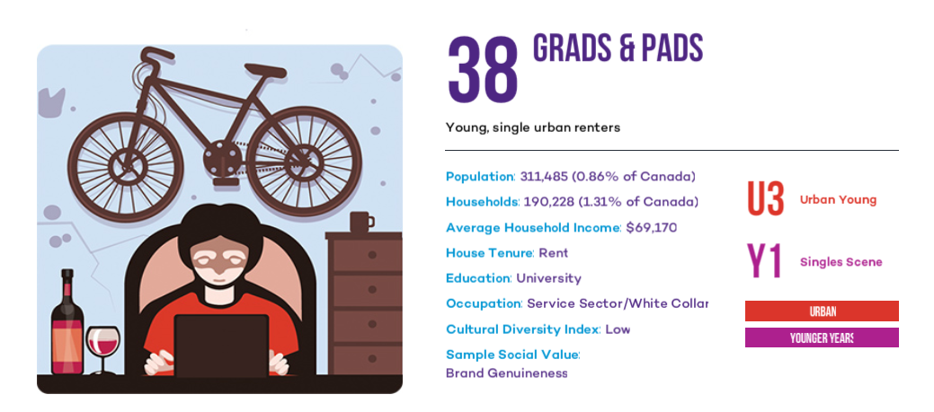
Appendix 6 PRIZM5 for postal code K2P 1M5 - Part 2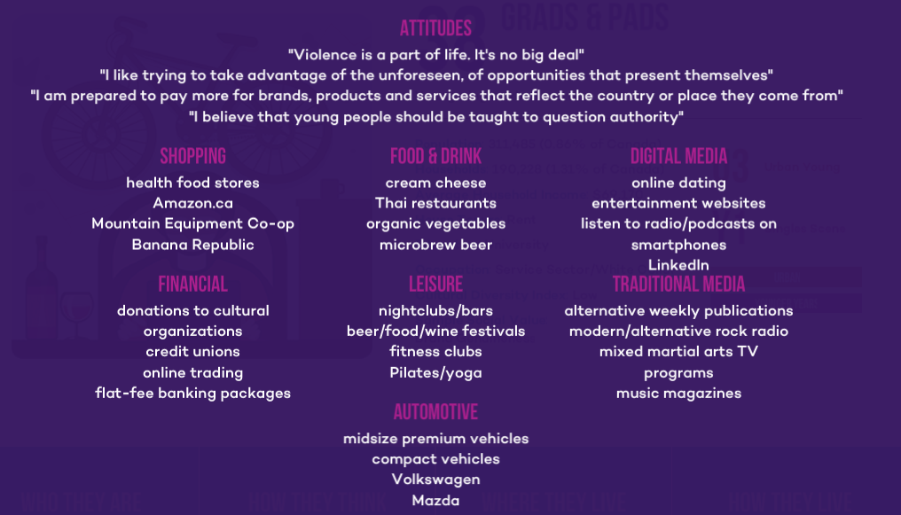
Appendix 7 Justification for segment size
Young Professionals | Based on 2011 data, the federal government employed 427,069 people, 32% of them work in Ottawa–Gatineau (Statistics Canada, 2011). Thus, 427,069*32%= 136,662.08 approximately 136,662 people work for the federal government in Ottawa-Gatineau.  There are 276,050 people aged 20-34 in Ottawa-Gatineau (Statistics Canada, 2017). This age range is considered young professionals because many college students graduate as 20 year olds and many graduate students finish school anywhere from 25 to 30 years old and begin their careers. There are also 897,825 people in the approximated working population of ages 15 to 64 (Statistics Canada, 2017). 276,050/897,825*100= 29.74% of the working population in Ottawa-Gatineau is aged 20-34.  136,662*29.74%= 40,643.2788 so approximately 40,643 people aged 20-34 work for the government. The vast majority of government offices are in downtown Ottawa  It's a reasonable assumption that people are willing to travel 5 blocks for lunch. The area within 5 blocks of Pirho Grill makes up approximately ⅙ of the area considered downtown Ottawa (See Appendix 19)  40,643*(⅙)=6773.33 approximately 6773 people are classified as the potential target market of young professionals
Gym goers/Health Enthusiasts | 1 in 37 Canadians attend a Goodlife fitness gym (Daly, 2014). There is 1 Goodlife Fitness gym and several other gyms within close proximity to Pirho Grill, which makes it reasonable to assume that this statement applies to the area surrounding Elgin. There are approximately 136,662 people working for the federal government in Ottawa-Gatineau and thus, traveling downtown daily (see “Young Professionals” portion for justification of this figure)(Statistics Canada, 2011). This is relevant because many people go to the gym before or after work. 136,662*(1/37) = 3,693.567 so approximately 3,693 people are classified as the potential target market of gym goers/health enthusiasts.
Night Owls | 60% of millennials visit nightclubs, “of that 60%, only 25% spend time at nightclubs more than once a month” (New Theory Magazine, 2015). 0.6*0.25=15% of millennials visit nightclubs. Of the population of Ottawa-Gatineau, 92,650 individuals are aged 20-24 (Statistics Canada, 2017).15%*92,650= 13,897.5. Approximately 13,897 people travel downtown to party because the majority of nightclubs in Ottawa-Gatineau are in downtown. Since people generally go out late once a week this number should be multiplied by 1/7. 13,897*(1/7)= 1,985.28 approximately 1,985 people are classified as the potential target market of night owls

Appendix 8 Perceptual Maps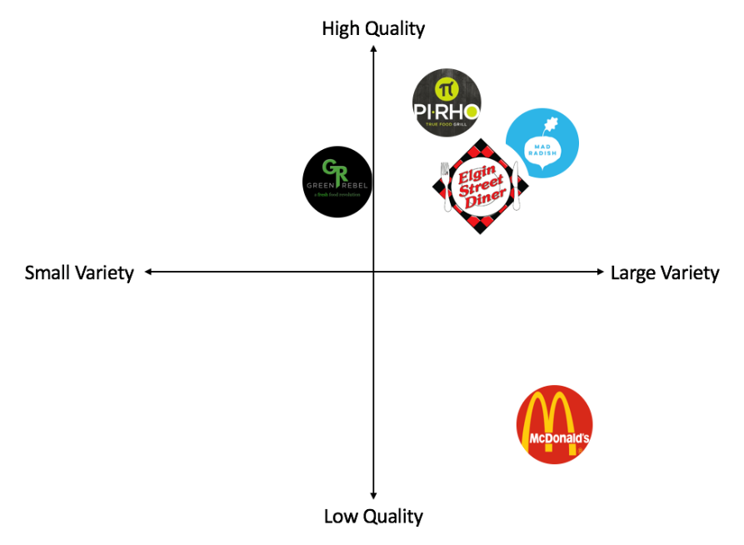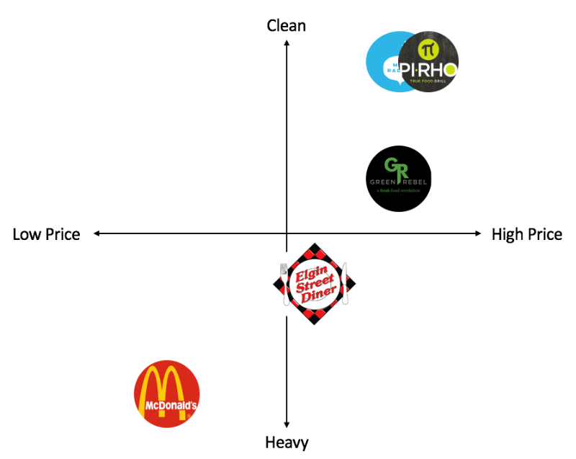
Appendix 9 Revenue and Cost Analysis for Facebook Ad
Revenue and Cost Analysis for Facebook Ad
Pirho makes a 10% profit on each meal sold, and a Pirho meal is on average $12. Each new customer is considered to give Pirho a $1.2 profit.
*Note: all information found is based off of a trial ad creation, Facebook offers estimates on advertising reach and link clicks (See Appendix 20).
Optimistic conditions:
The ad has the potential to reach up to 140000 people, 3000 link clicks, and potentially around 1500 new customers. With this information, Pirho has the opportunity to make a profit of $1,800.
Most likely conditions:
The ad could reach 50,000 people, 1,500 link clicks, and around 700 new customers. If this strategy attracts 700 new customers, Pirho has the opportunity to make a profit $840, excluding word of mouth as well.
Pessimistic conditions:
The ad has the potential to reach 23,000 people, 450 link clicks, and 175 new customers. If this strategy attracts 175 new customers, Pirho has the opportunity to make a profit of $210, excluding word of mouth as well.

Appendix 10 Revenue and Cost Analysis for In-Store Campaign
Revenue and Cost Analysis for In-Store Campaign
Costs
- Promotional Posters (Total Cost: 210 + 117.86 = $327.86)
Assuming a that there will be seven different promotional posters outlining the local sourcing for for Pirho Grill’s vegetables, sauces, spreads, proteins, and grains as well as two posters describing various eco-friendly initiatives. Assuming a student is hired to design the posters and it takes them 15 hours of work, a generous estimate, labour costs will be $210 assuming the 2018 minimum wage of $14.
14 x 15 = $210
Given the online pricing from Staples, a 12”x18” presentation poster costs $14.99 each. Therefore, plus tax, the cost of the physical posters will be $117.86.
14.99 x 7 x 1.13 = 117.86
- Events (Total Cost: 756 + 650.61+ 1800 = $3206.61)
Assuming we will need 3 extra employees to staff each event for 3 hours at a minimum wage of $14 and we have two events per month, labour costs will total $756.
3 x 14 x 3 x 6= $756
To promote the event, beyond social media, there will be 4 promotional posters per event at a cost of $23.99 each, with tax added on to that. Therefore, the total cost is $650.61 for these promotional posters.
23.99 x 4 x 6 x 1.13 = $650.61
To provide compensation to suppliers who attend events, $300 will be given to cover their expenses. Assuming 3 events with 2 suppliers, the total cost will be $1800.
3 x 2 x 300 = $1800
- Samples (Total Cost: 122.4 + 504 = 626.4)
Assuming a cost of $10 (retail value) /tray of food and that 1 tray is used per hour with a 34% cost of goods ratio, the total cost of food used for samples with 3 hours of samples once a week for 12 weeks will be $122.4
10 x 0.34 x 3 x 12 = 122.4
Assuming we will need one extra employee to work a sample shift of 3 hours, once a week for 12 weeks at a minimum wage of $14, the labour costs will be $504.
3 x 14 x 12 = $504

Therefore, the total cost, including a $1,000 safety net for unplanned expenses and doubling this value to include both locations, is $10,321.74
(4160.87 + 1000) x 2 = $10,321.74
Revenues
All revenues have been calculated on the assumption that a new customer will visit twice within 3 months and tell one friend that makes two visits. The calculations also assume the average that a customer spends on food is $12 at a 10% profit ratio. All revenues are doubled because of two locations)
- Optimistic Conditions (Revenues: 691.2 + 432 = $1123.2 x 2 = $2246.4)
Given that the samples bring 12 new customers per week, the events bring in 15 new customers per event and following the assumptions outline above, revenues will be $907.2.
Samples: 12 x 1.2 x 2 x 12 = 345.6 x 2 = $691.2
Events: 15 x 1.2 x 2 x 6 = 316 x 2 = $432
- Most Likely Conditions (Revenues: 518.4 + 288 = $806.4 x 2= $1612.8 )
Given that the samples bring in 9 new customers per week, the events bring in 10 new customers each and following the assumptions outline above, revenues will be
Samples: 9 x 1.2 x 2 x 12 = 259.2 x 2 = $518.4
Events: 10 x 1.2 x 2 x 6 = 144 x 2 = $288
- Pessimistic Conditions (Revenues: 172.8 + 57.6 = $23-0.4 x 2= $460.8)
Given that the samples bring in 3 new customers per week, the events bring in 2 new customers each and following the assumptions outline above, revenues will be
Samples: 3 x 1.2 x 2 x 12 = 86.4 x 2 = $172.8
Events: 2 x 1.2 x 2 x 6 = 28.8 x 2 = $57.6

Appendix 11 Sample Video Frame
Source: https://www.youtube.com/watch?v=I0S2oCx1ZJw
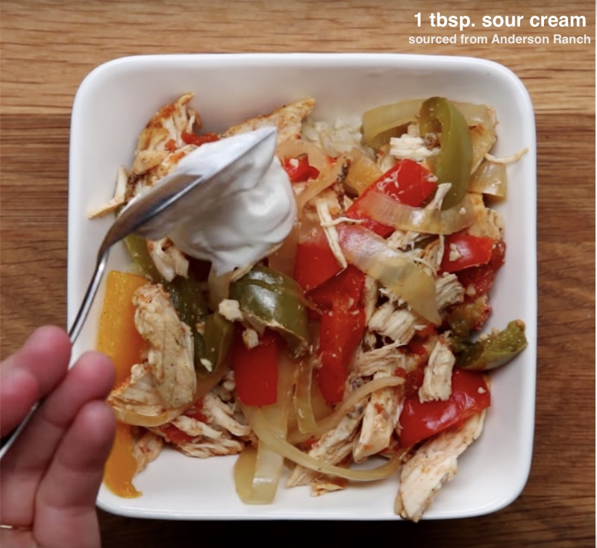
Appendix 12 Revenue and cost analysis for Point-of-View Video Campaign
Revenue and Cost Analysis for POV Video Campaign
Costs
- Film Intern (Qualified Student) (Total Cost : $768 + $384 = $1152)
Assuming each video shoot will take 6 hours and there will be 8 in total with a film intern hired at a wage of $16/hour to film. Assuming it will take 3 hours of editing per video.
6 hours x 8 shoots x $16 = $768
3 hours x 8 videos x $16 = $384
- Additional Website Pages (Total Cost: $224)
Assuming 4 additional pages are needed and a student is hired at $14/hour and will spend 4 hours on the programming and design of each new page.
4 x 14 x 4 = $224
- Food Cost (Total Cost: $65.28)
Assuming each shoot requires the use of two meals’ worth of ingredients at an average cost of $12/meal but a cost of goods at 34%. Assuming there are 8 shoots.
16 x 12 x 0.34 = $65.28
- Employee Cost (Total Cost: $1344)
Assuming each shoot will require 2 employees on-site to assist and make the food over the 6 hour shoot with 8 shoots in total and they are paid $14/hour.
2 x 6 x 8 x 14 = $1344
- Narcity Promotion (Total Cost: $2500)
Assuming the cost of a single narcity promotion is $2500.
- Instagram Influencers (Total Cost: $2000+$2000+$600+$450 = $5050)
  - Joey Kidney (Total Cost: $1000 x 2 = $2000)
Assuming that with 107 000 followers, he will charge $1000 per instagram feature and he will feature Pirho Grill videos twice.
  - ottcityfoodies (Total Cost: $500 x 4 = $2000)
Assuming that with 17 600 followers, they will charge $500 per instagram feature and they will feature Pirho Grill videos four times.
  - busygirlhealth (Total Cost: $200 x 3 = $600)
Assuming with 4 289 followers that she will charge $200 per instagram feature and she will feature Pirho Grill’s videos 3 times.
  - vegan3ats (Total Cost: $150 x 3 = $450)
Assuming with 2 238 followers they will charge $150 per instagram feature and they will feature Pirho Grill’s videos 3 times.
Therefore the total cost for this strategy, including a $1000 safety net for unexpected expenses, is $11,335.28.
Revenues
All calculations assume an average meal cost of $12 with a 10% profit margin.
- Pessimistic (Total Revenue : $240 + $120 = $360)
Assuming that this campaign reaches 100 new customers who come in twice in the next fiscal year and each tell one friend who comes in once.
100 x 12 x 2 x 0.1 = $240
100 x 12 x 0.1 = $120
- Most Likely (Total Revenue: $1080 + $1440 = $2520)
Assuming that this campaign reaches 300 new customers who come in 3 times in the next fiscal year and each tell 2 friends that come in twice.
300 x 12 x 3 x 0.1 = $1080
300 x 2 x 12 x 2 x 0.1 = $1440

- Optimistic (Total Revenue: $2880 x 2 = $5760)
Assuming that this campaign reaches 600 customers who come in 4 times and each tell two friends who come in twice.
600 x 12 x 4 x 0.1 = $2880
600 x 2 x 12 x 2 x 0.1 = $2880

Appendix 13 Decision Grid
Strategic Alternative/  Decision factor | DF1: Financial Implications | DF2: Time to Full Implementation | DF3: Aligns with Firm’s Strategic Objectives | DF4: Aligns with Firm’s Target Market | DF5: Length of promotion
ST1: Facebook Advertising | High financial outlay | Immediate Implementation | Partially | No | One year
ST2: In Store Campaign | Low financial outlay | 2 months | Yes | Yes | 3 months
ST3: POV Video Campaign | Low financial outlay | 2 months | Yes | Yes | 4 months

Appendix 14 Mini SWOT Analysis - Facebook Ad
Strategy 1 - Facebook Ad
Strengths | Weaknesses
- Increases brand awareness  - Facebook has the ability to do trial ads  - Facebook ads can be condensed to one very specific market segment  - By age, interests, location, language, gender, etc. | - Inability to give specific details and insights on Pirho Grill’s main values and initiatives  - Requires entire budget for the one proposed campaign.  - With campaign success the price would increase  - Higher cost for locally specified ads due to competing bidders for ads
Opportunities | Threats
- Facebook is an absolutely massive social media platform used by over half the canadian population (The Canadian Press, 2013). | - Facebook and social media users often use programs to disable advertisements such as AdBlock

Appendix 15 Mini SWOT Analysis - In Store Promotion
Strategy 2 - In Store Promotions
Strengths | Weaknesses
- Meets marketing objective of providing insights about initiatives to customers.  - Builds customer base by attracting customers to the store and introducing them to Pirho Grill values  - Non-technology focused strategy could attract the customers who aren’t tech savvy | - Limited reach since samples will only bring in customers that are walking in the area close to either location  - Events are not a guarantee that customers will purchase food  - Samples cost money and might create food waste
Opportunities | Threats
- Events in urban centres garner attention naturally, above and beyond promotional efforts  - Ottawa tourism is expected to increase in the next five years bringing more people downtown (Ottawa Tourism, 2017) | - Weather in Ottawa is unpredictable and unforgiving, people aren’t out and about in pouring rain.  - Winter lasts for a very long time in Ottawa and people generally don't go out in the cold.

Appendix 16 Picture of Pirho Grill food
Source: Pirho Grill Instagram
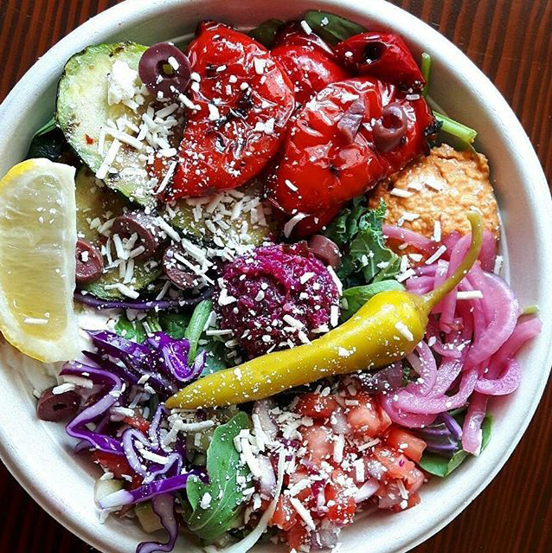

Appendix 17 Mini SWOT Analysis - Point-of-View Video Campaign
Strategy 3 - POV Video Campaign
Strengths | Weaknesses
- Strengthens Pirho Grill’s online platform  - Effectively reaches the younger part of Pirho Grill’s target market (20-25)  - Communicates details about initiatives concisely  - Improves customers familiarity with Pirho Grill products and the brand  - Fits on all social media platforms  - Provides detail without overwhelming customers | • Limited to online platforms  - Videos will require careful planning  - Videos may be time-consuming to produce  - Will pull staff away from regular duties, potentially requiring overtime or more staff
Opportunities | Threats
- Videos can be shared to friends and followers on social networks if people enjoy them | - Videos do not garner attention on their own - easy to pass over in a social media feed  - Ever-changing consumer attitudes could put video platforms out of style  - Social media representatives could become controversial

Appendix 18 Implementation Timeline
Implementation Timeline: Point-of-View Video Campaign
Preparatory Phase
Day 1 | Management will post a notice with a sign-up for the campaign team. Sign up will be open to management and kitchen staff. Management will also develop ad for student videographer and student web developer.
Day 4 | Campaign team will have the first meeting. Management introduces aim of campaign and hosts an open brainstorming session for additional input. Job ads are reviewed and placed online. Chosen social media influencers are reviewed by team (Narcity, Joey Kidney, Ottcityfoodies, busygirlhealth, vegan3ats, and vegan.ottawa) and can be changed if the committee sees fit.
Day  7 | Social media influencers will be initially approached with an outline of the campaign’s concept and Pirho Grill’s values.
Day 10 | Preliminary contracts and compensation will be drawn up with social media influencers.
Day 12 | Social Media influencers will have a meeting with management in order to fully grasp Pirho Grill’s values, feel the ambience of the restaurant and try samples of menu items.
Day 13 | Comment box near cash will open where customers can input their favorite Pirho Grill menu item.
Day 14 | Management will begin to analyze data to gain grasp on which menu items to feature on campaign.
Day16 | Management will analyze menu to see which menu items are lagging and need a boost of promotion.
Day17 | Third meeting will occur, open brainstorming session where all employees are encouraged to share which menu items they believe should be featured in the campaign.
Day 18 | Management will contact student interns for interviews that will occur within the next 7 days.
Day 24 | All customer and employee suggestions will be sorted by popularity.
Day 26 | Management will decide on a student intern for videography and website development.
Day 27 | Fourth meeting will occur. All options will be considered and the 8 most popular menu items and menu items needing a boost will be selected.
Day 28 | The 8 menu items that will be featured in the campaign will be finalized.
Day 30 | Committee will meet with student videographer to make the scripts for 4 videos.
Day 37 | First Day of Filming (Video 1)
Day  40 | Committee will meet again with student videographer to make the scripts for remaining 4 videos.
Day 42 | Student web developer progress check. Committee will be sent what has been completed so far. 2 out of 4 pages should have been completed at this stage.
Day  44 | Second day of filming (Video 2)
Day 53 | Third day of filming (Video 3)
Day55 | Student web developer progress check. Committee will be sent what has been completed. All 4 pages should have been completed by this stage.
Day 60 | Fourth day of filming (Video 4). End of preparation phase
Campaign Phase
Day 61 | First video is released to all social media platforms and promoted by two of the social media influencers in the coming 7 days. All new website pages will be posted
Day 65 | Fifth day of filming (Video 5).
Day 67 | Weekly analysis of videos views and committee meeting to discuss.
Day 72 | Sixth day of filming. (Video 6).
Day 74 | Second video is released to all social media platforms and promoted by two social media influencers. Biweekly analysis of social media following and sales volume conducted. Weekly analysis of video views.
Day 80 | Seventh day of filming. (Video 7).
Day 81 | Weekly Analysis of video views and committee meetings to discuss.
Day 87 | Eighth day of filming. (Video 8)
Day 88 | Third video is released to all social media platforms and promoted by two social media influencers. Biweekly analysis of social media following and sales volume conducted. Weekly analysis of video views.
Day 95 | Weekly analysis of video views and committee meetings to discuss.
Day 102 | Fourth video is released to all social media platforms and promoted by two social media influencers. Biweekly analysis of social media following and sales volume conducted. Weekly analysis of video views.
Day 109 | Weekly analysis of video views and committee meetings to discuss.
Day 116 | Fifth video is released to all social media platforms and promoted by two social media influencers. Biweekly analysis of social media following and sales volume conducted. Weekly analysis of video views.
Day 123 | Weekly analysis of video views and committee meetings to discuss.
Day 130 | Sixth video is released to all social media platforms and promoted by two social media influencers. Biweekly analysis of social media following and sales volumes conducted. Weekly analysis of video views.
Day 137 | Weekly Analysis of video views and committee meetings to discuss.
Day 144 | Seventh video is released to all social media platforms and promoted by three social media influencers. Biweekly analysis of social media following and sales volume conducted. Weekly analysis of video views.
Day 151 | Weekly analysis of video views and committee meetings to discuss.
Day 158 | Eighth video is released to all social media platforms and promoted by two social media influencers. Biweekly analysis of social media following and sales volume conducted. Weekly analysis of video views.
Day 158 - Day 168 | Gather final data on campaign.
Day 168 | Final day of campaign. Final committee meeting. Final data analysis and conclusions made.

Appendix 19 Downtown area(red) and area surrounding Pirho Grill(yellow)
Appendix 20 Facebook Advertising Metrics
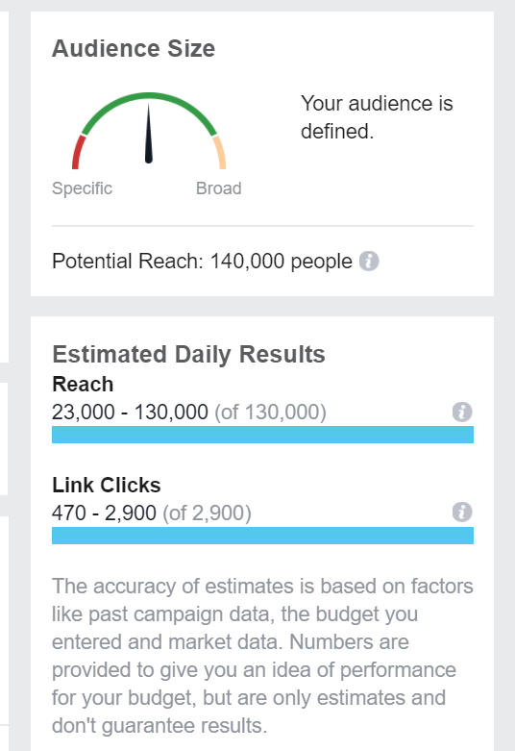

Appendix 21 Group Contract, Declaration of Academic Integrity, and Copy of Memorandum of Understanding
- To be submitted to Dr. Leighann C. Neilson in class Tuesday December 5th 2017.

