Chapter 1 – Introduction to the World of Retailing

Retailing: set of business activities that add value to the products and services sold to consumers for their personal or family use
- Also involves the sale of services
- Can be online

Retailer’s Role in a Distribution Channel
Retailer: business that sells products or services, or both, to consumers for their personal or family use
- Attempt to satisfy consumer needs by having the right merchandise, at the right price, at the right time, in the right quantities, at the right place

Distribution Channel: set of firms that facilitate the movement of products from the point of production to the point of sale to the ultimate consumer
Manufacturing Wholesaler Retailer Consumer

Wholesalers: engage in buying, taking title to, often storing, and physically handling goods in large quantities, then reselling the goods (usually in smaller quantities) to the retailers or industrial or business users

Vertical Integration: a firm performs more than one set of activities in the channel, such as investments by retailers in wholesaling or manufacturing

Backward Integration: when a retailer performs some distribution and manufacturing activities, such as operating warehouses or designing private-label merchandise

Forward Integration: occurs when manufacturer undertakes retailing activities, such as Roots operating its own retail stores

Functions Performed by Retailers
- Providing an assortment of products and services
  - Grocery stores provide everything – not just Kraft, or other manufacturer
- Breaking bulk
  - A function performed by retailers or wholesalers in which they receive large quantities of merchandise
- Holding inventory
  - Reduce consumer’s cost of holding the product
- Providing services
  - Accepting various methods of payments
  - Displaying products in a nice way

Social and Economic Significance of Retailing
Corporate Social Responsibility (CSR): voluntary actions taken by a company to address the ethical, social, and environmental impacts of its business operations and the concerns of its stakeholders

Firms typically go through several of stages before fully integrating CSR into their strategies
- Engage only in CSR required by law
  - Not actually convinced in the importance of CSR
- Go beyond activities required by law that provide a short-term financial benefit
  - Reducing energy consumption in stores just because it reduces costs
- Companies operate responsibly because it’s the “right thing to do”
- Believe these activities must be done for the well-being of everyone

Retail Sales in Canada
Largest retailers tend to concentrate their operations in Ontario, Alberta, Quebec and British Colombia
- 9 out of top 20 retailers in Canada are American

Opportunities in Retailing
- Management Opportunities
  - Retail manager
- Entrepreneurial Opportunities

The Retail Management Decision Process
Understanding the world of retailing
- Retail managers must understand their environment
- Changes in the macro-environment – technological, social, and ethical/legal/political factors on retailing
- Micro-environment – customers and competitors
  - Intratype Competition: competition between retailers of the same type
    - Loblaws vs. Sobeys
  - To appeal to broader group of customers, retailers increase their variety
    - The number of different merchandise categories within a store or department; also called breadth
    - Clothing and food are now available at grocery, department and discount stores
  - Scrambled Merchandising: the offering of merchandise not typically associated with the store type, such as clothing in a drug store
  - Intertype Competition: competition between retailers that sell similar merchandise using different formats, such as discount and department stores
    - Scrambled merchandising increases intertype competition
    - Makes it harder for retailers to identify and monitor competition
  - Intensity of comp. is greatest among retailers located close together with retail offerings that are viewed as very similar, such as in a shopping mall
  - Different management perspectives = different competition
    - Store manager vs. particular department manager
  - Customers – our needs are changing at an ever-increasing rate

Developing a Retail Strategy
- Next stage in the retail management decision making process
- Retail Strategy: indicates how the firm plans to focus its resources to accomplish its objectives
  - The target market, or markets
  - Nature of the merchandise/services the retailer will offer to satisfy needs of target market
  - How the retailer will build a long-term advantage over competitors
Self-Service: customers select merchandise, bring to checkout line and carry it to cars

Strategic Decision Areas
- Market strategy: based on analyzing the environment and the firm’s strengths/weaknesses
  - Must be consistent with the firm’s financial objectives
  - Sales, cost, expenses, etc. are used to evaluate market strategy and implementation
- Financial strategy
- Location strategy: location is usually the consumer’s top consideration when selecting a store
  - If you get best location, another comp. retailer needs to settle for second best location
- Organizational structure
  - And HR both intimately related to market strategy
  - Helps coordinate the implementation of retailing strategy by buyers, store managers, and sales associates.
- HR strategy
- Information systems
  - Help gain strategic advantage.
  - [UPC,POS] these technologies are part of an overall inventory management system:
    - to give customers a more complete selection of merchandise
    - increase awareness of inventory levels
    - decrease inventory investment
  - Retail information and supply chain management ^^^
- Supply chain strategies
- Customer relationship management strategies

Customer Relationship Management (CRM): business philosophy and set of strategies, programs, and systems that focus on identifying and building loyalty with a firm’s most-valued customers
- Use data analysis to find more valued customers

Implementing a Retail Strategy
- Management develops a retail mix that satisfies the needs of its target market better than competitors
- Retail mix includes the decision variables retailers use to satisfy customer needs and influence their purchase decisions
- Product, place, physical, price, people, promotion, process
- Look at page 17
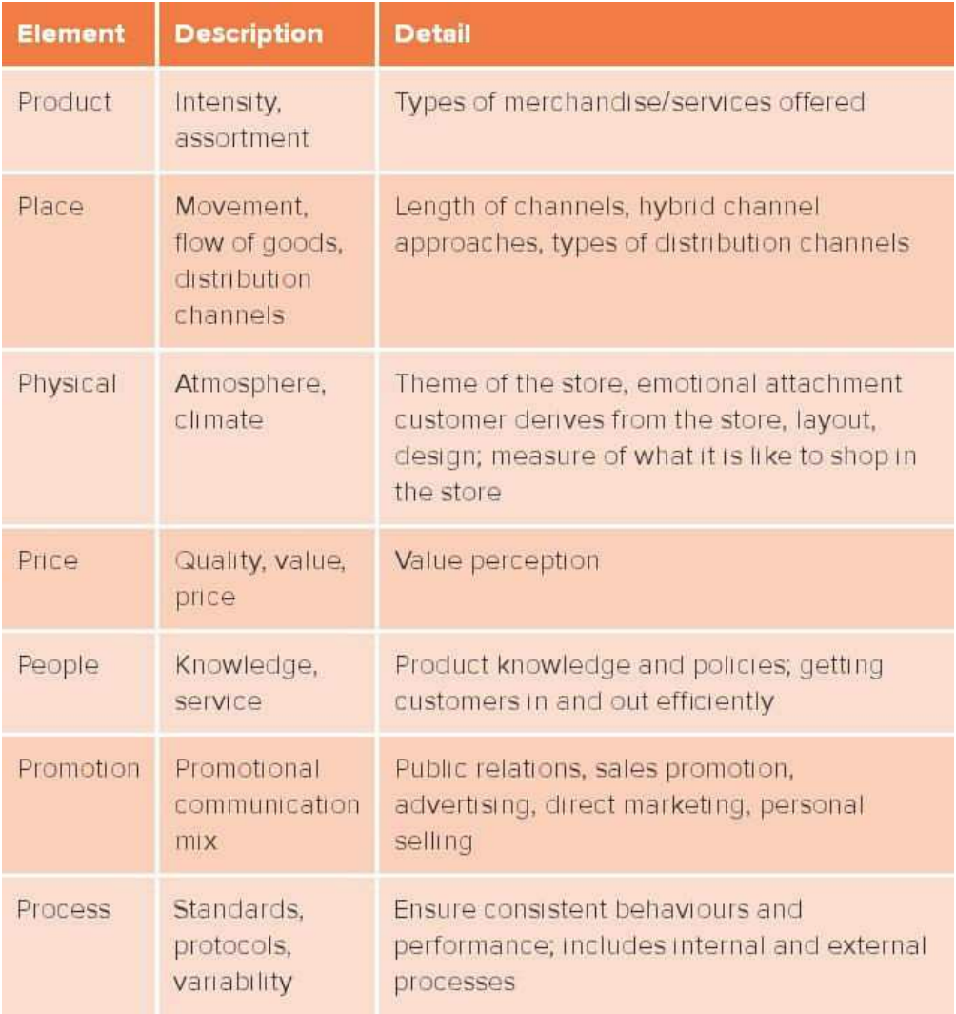

Ethics: principles governing the behaviour of individuals and companies to establish appropriate behaviour and indicate what is right and wrong

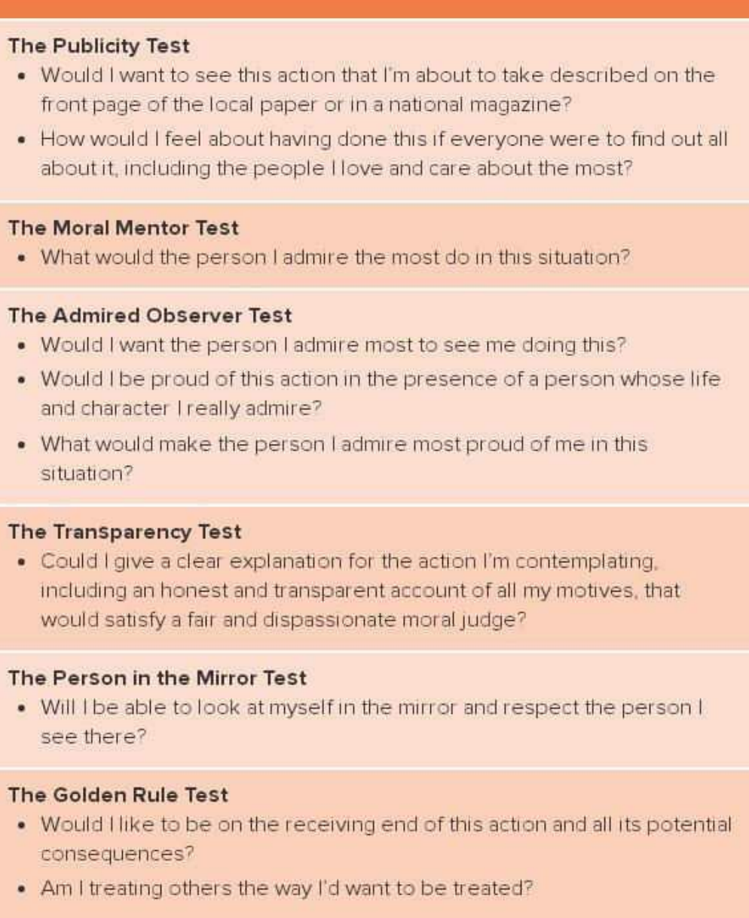

Chapter 2 – Types of Retailer

Growing Diversity of Retail Formats
Retail 2020 Report, following 10 trends are profoundly changing the retail industry

1. Empowered, discriminating consumers. Consumers can make informed decisions with
the increased access to product information, price comparisons, and user reviews, and
then widely share their experiences with others. These empowered, discriminating
consumers are putting pressure on retailers to add meaningful value to what they can
find for themselves, both online and in stores.
2. Ubiquitous connectivity. It has never been more critical for retailers to integrate digital
opportunities into the shopping experience, with the Internet available at work, at
home, and on the go (mobile). Digital and physical experiences are converging, with
shoppers expecting interactive, value-added experiences anytime, anywhere, and
through any channel.
3. Buying local, going green. Consumers want to consume in a responsible, sustainable
way. Retailers are responding by embracing the issues and helping customers and
suppliers do the same.
4. Explosion of consumer data. The enormous amount of data generated by points of sale,
social media, corporate websites, and tracking URLs is greater than the ability of many
retailers to exploit the potential value of this input.
5. New age of marketing. With increasing amounts of data available on customers, their
online activities, and their purchasing patterns, retailers are able to create more
targeted marketing campaigns.
6. Scientific retailing. By applying smart algorithms and deep, data-driven analytics to the
massive amounts of data, retailers are able to maximize all aspects of their business,
including pricing, assortments, shelf displays, staffing, and warehouse space.
7. Growing retailer power. The top five grocery stores in Canada now have 67 percent
share of the market, with Loblaw Companies Ltd. dominating with 29.9 percent. Canadian Tire’s recent acquisition of the Forzani Group is a critical component of its strategy to maintain leading market share in sporting goods in Canada.
8. Maturing retail technologies. A wide range of maturing technologies is allowing
companies to streamline backroom functions and increase efficiency, helping to offset
higher labour costs.
9. Blurring boundaries among channels, formats, and brands. Shoppers Drug Mart is selling
food; Loblaws has in-house bank branches; and Indigo has Starbucks cafés in stores.
Retailers are evolving into a more integrated business model where all channels share a
common strategy for profitable growth.
10. Challenged store economics. Physical stores turning into showrooms in the minds of
consumers and the rise of online buying are forcing retailers to rethink their costly real-estate
assets and merchandising formats.

Increasing Industry Concentration
Major mass merchandisers: Canadian Tire and Walmart
Drug Store: Shoppers Drug Mart
Consumer Electronics: Best Buy
Warehouse Club: Costco
Department Stores: Holt Renfrew, Hudson’s Bay and Sears
Grocery Stores: Weston Group (Loblaws, Superstore, No Frills, Zehrs, etc.)
Home Improvement: Home Depot and Rona

Trend towards blurring of retailing channels will continue
- Shoppers selling luxury cosmetics
- Grocery stores opening pharmacies

Retailer Characteristics
The most basic characteristic of a retailer is its retail mix – the elements used by a retailer to satisfy its customers’ needs (LOOK AT P. 18 FOR RETAIL MIX)

Four elements of the retail mix are particularly useful for classifying retailers
- Type of merchandise/services offered
- Breadth and depth of merchandise offered
- Level of customer service
- Price of merchandise

Type of Merchandise
North American Industry Classification System (NAICS): classification of retail firms into a hierarchical set of 6-digit codes based on the types of products and services they produce and sell
- To collect business data in Mexico, Canada and USA
- First two: identify firm’s business sector
- Remaining four: identify various subsectors
- Merchandise retailers: 44 and 45

Breadth and Depth
Variety/Breadth: number of merchandise categories a retailer offers
- A number of different product lines
Depth: number of different items in a merchandise category
- Number of items within each product line

Hudson’s Bay – wide and shallow
- A number of product lines, but a limited assortment in each category
Walmart – narrow and deep
- Limited number of merchandise categories and a large assortment in each category
House of Knives – narrow and shallow
- Few merchandise categories and limited assortment in each category

Stock Keeping Unit (SKU): each different item of merchandise
- The smallest unit available for keeping inventory control
- In soft goods merchandise, SKU usually means size, colour and style
- Box of Tide packets and Tommy Hilfiger shirt, size 12-20 are both SKUs
- Stores specializing in toys, for example, would have more types of toys (more SKUs)
  - 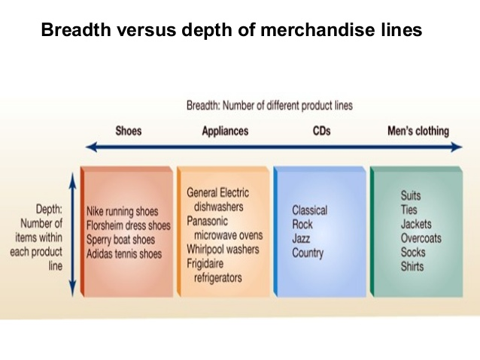Warehouse clubs or discount stores that sell many other categories of merchandise besides toys would have less
Cost of Offering Breadth and Depth of Merchandise and Services
Stocking deep assortment is great for customers but costly for retailers
- Offering many SKUs – inventory investment increases because retailer must have backup stock
- Sales are also costly because you need salespeople to provide info and assist

General Merchandise Retailers
Discount stores, specialty stores, category specialists, department stores, home improvement centres, off-price retailers and value retailers
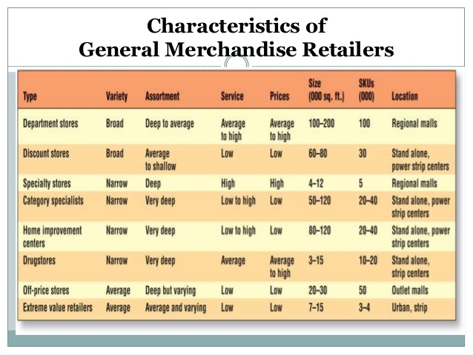

Discount Stores: retailer that offers a broad variety of merchandise, limited service and low prices
- Both private labels and national brands
- Referred to as mass merchandisers or full-line discount stores
- Dollarama, Giant Tiger, Walmart
- Full-line discount stores (Walmart) experience intense competition from discount specialty stores that focus on a single category merchandise
  - Golf Town, Staples, Home Sense, etc.
  - Old Navy and Hudson’s Bay for apparel
- To respond to this comp. they have created more attractive shopping environments, placed more emphasis on apparel and developed strong private-label merchandise programs

Specialty Stores: concentrates on a limited number of complementary merchandise categories and provides a high level of service in an area typically under 8000 sqf.
- Ie. Sephora, Pro Hockey Life

Issues in Specialty Store Retailing
- Retail strategy for a very specific market segment by offering deep but narrow assortments along with knowledgeable staff
- Vulnerable to shifts in consumer tastes and preferences as they focus on specific market segments
- H&M gets new merchandise 2-3x a week (it’s expensive)

Category Specialist/Category Killer
Category Specialist: a discount retailer that offers a narrow but deep assortment of merchandise in a category and thus dominates the category from the customers’ perspective, also called category killer
- Bass Pro Shops – everything a person needs for hunting/fishing
- 27 cent plastic bait to $45,000 rec vehicles
- Sales associates are knowledgeable outdoors people
- Big-box category killer – large format stores typically ranging from 40000-200000 sqf
  - Superstore 3x the traditional supermarket
  - Home depot
  - Chapters – 12x traditional bookstore
  - Winners

Issues for Category Specialists
- These sophisticated big-box, category killer venues are often grouped together in power centres, dominating the industry with their low prices, extensive product offerings, and ample customer parking
  - Competition is intense
- Where appropriate, category specialists have attempted to differentiate themselves
with service. For example, Home Depot, Rona, and Lowe’s hire licensed contractors
as sales associates to help customers with electrical and plumbing repairs.
- Bigger is not always better. North American retailers are turning to the smaller format
concepts that have been trending in Europe, Asia, and Latin America for several
reasons: Real estate is not always available for big-box players; populations are
shifting; and the Web is having a significant impact on consumer in-store
expectations and shopping processes.

Department Store: retailer that carries a broad variety and deep assortment of stock, offers some customer services, and is organized into separate departments for displaying merchandise
- Largest in Canada are Sears, Hudson’s Bay
- Organized into three tiers
  - First tier: upscale, high-fashion chains with exclusive designer merchandise and excellent customer service, such as Holt Renfrew and Nordstrom
  - Second tier: more modestly-priced merchandise with less customer service, such as Hudson’s Bay
  - Third tier: value-oriented catering to more price-conscious customers, such as Sears
    - Faces significantly competitive challenges from discount stores
- Sell both soft (apparel and bedding) and hard goods (appliances, furniture, electronics)
- Traditionally they attracted customers by pleasing ambiance, attentive service and a wide variety of merchandise under one roof
- Each department has a specific selling space allocated to it and a POS terminal to transact and record sales, and salespeople to assist customers
- Often resembles collection of specialty shops
- Sometimes departments are leased and operated by an independent company
  - Leased Department: an area in a retail store that is leased or rented to an independent firm
  - Leaseholder is typically responsible for all retail mix decisions involved in operating the department and pays the store a percentage of its sales as rent
  - Retailers lease when they feel lack of expertise to operate the department efficiently
  - Common leased departments in Canadian stores are salons, pharmacies, shoes, jewelry, furs, etc.
- Offer full range of services from altering clothing home delivery
- Apparel is displayed on mannequins to create excitement
- Emphasize special promotions such as elaborate displays during holiday season

Issues in Department Store Retailing
- Sales have stagnated, and market share has fallen in recent years due to increased competition from discount stores and specialty stores and a decline in perceived value for merchandise and services
- Consumers believe that department stores are no longer romantic or convenient
  - Difficult to get into as they are located in large malls
  - Difficult to find specific merchandise because same category is often located in several designer departments and diff to get professional sales assistance because of labour cutbacks
- Charge higher prices

To deal with eroding market share:
- attempting to increase the amount of exclusive merchandise they sell
- undertaking marketing campaigns to develop strong images for their stores and brand
- expanding their online presence

Drugstore: specialty store that concentrates on health and personal grooming merchandise

Issues in Drugstore Retailing
- sustainable sales growth bc aging population requires more prescription and margins for prescription pharmaceuticals are higher than for other drugstore merchandise
- Non-prescription side is squeezed by considerable competition from pharmacies in discount stores and supermarkets, and prescription mail-order retailers
- Major drugstores in response to this are building larger stand-alone stores offering a wider assortment of merchandise, more frequently-purchased food items and drive-through windows for picking up prescriptions
- Changing role of pharmacists – dispensing pills providing healthcare assistance

Off-Price Retailers: offers an inconsistent assortment of brand-name goods, fashion-oriented soft goods at low prices
- Winners
- They can sell brand-name and even designer-label merchandise at low prices due to their unique buying and merchandising practices
  - Most of it is bought from manufacturers or other retailers with excess inventory at the end of the season
  - Typically, it is bought 1/4-1/5 of the original wholesale price
  - Odd sizes or unpopular colours and styles or may be irregular (having minor mistakes in construction)
  - Don’t ask for advertising allowances, return privileges or markdown adjustments, or delayed payments
- Consumers can’t be confident that the same type of merchandise will be in stop every time they are in stock
- They will sometimes complement opportunistically bought merchandise with merchandise bought at regular wholesale price
- Two types of off-price retailers are:
  - Closeout Retailers: sell a broad but inconsistent assortment of merchandise usually obtained from a store closing or bankruptcy, consisting of general merchandise, apparel, and home furnishings.
    - Fashion Direct is an example
  - Outlet Stores: off-price retailers owned by manufacturers or retailers
    - Outlet stores owned by manufacturers are referred to as factory stores
    - They can be found clustered together in one geographic area (Halton Hills)
    - Manufacturers view outlet stores as an opportunity to sell irregulars, production overruns and merchandise returned by retailers
    - Also allow manufactures some control over where their branded merchandise is sold at discount prices
    - Holt Renfrew operates HR2
      - Holts can maintain their image of offering desirable merchandise at full price
    - Problems occur as traditional mall landlords dispute with tenants who are opening branches in power centres located close to their shopping centres
      - Fashion retailers are selling identical merchandise and price points of their clothes at their power Centre stores and their mall locations
        - The consumer is confused, assumes there are higher prices at the mall and thus avoids shopping at traditional shopping centres

Value Retailers: general merchandise discount stores that are found in either lower-income urban or middle-income families suburbs, or in rural areas, and are much smaller than traditional discount stores.
- Fastest-growing segment in Canada retailing
- These consumers demand well-known national brands, they often can’t afford to buy large-size packages
  - Vendors are creating special smaller packages for these people
- Follow variety of business models
- Suburban strip malls
- Specialize in giftware, party and craft items rather than consumables
- Few just sell merchandise for a dollar
  - $1 is focus, but chains carry many different price points, all rounded off at even dollars

Pop-Up Stores
- Temporary stores
- Pop up unexpectedly for hours, days or months, draw word-of-mouth crows then vanish and may resurface someplace else
- Subscribers are usually given notice via email as to time and place
- Retailers must be prepared to cater aggressively to their customers anywhere anytime
- Effective promotional medium

Food Retailers
People used to buy food primarily at conventional grocery stores
- Today, discount stores and warehouse clubs are significantly changing consumers’ food purchasing patterns because they also food
- Traditional food retailers carry many non-food items, plus many have pharmacies, photo processing centres, banks, and cafes

Combination Stores: retailers that sell both food and non-food items

Supermarkets
Conventional Supermarket: large, self-service retail food store offering groceries, meat and produce, as well as non-food items such as health and beauty aids and general merchandise
- Carry about 30,000 SKUs

Limited-Assortment Supermarkets (extreme-value food retailers): stock about 2000 SKUs
- M&M Meat Shops
- One convenient aisle and large glass-door freezers to display the entire section
- Certified product consultants serve the customer
- Dollar Tree Canada

Superstore: large conventional supermarket with expanded-service deli, bakery, seafood and non-food sections

To compete against other food retailing formats, conventional supermarkets are differentiating their offerings by:
- Emphasizing fresh perishables
- Targeting health-conscious and ethnic customers
- Providing a better in store experience
- Offering more private label brands

Fresh Merchandise
- Category that is around the outer walls of a supermarket, known as the power perimeter including dairy, bakery, meat, florist, produce, deli and coffee bar
- Attract consumers so they are profitable
- Dairy and produce sections are high-need, and if high quality and priced competitively can increase store loyalty
- Meal solutions for time-pressured consumers

Health/Organic Merchandise
- Conventional supermarkets are offering more natural, organic and fair-trade foods for the growing segment of consumers who are health and environmentally conscious
- Fair-Trade: purchasing from factories that pay workers a living wage – considerably more than the prevailing min wage – and that offer other benefits such as on-site medical treatment
- Locavore Movement: focuses on reducing the carbon footprint caused by the transportation of food throughout the world
- Miles calculated from farm to plate

Private-Label Merchandise
- Benefit to the customers include having more choices and finding the same ingredients and quality, but at lower prices
- Benefits to retailers are increased store loyalty, the ability to differentiate themselves form the competition, lower promotional costs, and higher gross margins compared with national brands
- Premium private label is the fast-growing segment within the private label category
  - Affordable indulgence and targets the so-called cross-shopping

Improving the Shopping Experience
- Creating enjoyable experience through better store ambiance and customer service
- “food as theatre” concept

Big-Box Food Retailers
Supercentres: 160,000 to 200,000 sqf in size and offer a wide variety of food (30-40%) and non-food merchandise (60-70%)
- Fastest growing in retail category
- 100,000 – 150,000 SKUs
- Loblaws expanded its product offering by including clothing, pharmaceuticals, and other non-food items
- One-stop shopping
- Customers would drive farther
- Higher margin for general merchandise

Hypermarkets: greater than 200,000 sqf, combination food (60-70%) and general merchandise retailers
- Typically, stock less than supercenters, 40,000-60,000 SKUs
  - Groceries, hardware, sports equipment, furniture, etc.

Supercentres vs. Hypermarkets
- HM not prevalent in North America
- Both large, self-service and located in warehouse type structures
- HM carry larger portion of food with greater emphasis on perishables
- SC have larger percentage of non-food items and more focus on dry groceries
- Big-box stores: large, limited service retailers
  - Challenging to find location

Warehouse Club: retailer that offers a limited assortment of food and general merchandise with little service at low prices to ultimate consumers and small businesses
- Large
- Low-rent districts
- Forklifts
- Little service
- Costco
- 50/50 food and merchandise
- reduced inventory because they are carrying limited assortment of fast-selling goods
- Two types of members:
  - Wholesale Members who own small businesses and individual members who purchase for their own use
- Members usually pay $55 - $110 annual fee
- Some only 5 cent over price instead of fee

Convenience and Drug Stores
Convenience Stores: provide limited variety and assortment of merchandise at convenient location in a 3000-5000 sqf store with speedy checkout
- Over half of items are consumed within 30 mins of purchase
- Receive deliveries everyday typically
- Limited breadth and depth
- Higher prices than supermarkets
- Gas is 55%
- Increased competition from other formats
  - Sales tend to increase during periods of raising gasoline prices, but their dependency on gas sales is a problem (low margins)
  - Supermarkets and centres are now offering gasoline (superstore, Walmart, Canadian tire)

Issues in Food Retailing
- Increasing level of competition

Non-Store Retail Formats
- Electronic retailers, catalogue and direct-mail retailers, direct selling, television home shopping and vending machines
- All before were brick-and-mortar

Electronic Retailing: retail format in which the retailers communicate with customers and offer products and services for sale over the Internet
- Provides safety and convenience
- More personalized info about products and services
- Broader and deeper assortments
  - Number of SKUs available is limited by store’s limited size, the internet is unlimited and catalogue is limited by pages
- More Timely Information for evaluating merchandise
  - Physical Store is limited to number of sales associates
  - More current info
  - Info from other customers
    - Less biased
- Personalization
  - Personalize the offerings and info for each customer
  - Customer can Format info in effective way
    - I.e. to see alternatives
  - Retailer can have a more proactive role in terms of personalizing merchandise
    - Live chats
    - Personalized landing pages (amazon showing what’s for sale based on what you’ve searched)
  - Online Retail in Canada
    - Canada spent only 5.9% of total retail sales online
    - Not as mature as in the states

Catalogue Channel: a non-store retail channel in which the retail offering is communicated to customers through a catalogue, whereas direct-mail retailers communicate with their customers using letters and brochures
- Historically most successful
- Today they enjoy catalogue
- Multichannel strategy by integrating internet into operations
  - get it in mail and then order it online
- drugs, beauty aids, computers and software, clothing and accessories, furniture and houseware, and books, music, and magazines
- niche catalogue retailing: focus on niche markets such as retired middle class women or young mothers
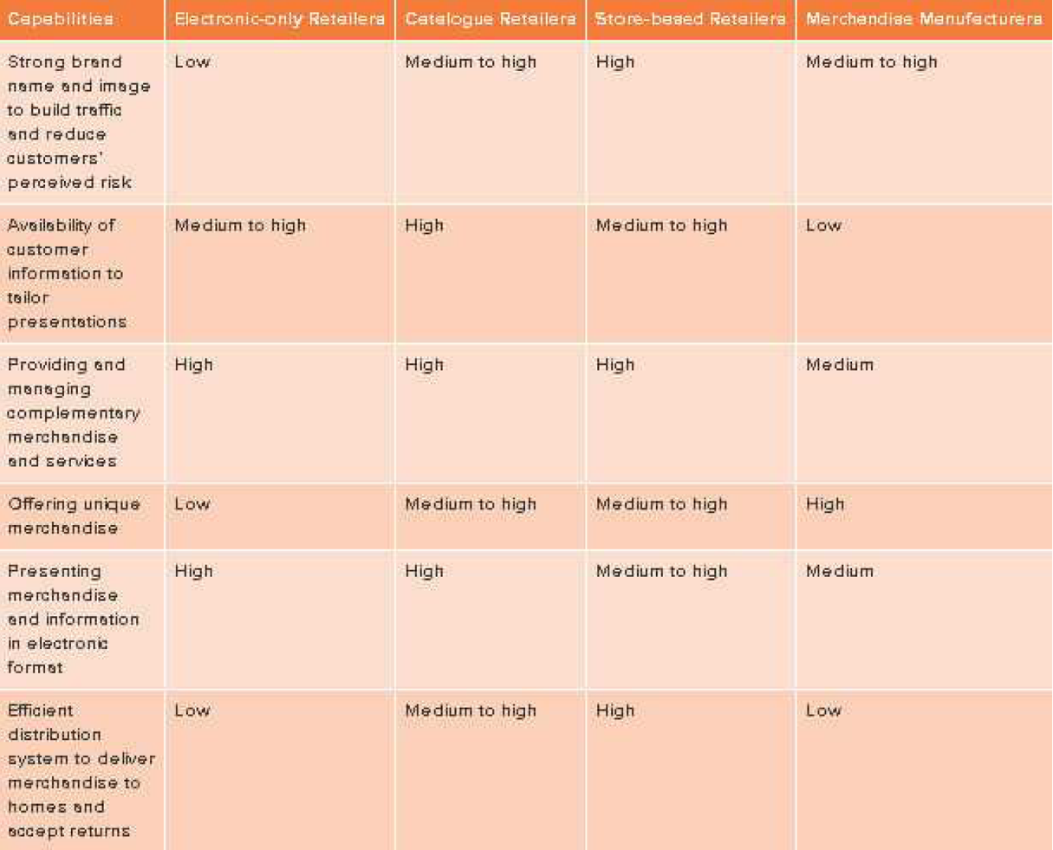

Unique convenience advantages of catalogues
- safety
  - they can do everything from home
- convenience
  - anywhere 24-7
  - they can take the catalogue anywhere
  - info is easily accessible for long period of time

Direct Selling: retail channel in which salespeople interact with customers face-to-face in a convenient location, either at the customer’s home or at work
- demonstrate merchandise benefits and/or explain a service, take an order and deliver the merchandise
- highly interactive
  - considerable info is conveyed to customers through f2f discussions
- costly
- personal care (makeup, etc.), home and family care, wellness, and leisure and educational items
- they are using Internet to complement f2f
- independent agents who are not employed by the direct sales firms, but rather act as independent distributors, buying merchandise from the firms and then reselling it to customers
- most work part-time
- Two special types of direct selling
  - Party Plan
    - Sales people encourage customers to act as hosts and invite friends or co-workers to a “party” at which the merchandise is demonstrated
    - Host receives gift or commission for arranging the party
    - Attendees place orders after party
    - Can be a multilevel network
  - Multilevel systems
    - Independent businesspeople serve as master distributors recruiting other people to become distributors in their network
    - Master distributor either buy merchandise from the firm and resell it to their distributors or receive commission on all merchandise purchased by the distributors in their network
    - MD are also involved in recruiting and training other distributors
    - Some multilevel direct selling firms are illegal pyramid schemes
      - Pyramid Scheme: develops when a firm and its program are designed to sell merchandise and services to other distributors rather than to end users
      - Founders of initial distributors profit from the inventory bought by later participants, but little merchandise is sold to consumers who use it

Television Home Shopping: also known as T-commerce or Teleshopping, is a retail format in which customers watch a TV program demonstrating merchandise and then place orders for the merchandise by telephone
- Recent tech allows users to purchase products by using the remote
- Three forms of electronic home shopping retail are
  - Cable channels dedicated to TV shopping
  - Infomercials
  - Direct-response advertising

Informercials: TV programs, typically 30 mins long, that mix entertainment with product demonstrations and then solicit orders placed by telephone

Direct-response advertising: includes advertisements on TV and radio that describe products and provide an opportunity for consumers to order them

Shopping channel located in Mississauga

Major advantage of TV home shopping compared to catalogue retailing is that customers can see the merchandise demonstrated on TV

Vending Machine Retailing: non-store format in which merchandise or services are stored in a machine and dispensed to customers when they deposit cash or credit
- Placed at convenient, high-traffic locations such as workplace, airport or university campuses
- Primarily contain snacks or drinks
- Sales growth is relatively slow because of consumers’ concerns about healthy eating habits
- New video kiosks enable consumers to see the merchandise in use
- Electronics and makeup are now starting to be sold in vending machines
- Canadian trend to offer healthier stuff in vending machines
  - Not as profitable bc you can’t store them as long
  - More expensive

Service Retailing

Service retailers: firms selling primarily services rather than merchandise, are a large and growing part of the retail industry
- They are retailers because they sell goods and services to consumers
- They are not just retailers – they sell to businesses too
- They are defined as retailers for which the major aspect of their offerings is services vs. merchandise

Differences between services and merchandise retailers
- Intangibility
  - Services are intangible
  - Services retailers have difficulty in evaluating the quality of services they are providing
    - Solicit customer evaluations and complaints
- Simultaneous production and consumption
  - Products are typically made in a factory, stored and sold by a retailer and then used by customers
  - Service providers hand, create, and deliver the service as the customer is consuming it
    - Restaurant – meal is prepared and consumed almost at the same time
- Perishability
  - Because the creation and consumption of services are inseparable, services are perishable
    - Cannot be saved, stored or resold
  - Merchandise can be held until customer is ready to buy it
  - Services must match supply and demand
  - There are times of the day when services are overused and underused (think of a restaurant)
- Inconsistence of the offering to customers
  - Merchandise is often produced by machines with very tight quantity control so that customers are reasonably assured that, ex, all boxes of cereal will be identical
  - Services are produced by people, no two services are identical
  - Challenge is to provide consistent high-quality services

Multichannel Retailing
Retailers were classified either as store-based or non-store (electronic, catalogue/direct mail, direct selling, TV home shopping and vending machines)
- Many retail firms use more than one channel to reach their customers

Multichannel Retailer: a retailer that sells merchandise or services through more than one channel
- Most are evolving into multichannel
- By using more, they are able to exploit the unique benefits provided by each channel
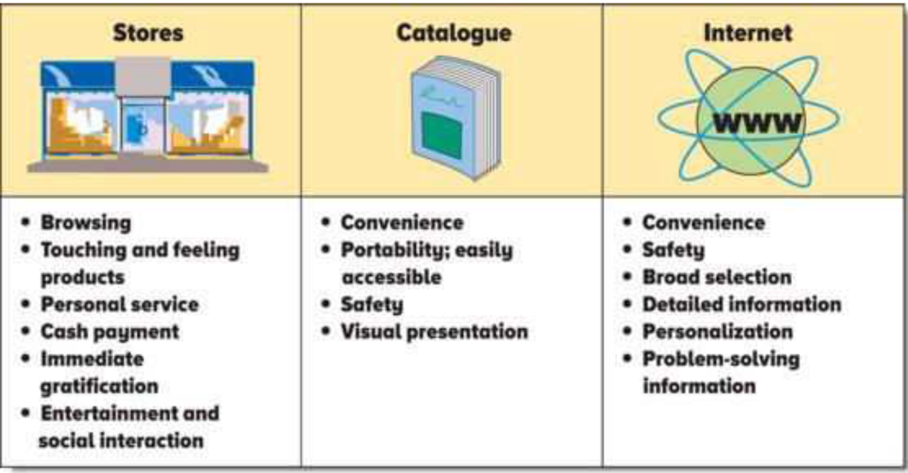

Store Channel

Benefits:
Personal Service
Cash payment
Immediate gratification
Entertainment and social experience
Convenience – non-store formats offer convenience
Safety – non-store have this advantage
Quality of Visual Presentations (in store)

Tuning into the Multichannel Universe

M-Commerce: the purchase of products and services through mobile devices
- Due to the rapid growth of domestic and international broadband access through mobile devices, retailers are very interested in this
- Retailers have developed apps
- Focus on what consumers would mainly need to access on the go: store locations, hours, contact info, etc.

The Rise of Omni-Channel Retailing
Omni-Channel Retailing: requires seamless integration between all channels so that shippers can shop any way they want with the exact same results

Econsutancy – “an integrated sales experience that melds the advantages of physical stores with the information rich experience of online shopping” (Def of omni…)
- Retailers allow customers to experience the brand, not a channel within the brand
- Merchandise, promos, pricing and customer service and communications are not channel specific, but rather consistent across all of the retail channels, not just two or one
- Everything is the same
- Physical stores and ecommerce sites become an extension of the supply chain in which consumers can make purchases but they are researched through other “channels” of communication
- To employ successful omni-channel retail strategy, an organization must consider:
  - Evaluate synergies across channels
  - Find the best operating methods
  - Choose technologies/processes for each operating method
  - Define optimal flow paths
  - Choose specific technologies
- Example of omni channel retailing
  - Starbucks
    - You are able to order from your phone, collect points, redeem them, etc.
- Each channel needs to be aware of the other
- Consumers move from channel to channel all the time to do the same thing, and they expect that whatever they do in one channel, will directly influence another

In-Store Electronic Kiosks
In-Store Kiosks: spaces located within stores containing a computer connected to the store’s central offices or to the internet
- Customers or salespeople can use these kiosks to order merchandise through a retailer’s electronic channel, check on product availability at distribution centres or other stores, get more info and scan bar codes for price
- Retailers like these because they create synergy between store and Internet
- Shoppers who buy in store and online from kiosk tend to buy more
- These kiosks can be expensive
- There is no guarantee that a customer will use it
- Maintenance costs

Customer Service using Technology
- Kiosks can provide routine customer service, freeing employees
- Customers can find more info on products
- Customized solutions
  - For example to see how something would look like after set up

Integrated Concept
- Retailers need to integrate their customer data bases and system used to support each channel
- Other critical issues facing retailers that want to provide an integrated, customer centric offering include:
  - Centralized customer database
  - Brand image
  - Merchandise assortment
  - Pricing

Centralized Customer Database
- This is crucial for exploiting the ability to collect detailed customer info through the Internet channel and providing a seamless experience for customers when they interact with the retailer through multiple channels

Brand Image
- Multichannel retailers need to project the same image to their customers through all chains
- Talbots reinforces their classic-style apparel and excellent customer service in its stores, website and catalogues

Merchandise Assortment
- A significant product overlap across channels reinforces the one brand image in the customer’s mind
- Trend now is to integrate the merchandise offerings across channels
- Multichannel retailers often offer a broader and deeper assortment through their internet channel than through their store channel
  - More efficient for merchandise that doesn’t have broad appeal
  - Store is good for “touch and feel” attributes such as fit of jeans
  - Internet is good for “look and see” price, colour, grams of fat

Pricing
- Customers expect pricing consistency across channels (excluding shipping charges and sales tax)
- Sometimes they have to adjust pricing strategy because of competition in different channels
  - Indigo prices online lower than instore because amazon is comp
- Retailers with stores in multiple markets often set different prices for the same merchandise to deal with differences in local comp
- Typical customers don’t notice these differences because they are only exposed to the local markets
- There may be a difficulty to sustain these price differences because customers can easily check online
- They have begun to offer new types of pricing such as auctions

Reduction of Channel Migration
- Multichannel retailers want to prevent channel migration – consumers collecting info about products and pricing on their channels and then buying from competitor
- They can reduce it by:
  - Offer uniquely relevant information based on proprietary data the retailer has collected about the customers
  - Promote private-label or exclusive merchandise that can be purchased only from retailer

Types of Ownership
- Independent, single store establishments
- Corporate retail chains
- Franchises

Independent, Single-Store Establishments
- Many such store are owner-managed
- Management has direct contact with customers and can respond quickly to their needs
- Flexible and can react quickly
- Not bound by bureaucracies inherent in large retail organizations
- Corporate chains can effectively negotiate lower prices
- Wholesale-Sponsored Voluntary Cooperative Group: an organization operated by wholesaler offering a merchandising program to small, independent retailers on a voluntary basis
  - To better compete against chains, some independent retailers join this
  - In addition to buying, warehousing and distribution, these groups offer member services such as store design and layout, site selection, bookkeeping, and inventory management systems, and employee training programs

Corporate Retail Chains
Retail Chain: a company operating multiple retail units under common ownership and usually has a centralized decision making for defining and implementing its strategy
- Some are divisions of larger corporations or holding companies
- Ex. Venator owns footlocker
- There has been concern that corporate retail chains drive independent retailers out of business
- Often, all stores in the chain have the same merchandise and services, whereas local retailers can provide merchandise compatible with local market needs

Franchises
Franchising: contractual agreement between a franchisor and franchisee that allows the franchisee to operate a retail outlet using a name and format developed and supported by the franchisor
- 1/3 of all north American retailers sales are made by franchisees approx.
- In a franchise contract, the franchisee pays a lump sum plus a royalty on all sales for the right to operate a store in a specific location
- Franchisee also agrees to operate the outlet in accordance with procedures prescribed by the franchisor
- Franchisor provides assistance in locating and building the store, developing products or services sold, management training, and advertising
- To maintain the franchisee’s reputation, the franchisor also makes sure that all outlets provide same quality of services and products
- This attempts to combine advantages of owner-managed businesses with efficiencies of centralized decision making in chain-store operations

Chapter 3 – Customer Buying Process

What are 21st customers looking for in their retail shopping experience?
- Pre-tail access: pre-tail means that people want to start shopping before they even enter the store
  - Technology – ie. Starbucks notifs popping up when you’re in the area
- Next-Generation Environment: customers are used to the totalizing shopping and entertainment environments offered online and increasingly look for the same kind of experience in traditional stores
  - Demand for omni-channel shopping
- Retail/Hospitality Mash-Ups: era of brands are over, customers enter stores looking for integrated lifestyle experience – retail and hospitality
  - Opening bars in your store
- Social Shopping: customers look at social media while they shop to validate their purchases
- Net-Tech Customer Service: increasing customer demands for tech innovations have set the bar very high for companies
  - “May day button” – users can enter a video conference with Amazon’s customer service

The Buying Process

Buying Process: steps customers go through when buying a product or service, begins when customers recognize an unsatisfied need, seek info about how they can satisfy the need, evaluate alternative retailers and channels available for purchasing the merchandise, select store or Internet, visit store or internet site, or read catalogue and make purchase, then post-purchase evaluation stage

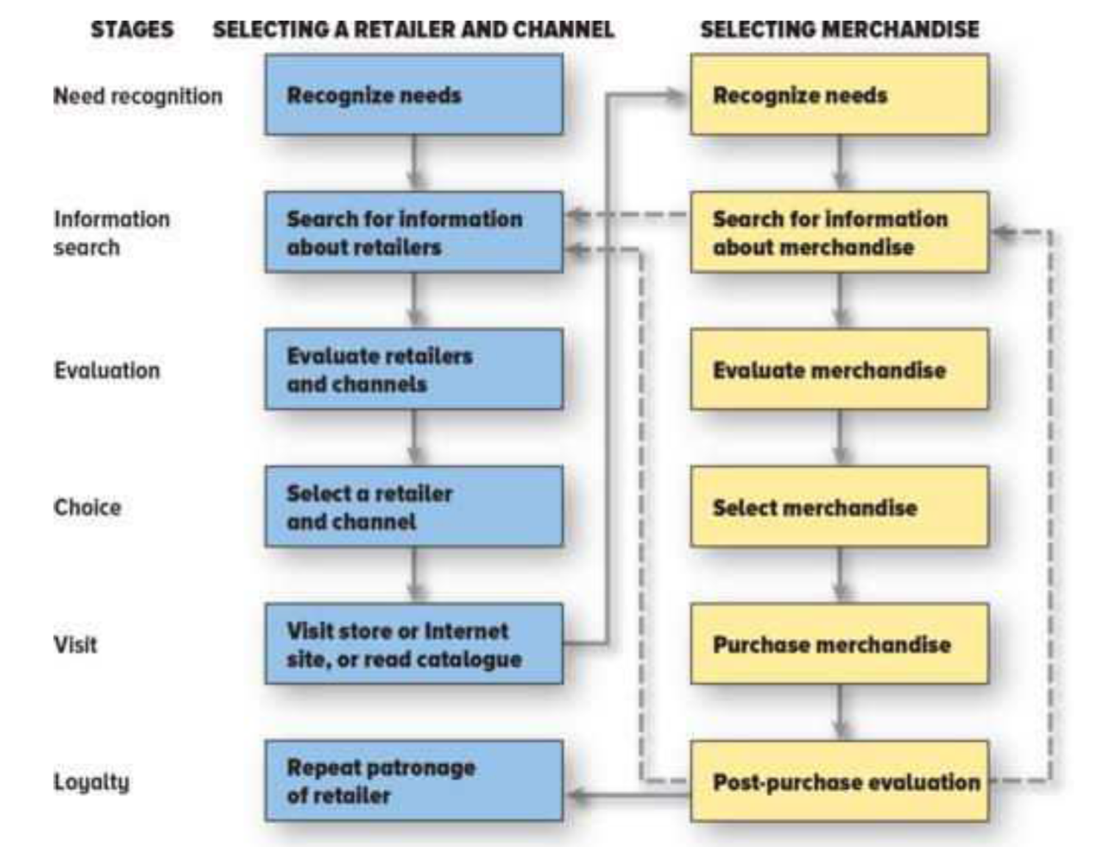

Need Recognition
- Buying process is triggered when consumers realize they have an unsatisfied need

Utilitarian Needs: Needs motivating consumers to go shopping to accomplish a specific task
Hedonic Needs: Needs motivating consumers to go shopping for pleasure
- Needs for entertaining, emotional and recreational experience
- Utilitarian associate with work, while hedonic with fun

Retailers want to satisfy both needs
- Make it fast and efficient for utilitarian needs
- Hedonic needs that retailers satisfy include:
  - Stimulation
    - Background music, displays, scents, etc.
    - Encourage customers to take a break from everyday lives
    - Exciting graphics on catalogue or website
  - Social Experience
    - Lifestyle centres (new malls) are now including theatres, restaurants, and even condo living
    - Indigo has Starbucks
    - Online customers are able to share products with friends or create personal blogs with their shopping lists
    - Writing reviews
  - Learning new trends
    - By visiting retailers, you learn new trends
  - Status and power
    - You can get attention/respect in a store
  - Self-reward
    - Customers frequently purchase things to reward themselves
  - Adventure
    - Customers often enjoy finding bargains, looking for sales, etc.
    - Walmart changes their assortment so customers never know what they will find
Conflicting Needs
- Buying a DKNY suit for entry level position – out of budget
  - Employers might feel she is not responsible if she wears suit that is too expensive
  - Needs often can’t be satisfied from one product, so you wear a Gucci bag but a H&M shirt
  - Cross-Shopping: pattern of buying both premium and low-priced merchandise or patronizing both expensive, status-oriented retailers and price-oriented retailers

Stimulating Need Recognition
- Event stimulated by event person’s life
- Advertising, internet promos, direct mail, publicity, and special events communicate the availability of merchandise or special prices
- Visual merchandising

Information Search

Information Search: the stage in the buying process in which a customer seeks additional information to satisfy a need
- Consumers will often spend more time when they haven’t had a lot of experience with what they’re shopping for
- Costs of search are time and money
- Tech can reduce cost

Factors influencing the amount of information search include:
- The nature and use of the product being purchased
- Characteristics of the individual customer
  - Some people search more than others
- Aspects of the market and buying situation in which the purchase is made

Marketplace Situational Factors:
- Number of competing brands and retail outlets
  - When there are more brands, there are more alternatives to consider
- The time pressure under which the purchase must be made
  - Amount of alternatives decreases, as time pressure increases

Sources of Information
Internal Sources of Information: customer’s memory, such as names, images and past experiences with different stores
- Major source is customer’s past shopping experience

External Source of Information: information provided by ads and other people
- When customers feel that their internet info is inadequate, they turn to external

Reducing Information Search
- Retailer’s objective
- Things such as the availability of delivery and credit
- Rona and Best Buy’s deep assortment
- Sales people providing good info
- Everyday Low Pricing Strategy (ELPS): a pricing strategy that stresses continuity of retail prices at a level somewhere between the regular non-sale price and the deep-discount sale price of the retailer’s competitor
  - Walmart and the Source
  - Many stores with this offer price-matching
- Retailers need to make use of social media and social communities to entice peer-to-peer communication and help build their brand through consumer discussions and recommendations

Evaluation of Alternatives: The Multiattribute Attitude Model
- Provides a useful way to summarize how customers use the info they have and collect about alternative products, evaluate the alternatives, and select one that best satisfies their needs

Multiattribute Attitude Model: based on the notion that customers see a retailer, a product, or a service as a collection of attributes or characteristics
- Designed to predict a customer’s evaluation of a product, service, or retailer based on
  - Its performance on relevant attributes
  - The importance of those attributes to the customer
- Can also be used for evaluating a retailer, product or vendor
- Weighted average score based on the importance of various issues and performance on those issues
- Does not reflect customers’ actual decision process, but it does predict their evaluation of alternatives and their choice

Getting into the Consideration Set
Consideration set – set of alternatives the customer evaluates when making a selection
4 methods to increase chances that customers will select its store for a visit
1. Increase beliefs about the store’s performance
2. Decrease the performance beliefs for competing stores in the consideration set
3. Increase customers’ importance weights
4. Add a new benefit

Purchasing the Merchandise or Service
- One measure of a retailers’ success at converting positive evaluations to purchase is the number of real or virtual abandoned carts in the retailer’s store and website

Post-Purchase Evaluation
Satisfaction: post-consumption evaluation of how well a store or product meets or exceeds customer expectations

Post-Purchase Evaluation: the evaluation of merchandise or services after the customer has purchased and consumed them

Three types of customer decision-making process:

Extended Problem Solving: purchase-decision process in which customers devote considerable time and effort to analyzing their alternatives
- Go beyond internal family, friends, experts
Limited Problem Solving: purchase-decision process involving a moderate amount of effort and time.
- Do this when they’ve had some prior experience with the product or service and their risk is moderate
- Tend to rely more on personal knowledge than external
- Limited problem solving – impulse buying
  - Retailers encourage this by having POP and POS displays

Habitual Decision Making: purchase-decision process involving little or no conscious effort
- “I’ll buy the same thing I bought last time at the same store”
- Decisions aren’t important and involve similar merchandise bought in the past
- Brand Loyalty: means that customers like and consistently buy a speicifc brand in a product category
  - Reluctant to switch even if it’s unavailabele
  - Coke drinkers wont by pepsi
  - If these are private-label brands owned by retailer then retailer loyalty is heightened
- Retailer Loyalty: customers like and habitually visit the same retailer to purchase a type of merchandise

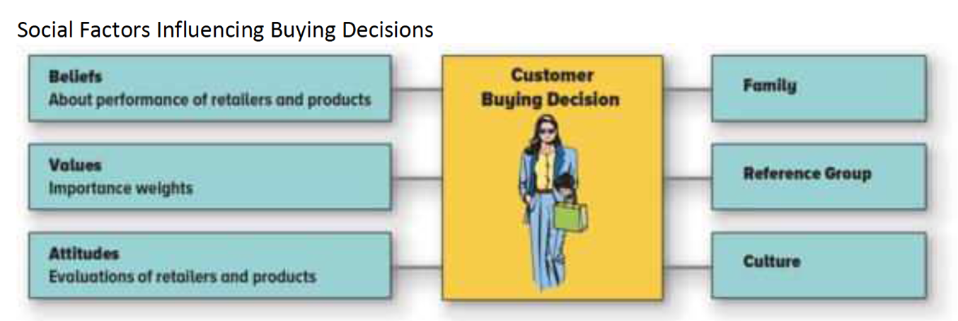
Social Factors Influencing Buying Decisions
Family
- Many purchase decisions are made for the entire family to use
- Consider needs of all family members
- Man grocery shops, wife cooks, kid eats
  - Store choice is made by husband, brand choice by wife and also greatly influenced by child

Reference groups: composed of two or more people whom a person uses as a basis of comparison for their beliefs, feelings and behaviours
- Offer information
- Provide rewards for specific purchasing behavior
- Enhance consumer’s self-image

They provide info directly through convo or indirectly through observation

Store Advocates: customers who like a store so much that they actively share their positive experiences with family and friends

Culture: the meaning and values shared by most members of a society
- Immigrants and people of diff cultures bring unique world views and cultures and shopping preferences to Canada
- They often arrive only with money and suitcase and need to buy necessary supplies to set up a home
- Immigrants are often used to sophisticated marketing from their home country and will
look to advertising for information, store product, price, and location.

Subculture – a distinctive group of people within a culture
- Share same customs and norms with the overall society, but also have unique perspectives
- Can be based on geography, ethnicity or lifestyle

Accessibility: the ability of the retailer to deliver the appropriate retail mix to the customers in the segment
- Customers of Marriott convention and resort hotels access in different ways as they use different sources to collect info about products and services

Market Segmentation
Retail Market Segment: a group of customers whose needs are satisfied by the same retail mix because they have similar needs
- Family travel needs are different than executives on business trips

Criteria for Evaluation Market Segments
- Actionability: means the definition of a segment must clearly indicate what the retailer should do to satisfy its needs
  - Customers in the segment must have similar needs, seek similar benefits, and be satisfied by a similar retail offering
  - Those customers’ needs must be different from the needs of customers in other segments
  - Addition Elle – focus on fill figured women (cant do the same for grocery)
- Identifiability: permits a retailer to determine a market segment’s size and with whom the retailer should communicate when promoting its retail offering
  - Permits the retailer to determine:
    - Segment’s size
    - With whom the retailer should communicate when promoting its retail offering
- Accessibility: ability of the retailer to deliver the appropriate retail mix to the customers in a targeted segment
  - Online vs. in store enable people who cant go in physically to do it online
- Size: a target segment must be large enough to support unique retailing mix

Approaches for Segmenting Markets

Geographic Segmentation: groups customers where they live
- Can be segmented by country or areas within a country, cities and neighbourhoods
- Usually focus on customer segment reasonably close to the outlet
- Though the Gap doesn’t focus on geography, they tailor their merchandise selections to different regions of North America
  - Snow sleds don’t sell well in Florida

Demographic Segmentation: a method of segmenting a retail market that groups consumers on the basis of easily measured, objective characteristics such as age, sex, income and education
- Demographics are numbers about people and this is collected through a census of the population
- These are the most common means to define segments because consumers in these segments can be easily identified and accessed

Who is the Male Shopper?
- Men show little ability or interest in honing their shopping skills
- Women view the supermarket as a place where they can demonstrate their expertise in getting the most value for their money

The Power of Women
Women want it all – made to feel special both online and offline but when it comes down it it, show no loyalty because price matters more than the brand

Knowledge of Demographics is Critical
- Can explain the growth of specialty beers and skin care creams, the demand for healthy food, the trends in real estate and golf members
- Social Expressionistas: community creators who are passionate about spreading the word online and are highly active on social networking sites
- Alpha Trendsetters: take their social lives and careers seriously and are very brand conscious; perfect market for retailers of luxury brands that aim their products at women
- Shopsessives: believe they are experts in all areas, ranging from fashion to health, and are shopping online across all product categories; this group of women highly influences the shopping decisions of friends and family
The Digital Generation
- New youth culture is smart, savvy and the first generation to grow up surrounded by digital media
- Retailers and suppliers will need to respond by providing this generation with the tools they need to create, co-create, or re-create to suit themselves

Retailing to Generation Z
- Born between 1995-present
- Fastest growing segment in Canada
- Kidfluence: the influence that kids have other family’s purchase decisions
- Demographics may not be useful for this

Geodemographic Segmentation: uses both geographic and demographic characteristics to classify customers
- “birds of a feather flock together”
- Consumers in the same neighbourhoods tend to buy the same types of cars, appliances and apparel and shop at the same retailers
- Know you by your postal code
- Geodemographers group people into clusters, using census data to determine factors such as age, income, education and ethnicity, and overlay the findings with consumer purchasing and attitudinal data
- Cosmopolitan Elite – represent those earning in excess of $330,000 annually (Forest Hill)
- Young Digerati – consists of tech-savvy singles and couples living in fashionable urban neighbourhoods in a handful of large cities
- Young Digerati – as cutting-edge as their laptops
  - Eager to succeed but don’t want to climb an outdated corporate hierarchy to do so; marketing campaign should highlight independent spirit
- Particularly appealing to store-based retailers because customers typically patronize stores close to their neighbourhood

Lifestyle Segmentation: method of segmenting a retail market based on consumers’ lifestyle
- Consumer Psychographics: how consumers live, how they spend their time and money, what activities they pursue, and their attitudes and opinions about the world they live in
- Retailers today are placing more emphasis on lifestyles than demographics to define target segment

Buying Situation Segmentation: method of segmenting a retail market based on customer needs in a specific buying situation, such as a fill-in shopping trip vs. weekly shopping trip
- For example, parent of four kids prefers supercenter rather than Internet grocer
  - If they run out of milk, they would just go to the convenience store rather than warehouse club (fill-in shopping)

Benefit Segmentation: a method of segmenting a retail market on the basis of similar benefits sought in merchandise or services
- In the multiattribute attitude model, customers in the same benefit segment would attach a similar set of importance weights to the attributes of a store or product
- Benefits clearly indicate how retailers should design their offerings to appeal to the segment
- Not easily identifiable or accessed
  - Hard to look a person and determine what benefits they are seeking
- Typically audience for media used by retailers is described by demographics rather than by the benefits sought

Composite Segmentation: a method of segmenting a retail market using multiple variables, including benefits sought, lifestyles and demographics

Chapter 4 – Retail Market Strategy

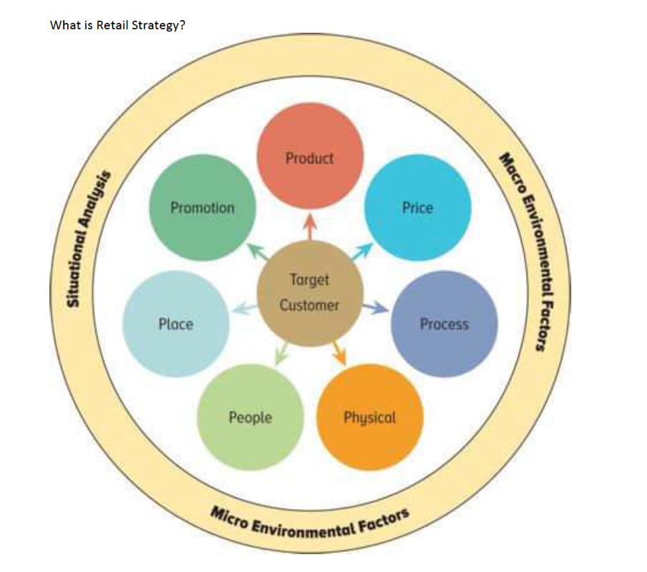
What is a Retail Strategy?

A retail strategy is a statement identifying:
- The retailer’s target market
- The format the retailer plans to use to satisfy the target market’s need
- The bases upon which the retailer plans to build a sustainable competitive advantage

Target Market: the market segment(s) toward which the retailer plans to focus its resources and retail mix
Retail Format: the retailers’ type of retail mix (Product, price[value], promotion[communication], place, people, processes

Sustainable competitive advantage: an advantage over competition that cannot be easily copied and can be maintained over a long period of time

Every retail strategy involves the following:
- Selecting target market segment(s)
- Selecting a retail format
- Selecting the elements in the retail mix
- Developing sustainable competitive advantage that enables the retailer to reduce level of comp it faces

Target Market and Retail Mix
Retailing Concept: a management orientation that holds that the key task of a retailer is to determine the needs of its target market and satisfying those needs more effectively and efficiently than its competitors
- Selection of retail format outlines the retail mix to be used to satisfy the needs of the customers
- Retails strategy determines the markets in which a retailer will compete
- Traditional markets such as farmers’ markets, are places where buyers and sellers meet and make transactions
- Modern markets – potential buyers and sellers aren’t necessarily located in one place; transactions can occur without the face-to-face interactions

Retail Market: group of consumers with similar needs(market segment) and a group of retailers using a similar retail format to satisfy those consumer needs

Product: Product and/or service, package, warranty, after-sales services, brand name, company image, return policies and other factors

Price(value): Prestige pricing, competitive(at-the-market) pricing, discount pricing, everyday low pricing (EDLP)

Place: Use of a store or non-store format; placement in a geo area; database management, retail information systems, data mining, and micromarketing; IT; and physical distribution (collaborative planning, forecasting and replacement (CPFR), QR)

Promotion: Communication mix, including advertising, direct marketing, personal selling, sales promotion and public relations

People: Human Resource Management (recruiting, selecting, training, recognition, retaining and supervising), and customer service (personal attention provided)

Process: The systems used to develop the service (Inputs, throughputs, and outputs); making the process consistent by reducing variability

Physical: Store design and displays, store atmosphere

Building a Sustainable Competitive Advantage
Two sets of variables that will impact your retail business must be assessed:
- Micro-Environment: all of the things within the retailer’s control, including the retail product that will be sold, the price for the product, the store location, the promo and visual image of the store, the processes, and the human resource management decisions
- Macro-environment: the external environment that a retailer cannot control. This includes competition, economic stability of the trade area, the tech that will make retailing more efficient, the regulatory and ethical environment in which the business operations, and social trends, including consumer behavior and lifestyle and demographic trends

SWOT Analysis: analysis of strengths, weaknesses, opportunities and threats
- Designed for macro and micro

Three approaches for developing sustainable competitive advantage:
- Building strong relationships with customers
- Building strong relationships with suppliers
- Achieving efficient internal operations
  - These all include loyal customers, strong vendor relationships, committed effective human resources and efficient systems and attractive locations

Relationships with Customers

Customer Loyalty: customers are committed to shopping at a particular retailer
- Having dedicated employees, unique merchandise and superior customer service will solidify this

Build by:
- Developing clear and precise positioning strategies
- Developing a strong brand for store or store brands
- Providing outstanding customer service
- Creating an emotional attachment by using loyalty programs

Brand Image: sets of associations consumers have about a brand that are usually organized around some meaningful themes
- McDonalds = fast food
- Facilitate customer loyalty
- Emotional tie with customers that builds their trust and loyalty
- Strong part of positioning

Positioning: the design and implementation of a retail mix to create an image of the retailer in the customer’s mind relative to its competitors – brand building
- Emphasizes that the image in the consumer’s mind is critical
- Perceptual map is frequently used to represent the customers image and preference for retailers (109)
  - How close stores are to each other indicates how similar the stores are to consumers

Unique Merchandise

Private-Label Brands: products developed and marketed by the retailer and available for sale only by that retailer; also called store brands
- You can only buy a Kenmore washer at Sears

Customer Service
- Build sustainable comp advantage by having great customer service
- Difficult because humans are less consistent than machines
- Once a retailer has earned a service reputation, it can sustain this advantage for a long time because it’s hard for a competitor to get a comparable reputation

Loyalty Programs
- Part of an overall customer relationship management (CRM) program
- The purchase info is stored in a huge data based called the data warehouse
- the coordinated and periodic copying of data from various sources, both
inside and outside the enterprise, into an environment ready for analytical and informational processing. It contains all of the data the firm has collected about its customers and is the foundation for subsequent CRM activities.
- From this analysts determine what types of merchandise and services certain groups of customers are buying

Relationship with Suppliers

Vendor relations
- By strengthening their relationship, both retailers and vendors can develop mutually beneficial assets and programs that will give the retailer-vendor pair an advantage over competing pairs
- Walmart & P&G relationship initially focused on improving supply chain inefficiencies
  - Now they share sensitive info with each other so they better plan for new P&G products in stores

By developing strong relations with vendors, retailers may gain the following exclusive rights:
- Selling merchandise in a specific region
- Obtaining special terms of purchase that are not available to competitors who lack such relations
- Receiving popular merchandise in short supply

Efficiency of Internal Operations
- Largest company size typically produces more efficient internal operations
  - Have more bargaining power with vendors and can buy merchandise at lower costs
  - Invest in developing sophisticated systems and spread the fixed cost of these systems over more sales

Human Resource Management
- Knowledgeable and skilled employees committed to the retailer’s objective are critical assets that support the success of companies such as Harry Rosen
- Recruiting and retaining great employees isn’t easy
- They have to develop programs that motivate and coordinate employee efforts, providing appropriate incentives, fostering a strong and positive organizational culture and managing diversity

Distribution and Information Systems
- All retailers strive to reduce operating costs – the costs associated with running a business and make sure that the right merchandise is available at the right time and place
- The use of sophisticated distribution and information systems offers an opportunity for retailers to achieve these efficiencies

Location
- Critical in consumer selection of a store
- Not easily duplicated
- Starbucks saturates a market before going to a new one

Multiple Sources of Advantage
- Retailers use multiple sources to get a sustainable comp advantage

Growth Strategies
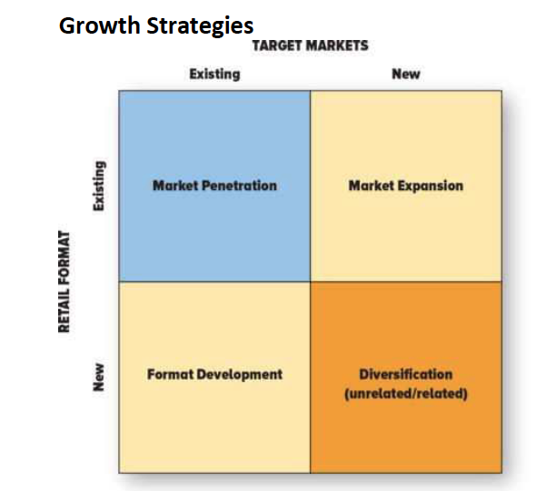

- Market penetration
- market expansion
- retail format development
- diversification

Market Penetration opportunity: involves directing efforts towards existing customers by using the present retailing format
- can achieve this growth strategy by attracting consumers in its current target market who don’t shop at its current outlets or by devising strategies that induce current customers to visit a store more often or to buy more merchandise on each visit
- attracting new customers by opening more stores and keeping existing stores open for longer
- displaying merchandise to increase impulse
- training employees to cross-sell – sales associates in one department attempt to sell complementary merchandise from other departments to their customers
  - selling dress and then selling them shoes in the shoe department

Market Expansion Opportunity: employs an existing retail format in new market segments
- A&F’s primary target market is uni people but since uni people don’t like hanging out with high schoolers, they opened up lower-priced chain called Hollister
  - Retail format is the same

Retail Format Development Opportunity: involves offering a new retail format – a format with a different retail mix – to the same target market
- Chapters began selling books over the Internet to its present target market
- Adding merchandise categories (Amazon and DVDs)
- Best buy offering professional services to install equipment

Diversification opportunity: occurs when a retailer introduces new retail format directed toward a market segment that’s not currently served
- The Gap opened Old Navy to attract different demographic profile

Related vs. unrelated diversification
Related Diversification opportunity: the present target market or retail format shares something in common with the new opportunity

Unrelated Diversification: lacks any commonality between the present business and the new business
- Canadian Tire buying Forzani Group (Sport Check, etc.)
- Home depot built a wholesale building-supply business called HD supply
  - Stores were already selling similar merchandise to contractors
  - Management thought this was related, but it was actually unrelated because they sold primarily pipes, lumber and concreate – products with limited sales in Home Depot’s retail stores
  - Ended up selling it

Vertical Integration: diversification by retailers into wholesaling or manufacturing
- The Limited’s acquisition of Mast Industries (a trading company that contracts for private-label manufacturing) and Zale Corporation’s manufacturing of jewelry
- When retailers integrate by manufacturing products, they are making risky investments because the skills required to make products are different from those associated with retailing
- Designing private-label merchandise is related diversification because it builds on the retailer’s knowledge of its customers, but actually making the merchandise is considered an unrelated diversification

Forward Integration: designer/manufacturer has control of both the manufacturing and distribution processes and makes the strategic decision to move forward and control the retailing process by opening its own stores

Strategic Opportunities and Competitive Advantage
- Typically retailers have the greatest competitive advantage in opportunities that are similar to their present retail strategy
- Therefore, they would be most successful in engaging in market penetration opportunities that don’t involve entering new and unfamiliar markets or with new formats
- Least comp. advantage when pursue diversification because risky
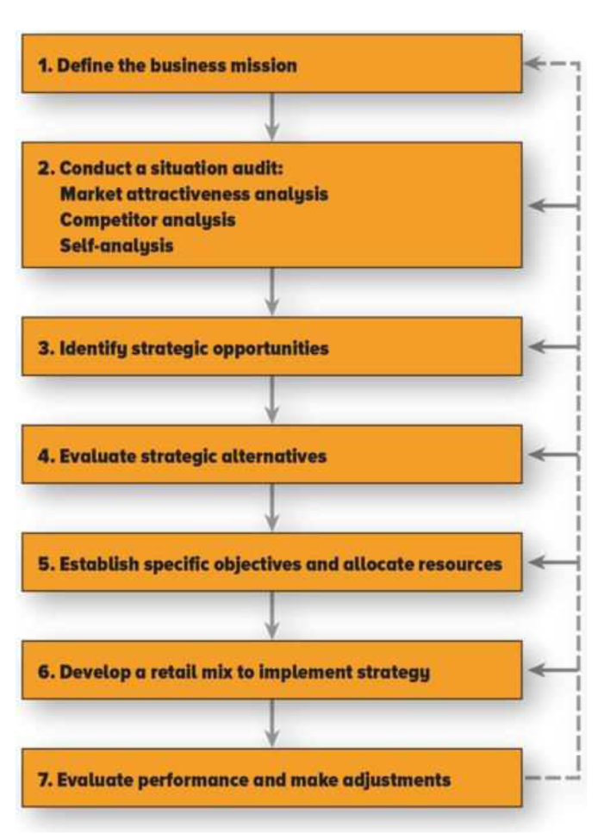
The Strategic Retail Planning Process
Strategic Retail Planning Process: the set of steps a retailer goes through to develop a strategic retail plan
- Describes how retailers select target market segments, determine the appropriate retail format, and build sustainable comp advantages
- Not always necessary to go through entire process each time
- Can be used to formulate plans at different levels

EXAMPLE: Kelly owns Gifts to Go, in Vancouver, 1000 sqf store, is located in downtown, the other is in upscale suburban mall
- Target market is upper-income men and women looking for gifts
- Treats associates as part of the family and they share profits and have benefits
Step 1: Define Business Mission
Mission statement: broad description of a retailer’s objectives and the scope of activities it plans to undertake
- Objective of a publicly held firm is to maximize stockholders’ wealth by increasing value of its stock and paying dividends
- Owners of small privately held businesses have other objectives such as achieving specific level of income and avoiding risks
- Mission statement should define the general nature of the target segments and retail formats that the firm will consider
- Developing mission statement, managers answer five questions:
  - What business are we?
  - What should be our business in the future?
  - Who are our customers?
  - What are our capabilities?
  - What do we want to accomplish?
- “To be the leading retailer of higher-priced gifts in Vancouver area and provide a stable income of $100,000 per year for the owner”
  - This clarifies that they won’t consider retail opportunities outside of the Vancouver area, lower-priced gifts as that would jeopardize the desired salary

Step 2: Conduct Situation Audit
Situation Audit (SWOT analysis): is an analysis of the strengths and weaknesses of the retail business relative to its competitors and the opportunities and threats in the retail environment
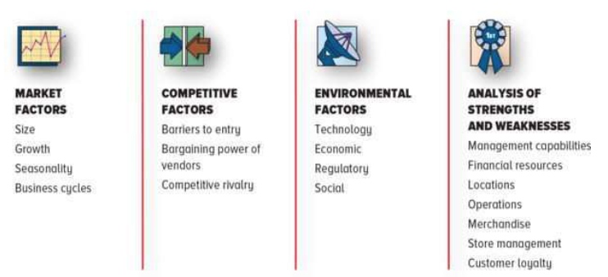

Market Factor
- Market size, growth or declining markets
  - Retail markets for specialty stores are growing faster than department store
  - Margins and prices are higher in growing markets because comp is less intense than in mature markets
  - Firms are often interested in minimizing the business cycle’s impact on their sales
    - Retail markets affected by economic conditions (cars and major appliances) are less attractive than retail markets unaffected (food)
  - Highly seasonal sales are unattractive
- Kelly went on the internet to get info about size, growth, and cyclical and seasonal nature of the gift market
  - She concluded that market factors were attrative, expensive gifts market was large, growing and not vulnerable to business cycles
  - Negative aspect of seasonality (Chrstimas, June (weddings), Christmas and other holidays)

Competitive Factors
Barriers to Entry: conditions in a retail market that make it difficult for firms to enter the market
- Scale economies, customer loyalty, and availability of great locations
- Scale economies: cost advantages due to retailer’s size
  - Markets dominated by large competitors with scale economies are unattractive
  - Small entrepreneur would avoid becoming an office supply specialist category specialist because it is dominated by Staples
    - They can buy merchandise more cheaply and operate more efficiently by investing in the latest tech and spreading its overhead across more store
  - Home Depot’s high customer loyalty makes it hard for a competing home improvement centre to enter the market
  - Lack of good retail locations in Hong Kong make the market attractive already in the region but less so for others
Bargaining Power of Vendors: a competitive factor that makes a market unattractive when a few vendors control the merchandise sold in it. In these situations vendors have an opportunity to dictate prices and other terms, reducing retailer’s profits
- Eg. Market for retailing fashionable cosmetics is less attractive because two suppliers Estee Lauder (owns a bunch) and Loreal (also owns a lot) provide the most premium brands
  - These brands have the power to sell their products to retailers at high prices
Competitive Rivalry: the frequency and intensity of reactions to actions undertaken by competitors
- when rivalry is high, price wars erupt, advertising and promo expenses increase and profit potential falls
- Conditions that may lead to intense rivalry include:
  - A large number of competitors that are all about the same size
  - Slow growth
  - High fixed costs
  - Lack of perceived differences between competing retailers
- Starbucks, McDonalds and Tim Hortons have intense rivalry
- Kelly realized that identifying her competitors is not easy
- There are no gift stores carrying similar merchandise at same price points in Van, there were various other ones from which customers would buy gifts
- She identified primary comp – department store,s craft galleries, catalogues and Internet retailers
- Lack of large suppliers meant that vendor’s bargaining power wasn’t a problem and comp rivalry was minimal because the gift business was not critical part of dep store’s overall business

Macro-Environment
- Factors that affect market attractiveness span technological, economic, regulatory and social changes
- When retail market is going through significant tech changes, the existing retail market is vulnerable to new entrants that are skilled at using the new tech
- 1990s and e-tailing
- Some retailers may be more affected by econ conditions than others
  - Discount, off-price, warehouse clubs, etc. are in a much better position in those times
- When unemployment is low, costs may increase significantly as salespeople’s wages rise due to the difficulty in hiring qualified people (Harry Rosen)
- Walmart that provides little to no service wouldn’t suffer from that, also much lower labour costs
- Government regulations can reduce attractiveness of a market
  - Diffult for large retailers to open up new stores in France due to the size restrictions placed on new store
  - Walmart is stopped from entering new markets because people want to protect local retailers
- Trends in demographics, lifestyles, attitudes, and personal values affect retail markets attractiveness (social)
  - Harry Rosen needs to appeal to younger clientele
  - Retailers need to answer 3 questions about the macro-environment:
    - What new developments or changes might occur, such as new technologies and regulations or different social factors and economic conditions?
    - What is the likelihood that these environmental changes will occur? What key factors affect whether these changes will occur?
    - How will these changes impact each retail market, the firm and its competitors?
- Kelly’s concern – potential growth of Internet gift retailers
- She recognized that they could also get info about customers and tailor promos and suggestions to them

Strengths and Weaknesses Analysis (126)
- Most critical aspect of situation audit
Strength and Weaknesses Analysis: indicates how well the business can seize opportunities and avoid hard from threats in the environment
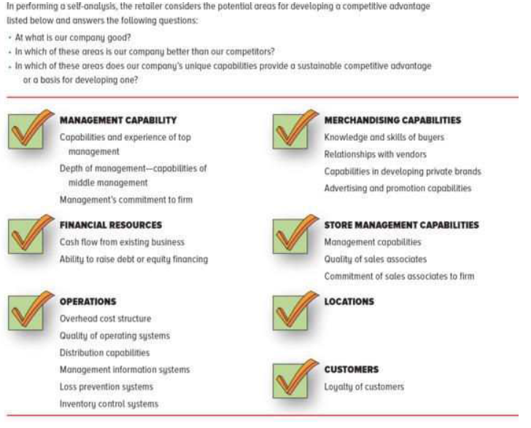

Step 3: Identify strategic opportunities
- For increasing retail sales
- This could involve redefinition of retailer’s missions statement
- Market preparation, market expansion, retail format development or diversification
- Kelly uses a specialty store format
- P. 126 for her growth opportunities

Step 4: Evaluation Strategic Opportunities (126)
- Evaluate opportunities that have been identified in the situation audit
- This determines the retailer’s potential to establish a sustainable competitive advantage and reap long0term profits from the opportunities under evaluation
- Market attractiveness and the strengths and weaknesses of a retailer need to be considered in evaluating strategic opportunities

Step 5: Establish Specific objectives and allocate resources
- Establish a specific objective for each opportunity
- Overall objective Is in the mission statement
- Specific objectives are goals against which progress toward the overall objective can be measured
- They have three components
  - The performance sought, including a numerical index against which progress may be measured
  - A time frame within which the goal is to be achieved
  - The level of investment needed to achieve the objective
- Typically performance levels are financial criteria such as ROI, sales or profits
- Kelly’s objective is to increase profit by 20% for the next 5 years
  - She expects she will need to invest an additional $25,000

Step 6: Develop a Retail Mix to Implement Strategy
- Develop retail mix for each opportunity in which investment will be made and to control and evaluate performance

Step 7: Evaluate Performance and Make Adjustments
- Evaluating the results of the strategy and implementation program
- If they are meeting or exceeding, changes aren’t needed
- Otherwise, re-analysis is needed
  - This start with reviewing implementation programs, but it may indicate that the strategy, or even the mission statement, needs to be reconsidered
  - This means you have to start a new planning process – new situation audit
- Changes in the macro-environment can force trailers to re-evaluate their strategy
  - Could involve targeting a new market segment and tailoring their offering to meet the needs of this new segment

Strategic Planning in the Real World
The planning process (orange list) indicates that strategic decisions are made in sequential manner
- But, actual planning processes have interactions among the steps
  - For example, situation audit may uncover a logical alternative for firm to consider even though this alternative isn’t included in the mission statement
- Situation analysis is essential part of developing sustainable retail strategy, it will reveal the retailer’s potential for success by analyzing macro and micro environment to highlight unique capabilities

Chapter 7 – International Retail Strategy

International Retailing: Canadian Issues
American Retailers Come to Canada
- NAFTA prompted a surge of big-box retailers and category killers across the border
  - By 1995, Canadian retail industry was in crisis, experiencing a record number of bankruptcies
- US retail banners now control approx. 38% of all retail sales in Canada

Canadian Retailers in the United States
- Canadian Tire, Future Shop, Mark’s Work Wearhouse, Shoppers Drug Mart, Coles Books, etc.
- La Senza and Danier managed a couple of years
- Problems include:
  - Inability to secure good real estate
  - Underfunded advertising budgets (US retailers spend about 6% of overall sales on advertising compared to 3% in Canada)
  - Underestimating the competitiveness of the US
  - Failing to do adequate research
  - Not devoting enough money and resources to the project
- A more successful route for Canadian retailers has to been to expand cautiously through:
  - Acquisition of existing US retailers
  - Developing a unique product that people want

Global Growth Opportunities
- Of the 50 largest retailers in the world, only two operate in one country
- By expending internationally, retailers can increase their sales, leverage their knowledge and systems across a greater sales base, and gain more bargaining power with vendors

Attractiveness of International Markets
Two factors are often used to determine the attractiveness of different international opportunities
- The potential size of the retail market in the country
- The degree to which the country can and does support the entry of foreign retailers

Global Consumer Attitudes and Retail Trends
Canadian Anthony Stokan writes about 10 global retail trends
- It’s a Wally, Wally World—Walmart will increase its retail power across all income
levels.
- The Death of Inspiration—Price emphasis focuses on utilitarian store environments.
- Experience Shopping—Go beyond entertainment to attract niche markets.
- Empowered Consumers—Consumers use the Internet to comparison shop.
- Kidopoly—Kids are a big market opportunity; $25 billion in direct sales and $500 billion
Worth influencing parents’ spending in North America
- Dollar Store Euphoria—Consumers like the value of low-priced merchandise.
- Luxury for All—Include affordable luxury elements in products for all shoppers.
- E-Commerce: Action/Transaction—Sales online will remain a minor share of overall
retail sales.
- The Loyalty Myth—There is value in keeping and growing an existing customer base.
- The New Brand Management—Successful retailers will build their own brands.

When home marketplace is not producing desired sales and profits diminish over time, some of the problems may be attributed to:
- A saturated home marketplace with no room to grow
- A highly competitive marketplace
- An aging population that spends less and saves more *important in US and Canada*
- An economic recession, which limits consumer spending
- High operating costs, including staff wages, rental costs, and taxes
- Restrictive policies on retail development
- Shareholder pressure

Some factors that would encourage a retailer to enter into the international market place include:
- Limited competition in the international marketplace
- Rising numbers of middle-class consumers with improved standard of living
- Younger population with increasing purchasing power
- Trade agreements and organizations, including NAFTA, WTO(World Trade Organization), European Union
- Relaxed regulatory framework
- Favourable operating costs, including lower wages and taxes
- Opportunity to diversify
- Opportunity to try innovative concepts

The World’s Largest Shopping District
- Bawadi in Dubailand
- Multi-billion dollar

Who is Successful and Who Isn’t?
- Category killers and hypermarket retailers may be particularly suited to succeeding internationally because of the expertise they have developed at home

Keys to Success
Four characteristics of retailers that have successfully exploited international growth opportunities are:
- Globally sustainable competitive advantage
- Adaptability: a company’s recognition of cultural differences and adaption of its core strategy to the needs of local market
  - For eg. In China, white is for mourning, so wedding dresses are red
- Global culture: a company embracing a multi-cultural perspective and developing an infrastructure that makes maximal use of local management
- Financial resources: resources that enable companies to make strategic decisions, such as expansion into international markets, requiring significant and ongoing financial commitment, often at the expense of short-term profit

Entry Strategies
- Direct Investment
- Joint Venture
- Strategic Alliance
- Franchising

Direct Investment: involves a retail firm investing and owning a division or subsidiary that builds and operates stores in a foreign country
- Requires highest level of investment
- McDonalds chose this in UK – building a plant to produce buns where local suppliers could not meet specifications

Joint Venture: formed when the entering retailer pools its resources with a local retailer to form a new company in which ownership, control and profits are shared
- Reduces entrants’ risks
- Local partner has many connections
- Some countries, such as China, require a joint venture

Strategic Alliance: collaborative relationship between independent firms
- A foreign retailer might enter an international market through direct investment but develop an alliance with a local firm to perform logistical and warehousing activities

Franchising
- Offers the lowest risk and requires least investment
- Entrant has limited controls over the retail operations in the foreign country, potential profit is reduced and the risk of assisting in the creation of a local domestic competitor is increased

Costs Associated with Global Decisions
- Foreign currency fluctuations, tariffs, longer lead times, and increased transportation costs
- Production facilities in developing countries are cheaper
- Can use options and futures contracts to minimize the effects of currency fluctuations

Tariffs: also known as duties, are taxes placed by a government on imports that increases the cost of merchandise imported from international sources
- Have been used to shield domestic manufacturers from foreign competition
- Because they raise the cost of imported merchandise, retailers have a strong inventive to use their political clout to reduce them

International Human Resources Issues
- Canada has led the world in eliminating workplace discrimination
- In Singapore, it is completely legal to place employment ad saying you’re looking for a male and Chinese

Global vs. Multinational Retailers
Global Strategy: replicating a retailer’s standard retail format and centralized management throughout the world in each new market

Multinational Strategy: a strategy that involves changing a retailer’s products and image to reflect the international marketplace, using a decentralized format, learning about the country’s culture, and changing the retail concept to adapt to cultural differences and cater to local market demands
- The greater the cultural diversity, the more likely the multinational retailer is to enter a joint venture with a company from the host country

Global Location Issues
- Developer-retailer-landlord problems
- Government may require key payment upfront, etc.
- Traffic Flow: the balance between a substantial number of cars and not so many that congestion impedes access to the store
  - Most desirable side of the street
  - Urban development patterns
  - If the retailer chooses the wrong side of the street, they may fail
- Costs such as occupancy costs
  - London, Paris, etc. so expensive
- European centres are smaller, fewer entertainment options, etc. but they are slowly growing

The Top 250 Global Retailers

Structure of Retailing and Distribution Channels Around the World

Some factors that have created these differences in distribution systems in the major markets:
- Social and political objectives. A top priority of the Japanese economic policy is to
reduce unemployment by protecting small businesses such as neighbourhood retailers.
Japan’s Large Scale Retail Stores Law regulates the locations and openings of stores of
over 5000 square feet. Several European countries have also passed laws protecting
small retailers. For example, in 1996, France tightened its existing laws to constrain the
opening of stores of over 3000 square feet. European governments have also passed
strict zoning laws to preserve green spaces, protect town centres, and inhibit the
development of large-scale retailing in the suburbs.
- Geography. The population density in Canada is much lower than in Europe and Japan.
Thus, Europe and Japan have less low-cost real estate available for building large stores.
- Market size. The North American retail market is larger than Japan or any single
European country. In Europe, distribution centres and retail chains typically operate
within a single country and are therefore not able to achieve the scale economies of
North American retailers serving a broader customer base. Even with the euro and other
initiatives designed to make trade within European countries easier and more efficient,
barriers to trade still exist that are not found in the Canadian and American
marketplaces.

Counterfeiting is a Global Threat
Counterfeit Merchandise: goods that are made and sold without permission of the owner of a trademark, a copyright, or a patented invention that is legally protected in the country where it is marked
- Imitation or fake
- Usually involves forged currency or documents, but can also describe clothing, software, electronic stock share or certificates, pharmaceuticals, watches, or more recently auto parts, cars and motorcycles
  - This usually results in patent/trademark infringement

Bootleg: the sale of imitation goods where there is little or no attempt to hide the fact that the product is a counterfeit
- Such as CDs, DVDs, computer software and toys
- The user is fully aware of its illegal status

Knockoff: a copy of the latest styles displayed at designer fashion shows and sold in exclusive specialty stores. These copies are sold at lower prices through retailers targeting a broader market
- Inferior quality
- Usually no attempt to deceive the buyer or infringe upon the original product

Counterfeit products have increased dramatically in recent years

