The Bernoulli Experiment: Static Pressure and Volumetric Flow Rate in a Venturi Tube

Student name: Basheer Saleh
Student ID #: 101083316

Teammates’ name:
Khaled Majbour
John Regan
Aaron Vormaworh

Lab TA: Chris Baldwin

Summary

The report presents the study of the difference between real and approximate analysis of a flow utilizing a Venturi, specifically its bell mouth and throat, as a measurement reference. The volumetric flow rate of the fluid stream is also altered to emphasize the relationship between static and dynamic pressure at different points in a Venturi. The results and findings of this lab experiment highlighted the correlations between static and dynamic pressure, the quantitative result differences between experimental and idealistic approaches to solving for static pressure and finally the applications of Bernoulli’s equation and the uses of the conservation of energy to influence fluid flow’s velocity and pressure. These results lead to the conclusion that although Bernoulli’s equation is extremely useful in fluid flow analysis, it has its limitations due to its many assumptions and its idealistic nature should always be taken into account while applying it to real life scenarios.

Nomenclature

Symbol | Meaning | Unit
P | Pressure | Pa = N/m²
_ϱ_ | Density | Kg/m³
V | Velocity | m/s²
Q | Volumetric Flow Rate | -m³/s²
C_{v} | Discharge Coefficient | Unit-less
A | Area | -m²
z | Height | -m

Theory/Flow Analysis

The use of a Venturi containing some form of fluid flow is a well-known experiment that attempts to validate and apply Bernoulli’s equation. The law of conservation of energy states that energy in the universe can not be created nor destroyed, it transforms from one form to another, this idea is applicable to fluids in motion. In a pipe or a linage, the relationship between pressure, height and velocity remains constant, hence, an alteration in one of those parameters will result in a respective change in at least one of the others. For example, if the pressure in the flow increases, the speed decreases to compensate or if the area that the flow travels in decreases the speed of the flow increases because the amount of fluid flow per unit volume is constant. Bernoulli’s equation attempts to package this concept of conservation of energy into one equation relating height, pressure and speed.

$\frac{P_{1}}{ρ_{1}}+\frac{V_{1}^{2}}{2}+z_{1}g$ = $\frac{P_{2}}{ρ_{2}}+\frac{V_{2}^{2}}{2}+z_{2}g$

The equation on its own assumes many conditions to preserve its ‘ideal’ representation of energy in fluid motion. Firstly, the fluid is assumed to be ideal, which indicates two properties: incompressibility (density does not change with pressure or volume variance) and being inviscid (viscous forces are negligible). The equation also demands that the fluid flow is steady, which means there is no energy entering (temperature increase for example) or leaving (a turbine which is being pushed by the flow) the flow in its path. A laminar flow path is assumed, meaning that the flow would not experience any turbulence as it moves along its constant streamlines. Finally, all energy losses due to frictional or drag forces is neglected to generate the ideal conditions. Note that the large number of assumptions strongly impacts the discrepancy between experimental and theoretical values, which is what will be explored in this report.

In the equation the first term is referred to as the static pressure, as it represents the hydrostatic pressure within the flow itself, P₁ is flow pressure and $ρ$ is the density of the fluid that is moving. The second term is the dynamic pressure, or the pressure that arises from the fluid’s motion, with V representing the velocity of the flow. Finally, the last term is the pressure generated by depth (vertical position relative to a datum), which would vary strongly in liquids but significantly less with gases. In this experiment the depth term will be ignored as the Venturi apparatus has an insignificant vertical variance for the flow and the fluid used will be air, and as mentioned gas pressure is only slightly affected by depth. The g term in the equation refers to gravitational acceleration which on earth is a constant valued at 9.81 m/s².

The two sides of the equations are nearly identical, since the equation is basically saying the sum of these three terms should always be the same, no matter what each individual term’s value is.

Experimental Procedure

The entire experiment was conducted according to the instructions provided in the lab manual.

Apparatus sketch:

Results and Discussion

Tap Number | Flow 1 Pressure Head (mm) | Flow 2 Pressure Head (mm)
1 | 92 | 86
2 | 136 | 174
3 | 136 | 174
4 | 138 | 176
5 | 148 | 198
6 | 159 | 218
7 | 180 | 260
8 | 203 | 310
9 | 242 | 384
10 | 322 | 544
11 | 314 | 508
12 | 244 | 380
13 | 226 | 338
14 | 196 | 284
15 | 184 | 256
16 | 172 | 238
17 | 165 | 222
18 | 92 | 86
19 | 92 | 86
20 | 92 | 86
Table 1: Experimental Pressure Head Values for Flow 1 and Flow 2

The first tab and the last 3 tabs of the manometer were not connected to the Venturi, hence displaying the pressure head value for the atmospheric pressure. The fact that all the other pressure head values are greater than the 4 atmospheric pressure tabs proves that pressure head increases as static pressure decreases. This claim is supported by the Bernoulli equation, the increase in flow velocity converts some of the static pressure in the flow to dynamic pressure, the atmospheric tabs preview the pressure head for a stagnant flow. The flow’s decrease in static pressure exerts less force due to pressure on the water inside the manometer, allowing the water to expand a reach a higher pressure head value.

The steady increase of pressure head between the first tab and the 10th tab proves that the velocity of the flow increases gradually as the Venturi tube gets thinner (area decreases), this is because:
$$Q_{1}A_{1}=Q_{2}A_{2}$$

This equation is true due to the fluid’s assumed incompressibility. Since the Venturi’s area decreases as the tabs get closer to the centerline the velocity of the flow increases. To further support this claim, the pressure heads decrease as the Venturi gets wider again, meaning the speed decreases with area.

Also, the pressure head values for flow 2 are significantly larger than flow 1’s values. This can be attributed to the difference of power that the suction control supplies the air entering the Venturi with, the larger the voltage the more the power supplied. Hence the velocity term in the Bernoulli equation increases even more notably in flow 2 compared to flow 1 resulting in a significant decrease in static pressure due to conservation of energy, which allows the water in the manometer to expand more in flow 2 than it expands in flow 1.

Tab number | Distance from first tab  (in.) | Diameter at that tab (m)
1 | 0 | 0.265
2 | 1.00 | 0.251
3 | 2.00 | 0.237
4 | 2.50 | 0.231
5 | 3.00 | 0.224
6 | 3.50 | 0.217
7 | 4.00 | 0.210
8 | 4.50 | 0.203
9 | 5.31 | 0.192
10 | 6.13 | 0.182
11 | 6.63 | 0.187
12 | 7.13 | 0.194
13 | 7.63 | 0.201
14 | 8.13 | 0.208
15 | 8.63 | 0.215
16 | 9.63 | 0.229
Table 2: Distance vs. Diameter in the Venturi apparatus

To obtain the theoretical pressure head values, the area of the Venturi apparatus at each tab had to be found. The method of getting the areas was to use the diameter of the bellmouth and the throat as two points on a Cartesian plot and assuming a linear relationship between diameter and Venturi length. Also, the Venturi apparatus was assumed to be symmetrical, so the points after the center line have the diameters of mirrored points along the centerline.

Figure 1: Experimental vs theoretical results for flow 1

The discrepancy between the theoretical and actual pressure heads is very apparent, the data points for the theoretical pressure heads are almost always above the experimental pressure heads, which supports the fact that the assumptions made by Bernoulli’s equation such as ignoring frictional losses, viscous effects and compressibility result in pressure heads that are far greater than what is physically correct.

Figure 2: Experimental vs theoretical results for flow 2

This figure also supports the claim made above with almost all the ideal pressure heads superseding the experimental pressure heads. Both figures suggest that although Bernoulli’s equation is crucial in fluid flow analysis and has many applications in almost all fields of engineering and design it does not come without limitations. The many assumptions demanded by the equation cause the results it provides to be flawed and over-valued, and that should always be considered when applying Bernoulli’s equations in the real world.

It is also worth mentioning that both graphs show the difference between the slopes of the 7 data points of the theoretical and experimental graphs. The theoretical graphs have perfectly straight lines while the experimental graphs show some turbulence, which could suggest that assuming the Venturi apparatus’s diameter varies linearly with the distance from the bellmouth was incorrect.

The velocity profile varies between the bellmouth and throat very significantly, the lack of viscous and frictional forces between the atmosphere results in a uniform profile where the velocity is equal at all points of the flow. But as the fluid passes through the Venturi apparatus it is clear that the velocity profile is no longer uniform; the parabolic shape created by the tips of the velocity profile arrows is created due to the viscous effects slowing down the velocity at the surface of Venturi at the top and the bottom of the flow according to the no-slip condition. This is also shown in the fluid exiting the Venturi tube. While the velocity arrows are shorter due to the decrease in flow velocity due to the fluid’s incompressibility along with the change in the Venturi’s area, the no-slip condition still holds true and the same parabolic shape is produced.

Conclusion

In this lab the main conclusion drawn from the results is that the Bernoulli equation’s many assumptions make the results obtained from its applications slightly over-estimated, and that employing it in real life scenarios involves accounting for frictional losses, viscous and compressibility effects. This indicates that the lab was successful and emphasizing the difference between theoretical and experimental values obtained for the fluid flow in a Venturi. In the field, most of the work done by engineers relies heavily on precision, hence inaccuracies such as Bernoulli equation’s theoretical values can damage the quality of work if not used properly; with thorough understanding of what the equation considers and what it does not.

Appendix

Appendix A:
Signed original data sheets
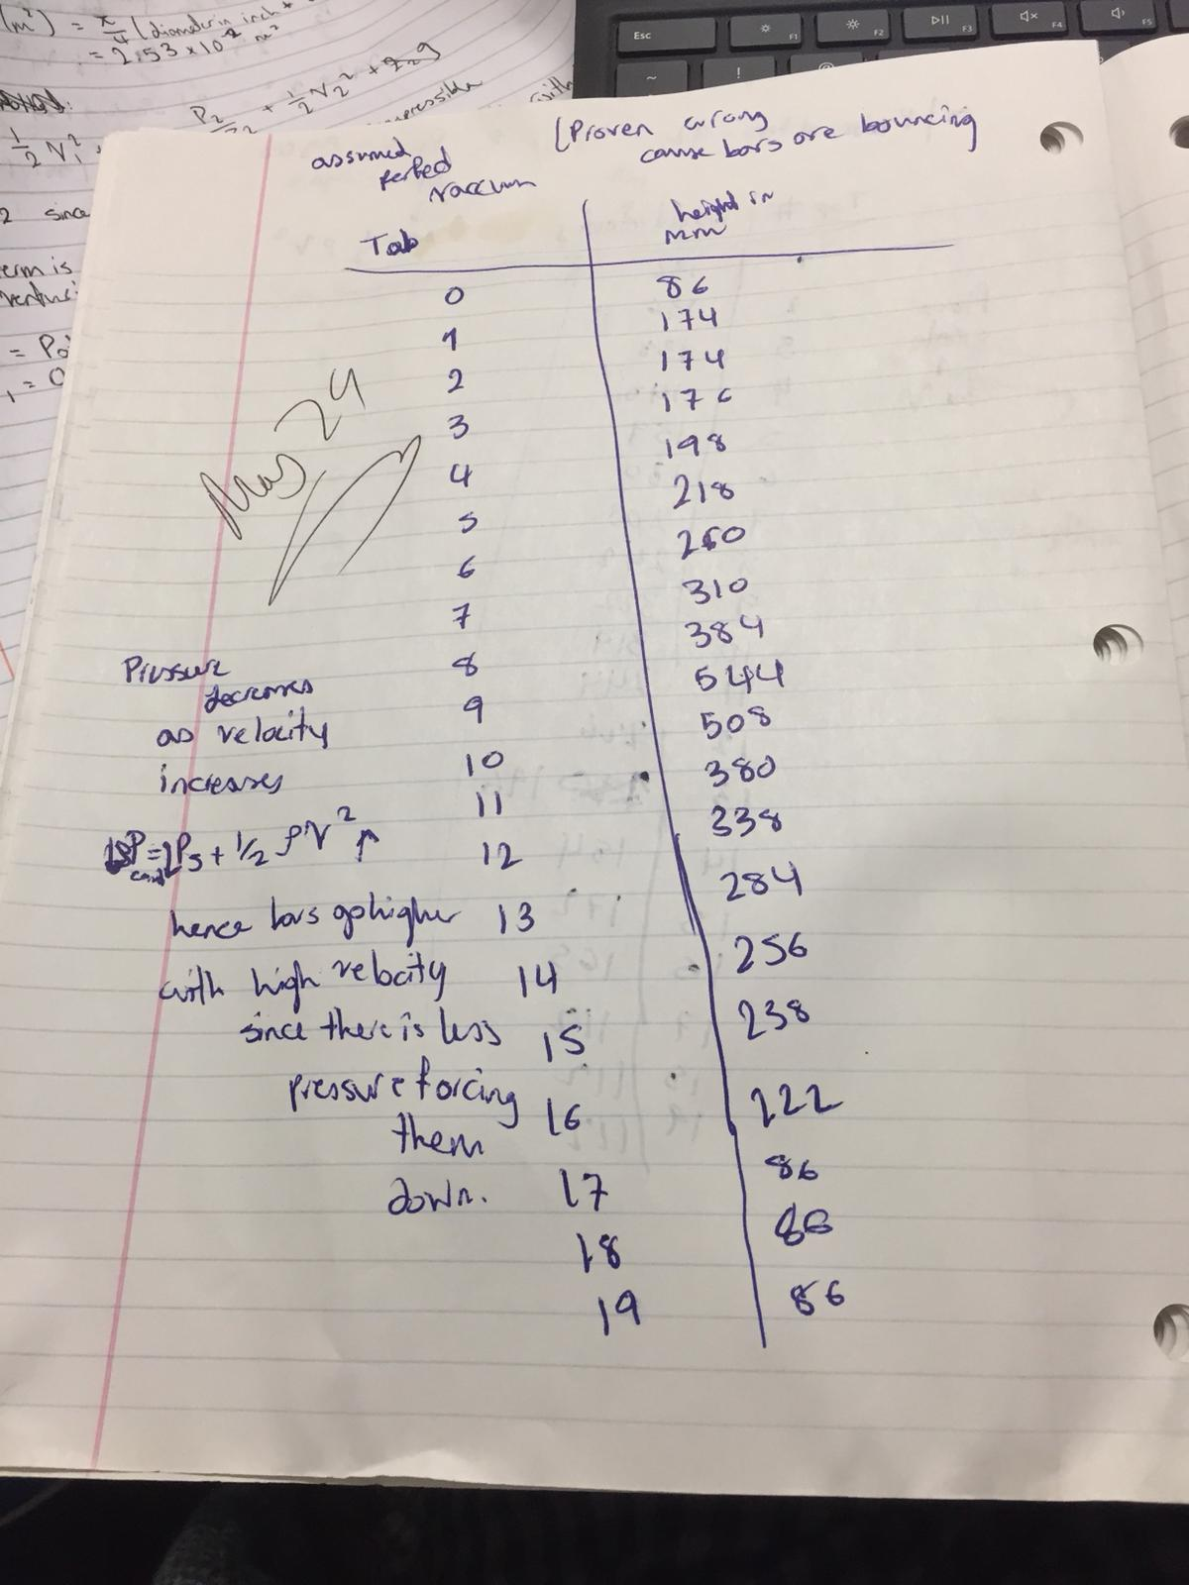
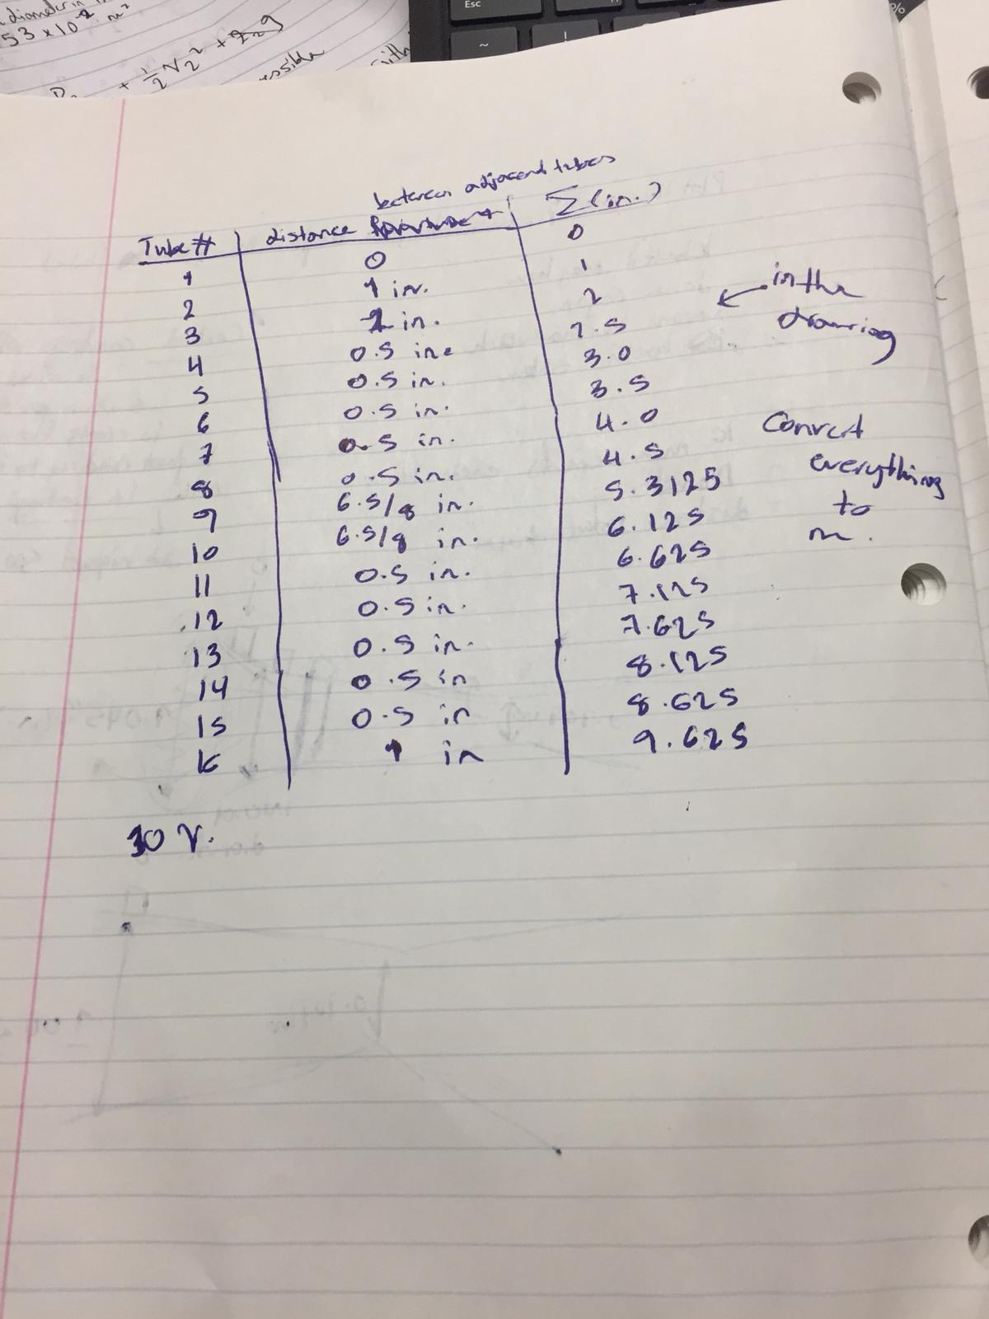

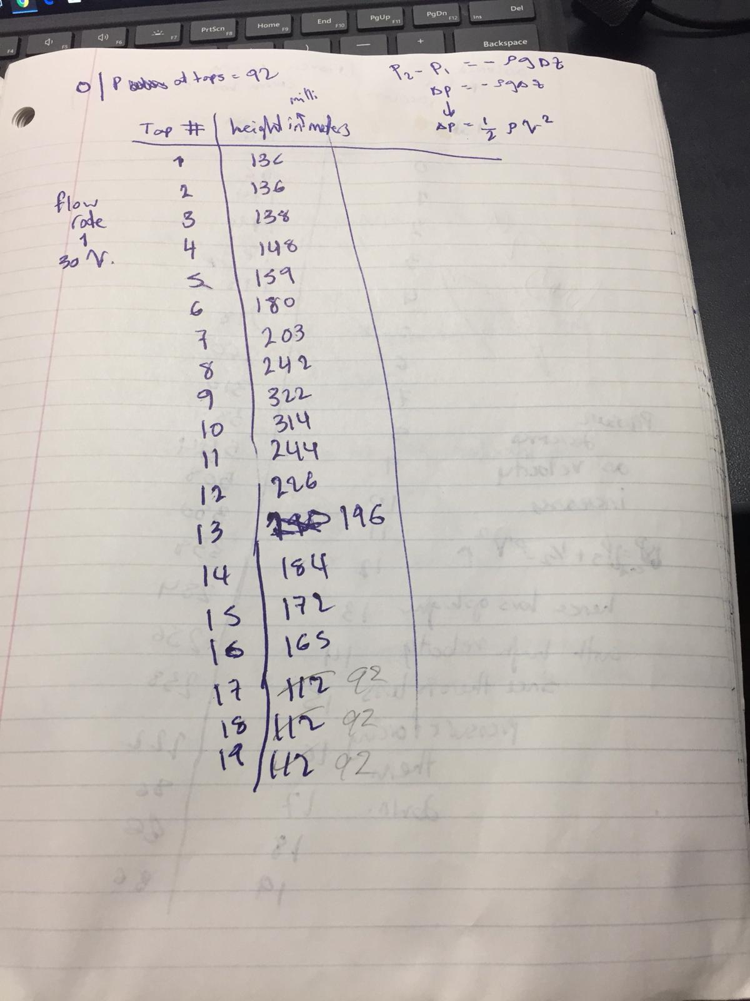

Appendix B:
Sample Calculations


