How to solve a Legal Case:
- Carefully read and understand the facts in the case as they determine the relevance of any legal points made.

- Identify and state the relevant legal issues:

- What are the parties fighting about? What needs to be resolved? e.g. is the contract enforceable? Has A committed a tort against B?
- The order of issues matters, e.g. was there an offer? Was there an acceptance?
- Deal with one issue at a time

- Discuss the law relevant to the issue (legal test):
- Legal test : the elements (factors/ingredients/checklist) to show that a particular tort has occurred. Say it “in the abstract”, as a general principle. NO FACTS YET.
- Is there a legal principle, rule or test relevant? State legal principle in the abstract without referring to the facts yet
- Cite supporting authorities

- Apply the law to the facts:
- Identify the anchor fact = a fact given that links the law to the fact pattern.
- application = law + anchor facts
- drives to your conclusion, which resolves the “issue”

- First State Anchor Facts (a fact given that links the law to the fact pattern.)
- Than state application (law + anchor facts)
Starting the Legal Analysis
Facts –> Issue –> Law -> Application
- Suppose you are given a set of facts and asked to “spot the issue”. Where do you start?
- Ask yourself: is this a tort or a different type of legal wrong?
- If it is a tort, what kind of tort is it? (Intentional, negligent, strict liability)
- Now, what tort specifically is involved?
ISSUE: Has D. committed the tort of battery?
LAW: Battery: intentional imposition of offensive contact that causes injury
ANCHOR FACTS: D hit P by intentionally swinging her fist; P’s nose is broken
APPLICATION: By swinging her fist, D imposed offensive contact. There was harm: P broke her nose.
CONCLUSION: YES. D has committed the tort of battery.)

Tort of Battery (pg. 84)
Test: Defendant intends* to cause offensive, physical contact with the plaintiff that causes harm
Elements:
- Intends to Cause*
- Offensive
- Bodily contact
- Harm
(*Intent: This is a low level of intent. It does not mean mental intent but just physical control over one’s own body.)
Battery: level of intent is “did you mean to act”; Intent to harm is not relevant.
*contact may be offensive even if not harmful (eg unwanted kiss)

EXAMPLE OF BATTERY TEST:
(Pg 24- pp1)
ISSUE: Has D. committed the tort of battery?
LAW: Battery: - intentional imposition of offensive contact that causes harm
: - Defendant causes offensive, physical contact with the plaintiff that causes harm
ANCHOR FACTS: D hit P by intentionally swinging her fist; P’s nose is broken
APPLICATION: By swinging her fist, D imposed offensive contact. There was harm: P broke her nose.
CONCLUSION: YES. D has committed the tort of battery.

(Pg 26- pp1)
ISSUE: Has D. committed the tort of battery?
LAW: Battery: level of intent is “did you mean to act”; intent to harm is not relevant.
ANCHOR FACTS: D hit P by intentionally swinging her fist; she meant to swing her fist.
APPLICATION: Because she meant to swing her fist and because battery only requires intent to act, D has the required intent
CONCLUSION: YES. D has committed the tort of battery.

Tort of Assault (pg. 83)
Test: Assault occurs when the defendant intentionally causes the plaintiff to reasonably believe that offensive bodily contact is imminent.
Elements:
- Reasonable belief on the part of the plaintiff of imminent, (i.e., immediate) offensive bodily contact (not necessarily frightening)
- Belief intentionally caused by defendant
- NO physical contact is required (contact usually triggers tort of battery)

Tort of Deceit (pg. 112)
Definition: Occurs when the Defendant makes a false statement that the Defendant knows is false/untrue and with which the Defendant intends to mislead the Plaintiff and which causes the Plaintiff to suffer a loss as a result of having reasonably relied on the false statement.
The Legal Test:
Plaintiff must prove/elements:
- Defendant made false statement
- Defendant knew statement was false (when s/he made it) or was reckless in determining truth
- Defendant intended to mislead the plaintiff
- Plaintiff suffered loss as a result of reasonably relying upon statements

*Caveat Emptor: Let the buyer beware: seller not obliged to volunteer info
* Tort of deceit requires more than just carelessness; it requires knowledge that a statement is not true.
*may be liable for half truths
*may be liable for failing to update info

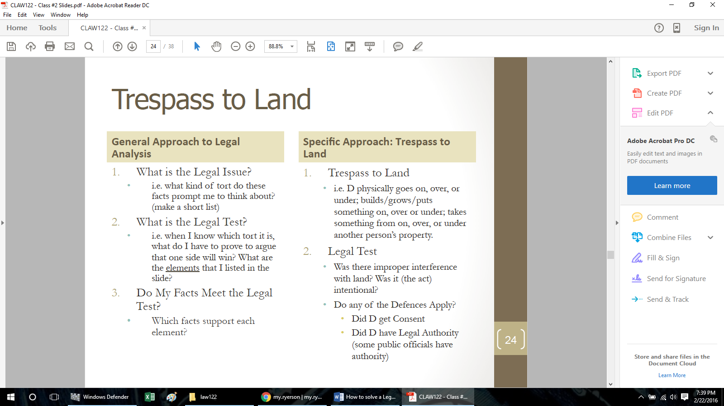
Intentional Tort to Trespass Land (pg 91)
Test: Improper interference with land
Elements:
- Intentional* act
- Causing person or object to interfere with land
- Has to be “improper”
*Low test intentional; intention to act
*Land: above, on, or below
*“Interference”: wide definition

Defense:
Consent = not “improper” (a defence)
Legal authority = not “improper” (a defence)
*Public places have implied consent
(The Law says that there is implied consent to be on property that is open to the public. But that consent can be withdrawn with notice, as long as a person is not excluded for reasons that violate the Human Rights Act.)
(Remedies: PP2, pg 25)
Eg. PP2 pg. 20
ISSUE: Can the Ontario Jockey Club legally keep Russo off their property (Woodbine Race Track and other race tracks owned by the Club)? The property is open to the public.
LAW/Legal Test: The Law says that there is implied consent to be on property that is open to the public. But that consent can be withdrawn with notice, as long as a person is not excluded for reasons that violate the Human Rights Act. 21
ANCHOR FACTS: • The Jockey Club = privately-owned property, open to the public
• Russo was told to stay away
• The reasons for excluding her do not violate human rights codes
APPLICATION: Since the Club is private property and since it withdrew consent for Russo to be on the property, Russo no longer has the right to be there. The Club can now exclude her, and if she returns, she is trespassing
CONCLUSION: If she returns, she is trespassing

Tort of Defamation: (pg. 121)

Definition: Defendant makes a false statement that could lead a reasonable person to have lower opinion of plaintiff
The Legal Test:
Plaintiff must prove/elements:
- The statement reasonably refers to plaintiff
- The statement could hurt plaintiff ’s reputation
- The statement was published to third party
- The statement was not true
*Includes any communication (e.g. spoken, written, gestures, documents, and puppet shows)
*does not have to intend to refer to the plaintiff

Defenses to Defamation Include:
- Justification (i.e. that the statement is true)
(Honest and reasonable belief in truth insufficient)
- Privilege: encourages free speech
- Absolute privilege
-Complete immunity from liability, no liability even if statement in bad faith
-Limited to: parliamentary proceedings; between high government official dealing with government business; by judge, lawyer, litigants, or a witness in context of a legal proceeding; between spouses
- Qualified privilege
-Applies when (i) legal, moral, or social obligations to make a statement, and (ii) to someone with a similar duty or interest in receiving it (eg. manager to boss)
-Liability if statement made in bad faith or motivated by malicious purpose
- Fair comment: encourages useful debate on significant issues
-Expression of an opinion on a matter of public importance
-(public interest responsible journalism)

Remedies for Defamation (pg. 125)
- Usually compensatory damages to repair losses and sometimes for personal distress
- Sometimes punitive damages for outrageous conduct
- injunction to prevent defamation:
-rarely awarded due to concern for free speech
-requires clear evidence that defamation is likely
Tort of Interference with Contractual Relations (pg. 109)
Definition: disruption of contract between plaintiff and another
Risk management
- danger in luring away competitor’s customers
- danger in luring away competitor’s workers
Forms of interference:
- Direct inducement to breach of contract: e.g. convince customer to break agreement, or employee to quit job (Ask: did D encourage P to commit a breach of K)?
- Indirect inducement to breach of contract: e.g. prevent employees from going to work, or steal worker’s tools to prevent performance
The Legal Test:
- Direct Inducement
- Defendant knows about the contract
- Defendant. intends to cause the 3rd party to breach the contract
- Defendant must actually cause the 3rd party to breach the contract (usually by convincing the 3rd party to breach)
- Plaintiff suffers a loss

- Indirect Inducement
- Defendant knows about the contract
- Defendant intends to cause the 3rd party to breach the contract
- Defendant must actually cause the 3rd party to breach the contract through an illegal act
• Plaintiff suffers a loss

*(If a company breaches a contract with a customer because the company’s unionized workers on a legal strike, the union is not liable to the customer)
Tort of Nuisance: (pg. 117)

Definition: The way the defendant uses its land unreasonably interferes with the plaintiff ’s reasonable use and enjoyment of the plaintiff ’s own land.
The Legal Test: Whether the interference caused by the defendant is unreasonable or not.
Factors to consider:
- Type of nuisance The statement reasonably refers to plaintiff
- Nature of the neighbourhood
- Time and day of the interference
- Intensity and duration
- Social utility of interference
- Defendant’s motivation

Defenses to Nuisance (pg 119):

Statutory Authority: Only if the defendant`s nuisance was an inevitable result of compliance with the statute/legislation/law

- It does not matter who was there first. What matters is what the neighborhood is now like. Urban sprawl means that farmers may find that they become nuisances
Remedies
- Damages for loss of value to property
- Injunction (to stop the interference), but only under certain circumstances. Overall social good must be considered.

Tort of Negligence: (pg. 135)

Definition: The careless causing of harm
Purpose: To compensate for harmful, risky actions conducted carelessly, but to allow for careful risk-taking.
Elements of Negligence:
- Owed duty of care (required to act carefully toward plaintiff)
- Breached standard of care by acting carelessely
- Caused harm to plaintiff
* All three elements must be met to impose liability for the tort of negligence.
- Elements of Duty of care
For there to be a Duty of Care, there must be:
- Reasonable foreseeability
Objective Test:
- Would a reasonable person have foreseen risk that harm would occur?
- Slip and fall on icy sidewalk in fron of store? In Florida?
- Not subjective- opinion of either plaintiff or defendant don’t matter
- Not Perfect - average
- Proximity
-Means close and direct connection between parties
• Physical proximity (contractor and tools, careless driver hits bridge)
• Social relationship (parent and child)
• Commercial relationship (Bar and drunk driver, Manufacturer and consumer (Donoghue)
- Asks should there be a general duty for this relationship?
Examples of well-established duties of care:
- Doctor-patient
- Lawyer-client
- Manufacturer of goods – user of goods

But even if there is a duty of care, a court might not enforce it due to:

- Public Policy
What effect would duty of care have on society and legal system?
- Open the floodgate for litigation
- Interfere with political decisions
- Hurt a valuable type of relationship (mother child)
Special Case: Duty of Care for Statements
The Legal Test:
Reasonable Foreseeability
- Communicated on a serious occasion
- Made in response to an inquiry
- Defendant was paid for statement
- Statement of fact vs. statement of opinion
- Disclaimer
Proximity
- Defendant knew that the plaintiff, either as an individual or as a member of a group might rely on the statement; AND
- Plaintiff relied on the statements for its intended purpose

- Standard of Care
- Focuses on the defendant’s actions or omissions.
- Defines how much care a person with a duty of care must exercise.

Legal Test:
- Reasonable Person Test: What would a reasonable person in the position of the defendant have done?
- Reasonable person is objective
- Would weight severity of: harm (magnitude), likelihood of its occurrence (probability), cost of avoiding harm
Standard of Care for Professionals:
- Professionals must act as a reasonable professional would under similar circumstances
- Standard is higher than for a reasonable person (no allowance for inexperience, exaggerated credentials)
Limits to Professional Standards:
- Hindsight cannot be used, focus on info available at time
- Error of judgment different form carelessness
- Compliance with approved statutory standard

Standard of Care for Product:
- Product liability
- Harm caused by manufactured products
- Negligence in Canada
- Manufacturer liable only for careless defects in design
- Manufacturer usually strictly liable for manufacturing defects

- Causation:

Who caused the harm?

Test: The “but for” test
- Would plaintiff still have suffered harm but for the defendant?
- Defendant must be a cause in fact and in law of of the plaintiffs injury
- If defendant had not been careless, would plaintiff still suffer same injury?

(pp 04 pg. 30)

Defenses to Negligence (pg 135):

Contributory negligence
Voluntary assumption of risk
Illegality

(look at pp4, pg 40)

Occupiers Liability: (pg. 114)

Definition:
- “Occupier” is any person having possession of or control over and responsibility for premises or activities on premises;
- May have multiple “occupiers” for the same premises.
- The term “premises” is broadly defined to include land, buildings, other structures, water, planes, trains, automobiles, and nother vehicles.

- When the occupier of a premise is held liable for injuries that someone sustains on these premises.
- Ontario has adopted legislation to codify occupiers’ liability.
• Occupiers’ Liability Act (Ontario)

General Duty and Modified Duty:

Occupiers’ Duty of Care [s. 3]:
- “An occupier of premises owes a duty to take such care as in all the circumstances of the case is reasonable to see that persons entering on the premises, and the property brought on the premises by those persons are reasonably safe while on the premises”;

Voluntary Assumption of Risk [s. 4]:
- The occupier may defend any claim of liability on the basis of risks willingly assumed by persons entering the premises under the circumstances described in s. 4, and provided there was no deliberate intent to do harm or act with reckless disregard for the presence of the person

Who is deemed to accept the risk of being on premises? (pg 115)
- Trespassers are deemed to have assumed all risks;
- People on the premises engaged in criminal acts are deemed to have assumed all risks
- Those entering for recreational activity under certain circumstances are deemed to have assumed all risks.

Employer Risk in Tort Law (Vicarious Liability) (pg. 70)
Legal Issue: Vicarious Liability
Definition: Employer is responsible for a wrongful act done by an employee when it is done in the course of employment
Legal Test: Employer is liable for torts committed during the course of employment, i.e
1) Acts the company authorized an employee to do
2) A tortious act closely connected to employment relationship

NO vicarious liability when:
- Employer is not vicariously liable for independent contractors (non-employees)
- Employee tort occurred completely outside the employment relationship
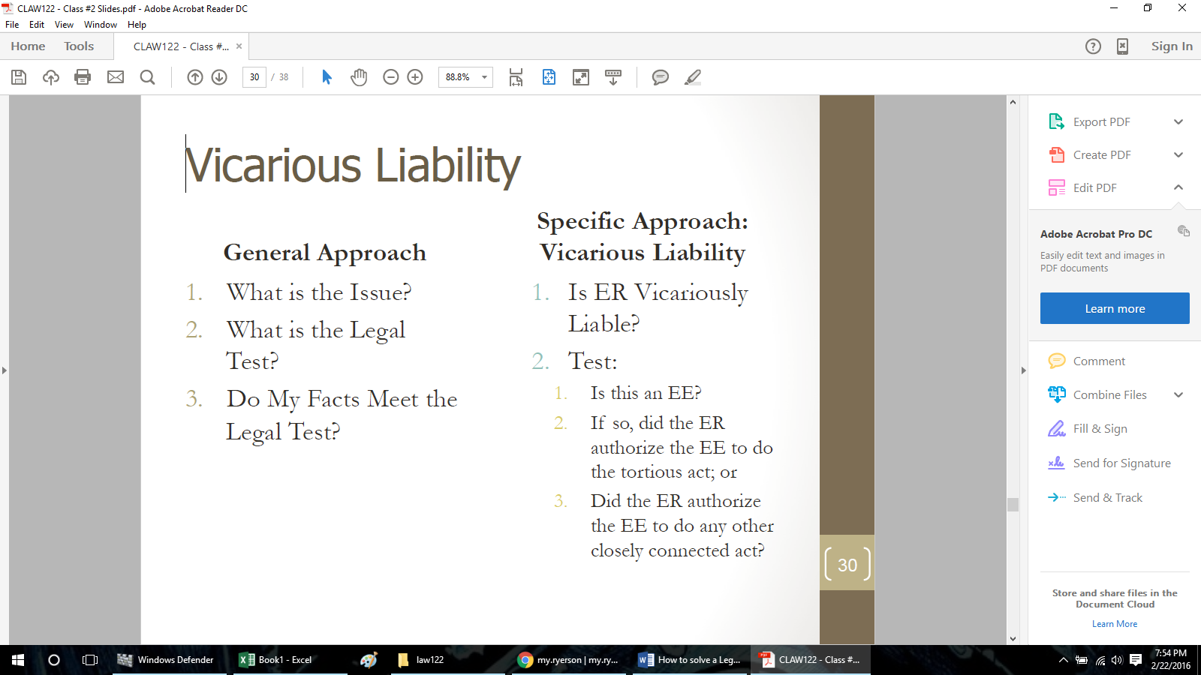
eg. ( Application:
Nature of Employee’s authorized
activities (intimate parenting)
increased the risk of wrongdoing –
combination of job-created power
and job-created intimacy.)

*ER=employer *EE=employee

Independent Contractors
• Control over when, where, and how the work is done.
• Whose equipment and premises are used?
• How is the worker paid? (Salary or lump sum at the end of a project?)
• Level of integration into employer’s business. Does the worker have other clients?
Effects of Vicarious Liability
Company will be held liable even though they didn’t do anything tortious:
• Victim can sue both employee & employer for their torts:
• Employees are directly liable for their own tort
• Employer may also be directly liable if it committed a separate and independent tort, e.g. careless training of careless employee or failure to properly screen candidates for a position

Employers may be vicariously liable for employee’s tort, even if employer was not careless
Defences In Intentional Tort (pg. 100)
Full Defences in intentional Tort (pg 97)
- Self-Defence & Third Party Defence (defence of property)
Definition: Right to protect oneself from actual and threatened violence
Elements:
- Defence to torts of assault and battery
- Available only if person at immediate risk
- Limit on Defence - Cannot use more force than necessary in circumstances
- Also allowed to defend third party e.g. parent protecting child

Limits to Defence of Property
- Force used to respond to threat must be proportionate and reasonable
- Self-defence and defence of third party are broadly defined because they protect human life and well-being. There is more room for the use of force, even lethal force.
- But the defence of property is less generous.
- If only threat is to land and chattels, may never be reasonable to deliberately cause death or serious injury

- Consent
- Plaintiff consented to interference with his/her body, property, or land.
- Consent must be voluntary and informed. It can be withdrawn or limited.
- There is implied consent in limited cases, e.g., implied consent to receive life-saving assistance unless evidence to the contrary (DNR orders).

- Defence of Necessity
Definition: Defendant’s actions are justified by an emergency
Elements:
- Immediate action must be required to avoid calamity
- Benefits flowing from conduct weighed against harm
- e.g. doctor giving urgent medical care to unconscious patient
- e.g. tearing down house to prevent spread of fire
- Usually a complete defence but sometimes only partial defence

Defence of Necessity (cont.):
Consider American case:
- Emergency caused by storm caused ship to moor to dock
- Damage caused to dock during storm
- Trespass was justified, however compensation required for damages

Partial Defences in intentional Tort (pg 99)
- Allows court to reduce damages on basis of plaintiff ’s own responsibility for injury
- Applies even though defendant committed an intentional tort

- Provocation
Definition: Words or actions that would cause a reasonable person to lose self-control
- Typically, defendant “snaps” after being taunted or insulted
- Tied to torts of assault and battery
- Defendant liable for attack, but plaintiff ’s damages are reduced

- Contributory Negligence
Definition: Occurs when plaintiff partially responsible for injury that defendant tortuously caused: the plaintiff’s own careless was a cause or added to the injury he or she suffered.
- Damages reduced to reflect plaintiff ’s contribution to harm
- Elements of the defence differs through Canadian jurisdictions:
• Some divide responsibility on basis of parties’ fault
- allows defence to apply to any tort, including intentional
• Some divide responsibility on basis of parties’ negligence
- Courts have found the defence difficult to apply to intentional torts as concept of negligence does not naturally fit intentional torts

