CHAPTER 20: THE CANADIAN CHARTER OF RIGHTS AND FREEDOMS AND REGULATORY STANDARDS
Legal Framework
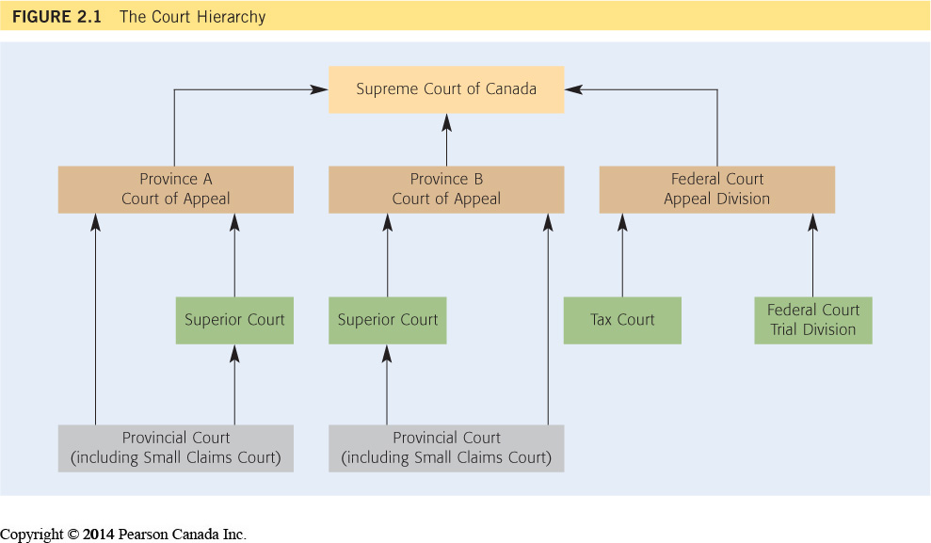
Judicial Framework

Introduction
- Most employment law statutes have separate officials or tribunals to deal with any complaints of contravention (e.g., Employment Standards Officers, Human Rights Tribunal, Workplace Safety and Insurance Tribunal, Labour Relations Board).
- The court system and the law generally are founded on precedence and the judicial doctrine of stare decisis (to stand by things decided).
- A lower court in the hierarchy must abide by the legal principles, doctrines and interpretations of a higher court in the hierarchy.
- The courts generally are involved only on appeals from tribunal decisions (notable exception: wrongful dismissal claims).
- The courts generally will overturn a tribunal decision only if it was patently unreasonable.

Constitution
- The Constitution is the dominant source of Canadian law.
- All legislation and the common law must conform to the Constitution.
- The Constitution Act, 1867
  - This Act established Canada’s system of government, including the division of powers between the federal government and the provinces and territories.
- General constitutional authority to deal with employment is vested in the provinces under S. 92 (Property and Civil Rights).
  - Ref. Toronto Electric Commissioners v. Snider, [1925]
  - An exception exists for organizations of “national importance.”
- The Constitution Act, 1982
  - Established and confirmed the essential rights and freedoms of all Canadians through the Canadian Charter of Rights and Freedoms (the Charter).

Charter of Rights and Freedoms
What or Whom Does the Charter Govern?
- The Charter only applies to government action.
- Purpose: to regulate the relationship between governments and citizens, not the relationships between private citizens and private companies.
- The charter sets limits on government actions.
- How do governments act?
  - They enact and administer laws and regulations
  - They act in the capacity of the employer or their own employees.
  - Occasionally courts have been asked to decide whether an employer is “the government” on the basis that it receives significant government funding, or is highly regulated by the government
    - For example, colleges, the SCC has treated colleges as government actors for the purposes of the Charter
    - However, universities are not government actors because although they receive public funding, governments have far less direct control over universities than they do colleges.
Understanding the Charter Challenge
- How the Charter operates in practice: governments must consider the Charter whenever they are proposing and drafting new laws.
  - Usually, a government that receives legal advice that a proposed law (a bill) will infringe the Charter is expected to revise the bill to bring it into Charter compliance or withdraw the bill.
  - Once legislation is enacted into law, it can be challenged by anyone who believes that the law violates a right or freedom protected by the Charter.
SCC has a two-step process to analyze Charter Challenges.
Step 1: has Government Infringed a Charter Right or Freedom?
Step 2: if an Infringement Exists, is it Justified in a Free and Democratic Society?
- In certain instances, in order to protect or pursue an important public interest, it may be necessary to impinge upon Charter rights and freedoms.
- Language in section 1 is very vague R v. Oakes test
  - Oakes Test: the test applied by courts and tribunals when interpreting section 1 of the Canadian Charter of Rights and Freedoms. The test requires courts and tribunals to balance the interests of individuals in having their Charter rights and freedoms protected against any broader social benefits that would result from allowing a restriction of a Charter right or freedom.
What Rights and Freedoms in the Charter Are Important to the Law of Work?
- Part I of the Constitution Act, 1982
  - Introduced as part of the repatriation of the Canadian Constitution;
  - Establishes or confirms certain basic rights and freedoms of Canadians;
  - Decisions under the Charter have had a profound impact on Canadian life, including employment.

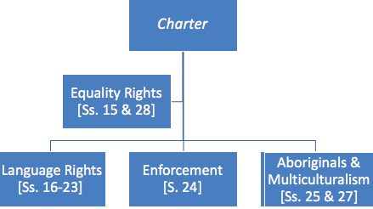
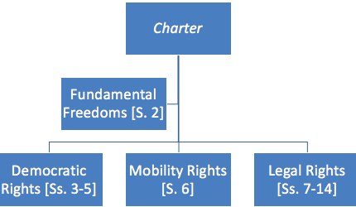
- Equality Rights [S. 15]
  - “(1) Every individual is equal before and under the law and has the right to the equal protection and equal benefit of the law without discrimination and, in particular, without discrimination based on race, national or ethnic origin, colour, religion, sex, age or mental or physical disability.”
(2) Describes an exception for affirmative action programs targeted at disadvantaged groups.
- Rights Guaranteed Equally to Both Sexes [S. 28]
  - “Notwithstanding anything in this Charter, the rights and freedoms referred to in it are guaranteed equally to male and female persons.”

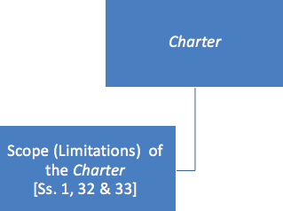

- Limitations [S. 32]
  - “(1) This Charter applies
(a) to the Parliament and government of Canada in respect of all matters within the authority of Parliament including all matters relating to the Yukon Territory and Northwest Territories; and
(b) to the legislature and government of each province in respect of all matters
within the authority of the legislature of each province.”
- S. 32 was interpreted by the Supreme Court of Canada to mean that the Charter applies only to government, or government-relied-upon, action and not to strictly private matters.
  - Ref. RWDSU v. Dolphin Delivery Ltd., [1986] SCC
- Limitations (Notwithstanding Clause) [S. 33. (1)]
  - “(1) Parliament or the legislature of a province may expressly declare in an Act of Parliament or of the legislature, as the case may be, that the Act or a provision thereof shall operate notwithstanding a provision included in section 2 or sections 7 to 15 of this Charter.”
- S. 33. (3)
  - “A declaration made under subsection (1) shall cease to have effect five years after it comes into force or on such earlier date as may be specified in the declaration.”
- S. 33. (4)
  - “Parliament or the legislature of a province may re-enact a declaration made under subsection (1).”
- Limitations [S. 1]
  - “The Canadian Charter of Rights and Freedoms guarantees the rights and freedoms set out in it subject only to such reasonable limits prescribed by law as can be demonstrably justified in a free and democratic society.”
- R. v. Oakes, [1986] SCC
- The SCC established a three-part test for determining whether a violation of the Charter was justifiable under S. 1 as follows:
  - Does it enforce or reflect an important societal concern? “Trivial” objectives will not warrant overriding a Charter right.
  - Was the limitation on Charter rights minimal?
  - Is the limitation precise as to the prohibited conduct?
- Most relevant Charter provisions to the law of work:
  - S. 1 – Guarantee of Rights and Freedoms
  - S. 2 – Fundamental Freedoms
  - S. 6 – Mobility Rights
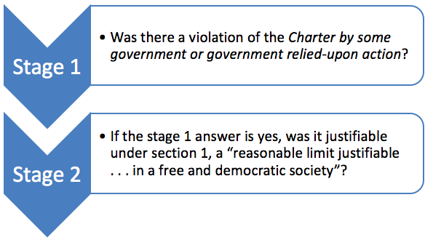
  - S. 15 – Equality Rights
- Ref. Box 20.2

- Ref. Boxes 20.3 and 20.4

The Charter and the Common Law Regime of Work Law
- BC the charter only regulates government action, not the actions of private citizens and organizations, a lawsuit between two private (i.e., not government) actors, the Charter does not directly apply.
  - But should be guided by Charter values so that it indirectly influences the development of the common law
The Charter and the Regulatory Standards Regime
- The Charter was never intended to have a substantial impact on the common law regime, but it was expected to influence the development of the regulator standards regime.

What Do You Think?
Class 1 Fact Scenario 1
M. v. H., [1999] SCC
Two women lived in a spousal relationship for many years. They separated, and M. sought spousal support under Ontario’s Family Law Act. Support was denied, as the Family Law Act restricted the meaning of “spouse” to heterosexual relationships.

S. 15 (1) of the Charter: “Every individual is equal before and under the law and has the right to the equal protection and equal benefit of the law without discrimination and, in particular, without discrimination based on race, national or ethnic origin, colour, religion, sex, age or mental or physical disability.”

- Did this definition of spouse violate the couple’s equality rights under section 15 of the Charter?
Yes as the definition of spouse violated the couple’s equality rights under section 15 of the Charter.
- M. v. H., [1999] SCC
- The Supreme Court of Canada held that this statutory definition was unconstitutional, as it breached the couple’s equality rights under S. 15 of the Charter (sex).

Vriend and M. v. H. are notable because:
  - The authority of the SCC extends to writing legislation. Sexual orientation was added to the list of prohibited grounds under Alberta’s Individual Rights Protection Act (“Vriend”), and the definition of “spouse” under Ontario’s Family Law Act was expanded to include same-sex couples (M. v. H.);
  - The SCC was prepared to declare a violation of S. 15. (1) by what a legislature failed to do, not simply by what it did;
  - The SCC determined there was a violation of S. 15. (1) on a ground analogous to those enumerated in that section. The enumerated grounds in S. 15. (1) are not exclusive;
  - In all of these ground-breaking decisions advancing the rights of gays and lesbians, the court rejected any argument under S. 1 of the Charter that these limitations or denial of equal rights represented “. . . reasonable limits . . . demonstrably justified in a free and democratic society”;
  - The courts in making Charter decisions are making social policy. They are key players in determining Canadian social values.

Legal Framework


