MKT 100

Chapter 1

Marketing – A set of business practices designed to plan for and present an organizations products or services in ways that build effective customer relationships

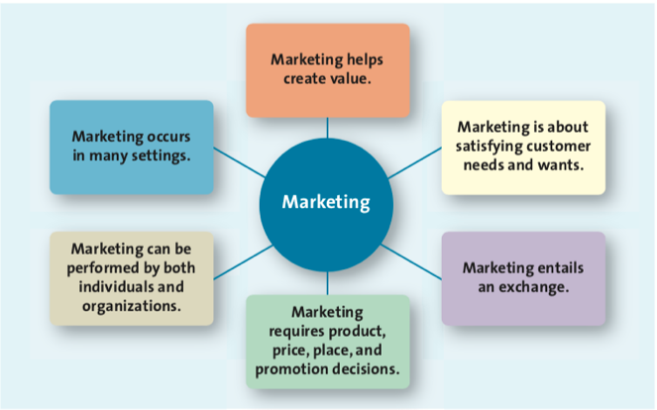

Marketing is about satisfying customer needs and wants
- Needs: basic necessities, such as food, clothing, shelter, and safety
- Wants: the particular way in which a person chooses to satisfy a need, which is shaped by a persons knowledge, culture, and personality
Target market: the customer segment or group to whom the firm is interested in selling its products and services
Exchange: the trade of things of value between the buyer and the seller so that each is better off as a result

Good/ Services (Sellers) Communications and Delivery Customer/ Consumers (Buyers)
Good/ Services (Sellers) Money and Information Customer/ Consumers (Buyers)

Marketing Mix/ Four P’s: Product, Price, Place, Promotion – the controllable set of activities that a firm uses to respond to the wants of its target market

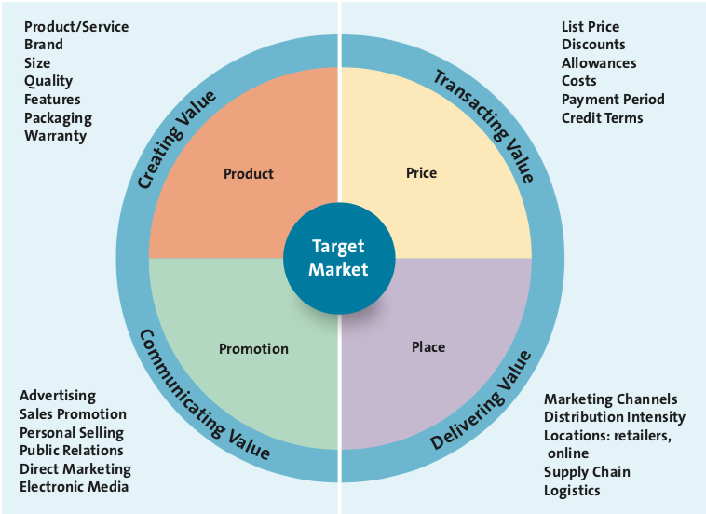
Product: Creating Value
- Goods: Items that you can physically touch (Ex: Nike shoes, beer)
- Services: Intangible customer benefits that are produced by people or machines and cannot be separated from the producer (Ex: Banking, Insurance)
- Ideas: Thoughts, opinions, philosophies, and intellectual concepts that can also be marketed (Ex: Promoting a company)

Price: Transacting Value
- everything the buyer gives up – money, time, energy – in exchange for the product

Place: Delivering Value
- all the activities to get the product from the manufacturer or producer to the right customer when that customer wants it. Deals with retailing

Promotion: Communicating Value
- communication by a marketer that informs, persuades, and reminds potential buyers about a product or service to influence their opinions or elicit a response

- Marketing between Orgs and Individuals
  - B2B (Business to Business) – the process of selling merchandise or services from one business to another
  - B2C (Business to Consumer) – process in which businesses sell to consumer
  - C2C (consumer to consumer) – process inn which consumers sell to other consumers
- Social Media: The use of digital tools to easily and quickly create and share content to foster dialogue, social relationships, and personal identities

The Four Orientations of Marketing
- Product Orientation: Focus on developing and distributing innovative products with little concern about whether the products best satisfy customer needs.
- Sales Orientation: View marketing as a selling function where companies try to sell as many of their products as possible rather than focus on making products consumers really want. Depend on personal selling and advertising to attract new customers. Focus on making a sale or on each transaction rather than building long term customer relationships
- Market Orientation: focus on what customers want and need before they design, make, or attempt to sell their products and services. Understand and respond to customers needs and do whatever they can to make customer happy.
- Value-based Orientation: Providing customers with greater value than their competitors. Focus on triple bottom line: People (consumer needs and wants), profits (long term profitable relationships with customers and suppliers), and planet (doing it in a socially and environmentally responsible way)
  - Value: relationship of benefits to costs, or what you get for what you give
  - Firms become more value oriented by sharing information, balancing benefits with costs, building relationships with customers, and connecting with them through social media

Chapter 2 – Developing Marketing Strategies and a Marketing Plan

Marketing Strategy – Identifies a firms target market, a related marketing mix (the four Ps), and the bases upon which the firm plans to build a sustainable competitive advantage
- sustainable competitive advantage – an advantage over the competition that cannot be easily copied and can be maintained over a long period of time

Four strategies that focus on aspects of the mkting mix to depict sustainable competitive advantage
- Customer excellence: Focuses on retaining loyal customers and excellent customer service
  - Firm develops a value based strategy for retaining loyal customers and providing outstanding customer service
- Operational excellence: Achieved through efficient operations and excellent supply chain and human resource management/ strong relations with suppliers
- Product excellence: having products with high perceived value and effective branding and positioning
- Locational excellence: having a good physical location and internet presence. Important for retailers and service providers

Marketing Plan
- Written document composed of an analysis of the current mkt situation, opportunities and threats for the firm, and so on.
- 5 steps
  - Planning phase
    - Step 1: Marketing execs and top managers define the mission and objectives of the business
      - Called a mission statement
    - Step 2: Evaluate the situation by assessing how various players, both inside and outside organization, affect the firms potential for success (situation analysis)
      - Use a SWOT analysis
        - Strengths and Weaknesses internal
        - Opportunities and Threats external
  - Implementation phase
    - Step 3: Identify and evaluate different opportunities by engaging in segmentation, targeting, and positioning
      - Segmentation: the process of dividing the market into distinct groups of customers where each cx has similar needs, wants, and characteristics
      - Targeting: evaluating the attractiveness of various segments and then deciding which to pursue as a market
      - Positioning: defining the mkting mix variables so that cx’s have a clear understanding of what the product does in comparison with competing products
    - Step 4: Implement the marketing mix using for P’s (Product, Price, Place, Promotion)
  - Control phase
    - Step 5: evaluate performance of the mkt strategy by using mkting metrics and taking any necessary corrective actions
      - A metric is a measuring system that quantifies a trend, dynamic, or characteristic.
      - Compare a firm’s performance over time or to competing firms
      - View the firm’s products or services as a portfolio

Portfolio Analysis
- Stars: Occur in high growth mkts and are high mkt share products. As mkt share growth slows, they transition to cash cows
- Cash Cows: Low growth mkt and high share products
- Questions Marks: high growth mkt but low mkt share
- Dogs: low growth mkt and low mkt share

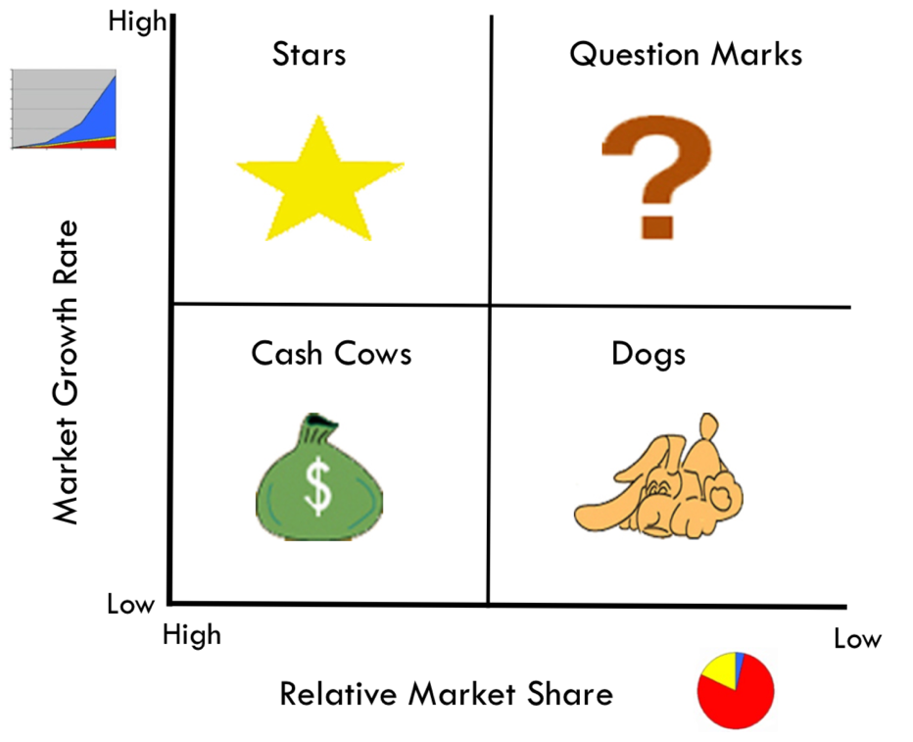

Growth Strategies

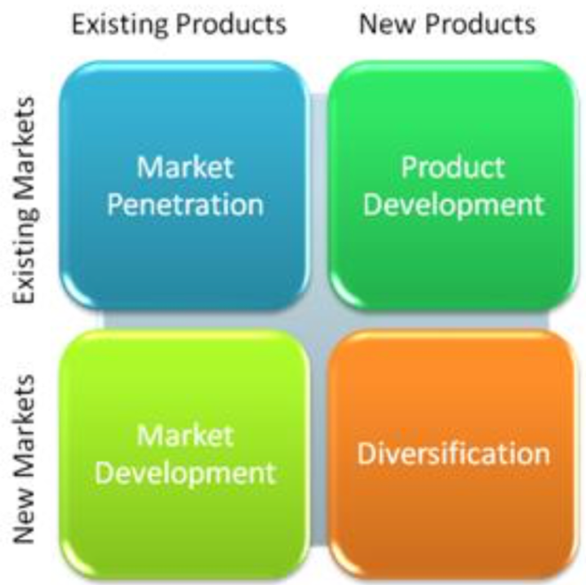

- Market Penetration
  - Employs the existing mkting mix and focuses the firms efforts on exisiting customers
- Market Development
  - Employs the existing mkting offering to reach new mkt segments, whether international or domestic
- Product Development
  - Offers a new product or service to a firms current target mkt
- Diversification
  - Firm introduces a new product or service to a mkt segment that it does not currently serve

Chapter 3 – Analyzing the Mkting Environment

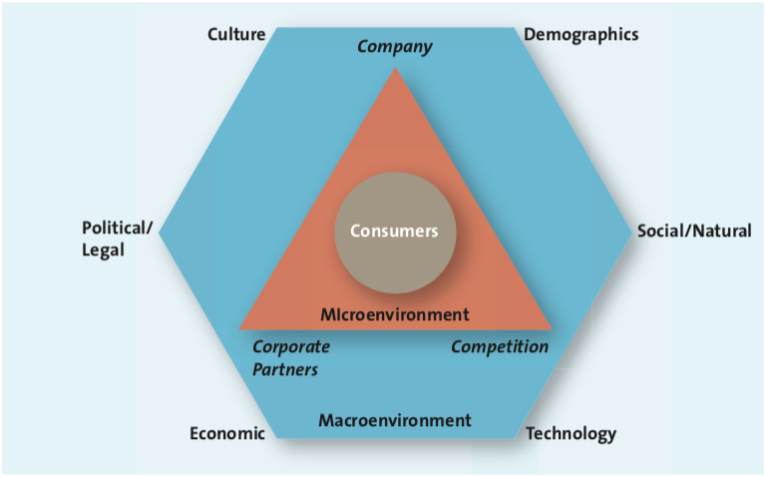

Framework companies use to analyze the mkting environment. The heart of it is the cx
Cx can be affected by the firms microenvironment (triangle) and/or the macroenviroment (hexagon)

Microenvironmental Factors (internal)
- Company capabilities
  - Focus efforts on satisfying cx needs that match their core competencies
- Competition
  - More competition = more choices for cxs
  - Firms must understand competitions strengths and weaknesses and adapt to it
  - Competitive Intelligence: something that firms use to collect info about their position with respect to their rivals, allows companies to anticipate changes in marketplace rather than react to them
- Corporate partners
  - Align with suppliers
  - Just in Time deliveries

Macroenvironmental Factors (External)
- Culture
  - the shared meaning, beliefs, morals, values, and customs of a group of people
  - Country’s Culture: easy to spot visible nuances that are particular to a country, such as dress, symbols, food preferences
  - Regional subcultures: the region in which people live in a particular country affects the way they react to different cultural rituals.
- Demographics
  - provides an easily understood snapshot of the typical consumer in a specific target market
  - Generational cohorts – a group of people of the same generation

    - Tweens
      - not quite teenagers but not young children either
      - have $2.9 billion buying power annually in Canada
      - speeders: first generation after emergence of internet, learn quick
    - Gen Y (millennials/ “echo boom”)
      - between ages 13 and 32
      - 21% of Canadas population
      - grew up in a media intensive and brand conscious era
      - Internet and tech savvy
    - Gen X
      - Between ages 36 and 47
      - 15% of Canadian population
      - grew up in times of economic recession
      - first to grow up in dual income households
    - Baby Boomers
      - Between ages 48 and 66
      - 30% of Canadian population
      - have immense buying power
      - prize holding on to youth
      - use anti aging cream
    - Seniors
      - Aged 67 or older
      - 13.7% of Canadian population
      - grew up in traumatic times
      - like “made in Canada” items
      - like to travel, buy second homes and luxury cars
  - Income
    - Upper class: very affluent, buy luxury and not influenced by economic patterns
    - Middle class: afford a good life and are careful about their spending
    - Working class: low income, barely sufficient income to cover their basic needs
  - Education
    - The higher the education, the better the income
    - College and uni students tend to be engaged in playing sports and going to nighclubs
    - High school grads more likely to watch sports and go to bars
  - Gender
    - Male/ female roles have been shifting, companies are now more cautious of gender neutrality in workplaces
  - Ethnicity
    - Every 1 out of 5 Canadian was not born here
    - Two fastest growing groups: Chinese and South Asians
    - Challenge for marketers to understand culture, value, and spending patterns of various groups
- Technology
  - Tech changes that have contributed to the improvement of the value of products and services in the past few decades
  - Internet is very powerful, now used for everything (online shopping, tracking)
  - Social Media Marketing is now taking over
- Economic Situation
  - Economic changes that affect the way consumers buy merchandise and spend money
  - Major Factors
    - Inflation: persistent increase in the prices of goods and services (a dollar buys less than it used to)
    - Foreign currency fluctuations: changes in value of countrys currency relative to currency of another country
    - Interest rates: the cost of borrowing money (from bank, etc)
    - Recession: a period of economic downtown when the economic growth of the country is negative for at least two consecutive quarters
- Political/ Legal Environment
  - Comprises political parties, govt organizations, and legistlations and laws that promote or inhibit trade and marketing activities
  - Protects consumers since manufacturers are abstained from false advertising and are required to remove any harmful materials
- Social/ Natural Trends
  - Shape consumer values in Canada and the US, and around the world. Tends to change over time
  - Some big trends in todays world
    - Greener Consumers
      - Green Marketing involves a strategic effort by firms to supply customers with environmentally friendly merchandise.
      - Cx appreciate the efforts of companies to supply them with environmentally friendly goods
    - Time poor society
      - Most families work
      - Consumers have many more choices regarding leisure time

Chapter 4: Consumer Behavior
- Use principles from sociology, anthropology
- Understand consumer actions and develop basic strategies to deal with them
- Understand why people buy products and services

The consumer decision process
- Step 1: Need Recognition
  - Occurs when customers recognize they have an unsatisfied need and want and want to go from their needy state state to a different, desired state
  - Classifications of consumer needs
    - Functional
      - Pertain to the performance of a product or service
      - Ex: Cx buys a functionally and tested superior product
    - Psychological
      - Pertain to the performance of a product of service
      - Ex: Cx buys $1500 branded shoes over regular $50 shoes
- Step 2: Information Search
  - Searching for information about the various options that exist to satisfy that need.
  - Internal Search for Information
    - Occurs when the buyer examines his or her own memory and knowledge about the product or service, gathered through past experiences.
  - External Search for Information
    - Occurs when buyer seeks information outside his or her personal knowledge base to help make the buying decision
    - Ex: searching online or talking to someone about it
  - Factors affecting consumers search processes
    - The perceived benefits vs perceived costs of search
      - Is it worth the time to search for this product?
    - The locus of control
      - Internal locus of control
        - When consumers believe they have some control over the outcomes of their actions, in which case they engage in more search activities
      - External locus of control
        - When consumers believe that fate or other external factors control all outcomes
    - Actual or perceived risk
      - Performance risk
        - Involves the perceived danger inherent in a poorly performing product or service
        - A sports car wont work on the day he is supposed to take his gf out for a drive
      - Financial risk
        - risk associated with a monetary outlay; includes the initial cost of the purchase, as well as the costs of using the item or service
        - car manufacturers increasing warranties on cars to get more cxs to buy them to alleviate cx financial risk worries
      - Social risk
        - Involves the fears the consumers suffer when they worry others might not regard their purchases positively
      - Physiological risk (aka safety risk)
        - Risk associated with the fear of an actual harm should the product not perform properly
      - Psychological risk
        - risk associated with the way people will feel if the product or service does not convey the right image
- Step 3: Alternative Evaluation
  - Evaluative criteria consist of a set of important attributes about a particular product that are used to compare alternative products
  - Determinant attributes: product or service features that are important to the buyer and on which competing brands or stores are perceived to differ
  - Consumer decision rules: set of criteria consumers use consciously or subconsciously to quickly and efficiently select from among several alternatives
  - Compensatory
    - Compensatory decision rule: assumes that the consumer, when evaluating alternatives, trades off one characteristic against another, such that good characteristics compensate for bad characteristics
  - Noncompensatory
    - When customers choose a product or service on the basic of a subset of characteristics, regardless of the values of its other attributes
  - Decision Heuristics
    - Mental shortcuts that help consumers narrow down choices
- Step 4: Purchase
  - Ritual consumption: refers to a pattern of behaviors tied to life events that affect what and how people consume
- Step 5: Post-Purchase Evaluation
  - Marketers hope to create loyal customers who want to purchase the product again
  - Three possible outcomes
    - Customer satisfaction (+ve)
    - Postpurchase cognitive dissonance (buyers remorse) (-ve)
      - An internal conflict that arises from an inconsistency between two beliefs, or between beliefs and behavior
      - Might rethink if buying an expensive tv was worth it or not
    - Customer loyalty (or disloyalty)
      - Want cxs to be satisfied from first purchase so that they buy from same company over and over again
    - Undesirable consumer behavior (-ve)
      - Negative word of mouth
        - Occurs when consumers spread negative info about a product, service, or store to others

Factors Influencing consumer buying decisions
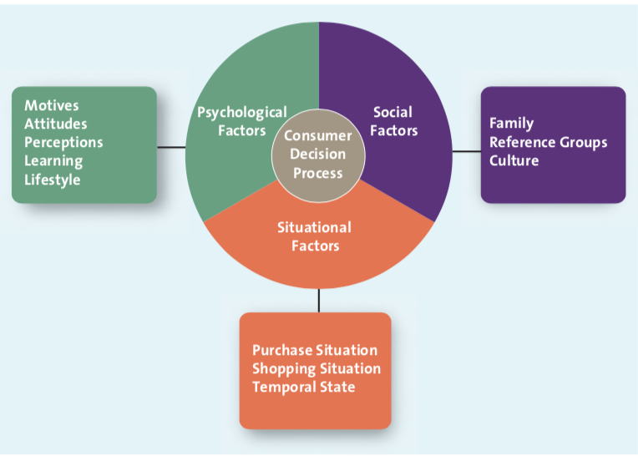
- Psychological factors
  - Motives
    - A need or want tat is strong enough to cause the person to seek satisfaction
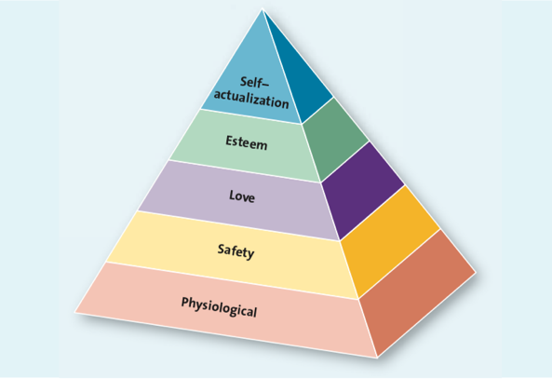
    - Physiological needs
      - Relate to the basic biological necessities of life: food, drink, rest, and shelter
    - Safety needs
      - Pertain to protection and physical well-being
    - Love (social) needs
      - Relate to our interactions with others
    - Esteem needs
      - Allow people to satisfy their inner desires

    - Self-actualization needs
      - Occurs when you feel completely satisfied with your life and how you live
  - Attitude
    - A persons enduring evaluation of his or her feelings about and behavioral tendencies towards and object or idea
    - Three components
      - Cognitive component: reflects what we believe
      - Affective component: what we feel about the issue at hand
      - Behavioral component: the action we take based on what we know and feel
      - When there is incongruence, it can cause cognitive dissonance
  - Perceptions
    - The process by which people select, organize, and interpret information to form a meaningful picture in the world
    - Marketers must understand and focus on the four components of perception
      - Selective exposure: ignoring some channels, watching only some
      - Selective attention: listening to messages consistent with own beliefs
      - Selective comprehension: when consumers interpret a marketing message in a way that is different from marketers intention
      - Selective retention: consumers do not remember all the info they see, read, or hear
  - Learning
    - Refers to a change in a persons thought process or behavior that arises from experience and takes place through the consumer decision process
  - Lifestyle
    - Refers to the way consumers spend their time and money

- Social Factors
  - Family
    - the entire family makes the decision, not just one person, so the initial decision could change
  - Reference Groups
    - One or more persons and individual uses as a basis for comparison regarding beliefs, feelings, and behaviours
    - They offer info, enhance consumers self image, and provide rewards for specific purchasing decisions
  - Culture
    - Marketers have to make sure they change their marketing strategy according to the culture or country theyre in

- Situational factors: factors affecting the consumer decision process, those that may override, or atleast influence, psychological and social issues
  - Purchase situation
    - Consumers buy specific products or services because of some underlying psychological trait or social factors
  - Shopping situation
    - Consumers want to buy product but change decision last minute due to some reason or vice versa
      - Salespeople: liked the person helping them so bought it
      - Crowding: too many people or line too long so didn’t buy
      - Store atmosphere: liked the specific environment in store
      - In store demos: likes the look of demo on a mannequin
      - Promos: exclusive in store deals
      - Packaging: design or look of the box you get your shoes in
  - Temporal state
    - Our state of mind at a specific time, whether or not we’re in the mood to buy it at a specific time

Involvement and Consumer buying decisions
- Involvement: The consumers degree of interest or concern in the product or service
- Extended problem solving
  - Consumer devotes a considerable amount of time and effort to analyzing alternatives; often occurs when the consumer purchase decision entails a great deal of risk
- Limited problem solving
  - occurs during a purchase decision that calls for, at most, a moderate amount of time and effort
    - impulse buying: common type limited problem solving, a buying decision made on spot when cxs see merchandise
    - habitual decision making: another common type, consumers engage with little conscious effort (it’s a habit so they just do it)

Chapter 5: Business-to-Business Marketing

Business to Business (B2B) Marketing
- refers to the process of buying and selling goods and services to be used in the production of other goods and services, for consumption by the buying organization, or for resale by wholesalers and retailers.
- Challenges that must be mastered for each business customer they want to serve
  - Identify the right persons or decisions makers within the organizations who can authorize or influence purchases
  - Marketers must understand the buying process of each client
  - Identify the factors that influence the buying process of potential clients
Difference between B2B and B2C
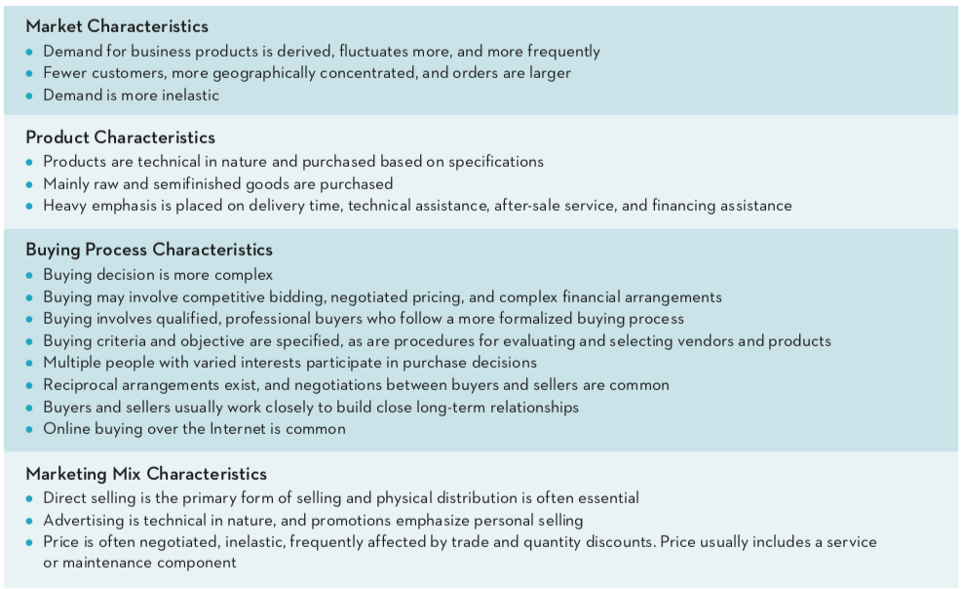

The B2B Buying Process
Step 1: Need Recognition
- The buying org recognized, through either internal or external sources, that it has an unfilled need
Step 2: Product Specification
- The buying org specifies to vendors what they want
Step 3: RFP Process
- Request for proposals (RFP): process through which buying org invites alternate suppliers to bid on supplying their required components
Step 4: Proposal Analysis and Supplier Selection
- Buying org evaluates all RFPs and selects one
Step 5: Order Specification
- Buying org places order with supplier
Step 6: Vendor Performance Assessment Using Metrics
- Buying org analyze vendors performance so they can make a decision about their future purchases

The buying centre
- The group of people typically responsible for the buying decisions in large organizations
- Six roles within a buying centre
  - Initiator: person who first suggests buying the particular product or service
  - Influencer: person whose views influence other members of the buying centre in making final decision
  - Decider: person who ultimately determines any part of buying decision
  - Buyer: person who handles paperwork of purchase
  - User: person who uses product or service
  - Gatekeeper: person who controls info and access to decision makers and influencers

Organizational Culture
- Reflects the set of values, traditions, and customs that guides its managers and employees behavior
- Types of org cultures
  - Autocratic buying centre
    - One person makes the decision alone
  - Democratic buying centre
    - Majority rules in making decisions
  - Consultative buying centre
    - One person makes decision, but he or she solicits input from others before doing so
  - Consenses buying centre
    - All members of the team must reach a collective agreement that they can support a particular purchase

Buying situations
- Three types
  - New buy
    - Buyer doesn’t have experience with item, will probably go through all six steps in buying process before making a decision
  - Modified rebuy
    - buyer has purchases a similar product in the past but has decided to change some specifications
  - Straight rebuy
    - When buyer simply buys additional units of products that have previously been purchased

Chapter 7: Marketing Research

Marketing Research
- A set of techniques and principles for systematically collecting, recording, analyzing, and interpreting data that can aid decision makers involved in marketing goods, services, or ideas

The Marketing Research Process
- Step 1: Define Research Problem and Objectives
  - What info is needed to answer specific research questions?
  - How should that info be obtained?
- Step 2: Design the Research Plan
  - Identify the type of data needed and determine the type of research necessary to collect it
- Step 3: Collect Data
  - Collected from secondary and primary sources
  - Secondary data: pieces of info that have been collected prior to the start of the focal project
    - includes both internal and external data sources
  - Primary data: those data collected to address specific research needs currently under investigation
    - Include focus groups, in-depth interviews, and surveys
- Step 4: Analyze Data and Develop Insights
  - Data: Raw numbers or other factual information of limited value
  - Information: Data that has been organized, analyzed, interpreted, and converted into a useful form for decision makers
- Step 5: Present Action Plan
  - Analyst prepares the results and presents them to decision makers who undertake appropriate marketing actions and strategies

Secondary Data
- Comes from external sources such as census data, info from trade associations, books, journals, articles, etc
- Internal Secondary data
  - Data mining: the use of statistical analysis tools to search for patterns in data or relationships among variables
  - Ex: Viewing history on Netflix, loyalty card at any supermarket, etc
- External Secondary Data
  - Current and relevant data from places such as Statistics Canada, Online Sources, Databases, etc
  - Syndicated data
    - Data available for a fee from commercial research firms such as symphony iri group
  - Scanner data
    - Type of quantitative research that uses data obtained from scanner readings of UPC codes at checkout counters
  - Panel data
    - Type of quantitative research that involves collecting information from a group of consumers (the panel) over time; data collected may be from a survey or a record of purchases

Primary Data Collection Techniques
- Some cases, info is available only through primary data
- It can be tailored to fit the research questions, however it is more costly than secondary data, and the collection takes longer
- Two types
  - Qualitative research
    - Attempts to begin the understand the phenomenon of interest, it also provides initial info when the problem lacks any clear definition
    - More informal than quantitative
    - Reliability: the extent to which the same result is achieved when a study is repeated under identical situations
    - Validity: the extent to which a study measures what it is supposed to measure
    - Sample: a segment or subset of the population that adequately represents the entire population of interest
  - Quantitative research
    - Provides info needed to confirm preliminary insights (gotten from qualitative) which managers can use to pursue appropriate courses of action
    - Hypothesis: a statement or proposition predicting a particular relationship among multiple variables that can be tested through research
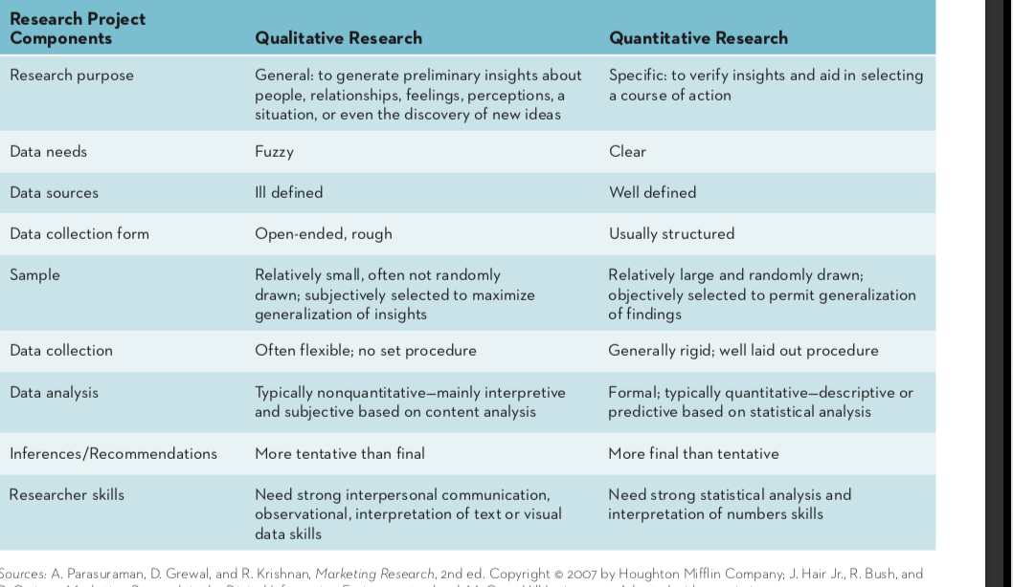

Qualitative and Quantitative research methods

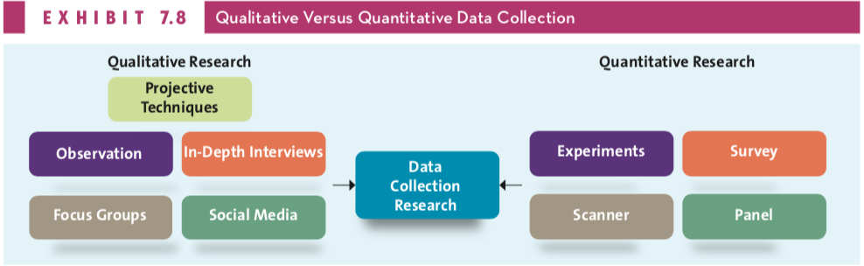

Qualitative
- Observation
  - Entails examining purchase and consumption behaviors through personal or video camera scrutiny
  - Ethnography: an observational method that studies people in their daily lives and activities in their homes, work, and communities
- Social Media
  - Blogs, provide research
  - Building online communities for companies
- Focus Groups
  - small group of persons come together for an in depth discussion about a particular topic, with the conversation guided by a trained moderator using an unstructured method of inquiry
- In-Depth Interviews
  - Trained researchers ask questions, listen to and record the answers, and then pose additional questions to clarify or expand on a particular issue
- Projective Technique
  - Subjects are provided a scenario and asked to express their thoughts and feelings about it

Quantitative
- Experiments
  - Systematically manipulates one or more variables to determine which variable has a causal effect on another variable
- Survey Research
  - Survey: systematic means of collecting info from people that generally uses a questionnaire
  - Questionnaire: form that features a set of questions designed to gather info from respondents and thereby accomplish the researchers objectives
  - Unstructured questions: open ended questions that allow responders to answer in their own words
  - Structured questions: closed ended questions for which a discrete set of response alternatives, or specific answers, is provided for respondents to evaluate
- Scanner
- Panel
  - Similar to a survey

Chapter 18: Ethics and Socially Responsible Marketing
- Ethics
  - moral principles and values that govern the actions and decisions of an individual or group.
  - Business ethics
    - Branch of ethics that examines ethical rules and principles within a commercial context, the various ethical and moral problems that may arise in a business setting, and any special duties or obligations that apply to persons engaged in commerce
  - Marketing ethics
    - Refers to those ethical problems that are specific in the domain of marketing
- Ethical Climate
  - The set of values within a marketing firm, or in the marketing division of any firm, that guides decision making and behavior
- Social Responsibility
  - the idea that organizations are part of a larger society and are accountable to that society for their actions.
  - Corporate social responsibility: the voluntary actions taken by a company to address the ethical, social, and environmental impacts of its business operations and the concern of its stakeholders
    - Ex: Establishing charitable foundations, supporting minority activities, associating with nonprofit groups
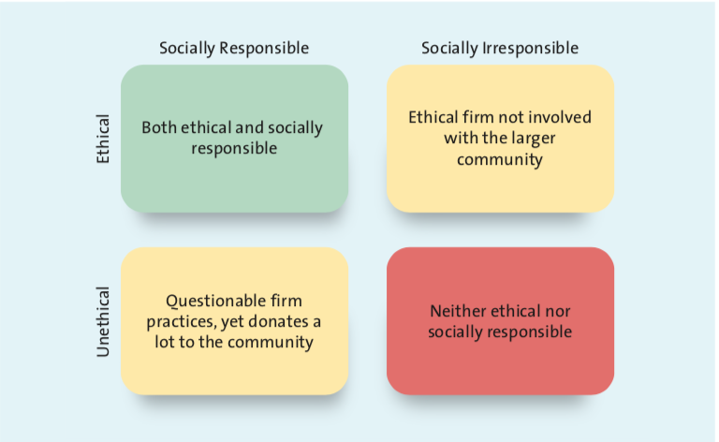

- Cause Marketing
  - occurs when the charitable contributions of a firm are tied directly to the customer revenues produced through the promotion of one of its products.

Consumerism, ethics, and socially responsible practices
- Consumerism: a social movement aimed at protecting consumers from business practices that infringe upon their rights
- Employees
  - CSR to employees is to ensure a safe working environment, free of threats to physical safety, health, or well being
  - Happy employee families make happy and productive employees
- Customers
  - Ensuring healthfulness of products, especially those aimed at children
- Marketplace
  - When one firm leads to CSR, competition has to as well, or they will be left behind
- Society
  - Firms expend considerable time and energy engaging in activities to improve the overall community and the physical environment

Framework for Ethical Decision Making

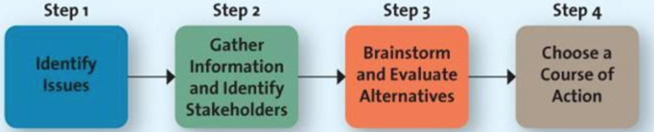

Integrating Ethics into Marketing Strategy
- Planning Phase
  - Include ethical statements and firms mission statement
- Implementation Phase
  - Where firms are identifying potential markets and ways to deliver the 4 Ps to them
  - Firm has to go ahead carefully since the way firms pursues choice of target market can lead to charges of unethical behavior
- Control Phase
  - Managers must be evaluated on their actions from an ethical perspective
  - Emergence of new markets and new tech ensure that new ethical issues always arise
  - Firms that respond first to crisis will suffer fewer long term negative effects on reputation, credibility, and level of trust among consumers

