Experiment 3: Flow through a Sluice Gate and Hydraulic Jump
Chuangxin Chen
Student NO.: 101016643
chuangxinchen@cmail.carleton.ca
L04-G23
Date Lab performed: April 2nd, 2018
Due Date: April 9th, 2018
TA: Nick Brooker

Summary
The purpose of this experiment is to analyze the phenomenon of “hydraulic jump” by making use of three fundamental equations: Bernoulli’s equation continuity equation, and linear momentum equation, and to test if the flow of water is predictable. In this experiment we have two different water flow that passing through a hydraulic jump, we use it to determine the velocity of water flow.

During the calculation, the velocity at position 2 is 3.183 m/s for flow 1, and the 2.589m/s for flow 2. However, the theoretical velocities for flow 1 is 1.8997m/s, and the 2.4183m/s for flow 2.

Nomenclature
$$A :cross sectional area \left[m^{2}\right]$$
$$\sum{F} : sum of all the forces \left[N\right]$$
$$g :acceleration due to gravity=9.81 m/{s^{2}}$$
$$h :water level in V_notch \left[in\right]$$
$$H :total head \left[m\right]$$
$$\dot{m} :mass flow rate \left[{kg}/s\right]$$
$$P :static pressure \left[Pa\right]$$
$$P_{atm} :atmospheric pressure=101.3 kPa$$
$$Q : volume flow rate \left[{m^{3}}/s\right]$$
$$V :velocity of fluid \left[m/s\right]$$
$$w : channel width=0.16 m$$
$$z :water level \left[m\right]$$
$$ρ :fluid density\left[ {kg}/{m^{3}}\right]$$
PROCEDURE: LARGE CHANNEL
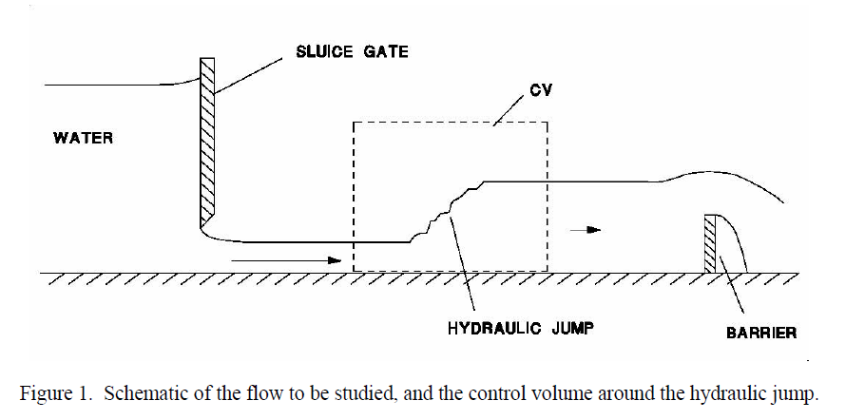

1. Note the width of the flow channel. You will need it for your analysis. For two different flow rates.
2. Observe the occurrence of the hydraulic jump and measure the depths: upstream of the sluice gate; downstream of the sluice gate; and downstream of the hydraulic jump. Make certain that conditions are steady before taking readings.
3. Using a Pitot tube with a tubular glass stem, measure the total head in the flow at the same three locations.
4. Measure the flow rate in the channel using the V-notch weir at the downstream end of the flume.

Refer to (MAAE 2300 Fluid Mechanics I – Laboratory Manual – W2018)

Flow Analysis:

The volume flow rate through a 90 degree V-notch :
Q = 2.5H^{2.5})

Or the volume flow rate can be calculated with velocity and cross sectional area:
Q = V*A

Mass flow rate:
m = Q*ρ = ρAV

Due to the continuity of mass flow rate:
m1 = m2
ρA₁V₁ = ρA₂V₂
Then the equation can be write as:
V1=$\frac{A2V2}{A1}$

Bernoulli equation can be used to determine the velocity of water:
1/2 ρ_{water} v₁ ² +ρ_{water} gz₁= 1/2ρ_{water} v₂ ² +ρ_{water} g z₂

The ideal velocity at position 2:

V2=$\sqrt{\frac{2(P1-P2)}{ρ(1-\frac{A_{2}^{2}}{A_{1}^{2}})}}$

The total head at a particular point in a flow:
$H_{tot}= \frac{P}{ρg}+ \frac{V^{2}}{2g} +$z

Since the z is 0 in this lab.
H = $ρgh$

The h is the height of head. Since m1=m2, density is constant.
Then ρA₁V₁ = ρA₂V₂ can be rewrite as:
A₁V₁ = A₂V₂
The crossing section area A can be replaced by h*w, where h is the water height and w is the width of the channel.
$$V_{2}= \frac{V_{1}h_{1}}{h_{2}}$$

The momentum equation:
$\frac{Q/w}{g}=\frac{1}{2}*(h_{1}^{2}-h_{2}^{2})$

$$\frac{Q^{2}}{g}\left(\frac{1}{h_{2}}-\frac{1}{h_{1}}\right)= \frac{1}{2}ω^{2}(h_{1}^{2}- h_{2}^{2})$$

$$h_{2}^{2}+h_{2}h_{1}-\frac{2Q^{2}}{gω^{2}h_{1}}=0$$

Z3:
$$Z_{3}=\frac{\left(-Z_{2}^{2}\right)+\sqrt{\left(Z_{2}^{4}\right)-4 ×\left(Z_{2}\right)×\left(-\frac{2×{\dot{Q}}^{2}}{gw^{2}}\right)}}{2×Z_{2}}$$
$$=\frac{\left(-{0.021}^{2}\right)+\sqrt{\left({0.021}^{2}\right)-4 ×\left(0.021\right)×\left(-\frac{2×{\dot{0.01073}}^{2}}{9.81×{0.163}^{2}}\right)}}{2×0.021}$$
$$=0.5297 m$$
With the same equation, the following table can be done.
 | Flow 1 | Flow 2
$Z_{3}$ (Theoretical) | 0.5297 m | 0.5287 m
Table 6

$5.5 ∆H$ (Theoretical)

According to equation 4.5.2, Theoretical H can be calculated.
$$H_{3}=\frac{P_{atm}}{ρ_{water} ×g}+\frac{V_{3}^{2}}{2 ×g}+Z_{3}$$
$$=\frac{101 325 Pa}{1000 {kg}/{m^{3}} ×9.81 m/{s^{2}}}+\frac{{0.6312m/s}^{2}}{2 ×9.81 m/{s^{2}}}+0.5297 m$$
$${The theoretical H}_{3} in flow 1 is 10.8906 m$$
Using the same equation, the theoretical $H_{3}$ in flow 2 can be solved as 10.8738 m

Table 1
Position | Water Height of Flow 1(m) | Water in pitot tube height in flow 1 | Water Height of Flow 2(m) | Water in pitot tube height in flow 2
1 | 0.2032 | 0.205 | 0.3975 | 0.386
2 | 0.02103 | 0.203 | 0.03536 | 0.33
3 | 0.1036 | 0.105 | 0.1588 | 0.165
V-notch | 0.113m |  | 0.128m

Table 2
 | Flow 1 | Flow 2
Area 1 ($m^{3})$ | 0.03251 | 0.06360
Area 2 ($m^{3})$ | 0.00336 | 0.00566
Area 3 ($m^{3})$ | 0.01658 | 0.02541
Velocity at position 2 experimental (m/s) | 3.183 | 2.589
velocity at position 2 theoretical (m/s) | 1.8997 | 2.4183

Width: 0.16m
Calculation
Experimental velocity of position 2
Q1 = 2.5$H^{2.5}$ = 2.5 * ${0.113}^{2.5}$ = 0.01073$m^{3}$/s
Q2 = 2.5$H^{2.5}$ = 2.5 * ${0.128}^{2.5}$ = 0.01465$m^{3}$/s
Vp2-1 = Q1/A1 = 0.01073/(0.02103*0.16)=3.183m/s
Vp2-2 = Q2/A2 = 0.01465/(0.03536*0.16)=2.589m/s

Theoretical velocity of position 2
Vp2-1 = $\sqrt{\frac{2g(Z_{2}-Z_{1})}{{(\frac{Z_{2}}{Z_{1}})}^{2}-1}}$ = 1.8997
Vp2-2 = $\sqrt{\frac{2g(Z_{2}-Z_{1})}{{(\frac{Z_{2}}{Z_{1}})}^{2}-1}}$ = 2.4183

Discussion
The experimental velocities of flow in downstream of sluice gate for flow 1 at position 2 is 3.183 m/s, and 2.589 m/s for flow 2 at same position. However the theoretical velocities calculated by the Bernoulli’s equation is 1.8997 m/s for flow 1, and 2.4183 for flow 2.

We can see the difference of value of velocity is little bit large between experimental and theoretical result of flow 1. But, the two values of velocities of flow 2 is so close to each other. However, both experimental result are higher than theoretical, one of the possible reason is that the theoretical velocity assumed the upstream velocity as zero, it only depend on the height difference between those two positions, that will cause a lower value.

There are some possible source of error. First, the Bernoulli’s equation is usually used for prediction, it assuming that no friction alone the channel, and the fluid is uncompressible. Also, no work done to the fluid, and no heat transfer during the process. Which means the energy loss was ignored for Bernoulli’s equation. However, the friction exist between the fluid and tank. Which means, the Bernoulli’s results of velocity have errors, same for the linear momentum equation. The other method that used continuity of flow rate gives a different result, which is the actual velocity at the sluice gate. During the experiment, the water does not accumulate the inside the channel. However, the position of hydraulic jump has small variation. So the whole flow in the experiment is close to steady state, but not at steady flow.

Conclusion
In this experiment, The experimental velocities of flow in downstream of sluice gate for flow 1 at position 2 is 3.183 m/s, and 2.589 m/s for flow 2 at same position. However the theoretical velocities calculated by the Bernoulli’s equation is 1.8997 m/s for flow 1, and 2.4183 for flow 2. The experimental velocity for flow 2 does not make sense according to the experiment theory, so it might cause by the reading error. However it does not affect the result for the flow head change.

The error could be caused by turbulence flow after the jump. The water flow was almost steady flow at position 2 before the jump, because the high flowing velocity. However, depend on observing the water after jump, the flow become unstable, is really hard to measure the height of water flow accurately during the experiment, which can cause huge error of our calculated result.

Appendix:


