Chapter 1 - Intro to Business-to-Business Marketing- Emily

Entrepreneurial Marketing - is conducting marketing in a way that involves innovation, acting proactively, and taking calculated risks
- E.g., UPS Mail Box offering = combination of services (gave small businesses mail drop locations and “suite” of business addresses, lending credibility to their images, offering shipping locations closer to small business regions)
  - FedEx Kinko = different opportunity, different segment, addressed with different offering (targeted at small businesses that need office and graphics services combined with shipping, File, Print FedEx Kinko (FPFK) customer can send FedEx document via internet and they will prepare and send it)

Business Markets - consist of all organizations that purchase goods and services to use in the creation of their own goods and services (does not include transaction for resale)
- - of fewer but larger customers than consumer markets
- Involved in large value purchases that have complex economic, technical, and financial considerations

Business Marketing - process of matching and combining the capabilities of the supplier with the desired outcomes of the business customer, i.e., creation of value for business customers
- Business marketer must define the value he provides in terms of helping the customer provide value for the customer’s customer

4 Ps
Product - core product (or service) that can be augmented by additional features and options that will appeal to different buyers
- Total offering - augmented B2B product, provides a complete solution to the buyer needs
  - May include: financing, delivery, service, or based on buyer preference, only the core product
- B2B products - products are defined and developed to specifically match the buying organization's requirements, offering created by a partnership between the buying organization and the marketing organization, technically complex, customized
Price - mutually agreed-upon amount of money that satisfies both sides in the exchange, measure of value exchanged is determined by the market (not by costs)
- B2B price - can be the final step of a collaborative effort, may be the result of a competitive bidding process, varies from fixed prices (offers discounts and allowances), complex financing, can be commission-based or profit-sharing
- Consumer prices - often fixed and discounted
Place - getting the product to the customer in the right form, at a useful time, with minimum inconvenience associated with the place, and with possession ease
- Economic utility - Ability of a good or service to satisfy one or more need or wants of consumers
- Satisfaction of consumer preferences in locational convenience, required purchase quantities/sizes, temporal convenience and acquisition convenience, pivotal part of concept of value in B2B markets which takes the form of supply chain management, inventory services, and material resource planning
- Businesses design their marketing channels to provide max value to their customer while minimizing costs associated with the creation of economic utility
- Direct relationships between manufacturer and customer
- Supply chain management - planning, coordinations, and delivery of the place part of the marketing mix, involves many companies at different stages of the supply chain
Promotion - in consumer markets, advertising plays the largest role in the promotion mix, in B2B, personal selling is the most used and effective type of promotion
- B2B marketing - relationship is often closer and longer lasting than in consumer marketing, communication is a dialogue

Marketing concept - the firm should be contextually market sensitive, understand customer needs, meet those needs in a coordinated way that provides value to the customer, and do so in a way that meets organizational goals to be successful
- Firm that is market/customer-driven is applying the marketing concept, recognizing that every employee of the firm contributes to the marketing effort

Consumer demand - the quantity of goods or services desired to be bought, given market conditions (usually expressed as function of market prices)

Derived demand - demand experienced by the chain of suppliers and producers that contribute to the creation of a total offering, without initial consumer demand, there will not be any demand on the chain of suppliers

Supply chain - chain of entities and activities that results in products provided to end-users, starts with raw materials and traces the flow of materials and sub-assembles through suppliers, manufacturers, and channel intermediaries to the final customer, stable, flexible, enough to meet varying marketing demands

The Bullwhip Effect - a small percentage change in consumer markets leads to much greater changes in business markets, as consumer demand varies “upstream” suppliers of services and components that contributed to the total offering experience a leveraged impact, this can cause wide swings in upstream demand as inventory levels, timing and order quantities adjust to the new level of end-use demand
- Many suppliers to a company can be affected by one supplier (e.g., Ford/Firestone tire recall)

Discontinuous demand - condition in which quantity demanded in the market makes large changes up or down in response to changes in market conditions, transition from one market state to another occurs in large increments rather than small incremental changes in demand
- When demand on suppliers reaches a level that is the maximum that existing facilities can efficiently produce, the capitalization of new production capability is required (resulting in discontinuity in supply capability)
- If the supplier elects to invest in additional capacity, the addition not only provides increased capacity to the marketplace of the supplier, but also creates demand in the markets of producers of manufacturing equipment and other production and infrastructure-related products

Elasticity - refers to the % change in quantity demanded relative to the % change in price, if a price change produces a change in demand that is less in % than the % price change, the demand is said to be inelastic (%▲P < %▲D)

Volatility in B2B markets - small changes in consumer buying attitudes are closely watched a potential indicators of change in our economy

Complexity - the impact of the discontinuous nature of demand can be mentioned by business marketers’ participation in the relationship with the customer on a continuing, ongoing basis

Outsourcing - purchase of part of the company’s continuing operations, rather than investing in the infra to accomplish the task internally

Switching costs - cost of switching suppliers, high switching costs in B2B markets can result from the investment that the partners make in matching buying, ordering, inbound logistics, delivery systems to each other (the creation of an efficient, specialized supply chain)

Brand identification - because each buyer has a different idea of what product provided the best value, marketers tailor offering to specific buyer value definitions

The degree to which a company networks, on the supply side, to other companies depend on:
- How long the company has been in business
- The desirability of diversifying, through vertical integration, into another business
- The availability of quality supply choices in the market
- The speed at which technology is changing in the market
- The degree of uniqueness or specialization of the supplied or manufactured component
Larger companies are often more vertically integrated than small companies

B2B products have fewer hurdles to clear international markets (subject to same politics and tariffs, materials, supplies and components must meet standards that are agreed to and consistent across international barriers)

Customers do not purchase products, they purchase offerings that create solutions and satisfaction

Evaluated price - total cost of owning and using the product, may include transportation, inventory carrying costs, financing costs, potential obsolescence, installation, flexibility to upgrade, cost of failure, obsolescence of existing products or equipment, plus the price paid to the vendor

Value chain - chain of activities that creates something of value for the targeted customers

Direct activities vs. support activities - direct activities contribute directly to the offering, support activities make it possible to perform the direct activities
- Implication 1
  - Organization should start by really understanding its customers
  - “ “ understand what customers perceive as valuable
  - “ “ “ how customers might be persuaded to change their mind about what is valuable
- Implication 2
  - Not all prospective customers are alike, segments exist based on what prospective customers value/can afford
- Implication 3
  - Both direct and support activities are important in the creation of value
- Implication 4
  - Creation of value extends from the customer back through distribution channels

Misunderstanding of the value and value chain concepts
- Marketing managers can get caught up in trying to create profits for their companies that they lose sight of what customer value really means, managers sometimes think that they can forgo some customer value to reduce costs
- Managers often lose sight of what creates value for the customer
- Difficult to pin down exactly what combination of features in an offering is valued by the most important customers (poor job in defining segments)

Hypercompetition - new companies that emerge quickly or create new markets and industries almost overnight challenge established companies

Channel facilitators - service providers to the channel that are not part of the channel design but who make possible the efficient operation of the channel (e.g., financial institutions, transportation and logistics companies, third-party service providers)
- These organizations provide outsourced services to facilitate the effective operation of the channel

Time compression - an increase in the “speed” of doing business

Chapter 2 - B2B Environment: Customers, Organizations, and Markets- Mallory
Types of Organizational Customers
Commercial Enterprises- segment of for-profit organizations based on how the product/services are going to be used (industrial distributors, resellers, original equipment manufacturers, etc.)

Industrial Distributors- organizations that act as middlemen, providing economic utilities of form, time, place, and possession to the manufacturers of the products they distribute and segments of customers of those that they serve

Value added resellers- Provide manufacturers products with unique enhancements; most likely personalized

Original equipment manufacturers- purchase goods to incorporate them into goods they produce and sell to their customers

Users or end users- Manufacturers that purchase goods and services for consumption, either as supplies, capital goods, or materials for incorporation into their products such that the identity of the purchase product is lost are known as users or end users

Government units- Well, it’s the government…

Nonprofit and not-for-profit organizations- hospitals, churches, colleges, nursing homes, etc.
Producer types- goods produced may also serve to classify b2b organizations

Raw materials producers- often loses its identity when used in a product. Extremely price sensitive

Component parts and manufactured materials producers- usually retain their identity, even when full incorporated into another product. They are highly differential and often add value to the products which they purchase for their consumers

Capital goods manufacturers- capital goods ‘goods used to produce output’ are usually purchased with input from many parts of the organization. The process is lengthy and usually includes the development of sophisticated specification.

Classifying the Business-to-Business Market Environment
Publics
Financial Publics- Banks and other lending organizations, etc. The members of this community typically set out to maximize their profit. Much marketing effort is psend on communicating with the members of the financial public and working to meet their needs.
Independent Press- Media can destroy market position of a company in seconds. A lot of effort goes into maintaining relationships to get advanced warning of potential disasters
Public interest groups- pulic interest groups are often able to get the attention of media and occasionally financial publics. A good PR effort w/ a inoculation strategy can minimize the negative impact of these groups.
Internal publics- every employee is a representatitve of the organization to the public and a representative of her part of the organization to the public. A major part of internal marketing programs is to promote belonging and ownership among employees
The Macroenvironment
Demographic environment- vital statistics that describe population. All variables have an impact on consumer consumption which translated into business consumption in the effort to meet consumer needs. Business additionally have demographic characteristics (type and size of industries that exist, size and location, ages of the business, etc.) These are a large part in deciding how a business is classified.
Economic environment- influence how b2b customers buy and consume. The macroeconomy of a region is the sum total of all eaconomic activity and certain characteristics of note (how fast the ecnomy is growing, level of employment, rate of employment, etc.)
Sociocultural environment- has an impact of what people buy, why they buy it and use it, how they buy it and how they react to stimuli. Simialrities in behavior- the cultural norms- of a market or marketer must e aware of the cultural norms and scial trends
The Natural Environment- includes natural resources, raw materials, the ecology, the weather, and, on occasion, geologic activity. Marketers perceive the impacts of the natural environment principally as constraints on the products that they can offer
Technological Environment- Tech developments can dramatically change b2b markets (changes in competitors product, competition, changes in channel members’ tech, etc.) It can greatly benefit a firm or hinder it if it’s not been keeping up to date.
The competitive environment
Pure Competition- many buyers and sellers with no single entity having much effect on price
Monopolistic Competition- many buyers and sellers, but product is differentiable so a range of prices is possible
Oligopolistic Competition- Few sellers who are highly sensitive to each other’s strategies
Pure monopoly- consists of one seller
Value Networks and Supply Chains
-supply chain is a network of relationships that produces and facilitates a physical flow of materials and goods from raw materials producers through to final customers
-from a marketing perspective the implications of partnerships and alliances can create a multidimensional network of relationships that change frequently
-companies in fast paced markets are finding it easier to complete their supply chain with multiple parties
-the network alliance will create opportunities to disclose, willingly or inadvertently, many facets of each partner’s oeprations, creating challenges to many traditional organizational schemes and confidentiality procedures
Supply chain management as a form of value network management
-object of managing an integrated supply chain is to create value for the targeted customers through a combination of availability, assured supply, customization, quality control, and cost control

Using the value network and supply chain concepts
1. When a business markets its products or services to a customer within an integrated supply chain, the market needs to understand the motives and behaviors of the suoly chain
2. When analyzing competition, the marketer needs to look at competitive clusters of partnered companies
3. In designing offerings, companies must decide what to outsource, what to task to internally and what to develop joint efforts
Changes in markets over times
Over the years, marketers, strategists, and academics have noticed patterns in how markets change over time. The following two ideas, namely the PLC and the TALC provide some generalizations about these patterns and what they mean. Of these two, the plc is more generally usable. The TALC has particular applicability in the case of breakthrough innovations
The Product Lifecycle
-the concept of the product life cycle is that product categories through several life stages

- The level at which the PLC has the most relevalnce is at the “category” level. The product category is still ambiguous
- The principal reason marketers want to understand the PLC is to anticipate the general behavior of customers and the nature of competition
- The PLC does not specifically provide a means for predicting changes from one stage to the next (predicting changes in the business environment is nearly impossible), nor does it provide prescriptions for strategies or actions (companies face unique combinations of multiple factors, PLC can suggest general directions but the marketer must figure their own shit out.)
- PLC can be an aid in situational analysis
- Understanding the general theory that several factors interact concurrently, leading to changes in trends in total sales, marketers should be aware of and eamine these factors (competitive actions, major price changes in the market, withdrawl of major competitors, major competitor adds new capacity, a major player introduces a new technology and so on.)
The Technology Adoption Life Cycle
- The TALC focuses more on the kinds of customers and how they come to adopt new technology
Bridging a chasm
-Broken down into technophiles, visionaries, pragmatists, conservatives and skeptics
-Moore identified the existence of a chasm- a break in the sales growth curve for a new technology- and a tornado- chaos that occurs in a period of rapid growth.
-There are natural breaks that occur between each group (the largest being the chasm which occurs between visionaries and pragmatists
-pragmatists only purchase when other members of their group purchase…. So the difficulty is finding those first few
-these pragmatists usually are a niche and have a need for the product so compelling that they are willing to take the risk
-after this gap is crossed, production capabilities, size and culture will change as well as the markets offering

Across the chasm and into the tornado
-demand grows, competitors enter the market, the market generally wants to support the market leader
- the market leader has the opportunity to become the gorilla and does what it wants as long as it does not deviate too far too often from what the pragmatist buyers desire

Chapter 3- Organizational Buying and Buyer Behaviour

Consumer Buying Process:
1. Need Recognition
2. Information Search
3. Evaluation of Alternatives
4. Purchase Decision
5. Post Purchase Behaviour

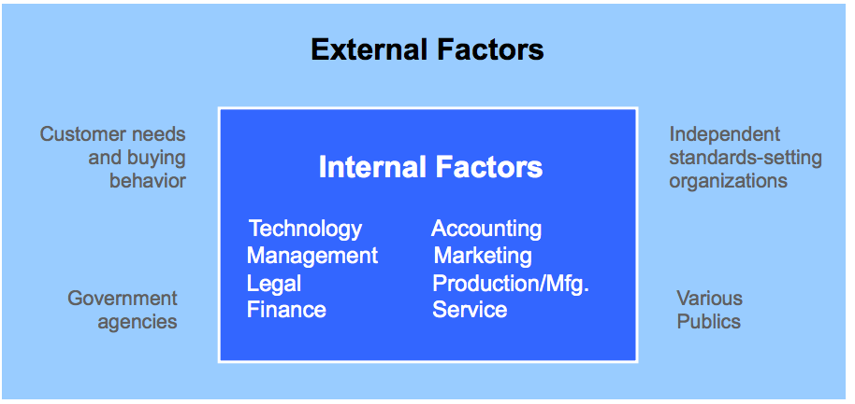
The Buying Center- Represent Internal Customers

-Internal stakeholders input their expertise to make sure all are accommodated

Organizational Buying Vs. Consumer Buying

-Involves more buyers
-Stakeholders in buying center are driven by professional responsibilities
-Different decisions occur simultaneously in the buying center

Traditional B2B Buying Decision Process
- Problem Recognition
- General need description
- Product specification
- Supplier/source search
- Proposal solicitation
- Selection
- Make transaction routine
- Evaluate performance

Factors of The Process

Fluid- Interaction is fluid- and broad based
Simultaneous- Not sequential
Proven- “Track-Record” is important
Loyalty- Built through relationships

Buying Center- Needs in Decision Making Process

Organization Needs- Benefits of the product or service
Individual Professional Needs- Based on professional activities and functions of the job
Individual Personal Needs- Career, Quality of life, Recognition

Process Flow Stages Model
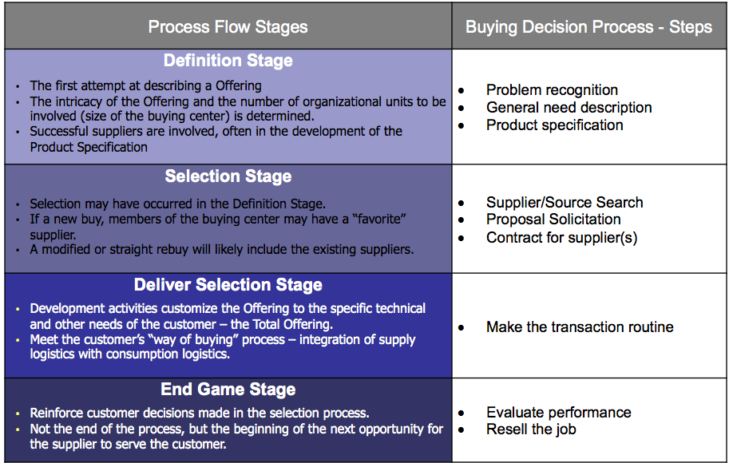

Buying Process Examples: Re-Buys

Typical New Task Situation
- Need not yet faced by org.
- New offering with new tech.
- Utilize complete buying process to investigate alternatives

Typical Re-Buys’
Straight Re-Buy
- Routine buying situation with established offerings (Office Supplies)

Modified Re-Buy
- Situation from new task
- Limit exposure from competitive forces
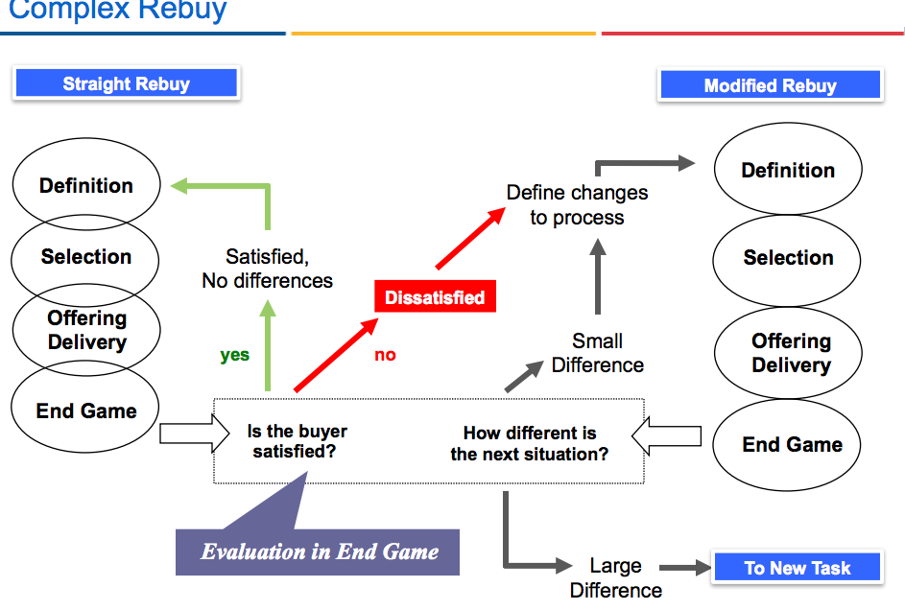

What is the “Value Image”?

All Impressions- Is the total of all impressions a customer has of the firm
Offering Positioning- Value imagining is similar to positioning that occurs with consumer goods
Maximizing Value- Need to maximize the value image “offering” in the mind of the buyer

Chapter 5 - Dylan

Strategy:
- Strategy helps keep the people involve working toward a desired outcome and approaching goals.
Developing an effective strategy (strategy that leads to increased performance) requires several elements:
- Setting goals or objectives
  - Goals are not time limited
  - Objectives are specific targets measured in quantifiable terms, and specifying when they must be met.
- Understand the environment in which you are operating.
  - This is to provide information to make judgements in regard to the direction to pursue and how to pursue it.
- Learn from experience
  - Collect information on the impact of the strategies
    - Traditional strategic management, performance is monitored and compared to expected performance
    - In less formal, interviews are held with employees to diagnose the problems with the strategy and possible modifications required.
- Thinking
  - This involves processes of making decisions based on and interpretation of what is known about the environment, and informed assumptions of how customers, competitors and other actors will act in this environment and react in the near future.
No one special instruction - desifgned with the company’s situation in mind.

Strategy Making and Strategy Management Processes
- Strategic management process:
- Setting goals and objectives
- Analysis of the current situation
- Swot Analysis: Strengths, Weaknesses, Opportunities and Threats.
- Strategy design and choice of the best strategy
- Implementation plan design
- Strategy implementation
- Monitoring of environment and performance results
- Analysis of variance from desired performance levels
- Adjustments based on analysis of variance of current performance and what was expected.

Strategic management process broken down and explained:
- Develop goals and objectives (must be able to measure performance):

Goals - are general- qualitative description of some desired outcome.
    - In example, the goal may be to achieve superior profitability and leadership in the industry.
    - Corporate level: performance must be in line with the expectations of relevant stakeholders, such as investors, employees, etc.
    - Lower level: manner or form of corporate goals that are specific to the portion of the organization within reach, control and responsibility of lower management.
Objectives - specific breakdown of goals with specific targets in specific time periods.
    - In example: in order to gain profitability we may want to achieve a return on investment of 20% after taxes by the end of 2011.
    - Corporate level: objectives must be reachable, challenging, and internally consistent.
    - Lower level: accurately measure the contribution of the business unit, product line, or program in alignment with the corporate objectives.
- Environmental analysis:

Current situation and future opportunities are explored. The environmental analysis should include the following elements:
- Markets, segments, and customers
- Competition
- Channels of distribution
- Internal company environment
- Effects of the economy
- Effects of technology change
- Public policy
Analysis is usually arranged as a depiction of the current situation and a SWOT analysis that is more future oriented.

- Strategy Design:

This is the step in which strategy planners decide how to meet or exceed the objectives that been set, given the realities of the business environment.

- Create alternative strategies and choosing among the alternatives - strategies are often made during SWOT analysis.
- Designing a corporate level strategy should include:
  - A vision of the business and it’s industry
  - The choice of goals and objectives
  - The choice of which businesses to pursue
  - The determination of allocation of resources across businesses
  - Determination of which strategic competencies to emphasize and build in the future.
  - Allocation of resources to invest in build strategic competencies
- Implementation Plan Design

Strategy is now designed - now implementations are put into place to determine who will do what, when, with whom and at what cost.

Resources must be allocated to measure results, analyse the measures and make adjustments. Without monitoring, the organization will not learn about what worked and what did not; reducing the value of the experience.

One the implementation plan is displayed, costs, personnel resources, skills needed and time required are determined - if the implementation requires more than what the organization can afford changes must be made in the strategy or even objectives.

- Strategy implementation

Actions are taken according to plan. Systems should be in check to verify actions began and are competing to plan. If something goes wrong not according to plan, solution must be made.

- Monitoring of Environment and Performance results

As Mentioned in Step 4 some implementation activities should be aimed to collecting and analyzing data. This data should track progress of objectives determined in Step 1.

- Analysis of performance:

Any significant variance from desired performance from actual must be analyzed, to determine the cause. This may require interviews with participants, collection and assessment of satisfaction surveys or other market research.

- Adjustments

Based on analysis of performance adjustments may be required to strategy, implementation, objectives and maybe even goals. Small adjustments can wait until the next planning cycle, large adjustments may require total plan restart.

Critique of model

This process takes much time but this time can be reduced using planning softwares. The problem with softwares is that calculations are invisible therefore following the process may be more difficult for managers. It is better to have a plan rather than doing nothing, and understand data then speeding and not fully understanding what it means. Often people get stuck in the analytic portion of planning and miss the creative design portion of opportunities and innovation.

Key Strategy Concepts
- Business strategy designers should establish a fit between the business environment and the strategy.
- The key element of fit means to connect the strategy to the needs of the market to provide superior value to customers.
- Superior value means differentiating from competitor offerings in the minds of the targeted customers.
- Differentiation occurs by using core competencies as an advantage. The more your core competencies differ the higher the customer value achieved and profit margins produced.
- Quality improvement and process improvement are fundamental to provide superior value.
- Measuring and tracking creates learning and sets the stage for improvement in future plans.

Modern strategy focuses on driving change as opposed to adapting to it. This makes it so the environment changes in a position where the company is a better fit than it’s competitors.

Core competencies: a company’s skills, capabilities, knowledge assets make it possible for them to differentiate

Using its core competencies the company tries to influence change to make a better environment for itself.

Summation:

- While companies affect the change of the market they do not affect the pace of change.
- Companies need to look for ways to change the rules or the market in favor to their business model (configuration of how elements of a business work together and builds profits), this will translate into advantages in the future as they will be a better fit for the market.
- Advantages do not last long, so companies must continue to innovate and change the rules on an ongoing basis - stay AHEAD of the competitor.

Strategic resource allocation:
Allocating finite resources will result in opportunities that will benefit the organization. This must be done after gaining knowledge of current competencies and anticipating the future core competencies of the organization. This data provides a vision of the future and direction to attack it.

Strategic Business Unit Management

Corporate strategy creates the “Strategic architecture” or blueprint that will guide the organization in the next 5-10 yrs. A strategy that incorporates the firm’s direction, while allowing the division of strategy on the basis of tailored portfolios is desired.

Strategic business units: is a business, department, organization, or product line within an organization that has separate goals and objectives. These must be planned and measured independently from the rest of the organization.

Business portfolio: The collection of strategic business units that serve various needs. In example, creating funding for other projects.

Strategies for SBU portfolios involve:
- Choice of the market segment or segments to target
- A structure of a portfolio of products (including services) to address the target segments;
- Positioning of the offerings for that segment or segments;
- Product and service features to include and emphasize in the offering
- Communications and selling methods to address the target segments and implement the chosen positioning
- A design for managing distribution
- Design of a pricing structure
- An approach for developing key capabilities and competencies
- A design for innovating in the elements of marketing in the future.

The Growth Share Matrix
- Produced by Boston consulting group.
- Resource allocation tool
- Seek to develop and nourish those with greatest opportunity
- Maintain those that are self-sustaining producers of resources
- End and reap the rest of those that are no longer productive or beneficial

- Cash Cows: generate resources to fuel other parts of the organization. Slower-growth market where the SBU is dominant in the market. May be in matured or in late growth, declining stages. (high Share low growth)
- Stars: high growth markets and large market share. Require heavy investments to maintain position in growing market. Likely able to be positioned in a prominent location that is in the growth stage. Looks to own market as an objective. (High growth High share)
- Dogs: Slow or negative market share. PLC places them in the decline stage, or anywhere except the growth stage. Do we milk it more or kill the dog. (High share low growth)
- Question marks: potential to be attractive in the market, but no significant ownership of market. Would require investments, but may never grow to be prosperous. It’s question mark because it’s up in the air what might occur with it. They are viewed as in the introductory or early growth stages of the PLC. (Low share high growth)

Problems with the matrix
- Relationship between market share and profitability is questionable.
- Distinction between the categories is purely subjective and may not be viewed the same to other organization. May be more viable when compared externally. The matrix is only a snapshot in time, current market growth have little predictions on future market growth because future market growth is very unpredictable.

MultiFactor Portfolio Matrix (more sophisticated tool)
This model assumes no new competencies formed and gives preference to businesses or products in which the company already has competencies in place.

Future business strength can be defined by giving a high score to a business or product that makes better use of available resources.

This may drive room for decision on whether to build their own products in house or to focus on their special competencies.

Incompatibility of culture within the organization
- Company cultures feed on rapid change, and must abandon older offerings. If not they become a multi offering company with several businesses at different stages of the PLC.
- A rivalry for resources could occur if two products operate differently, a corporation that does not properly handle this situation may douse the future stars with its cash cow.

Portfolios and value
- Most productive way to create an offering with maximum value for a particular market is the combination of elements from different organizations. The matrixes are bad for providing partnership and networking insight, ignoring market perspective of value for customers.
- Not being weary of value to customers means potentially losing on possible synergies within the company or outside the company.

Balanced Scorecard
- Tool for strategy content that focuses on the goals of the organization and quantifies these into specific performance targets.
- This focuses on relying on the future and concentrates on measure that are forward looking given the company’s particular situation.
- Goals and measures are divided by
  - Financial performance perspective
  - Customer perspective
  - Internal business perspective and stakeholder value perspective. (i.e., upper level management).
- Process is done by the manager discussing their vision of the future
  - A facilitator draws up the potential scorecard from the discussion and presents it to the strategy makers.
    - The strategy makers discuss and come to an agreement on strategy and a shorter list of measures
      - They discuss the vision objectives and measures associated
        - They build a set of activities to address the performance targets
        - They build an implementation plan
          - Data is collected and compared to the targets, the performance is then the driver for strategy and strategy changes.

Taking an entrepreneurial approach to marketing strategy

- Building an entrepreneurial culture within a company helps the company adapt to environmental changes. Managers should set rewards to stimulate creativity and innovation.
- Organization Mission: Industry trend trackers within the organization should make up a list of possible future scenarios the company is likely to face in preparation to mission creation.
  - If no trackers exist within pay consultants outside
With this new information the company will look how to they plan to face and create its future.
In order to motivate people to work towards a same goal, making the goal personal to the individual makes it something significant to them. If they feel the goal is solely for the company they will not be motivated.

Fostering Ownership: Management should stimulate and provide support for individuals to gain ownership of the entrepreneur's vision and goals. This can be supported by rewards and can build a bigger team effort if the reward is organizational compensation.

Change the Rules:

Ultimate way to act entrepreneurially is to change the flow of the market, this can upset the current competitive balance and start the process of establishing a new market owner.

Chapter 6- Leigh
Ch.6
Market intelligence
· Market Research requires adherence to:
o Research Design
o Data Collection
o Analysis and Interpretation
Competitive Intelligence gathering is less involved
• In B2B marketing market intelligence is “knowing your market”
Market Research is the systematic collection and interpretation of specific data related to the resolution of a specific problem or to satisfy a specific objective.
Competitive Intelligence- The collection and informed interpretation of might appear at first as a number of random, unrelated events.
Knowing your Market
One must understand the Customer’s:
• Technologies
• Products
• Markets and Customers
• Competitors
• Channels
• Buying Center and Buying Patterns
• Culture
Secondary Data- The results of a research effort developed for another reason, information compiled for other purposes, such as existing sales tracking information, as well as third party research.
Primary Market Research- The Collection of data directly from respondents in the population in question. The marketer determines what data needs to be collected and sets out to obtain it.

Market Research Fundamentals
Market Research Process
Market Research Fundamentals
• Define the Problem and Research Objectives
• Design the Research Method to Achieve
Objectives
• Collect the Data
• Analyze the Data and Draw Conclusions
• Present the Findings
Define the problem and research objectives
o What decisions will be supported?
o What information is needed to make these decisions?
o Should the type of research be exploratory or conclusive?
Design the Research Method
o What respondents will be sought?
o What sampling method should be used?
o Design the research instrument
Collect the Data
o Control the quality of data collection
o Enter data in database
Analyze the Data and Draw Conclusions
o Apply appropriate analysis techniques
o Control for non-random error
o Draw appropriate conclusions, given the results and quality of the data
Presenting Findings
o Apply information to decisions
o Present the findings

Market Research in Decision Support
Implications of Type of Decision Support
Innovation Translation
Is this really a market?
o Look for new customers
o Verify existence of segment (ALL ASPECTS IF THE OFFERING)
o Do so by transferring technology offering of the first customer to other customers
o Involves exploratory interaction with current and prospective customers
Research to support targeting decisions
Good segmentation research is usually a two stage research design:
o Exploratory research: determining a basis for segmentation
o Conclusive research: dividing the sample into segments using the basis for segmentation
Research to Support Go/ No- Go decisions
Analytics Applications Solutions Offering pipeline model

Differences from market research in consumer markets
o Concentrated Markets (smaller data samples not relevant for large scale surveys)
o Diversity of Interests in the Buying Center (broader more complex interests than in household)
o Technical Expertise (bidirectional translation of technical requirements into terms understood by both supplier and buyer)
Special Circumstances:
• Time Compression (urgency and validity of research results)
• Uncertainty (changing environment and context while research is being conducted / relevance)
Market Research- Interviews
Personal Interviews: obstacles in qualitative Market Research
o • Small number of prospective customers
o • Size, complexity, and informality of Buying Center
o • Unpredictability of Buying Center interactions
o • Technical or complex nature of products
o • Short time horizons for making decisions
o • Lack of time for respondents to participate
o • Heightened uncertainty about market dynamics
Improving Co-operation from interview respondents
o Understand respondent’s organization
• Reassure confidentiality of source
• Ask open-ended questions
• Have some follow-up questions ready
• Lead in with an easy question to break the ice
• Ask important questions early
• Don’t overstay your welcome
Ask essentially same questions of everybody
• Ask only what you need to know
• Take good notes
• Write up summary immediately after interview
Competitive Research

Information to collect on individual competitors
o • Competitor Goals
o • Competitor Strategies
o • Competitor Capabilities
o • Competitor Assumptions
Sources of competitive information
o • The Internet
o • Business and Trade Press
o • Trade shows
o • Competitors’ Communications
o • Other Sources

Chapter 7- Segmenting, Targeting and Positioning - Callum

Segments in B2B - groups of firms that are distinct from others in terms of how they buy and what they need

Goal: produce an offering that meets the needs of customers in a segment better than the competitors, and reach segment through communication and distribution channels where customers can realize the superior value added

Marketers chose segments to target by:

Measurability - is the size able to be determined, if potential success cannot be measured it makes it difficult to chose between alternatives
Accessibility - are these people reachable through distribution channels
Substantiality - is there enough customers to make it worthwhile, is there a segment that desires the value offering you present and that segment is profitable enough to serve differentially from others
Actionability - is the organization capable of creating a total offering with a competitive advantage with respect to the specific needs of the segment

**an effective segment has members that are the same (homogenous) within the segment and those members as different (heterogenous) as possible with the members of other segments**

Strategies for Market Segments

Cost - low cost position
Differentiation - differentiated offering
Niche - providing an exact product to a niche market

More Segmentation Basis

- Product offered
- Geographic region
- Industry
- Size of customers company
- Size of account
- Buying behaviours or preferences
- Tech used by customer
- Process and supply chain requirements - companies may have different standards of of inventory control and on time performance

Innovation Translation
- Look for new customers
- First of a kind>one of a kind
- Verify existence of segment by transferring tech offering of the first customer to other customers
- Exploratory interaction with current and prospective customers

Some Factors in Assessing Segment Attractiveness
- Size and growth rate
- Intensity of unmet needs
- Reachability through comm channels
- Readiness to adopt offerings
- Likelihood of competitive intensity
- Sufficiency of channel reach
- Match between segment needs and supplier strengths
- Differentiability of offering
- Opportunity to achieve strategic goal
- Opportunity to achieve learning goal

Setting Goals: achieving sales level, gowing at desired level
Defining Segments: measures that reflect differences in need

Technology Adoption Life Cycle: Adopter Categories

- Technophiles tries out the latest and greatest technology, does not need fully developed offering
- Visionaries See competitive advantage by using technology, standardized buying with custom offering
- Pragmatists want same as visionaries but will not buy if unless technology is easily adopted with minimal difficulty
- Conservatives only buy when doesn’t cost to adopt, need to be convinced offering exact for needs
- Laggards will avoid adoption of technology at all costs

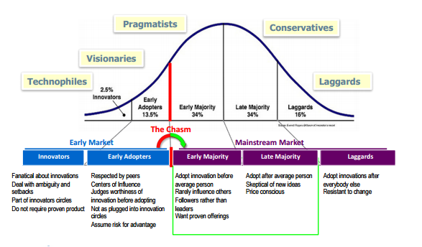

Chapter 8: Developing the Product, Service, and Value of the Offering
- Research has shown that the largest single reason for the failure of new products and services in the marketplace is a lack of a thoroughly developed and executed marketing plan
- In the marketplace, customers seek solutions, not technologies or products.
- Offerings are perceived by the value they deliver, not by the specific technology that makes them work
- B2B marketing organizations are influenced by the technology of products they offer and the longevity, or survival, of that technology in the marketplace
- The Supplying organization must recognize the value that the technology provides from the customer view. A supplier’s new product development should focus on the market of the customer, not the current product or product line of the supplier

Why do markets fail?
- No real need exists
- The market size is overestimated or a “me too” product fails to penetrate the market
- The offering fails to meet needs adequately
- Market will not pay
- Contrary perceptions of innovation - unrealized potential of shadowed/delusionary product

The Product Life Cycle
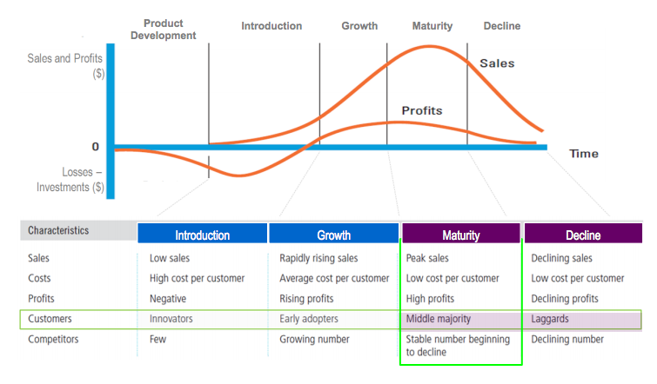
Assumptions of the PLC
- All products have a limited life
- All products pass through different stages of evolution, for each, there is an idealized marketing mix that best fits the environment in that stage when the life cycle is viewed from the viewpoint of a product category
- Different stages require different marketing mix, Different SWOT
- Within market segments, products and services evolve through the use of new technologies, materials and manufacturing methods

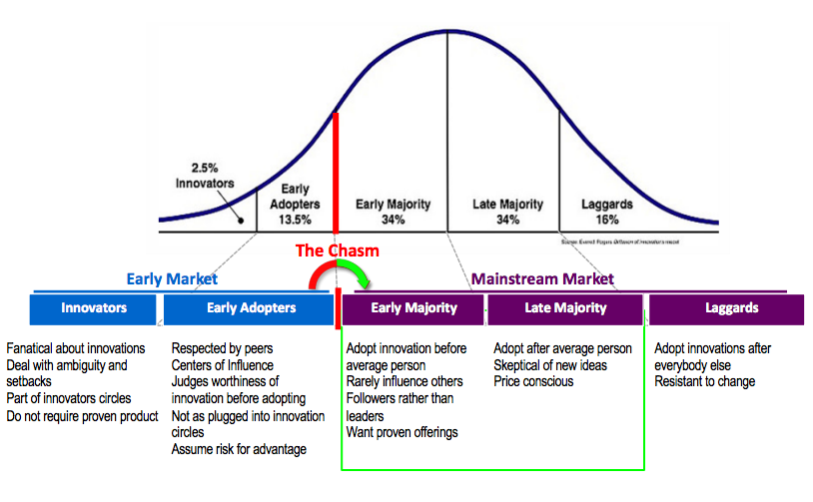

PLC: Development Stage
- Provides a visual reminder of the complexity and potential need for collaboration in the development of new offerings
- Organization spends R&D, prototyping, field testing, and trial use resource to prepare the offering to correctly address the customer need
- No sales volume, profits don’t exist
- Product isn’t completely defined, price/volume are being determined
- Promotion may be oriented towards publicity about tech developments
- Investment to prepare the offering for satisfying customer needs
- Potential need for collaboration, pre orders, beta release

PLC: Offering Introduction Stage
- Many decisions about the offering are made through the development stage and into the into stage of the PLC
- Low sales volume, profits are typically negative
- Supplier experiences the growing pains of commercial manufacturing, and mainstream involvement as a member of the customer supply chain
- Promotion is used to build awareness
- Field marketing and missionary sales are used
- If offering elements are outsourced for first-time value network, logistical process experiences a learning curve

PLC: Growth Stage
- Target market has accepted the new offering (crossed the chasm), and successfully attracts competition
- Profits increase, new adopters and pragmatists accept product
- Economies of scale may be necessary
- Question marks -> stars
- Product differentiation is important: viewed as legitimate offering; competition differentiate off your offering; total offering becomes increasingly important
- Distribution is often important in the training and education of customers

PLC: Maturity Stage
- Profits will have peaked and competition may begin to fight over market share.
- Promotion is used to reinforce buying decisions and often focuses on supplier reputation and value
- Distribution efforts intensify to reach all possible sub segments of the market
- New customers will not replace the volumes lost as old customers move to new offerings
- Price is a major part of the marketing mix

PLC: Offering Decline Stage
- Promotion is reduced to the minimal levels that will accommodate existing customers
- Consolidation usually occurs among suppliers, weaker competition drops out
- Price in relation to long-term contracts, is a major part of marketing mix
- Promotion is reduced to min levels to accommodate existing customers

Basic New Product Development Process

- Idea Generation
- Ideally, an organization operating under the marketing concept looks to customer needs for new product ideas
- The B2B marketer is much closer to the needs and wants of the customer and more able to anticipate the customer need for new offerings and solutions

2. Product Screening
- Multidisciplinary team reviews descriptions of potential projects to determine those that warrant continuation
- Each product needs an intrapreneur to get beyond 2nd stage
3. Business case analysis
- Business plan must have both a market and technical assessment
- Probable revenues and costs are analyzed
- Consider additional attributes that will comprise the total product offering
4. Product/Strategy/Plan development
- Product tech is further developed and refined
- Strategy and implementation are being developed
- Outcome is a well defined product specification written by the customer that is well matched by the custom offering
5. Test Market
- Beta release - used to fine tune the offering
6. Product launch
- Promotion efforts aimed at target markets may be used to create awareness, interest, and early trials
7. Hand off to the innovation translation/customer education team
- Innovation translation approach - used to validate a new segment, translation to other potential customers validates the existence of a market segment, without this process, the new business is an isolated application of the design and development efforts of the supplier

Customer/Market Orientation
- There are 2 approaches to effectively developing new products or services

Engineering Driven (inside out)
- Develop without focus customer input

Market/Customer Driven (Outside in)
- Developed with customer involvement across the process, critical in new markets

Team Approach
- Avoid Silos - use cross functional approach
- Product “champion” is often required

Invest in the Early Stages
- Use rigorous market-driven standards early in the development process
- Identify and weed out likely new product losers early in the process

Stage gates - are simply checkpoints after each stage of the product development process
- 2 qualitative aspects: technical milestones and market/business milestones
- Is a process used to facilitate NPD, not a checklist of functional items that must be done by each department before project is handed to next group
- Show milestones to ensure:
  - Original goals are viable
  - Offering meets expectations initially approved

The Role of Marketing in the Product Development Process
- Marketing is responsible for the definition of new offerings based on continuous review of customer needs
- Most underfunded and deficient part of the new product plan
- Helps to understand the technology in depth
- Define and redefine current and future customer needs
- Motivates other company departments and organizations
- Can make progress toward synergy by involving as many corporate tech and development participants with the customer as possible
- Guides new product development with the continuous redefinition of current and future customer needs already noted
- Reward efforts of the tech and support staff

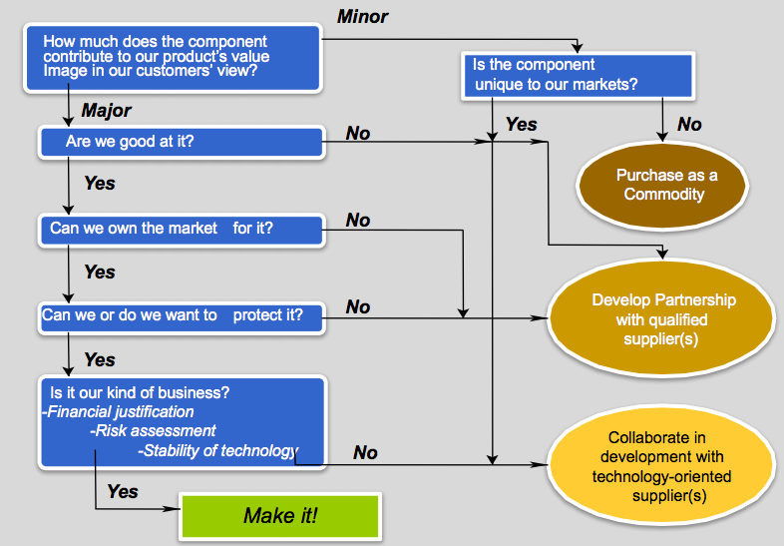

Chapter 9- Liam

Two methods to create competitive advantage for a business to business firm:
- Entreprenurial orientation ( proactiveness, controlled risk taking, opportunity seeking as well as innovation)
- Innovation (in the context of marketing)

NOTE: THERE IS NEVER AN EQUILIBRIUM...PEOPLE ALWAYS WANT TO DO THINGS DIFFERENTLY

The Entrepreneurial approach looks at four key elements
- Seeking opportunities
- Innovating
  - The creation of something new and commercially useful, or the improvement of something to make it more useful
- Acting proactively
- Taking controlled risks
  - Minimize using resource that are at risk
  - Gather information to run one or more “experiments”
  - Results can be assessed and revised for product launch success
  - Change the rules of the market

Entrepreneurial marketing is the undertaking of a marketing strategy that actively pursues a new opportunity and have relatively high levels of innovation, proactivity, and controlled risk taking.

How to create an Entrepreneurial Orientation

- Hiring the right kinds of people
  - Ability to persistently pursue a passion
  - comfortable being uncomfortable
  - Bias for action
- Directing appropriate activities
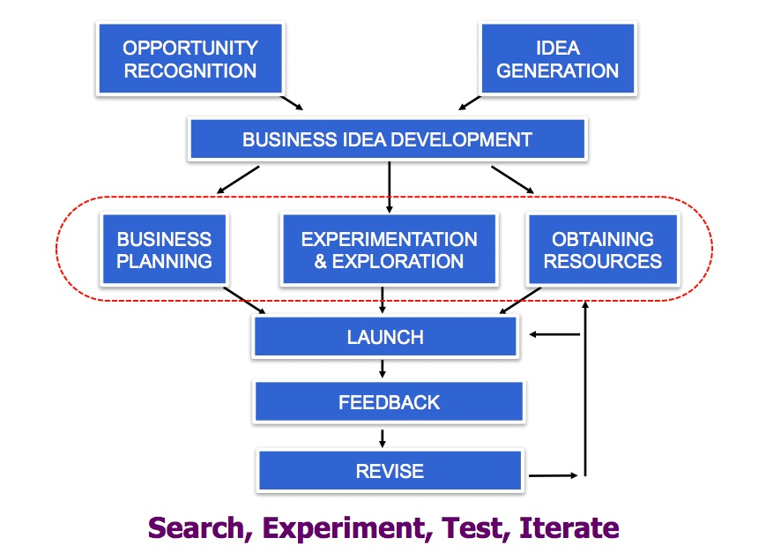
- Removing Impediments
  - Don’t punish failure as failure is positive as long as
    - Something valuable is learned
    - It does not kill the company
- Providing Incentives

Competing Through Innovation

Creating innovations away from the product allowing you to sustain a competitive advantage

This can be done through:
- Designing for more efficient production
- Less use of raw materials
- Reduced environmental impact
- More effective marketing communication or selling
- More effective distribution systems

Technology - a way of accomplishing something, based on scientific principles or knowledge.

Types of Innovation:

Incremental take the existing product and offering and make small-step improvements to the original design. (The Wireless Phone)

Radical produce large changes in the functions and performance of a product or offering (The cellular phone)

Breakthrough Innovations are a new term that is inconsistently used at times
-sometimes used to mean an extreme change in performance or costs with technology changing marginally (iif at all)
-othertimes meant to explain the advancement of technology architecture making the benefit structure essentially different and vastly better. (The IPhone)

Sustaining Innovations - improves the existing dominant technology, products, or offerings. They serve the needs of higher-end customers who already purchase similar products, but who want more value….stays on the same technology vector

Disruptive Innovations - introducing a product or business idea that creates a new kind of value. Addresses customers can be segments that are over served by the products previously available. Starts as an under performer then replaces existing through growth. Example - word processing software.

The Innovator’s Dilemma

- In all industries, customers (the demand side) have an increasing appetite for features over time
- In many industries, leading competitors actually tend to increase the provision of such features at a faster rate than the demand side requires
- The second-tier of suppliers do the same and can (sometimes quite quickly) reach a level of features provision that is good enough for customers
- At which point a dramatic shift can happen where the majority of customers carry their business to these seemingly ‘second-tier’ suppliers. In effect, the industry has been distrupted!

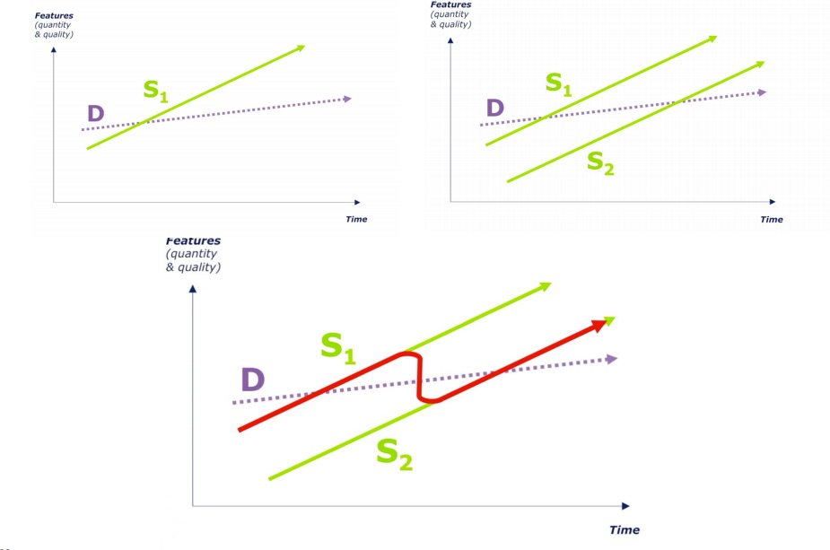

What we are currently seeing:

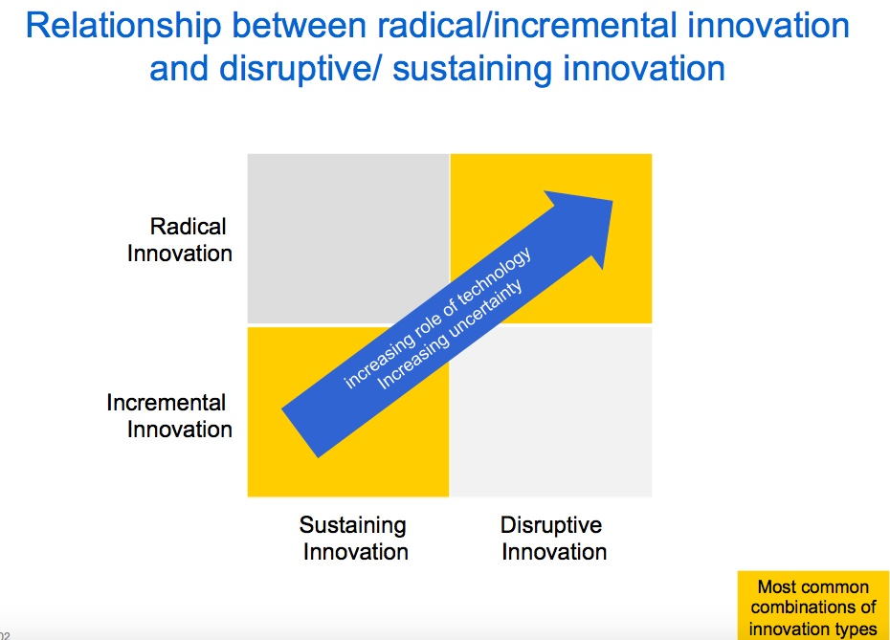
Implementation involves 5 things

- Separate the project or business unit responsible for pursuing disruptive innovation from the existing company with its established customers and business models. Find new customers that really want it
- Address the new business with a small business unit appropriate in size for the small market size of the initial opportunity
- Use an iterative, exploratory approach for finding the right market and the right way of addressing the market
- Use processes and decision making rules appropriate to the new business model; do not use the processes and rules of the existing organization, as these were not likely designed for an emerging business, nor will they facilitate changes
- Develop the markets that want the offering; do not try to find the breakthrough technology advance that makes the disruptive technology competitive in the old mainstream market. Eventually the new markets will evolve together into a new mainstream of their own.

Practical Aspects of Accomplishing Innovation
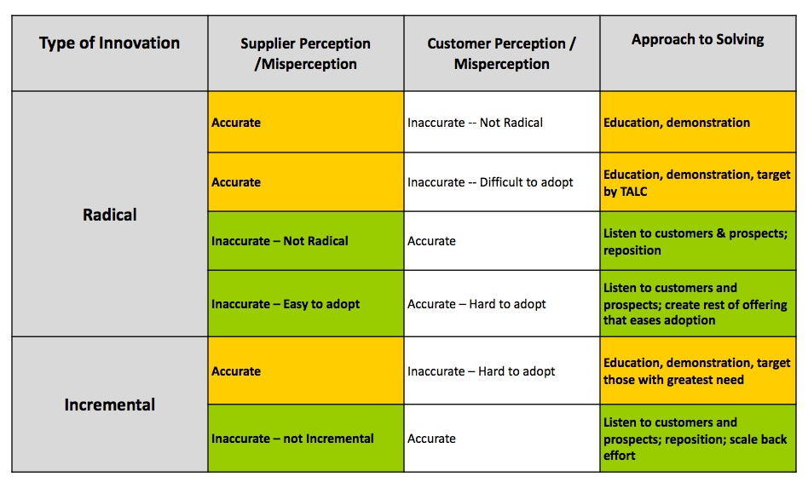

Chapter 4 - Legal and Regulatory Environment

Business Regulation in a Free Market
- Protect companies from each other
- Protect consumers
- Protect the interests of society

Injunction - agreements that can be imposed by the courts to prevent, delay, or enjoin a particular activity

Treble Damages - three times the actual loss incurred by the injured party as a result of a violation of antitrust law. Damages are awarded as compensation to the injured party. The injured party must prevail in a civil court

Legislative Acts that Affect Marketing

Statute | Focus
Sherman Antitrust Act | Monopolies, attempts to monopolize. Provided for both civil and criminal penalties. Broad coverage was base for later legislation.
Clayton Act | Trying agreements, interlocking directorates, intercorporate stockholding. Provides for civil penalties only.
Federal Trade Commission Act | Broadly defined unfair competition or competitive situations.
Robinson-Patman Act | Often known as the price discrimination act, provided penalties for both buyers as well as sellers. Requires proportionally equal terms to buyers in common markets.
Celler-Kefauver Act | The Antimeger Act. Broadened power to prevent acquisitions where they may substantially impact competition.
Consumer Goods Pricing Act | Repealed Miller-Tydings Act which had allowed fair trade, a form of price maintenance.

Cross Licensing - companies will find, within legal limits, circumstances encourage licensing or cross licensing. Two companies may cross license patents, in order to enable them to approach the market. Ex. processing patent (manufacturing) and patent for composition of solvent

Patents - protection or ownership rights granted by the U.S, gov to inventors for their original processes, products, or composition of matter.

Copyrights - apply to original works of, among others, authors, musicians, and photographers. Protect expression of ideas.

Trade Secrets - value is dependent on secrecy. A process, technique, or competitive advantage whose owner has not chosen to seek additional legal protection.

Chapter 10 - Pricing - Emily
Price
- Strategic element of the marketing mix
- Indicates value or worth
- Without it, transactions could not take place (enhances total value)
- Important part of a broader set of strategic initiatives (includes product strategy and communications)
- Both customers and competitor react to price changes - neither the customers nor the supplier will act unless the price makes it worthwhile for both parties
- Pricing is situational, depends on strategic purposes and business environment
  - Elements of price (all part of the total offering and a consideration in the customer’ buying process):
    - Financing
    - Setting financing terms
    - Allowing for several methods of payment
    - Establishing payment terms and schedules
    - Allowing price adjustments for activities performed by the customer or services provided by the supplier
    - Calculating exchange rates to allow for payment in any currency
- B2B pricing differs from B2C pricing
  - B2C - price is a deliberate contributing factor the final decision, usually entails a predetermined suggested list price, used as an attractive feature of the offering, major part of the marketing mix
    - Consumers evaluate prices and costs in light of their perceptions of acceptable price level (determined by position of competitive offerings)
    - More psychological than B2B
  - B2B - all costs (indirect and direct) and direct benefits from the offering are considered
    - B2B offerings are evaluated objectively in light of the customer’s value chain
    - Professional buyers - skilled at extracting value from transactions (part of customer buying centres)
    - Involves competitive bidding and negotiating
    - Psychological aspects of pricing are subdued
- Easiest marketing variable to change, hardest to do well (cutting price = “magic word” to sell a product to unwilling customers), price cuts = short term benefits, long term consequences (signifies problem with product or relationship - undermines margins, few resources for investing more in growth of the business)
  - Customers will get used to and predict price cuts - will stockpile enough product to wait for another promotion, intensifies bullwhip effect)
  - Sets a benchmark for future negotiations
- B2B pricing must establish relationships with customers and balance competing forces - pressure to give customer price breaks, extracting maximum profit from transactions (pressure to charge as must as the “market will bear”) Win-win situation
Value-based pricing - pricing based on customer’s perceived value, create prices that are consistent with the marketer’s strategy (hard to establish)
Cost-based pricing - determination of price by figuring costs of offering a product or services and then adding on a standard percentage profit, runs the risk of losing profits or pricing too high for the market (easy to establish, often mistakenly used)
- Alternative method - determine a method that will yield a targeted rate of return on capital invested in the offering
  - Problems with both methods
    - Costs per unit usually depend on volume and volume is set arbitrarily
    - Many cost categories are added based on a “standard rate” that may have no relationship to actual costs required or incurred
    - Most importantly, price has no relationship to customers’ perceptions of the worth of the offering (customer’s might be willing to pay more or less for an offering)
  - Costs are important in determining profit levels
  - Overall, cost has little to do with price (marketers need to understand what costs are relevant)
- Part of cost consideration is price paid for total offering, the other part is the cost of acquisition and use of the product or service that is acquired in the offering
  - Evaluated price - price of the offering from the view of the customer after all costs associated with the total offering are evaluated
Total offering - provides a complete solution to the buyer’s needs (may include financing, delivery, service or simply the core product)
- Different customers may have different view as to what the value of the total offering is
Maximum price a marketer can charge - if there is no competition, price at which benefits are just noticeably more than the evaluated price (i.e., the point at which there is a noticeable value for the offering)
- If a marketer wishes to establish or maintain a relationship with customers, charge a price at a level where customers believe they are getting a “fair” price and are willing to work with the supplier in the future (“fair price” = ambiguous)
- If there are competitors, the customer will use the price charged by competitors as a reference point (WTP a premium if offering creates more benefits compared to competitors and vice versa
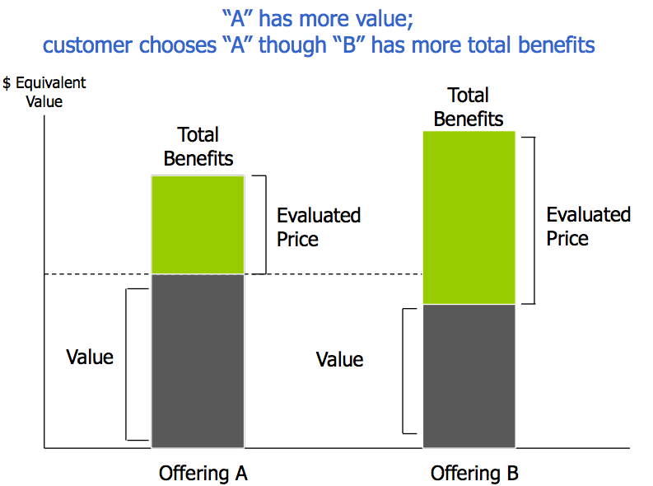
Value-cost model - diagram of the customer’s value chain showing the key elements that contribute to value for the customer’s customer and the key elements that contribute to the customer’s costs
Revenues - actual price received for the product x the # of items sold
Ongoing costs and revenue - cash flow associated with the incremental activities required specifically to offer the product in question
- Revenues from the product are reduced by only those costs directly attributable to the product
Timing of when pricing decisions are made has to do with which costs are relevant, relevant costs follow these criteria:
- Resultant costs - costs that result from the in-process decision, part of a decision that affects two or more of the 4 Ps (e.g., development of a new product - relevant costs are manufacturing, marketing, operations, etc.)
- Realized costs - actual costs incurred
- Forward-looking incremental costs - costs that will be incurred for the next unit or units of product that will be sold when the decision is implemented (i.e., next costs to be incurred)
- Avoidable costs - costs that would not be incurred if the decision were not made
Contribution margin - difference between ongoing attributable costs and ongoing attributable revenue
- TC = [(P-VC) x Q] - Attributable costs
- Demand curve - shows what quantity of products will be sold in a market at different price levels
- Supply curve - shows how much product will be produced in an industry at different levels of price
- Elasticity - tendency of demand to react to changes in price; generally higher prices yield lower demand and vice versa
Key takeaways from economic fundamentals of price:
- Demand levels will be different at different levels of price; different market segments will have different price sensitivities based on segment members’ perceptions of the benefits from the product or service in question : in most markets, one price does not fit all segments
- Changes in price yield reactions from customers, which are different in the short terms from their long term reactions: short-term reactions are usually constrained by customers’ situations; longer-range reactions allow greater flexibility. In other circumstances, customers may shift the timing of their expenditures in response to short-term price changes; their longer-term reactions may show less elasticity
- Changes in price will yield reactions from competitors: it is important to pay attention to their communications, since these may give clues to how they are viewing the market, prices, and other pressures that may influence future actions
Pricing throughout the Product Life Cycle
- Introduction - pricing is constrained by customer perceptions of competing pressures, and objectives pursued by marketer may focus more on learning about needs and building early references than on creating cash flow
- Growth - volumes will be low, development costs high, pricing will tend to be high to compensate for costs
- Chasm - pragmatist buyers may need additional incentive to spur adoption of the product, pricing however can be sent in a many directions (market growth may be spurred by a reduction in prices or vice versa)
- Maturity - consolidation among market participants, structure of the supply begins to appear oligopolistic, dominant players exercise control of market, pricing depends on how much the supplier can differentiate its offering (non-product differentiation can allow for premium pricing)
- Decline - pricing depends on the market segments still served, b/c of unique switching costs some users may use old equipment or suppliers from an earlier era, premium price is possible but there is a limit, other customers will stay with older products only if they get a discounted price (depending on the supplier’s cost structure, it may be profitable to serve these customers)
Price skimming - charging high prices that take advantage of early customers’ strong need for the new product
Penetration pricing - charging low prices to entice as many buyers into the early market
- Penetration pricing would make sense if the marketers believes the following:
  - The market can be dominated by gaining early customer commitments
  - Key large customers will commit early rather than waiting for a competitor if they believe that they are getting the best price now
  - A learning curve effect will result from early adoptions all coming to the marketer’s company allowing cost or quality improvements that give the market;s offering a competitive advantage over forthcoming entrant
Learning curve - as more product units are produced and sold, unit costs can be reduced through the learning that has occurred
- Conditions needed:
  - Must be enough prospective customers, with high quantity demand, who are price sensitive and will adopt the right price
  - Must be ample opportunity for learning to occur, and enough future demand
  - Must be sufficient time to learn
  - Must be sufficient lead over the competition to avoid direct price competition
  - Must not be a competitor who will come along in the near future with a process innovation that will start a new learning curve
  - Marketer must ensure learning takes place
Price bundling - when several products are sold together as a package for one price
Sealed bid (closed bid) - pricing involves placement of private bids by prospective suppliers
Open bid - competing suppliers see each others’ bids
- Bidding equation for maximized profit
  - Expected profit = Probability of winning bid at price PR x Profit at price PR
  - or E(PF) = PW(Pr) x PF(Pr)
Types of Negotiation Situations
Situation
 | Stand-alone Transaction | Balanced Between Transaction and Relationship
Effective bargaining styles | Competitive; problem solving | Problem solving; compromising
Effective approach | Use of leverage | Seek common interests

Leverage - power to get others to accede position, unequal distribution of importance
Integrative bargaining - negotiation approach in which multiple dimensions are considered simultaneously

Chapter 11 - Business Development and Planning - Peter
Marketing has three primary goals at every stage of the Product Life Cycle
- Obtain new customers
- Continue to meet the needs of existing customers
- Coordinate offerings that are in different stages of the PLC and manage them such that the business’ prospects are not tied to the PLC for a single product or for a cluster of related products

Business Development
- The search for Opportunities and the Structuring of business entities to exploit those opportunities with current or near term organizational capabilities (essentially taking advantage of business opportunities and structuring business entities to be effective at taking advantage of those opportunities)

Business Development Involves
- Creation and analysis of markets and market segments
- Maintenance of relationships with partners:
  - Customers
  - Channel members
  - Suppliers of complementary products and services

Ex. Business Development: Analytic Applications PSP
- Business Development Partner Solutions Program
  - Expand portfolio
  - Program and Offering
  - Complimentary or complete
  - Legal protection
  - Selling
  - Recruiting
- Pricing Strategy - how to maximize returns intro stage
  - Revenue sharing
  - Tiered
  - Proportion of revenue

Forecasting
- Marketing Forecast accounts for:
  - Technological change
  - Time horizons
    - The longer the time frame, the less accurate and useful the forecast will be
  - Barriers to entry/exit
  - Elasticity of demand
    - Demand in b2b markets is somewhat volatile
    - Changing technology forces offerings through the adopter stages more rapidly as
      - Early adopters embrace newer technologies
      - Suppliers abandon “late cash cows and dogs” faster, for new products and markets, searching for higher growth rates
  - Forecast expenditures
- Usefulness of Forecast is determined by
  - Time
  - Effort
  - Money invested
- Types of Forecast
  - Strategic forecasts
    - “Top down forecast”
    - Usually 3 to 5 years
    - More qualitative than quantitative
    - Attempt to reconcile reality with desired strategic direction
  - Market planning forecasts
    - Associated with a product or market
    - Significant inputs from market research and competitive analysis
    - Attempt to predict what customers and competitors will do
    - Usually 1-3 year periods
  - Market operation forecasts (MOFs)
    - Provides the “who, what, where, when, and how much information about current and future business
      - A visual of the following is on the Business Development Tracking Grid below
      - Core Business
      - Core Churn
      - Real New Business
      - Translation Business
    - Usually responsibility of the field marketing organization
    - Tactical in nature
    - Source of significant market information, often sourced through customer relationships
    - An element in sales forecasts
    - Serves many parts of the organization
    - Usually 1-3 year periods, continuously updated
  - Sales forecasts
    - Shorter range than MOF
    - Input to logistical functions, resource planning, and so on
    - Usually derived from analysis of historical data - assumption that future activities will follow current patterns

Top-Down Vs Bottom-Up Planning
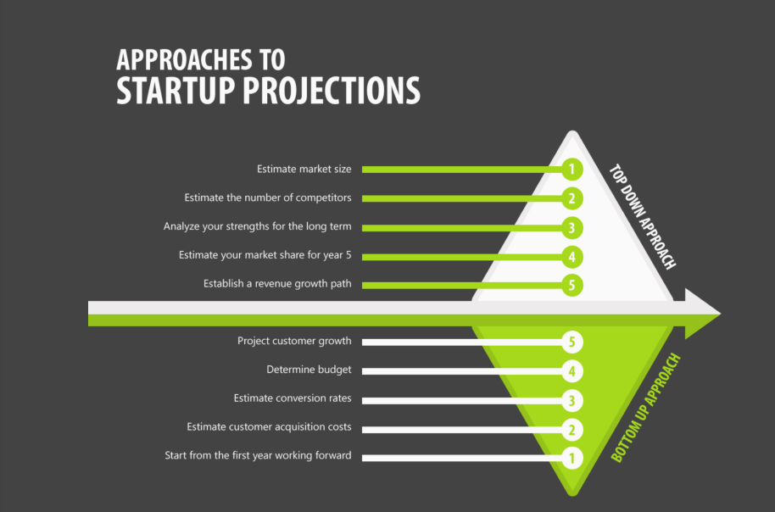

Improving Sales Forecasts
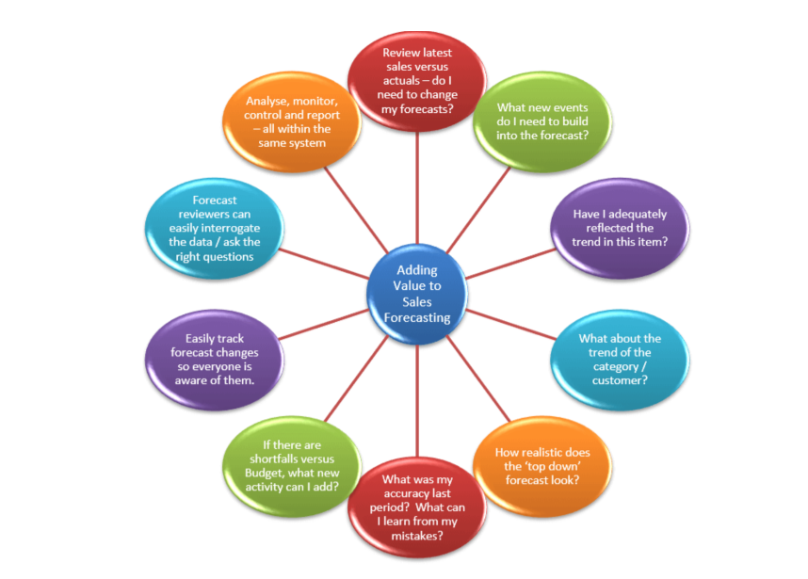

Mechanics of Sales Forecasts
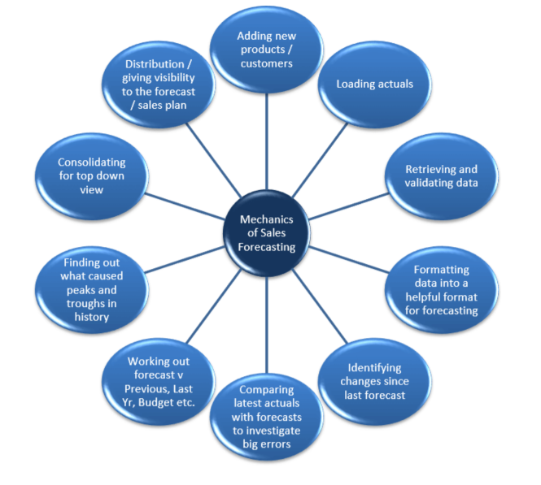

Types of Forecast: Other Predictive Models
- Often involves statistical manipulation of historical data
  - Rolling averages
    - Forecast for the next period is a weighted average of a preset number of prior periods
  - Econometric models
    - Forecasts are based on relationships derived through statistical analysis
  - Delphi approach
    - Forecasts are from a panel of experts who are systematically polled

Prioritization in Forecasting
- Usefulness of Forecast determined by: Time, Effort, Money Invested
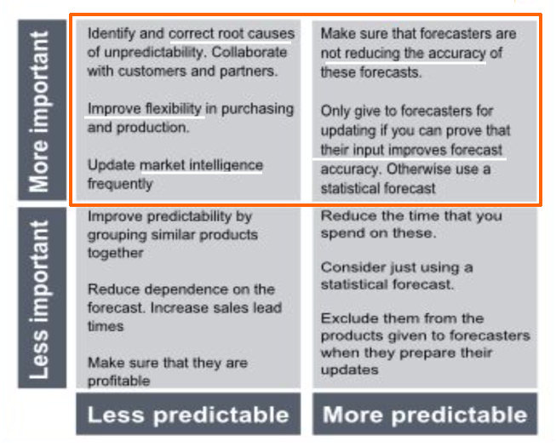
Business Development Tracking Grid
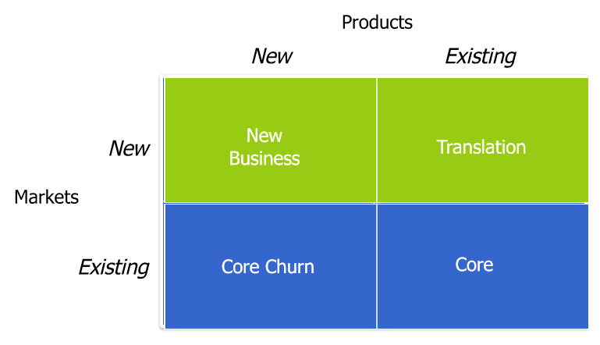
Marketing and Business Development: Throughout the Product Life Cycle
- Development
- Introduction
- Growth
- Maturity
- Decline

Marketing Emphasis (I believe this is the chart the professor said we would be asked on on the exam)
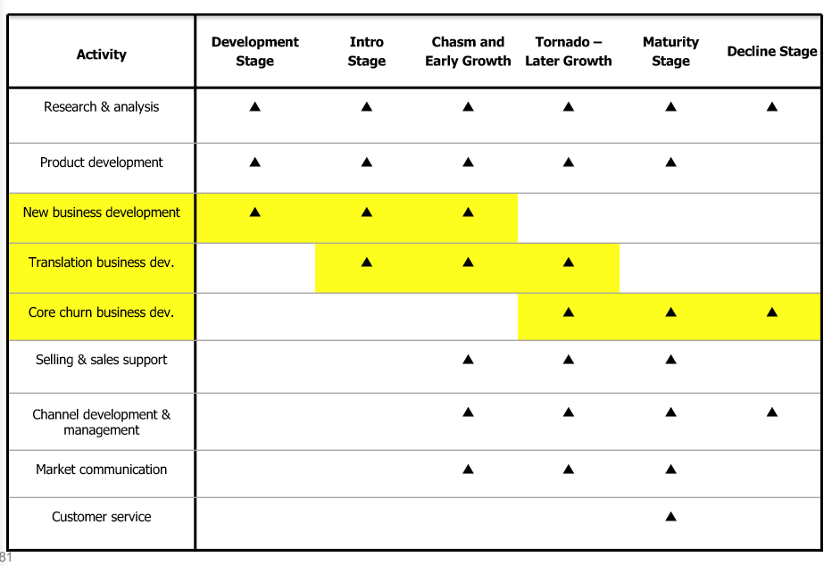
- An example question he said in class was “Which of the following is / not a marketing emphasis in the xyz stage of the product life cycle”

Business Development Bands over the Product Life Cycle
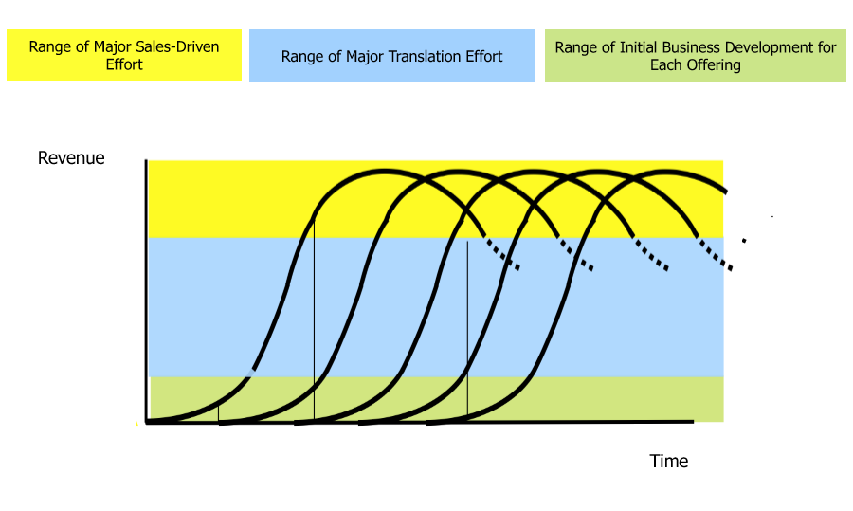

Chapter 12 - B2B Selling - Liam

What is B2B selling - Creatively joining your company’s capabilities with your customer’s needs. (Relationships!!!)

Sales vs Marketing
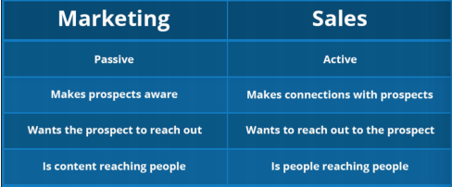

Boundary Personnel
Comprised of buyers and sellers
• Span boundaries of own organization and those of customer’s
• Liaison to other key organizations
• Can be major asset in buyer-seller relationship
Characteristics of B2B Selling
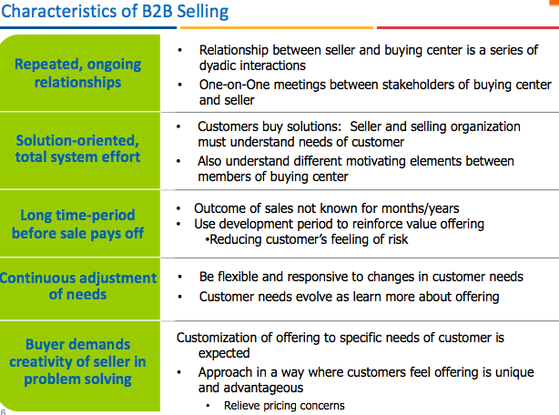

Inward, Sales Driven Cultures:

Maximizing production/sales is often the goal
• Production Era
• Product Era

Market Value Driven Cultures:
Maximizing market choice or life quality and focus on satisfying a need
• Marketing Era
• Societal/partnering/ value network Era

Selling Structures
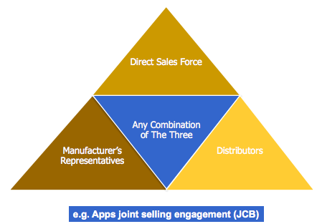

Appropriate Market Conditions: Direct Sales Force

• The product is technically complex
• The situation requires a specialized background
• Control is important – the organization selects, trains, and controls personnel
• Long lead times expected for results
• Prospecting for new customers is required
• The customer base is concentrated
• Explicit customer feedback is desired
• High fixed costs

Manufacturers Representatives

Specialists in a particular market segment or collection of segments that have common users or call patterns.
• In business for themselves or as part of an agency of reps’
• No ownership for what they sell
• Carry no inventory
• Have low fixed costs
• Have little or no transaction between principle and customer
• Commission given only after sale is booked

Appropriate Market Conditions - Manufacturing Representative
The product is standardized or generic
• For technical products, a technical background is important
• Control of personnel is less important
• Short sales cycles are common
• The reps have other complementary lines
• Reps have established relationships with target customer segments
• Match of reps’ existing call patterns
• The market is dispersed and/or when the market consists of many small customers • Customer feedback is less critical
• Low fixed costs are required

The mutual Needs of buyer - seller
- Needs of Organization
- Needs of Job Function
- Individual Needs of Buyer/Seller

4 Different types of sellers
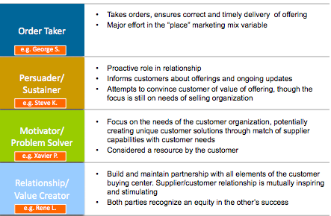

Correlation of Value & Complexity of Relationships: A Generalized Case

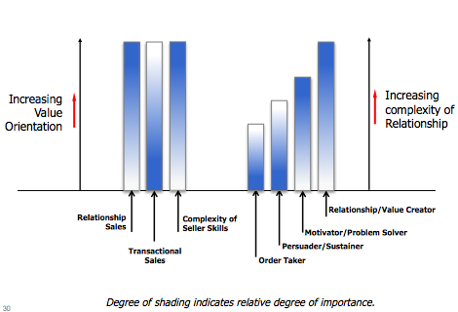

Other types of seller roles:
- Missionary Sellers—Task oriented
- Field-Marketers—Market developers, focus in translation
- Post-Sale Customer Service—Reinforce purchase decision

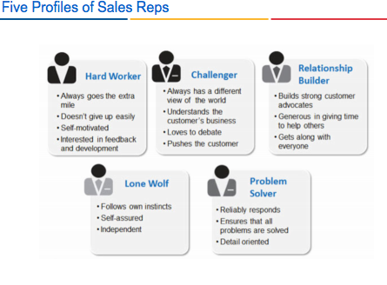
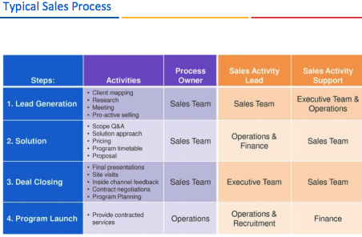

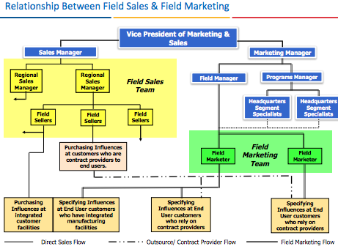

Sales enablement is a strategic, ongoing process that equips all client-facing employees with the ability to consistently and systematically have a valuable conversation with the right set of customer stakeholders at each stage of the customer’s problem-solving life cycle to optimize the return of investment of the selling system

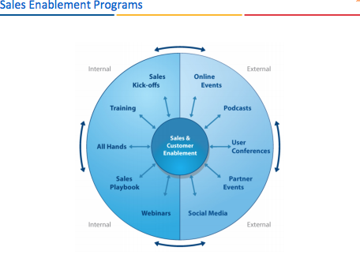

Sales Pipeline
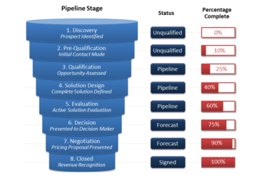

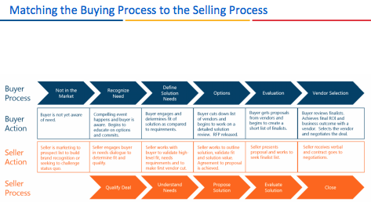

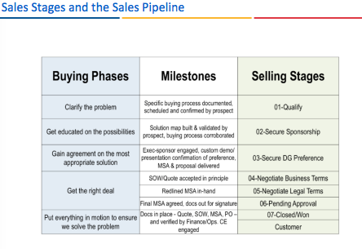
How to build successful relationships
Successful relationships between customer and seller involve:
• Mutual Respect
• Trust
• Authenticity

Levels of Relationship and Intricacy:
• Discrete Exchange
• Differentiating an undifferentiated product
• Multiple Transactions
• Collaboration/Partnering

Sales compensation

- Straight Commission
  - Repeat efforts necessary to sustain customer purchases
  - Rewards short term
  - Sellers focus on those who have frequent purchases
  - Inappropriate during new product introductions
  - Compensation variability/ volatility may be a problem for the seller
- Straight Salary
  - Management has greater control over sales force
  - Appropriate when sellers provide design and engineering assistance
  - Motivator/Problem Solver, Relationship/Value Creator
  - Creates Stability
  - Does not tie financial rewards to sales results
- Combination Plans
  - Frequently used form of compensation
  - Salary portion contributes to needs of management control
  - Commission encourages higher sales
  - Commission is paid as it is earned

Terms to know:

MVP (Most Viable Product)

Chapter 13 - B2B Branding - Mallory

Brand- a collection of experiences and associations attached to a company, organization, product, or service; more specifically, brand refers to the concrete symbols such as a name, logo, slogan, and design scheme. A brand is a symbolic embodiment of all the information connected to a company, organization, product, or service

Holistic Branding- a holistic approach is one that emphasizes the total offering- the functional relationships between all of the pieces. This is consistent with the earlier definition of a total offering- the offering that provides a complete solution to the buyer’s needs; this may include financing, deliver, service, and so on

Characteristics of B2B Branding
-increased information efficiency
-in regards to how fast a customer can process information
-risk reduction
-brands make it easier for customers to find functional products
-value-added or image benefit creation

The role of B2B Brands
-differentiate
-secure future business
-create brand loyalty
-differentiate marketing efforts
-create preferences
-command price premium
-create brand image
-increase sales

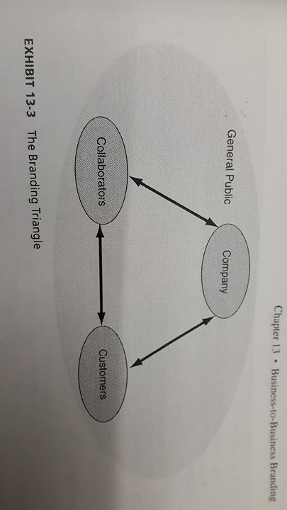
Branding Triangle

-represents marketing related connections between company, collaborators, and customers.
-collaborators= employees, wholesalers, dealers, ad agencies, etc.
Branding Dimensions

Brand Management- the organizational framework that systematically manages the planning, development, implementation, and evaluation of the brand strategy

Brand Strategy
- Choice of common and distinct brand elements a company applies across the company itself and the various products and services it sells
- A brand strategy is one of the most valuable assets to your company. In order to plan and implement a brand strategy, the current state of your business must first be understood so that you can uncover the needs and issues that are unique to your company and your industry. It’s only by gaining this understanding, and aligning it with the company’s vision, that the brand strategy can be revealed
Brand Architect
- Defines the relationship between brands, the corporate entity, and products and services
- Companies can stretch brand by width (individual to corporate), length (low to high end) and depth (national to international)
- Companies can have individual brands, or brand families, and everything under one cororate brand
- brand strategy and brand architecture must be adjacent

Communication and Corporate Identity/ Visual Identity Code

Key elements of a strong brand are as follows:
- Name
- Logo
- Tagline (or slogan)
- Brand story
Visual Identity Codes are used to specify the use of each brand element. Guidelines include:
- Available- should be available and usable across all intended markets
- Meaningful- should captuer the essence of the brand and communicate the nature of the business
- Memorable
- Protectable
- Positive- can evoke positive associations in the markets served
- Transferable- can use the brand element to introduce new products in the same of different market

- First four criteria can be characterized as brand building. Latter three are defensive
External Marketing- regular work of pricing, distributing, and promoting of products and services to customers
Internal Marketing- all actions that train and motivate collaborators to become true brand ambassadors.
Interactive Marketing- primairly affected by internal marketing efforts

Measuring Equity and Value
It’s important to provide rough estimates of brand value which can be used to provide a frame of reference when developing programs and budgets
- Research-based evaluations
  - Measures customer behaviors and attitudes that have impact on the brands
- Financially driven approaches
  - Partially based on subjective judgements of knowledgeable peopel in an organization
- Combined approaches- uses both of the two above mentioned methods

Competing Through Branding

Branding as standard

- A positive brand name has an advantage at each stage of the decision process, even under high learning purchasing situations
- ideal state for a marketer is to reach a point where their products are standard
- First with new technology: that brand might become new jargon (i.e. kleenex) and future copycats will be called by the first manufacturers brand
- Being best with service: market ownership is necessary. Customer loyalty and service quality will help create a standard (i.e. FedEx)

_Channel Relations and Side Bitch Supply Chains (omg you’re so funny D)
Marketing Channel - means to manage the presale contact, transaction and fulfillment activities between the supplier and the final buyer.

Value can be established through the original supplier, or through more channel intermediaries (organization that performan channel functions between the original supplier and the final buyer).

Without the place element - supplied directly through OG suppliers or intermediaries - the customer cannot realize the value contained in the supplier’s product/service.

Places involve many organizations:
- Primary channel participants: These are part of the proactive marketing design of the channel. These intermediaries are associated with responsibilities with pre sale customer contact, sales, customer services and transaction within the channel. (Primary channel participants for a link between the supplier and the final user.
- Ancillary channel members: Businesses and services that are traditional generic but in which the channel could not work without. Marketers do not pick specific trucking companies but knows that it will need a trucking company for logistical requirements. Markets specify the function in the channel design, but the specific provide.
  - NOTE: These channel members have their own goals that may not be consistent with the channel leaders and may be more resistant to change which can make place a difficult part of the marketing mix to alter.

Channels are usually Supplier-customer, these are called Direct Channels.

Direct channels: are formed when the supplier markets and sells directly to the buying organization or end user; this uses NO additional primary intermediaries.

So why even have channel intermediaries? (yeah like wtf?)
LET ME GIVE YOU THE LAY DOWN:
- It’s all about the economic theory of division labor! The what?
- In more clear words: people are usually more competent at providing a service when it is their core business offering. In many cases intermediaries often have efficiencies, special skills or special circumstances that suppliers do not.
- EXAMPLE: Having an intermediaries cuts the numbers of transaction of the supplier by allowing them to sell the product: reducing Selling costs and Margin of Error. This also lowers costs to consumers because they can get the product for cheaper thanks for the difference in pricing at different quanities! (OH NOW I SEE HOW THAT RELATES WITH VALUE IN THE CHANNEL!)

BTW not all customers have the same expectations about the level of services that are provided with purchases, therefore target segments may alter the shape of the channel structures.

>Incongruence in customer expectations of services = different shape of channels per target segment.

^Therefore, each will deliver different levels of form, time, place and possession value. (WOW REALLY!!?)

MARKETING CHANNELS DELIVER VALUE:

- Economic utility: This value has four parts (YAWN) but these at a minimum are required for marketing strategy success.
  - Form utility: is the usable quantity or mode of the product most preferred by the customer.
    - EXAMPLE: this form could be PALLETIZING (when products are put on a pallet to accommodate the operations of a customer’s manufacturing facility.
  - Time utility: is the availability of the product when the customer needs it.
    - Just in time delivery
    - C2C store hours
  - Place utility: (Locational convenience) delivery of components parts directly to the customer’s manufacturing site.
    - “Locational Convenience,” the availability of the product where the customer needs it
  - Possession: how customers obtain ownership or the right to use of the product or service.
    - Finance of customer purchases can be a major part of the total offering.

- Each of the four types are required, but may be shifted across different channel members. (distributors, wholesalers, manufacturers, etc.) BUT CANNOT BE ELIMINATED OR IT WILL CAUSE CHAOS IN THE DELIVER OF VALUE.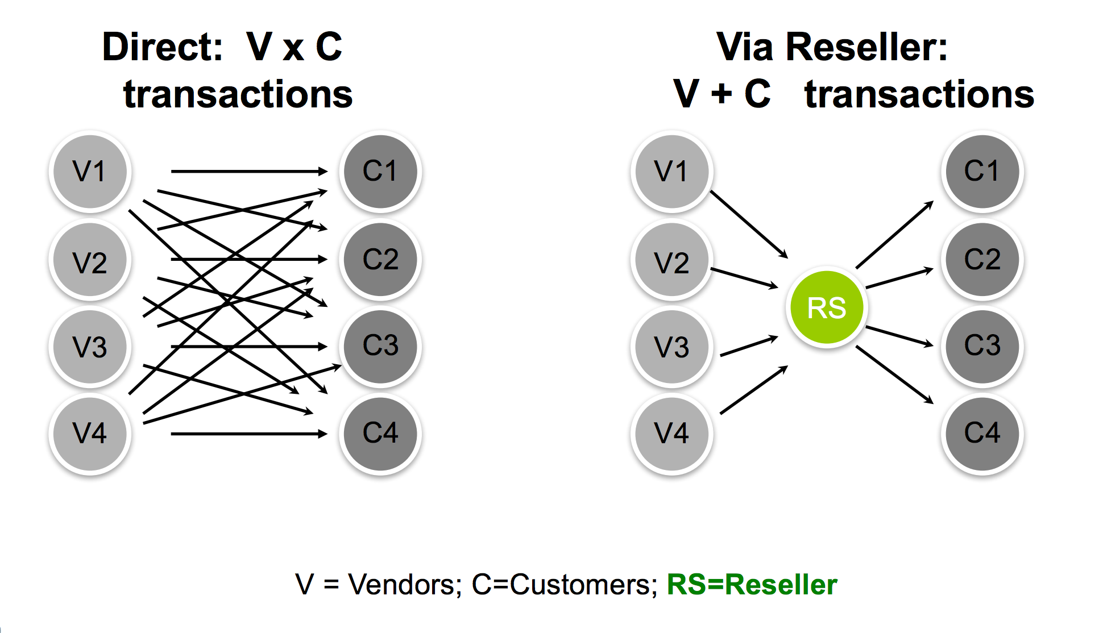

- Channel flows and activities that create value:
  - Marketing and sales flows:
    - Creating products tailored to the customer demand.
    - Creating a communication channel between the supplier and customer.
    - Price establishing and negotiating.
  - Product and ownership flows:
    - Taking temporary ownerships, transferring title, handling gov. Documentation and registration and so on.
  - Installation, training and service flows:
    - Providing before and after sales services to customers.
  - Ancillary flows
    - Providing financing for customers or suppliers.
  - Contracted transportation, handling and storage services:
    - Contracted promotion services
    - Arranging for insurance, financial protection
    - Managing information gathering, analysis, and dissemination.
- Channel pattern: the specific arrangement of intermediaries that perform channel functions.
  - Different targets in the market may change the channel patterns to meet specific requirements.

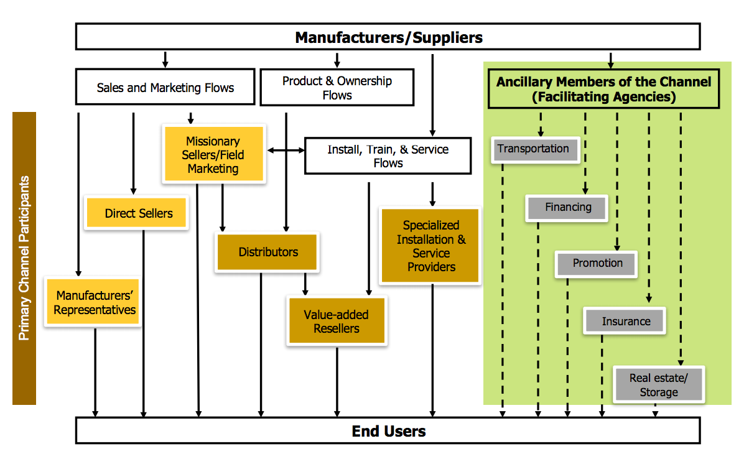

PRIMARY CHANNEL PARTICIPANTS
- Sales and marketing would flow to direct sellers for large accounts (e.g., GM, Ford)
- Service channel would use distributors able to provide the specific needs of repair personnel.
- Missionary sellers assist the distributors in assortment and quantity decisions and provide product training to distribution personnel.

DIRECT CHANNEL
Would be from the manufacturer to the customer + all the ancillary members of the channel.

Trade credit is the credit extended to you by suppliers who let you buy now and pay later. Any time you take delivery of materials, equipment or other valuables without paying cash on the spot, you're using trade credit.

A major source of customer and market information is obtained by the participants from the end users in a bottom up market analysis.

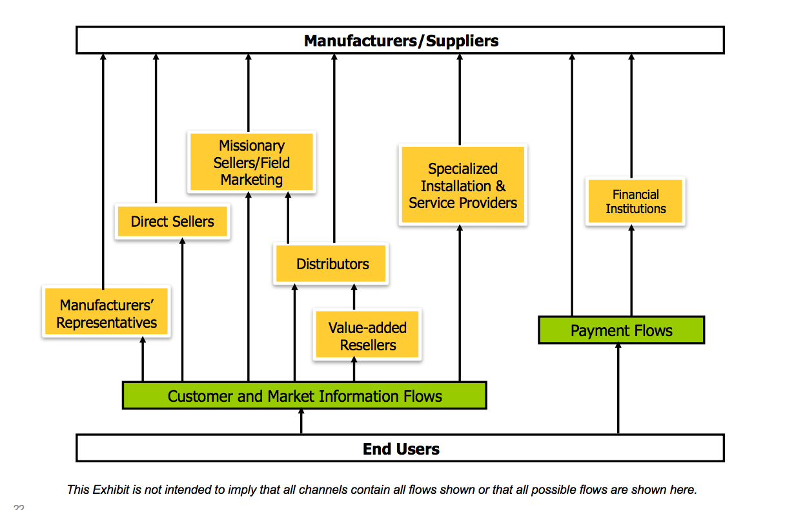

The Marketing channel is organized by intermediaries so that goods and services are provided to customer in the form and time in which they desire. As mentioned earlier different market have different expectations.

These patterns that are made through such organizing tactics are called Channel Patterns.

Vertical integration: refers to the degree of ownerships a firm has of its Marketing Channel. If the firm owns its own distributors and ancillary services may provide ECONOMIES OF SCALE but may be EXPENSIVE when trying to implement a change in channel design or service required. (NOT FLEXIBLE)

Solution to this problem? Firms use specialists to perform ancillary tasks, allowing the firm to concentrate on development of its markets.

This is called a Functional Spin-off when larger companies acquire specialized firms to provide services at a lower capital investment, greater flexibility and a broader range of long-term options.

Industrial Distributors Serve Industrial End Users:
Why do End consumers not purchase directly from Manufacturers? Manufacturers are often not willing or are unable to do so unless they have economies of scale. Therefore distributors fill the gap and build relationships with medium and small users for them.

This often happens when distributors buy products from suppliers and sell them to small/medium size purchasers (large companies who may purchase small quantities) to provide better customer service.

Industrial Distributors serve Industrial End Users (Mill) in varied ways:
- They provide fast delivery
  - Distributors maintain local inventory for suppliers they rep.
  - Arrangements for JIT orders to allow customers ability to avoid large resource commitments.
- Provide segment based product assortment:
  - The distributor provides a product line based on the target segment needs. This creates product assortments from many sources.
- Provide local credit:
  - They provide trade credit for small/medium businesses who can’t afford financing.
- Provide product information:
  - Able to provide requested product knowledge.
- Assist in buying decisions:
  - Often advise retailers regarding “hot sellers” and help them avoid “turkeys” from a manufacturer's line.
  - If they have profitable successful customers they become successful through more purchases!
- Anticipate needs:
  - Essentially becoming a material handling specialist for the customer, by being well in the loop of new business opportunities that the customer is pursuing.

Industrial distributors serve industrial suppliers (Manufacturers)
- Buy and hold inventory: Dist. are cust. Of the manufacturers, selecting, buying and paying for goods. They then hold the inventory for smaller customers because it's too costly for Manufacturers. THEN THEY SELL IT IN THE FORM REQUESTED BY THE CUSTOMER.
- Combine Manufacturers’ outputs: Distributor provides an assortment of outputs to from different manufacturers and provides a selection based on the customer segment.
- Share Credit risk: Manufacturer's provide credit to dist. To be able to hold inventory. LESS RISKIER with Manufacturers (with strong relationships) and MORE RISKIER with small companies. Man. provides credit which allows dist. To provide credit to small companies.
- Share selling risk: Although Dist. our independent business, goods are assumed to be sellable and the Man. develop that marketability. Both partners have a stake in the success of the product.
- Forecast market needs: Since it’s proximity to the market, distributors provide information for manufacturers to establish better scheduling of its own production activities.
- Provide market information: Also capable of achieving an understanding of unmet customer needs

