PSYC1001A November 8, 12
Bruce Tsuji
Exam: Saturday DEC8 19:00
50% (6,7,8)

Human Memory
How does stuff get into memory?
How is stuff maintained in memory?
How is stuff pulled back out?

Our Study of Memory
3 memory storage systems
3 memory processes
When memory fails

Three Memory Storage Systems
- Sensory memory
- Working memory
- Long term memory

Three Memory Processes
3 Storage systems; what happens between them?
- Encode: Transform info into form that can be retained. Requires Attention
- Storage: Keeping info in memory
- Retrieval: When info stored in memory is brought back to mind

1. Encode: Transform info into memory
- Attention, focus awareness
- Selective attention: selection of input
- Filtering: early or late?

Levels of Processing (Craik & Lockhart, 1972)
- Info encoded at different levels
- Deeper processing=lasts longer
- Encoding levels:
  - Structural=shallow
  - Phonemic=Intermediate
Level Of Processing | Type of Encoding | Example
Shallow | Structural, emphasizes physical structure. | Is word written in capital letters?
Intermediate | Phonemic, emphasizes sounds of words. | Does word rhyme with “orange”?
Deep | Semantic, emphasizes meaning of words. | Is word similar in meaning to “insight”?
  - Semantic=deep

“Deeper” encoding better retention

Levels of Processing Example
- McMaster University Medical School
  - Disease symptoms for exams (shallow)
  - Disease symptoms for rounds (medium)
  - Disease symptoms for specific patient (deep)
- Deep processing better retention than medium or shallow

Better Encoding to Improve Memory
- Elaboration: Link other info at time of encoding
  - Examples related to a concept
- Visual Imagery: Create images to represent things to be remembered
  - Dual-coding theory (text concept chart)
- Self-Referent Encoding: Making info personally meaningful

2. Store: Maintaining Info in Memory
- Info storage in computers ~ info storage in human memory
- Information processing theories propose three storage systems:
- Sensory, Short term, Long term

3. Retrieve: Info Out of Memory
- Tip of the tongue phenomenon
  - Failure in retrieval
  - Jogged with retrieval cues
- Recalling an event
  - Context cues, encoding specificity
- Reconstructing memories
  - Misinformation effect
    - Source monitoring, reality monitoring
Three Memory Stores:
Atkinson-Shiffrin Model
- Sensory memory
- Short-term (or working) memory
- Long-term memory

Sensory Memory
- Brief storage in original sensory form
- Visual – ¼ second
- Auditory sensory memory ~ 2 sec.
- What we attend to goes into STM
  - George Sperling (1960)
    - Classic experiment on visual sensory memory
- Sensory Memory is basically information preserved in its original sensory form for a brief time. This type of memory allows the sensation to linger briefly after the sensory stimulation is over…in the visual system, an afterimage.

Working on Short Term Memory (STM)
- Limited capacity: Miller’s magic number 7 plus or minus 2
- Limited duration: ~20 seconds
  - Rehearsal: Repetitively verbalizing or thinking about info
  - Chunking: Group familiar stimuli for storage as a single unit
- Short-term memory is defined as a limited-capacity store that can maintain unrehearsed information for up to about 20 seconds.
- George Miller (1956) wrote a famous paper called “The Magical Number Seven, Plus or Minus Two: Some Limits on Our Capacity for Processing Information," where he illustrated that the average person can hold between 5 and 9 chunks of information in STM.
- A chunk of information is a group of familiar stimuli stored as a single unit…for example, the following numbers 8 -6- 7- 5- 3- 0- 9 can be thought of as 7 individual numbers or they can be chunked together in groups of 2, 3, etc.
- STM also has a limited duration…in other words, information can only be kept there for a brief time before it is lost, unless rehearsal occurs.
- Rehearsal is the process of repetitively verbalizing or thinking about the information…keeping it in use.
- Peterson and Peterson (1959) conducted a study illustrating how quickly information is lost from STM…this study is illustrated on the next slide.

What is “Chunking”?
- Divide a chapter into smaller pieces
- Learn a phone number by its area code + 3 digits + 4 digits

STM as “Working Memory”
- STM stores info from Sensory Memory & info retrieved from LTM
- Info loss from decay; but maintained through strategies like rehearsal, chunking
- Baddeley (1986) – Working Memory
  - Phonological rehearsal loop
  - Visuospatial sketchpad
  - Executive control system
  - Episodic buffer

Long Term memory (LTM)
- Unlimited capacity
- Permanent, accurate storage?
  - Penfield’s ESB
    - http://www.youtube.com/watch?v=52bYneF6JEk
  - Flashbulb memories (yours or mine?)
  - Recall through hypnosis

Multiple LTM Systems
- Retrospective versus Prospective
- Explicit versus Implicit
- Declarative versus Procedural
- Semantic versus Episodic

LTM Subsystems
- Declarative Memory (explicit) verbal or image information
  - Episodic: Events of your life (personal)
  - Semantic: General knowledge, objective facts and information (encyclopedic)
LTM Subsystems
- Procedural memory (implicit) motor skills, habits, simple classically conditioned responses.
–Eating with knife & fork, chopsticks.
–Riding a bicycle.
–Sniffling.
–Salivating when smell your favourite meal.

How is Knowledge Organized in Memory?
- Analogical & Conceptual representations
- Clustering and conceptual hierarchies
- Schemas and Scripts
- Semantic Networks
- Connectionist and parallel distributed processing models

Sir Frederic Bartlett (1920’s)
- Subjects memorize aboriginal legends
- Memory very poor over time
  - Reconstructed stories
  - Simplified
  - Remembered “Isolated but striking details”
  - Memory organized within framework of own experience – schemas

Measuring Memory
- Recall: Info without retrieval cues (i.e. essay questions)
- Recognition: Info with retrieval cues (i.e. M/C questions)
- Relearning: Measuring time it takes to relearn

Recognition (M/C) almost always better than Recall (essay)

Serial Position Effect
- Primacy effect: info at beginning of sequence recalled because already placed in long-term memory
- Recency effect: Info at end of a sequence recalled because still in short-term memory

Why Do We Forget?
- Ineffective Encoding
- Decay Theory
- Interference
  - Proactive
  - Retroactive
- Sometimes adaptive

Retrieval Failure
- Encoding Specificity (Retrieval cue match to stored code)
- Transfer-Appropriate Processing (Encoding match to retrieval)

Context-Dependant Memory
- Info easier to recall when in same environmental context as when learned
  - Underwater
  - Same classroom
  - Odours
  - Clothes

State-Dependant Memory
- Info easier to recall (but not recognize) when same emotional or physical state when learned
  - Anxiety
  - Alcohol
  - Marijuana & other drugs

Causes of Forgetting
- Consolidation failure (trauma, loss of consciousness, no REM)
- Motivated forgetting

Motivated Forgetting – Repression
- Unconscious, inadvertent forgetting
- Authenticity of repressed memories
- Examples?

Williams (1994)
- April 1973 to June 1975, 206 sexual abuse victims (1 – 12 yrs) in hospital
- 1991 all re-contacted, 3 hours interviews conducted with 129
- 38% did not report sexual abuse
- Did they forget? Choose not to?

Eyewitness Testimony
- Often erroneous and should be viewed with caution
- Children good eyewitnesses only when interviewers take precautionary steps
- Hypnosis does not improve accuracy, only confidence in memory
- Research supports existence of repressed memories and false memories can be reconstructed in response to suggestions of abuse

Children Reporting Sexual Abuse?
- Real or imagined?
- Poor memory of birth to 3 years because hippocampus incompletely developed and language poor
- Repressed memory from trauma? Connie Kristiansen (Carleton) says it happens between 3.9% to 13.6% of cases

Biology of Memory
- Biochemistry
  - Alteration in synaptic transmission
  - Hormones modulate neurotransmitter systems
- Neural Circuitry
  - Localized neural circuits
  - Long-term potentiation
- Anatomy
  - Anterograde and Retrograde Amnesia
  - Hippocampus?

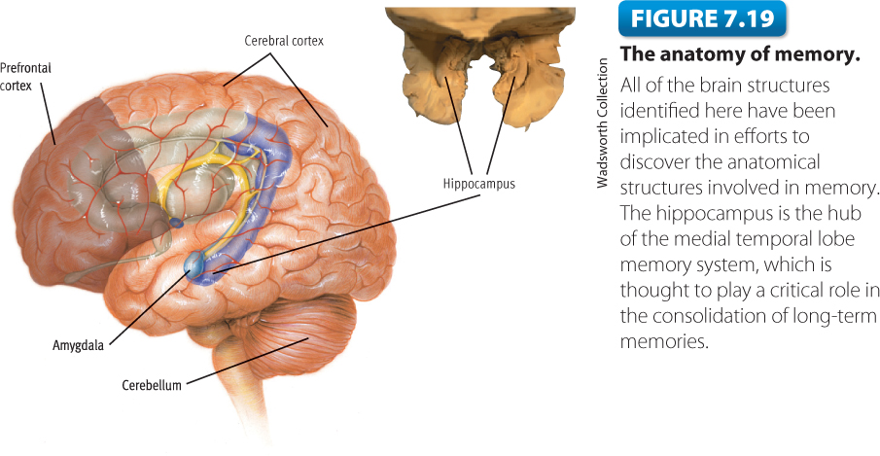

Retrograde Amnesia
- John O’Donnell: 45 year old white male
- Ran grocery store with wife, 2 children
- Store burned down without insurance
- Depressed, started drinking, stopped, mother died, started drinking again. Wife and children left him
- Found in woods near home, disoriented, malnourished
- Korsakoff’s Syndrome, retrograde amnesia

Amnesia’s
- Retrograde: forget info before event
- Anterograde: Unable to retain info after event or learn new material

The Nature of Memory
- Memory as permanent record: video recorder analogy? No.
- Memory as reconstruction: partly fact and partly fiction
  - Piece together highlights with info that may or may not be accurate
  - Schemas can affect how we encode and recall information
- Specific brain location of memory? No, but we understand how specific structures contribute

Improving Our Memory
- Effective encoding and rehearsal
- Distribute practice, minimize interference
- Emphasize deep processing and transfer-appropriate processing
- Organize information. Personalize it.
- Use verbal, visual mnemonics
- Use SQ3R
- Allow time for memory consolidation

