Week 1: Imagining the Landscape:
From Arcadia to Necessary Aesthetics

Why is landscape architecture not more prominent?
Architecture is the art of designing space using inorganic materials at a large scale (the scale of the site)
In the 20th century the interest of landscape design became increasingly secondary to the importance of the building or the architecture itself
Why?
- This is an issue of the rise of technology
  - Because of the industrial revolution, the need to advance technology increased which changed how things were being produced
    - Rather than by hand everything needed to be mass produced
    - Since the devastation of WWI, the goal of architecture was to create house to remedy the country and rebuild Europe
      - Due to this the priority was a social housing revolution
      - In the 20th century it stopped being about creating extravagant houses for the elite but rather to create as much housing as possible as fast as possible
      - Landscape is the opposite of technology and architecture which is associated with mass production and industry, resulting to landscape architecture being rejected since that was the focus in the 19th century
      - Landscape architecture was also seen as frivolous and only now in the 21st century are we redirecting our focus back to landscape architecture
    - In world war 2 there was the discovery of the atomic bomb
      - This affected the view of landscape architecture because it introduced the idea that we as humans have the capacity to destroy the planet
Landscape myths
What is a myth?
- A myth is a story that helps people better understand themselves
- Usually it’s quality that has a positive perspective on themselves to justify actions that people tale
  - For example: Canada post cards
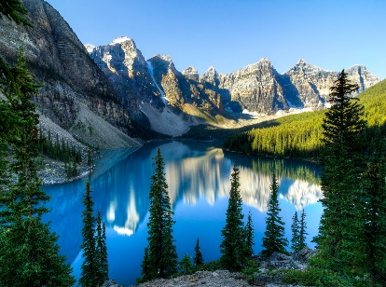
    - Usually represented as a natural environment while every block of nature is managed in some are feeding human history
    - Our myth is that Canada can keep expanding because we have an unlimited amount of land while every block of land is planned for industry
    - Even natural parks are not technically natural because we control everything from fires or animal
    - People tend to be more attracted to the more organic ideas of landscape rather that synthetic artificial landscape because it makes us feel more involved with the environment

"It is in vain to dream of a wilderness distant from ourselves. There is none such. It is the bog in our brains and bowels, the primitive vigor of Nature in us, that inspires that dream. I shall never find in the wilds of Labrador any greater wildness than in some recess of Concord, i.e. than I import into it."
- Henry David Thoreau, Journal, August 30, 1856

Landscape Key terms
Garden
- Is an old roman word that means fence?
- The difference between garden and a landscape is that a garden has a more defined boarder and less of an architectural focus
- Gardens are also usually organic
Wilderness
- A space in the environment that is beyond the control of humans
Landscape
- Is a term of designing architecture at the scale of the site?
- As opposed to architecture landscape is an evolving space that changes throughout time

Three schools of landscape
These are fundamental rules of landscape architecture in western history
The Greeks
The romans
The modern western word (primarily Christian)
This exploration is to show how the perception of nature though time changes
Landscape philosophy deals with the views of a period

The Greeks
      - Greece is an abundant and fertile land
      - All clothes and foods are easily attainable because the resources are abundented
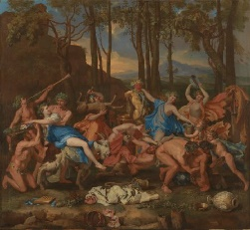

The Romans
- They are associated with engineering
- During the roman empire where there take over the Greek
- The romans are much more ambitious and organized seen though their status
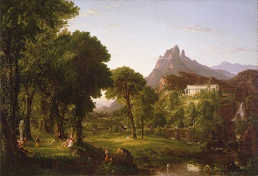
      - What they are imposing on the landscape is that everything needs to be organized
      - They also like the Greeks think that the world is boutable but they think there should be some sort of management
      - The romans view is that the human control of the environment can allow the world become more efficient and allow the entire roman empire to have necessary resources

500 BC
  - the fall of the roman empire where they get attacked and become unprotected and separated into different countries
- this is the beginning of the dark ages and the Christian era

