Mortgage Exam Notes

Basic Mortgage Concepts:

Mortgage Contract:
Borrower must:
-pay back the loan
-insure the property
-Maintain the property, keeping it in good sellable condition
-must not commit waste, and ultimately lose property value
-pay property taxes on time

Lender Must:
-once receiving full mortgage funds, must provide the borrower a certificate of discharge, showing that they have paid back their certificate in full
-the borrower has the right to redeem the mortgage and use a new mortgage company
-quiet possession: when not in default, the borrower must have full uninterrupted right with the property.

Mortgage Registration Docs:
- The charge/mortgage (the instrument used to register the loan against the borrower’s property. It forms the security of the debt).
- The discharge of charge/mortgage

Mortgage Ranks
First mortgage first mortgage registered on the property
Second third etc.
-Once the borrower pays off the first, the second becomes the first.

Purposes of using a mortgage:
- Purchase getting the full mortgage
- Refinance or Equity Take Out borrower already has a home. Refinancing meaning increase the size of the mortgage, or renogotiate it in some other way. The borrower may have to pay a penalty for repaying the mortgage before the end of the term. Unless the mortgage is fully open.
- Equity Take Out when a borrower increases the size of their mortgage or takes out a second mortgage, or another debt on the property. This is done to close the amounts on higher rated debts, such as credit cards.

Advanced Mortgage Concepts
Financial components of a mortgage:
- Face Value mortgage amount
- Term amount of time you have a contract with lender before it comes up for renewal
- Amortization amount of time it will take until the mortgage is paid fully
- Interest Rate rate for using the lender’s money
- Compounding frequency Number of times during the year the interest rate will compound
- The amount that will be made in payments to repay the amount borrowed

Types of Mortgage Products
- Partially Amortized, blended constant payment mortgage with a fixed rate.
-partially amortized means there is a term in which renegotiating will take place. If it was fully amortized there would be no term
-Blended constant payment means during the term, the payment is constant, blended with interest and principal. Making the payments of interest, along with the payments of principal will eventually lead the payments to zero.
-Fixed rate during the term, the interest rate will stay the same

-After the term is finished, you can refinance it (to get extra funds or if you plan on doing a home renovation, switch the mortgage (transfer from one lender to another without changing amount borrowed), or renew with the current lender.

- Partially Amortized, blended constant payment mortgage with a variable rate.
-The interest rate is variable, meaning that if during the term the interest rate fluctuates, the payment will change too. If the rate goes up, more money will go to the interest rate and less to principal, vice versa.

- Partially Amortized, blended variable payment mortgage with a variable rate.
-The interest rate and the mortgage payment will fluctuate if the interest rate changes during the term. If the interest rate goes up, so does the payment, and vice versa.

Types of mortgage products:
-Interest Only Mortgage During the term of the mortgage we are only making payments for the interest that is accrued for that payment period. Not making blended payments of interest and principal. Therefore, this is not an amortized mortgage. Usually for a second mortgage, to keep the payments low.
-HELOC Home equity line of credit. This is a line of credit assured by real property. Benefit: Interest rates much lower.
-Reverse Mortgage not making any payments or paying off mortgage at all, as long as the people are alive and well to live in the house

Mortgage Options:
Prepayment options:
-Fully opened mortgage can be paid off at any time with no penalty
-Partially opened mortgage Can be repaid at any time during the term however a penalty will be involved.
Closed Mortgage You do not have the right to prepay the mortgage before the term unless the property is sold.

-Payment Increase Mortgage Can request to increase the payments from the lender, so that the mortgage can be paid off quicker. If you cannot meet the faster payments then the payments can usually be decreased back down to original amount.
-Accelerate Mortgage payment agreement with the lender to make larger payments to pay off the mortgage quicker.
-Lump some payments Can pay by lump some to help pay off mortgage quicker
-Extended Amortization allows borrower to lower payments by increasing the amortization period
-Cash back option Allows the borrower on closing to receive an amount of cash back from the lender, beneficial if the borrower needs money to buy furniture etc.
-Combined or bundled option Combines a line of credit with a standard mortgage. Provides the borrower some flexibility. As the standard mortgage is paid down the availability on the line of credit increases too.
-Portability/assumability option Allows the borrower to take their mortgage to their new home. If market rates are higher than the one on their current mortgage, they can take it to their new home. If the house is bigger, then they will need to apply for additional funds. Assumability option – can take over the mortgage of the previous owner. Can blend the current mortgage interest rate with their current interest rate.

Penalties
-3 month interest penalty on prepayment of the mortgage, must give the lender 3 months worth of interest
- Interest rate differential If the market price of interest rate lowers from 4% to 3% for example, the lender would be losing money. So to compensate they will charge the differential (1% x outstanding balance x time left in contract)

Mortgage Default Insurance
-Commonly referred to as CMHC Insurance is mandatory in Canada for down payments betwee 5%-19.99%.
-Protects lenders. In the event a borrower ever stops making payments and defaulted on their mortgage loan.
-Costs homebuyers 2.8%-4% of their mortgage amount (but allows people that may not be able to afford it at the time a house).

Section 2 – Chapter 8

1. The Present Value (the mortgage amount) The mortgage amount typically refers to the amount of money that must be repaid by the borrower
2. The Amortization Period The amortization period tells us how long it will take to fully repay the mortgage amount. The amortization period is expressed in years Chapter 8: Calculating a Mortgage Payment 169
3. The Interest Rate The interest rate tells us how much the lender is receiving in interest in return for providing the mortgage amount. This number has two components: the annual rate and the compounding frequency
4. The Compounding Frequency The compounding frequency tells us how often the annual rate of interest compounds, which in turn tells us the precise amount of interest that is being charged
5. The Future Value The future value tells us how much money will be outstanding at some future point in time. For our purposes the future amount will always be zero since the payment being calculated is the payment that is required to pay the entire mortgage amount off over the full amortization period.
6. The Payment Once you have the previous 5 components, you can calculate the payment. The payment tells us exactly how much money is required to be paid to the lender in each payment period. A payment period would be equal to a month if the mortgage had monthly payments, a week if the mortgage had weekly payments, and so on

Canadian mortgages are calculated in arrears, or at the end of the compounding period. For example, if a borrower was making monthly payments on his or her mortgage and the next payment date was January 1st, that payment would cover the month of December.

J2 = 6% J refers to the fact that this is an annual interest rate 2 refers to the fact that this interest rate is compounded semi-annually, or twice per year (there are two semi-annual periods in a year). 6% is the rate of interest.

If the rate was 6% compounded annually, not in advance it would be written as: J1=6% If the rate was 6% compounded monthly, not in advance it would be written as: J12=6%

-To calculate compounded interest, divide the interest % / number of times it is compounded yearly. Then multiply it by the principal. Then add it to the principal. Then, multiply this number again by the principal added with the previous interest, then add it to the whole number.

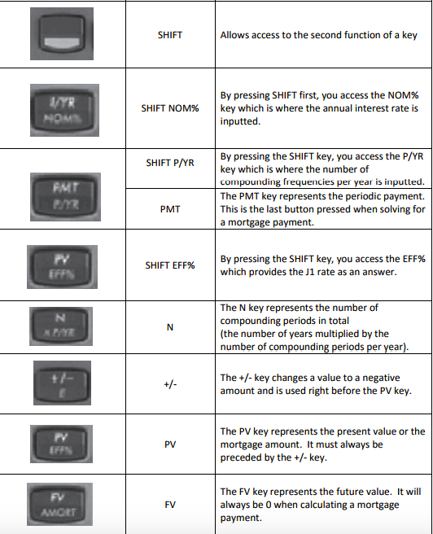

Section 3 – Chapters 9-11
-Be honest, and do not have misleading advertisements of any sort. Speak on behalf of you and your company only

Documentation needed from potential client:
-employment verification
-PIPEDA consent (consent to review personal info)
-Photo ID
-Divorce agreement (if applicable)
-Child support order (if applicable)

Specific Documentation for a Purchase
The following is a list of documentation that is typically required when a client is purchasing a property: • Purchase and Sale Agreement • MLS Listing • Proof of Down payment • Rental Letter (if applicable) • Real estate salesperson Information
Specific documentation for a Refinance, Equity take-Out and Switch
The following is a list of documentation that is typically required when a client is refinancing his or her current mortgage, taking equity out of his or her property or switching lenders on renewal:
• Current mortgage statement • Charge/Mortgage • Transfer/Deed • Property tax statement • Property insurance policy • Mortgage repayment history (if applicable)

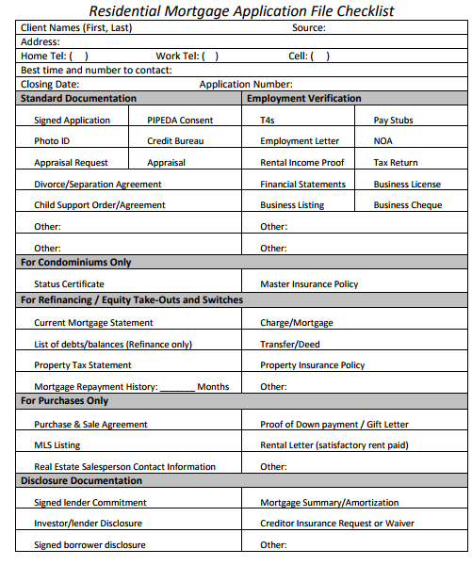

Section 4 – Borrower Documents

T4A – provided to individuals from their employer, and summarizes income from various sources, and is used for submitting annual income tax return. Usually for independent contractors.

Box 61 - Payer's Business Number (BN) This is the 15-digit BN of the employer, and does not appear on copies provided to the recipient. If the BN does appear the broker/agent should confirm the information on the slip from the employer as this may be a sign of a forged document, since many individuals aren’t aware that the BN is not to appear on the recipient’s slip.

T4 - A T4 is a document provided to an individual by his or her employer to summarize income for a given one year period. This document is typically obtained by a broker/agent when the applicant has employment income such as salaried or hourly income.

Job Letter - 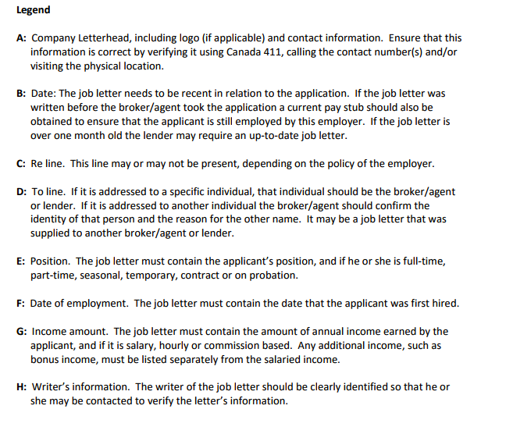

NOA – An NOA is issued by the federal government when a personal tax return has been completed and filed. This document provides a breakdown of the year’s income along with the balance owing or refund due. A broker/agent will typically obtain this document when processing an application using a “Stated Income” program to provide proof that there are no outstanding back taxes owing to the Canada Revenue Agency. This document may also be required in other circumstances, as determined by each lender.
***SECTIONS UP TO 6150 ON THE NOA ARE ROUNDED AND NEVER INCLUDE CENTS

Property Documentation:
MLS listing – online listings of properties that are being sold, available for buyers and sellers.
Agreement of purchase and sale - The agreement of purchase and sale is a document used when real estate in Ontario is being purchased or sold. In all cases, where the applicant is applying for a mortgage to purchase a new or resale home, the lender will require a fully completed purchase and sale agreement.

Insurance Documentation:
This is a document used by an Insurance Company to determine the eligibility of an applicant for creditor insurance. Creditor insurance has become a regular offering in a mortgage transaction. Used to ensure that applicants have protection against the perils associated with death, disability or job loss, it is important to consider.

Chapter 13

LTV – Loan to value ration – The amount of the loan in dollars, relative to the value of the property, in dollars. Percentage, rounded to 2 decimal places (unless a whole number.
Calculating LTV of first mortgage = loan / value of house x 100
Calculating LTV of second mortgage:
= 1st mortgage + Second mortgage / value of house

Calculating Max mortgage amount= LTV% x property value

GDS – Gross debt service
-designed to determine if the potential borrower can afford the mortgage payment, based on their income.

GDS = ((PITH + ½ condo maintenance fee ) / Gross Income) x 100

*PITH = principal(per year), interest, property taxes, and heat
-heat = $75/month

**Industry standard = Maximum ratio is 32%

TDS = Total Debt Service
-Difference between GDS and TDS is TDS includes all debts the borrower has.
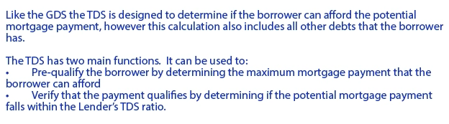
Maximum Mortgage Payment = (Income x Max TDS / 100) – (Property Taxes + Heat + ½ Condo Maintenance Fee + Other Debts)

If the mortgage agent has already determined the mortgage payment that the potential borrower requires, it is then necessary to determine if that payment meets the industry standard 40% TDS ratio or whatever the ratio is for the lender we’ve chosen or are considering.

TDS Ratio = ((PITH + Other Debts) / Income) x 100

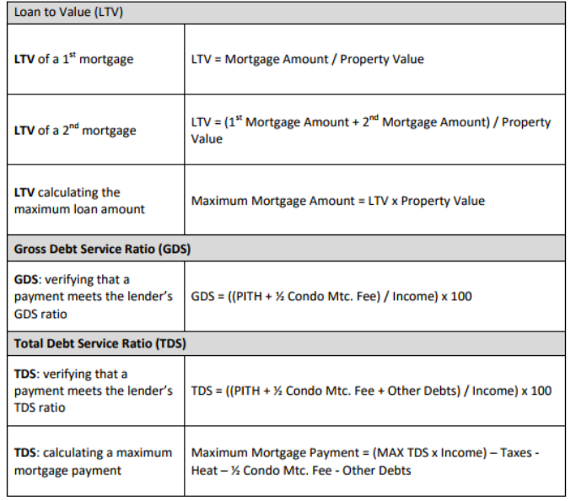

Section 5 - Choosing a Lender

Types of lenders:

Prime mortgage lending – lending to prime borrowers – excellent credit, provable income, and stable employment. Majority of Canadians fall into this category.

Sub Prime Mortgage Lending – lend to mostly alt-A borrowers. An alt-A borrower is an individual who has decent credit, that cannot fully prove their income. Offered to people usually declined by prime lenders.
-these lenders usually charge a higher rate of interest, or a borrower/lenders fee.
-many call themselves self insured lenders. Their fees essentially mean their lenders fee is the cover for their no insurance.

Private Mortgage Market – A private lender is an individual, or group of people that offer mortgage financing. They use mortgage brokerages to find potential clients.
-Charge the highest rate and a lenders fee

Credit Scores

Range from 300- 900

The property

Appraisal – exact estimation of the value of a property. Using techniques by an appraiser.
-typically done by the lender. They also typically charge for the appraisal report.

Calculating market value

- Income approach – for apartments/ income producing properties. Calculates the value of the net operating income and provides a rate of return for the area to get the market value.
- Cost approach – calculates the value of a property based on the cost of replacing it
- Direct comparison approach – most appropriate for mortgage financing. Find a house in the same area, and see what it was sold for.

AVM – Automated Valuation Model
Method of calculating the valuation of a property using a database of comparable properties and using mathematics to add or subtract to the value of the property based on its features.

Desktop Appraisal
-Used when the property is used in a marketable area. Does not have an inspection on the property
-Uses an MLS reports for data on recent sales or listings.

Drive By Appraisal
-Uses a desktop appraisal, and a look at the exterior of the property. Shows the immediate neighbourhood and pictures from the outside

Full Appraisal
-Includes a full inspection of the property. Notes all defects and notes on the phone.
-Offers the most information
-Appraisal of choice usually
-Most insist a full appraisal because it includes the most data.

Submitting The Application

How Disclosure Must be Made A brokerage is required to provide detailed disclosure to lenders and investors involved in a mortgage transaction, including a mortgage renewal, unless that lender or investor is a member of a designated class of lenders and investors as previously defined in the Key Terms and Definitions section of Chapter 5. This disclosure must include a completed disclosure form, in a form approved by the Superintendent, signed by a broker. The disclosure document used to provide disclosure, consent or acknowledgement to an investor or lender must be clear and concise and presented in a manner that is clearly understandable.

17.3 The Commitment Letter
Once the application has been submitted and the underwriter has approved the mortgage application, he or she will send the mortgage agent a commitment letter or approval. This document explains the terms and conditions of the mortgage that the lender is committed to providing along with the conditions that must be met before the lender will fund the mortgage.

Chapter 18: Borrower Disclosure

Completing the Borrower Disclosure Document
What Must be Disclosed
The MBLAA states that the borrower disclosure must include the following information: 1. Fees and payments associated with the mortgage 2. The relationship between the brokerage and lender under the proposed mortgage 3. The role of the brokerage 4. The number of lenders the brokerage represented during the previous year 5. Potential conflicts of interest 6. Risks associated with the proposed mortgage 7. Terms and conditions of the proposed mortgage 8. Estimated costs 9. The cost of borrowing

1. Fees and payments associated with the mortgage
2. The relationship between the brokerage and lender under the proposed mortgage
3. The role of the brokerage
4. The number of lenders the brokerage represented during the previous year
5. Potential Conflicts of interest
6. Risks associated with the proposed mortgage
7. Terms and conditions of the proposed mortgage
8. Estimated costs
9. The cost of borrowing

