Library Research Report

Carleton University
CCDP 2100

Jacob Westen

Instructor: Dr. Marlene Lundy
Team Name: Aquifina
Date: 02/13/18

INTRODUCTION
A team has been brought together to research methods to increase water sustainability in society. This paper evaluates reference resources that were gathered for the water pumps portion of the team project proposal. The research question asks how applying knowledge about the net positive suction head (NPSH) helps to reduce and prevent cavitation from occurring. Increasing the pumps efficiency in this way ultimately adds to the sustainability of water as functioning pumps are essential to achieving this goal. Every other subtopic addressed in the proposal also works toward the team goal of sustainable water by increasing efficiency, waste management, and water recycling among other factors. The rest of this paper will introduce and evaluate the resources used for research on water pumping and overall water sustainability.

SOURCE DOCUMENTS
This section will address the different sources used and what role they will partake in the project proposal. There are four different types of resources. There are two sources that cover overall water sustainability and two that focus specifically on the function and efficiency of water pumps.

Textbook -- Sustainable Water Engineering: Theory and Practice
This textbook will be a useful resource for the project as it gives a detailed outline of the issues surrounding water sustainability and their causes. The textbook contains entire chapters that describe the societal, environmental and economic issues regarding water sustainability and provide general supporting data. This information can be used to formulate a background and introduction to the research project. For example, the textbook outlines how lower pH in freshwater, caused by pollution from industrial operations, can be dangerous or fatal to organisms that are sensitive to the acidic environment [1].

Government Report -- Human Activity and the Environment: Freshwater in Canada

The report contains recent and accurate data regarding the quality, efficiency, and quantity of freshwater in Canada. The importance of this data is that it provides information that is current and relevant by location. This data is beneficial to the research paper as it contributes to its credibility and relevance. An example of data from the article is the percentage breakdown of total water used by each main water users in 2013. According to the report, 68% of the water was used for production and transmission of electric power; 10% in manufacturing; 9% in households; 5% in agriculture; and 3% in mining and oil drilling [2].

Handbook -- Centrifugal Pump Handbook (3rd Edition)
This handbook is an essential resource for the research project as it contains all the technical and theoretical knowledge necessary to formulate an answer to the research question. Included in the handbook are the energy conversion equations along with other equations necessary for the innovative process. Additional information from the handbook that will be particularly useful are methods of improving the pump suction performance and detailed information about cavitation of the impeller. An example of this content is that according to the handbook, the cavitation erosion intensity is proportional to (NPSH)^3 [3].

Journal -- Experimental Analysis of the Onset and Development of Cavitation in a Centrifugal Pump

In this paper, research was done to test if the onset of cavitation corrosion could be monitored using acoustic emissions [4]. The results of the experiment confirmed this to be the case. This new and innovative method allows for action to be taken to prevent the cavitation, thereby increasing the efficiency and lifespan of pumps significantly. Since improving both of these aspects of water pumps is in the interest of the research project, this study provides an excellent resource.

CONCLUSION
This research report was made in order to evaluate the resources that have been gathered for the project. Of the resources gathered thus far, the handbook will be the most informative and essential in the research report. Although it does not present new ideas, it provides a solid foundation of theory and knowledge necessary to do so. Further research on improvements for water pumping would assist in completion of the project proposal.

REFERENCES

[1] | R. Chandrappa and D. B. Das, Sustainable Water Engineering: Theory and Practice, 3rd ed. Chichester: John Wiley & Sons Ltd, 2014.
[2] | Environment, Energy and Transportation Statistics Division, "Human Activity and the Environment: Freshwater in Canada," p. 6. Minister of Industry, 2017.
[3] | Sulzer Pumps Ltd., Centrifugal Pump Handbook, 3rd ed., Burlington, Massachusetts: Elsevier Ltd., 2010.
[4] | M. G, N. Karlsen-Davies, A. G, A. J and P. D, "Experimental Analysis of the Onset and Development of Cavitation in a Centrifugal Pump," pp. 1-2. Zografou, Athens, 2017.

APPENDICIES

“Industrial activities, mining as well as power production using fossil fuels, can cause acidification of freshwater systems locally. Acid rain, due to emissions from fossil fuel and atmospheric processes, can affect larger areas. Acidification affects young organisms (both flora and fauna), which are less tolerant to a low pH. Further, lower pH can mobilize metals in soils, resulting in additional stresses/fatalities amongst aquatic species. Acidification is widespread downwind of power plants, emitting huge quantities of oxides of nitrogen and sulfur. Downstream of mines, contaminated groundwater causes stress to the environment. Freshwater flora and fauna usually do not tolerate high salinity. Actions such as agricultural drainage from high-salt areas, groundwater discharge from oil/gas and other pumping operations, numerous industrial activities and some municipal water-treatment operations can change the salinity of soil (UNEP, 2010).
The increasing incidence of invasive species displacing endemic species and altering water quality and local food webs affects freshwater systems and needs to be considered a water-quality issue (Carr and Neary, 2008). Aquatic species have been introduced, in many cases deliberately, into far-away ecosystems for recreational/economic/other purposes (UNEP, 2010). In many situations, these introductions have devastated endemic aquatic organisms.” [1]

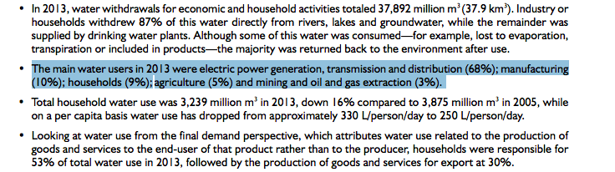[2]
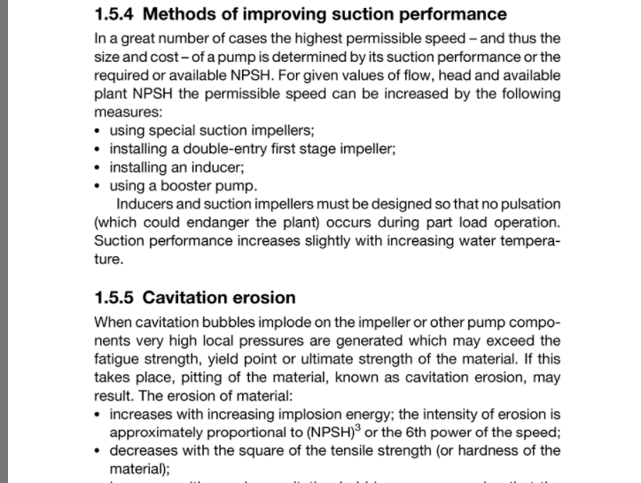[3]
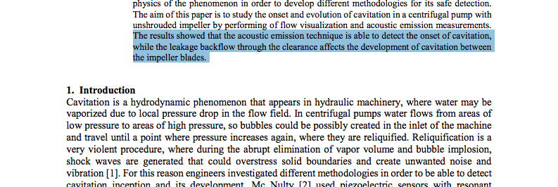[4]

