FINAL REPORT
CCDP 2100 E TEAM PROJECT: FIRE-FIGHTING SYSTEMS.
“THERMAL ENERGY DETECTOR”

.
TABLE OF CONTENTS
Content Page #
1.0 Introduction 3
2.0 Background: on the thermal energy detector 3
3.0 Importance of the thermal energy detector 4
3.1 Components and design of the detector. 4
3.2 The photoelectric sensor 5
3.3 Pressure of the fire-squelching gases in the gas tank. 6
4.0 Conclusion 6
Glossary 7
List of References 8
Appendix A: Project Outline Form 9

1.0 – Introduction
This final report is a follow-up to the RFP issued on September 12th 2017 for the CCDP 2100E term project on “Unmanned Firefighting Vehicle”. The purpose of this report is to explain the engineering principles behind the design, “Thermal energy detector” and how it benefits potential users. During fire outbreaks, firefighters who are called for rescue purposes or to dissipate the fire are faced with certain risks. The design, ‘thermal energy detector’ eliminates the risks attached with taking out fire quickly and more efficiently. The thermal energy detector detects fire while it is still at the source and eliminates it, reducing the risk of large-scale fires in the environment. In this document, the importance and description of the proposed design can be found in Sections 2.0, 3.0 and 4.0.
2.0 – Background
On June 24th 2017, there was a fire incident in Grenfell tower, London. The tenants of the apartment building complained to the owners of the property that there were no proper fire systems installed in the building. Eventually a fire started and lives were lost and a lot of property was burnt. The thermal energy detector addresses these issues and detects fire while its still at the source and eliminates it using carbon dioxide. When a fire starts, the system sends a text to the owners of the house to alert them about what’s going on while tackling the fire. Carbon dioxide is being used to tackle the fire because it reduces the oxygen needed for the fire to burn.

3.0 – Importance of the thermal energy detector.
When there is a fire outbreak, controlling and eliminating the fire becomes a tough task. Although the firefighters respond somewhat quickly, the rate at which the fire spreads consumes things rapidly as there is still enough oxygen for combustion. [1] When fire comes in contact with manufactured products, they give off harmful gases such as carbon monoxide and hydrogen cyanide. [1]These gases that are released cannot be detected as carbon monoxide is odorless and colourless while hydrogen cyanide has a faint smell. [1] Although firefighting techniques have improved, the rate at which firefighters die has become much greater as a result of inhaling the harmful gases released. These examples are reasons why changes need to be carried out to ensure that the first responders and victims are kept safe. The thermal energy detector puts all these to rest by attacking while the fire is still growing. As the amount of thermal energy begins to increase, the detector sends a signal to the system which disperses carbon dioxide and other fire-squelching agents.
3.1- Components and design of the detector.
The thermal energy detector consists of an infrared camera, hoses for passage of fire-squelching agents, photoelectric sensor and a gas tank filled with carbon dioxide. Fire is detected by the infrared camera which detects rapid change in thermal energy. As thermal energy increases, the system uses an if-else statement to discern if the change in thermal energy is a fire or a smoke. [2] A while loop is also in place to alert the owner of the building while eliminating the fire. As the owner is informed, tackling of the fire is taking place. A signal is sent to the photoelectric sensor. The photoelectric sensor emits photoelectrons to the surface of the fire, detecting if it’s a small scale or large-scale fire and disperses the carbon dioxide unto it. Refer to Appendix A for a list of principles governing the design and to Figure 1 below for a diagram of the thermal energy detector.
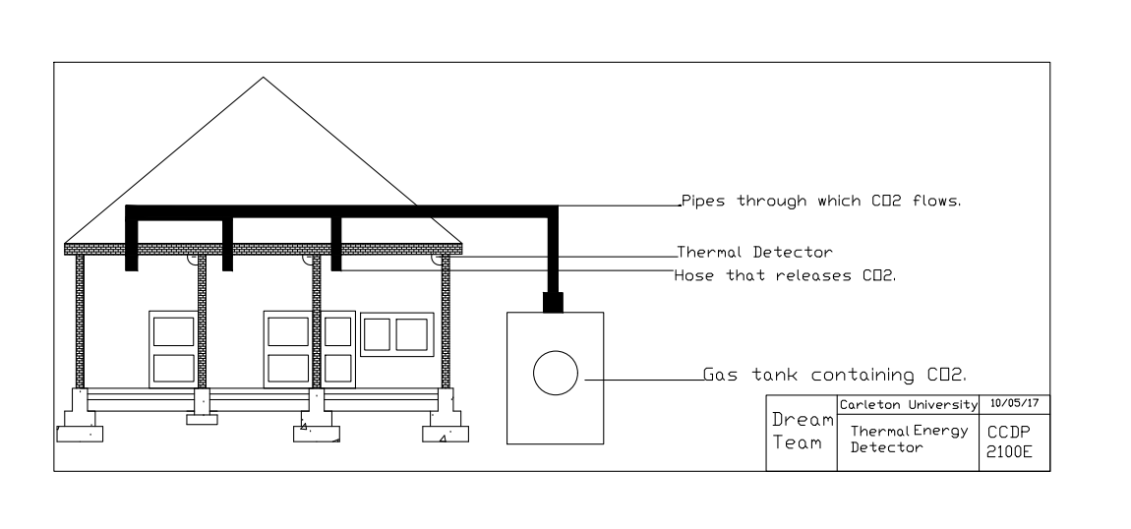

3.2- The photoelectric sensor.
As the thermal energy begins to rapidly increase, the infrared camera scans the environment and detects where the energy increase is occurring. [3] The infrared camera is equipped with a photoelectric sensor which emits photoelectrons to the surface of the fire. Light rays from around the environment come in contact with the photoelectric sensor. Thus, the photoelectric sensor is metallic in order for emission of photoelectrons.

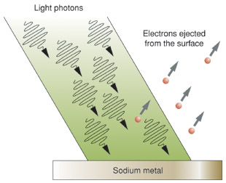
This process is known as the photoelectric effect. As the thermal energy increases, more photons come in contact with the photoelectric sensor. As the frequency at which the light rays are received increases, photoelectrons are then emitted to the fire. The minimum frequency at which the photoelectrons are emitted from the photoelectric sensor is known as the threshold frequency [3]. The energy at which the photoelectrons are ejected depends on the frequency of the light photons. This is illustrated by the equation,
E = h( f – $f_{0})$ (Equation 1) [4]
E = maximum Kinetic energy at which the photoelectrons are ejected.
H = Planck’s constant
f = frequency of the light photon
$f_{0}$ = threshold frequency.
The photoelectrons are ejected when the frequency of the light photons exceed the threshold frequency of the photoelectric sensor. The photoelectrons are used to measure the fire and are bounced back to the photoelectric sensor. This makes the system more accurate as increase in thermal energy results in more light photons which allows the fire to be eliminated properly. Afterwards, a signal is sent to the gas tank and fire-squelching agents are released to combat the fire.
3.3- Gas tank and its pressure.
After it has been determined that the fire needs to be extinguished, the gases needed are passed through the pipes and dispersed through the hoses. [4]The ideal gas law is in effect. Based on the gas law,
PV = nRT (Equation 2) [4]
Where P = pressure of the gas
V= volume of the gas.
n = number of mole of the gas.
R = gas constant.
T = temperature of the gas.
pressure and volume of the gas are inversely proportional and directly proportional to the temperature of the gas. The signal from the device activates the temperature gauge. [4] The pressure of the gases increase as the temperature in the gas tank increases. The gases leave the tank through the pipes which reduces the volume of the gas. As the volume of the gas decreases, the pressure of the gas increase which leads to more gas being used to extinguish the fire.
4.0: Conclusion
Dream Team is devoted to making sure that fires are put out quickly and more efficiently. We hope that the thermal energy detector can bring to end the risks associated with fighting fires. We appreciate any feedback you might have. If you have any inquiries, please do not hesitate to reach us at the contact details provided:

GLOSSARY
Combustion: The process at which substances burn. [4]
Fire-squelching agents: chemicals used to extinguish the fire. [1]
Ideal gas law: States that pressure and volume vary inversely while varying directly with temperature. [4]
If-else statement: A programming statement which compares two data sets and carries out activities based on the result of the data.
Infrared camera: A device that shows how heat is distributed by using radiation. [6]
Photoelectric effect: The emission of photoelectrons unto the surface of a material. [4]
Photoelectric sensors: The devices that emit the photoelectrons. [4]
Photoelectrons: Emitted electrons to the surface of a material by light. [4]
Photons: An elementary particle which is in the electromagnetic radiation of light. [4]
Thermal Energy: A type of kinetic energy in which there is motion of the particles and the temperature can be measured. It can be transferred in form of heat. [5]
Threshold frequency: The minimum frequency at which light photons result in emission of photoelectrons. [4]
While loop: A programming statement that carries out a set of instructions continuously if the data presented meets the requirements of the program.

REFERENCES
[1] “The consequences of fire,” www.nfpa.org. Accessed October 8, 2017.
[2] Zybooks https://my.zybooks.com/#/zybook/CARLETONECOR1606Winter2017/dashboard . Accessed September 26, 2017.
[3] Skip Walker, “Ionization versus Photoelectric Smoke Alarms: In Real-World Fires The Differences Are Deadly” www.propertyevaluation.net. Accessed September 23, 2017.
[4] Robert C. Burk, Greg Williams and John Olmsted III, Chemistry. Mississauga: John Wiley & Sons Canada, Ltd, 2013.
[5] M. J. Moran, H. N. Shapiro, D. D. Boettner, and M. B. Bailey, Fundamentals of Engineering Thermodynamics. Hoboken, United States: John Wiley & Sons Inc., 2014.
[6] Jearl Walker, Fundamentals of Physics, 10th Edition. Cleveland State: University Press, 2014.

APPENDIX A: PROJECT OUTLINE FORM
PROJECT TOPIC TITLE  Thermal energy detector | TEAM NAME | TEAM MEMBERS
This system detects a rapid change in thermal energy and eliminates fire at the source so that the fire does not turn large scale.

Component 1: Infrared camera Team member:
Principle 1: Conservation of Energy [2] Principle 2: Wave equation.[1]
Source course : MAAE 2400 Source course : PHYS 1004

Component 2: Battery Team member
Principle 1: Kirchhoff’s Law[2] Principle 2: Chemical reaction for batteries[2] Source course : PHYS 1004 Source course : PHYS 1004

Component 3: Gas tank Team member:
Principle 1: Pressure of gas[4] Principle 2: Photoelectric effect[4]
Source course: CHEM 1101 Source course: CHEM 1101

Component 4: Sensors Team member:
Principle 1: If-else loop[3] Principle 2: While loop[3]
Source course: ECOR 1606 Source course: ECOR 1606

REFERENCES

[1] Jearl Walker, Fundamenals of Physics 10th Edition. Cleveland State: University Press, 2014.
[2] M. J. Moran, H. N. Shapiro, D. D. Boettner, and M. B. Bailey, Fundamentals of Engineering Thermodynamics. United States: Wiley, 2014.
[3] Zybooks https://my.zybooks.com/#/zybook/CARLETONECOR1606Winter2017/dashboard . Accessed September 26, 2017.
[4]Robert C. Burk, Greg Williams and John Olmsted III, Chemistry. Mississauga: John Wiley & Sons Canada, Ltd, 2013.

