SYSC 2320 LAB 1 REPORT

[Checkpoint] What is the minimum ROM Address Bit Width needed to implement Table 1, and why? What is the minimum ROM Data Bit Width needed to implement Table 1, and why?
Answer: The minimum ROM address bit is 3. Since there are 6 states, the ROM ought to have enough room to store them. 2^n>6 → the minimum of n is 3; the minimum ROM data bit width is 6 because the ROM needs to store 3-bit outputs and the 3-bit next state information.

[In the Lab] Implement Table 1 as a ROM-based FSM:
Figure 1 is the circuit of a ROM-based FSM. Address calculations in ROM:
State 0: 000 (decimal 4) → 000 100 → 0x 04
State 1: 010 (decimal 5) → 010 101 → 0x 15
State 2: 010 (decimal 3) → 010 011 → 0x 13
State 3: 001 (decimal 0) → 001 000 → 0x 08
State 4: 001 (decimal 1) → 001 001 → 0x 09
State 5: 100 (decimal 2) → 100 010 → 0x 22
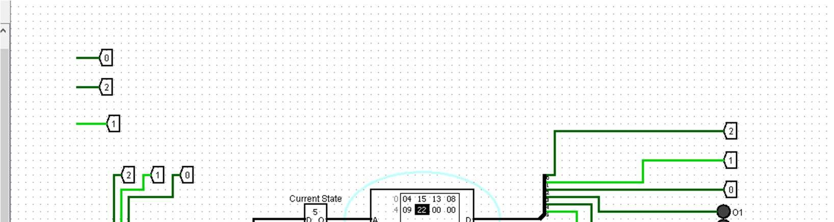
Figure 1: ROM-based FSM circuit
Figure 2 is the logging table.
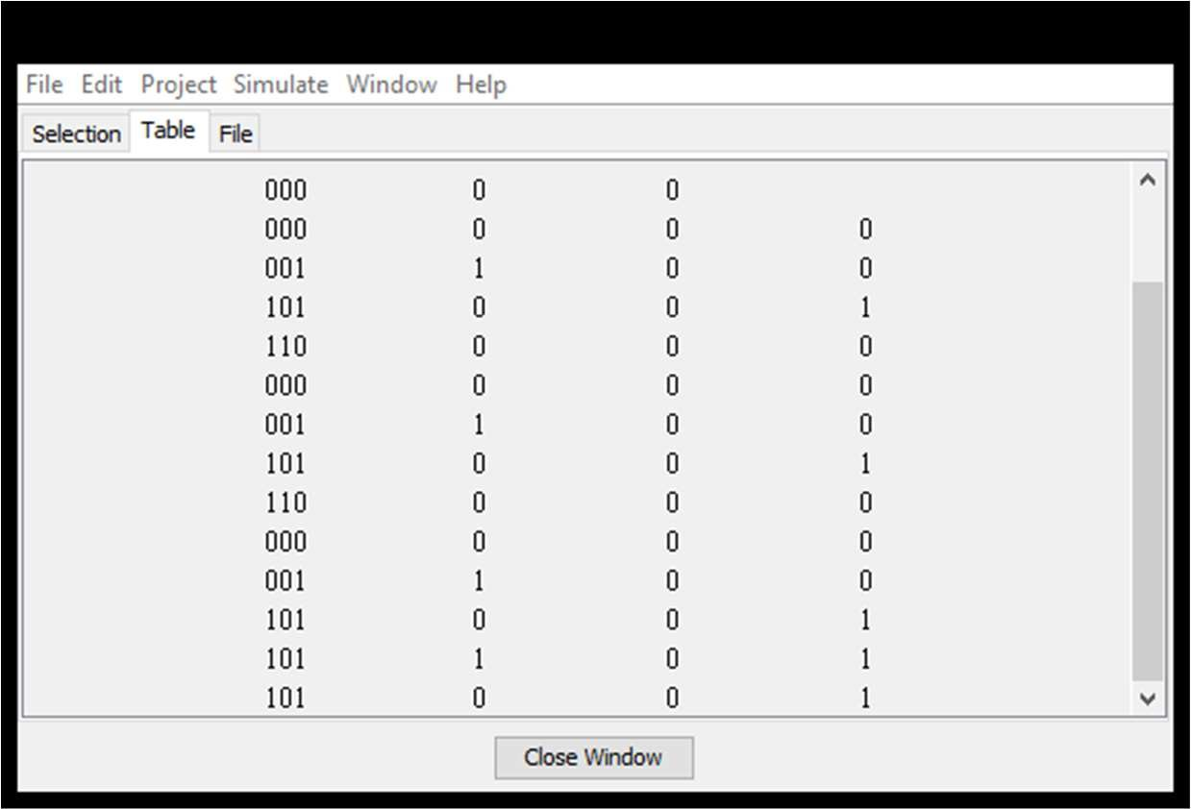
Figure 2: Log table

