Slide 1
An IBM commercial from 2006 depicts a man walking in a store grabbing items and paying just by walking through a scanner. The convenience and speed may have seemed fictional then but fast forward to almost a decade later and such easy and secure payments are expected to be standard. While there may not (yet) be RFID chips installed in our bodies through which we can make payments, we are seeing the trend of payments through biometrics become increasingly popular in recent times. In fact a new study by Goode Intelligence called “Biometrics for Payments – Payments Security Gets Personal; Market and Technology Analysis, Adoption Strategies and Forecasts 2015-2020” forecasts that by 2020 $5.6 trillion of payments will be secured through biometrics.
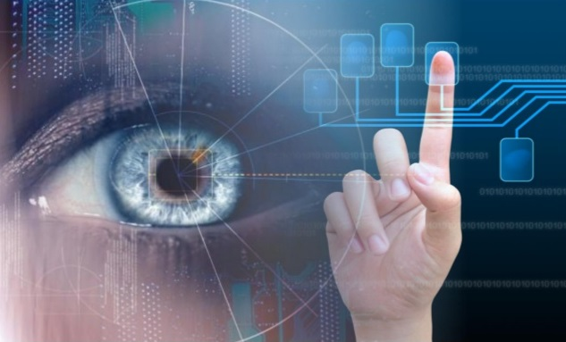

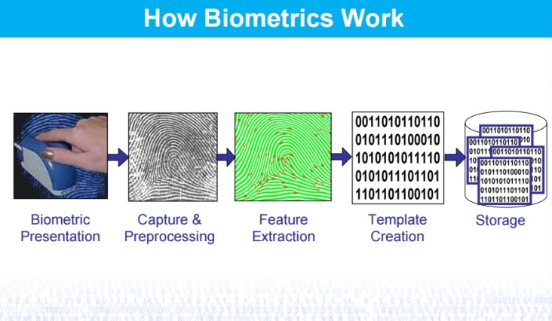
Slide 2
Types of biometric solutions
- Finger print reader
- Voice recognition
- Iris scanner
- Palm vein
- Facial recognition

NOTES:
Finger print reader: a feature now available in select smartphones which not only allows user authentication but also acts as portal for payment. Fingerprints can be easily acquired and because fingerprint readers are becoming easily available through personal devices, businesses do not necessarily need to implement their own readers. Such functionality is perfect for e-businesses as the authentication does not hinder mobility.
Voice recognition: an ideal scenario for over the telephone authentication is to have a system that provides either speaker recognition (who is speaking) or speech recognition (what is being said).
Iris scanner: a relatively new feature which is not as commonly available for non-commercial use (due to patent limitations) is the iris scanner. The limitations have caused the cost of this solution to be on the higher side and hence it is not as popular as say the fingerprint reader. With that being said the iris scanner promises to be the biometric solution of the future because the iris does not change due to ageing and is less prone to damage due to injury or illness as compared to other biometrics.
Palm vein: an alternate to fingerprints, the palm vein solution is said to be an extremely reliable contactless authentication. Conditions of the skin are not a concern as palm vein readers scan below the surface of the skin. Of the many different biometric solutions available, palm vein is said to have the lowest false acceptance rates (FAR) and false rejection rates (FJR).
Facial recognition: bringing a lot of excitement to the tech world is a recent announcement by MasterCard which is known as the selfie pay. Moving quickly with the fad of the decade, MasterCard may be the first to authenticate users by allowing them to take a picture of themselves (selfie). This quick and trendy way of payment could become very popular if MasterCard is able to make it as secure as they claim. Another company offering a similar concept is Alibaba.com with their “Smile to Pay” solution.

Slide 3
Importance and impact on individuals, organizations, and governments
When it comes to payments, from the days of barter system to currency and card payments, the methods have always been evolving. Biometrics promises to provide much higher levels of security and efficiency to this stage of the evolution. Whether it is for B2C, B2B, B2G or G2B, once further improved and accepted more widely, users will benefit from the convenience, speed, and reliability of this trend.

NOTES:
As an individual in today’s world the convenience that biometrics can provide is almost becoming a requirement. According to eMarketer.com, mobile transactions will account for 25% of all retail ecommerce sales in the US by the end of 2016. As individuals become more dependent on e-commerce, the ability to just scan your finger or take a selfie to quickly place an order will serve as a powerful tool in enhancing the customer experience. Business organizations could aim to achieve much higher levels of customer satisfaction (read revenue) through analytical data and targeted marketing. Other benefits could include but are not limited to higher ROI, accountability, going green, and higher operational efficiency. Governments will similarly benefit from the security, access control, identity management, as well as time and attendance management to name just a few.

Slide 4
Strengths and Weaknesses
Strengths:
- Convenience and ease
- Security
- Efficiency
- Reliability
- Profitability
Weaknesses:
- Privacy intrusion
- Security
- Affordability
- Transparency

NOTES:
Biometrics has become widely accepted and trusted in many different industry firms for the purpose of authentication. The target of these industries is to achieve optimal cost and operational efficiency without having to compromise on the quality of their business solutions. Bearing this in mind and considering the vast variety of biometric solutions existing today, it becomes increasingly difficult to apply the correct biometric solution to an industry. This factor alone can cause hesitation in moving towards a biometric solution. Before implementation of such solutions businesses or even governments must also consider the return on investment as well as the total cost of ownership. For many, such solutions are still not affordable.
While on one hand we may benefit from the security of being identified and authenticated using biometrics that are unique to each individual, on the other we also must consider the issues that can arise from stolen biometric information. If in the wrong hands information such as fingerprints can be planted at crime scenes, be used to gain access to restricted areas, and of course for fraudulent payments. Other important factors that also must be considered are False Acceptance Rates and False Rejection Rates of these biometric devices. There is a possibility of the system identifying a correct biometric record incorrectly and vice versa. Despite being greatly reduced, a margin for error still exists which makes some skeptical of the reliability this solution offers.

Slide 5
Here to stay
“Biometrics Research Group predicts the global biometrics market to soar to $15 billion this year, up from an estimated $7 just three years ago.” – Sharon Goldman
“Technology consulting firm Frost & Sullivan forecast that nearly a half-billion people will be using a smartphone equipped with biometric technology by 2017.” – Sharon Goldman
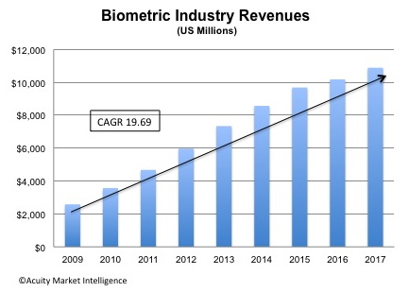

NOTES:
In my opinion this trend will not only last but eventually take over current authentication and payment systems. In our quest to find more secure methods of authentication and payments, biometrics will prove to be the most reliable as it uniquely identifies individuals. The convenience currently found from e-businesses demands innovative and faster approaches to making transactions. With the “world” at your fingertips it only seems like a natural step to involve biometrics in every day transactions. Like with every technology biometrics also has creases that must be ironed out however the pros definitely outweigh the cons.

Slide 6
Relevance to e-business, digital media, and enterprise information systems
The use of biometrics in business is not so new. Brick and mortar businesses and governments have used these solutions for authentication, access control, as well as time and attendance management for some time now. The relevance of biometrics to e-business however is relatively new. The introduction of this technology for payment purposes or even authentication to access one’s own device or an app is an upcoming trend gaining rapid popularity. Biometric solutions can simplify transactions for more and more e-businesses enabling many to have the one click checkout that Amazon.com is famous for. Enterprise information systems (EIS) must deal with large volumes of data and must be able to be used by all parts and all levels of an enterprise. Biometrics can provide stronger access control systems to high security settings within an EIS. Similar use applies when it comes to digital media. Biometrics can provide unparalleled security and control to limit or allow access to media.

Slide 7
E-business architecture, security & control, and billing and payment
- Currently, safeguarding of valuable data is mostly done through passwords.
- A complete business process reengineering may be required for organizations wanting to implement biometrics to their existing e-business architecture.
- A client-server system may benefit from using biometrics to authenticate clients trying to access the server but the integration of biometrics would require thorough planning.
- Middleware may also be required to make sure there is seamless communication between biometric readers and the rest of the system.
- Biometrics can be applied in collaboration with customers as well as with suppliers.
- Security policies must be thoroughly reviewed from end-to-end rather than just the factor of biometrics as biometrics can be used in many different areas.
- A risk assessment should be done to identify any shortcomings before actually implementing the solution.
- Biometrics will add to and make better the existing systems of billing and payment.
- Companies like PayPal can use the solution to further strengthen their security.
- On smartphones the existing near-field communication (NFC) technology will be paired with fingerprint readers on mobile devices to allow instant and secure payment options.

Slide 8
Industries
"Biometrics in retail could see two major applications: increase levels of security in the retail environment or support marketing and operations activities." – Isabelle Moeller
In retail industries biometrics can provide additional layers of security reducing fraud and creating a better customer experience. Fraudsters could be identified and data can be shared with businesses if their biometrics are on file. The ease and security of payments through biometrics can lead to an increase in sales especially online. Marketing can be targeted through new analytics gained from biometrics. Information such as spending habits of different demographics could be directed towards creating a more customer focused environment. Biometric analytics can enable businesses to truly “know their customers”. A company called Amscreen for example has designed a product called Optimeyes. This product uses facial recognition to capture data of anyone staring at its screen to quickly assess age, gender, time of the day and location in order to provide relevant advertising. Biometrics can help create a truly unique experience for every customer.

Slide 9
Reference list:
Trites, G., & Boritz, J. (2013). EBusiness: A Canadian perspective for a networked world (4th ed.). Toronto: Pearson Canada.
Biometric solutions. (n.d.). Retrieved October 8, 2015, from http://www.biometric-solutions.com/solutions/index.php
Jacobs, B. (2015, July 16). Biometric solutions as a business strategy. Retrieved October 4, 2015, from https://www.linkedin.com/pulse/biometric-solutions-business-strategy-barry-jacobs
Goode, A. (2015, October 2). Biometrics for Payments - Payment Security Gets Personal; Market & Technology Analysis, Adoption Strategies & Forecasts 2015-2020 | Goode Intelligence. Retrieved October 4, 2015, from http://www.goodeintelligence.com/report-store/view/biometrics-for-payments-payment-security-gets-personal-market-technology-analysis-adoption-strategies-forecasts-20152020
Lee, J. (2015, October 5). Biometrics to secure over $5.6T of payments by 2020: Goode Intelligence. Retrieved October 6, 2015, from http://www.biometricupdate.com/201510/biometrics-to-secure-over-5-6t-of-payments-by-2020-goode-intelligence
Germain, J. (2015, September 25). OPM's Latest Bad News: 5.6 Million Fingerprints Lifted. Retrieved October 8, 2015, from http://www.ecommercetimes.com/story/82534.html
Goldman, S. (2015, October 6). 5 cutting-edge retail technology trends. Retrieved October 7, 2015, from http://www.cio.com/article/2989716/retail/5-cutting-edge-retail-technology-trends.html
Biometrics Meets E-Commerce. (2003, June 19). Retrieved October 3, 2015, from http://www.bloomberg.com/bw/stories/2003-06-19/biometrics-meets-e-commerce
Info on palm vein reader from http://www.m2sys.com/palm-vein-reader/
Information on biometrics from http://www.biometrics.gov/documents/biotechstandard.pdf
IBM RFID Commercial - The Future Market from https://youtu.be/eob532iEpqk

