MEMORANDUM
To: Dr. Marlene Lundy
From: Bello Mubarak
Date: 2017-10-06
Subject: Proposal requesting to carry out a research project on electric cars.

1.0 INTRODUCTION:
This proposal is written in response to the request for proposal gotten by team electric car from Dr. Marlene Lundy. This proposal focuses on the electric car as a grand engineering challenge of the 21st century to be analysed by team electric car. The team will be focusing on the efficiency of the electric vehicle, the environmental effects of the electric vehicle, motor control and effects of the vehicle’s shape and weight on its performance. This paper is divided into numbered sections with each section clearly focusing on the efficiency of the electric car.

2.0 BACKGROUND ON THE ELECTRIC CAR:
Currently, the world is meeting great amount of its transportation needs mainly from fossil fuels. These energy source is not renewable i.e. they will not last forever and will disappear after a certain period of time. In addition, fossil fuels are very harmful to the environment, it releases large amounts of carbon dioxide (CO2) and also some cases oil spilling at sea. The most pronounced negative effect of fossil fuel is global warming. This is probably the greatest challenge that the human race has encountered in its short history. A typical internal combustion passenger vehicle emits about 4.7 metric tons of carbon dioxide per year [1]. CO2 is considered the leading cause of global warming on earth. Carbon dioxide is released through burning fossil fuels. Humans have increased atmospheric CO2 concentration by more than a third since the Industrial Revolution began. This is the most important element forcing climate change [2]. A lot of research are going on to switch to renewable energy sources such as solar, wind and also chemical batteries. Economically, the gasoline used to power the current internal combustion engine (ICE) is only available in large quantities in some countries. The countries who don’t have these crude oil have to import from countries that have at high cost. In 2016, the United States imported approximately 10.1 million barrels per day of petroleum from about 70 countries [3]. Also, the current ICE waste a lot of energy, most internal combustion engines are incredibly inefficient at turning fuel burned into usable energy. The efficiency by which they do so is measured in terms of "thermal efficiency", and most gasoline combustion engines average around 20 percent thermal efficiency. Diesels are typically higher--approaching 40 percent in some cases [4]. The electrical car eliminates the emission of CO2 as it makes use of chemical cells rather than fossil fuel and also eliminates the need to import so much crude oil as chemical cells can be said to be readily available in every country. The electric car is a lot more effective than regular ICE with technology such as the regenerative braking.

3.0 TEAM ELECTRIC CAR’S PROPOSAL STATEMENT:
Team electric car will be looking critically at the electric vehicle and how to make it a lot better than what is available on the market today. If this proposal is accepted for team electric car to move forward, a detailed report will be provided containing a context for the electric car, explaining the social, environmental, and possible social impacts of the electric car, and explaining in detail the working operation of the electric car. An oral presentation will also be delivered by the team to all interested persons in the electric car.

3.1 Overview of the Electric Car:
An electric car is an automobile that is propelled by one or more electric motors, converting electrical energy stored in rechargeable batteries. The electric vehicle operates on an electric/current principle. It uses a traction battery pack to provide power for the electric traction motor. The motor then uses the power (voltage) received from the batteries to rotate the transmission and the transmission turns the wheels [5]. It’s an innovation aimed at reducing the amount of fossil fuel used and reduce the amount of CO2 released into the air. Compared to cars with ICE, electric cars are also a lot quieter. Below in Figure 1 is a picture of an electric car showing its different components differentiating it from the regular ICE cars.
Figure 1: An All-Electric Car Showing its Different Components.
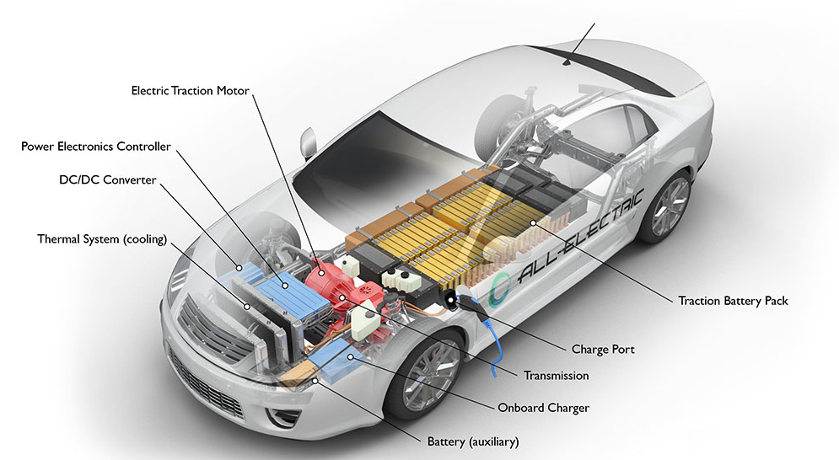
The image above is showing the most important parts of the electric car. The different components and its uses in the movement and performance of the electric car will be analysed further in the report if this proposal is accepted.

3.2 Description of work product:
This component of the proposal contains an overview on team electric car and Bello Mubarak’s aspects of the electric car to be covered in the final research report.

3.2.1 Team Electric Car Description of Work Product on the Electric Car:
Team electric car will be looking at the electric cars as a whole divided into different subtopics to be taken on by the different members of the team as shown below in Table 1.

Table 1: The Table Shows the Division to Sub- Topics of the Electric Car.
Subtopics | Relevance to electric vehicles | Research question 1 | Research question 2 | Technical principle 1 | Technical principal 2
Braking  -Mubarak Bello | Due to a lack of efficiency, electric vehicles are not in common use at the moment. If they are to be a replacement for combustion vehicles, efficiency will be a key factor. | What energy losses occur in a standard breaking system? | How does a regenerative braking system mitigate the losses that occur from the standard system? | Friction | Electric motors and generators.
Environmental  -Daniel Williams | The whole purpose of the electric vehicle is to protect the environment from the side-effects of internal combustion engines. | Why switch from internal combustion to an electric motor? | What are the effects on battery life of recharging a battery? | Greenhouse Effect | Battery Charging
Motor control  -Jason Nyentap | For an electric vehicle to be drivable, the driver must have precise control of the electric motor. | How is the speed of the car controlled based on pedal position? | What kind of hardware is required to change the speed and direction of the motor? | PID control loop. | H-Bridge.
Performance  -Andriyko Goyaniuk | If an electric vehicle does not have at least equivalent performance as a combustion vehicle, the consumer won’t be as interested. | How do electric motors work, and how is the performance of the car dependant on them? | How does the gear ratio affect performance? How can this assist in improving performance? | Electric Motor  (Faraday’s law) | Gear Ratios
Kingsley Amiah | The shape and weight of the electric car will affect the range of the vehicle. | How does the shape of the car affect the work required to move the car? | Which material is best to ensure that the car remains light and agile? | Drag | Density

The table shows the different subtopics, its relevance to the electric car, two research questions and the principles related to the research questions. The table ensures the topics are effectively distributed to cover all parts of the electric car in the final research report.

3.2.2 Braking of the Electric Car to be analysed by Bello Mubarak:
The “ideal” electric car team electric car is looking at is predicted to be a lot more effective than the ones in the market at the moment. the efficiency of the electric car depends a lot on the braking of the vehicle. The vehicles braking depending on what form is used determines if the energy in the car is conserved or its lost. The popular forms of braking in vehicles today include dynamic braking, friction braking and regenerative braking. In the final report, the following questions will be answered in detail: i) What energy losses occur in a standard breaking system? ii) How does a regenerative braking system mitigate the losses that occur from the standard system?

For the first question, the principle of friction will be researched. friction is a force that opposes the relative lateral motion of two solid surfaces in contact. [6]. friction most times leads energy loss as it converts mechanical energy to heat and sound energy which are not needed and can be considered a waste.

For question number two, the principle of electric motor and generators can be used to answer the question. The idea of regenerative braking is capture some of that kinetic energy and store it, instead of discarding it as heat. Electrical regenerative braking typically involves a vehicle propelled by an electric motor from a battery, If the wheels and axles of the car do work on the motor (the motor acts as a generator and energy flows back to the battery.

3.3 Timeline:
Team electric car are a group of diligent student who stick to time on their work. The Table 2 below show the schedule of how the research project will be carried out.

Table 2: Table containing the schedule for team electric car for the rest of the project.
Activity | Due date
Team meeting on preparation for group presentation | October 6
Project proposal submission | October 13
Team meeting on figures and image gathering | October 13
Team meeting | October 20
Team meeting on outline preparation for final design project | November 3
Written explanation of principles | November 3
Team meeting | November 10
Team meeting | November 17
Team meeting | November 24
Final design project submission | December 1
Group presentation of findings | December 1

4.0 CONCLUSION:
This paper contains a proposal requesting to carry out a research project on electric cars by team electric car. It contains all the information about how the research is to be completed. Hopefully this proposal is accepted and team electric car can produce a great research project report and presentation to interested parties. All questions and feedbacks about this proposal can be forwarded to the team leader Daniel Williams at danielwilliams@cmail.carleton.ca .

REFERENCE

[1]"Greenhouse Gas Emissions from a Typical Passenger Vehicle | US EPA", US EPA, 2017. [Online]. Available: https://www.epa.gov/greenvehicles/greenhouse-gas-emissions-typical-passenger-vehicle-0. [Accessed: 05- Oct- 2017].

[2]"CARBONDIOXIDE", Climate.nasa.gov, 2017. [Online]. Available: https://climate.nasa.gov/vital-signs/carbon-dioxide/. [Accessed: 05- Oct- 2017].

[3]"How much petroleum does the United States import and export? - FAQ - U.S. Energy Information Administration (EIA)", Eia.gov, 2017. [Online]. Available: https://www.eia.gov/tools/faqs/faq.php?id=727&t=6. [Accessed: 05- Oct- 2017].

[4]A. Ingram, "Toyota Gasoline Engine Achieves Thermal Efficiency Of 38 Percent", Green Car Reports, 2017. [Online]. Available: http://www.greencarreports.com/news/1091436_toyota-gasoline-engine-achieves-thermal-efficiency-of-38-percent. [Accessed: 05- Oct- 2017].

[5]"Electric Cars: They're Cleaner, but...", Science News, vol. 91, no. 10, p. 232, 1967.

[6]J. Walker, R. Resnick and D. Halliday, Fundamentals of physics, 10th ed. Hoboken, NJ.: Wiley, 2014, p. 102.

