MCSA Guide to Installing and Configuring Windows Server 2012/R2, Exam 70-410

Chapter 1
Introducing Windows Server 2012/R2

Objectives

• Explain the function of a server operating system in a network
• Describe the editions of Windows Server 2012/R2 • Define private cloud terms and technologies
• Explain the core technologies of Windows Server 2012/R2
• Describe Windows Server 2012/R2 roles

• Summarize the new and enhanced features of Windows Server 2012

MCSA Guide to Installing and Configuring Windows Server 2012/R2, Exam 70-410
© Cengage Learning 2015 2

The Role of a Server Operating System

• The functions a server performs depend on: – Type of business using the server
– Size of the business

– Extent to which the business has committed to using technology to aid operations

• A server is used to provide services that aid the operations of an organization

MCSA Guide to Installing and Configuring Windows Server 2012/R2, Exam 70-410
© Cengage Learning 2015 3

Server: Hardware or Software?

• A computer becomes a server when software is installed on it that provides a network service to client computers
• OSs such as Windows 8.1 and its predecessors are designed to be on desktop computers
– These OSs can perform server functions such as file and printer sharing

• Server operating systems: OSs designed to emphasize network access performance and run background processes rather than desktop applications

MCSA Guide to Installing and Configuring Windows Server 2012/R2, Exam 70-410
© Cengage Learning 2015 4

Server Operating Systems Versus Desktop Operating Systems

• Windows Server 2012/R2 network services: – File and Printer sharing
– Web server
– Routing and Remote Access Services (RRAS) – Domain Name System (DNS)
– Dynamic Host Configuration Protocol (DHCP) – File Transfer Protocol (FTP) Server
– Active Directory
– Distributed File System (DFS) – Hyper-V
– Fax Server

MCSA Guide to Installing and Configuring Windows Server 2012/R2, Exam 70-410
© Cengage Learning 2015 5

Server Operating Systems Versus Desktop Operating Systems

• Windows 8.1 desktop OS supports only Hyper-V, File and Printer Sharing, Web Server, and FTP Server in limited capacity
• Windows 8.1 is restricted to 20 logged-on network users
• Windows Server 2012/R2 includes fault-tolerance features such as:
– Redundant array of independent disks (RAID) 5 volumes
– Load balancing – Clustering

MCSA Guide to Installing and Configuring Windows Server 2012/R2, Exam 70-410
© Cengage Learning 2015 6

Windows Server 2012/R2 Editions

• Windows Server 2012/R2 editions have been streamlined compared with Windows Server 2008:
– Datacenter – Standard – Essentials
– Foundation

• Businesses can choose the best solution for their size and services required

MCSA Guide to Installing and Configuring Windows Server 2012/R2, Exam 70-410
© Cengage Learning 2015 7

Datacenter and Standard Editions

• Datacenter Edition - install an unlimited number of virtual instances of the OS
– Datacenter with Hyper-V can be installed on a physical server
• Install as many virtual machines as you need

– Must purchase one Datacenter Edition license for every two physical processors installed on a server

• Standard Edition - has all the features of Datacenter Edition and the same processor licensing conditions
– Permits only two virtual instances

MCSA Guide to Installing and Configuring Windows Server 2012/R2, Exam 70-410
© Cengage Learning 2015 8

Datacenter and Standard Editions

• Both Datacenter and Standard editions support: – Up to 4 TB of RAM
– Up to 64 physical processors

– Server clusters with up to 64 nodes per cluster

• Both editions have the option to be installed without the standard graphical user interface (GUI)
– A mode called Server Core (now the default)

• Both editions require client access licenses (CALs)
– Legally mandated for each user who logs on to the

server
MCSA Guide to Installing and Configuring Windows Server
2012/R2, Exam 70-410

© Cengage Learning 2015 9

Essentials Edition

• Essentials Edition - aimed at small businesses with 25 or fewer users
• Automatically configured as a root domain controller
• Other automatically configured services:

– Active Directory Certificate Services, DNS, File Services, Web Server (IIS), Network Policy Server, and Remote Desktop Services
• Comes with a management interface called Dashboard
• No CALS are required

MCSA Guide to Installing and Configuring Windows Server 2012/R2, Exam 70-410
© Cengage Learning 2015 10

Foundation Edition

• Foundation Edition - entry-level edition – Suitable for small businesses
– Available as an OEM version only – Licensing limited to 15 users
– No CALs are required

– Supports a single physical processor – Supports up to 32 GB RAM
– Can be configured as a stand-along server or a root domain controller
– Doesn’t support Hyper-V

MCSA Guide to Installing and Configuring Windows Server 2012/R2, Exam 70-410
© Cengage Learning 2015 11

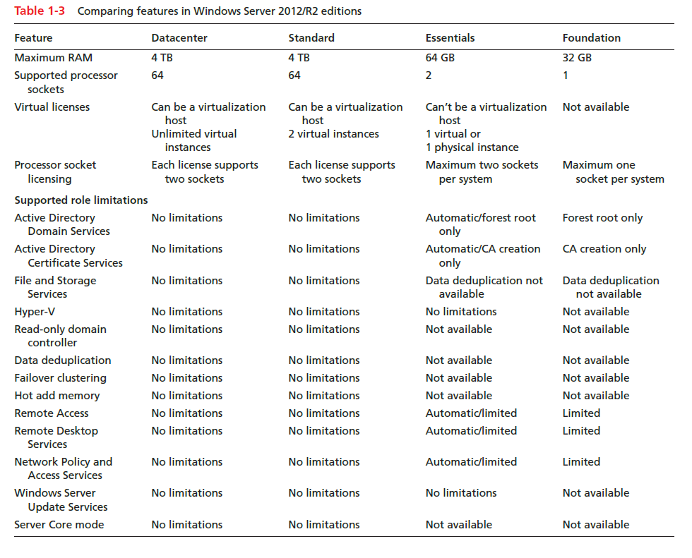

Table 1-3 Comparing features in Windows Server 2012/R2 editions

MCSA Guide to Installing and Configuring Windows Server 2012/R2, Exam 70-410
© Cengage Learning 2014 12

Windows Server 2012/R2 and the Private Cloud

• Cloud computing - a collection of technologies for abstracting the details of how applications, storage, network, and other computing resources are delivered to users
• Virtualization - a core technology of cloud computing
– Uses software to emulate multiple hardware environments so that multiple operating systems can run on the same physical server simultaneously

MCSA Guide to Installing and Configuring Windows Server 2012/R2, Exam 70-410
© Cengage Learning 2015 13

Windows Server 2012/R2 and the Private Cloud

• Virtual machine (VM) - the virtual environment that emulates a physical computer’s hardware and BIOS
• Host computer - the physical computer on which VM software is installed and VMs run
• Virtualization software - software for creating and managing VMs and creating the virtual environment in which guest OS is installed
• Hypervisor - virtualization software component that creates and monitors the virtual hardware

environment
MCSA Guide to Installing and Configuring Windows Server
2012/R2, Exam 70-410

© Cengage Learning 2015 14

Public Cloud versus Private Cloud

• Public could - cloud computing service provided by a third party
– Examples: DropBox, SkyDrive, Google Apps

• Private cloud - cloud computing service provided by an internal IT department
– Typical services include virtual desktops, storage, and applications

• Virtual desktop infrastructure (VDI)

– Users connect to private cloud with a Web browser or client software
– Can access their desktop from any Internet connection

MCSA Guide to Installing and Configuring Windows Server 2012/R2, Exam 70-410
© Cengage Learning 2015 15

Windows Server 2012/R2 Core Technologies

• Server Manager

• New Technology File System (NTFS) • Active Directory
• Microsoft Management Console • Disk Management
• File and printer sharing • Windows networking

MCSA Guide to Installing and Configuring Windows Server 2012/R2, Exam 70-410
© Cengage Learning 2015 16

Server Manager

• Provides a single interface for installing, configuring, and removing a variety of server roles and features
• Summarizes server’s status and configuration

• Includes tools to diagnose problems, manage storage, and perform general configuration tasks
• Can be used to manage all servers in your network

• Dashboard - shows a list of tasks, summarizes installed roles, and shows available servers to manage

MCSA Guide to Installing and Configuring Windows Server 2012/R2, Exam 70-410
© Cengage Learning 2015 17

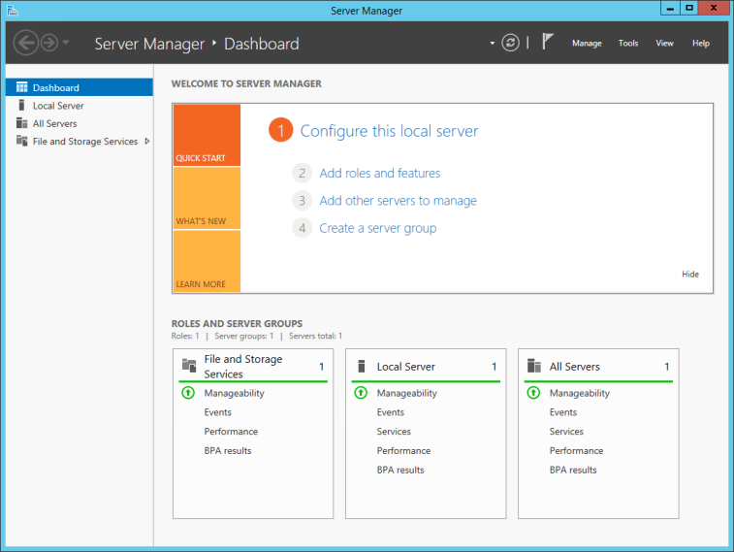

Figure 1-2 Server Manager Dashboard view

MCSA Guide to Installing and Configuring Windows Server 2012/R2, Exam 70-410
© Cengage Learning 2014 18

NTFS

• New Technology File System (NTFS) – Introduced in Windows NT in early 1990s
• Important feature - capability to set user and group permissions on both folders and files
– Administrators can specify which users can access a file and what users can do with a file if granted access
• Increases a server environment’s security

MCSA Guide to Installing and Configuring Windows Server 2012/R2, Exam 70-410
© Cengage Learning 2015 19

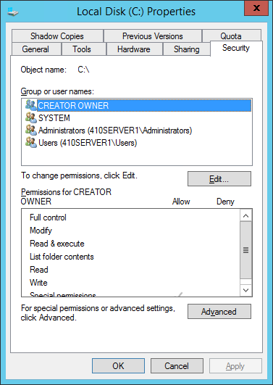

Figure 1-8 The Security tab showing NTFS permissions

MCSA Guide to Installing and Configuring Windows Server 2012/R2, Exam 70-410
© Cengage Learning 2014 20

Active Directory

• Provides a single point of administration of network resources (Users, groups, shared printers, etc.)
• Provides centralized authentication and authorization of users to network resources
• Along with DNS, provides domain-naming services and management for a Windows domain.
• Enables administrators to assign system policies, deploy software to client computers, and assign permissions and rights to users of network resources

MCSA Guide to Installing and Configuring Windows Server 2012/R2, Exam 70-410
© Cengage Learning 2015 21

Microsoft Management Console

• Creates a centralized management interface for administrators
• Uses snap-ins, which are designed to perform specific administrative tasks (such as disk management)
• Important feature: the capability to connect to servers remotely

MCSA Guide to Installing and Configuring Windows Server 2012/R2, Exam 70-410
© Cengage Learning 2015 22

Disk Management

• To manage disk and volumes on a Windows Server 2012/R2 computer:
– Use the Disk Management snap-in or the File and Storage Services role (which is integrated into Server Manager)
• Both tools can be used to:

– Monitor disk and volume status – Initialize new disks
– Create and format new volumes – Troubleshoot disk problems
– Configure redundant disk configurations (RAID)

MCSA Guide to Installing and Configuring Windows Server 2012/R2, Exam 70-410
© Cengage Learning 2015 23

File and Printer Sharing

• Offers advanced features such as: – Shadow copies
– Disk quotas

– Distributed File System (DFS) • Also offers:
– Redundancy

– Version control

– User storage restrictions

MCSA Guide to Installing and Configuring Windows Server 2012/R2, Exam 70-410
© Cengage Learning 2015 24

Windows Networking Concepts

• The Workgroup Model

– A small collection of computers that share common roles, such as sharing files or printers.
– Also called a peer-to-peer network

– Decentralized logons, security, and resource sharing

– Easy to configure and works well for small groups of users (fewer than 10)
– A Windows Server 2012/R2 server that participates in a workgroup is referred to as a stand-alone server

MCSA Guide to Installing and Configuring Windows Server 2012/R2, Exam 70-410
© Cengage Learning 2015 25

Windows Networking Concepts

• The Domain Model

– Preferred for a network that has more than 10 computers or requires centralized security and resource management
– Requires at least one computer to be a domain controller
– A domain controller is a Windows server that has Active Directory installed and is responsible for allowing client computers access to domain resources
– A member server is a Windows Server that’s in the management scope of a domain but doesn’t have Active Directory installed

MCSA Guide to Installing and Configuring Windows Server 2012/R2, Exam 70-410
© Cengage Learning 2015 26

Windows Network Components

• Network connection - a collection of networking components working together
• Network Interface

– Composed of two parts: the network interface card (NIC) and the device driver software

• Network Protocol

– Specifies the rules and format of communication between network devices

MCSA Guide to Installing and Configuring Windows Server 2012/R2, Exam 70-410
© Cengage Learning 2015 27

Windows Network Components

• Network Client and Server Software

– A network client is the part of the OS that sends requests to a server to access network resources
– Network server software receives requests for shared network resources and makes those resources available to a network client
• In Windows, this server software is File and Printer Sharing for Microsoft Networks

MCSA Guide to Installing and Configuring Windows Server 2012/R2, Exam 70-410
© Cengage Learning 2015 28

Windows Server 2012/R2 Roles

• A server role is a major function or service that a server performs
• Role services add functions to the main role

• Server features provide functions that enhance or support an installed role or add a stand-alone function
• A server can be configured for a single role or several roles

MCSA Guide to Installing and Configuring Windows Server 2012/R2, Exam 70-410
© Cengage Learning 2015 29

Active Directory Certificate Services

• A digital certificate is an electronic document containing information about the certificate holder and the entity that issued the certificate
• The Active Directory Certificate Services (AD CS) role provides services for creating, issuing, and managing digital certificates
• When AD CS is installed:

– A number of role services can be deployed that have functions for managing certificates

MCSA Guide to Installing and Configuring Windows Server 2012/R2, Exam 70-410
© Cengage Learning 2015 30

Active Directory Domain Services

• Active Directory Domain Services (AD DS) installs Active Directory and turns a Windows Server 2012/R2 server into a domain controller
• Main purpose of AD DS is to handle authentication and authorization for users and computers in a Windows domain

MCSA Guide to Installing and Configuring Windows Server 2012/R2, Exam 70-410
© Cengage Learning 2015 31

Other Active Directory-Related Roles

• Active Directory Federation Services (AD FS)

• Active Directory Lightweight Directory Services (AD LDS)
• Active Directory Rights Management Services (AD RMS)

MCSA Guide to Installing and Configuring Windows Server 2012/R2, Exam 70-410
© Cengage Learning 2015 32

DHCP Server

• Dynamic Host Configuration Protocol (DHCP) Server role provides automatic IP address assignment and configuration for client computers
• Can provide default gateway address, DNS server addresses, WINS server addresses, and other options

MCSA Guide to Installing and Configuring Windows Server 2012/R2, Exam 70-410
© Cengage Learning 2015 33

DNS Server

• DNS Server resolves the names of Internet computers and computers that are members of a Windows Domain to their assigned IP addresses.
• When installing Active Directory, you can specify an existing DNS server or install DNS on the same server as Active Directory

MCSA Guide to Installing and Configuring Windows Server 2012/R2, Exam 70-410
© Cengage Learning 2015 34

File and Storage Services

• Enables administrators to ensure high availability, reliable, shared storage to Windows and other client OSs
• “Storage Spaces,” later in this chapter, describes some new capabilities of this role

MCSA Guide to Installing and Configuring Windows Server 2012/R2, Exam 70-410
© Cengage Learning 2015 35

Hyper-V

• Provides services to create and manage virtual machines on a Windows Server 2012/R2 computer
• A virtual machine is a software environment that simulates the computer hardware an OS requires for installation
• Installing an OS on a virtual machine is done using the same methods used on a physical machine

MCSA Guide to Installing and Configuring Windows Server 2012/R2, Exam 70-410
© Cengage Learning 2015 36

Network Policy and Access Services

• Enables administrators to create and enforce network access policies that apply to client authentication and authorization and client health
• Role services that can be installed: – Network Policy Server (NPS)
– Health Registration Authority (HRA)

– Host Credential Authorization Protocol (HCAP)

MCSA Guide to Installing and Configuring Windows Server 2012/R2, Exam 70-410
© Cengage Learning 2015 37

Print and Document Services

• Enables administrators to centralize and manage access to network printers
• Installs Print Server by default when you install the Print and Document Services role
• Internet Printing role service enables Web-based management of network printers
– And the capability to print to network printers by using HTTP

• Line Printer Daemon (LPD) role service provides print compatibility with Linux/UNIX clients

MCSA Guide to Installing and Configuring Windows Server 2012/R2, Exam 70-410
© Cengage Learning 2015 38

Remote Access

• Allows configuring a server as a virtual private network (VPN) server and a router
– As well as a DirectAccess Server

• DirectAccess enables users to connect to their work securely through an Internet connection
– More user friendly than a typical VPN connection

MCSA Guide to Installing and Configuring Windows Server 2012/R2, Exam 70-410
© Cengage Learning 2015 39

Windows Deployment Services

• Simplifies the installation of Windows over a network
• Can install and remotely configure Windows 8.1 and Server 2012 systems
• WDS provides all tools needed to deploy Windows in an enterprise network on a large scale

MCSA Guide to Installing and Configuring Windows Server 2012/R2, Exam 70-410
© Cengage Learning 2015 40

New and Enhanced Features in Windows Server 2012/R2

• Server Core

• Minimal Server Interface • Hyper-V 3.0
• PowerShell

• Storage Spaces

• Resilient File System (ReFS)

• IP Address Management (IPAM) • Dynamic Access Control

MCSA Guide to Installing and Configuring Windows Server 2012/R2, Exam 70-410
© Cengage Learning 2015 41

Server Core

• Provides a minimal user interface environment

• Must be managed from a command line or remotely by using Server Manager, an MMC, PowerShell, or a Windows remote shell
• Microsoft has made Server Core the recommended installation option
• Uses a little more than 5 GB of disk space

• A major enhancement in Windows Server 2012/R2 Server Core is the ability to switch between Server Core mode and GUI mode

MCSA Guide to Installing and Configuring Windows Server 2012/R2, Exam 70-410
© Cengage Learning 2015 42

Minimal Server Interface

• Allows performing most local management tasks with a GUI tool without some aspects of the full user interface
• It includes: Server Manager, some Control Panel applets and the MMC
• Does not include: the taskbar, the desktop, Internet Explorer, File Explorer, or the Start screen
• The command prompt and PowerShell are available

MCSA Guide to Installing and Configuring Windows Server 2012/R2, Exam 70-410
© Cengage Learning 2015 43

Hyper-V 3.0

• New features in Hyper-V 3.0:

– Multiple concurrent live migrations – Hyper-V Replica
– Support for 32 virtual processors

– Virtual machines with up to 512 GB of RAM – Clusters with up to 63 nodes
– Enhanced virtual networking – Virtual disks up to 16 TB

MCSA Guide to Installing and Configuring Windows Server 2012/R2, Exam 70-410
© Cengage Learning 2015 44

PowerShell

• A command-line interactive scripting environment that provides commands for almost any management task
• PowerShell uses the term “cmdlets” to describe commands and scripts
• Hundreds of cmdlets are available in PowerShell

– Ranging from performing simple tasks to managing aspects of Active Directory

• Windows Server 2012 R2 and Windows 8.1 are equipped with PowerShell 4.0

MCSA Guide to Installing and Configuring Windows Server 2012/R2, Exam 70-410
© Cengage Learning 2015 45

PowerShell

• Some of the enhancements to PowerShell include: – More than 50 new cmdlets
– Job-scheduling cmdlets – Language enhancements – Remote module import
– Module auto-loading

– Enhanced command auto-completion – Simplified command discovery
– Improved performance

MCSA Guide to Installing and Configuring Windows Server 2012/R2, Exam 70-410
© Cengage Learning 2015 46

Storage Spaces

• A new tool that uses virtual drives to give you a platform for creating volumes of storage pools that can be dynamically expanded and fault tolerant
• Volumes can be created from multiple drive types • Drives can be internal or external
• Permits thin provisioning

– Means the physical disk space isn’t allocated for a volume until it’s actually needed

MCSA Guide to Installing and Configuring Windows Server 2012/R2, Exam 70-410
© Cengage Learning 2015 47

Resilient File System

• Resilient File System (ReFS) - a new file system intended for large data storage applications requiring a high degree of reliability
• Largely backward-compatible with NTFS but doesn’t support some features
• The boot volume can not be an ReFS-formatted volume
• Advantages over NTFS:

– Automatic on-the-fly file system repair – Support for huge volume sizes

MCSA Guide to Installing and Configuring Windows Server 2012/R2, Exam 70-410
© Cengage Learning 2015 48

IP Address Management

• IP Address Management (IPAM) has tools to monitor and manage servers running DHCP and DNS
– Including automatic discovery of domain controllers and DHCP and DNS servers

• IPAM can be used to audit IP address use and track changes made to the IP address space

MCSA Guide to Installing and Configuring Windows Server 2012/R2, Exam 70-410
© Cengage Learning 2015 49

Dynamic Access Control

• Dynamic Access Control (DAC) allows for fine-tuned control over shared resources without some of the limitations of traditional file permissions
• DAC allows classifying data and assigning permissions by user attributes rather than group memberships
• Works alongside traditional sharing and NTFS permissions
– Gives administrators more flexibility in assigning access to resources

MCSA Guide to Installing and Configuring Windows Server 2012/R2, Exam 70-410
© Cengage Learning 2015 50

Summary

• A server is largely defined by the software running on the computer hardware
• Windows Server 2012/R2 is available in four main editions: Datacenter, Standard, Essentials, and Foundation
• Windows Server 2012/R2 has several features for creating and supporting private cloud environments
• The technologies that make up the core functions of Windows Server 2012/R2 include Server Manager, NTFS, Active Directory, MMC, disk management, file and printer sharing, and Windows networking

MCSA Guide to Installing and Configuring Windows Server 2012/R2, Exam 70-410
© Cengage Learning 2015 51

Summary

• Windows Server 2012/R2 includes more than a dozen primary server roles and many supporting role services and features
• Windows Server 2012/R2 builds on the success of Windows Server 2008 by adding a host of new services, including Minimal Server Interface, Storage Spaces, Resilient File System, IP Address Management, and Dynamic Access Control

MCSA Guide to Installing and Configuring Windows Server 2012/R2, Exam 70-410
© Cengage Learning 2015 52

