CHAPTER ONE
Organizational Behaviour: a field of study that investigates the impact of individuals, groups and within organizations; its purpose is to apply such knowledge toward improving an organization’s effectiveness
Organization: a consciously coordinated social unit, composed of a group of people, that functions on a relatively continuous basis to achieve a common goal or set of goals
BASIC OB MODEL
Challenges: Individuals
-Individual Differences
-Job Satisfaction
-Motivation
-Empowerment: giving employees responsibility for what they do
-Behaving Ethically (right vs wrong based on moral values)
Challenges: Groups
-Working with Others
-Workforce Diversity
Challenges: Organizational Level
-The Use of Temporary Employees: temporary employees often do not feel as secure in their job, earn less and receive fewer benefits from the job so organizations face the challenge of motivating these employees who do not feel as connected
-Improving Quality and Productivity
Productivity: a performance measure including effectiveness and efficiency
Effectiveness: the achievement of goals
Efficiency: the ratio of effective work output to the input required to produce the work
-Developing Effective Employees
Organizational Citizenship Behaviour: discretionary behavior that is not part of an employee’s formal job requirements, but that nevertheless promotes effective functioning of the organization
-Putting People First
-Helping Employees with Work-Life Balance
-Creating a Positive Work Environment
Positive Organizational Scholarship/Behaviour: an area of OB research that concerns how organizations develop human strength, foster vitality and resilience, and unlock potential
-Global Competition
-Managing and Working in a Multicultural World
Ubuntu: emphasizes group well-being and social harmony

The Building Blocks of OB
-Psychology, Social psychology, Sociology, Anthropology
OB Looks at Consistencies
-Behaviour is generally predictable, and the systematic study of behaviour is a means to making reasonably accurate predictions
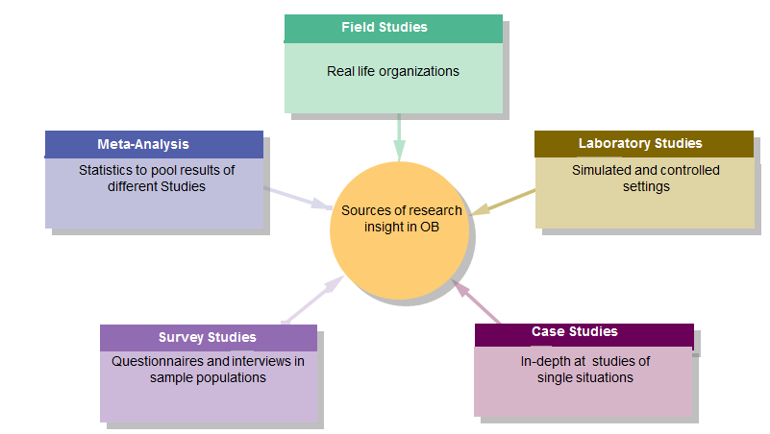
Contingency Approach: an Approach taken by OB that considers behaviour within the context in which it occurs

SUMMARY
- OB Considers the multiple levels in an organization: individual, group and organizational
- OB is built from the wisdom and research of multiple disciplines, psychology, sociology, social psychology and anthropology
- OB takes a systematic approach to the study of organizational phenomena. It is research-based
- OB takes a contingency approach to the consideration of organizational phenomena. Recommendations depend on the situation
CHAPTER TWO
Perception: the process by which individuals organize and interpret their impressions in order to give meaning to their environment
Perception is influenced by…
-The Perceiver: Attitudes, Motives, Interests, Experiences, Expectations
-The Target: Novelty, Motion, Sounds, Size, Background, Proximity
-The Situation: Time, Work Setting, Social Setting
Pygmalion effect: People often behave in a way to meet others expectations of them
Perceptual Errors
- Attribution Theory: the theory that when we observe what seems like atypical behaviour by an individual, we attempt to determine whether it is internally or externally caused
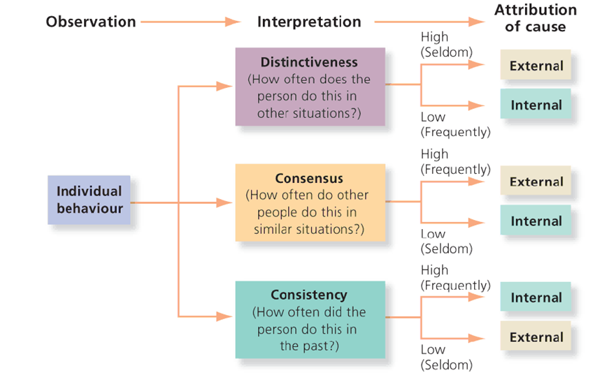
Distinctiveness refers to whether an individual acts similarly across a variety of situations
Consensus considers how an individual’s behaviour compares with others in the same situation
Consistency is a behavioural rule that considers whether the individual has been acting the same way over time
- Self-Serving Bias: The tendency for individuals to attribute their own successes to internal factors while putting the flame for failures on external factors
- Selective Perception: People’s selective interpretation of what they see based on their interests, background, experience and attitudes
- Halo Effect: Drawing a general impression of an individual on the basis of a single characteristic
- Contrast Effect: the concept that our reaction to one person is often influenced by other people we have recently encountered
- Projection: Attributing one’s own characteristics to other people
- Stereotyping: judging someone on the basis of one’s perception of the group to which that person belongs
- Central Tendency: Evaluating behaviour in the middle, lumping everyone together unless they really standout
- Perceptual Defence: Your body becomes overwhelmed and just shuts down; you see it but block it out from your brain
Personality: The stable patterns of behaviour and consistent internal states that determine how an individual reacts to and interacts with others
Personality is determined by heredity, the environment and situational factors
Personality Traits: Enduring characteristics that describe an individual’s behaviour
The Myers-Briggs Type Indicator – 100 multiple choice questions based on how they feel or act in given situations that classify people as either…
-Extraverted/Introverted
-Sensing/Intuitive
-Thinking/Feeling
-Judging/Perceiving ENFJ=ME
The Big Five Personality Model
-Extraversion: describes the degree to which a person is sociable, talkative and assertive
-Agreeableness: describes the degree to which a person is good-natured, cooperative and trusting
-Conscientiousness: describes the degree to which a person is responsible, dependable, persistent and achievement-oriented
-Emotional Stability: describes the degree to which a person is calm, self-confident and secure
-Openness to Experience: degree to which a person is imaginative, artistically sensitive and intellectual
Major Personality Attribute Influencing OB
-Locus of Control: the extent to which individual believes they control events that affect them
-Core Self-Evaluation: the degree to which a person likes or dislikes themselves
-Machiavellianism: the degree to which an individual is pragmatic, maintains emotional distance, and believes that ends can justify means
-Narcissism: tendency to be arrogant, have a large sense of self-importance, require excessive admiration and have a sense of entitlement
-Self-Monitoring: an individual’s ability to adjust behaviour to external, situational factors
-Risk Taking
TYPE A VS TYPE B PERSONALITIES
Type A: A personality with aggressive involvement in a chronic, incessant struggle to achieve more and more in less and less time and, if necessary, against the opposing efforts of other things or people
-Are always moving, walking and eating rapidly
-Feel impatient with the rate at which most events take place
-Strive to think or do two or more things at once
-Cannot cope with leisure time
-Are obsessed with numbers, measuring their success in terms of how many/how much of everything they acquire
Type B: A personality that is described as easy-going, relaxed and patient
-Never suffer from a sense of time urgency with its accompanying impatience
-Feel no need to display or discuss either their achievements or accomplishments unless such exposure is demanded by the situation
-Play for fun and relaxation, rather than to exhibit their superiority at any cost
-Can relax without guilt

Proactive Personality: A person who identifies opportunities, shows initiative, takes action and perseveres until meaningful change occurs
EMOTIONS: intense feelings that are directed at someone or something
Moods: Feelings that tend to be less intense than emotions and that lack a contextual stimulus
Emotional Affect: Other people’s moods affect our emotions
Emotional Labour: when an employee expresses organizationally desired emotions during interpersonal interactions
Emotional Dissonance: differences between the emotions people feel and the emotions they show
Felt Emotions: an individual’s actual emotions
Displayed Emotions: emotions that are organizationally required and considered appropriate in the given job
Surface Acting: hiding one’s inner feelings to display what is expected
Deep Acting: Trying to modify one’s true inner feelings to match what is expected
Emotional Intelligence: An assortment of non-cognitive skills, capabilities, and competencies that influence a person’s ability to succeed in coping with environment demands and pressures
EI is a persi knoon’s ability to
- Be self-aware ( to recognize one’s owns emotions when they experience them)
- Detect emotions in others
- Manage emotional cues and information
The Case for EI
-Intuitive Appeal
-EI Predicts Criteria that Matter – high EI means that a person will do well on the job
-EI is Biologically Based – EI is neurologically based in a way that is unrelated to standard measures of intelligence
The Case against EI
-EI is too Vague a Concept – It is not clear what EI is because it is too broad
-EI Cannot Be Measured – Because EI is a form of intelligence, there must be right and wrong answers on tests and though some do, the validity of some of these questions on these measures is questionable
-The Validity of EI is Suspect - Because EI is so closely related to intelligence and personality, once you control for thecdse factors, EI has nothing unique to offer
EI Tests
-MSCEIT: Test of Emotional Ability
- Mayor, Salovey, and Caruso Definition of EI:
  - “the ability to monitor one’s own and others’ feelings and emotions, to discriminate among them, and to use this information to guide one’s thinking and action” (Salovey & Mayer, 1990: 189).
  - MSCEIT
  - Measures emotional abilities: Perceiving emotions, facilitating thought, understanding emotions, and managing emotions
-Bar-on-EQI: Self-Report (Not as Good)
-ECI: Daniel Goleman’s test of Emotions
Employee Deviance: Voluntary actions that violate established norms and threaten the organization, its members, or both
Affective Events Theory: The theory that employees react emotionally to things that happen to them at work and that this emotional reaction influences their job performance and satisfaction
CHAPTER 3
Values: Basic convictions that a specific mode of conduct or end-state of existence is personally or socially preferable to an opposite or converse mode of conduct or end-state of existence
-They contain a judgmental element in that they carry an individual’s idea as to what is right, good, or desirable. Values generally influence attitudes and behaviour
Value System: a set or hierarchy of values
Milton Rokeach’s Value Survey
Terminal Values: goals that individuals would like to achieve during their lifetime
Eg. Comfortable life, equality, mature love, social recognition, wisdom
Instrumental Values: Preferable ways of behaving
Eg. Ambitious, Helpful, Loving, Intellectual, Independent, Courageous, Responsible

Cognitive Dissonance: a condition of conflict or anxiety resulting from inconsistency between one’s beliefs and one’s actions
-When personal values conflict with work behaviour people will attempt to reduce cognitive dissonance
Ethics: the study of moral values or principles that guide our behaviour and inform us whether actions are right or wrong – related to moral judgments of right and wrong
Hodgson’s Magnificent Seven
-Dignity of Human Life, Autonomy, Honesty, Loyalty, Fairness, Humaneness, the Common Good
Cultural Intelligence: The ability to understand other cultures as if you’re a part of that cultural group
3 Parts: The body [physical CQ], the heart [emotional/motivational CW] and the head [the cognitive CQ]
Hofstede’s Framework for Assessing Culture (30 years old)
-Power Distance
the extent to which a society accepts that power in institutions and organizations is distributed unequal
-Individualism vs Collectivism
the degree to which people prefer to act as individuals instead of as members of groups or vice versa
-Masculinity vs Femininity
M: the degree to which the culture favours traditional masculine work roles of achievement, power and control
F: a national culture attribute that sees little differentiation between male and female roles
-Uncertainty Avoidance
The extent to which society feels threatened by uncertain and ambiguous situations, thus tries to avoid
-Long-term vs Short-Term Orientation
L: emphasizes the future, thrift and persistence that are oriented to future rewards
S: emphasizes the past and present, respect for tradition and fulfillment of social obligations
The GLOBE Framework for Assessing Cultures
9 Dimensions in which countries differ
-Assertiveness
-Future Orientation
-Gender Differentiation
-Uncertainty Avoidance
-Power Distance
-Individualism/Collectivism
-In-Group Collectivism: extent to which members o society take pride in the membership in small groups
-Performance Orientation: the extent to which society encourages and rewards group members for performance improvement and excellence
-Humane Orientation: the extent to which society encourages and rewards being fair, altruistic, generous, caring, and kind to others.
Generational Value Differences
The Elders » over 60 years old
  - Core values: Belief in order, authority, discipline, and the Golden Rule
  - Major Events: WW2, Great Depression
Baby Boomers » born mid-1940s to mid-1960s
  - Core Values: Autonomy, career focus, disengaged Darwinists
  - Major Events: Post War baby boom, competition for jobs
Generation X » born mid-1960s to early 1980s
  - Core Values: Thrill-seeking materialists, aimless dependents, social hedonists, new Aquarians, autonomous, pessimistic, intellect, promotion, fun at work
  - Major Events: Economic downturn
The Ne(x)t Generation (Millennials) » born 1977 to 1997
  - Core Values: “Creators, not recipients”, Curious, contrarian, flexible, collaborative, high in self-esteem, change is ok, get bored easily
  - Major Events: Economic prosperity, technological advance, globalization
Attitudes: Positive or negative feelings about objects, people or events
-Attitudes are less stable than values and impact job satisfaction + organizational commitment
Key Sources of Job Satisfaction
- The Work Itself
- Advancement Opportunities
- Supervision
- Co-Workers
-Once a person reaches the level of comfortable living the relationship between pay and satisfaction disappears
-People with positive core self-evaluations believe in their inner worth and basic competence, and are most satisfied with their work
How Employees Can Express Dissatisfaction
-Exit: Quit the job
-Voice: Actively and constructively attempting to improve conditions
-Loyalty: Stick around through the tough times waiting for improvement
-Neglect: Not performing your best work at the job
Organizational Commitment: A state in which an employee identifies with a particular organization and its goals, and wishes to maintain membership in the organization
Three types…
Affective Commitment: an individual’s emotional attachment to, identification with and involvement in the organization
Normative Commitment: The obligation an individual feels to staying with the organization
Continuance Commitment: An individual’s calculation that it is in his or her best interest to stay with the organization based on perceived costs of leaving it
Reasons why Employees commit themselves
-They are proud of the company’s aspirations, accomplishments and legacy; they share its values
-They know what each person is expected to do, how performance is measured and why it matters
-They are in control of their own destinies; they savour the high-risk, high-reward work environment
-They are recognized mostly for the quality of their individual performance
-They have fun and enjoy the supportive and highly interactive environment
Major Workforce Diversity Categories
-Age, Gender, National Origin, Disability, Domestic Partners, Religion
CHAPTER FOUR
Motivation: the intensity, direction, and persistence of effort a person shows in reaching a goal
Douglas McGregor proposed to distinct views of human beings
Theory X: the assumption that employees dislike work, will attempt to avoid it, and must be coerced, controlled or threatened with punishment to achieve goals
Theory Y: the assumption that employees like work, are creative, seek responsibility, and will exercise self-direction and self-control if they are committed to the objectives
-Motivation is the result of the interaction of the individual and the situation
Individuals are all motivated differently
Intrinsic Motivators: a person’s internal desire to do something, due to such things as interest, challenge, and personal satisfaction (Linked to theory y)
Extrinsic Motivators: Motivation that comes from outside the person and includes such things as pay, bonuses and other tangible rewards (Linked to theory x)
Needs Theories describe the types of needs that must be met to motivate individuals
-Maslow’s Hierarchy of Needs
Psychological: Includes hunger, thirst, shelter, sex and other bodily needs
Safety: includes security and protection from physical and emotional harm
Social: includes affection, belonging, acceptance and friendship
Esteem: includes internal esteem factors such as self-respect, autonomy and achievement; and external esteem factors such as status, recognition and attention
Self-Actualization: Includes growth, achieving one’s potential and self-fulfillment; this is the drive to become what one is capable of becoming.
-Alderfer’s ERG theory –rework of Maslow’s work
Three groups of core needs…
Existence (similar to psychological and safety)
Relatedness (similar to social and status needs)
Growth (similar to esteem and self-actualization)
Alderfer did not assume that these needs existed in a rigid hierarchy but instead an individual could be focusing on all three at the same time
-McClellend’s Theory of Needs
Need for Achievement
Need for Power
Need for Affiliation
-Herzberg’s Motivation-Hygeine Theory
Hygiene Factors – Sources of Dissatisfaction
Extrinsic Factors
Motivators – Sources of Satisfaction
Intrinsic Factors
Process Theories help us to understand the actual ways in which we can be motivated
Victor Broom’s Expectancy Theory
-The theory that individuals act depending upon their evaluation of whether their effort will lead to good performance (Expectancy), whether good performance will be followed by a given outcome (Instrumentality) and whether that outcome is attractive to them (Valence)
Goal Setting Theory
- Specific and difficult goals can:
  - Direct attention
  - Regulate effort
  - Increase persistence
  - Encourage strategies for achieving goals
-SMART Goals
Specific Measureable Attainable Results-Oriented Time-Bound
Self-Efficacy Theory
-an individual’s belief that he or she is capable of performing a task

Equity Theory
-We compare inputs (efforts, experience, education, competence, creativity,etc) and outcomes (salary levels, raises, recognition, challenging assignments, working conditions, etc) to others
-Perceptions of inequality can be demotivating

