Ling 1001

- Naclo Practice Problems (“translation”)
- Linguistic competence the hidden knowledge speakers have of their own language (speakers are mostly not aware of the details of their language, like stating patterns and word orders) idea that knowledge of language is largely unconscious
- Uncovering language competence is the task of linguistics
- Performance speakers’ actual linguistic behaviour, by studying it, one can uncover somebody’s linguistic competence
- Two demonstrations of the unconscious nature of linguistic competence
1: aspiration in voiceless stops
2: wanna: contractions (want + to)
- Hypothesis 1: Any want to sequence can be pronounced wanna in fast/careless speech
- Ex. John is the person I wanna see
- Ex. John is the person I wanna dance. *wanna doesn’t really make sense here, therefore wanna can’t just be used whenever you see want + to*
- Ex. John is the person I want to succeed.
Could mean “I want John to succeed” or “I want to succeed John”
Wanna is acceptable with “I wanna succeed John” but not “I want John to succeed”
So, hypothesis 1 is wrong.
- Hypothesis 2: When the subject doing the ‘wanting’ is the same subject doing the verb, wanna is acceptable, SUBJECT want to VERB. Subject of wanna and the next verb must be the same.
- “John is the guy I wanna dance with” makes sense because “I” is doing the wanting and the dancing.
- Linguistic competence is the reason why a sentence may “feel wrong” even though you can’t identify exactly what is wrong with it. We know “John is the person I wanna dance” is wrong, but for the most part, we don’t think about why it’s wrong, we just know it is.

Friday, September 8th
Themes
- Language is systematic and composed of separate subsystems
- Knowledge of language is mostly unconscious
- “Infinite use of finite means.”
- Languages are diverse
- Linguistic diversity is not unlimited
- Language is not writing → not useful for linguists to think of it as such because not all languages have writing
- Language is not prescriptive grammar

Language is composed of separate subsystems.
- Phonetics→ physical properties of sounds
- Phonology → how sounds interact with each other
- Morphology → how words are built from smaller parts
- Syntax → how sentences are built from words
- Semantics → how meaning works

Languages are diverse.
- Some things languages do that English doesn’t:
- Instead of ‘right’ and ‘left,’ (depends on where the speaker is,) always use absolute/cardinal directions, like ‘north’ and ‘south.’
- In addition to singular and plural, have separate forms for two and three objects. Ex. Nauruan duwon ‘his/her body’, duwuror ‘their (two)
bodies’, duwurej ‘their (three) bodies’, duwura ‘their (4 or more)
Bodies’
- Have separate ‘exclusive’ and ‘inclusive’ pronouns: e.g. Nauruan ata
‘we, including the addressee’ vs. ama ‘we, excluding the addressee’
Forms of nouns depend on whether they are subject or object:
Russian Masha vidit Sashu ‘Masha sees Sasha’ vs. Sasha vidit
Mashu ‘Sasha sees Masha.’
- Forms of verbs that depend on how the speaker came about the information, observation, hearsay, conjecture, etc…
- Allow words entirely composed of consonants.

Linguistic Diversity is Not Unlimited
- Some things languages never do:
- Form questions by reversing word order in the sentence.
- Have no vowels at all.
- Allow words with only an odd number of sounds.
- Have separate verb forms depending on current time of day
- Arrange words in a sentence by word length
- Lack of noun/verb distinction
- Have a finite sentence length limit

Consequences of limited diversity
- A baby born into a linguistic community is faced with a learning task: discover the rules of language from the ambient data
- This acquisition process proceeds largely unconsciously and without (direct) adult input on most aspects of the language
- Babies and young children are astonishingly good at this task (easier to learn a second language when you’re younger rather than starting as an adult)
- Because languages are so diverse, the task is hard: you don’t know ahead of time what you’re going to face.
- Because languages do not vary without limit, the task is easier: you know ahead of time that some things simply don’t happen in languages
- I.e. babies entertain some hypotheses and not others
- Example: English questions are formed by fronting the auxiliary. → ‘Kim is running.’ changes to, ‘Is Kim running?’ Children observe such data, and can form any number of hypotheses.

Linguistic Diversity → Beyond outward diversity, there is a more abstract hidden similarity across languages of the world

Infinite Use of Finite Means
- Languages have a finite set of sounds, and a finite (though large) set of words
- Out of this material they can build an infinite number of sentences

Duality of Patterns: Two Layers of Structure
- Sounds are generally meaningless, but combine into meaningful words
- Sounds → words → sentences = meaning
- Every language has syntax and phonology

Arbitrariness of the Sign:
Connection between sounds and meaning is arbitrary, as: languages are different, new things don’t have obvious names, new words don’t refer to obvious objects.
Exceptions to arbitrariness → onomatopoeia, sound symbolism.
Signifier: sound of “cat” → Signified: the animal cat. There is no law of nature that those particular sounds should refer to that particular animal, an ‘accident’ of the language.
Example: ‘cat’ is similar to the german word for cat, ‘katze,’ because they have a common descendant, not because the sound is the natural/obvious word for the animal

- Linguists are concerned about how languages work, not what is ‘right’ or ‘wrong’
- Language is a characteristic of our species, which is unique compared to other species

Wednesday, September 13th
Phonetics
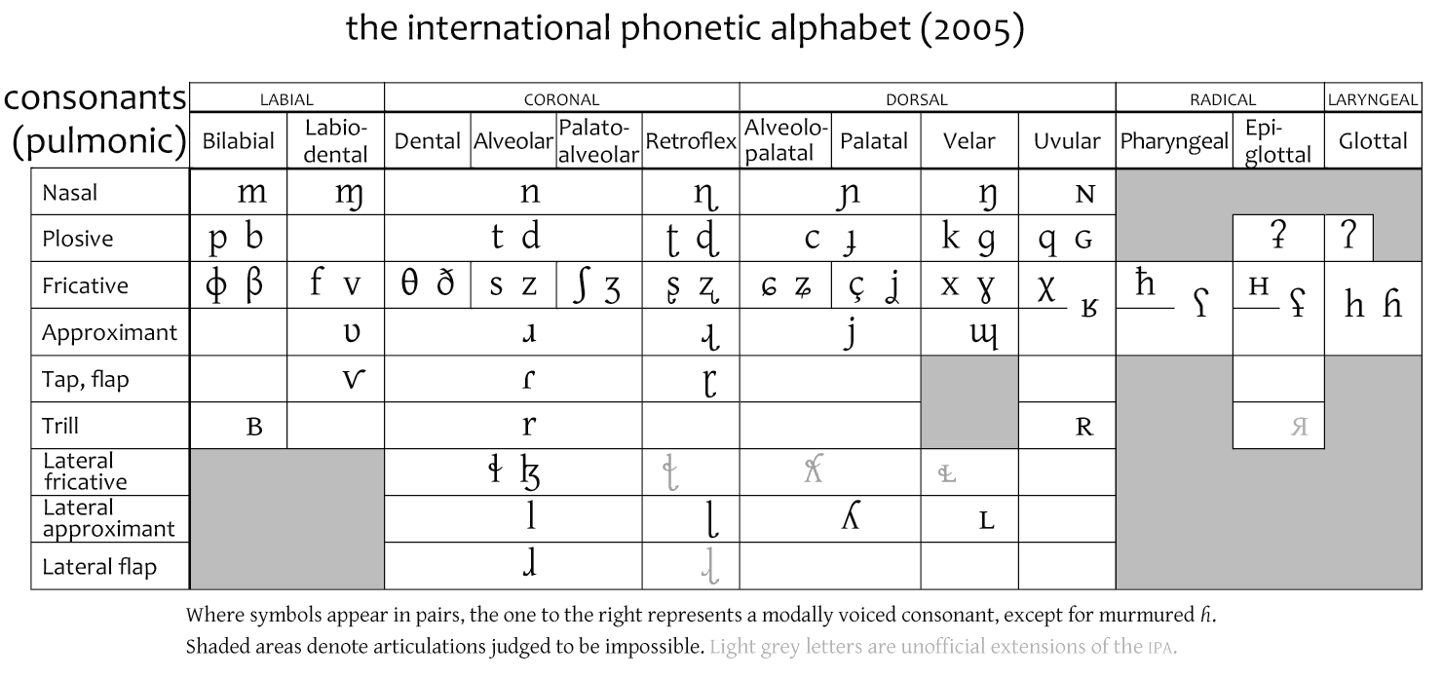
- Articulatory phonetics → study of speech production
- Acoustic phonetics → the study of the sound of speech
- Auditory phonetics → the study of the perception of speech sounds

Phonetic transcription → English spelling is not well-suited to represent sounds
IPA: International Phonetic Alphabet
- Standardized, equipped to represent all sounds in all languages, defined in terms of articulation (back of textbook)
- Limitations of IPA (or any) transcription → no two sounds are exactly alike, but there are a finite number of letters in the alphabet, you can go smoothly from an [i] to an [u] (infinite number of sounds with finite number of letters = limitation)
- Language is discrete, only a finite number of distinctions actually matter
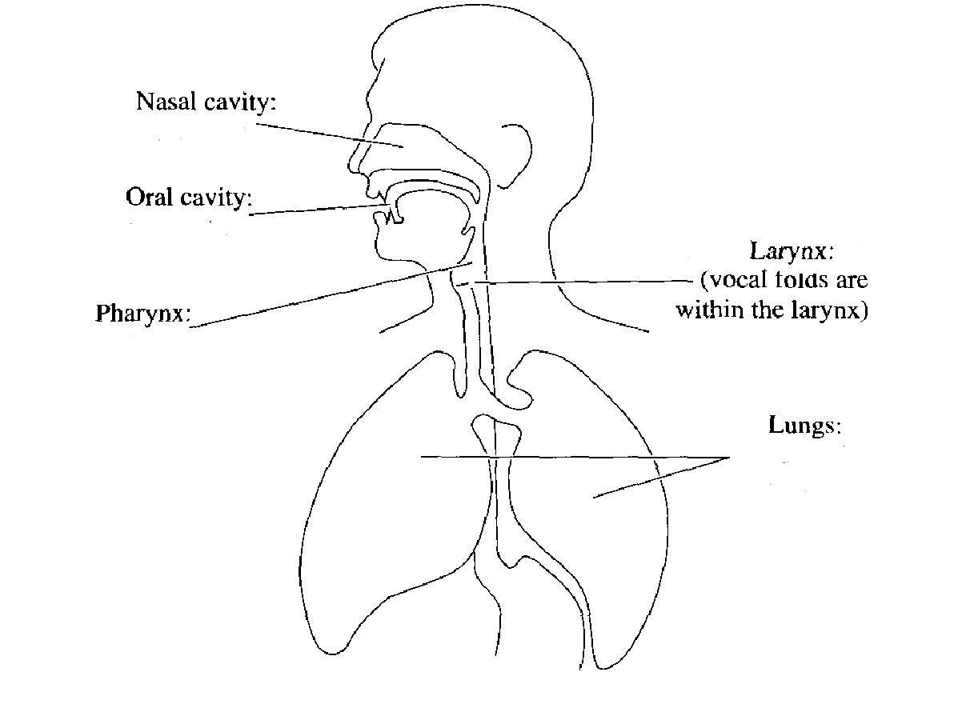
← speech production mechanism

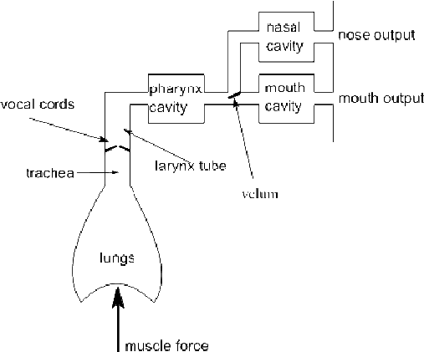
Lungs: create movement of air
Larynx: contains vocal folds → air moves between them while breathing, can be brought together (vibration) to produce sound
Soft palate: closes/opens nose
Trachea: air chord leading to lungs
Alveolar ridge: behind top teeth

- during speech productions, air flows from the lungs (for most sounds)
- vocal folds vibrate to create voiced sounds (“ZZZZ”)
- vocal folds are spread and let the air pass through in voiceless sounds (“SSSS”)
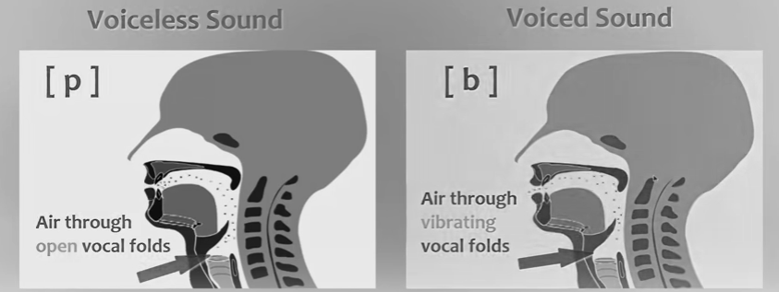
Describing Speech Sounds
- place of articulation → where in the vocal tract two articulators come together
- manner of articulation → how closely the two articulators come together

English Places of Articulation
- bilabial: both lips involved, come together ex. ‘P’ (oral, voiced) , ‘B’ (oral, voiceless), ‘M’ (nasal, you can continue saying, ‘MMM’ but not “PPP”)
- labiodental: upper teeth, lower lip ex. ‘V’ (oral, voiced), ‘F’ (oral, voiceless)
- dental: tongue and upper teeth ex. ‘th’ (oral, voiced)
- aveolar: tongue and alveolar ridge ex. ‘L’ (oral, voiced), ‘T’ (oral, voiceless), ‘D’ (oral, voiced), ‘N’ (nasal, voiced), ‘S’ (oral, voiceless) ‘Z’ (oral, voiced)
- post alveolar: tongue just in front of the hard palate
- palatal: tongue and hard palate
- velar: tongue and soft palate
- glottal: vocal folds
*not all sounds that last are voiced, it depends on the vibration of the vocal chords!*

Manners of articulation
- fricative → consonant produced by forcing air through a narrow channel made by placing two articulators close together. ( ‘f’ or ‘v’)
- affricative → a consonant that begins as a stop and releases as a fricative
- stop → complete closure of the vocal tract
- nasal → the velum is lowered during a stop closure, allowing air to escape through the nose
- liquid→ larger opening, less noisy airflow
- lateral → air escapes along the side(s) of the tongue
- retroflex → tongue carried backward
- glide → largest opening, most vowel-like

The Flap
- What about the middle consonant of letter, water, ladder, latter?
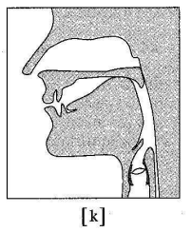
- Flap or tap [r]

3 Part Descriptions of Consonantal Sounds
- Voiced labial stop
- Voiceless postalveolar affricate
- Voiced velar nasal

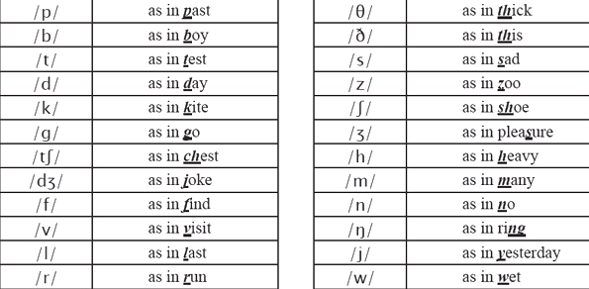

Friday, September 15th

Vowels
- Tongue height → high, mid, low
- Tongue backness → front, central, back
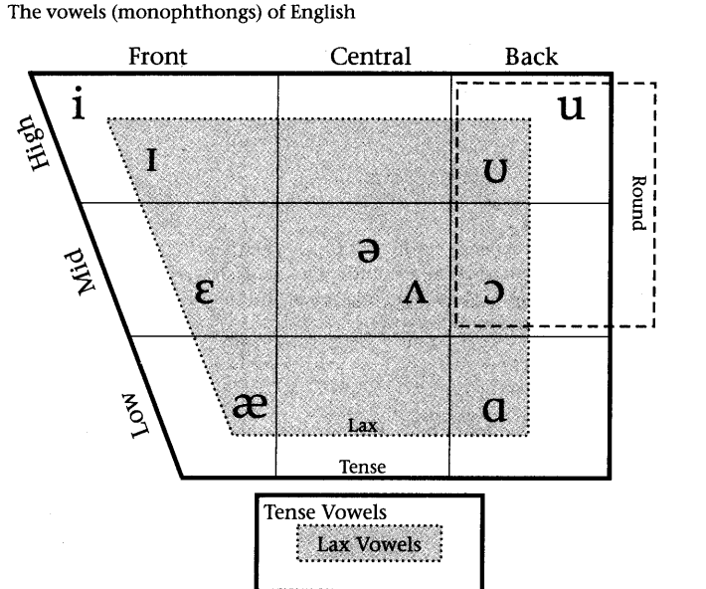
- Lip rounding → rounded, unrounded
- Tenseness → tense, lax

- [i] → high, front, unrounded, bead, weed
- [Ʌ] → mid, central, unrounded, the vowel of cut, but, cup, puck, flood
- [ə] → unstressed version of [Ʌ], the first vowel in about, astonish, admire
- [æ] low front unrounded, bad
- [ɛ] → mid, front, unrounded, bet
- [I] → high, front, unrounded, bid, category
- [ʊ] → high, back, rounded, would, pull, foot, Buddha
- [u] → high, back, rounded, pool, flute, loot

Syllables
- Abstract units of organization of segments (Cs and Vs)
- Each syllable has a nucleus, material before nucleus is called the onset and material after the nucleus is called the coda
- Normally, vowels are in the nucleus and consonants are in the onsets and codeas
- For transcription, [n, l, m,] are equivalent to [ən, əl, əm]
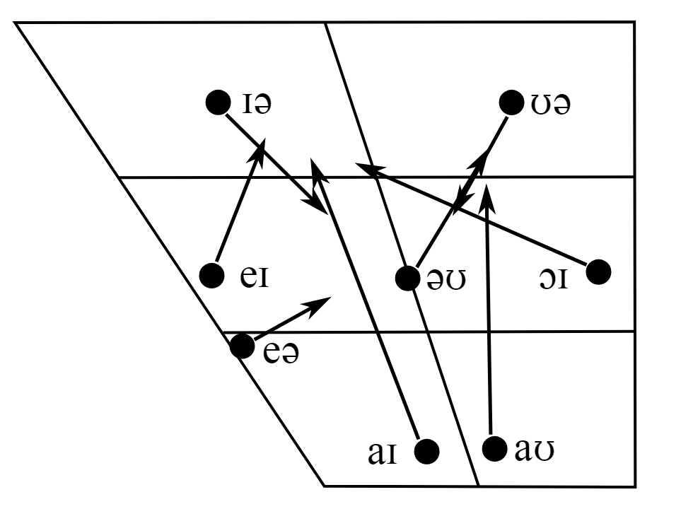
- Diphthongs: more than one vowel articulation in a single syllable (see page 62)
→ bait, boat [bert, boʊt]
→ bye, bow, boy [bɑI, bɑʊ, bəI]
- Vowels before [ɹ]
Bird → [bɹd]
Bard → [bɑɹd]
Beard → [biɹd]
Bare → [bɛɹ]
Board → [bəɹd]
attain → [əteIn]
fellow → [fɛloʊ]

Suprasegmentals
What’s the difference between:
permit (verb) and permit (noun)? → the syllables are stressed differently (‘per’ vs. ‘mit’)
survey (verb) and survey (noun)
protest (verb) and protest (noun)
stresses can be primary (kangaroo) or secondary (antelope)
- intonation = difference between questions and statements

general properties of sound → loudness, duration, and pitch (ex. asking questions)

Wednesday, September 20th
Phonology

Both English and Korean have the sounds [l] and [r], but Korean speakers have more trouble hearing the difference than English speakers do.
- Languages differ in the way sounds are organized in the grammar
- Which sounds can precede or follow other sounds?
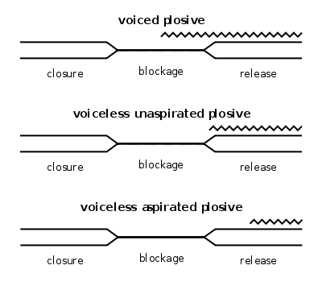
- Like other grammatical knowledge, phonological knowledge is largely unconscious
- In English, whether the voiceless bilabial stop is realized as [p] or [pʼ] is predictable from the sounds that are next to it, called the ‘environment’ ex. aspirated ‘p’ at beginning of syllable ‘pan’ and unaspirated ‘p’ elsewhere, like ‘spy’
Voice onset time →
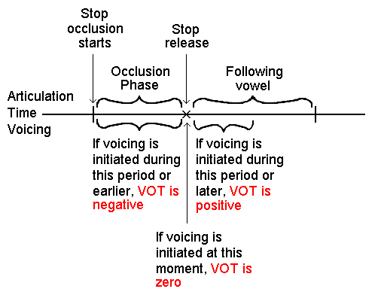

Distribution of a phone (=sound) *see slide*
Distribution can be contractive or complementary
Contrastive → sounds can occur in same environment (ex. plain or aspirated ‘p’)
- Minimal pairs are possible, words that differ only by the sounds in question
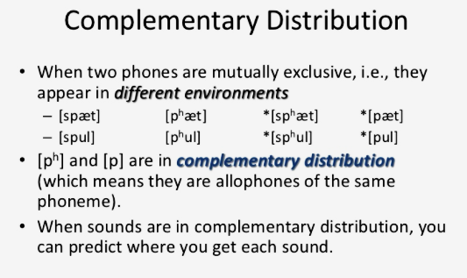
Complementary → minimal pairs are impossible
- A generalization (statement_ is possible about the environments of each sound
- Sounds in complementary distribution can be thought of as variants of the same sound ([p] and [p^h] are kind of ps in English)
- Such a class of sounds is called a phoneme
- Members of that class are called allophones of that phoneme (and of each other)
- *differences in phonemes makes differences in words*
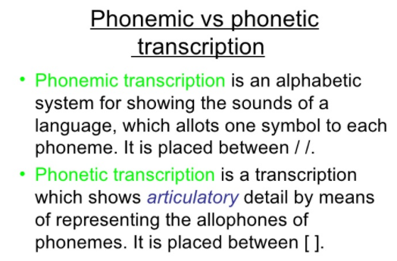
- Allophones go in between //
- Phonemes go in between []

- Speakers pay attention to differences in sounds that are used to distinguish meanings of words in their language, speakers are usually not as good at telling allophones apart.
- Phonetic form: only the contrastive information i.e. the phonemes
pat could be /pat/ or [p^hxt]
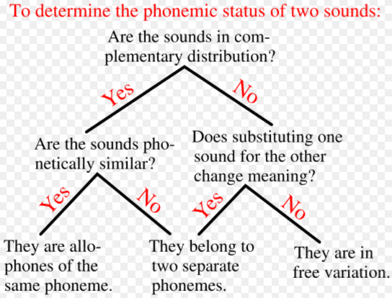
P → p^h at beg. of syllable
A rule is pattern of how allophones are distributed.
Format: a → b/c____d (a is replaced by b when it’s between c and d)
/l/ → [r]/__V (V for vowel)
Phoneme /b/ has two allophones, [p], and [b]

What it means to solve a phonology problem → Contrastive or complementary? Phonemes or allophones?

Ex. in Lugandan word for safari, ‘suuffali’ l is found between a__i.
in Lugandan word for’*see slide*, r is found between i__i.

r | l
i__i | a__i
e__a | o__u
e__a | u__e
e__e | o__i
- find things in common, so for example r is only found after i and e, and l is only found between a,o,u,#.
r is found i__ or e__
l is found elsewhere
*the rule that r is found after vowels is incorrect because l is also found after vowels, but they’re different vowels!*
r is found after front vowels (frontV__) l is found elsewhere = complementary distribution, they are allophones
[r] after front V, [l] elsewhere, but it’s hard to describe elsewhere, so choose /l/→ [r] as opposed to /r/→ [l]

Hypothesis A:
/l/ → [r]/frontV__

Hypothesis B:
/r/ → [l]/#__
/r/→ [l]/backV__

For simplicity, choose Hypothesis A (even though they are all correct)

/?/ → [r]/after frontV
/?/ → [l] elsewhere
- Most of the time where sounds are in a complementary distribution, the sound occurring in the most diverse type of environments should be picked as the underlying phoneme
- Interpret the arrow (-->) as ‘pronounced as’ or ‘replaced with’
See pg 145 Mokilese Voiceless vowels: p__s p__k k__s
Voiced vowels: #__d d__k k__# p__l p__d
Vowels with circle underneath are voiceless, back of textbook will help with homework!
Usually pattern for voiced and voiceless are the same, so i (with a circle underneath) will usually follow the same pattern as i (without the circle underneath)
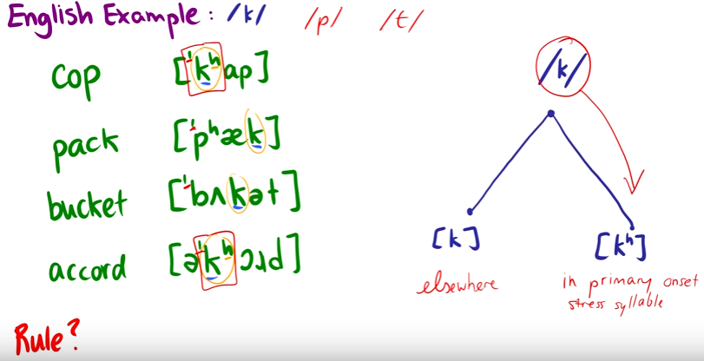
Phonemes
Phonemes are the basic sounds a language has; they are the building blocks for words. If you change a phoneme, you get a different word. The simplest way linguists test whether a pair of sounds are phonemes in a language or not is to is switching them--and only them--changes the meaning of the entire word. Any pair of words that differ in only one sound, but have their meaning change, is called a minimal pair. If you can find a minimal pair, then both of the sounds that got swapped have to be phonemes.
ex. blue and glue are minimal pairs, moving [b] to [g] makes a huge difference! This means that /b/ and /g/ must be different phonemes in English.
Other examples in English: cheek and cheat, beat and bit.
[i] and [ɪ] are different in English, but the same in Turkish.
A given phoneme will show up differently depending on what it’s pronounced near.
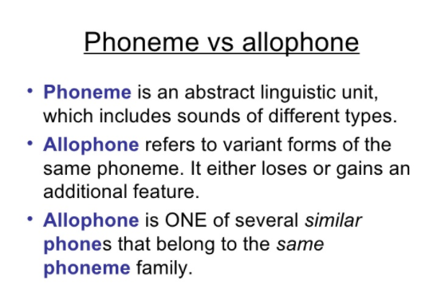
Allophones

- Totally predictable patterns of sound variation that don’t change the meanings of words.
Distribution statement: used to tell at a glance what the underlying phoneme is. Also tells us what variation we can find depending on what you’re pronouncing the sound near.

ex. /t/ is a phoneme, but there are different allophones of it.
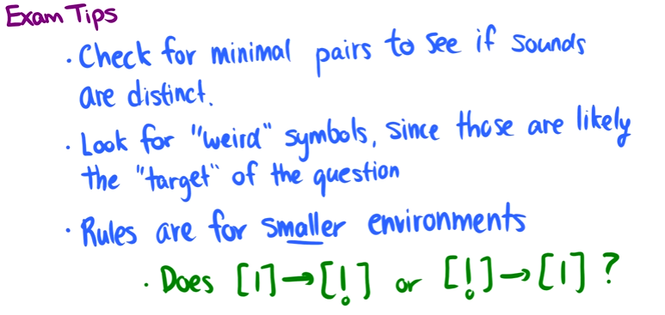

Wednesday, September 27th 2017
ɑɪ ‘ride’
ʌɪ ‘write’
Canadian raising → the onsets of the diphthongs /ay/ and /aw/ raise to mid vowels when they precede voiceless obstruents (the sounds /p/, /t/, /k/, /s/, and /f/). Low vowels become mid vowels.
To American ears, the Canadian pronunciation of about often sounds like aboot, but this is only an illusion. Because the more familiar pronunciation of /aw/ is articulated with the tongue in a low position, and because it raises to a mid position in Canadian English when the vowel precedes the voiceless obstruents listed above, speakers of other varieties of English will immediately detect the vowel raising, but will sometimes think that the vowel has raised farther than it actually does, all the way to /u/, which is a high vowel--hence the mishearing of this pronunciation as aboot.

t, d → ɾ/V___V

What’s up with [a]? Is it back or front?
- The IPA makes it a front vowel
- This conflicts with many phonologists, who use [a] to transcribe a central or back low vowel.
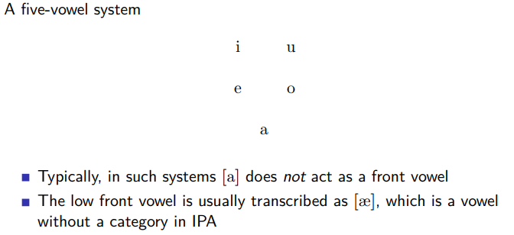

Issue one:
- [a] is easier to type than other nearby vowels
- It’s a low vowel if there’s only one low vowel in the system
Issue two:
- Phonemic vs phonetic transcription
- Phonetically, in a 5 vowel language, the low vowel actually varies between back and front, phonemically it’s almost always the back

Natural Classes
- Sets of sounds that participate in phonological rules are usually not random
- In the Spanish, [b], [d], [g], are not just three random consonants, they’re the only voiced stops of the language, they are natural classes
- They are describable in terms of their phonetic properties → voiced stops, voiceless fricatives, labials, back vowels, etc…
- Think of a natural class as the intersection of several phonetically defined classes of sounds.

Phonotactics → the set of constraints on what phonemes can occur in a word
Ex. neither [blɪk] nor [bnɪk] are English words, but only one of them could be.

Other constraints in languages:
Vowel harmony → vowels must be all back or all front (ex. Finnish)
Vowel reduction → rounded vowels cannot occur in unstressed syllables
Final devoicing → voiced stops and fricatives cannot occur at the end of the word
Place constraints → a nasal must have the same place of articulation as the following consonant
[e,o] may only occur next to uvular consonants

Effects of phonotactics:
- Sometimes they are static: they describe what is possible and impossible in a language.
- Sometimes they are active: they are enforcing by phonological rules
- Stop, fricative → unvoiced /__#
- Vowel → unrounded in unstressed syllables

Semantic Change

What word used to mean ‘Christian but now means ‘idiot?’ →
What word used to mean ‘holy’ but now means ‘stupid?’ →
What word used to mean ‘mark with blood’ and now means ‘sanctify?’ →
Also tends to rattle prescriptive grammarians. → disinterested, song, however

Evidence for semantic change
- Older meaning frozen in compounds and fixed expressions (midwife, time and tide wait for no man)

Types of semantic change
- Generalization, narrowing
- salarium ‘soldier’s allotment of salt’ → salary
- Lat. Passer ‘sparrow’ → Span. pajaro ‘bird’
- Metaphor
- Metonymy
- Synecdoche (part/whole)
- displacement/ellipsis
- Pejoration, amelioration
- Taboo replacement
- Hyperbole, litotes

