Final Exam Notes BIOL 1103
Chapter 10- Genetic Recombination
- Two molecules of DNA with similar sequence are brought into close proximity.
- Enzymes nick the DNA backbones, exchange the ends, and reattach them
- In this case, the final result is two recombined DNA molecules
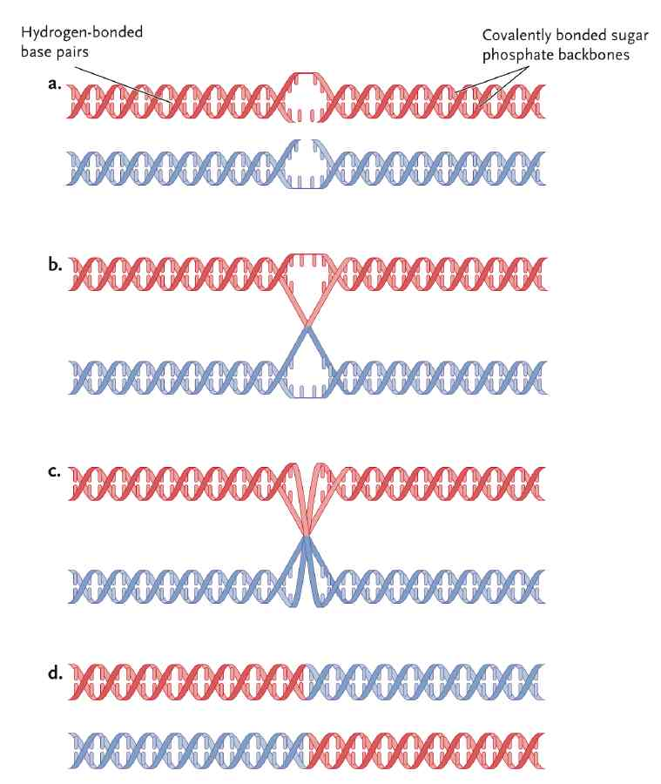

Mechanism of Genetic Recombination
- Requires 2 DNA molecules that differ from one another in at least 2 places
- Homology allows DNA on different molecules to line up and recombine precisely
- Enzymatic cutting and pasting of both DNA backbones from each of the 2 DNA molecules is required for recombination
- 2 circular molecules “fuse” together
Basically, recombination is when parts of two chromosome switch with each other. So they are basically crossing over, like A-A and B-B become A-B and B-A.
Genetic Recombination in Bacteria
Three primary mechanisms to bring DNA into bacterial cells from the outside:
- Conjugation
- brings DNA of two cells into close proximity
- Sex pilus and cytoplasmic bridge connects two bacteria
- Transformation
- Cells of some species absorb pieces of DNA released from cells that have been disintegrated
- Transduction
- DNA is transferred from one cell to another “by mistake” inside the head of an infecting virus.
- Lederberg and Tatum had an experiment to see if recombination occurred in bacteria as well.
- It was found that it occurs, they used E.Coli as their experiment.
- Some bacteria genetically reshuffle
  - Genes are transferred from one to another
- Bacteria can be grown on minimal medium (water, organic C, salts with N)
- E.Coli with mutagens no longer grows on minimal medium
- If combined strains grew on minimal medium, then recombination occurs
  - Several hundred out of 100 million grew
Prototrophs: Strains that are able to synthesize amino acids.
Auxotroph: Mutant strains that are unable to synthesize amino acids.
Replica Plating: identifies and counts genetic recombination in bacterial colonies
Complete medium: has full complement of nutrient substances
Auxotrophic mutants: will not grow on media missing nutrients
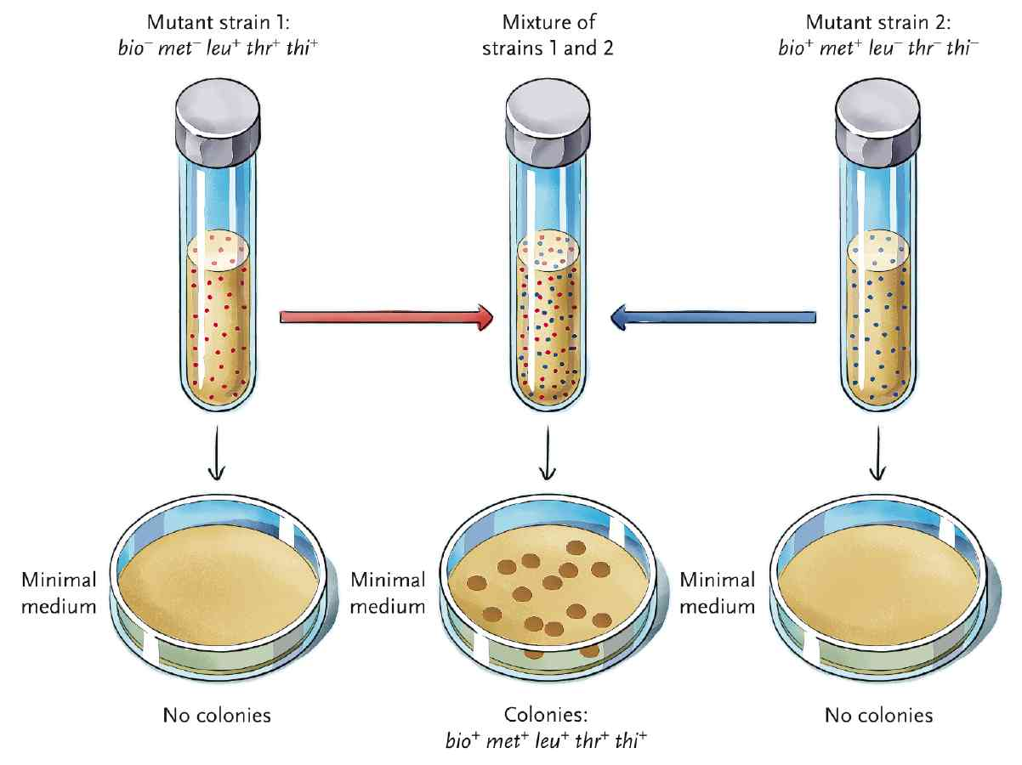
Conjugation
Plasmid: Circular, nonchromosomal transferable DNA
- E.Coli bacteria that are able to act as DNA donors in conjugation have an F (fertility) plasmid, making them F⁺; recipients that have no F plasmid and are F⁻.
- F factor has genes that code for Sex pilus
- Sex pilus connects F- to F+, then F- converts to F+ after receiving new DNA
- F plasmid replicates using a special type of DNA replication called “rolling circle”
- DNA and bacterial chromosome in bacterial cells create circles
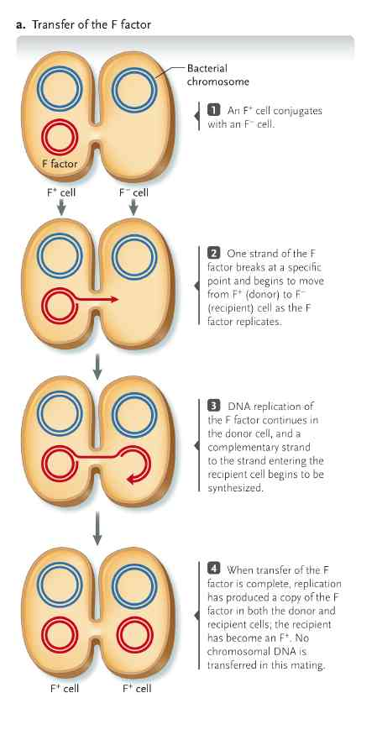
Transfer of genetic material during conjugation
Basically, there are two cells, F+ and F-. When they are conjugated, the genetic material is replicated from F+ to F-. This then makes the F- cell into a F+ cell. No chromosomal DNA is transferred.
Hfr Cells
- Can conjugate with F- cells
- The recipient becomes a partial diploid
- They integrate the F factor into bacterial chromosome through recombination
- Recombination only occurs in these bacterial cells
Mapping genes by conjugation
- Hfr and F cells were mated
- During intervals, after conjugation, scientists would remove some sells and blend them to break apart mating pairs
- They found that the longer the cells conjugated before separation, the greater the number of donor genes that produced recombination
Transformation
- Occurs when bacteria take up DNA from disintegrated bacteria
- Transformation bacteria usually have DNA binding protein in the wall
- Genetic manipulation of some bacteria requires artificial transformation
  - It alters the DNA membrane for DNA penetration
- Only some species of bacteria can take up DNA from the surrounding medium by natural mechanisms, and E.coli is not one of them.
- However, E.coli can be induced to take up DNA by artificial techniques
Electroporation: a form of artificial transformation used to introduce DNA into cells
Transduction
- Occurs when bacterial phages transfer DNA from one bacteria to another
- DNA is transferred from donor to recipient cells inside the head of an infecting bacterial virus.
- It begins when new phages assemble in an infected bacterial cell
- Virus incorporates DNA fragments from host cell
- If DNA fragments are homologous, bacteria become partial diploids
- May allow recombination of newly introduced DNA with host cell DNA
- There are two types of transduction:
- Generalized all donor genes are equally likely to be transferred using head of a lytic bacteriophage
- Specialized
- E.g. Lambda phage, which infects E.coli, it can go through lytic or lysogenic cycle.
- A virus in its lysogenic cycle is embedded in host DNA and is called a prophage.
Partial diploid: part of a genome of a haploid is diploid, happens between Hfr and F cells.
Homologous: Same chromosome
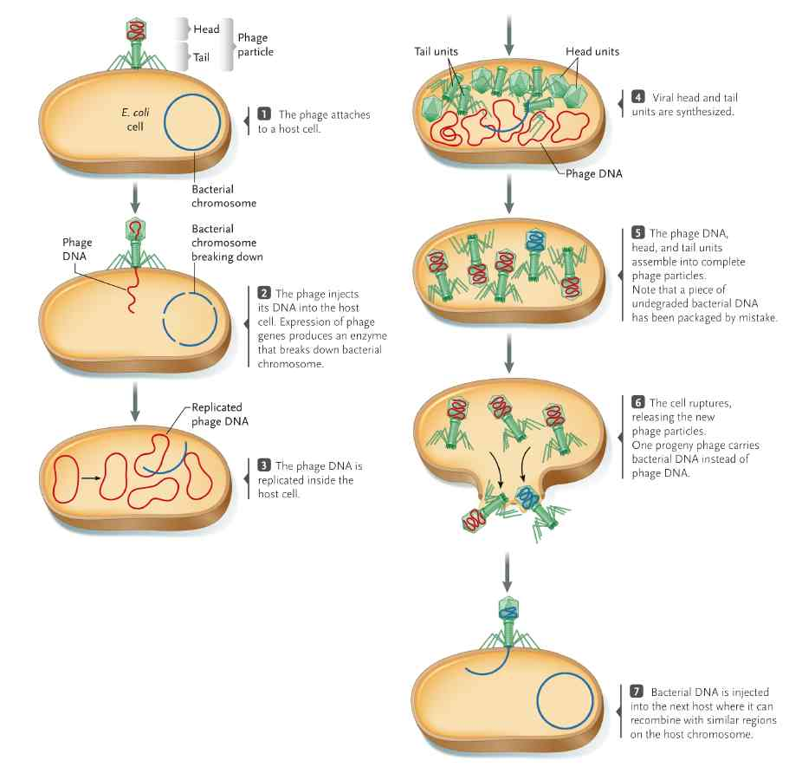
Basically…
…..conjugation, transformation and transduction are all ways in which DNA from two different bacterial cells are brought together.
…..homologous regions then pair and recombine.

Genetic recombination in Eukaryotes: Meiosis
- Produces four genetically different daughter cells
- Changes both chromosome number and DNA sequence
- Produces gametes (sperm and egg) with half chromosome number
- Fertilization fuses nuclei of egg and sperm
- Zygote cell is produces by fertilization, and parental chromosome number is restored.
Life Cycles
Animal life cycles
- Diploid phase dominates animal life cycles
- Haploid phase is reduced and short with NO MITOSIS.
Males ALL four nuclei from meiosis form separate sperm cells
Females’ only ONE nucleus becomes an egg
Meiosis Gametes (Sperm/egg) (n) Fertilization Zygote (2n) Animal(2n)
Plants and Fungi life cycles
- Alternate between haploid and diploid
- Fertilization produces sporophytes (diploid individuals)
- Sporophytes produce haploid spores (meiosis)
- Gametophytes produce gametes
Meiosis Spore (n)gametophyte (n) gametes(male/female)(n)FertilizationZygote (2n)Sporophyte (2n) (plant)
Other Fungi and Algae Life cycle
- In some, diploid phase is limited to single cell zygote
- Zygote undergoes meiosis
- Mitosis ONLY occurs in haploid cells
Meiosis Spore (n) gametophyte (n) gametes (n) fertilization zygote (2n)
Homologous Chromosome Pairs
- Parental chromosomes from male parent, maternal from female parent
- Alleles may be different with homologous chromosome pairs
- Meiosis separates homologous pairs
  - Before meiosis, diploid (2n)
  - After meiosis, haploid (n)
Meiosis I: First Meiotic division
- Produces TWO HAPLOID cells with chromatids attached
Meiosis II: Second Meiotic Division
- Sister chromatids separate into separate cells
- Produces FOUR recombined haploid cells
BASICALLY TWO Meiotic division = FOUR haploid cells.

Meiotic Cell Cycle
- Prophase I
- Sister chromatids condense to chromosomes
- Prometaphase I
- Nuclear envelope breaks down, and kinetochores attach to polar spindles
- Metaphase I and Anaphase
- Tetrads align on Metaphase plate
- Homologs segregate and move to poles (sister chromatids are attached)
- Telophase and Interkinesis
- No change in chromosome and spindle disassembles
- Prophase II, Prometaphase II and Metaphase II
- Chromosomes condense and spindles form.
- Nuclear envelope breaks down, and kinetochores form
- They align on Metaphase plate
- Anaphase II and Telaphase II
- Spindles separate chromatids and disassembles
- New nuclear envelope forms

To REMEMBER the order of these, use the following acronym = (PP MAT) ²

See….this is literally all you need to understand…
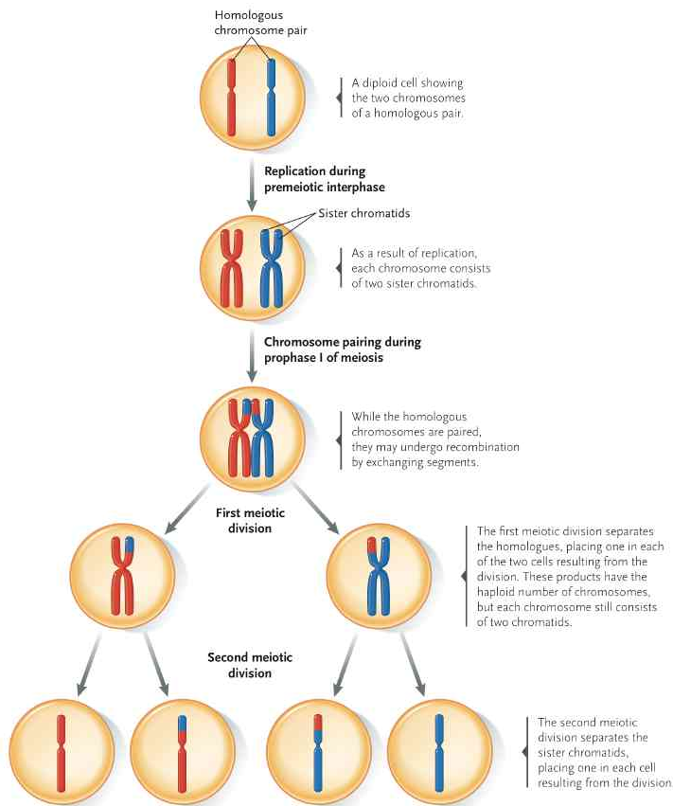

Synapsis: pairing of homologous chromosome
Tetrads: fully paired chromosome, held together at “synaptonemal complex”
Recombination: mixing alleles across tetrads through “crossing over” or “chiasma”
Interkinesis: no DNA replication between first and second meiotic division
Nondisjunction: creates abnormal chromosome numbers, when chromosome segregation fails at either meiosis I or II. Both chromosomes will connect to the same spindle pole.
Meiosis
HAPLOID
Four genetically different cells
Mitosis
DIPLOID
Two identical cells
BOTH
Similar cell divisions, EXCEPT meiosis divides TWICE

Sex chromosomes in meiosis
GO TO PAGE 214 FOR FULL DIAGRAM
Males gametes receive either X or Y chromosome
Females’ gametes receive X chromosome
Mobile Elements
- Two major types in prokaryotes
- Insertion sequence elements
- Transposons
Transposon Elements (TEs)
- First discovered in eukaryotes
- Segments of DNA that move around the cell genome
- No-crossing over
- E.g. when corn kernels show up in different colours.
- Both prokaryotes and eukaryote contain TEs
Tes can move in TWO ways:
- Cut and Paste, original TE moves
- Copy and paste, original TE stays in place
Bacterial Transposable elements
- Insertion sequences
- Contain only genes for transposition
- Enzyme catalyzes insertion or removal
- Inverted repeats marks insertion sequence
- Transposon
- Multiple genes within inverted repeat sequences
- Transposons can move to plasmids
Eukaryotic transposon is similar to prokaryotic.
Retrotransposons
- Transpose by copy-paste
- Transposition occurs via intermediate RNA

- Retrotransposon transcribes into RNA
- Enzyme uses RNA to make DNA
- DNA copy is inserted into DNA at a new location
Retrovirus
- RNA genome replicates with DNA intermediate instead
- Common in vertebrates, humans
- HIV and cancer retroviruses

