RYERSON UNIVERSITY
DEPARTMENT OF CIVIL ENGINEERING
CVL – 420 STRENGTH OF MATERIALS II
Final Examination (Winter 2011)

April 18, 2011 Time: 3 hours
Closed book exam Marks are indicated (Total 50 marks)
No communication devices allowed Instructor: Dr. K.M. Anwar Hossain

Answer all questions

Question 1
- Determine the deflection at the midpoint of BC for the beam shown in Fig. 1a using the Method of Superposition. EI is constant for the beam. The support at A is a pin while the support at B is a roller. (8 Marks)

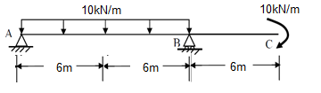

Fig. 1a

(b)
Two 40 X 100mm structural steel bars 6m long will be welded together, as shown in the figure below, and used for a pin-ended column. Determine the maximum load permitted if the load is applied at the point on the cross section indicated. Use the allowable stress method given E=180GPa and σ_{y}=270MPa (7 Marks)

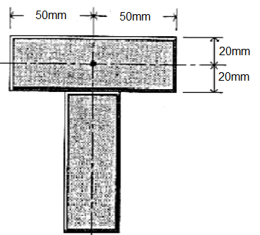

Question 2
A timber beam 850mm wide x 300mm deep has 175mm wide x 6mm-thick steel plate glued to the bottom face. The modulus of elasticity of wood and steel are 15 GPa and 185 GPa, respectively. If the allowable flexural stresses are 10 MPa in the wood and 85Mpa in the steel, determine the maximum load P that can be applied at the centre of the simply supported beam having a span of 12m. (10 Marks)
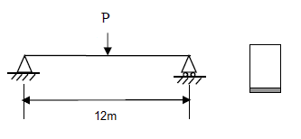

Question 3
A beam is loaded and supported as shown in the figure below. (15 Marks)
- Draw the shear forces and bending moment diagrams for the beam
- Find the location of the maximum shear and bending moment in the beam
- Find the centroid of the cross-section and the location of the horizontal neutral axis, and the 2nd moment area of the cross-section about the neutral axis. Calculate the maximum bending/flexural stress in the beam
- If the allowable stress is 200 MPa, find the factor of safety and comment on the safety of the design.

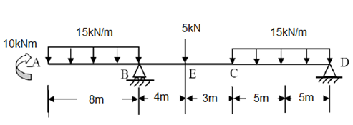

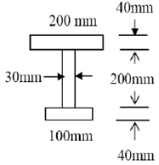

Question 4
A channel section is being used for a cantilever beam that supports a load P at the free end. Centerline dimensions for the channel are shown below. All metal in the channel section is o.5 in. thick. Assume that all of the section is effective in resisting flexural stresses and that only the web resists vertical shearing stresses.
- Locate the shear center of the section with respect to the center of the web. (6 Marks)
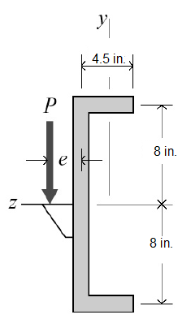

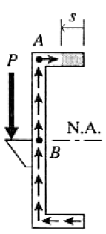

- Prepare a sketch showing the distribution of shearing stress on the cross section when the vertical shear at the section is 15kip. (4 Marks)

