MHR 405: EXAM REVIEW

Conflicts
- Conflict is a process in which one party perceives that its interests are being opposed or negatively affected by another party.

Emerging View: Constructive Versus Relationship Conflict
- Constructive (task-oriented) conflict
  - Parties focus on the issue while maintaining respect for people having other points of view.
  - Try to understand the logic and assumptions of each position
- Relationship conflict
  - Parties focus on personal characteristics (not issues) as the source of conflict.
  - Try to undermine each other’s worth/competence
  - Accompanied by strong negative emotions (drive to defend)

Minimizing Relationship Conflict Goal: encourage constructive conflict, minimize relationship conflict
- Problem: relationship conflict often develops when engaging in constructive conflict
- Three conditions that minimize relationship conflict during constructive conflict:
  - Emotional intelligence, Cohesive team, Supportive team norms

Model of Conflict Process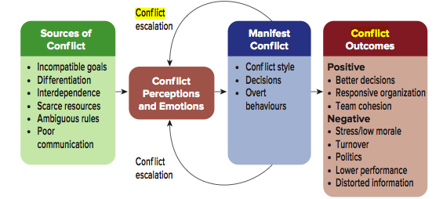

Structural Sources of Conflict`
- The six main conditions that cause conflict in organizational settings are (1) incompatible goals, (2)differentiation, (3)interdependence, (4)scarce resources, (5)ambiguous rules, and (6)communication problems.

Incompatible goals | - Goal incompatibility occurs when the goals of one person or department seem to interfere with another person’s or department’s goals. For example, the production department strives for cost efficiency by scheduling long production runs whereas the sales team emphasizes customer service by delivering the client’s product as quickly as possible.
Differentiation | - Another source of conflict is differentiation—differences among people and work units regarding their training, values, beliefs, and experiences.  - Different values/beliefs  - Explains cross-cultural and generational conflict
Interdependence | - Task interdependence refers to the extent to which employees must share materials, information, or expertise to perform their jobs Conflict increases with interdependence  - Parties more likely to interfere with each other
Scarce Resources | - Resource scarcity generates conflict because each person or unit requiring the same resource necessarily undermines others who also need that resource to fulfill their goals.
Ambiguous Rules | - Ambiguous—or nonexistent—rules breed conflict. This occurs because uncertainty increases the risk that one party intends to interfere with the other party’s goals. This explains why conflict is more common during mergers and acquisitions. Employees from both companies have conflicting practices and values, and few rules have developed to minimize the maneuvering for power and resources.
Communication problems | - Conflict often occurs due to the lack of opportunity, ability, or motivation to communicate effectively  - Reduces Motivation to communicate  - Increases stereotyping  - Escalates conflict when arrogant

Conflict Handling Styles/Conflict resolution strategies
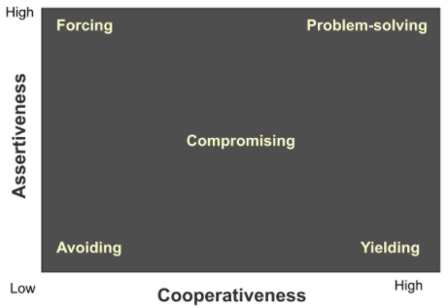
Conflict handling styles | Works best when... | Problems with style
Problem solving (win-win orientation) | - Interests are not perfectly opposing  - Parties have trust/openness  - Issues are complex | - Other party may use shared information to its advantage
Forcing (win-lose orientation) | - You have a deep conviction about your position  - Quick resolution required  - Other party would take advantage of more cooperative strategies | - Highest risk of relationship conflict  - May damage long-term relationship, reducing future problem solving
Avoiding | - Other party has much more power  - Issue is much less important to you than other party  - value/logic of position is imperfect | - Doesn’t usually resolve conflict  - May increase other party’s frustration
Compromising | - Parties have equal power  - Quick solution is required  - Parties lack trust/openness | - Sub-optimal solution where mutual gains are possible
Yielding | - Other party has more power  - Issue is more important to the other party  - value/logic of position is unclear | - Increases other parties expectation in future conflict episodes

Types of Third Party Intervention (How another person can help solve the problem between to parties)

Inquisition: Inquisitor's control all discussion about the conflict. They choose the form of conflict resolution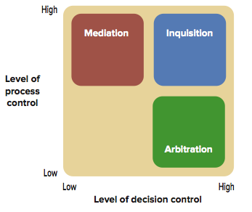

Mediation: Mediators have high control over the intervention process but little or no control over conflict resolution

Mediation-arbitration: Often referred to as “med-arb,” this is an alternate hybrid dispute resolution process.
Third party conflict resolution is any attempt by a relatively neutral person to help conflicting parties resolve their difference

Organizational Approaches to Conflict Resolution
Emphasize superordinate goals | - Emphasize common objective not conflicting sub-goals  - Reduces goal incompatibility and differentiation
Reduce differentiation | - Reduce differentiation in values, attitudes, and experiences  - E.g. move employees around to different jobs
Improve communication and understanding | - Use dialogue to improve mutual understanding  - Contact hypothesis, Johari window  - Warning: apply communication and understanding after reducing differentiation
Reduce interdependence | - Create buffers: any mechanism that lessens the dependence between two or more people or work units  - Use integrators  - Combine jobs
Increase Resources | - Increase amount of resources available
Clarify rules and procedures | - Establish rules and procedures  - Clarify roles and responsibilities

Power & Influence

Power and Dependence
- Power: is the capacity of a person, team, or organization to influence others.
- Power relationships depends on some minimum level of trust
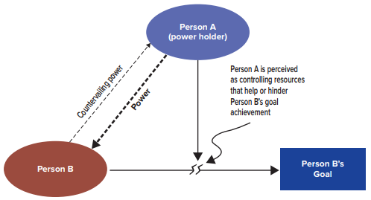

Person A
- (in the diagram) the power holder because their control over resources can help or hinder the goals of person B

Person B’s countervailing power over Person A
- countervailing power: the capacity of a person, team or organization to keep a more powerful person or group in the exchange relationship
- although person A dominates the power relationship, person B has enough countervailing power to keep Person A in the relationship and impact how the power is used
- it is an exchange relationship; although person A has the resources, A still needs B to accomplish his/her goals as well (interdependence)
- example: managers have power over subordinates but employees have countervailing power by possessing skills and knowledge to keep production going, somethings that managers can’t do alone

Person A’s control of resource valued by Person B
- (in the diagram) the line from Person A to B shows that B believes that A controls a resource that can help or hinder B’s ability to achieve their goal

Resource desired by person B
- essentially, person B believes that person A has a resource that can help him/her
- person B perceives a dependence on person A to provide the resource to achieve their goal

Person B
- (in the diagram) the one dependent on person A’s resource
- basically gives person A power by his dependence on him/her

Person A’s power over Person B
- Person A might have power over person B by controlling may resources such as a desired job assignment, useful information, rewards or even the privilege of being associated with him/her.

The 5 Bases of Power
Legitimate Power: Based on a person holding a formal position. Others comply because they accept the legitimacy of the position of the power holder. | Do it because I’m the boss
Reward Power: Based on a person’s access to rewards. Others comply because they want the rewards the power holder can offer | Do it because there is something in it for you
Coercive Power: Based on a person’s ability to punish. Others comply because they fear punishment or some negative consequence | Do it or else
Referent Power: Based on a person’s attractiveness to and friendship with others. Others comply because they respect and like the power holder. | Do it because you respect, like or identify with me
Expert Power: Based on a person’s expertise, competence, and information in a certain area. Others comply because they believe in the power holder’s knowledge and competence. | Do it because you value my expertise on the matter

Legitimate Power
- Agreement that people in certain roles can request certain behaviours of others
- Zone of indifference -- range of behaviors for deference to authority
- Norm of reciprocity -- felt obligation to help someone who has helped you
- Information control -- right to distribute information to other
  - Creates dependence
  - Frames situation

Other Sources of Power
- Reward power
  - Control rewards valued by others, remove negative sanctions
- Coercive power
  - Ability to apply punishment
- Referent power
  - Capacity to influence others through identification with and respect for the power holder
  - Associated with charisma
- Expert power
  - Capacity to influence others by possessing knowledge or skills that they value
  - Coping with uncertainty
    - Organizations operate better in predictable environments
    - People gain power by using by using their expertise to:
      - Prevent environmental changes
      - Forecast environmental changes

Contingencies of Power
Increasing Non-Substitutability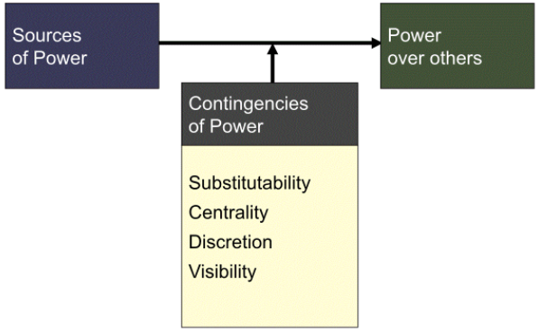
- Substitutability - availability of alternatives
>more power when few/no alternatives
- Reduce substitutability through:
>Monopoly over resource
>Controlling access to the resource
>Differentiating the resources

- Other Contingencies of Power
  - Centrality
    - Degree and nature of interdependence with power holder
    - Higher centrality when (a) many people affected and (b) quickly affected
  - Visibility
    - You are known as holder of valued resources
    - Increases with facetime, display of power symbols
  - Discretion
    - The freedom to exercise judgement
    - Rules limit discretion
    - Discretion is perceived by others
8 Types of Influences
Silent Authority | - Following requests without overt influence  - Based on legitimate power, role modeling  - common in high power distance cultures
Assertiveness | - Actively applying legitimate and coercive power (“vocal authority”)  - Reminding, confronting, checking, threatening
Information Control | - Manipulating others’ access to information  - Withholding, filtering, re-arranging information
Coalition Formation | - Groups forms to gain more power than individuals alone  - Pools resources/ power  - Legitmizes the issue  - Power through social identity
Upward Appeal | - Appealing to higher authority  - Includes appealing to firm’s goals  - Alliance or perceived alliance with higher status person
Persuasion | - Logic, facts, emotional appeals  - Depends on persuader, message content, message medium, audience  - Inoculation Effect: A persuasive communication strategy of warning listeners that others will try to influence them
Impression Management | - Actively shaping or public image  - self-presentation  - ingratiation (making someone in favor of you through flattery)
Exchange | - promising or reminding of past benefits in exchange for compliance  - negotiation, reciprocity, networking

Consequences and Contingencies of Influence Tactics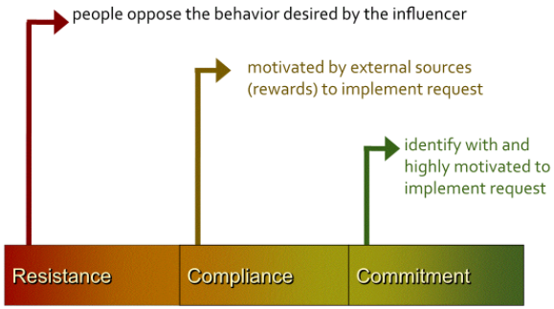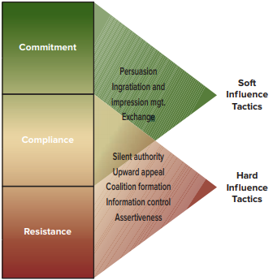

- Resistance
  - Occurs when people or work units oppose the behaviour desired by the influencer
  - At the extreme, people refuse to engage in the behaviour
  - There are degrees of resistance
    - Such as when people perform assigned tasks but continue their opposition by doing it poorly or complaining about the work
- Compliance
  - Occurs when people are motivated to implement the influencer’s request for purely instrumental reasons
  - Without external sources to cause the desired behaviour, compliance would not occur
  - Involves engaging in behaviour with no more effort than is required (bare minimum)
- Commitment
  - Strongest outcome of influence, where people identify the influencer’s request and are highly motivated to do so even when there are no external sources of influence to motivate them

23
Green Color from Kreitner Ch1

Triggers of Political Behaviour
- Political manoeuvring is triggered primarily by uncertainty.
- 5 common sources of uncertainty within organizations are:
  - Unclear objectives
  - Vague performance measures and unclear rules
  - Ill-defined decision processes
  - Strong individual or group competition
  - Uncertainty that results from change

Power of Social Networks
- Social networks - people connected to each other through forms of interdependence
- Generate power through social capital -- goodwill and resulting resources shared among members in a social network
- Three power resources through networks
  - Information: information received from other network members, which improves the individual’s expert power
  - Visibility: other network members think more readily of you and mention your name when asked to identify people with expertise
  - Referent power: people gain referent power because network members identify more with (or at least have greater trust in each other)
- Misperception: Social Networks are free spirits that cannot be orchestrated by corp. leaders. In reality, company structures and practices can shape these networks.
Chapter 12: Leadership

Perspectives of Leadership
- Leadership is influencing, motivating and enabling others to contribute towards the effectiveness and success of the organizations of which they are members
- Shared leadership is the view that leadership is a role, not a position assigned to one person, consequently, people within the team and organization lead each other

Competency Perspective

Implicit/Authentic Leadership Perspective
- Implicit Leadership Perspective
  - Follows perceptions of characteristics of effective leaders
    - Leadership prototypes
      - Preconceived beliefs about the features and behaviours of effective leaders
      - Favourable evaluation to leaders who fit the prototype
    - Romance of leadership effect
      - Amplify leader’s perceived effect on firm’s success
      - Due to need to simplify explanations
      - Due to need for situational control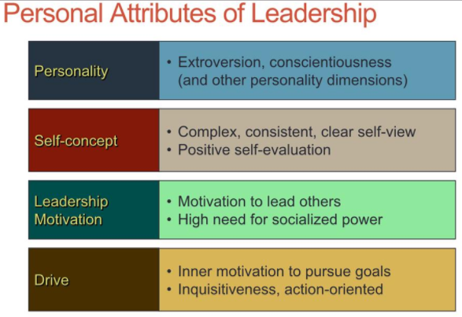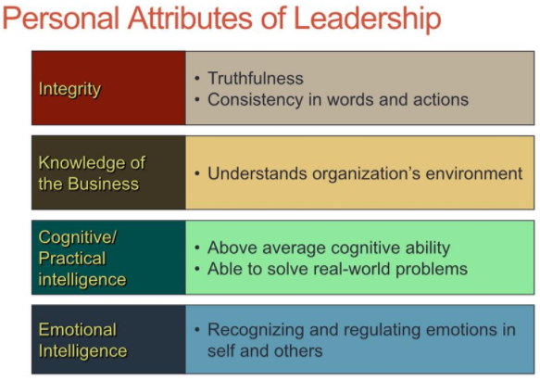

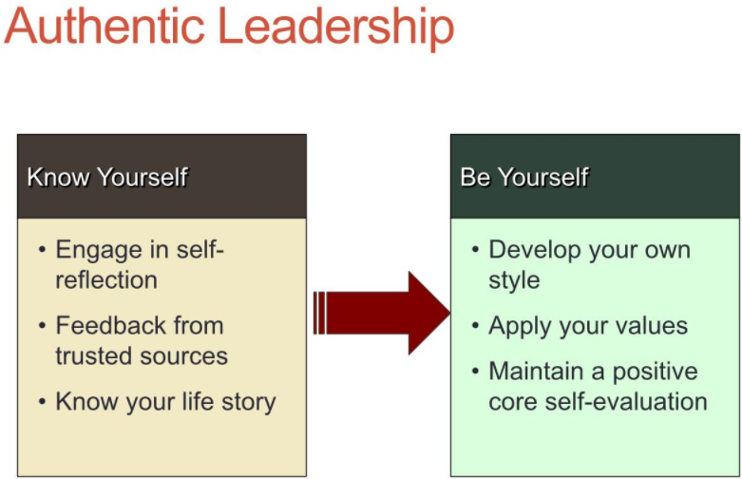

Behavioural Perspective
Leadership Perspectives

og

Transformational Perspective
- A leadership perspective that explains how leaders change teams or organizations by creating, communicating and modelling a vision for the organization or work and inspiring employees to strive for that vision
- Transformational leadership
- Changing the organization to fit environment
- Change agents
- Managerial leadership
- Effective leaders improve employee performance and well-being in the current situation
- Applies contingency leadership theories (e.g., path-goal)
- Transactional leaders
- Influence followers through rewards, penalties, and negotiation

Romance of leadership effect
- Followers tend to distort perception of leader’s influence
- Reason 1: Simpler explanation -- leader ability vs many complex reasons
- Reason 2: Need for situational control – employees feel better believing that leaders make a difference so they look for this evidence

Elements of Transformational Leadership
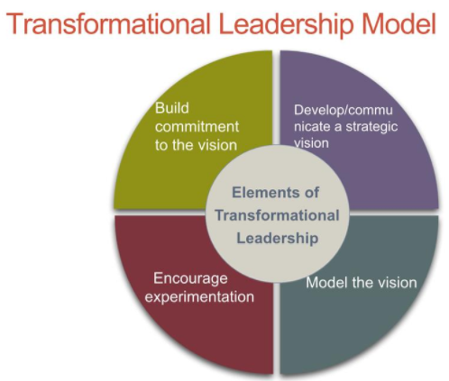
- Transformational Leadership Elements
  - develop/communicate the vision
    - Frame the vision
    - Communicate the vision with sincerity and passion
    - Use symbols, metaphors
  - Model the vision
    - Enact the vision (“walk the talk”)
    - Symbolize and demonstrate the vision through their own behaviour
    - Builds employee trust in the leader
  - Encourage experimentation
    - Encourage questioning current practices
    - Encourage discovering/trying out new practices (learning orientation)
  - Build commitment to the vision
    - Strengthened through communicating and modelling the vision
    - Increased through experimentation
    - Also through rewards, recognition, celebrations

Path-Goal Theory
- A theory stating that effective leaders choose the most effective leadership style(s), depending on the employee and situation, to influence employee expectations about desired results and their positive outcomes
- Contingency Factors :
  - Internal and external situational variables that influence the appropriateness of a leadership style. One style may be more effective than another.
  - Two important groups of variables:
  - employee characteristics
  - environmental factors
Path-Goal Leadership Styles
directive | - Consists of clarifying behaviour that provide a psychological structure for subordinates  - Clarifying performance goals, the means to reach those goals, and the standards against which performance will be judged  - Related to task-oriented leadership
supportive | - Provides psychological support for subordinates  - Leader is friendly and approachable  - Treats employees with equal respect  - Related to people-oriented leadership
participative | - Encourages employee involvement/engagement  - Asking for suggestions and takes ideas into serious consideration before making a decision
achievement-oriented | - Encourages employees to reach their peak performance  - Sets goals, expects employees to do their best, seeks improvement in employee performance  - Applies to goal-setting theory
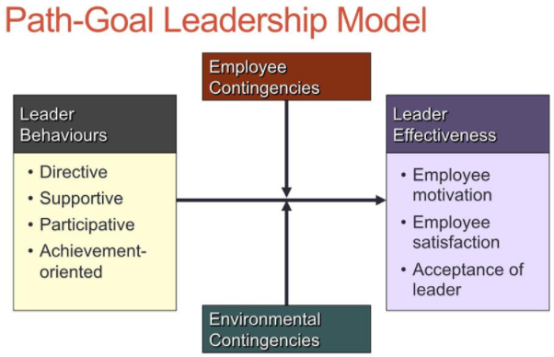

Path-Goal Leadership Model

- Employee
- Contingencies:
- Locus of control
- Task ability
- Need for achievement
- Experience
- Need for clarity
- Environmental
- Contingencies
- Task structure
- Work-group dynamics

Contingencies of Path-Goal Theory

Skill and experience | - When employees are (or perceive themselves as) inexperienced or unskilled  - The best path-goal leadership style to handle this is directive (to clarify performance goals and how to achieve the goals) and supportive (being approachable and treating with respect)
Locus of control | - When employees feel that they are in full control of their work environment  - Best way to handle these employees is through participative (encouraging employee involvement) and achievement-oriented (expecting employee to be at peak performance)
Task structure  (clarity of task, routine or nonroutine) | - When task is unclear, leaders should use a directive style  - When task is clear, directive is ineffective as it will serve no purpose and will be seen as unnecessary control  - When task is clear use supportive style to help employees cope with tedious nature of work  - Use participative when task is unclear because lack of rules gives more discretion to achieve goals
Team dynamics | - When there is team cohesion, it replaces supportive leadership  - Performance-oriented teams replace directive and achievement-oriented leadership  - When cohesion is low, use supportive style  - Use directive when team norms counteract objectives to get them back on track

Servant Leadership
- Leaders serve others toward their need fulfillment, personal development, and growth
- Described as selfless, egalitarian, humble, nurturing, empathetic, and ethical coaches
- Three main features:
  - Natural calling to serve others
  - Maintain a humble, egalitarian, accepting relationship
  - Anchor decisions/actions on ethical principles
- Servant leadership focuses on increased service to others rather than to oneself
- Less likely to engage in self-serving behaviour
- Is not a quick-fix approach to leadership
- It is a long-term approach to life and leadership

https://encrypted-tbn2.gstatic.com/images?q=tbn:ANd9GcSn6QzPUBZIqfOJA4r4jaNVycdearLpo0a8IOZg_kxfDvxpqltKpEnAVA

Shared Leadership
- Beige Color from Kreitner Ch1
- Studies on House’s theory have shown mixed results. House reformulated his theory. Among the new areas of focus is
- Shared Leadership:
- A simultaneous, ongoing and mutually influential process in which people throughout an organization share responsibility for leadership.

Gender Issues in Leadership
- Male/female leaders have similar task- and people-oriented leadership
- Female leaders use more participative leadership
- Women rated higher on emerging leadership styles

Leadership Substitutes
- Contingencies that limit a leader’s influence or make a particular leadership style unnecessary
- Examples:
  - Training and experience replaces task-oriented leadership
  - Cohesive team replaces supportive leadership
  - Self-leadership replaces task-oriented and achievement-oriented leadership
- Research evidence:
  - A few substitutes replace the need for task or people-oriented leadership, but others do not
  - Leadership substitutes do not completely replace leaders in these situations

Chapter 5: Motivation

Expectancy Theory of Motivation
- Definition: a motivation theory based on the idea that work effort results in behaviours that people believe will lead to desired outcomes
- Key constructs
  - Valence: a value or importance placed on a particular reward
  - Expectancy: belief that effort leads to performance
  - Instrumentality: belief that performance is related to rewards
- E-to-P expectancy
  - An individual’s perception that his/her effort will result in a particular level of performance
- P-to-O expectancy
  - Perceived probability that a specific behaviour or performance level will lead to a particular outcome
- Outcome valences
  - The anticipated satisfaction or dissatisfaction that an individual feels towards an outcome
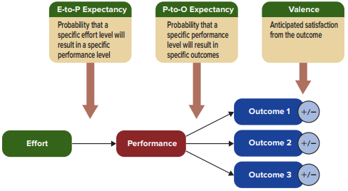

Management implications
- Increasing E-to-P Expectancies
- Assuring employees they have competencies
- Person-job matching
- Provide role clarification and sufficient resources
- Behavioural modelling
- Increasing P-to-O Instrumentality
- Measure performance accurately
- More rewards for good performance
- Explain how rewards are linked to performance
- Increasing Outcome Valences
- Ensure that rewards are valued
- Individualize rewards
- Minimize countervalent outcomes

Attribution Errors
- Fundamental Attribution Error
- attributing own actions to internal and external factors and others’ actions to internal factors
- Self-Serving Bias
- attributing our successes to internal factors and our failures to external factor

Levels of Task Interdependence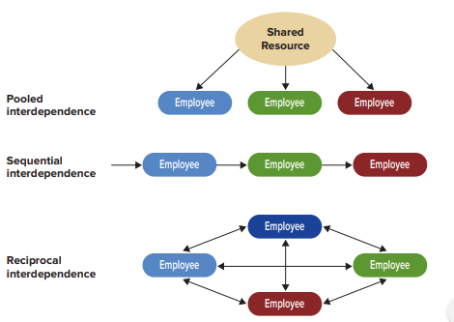
- High
  - the higher the interdependence, the more motivation there is to work in groups rather than alone
  - motivates others to be a part of a team
  - team must have the same task
  - Reciprocal interdependence
- Reciprocal
  - when work output is exchanged back and forth between individuals
  - this produces the highest degree of interdependence
- Sequential
  - the output of one person becomes the direct input for another person or unit.
  - this occurs where team members are organized in an assembly line
- Pooled
  - occurs when a employee or work unit shares a common resource (e.g machinery, administrative support, or a budget) with other employees or work units
- Low
  - Pooled interdependence

Chapter 8: Team Dynamics
- Teams: groups of two or more people who interact and influence each other, mutually accountable for achieving common goals, and perceive themselves as a social entity within an organization

Forming

Case study related questions
- Expectancy theory; management implications
- Individual sources of power; influencing tactics
- Path-Goal theory of leadership; leadership styles and contingencies
- Sources of conflict; Conflict-handling styles
- Team effectiveness model; team dynamics (5 stage model), team processes, e.g. trust

