Final Exam Review Natural Disasters

Lecture 11 Volcanic Hazards
- 20% of world’s population lives near volcanos
- Volcano types
  - Shield volcano
    - Hawaii
  - Cinder cone
  - Composite cone / stratovolcano
  - Calderas – collapsed volcanos
- Kilauea
  - Side of ocean
  - Just a black patch of dried lava

Lecture 12 Geomagnetic Hazards
Faraday’s Law of electromagnetic induction
- Magnetic fields induce current, current induces magnetic field
Faraday’s Law in nature
Variations in Earth’s magnetic field induce electrical (‘telluric’) currents
- In ground
- On electrically conducting networks
  - Telegraph and telephone lines
  - Pipelines
  - Power transmission lines
Magneto telluric sounding
- Prospecting technique
- Recorded for a few hours to a few days
  - Earths magnetic field
    - Magnetometers
  - Telluric currents
    - Electrodes
- Used to estimate the electrical conductivity in the subsurface (regional scale)
Electromagnetic surveying
- Prospecting technique
- Controlled experiment
  - Artificial varying magnetic field induces currents in subsurface ore bodies
  - These currents generate a magnetic field recorded at the surface or from the air
- Estimate the depth, shape and electrical conductivity of subsurface ore bodies
  - Metallic ore bodies are more conductive than surrounding rocks
The earths magnetic field (geomagnetic field)
Geomagnetic hazards
Extreme variations of the earths magneti field can have significant impact on technological systems
- Geomagnetic effects have been observed for 150 years after disturbances on the telegraph occurred
The internal geomagnetic field
Magnetometers at the surface of the earth record superposition signals from internal (earths core) and external (ionosphere, magnetosphere) geomagnetic fields
Internal
Due to movement of liquid iron in outer core
- Earths rotation
- Heat transfer by convection at the outer-inner core boundary
Magnetic lines of force – theoretical representation of the fore acting on a small magnet
Internal geomagnetic field resembles a bar magnet
- Horizontal at equator
- In through north pose and out at south pole
Slow field variations
- Magnetic poles wander
- Flip ever hundred thousand years (why isn’t fully understood)
Solar activity and the external geomagnetic field
Disturbances affected technological systems are caused by variations of the external geomagnetic field
- Short duration (hours, days)
- Driven by solar activity
Solar wind – stream of charged particles flowing away from the sun
- 4-5 days to reach earth
- The suns atmosphere (corona) is hot and turbulent
- Suns gravity cannot hold it down so upper fringes flow away
Coronal hole explosions cause solar gusts
- Occur in small localized areas fo the suns surface
- Violent explosions that send material into outer space
Coronal mass ejections cause strong gusts of solar wind
- Star-scale events

Solar cycle follows approx. 11-year cycle
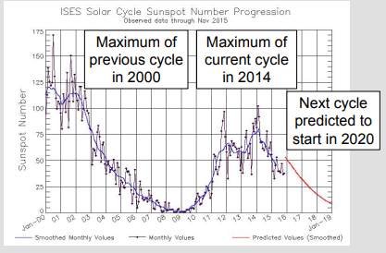
Magnetic Storm – temporary (hours/days) large-scale perturbation of the external geomagnetic fiend due to strong gusts of solar wind
- Most frequent at peak or decline phase of solar cycle
Magnetosphere – region around earth shielded from a solar wind by the external geomagnetic field
- Several 1000s km above surface
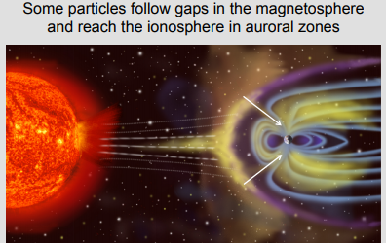

- charged particles are guided by magnetic field lines towards poles (excites atoms, light, aurora borealis)
- create currents that cause variations in the external geomagnetic field
Space weather
Changing conditions in space related to solar activity
Can be predicted and is used to forcase
- Satellite observations of the Sun
- Geomagnetic data from international network of observatories
- Knowledge of solar cycles
Impact on technological systems
Problems due to:
- Bombardment by charged particles (effects satellites)
  - Pressure from solar wind affects orbit
  - Charged particles can effect circuitry
  - Charge build up can lead to violent discharge
- Ionospheric disturbances (affects GPS)
  - Signal delay
    - Error in distance determination
  - Temporary loss of signal
- Electromagnetic induction effects
  - Extreme variations In the external geomagnetic field induce telluric currents along electrically conducting networks
    - Telegraph
      - First system using ling conductors – first link between technological problems and geometric activity
    - Telephone
      - Effected volume
    - Power transmission lines
      - Overheating of transformers caused by telluric currents along powerline
      - 1989 Quebec Blackout – 9 hours effected millions
        - induced high intensity telluric currents
        - collapsed entire hydro-Quebec grid
    - Pipelines
      - Pipelines maintained at certain optimal electric potential
      - Telluric currents cause potential to go out of safe range

Lecture 13 Impacts with Space Objects
Sources of extraterrestrial debris
Meteoroid: extra-terrestrial debris orbiting the sun
Sources of extraterrestrial debris primary source
Most meteoroids are asteroids or fragments from asteroids
Asteroid – small rocky body orbiting the Sun
Main asteroid belt
Jupiters gravity created a zone of perturbations
- During formation of solar system, small protoplanets didn’t stick together to form full planets
Most asteroids are between Jupiter and mars
- Size
  - Tiny pebblesCeres (Dwarf planet???)
  - 40,000 objects with diameter >1km
Asteroids from the main belt represent a low impact hazard
- some collisions between asteroids send fragments out of orbit
- rare
near Earth asteroids
asteroids that cross Earth or mars orbits
- 1/1000 amount of asteroids as in main belt
- Apollo and Aten asteroids cross orbits
high impact hazard
sources of extraterrestrial debris secondary sources
A few meteorites are fragments from comets
Comet – small object composed of ice and rock debris moving through outer space
- “Dirty Snowballs”
- Highly eccentric orbits
  - Tiny fraction travel to the inner solar system
- Comet ice can sublimate (solid gas)
Swift-Tuttle comet
- Observed in 1737,1862
- Rediscovered in 1992
- Next predicted approach July 11, 2126
- No collision hazard for several millennia
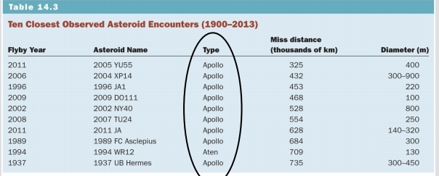
Impactors and impact scenarios
Most impactors are near earth asteroids or fragments of asteroids
Meteoroids
Meteoroids are classified according to size:
Cosmic dust (a few molecules to 1mm)
- Pass through the atmosphere unchanged
- Settles on surface 10⁵10⁶ kg/day
Shooting stars (1mm)
- Earth is protected by atmosphere
- Shooting stars melt in the atmosphere due to friction
- Blaze = 1second = 1km off surface
Meteorites (1-100mm)
- Pass through atmosphere hit surface
- Can split into fragments
- During entry, exterior is stripped away
- Cold when reaching surface
- Often covered in black glazed crust
- Thumb print texture due to atmospheric turbulence
- Atmospheric entry associated with a fireball and loud sound
  - If impact is fast/large
  - Might indicate it reaches the ground
- 2 different definitions
  - Impactor between 1 mmm and 100 m in diameter
  - Impactor that hits the ground
Abundance in nature
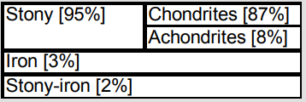
- See slide 38 for random facts
- Meteorites are the only source of extraterrestrial rocks and their formation processes
Asteroids (>100mm)
- Not slowed by atmosphere
- Explode when they hit earth
- 160 impact craters on earth currently
- 2 main definitions
  - Small rocky body orbiting the sun
  - Impactor larger than 100 m diam
>impact = > energy released…large impacts = not frequent…small = frequent

Mid- Air Explosions
Chelyabinsk (2013)
- See slides 49-55

Tunguska (1908)
- See slides 58-66
The K/Pg Boundary Event
Geological time
- Planet earth is 4.6 billion years (Ga) old
  - Worlds oldest rock found in NWT: 4.1 Ga
  - No rock record bw 4.1-4.6 Ga due to early crust being recycled
  - Time unit used in geology (Ma)
K/Pg boundary event
- K: cretaceous
- Pg: Paleogene
- Major extinction
  - 65% of all species died in a short period of time
  - Extinction of dinosaurs
- Worldwide iridium rich layer at the K/Pg boundary
- Meteorites are rich in iridium
- K/Pg boundary markes a ‘short’ episode of mass extinction
Impacts of global consequences is related to the extinction
- An asteroid of 10 km could cause this
- Earthquake
  - Magnitude 11.3
- Tsunami if it fell in ocean
  - Waves up to 300 m tall
- Wildfires caused from hot debris from atmosphere
- Acid rain
- Dust blocking sunlight
- Abrupt climate change
  - Winter for a few years followed by a few years of global warming
Hunt for impact crater
- Known craters are not the right age
- Haiti: shock minerals
- Cuba: huge angular blocks of rock
- Mexico: thick layer of shattered rock in borehole
  - Chicxulub crater
  - Pictures on slide77, not too useful
K/Pg boundary event cause: climate change
- Stress on life from extensive volcanism in Deccan traps, India
  - Massive outpouring of lava and debris in atmosphere
  - Global impact on climate
- At the end of the cretaceous, dramatic climate variations with volcanism had brought many lifeforms on the brink of extinction

- While this impact was simultaneous with the extinction level event, other extinction level events not linked with impacts

Close Encounters
- All near earth asteroids
NASA/JPL monitor near earth objects
- 1998-2008 objective: detect 90% of near earth asteroids with diam>1km
- 2020 objective: detect objects with diam >140m
Near earth object - <2,000,000 km (1.3 Au) from the sun
Most near earth objects are near earth asteroids
Torino Scale
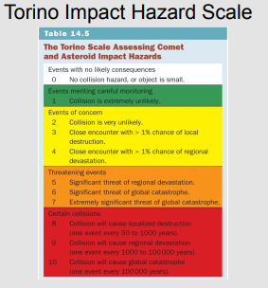

NEOSSAT
- Near earth object surveillance satellite
- commissioned by Canadian space agency
- launched feb 25, 2013
- not operational due to hardware issue
- dual purpose:
  - track near earth asteroids (natural hazard)
  - identify space debris (human made hazard)
  - circles every 100 min
  - telescope with great accuracy

Lecture 14 Great Canadian Impact Tour
Impact Crater morphology

- Crater diameter is 20 x impactor diameter
- Craters with diameter > 5 km do not contain meteorites
- Distinctive features of impact crater
  - Circular feature
  - Crater is steep-sided and closed
  - Rim rocks are titled away from the crater 4. Shattered rocks on the crater floor
  - Large angular blocks of rock scattered around crater
  - Presence of meteorite fragments
  - Shock minerals (indicative of extreme T° and pressure)
  - Shatter cones
  - Melted rock due to impact
- Shatter cone
  - A fragment of host rock fractured by the shock wave from impact
  - Cracks / shatter marks coming out from hole in middle
  - Terrestrial rock
- Small impactor = simple crater
  - Simple crater diameter is <5km
  - No central uplift
  - Raised rim
  - Meteorites might be found
- Large impactor = complex crater
  - Diameter >5km
  - Collapsed rim
  - No meteorites
  - Central uplift
Canadian impact crater tour

- 160 impact craters in the world
  - unevenly distributed
- 25 impact craters in Canada
  - craters are preserved bec rock hasn’t changed
  - large area
- none in Rockies
  - they are young
  - destroyed bec of subduction
- Sudbury ON
  - Largest and oldest impact crater in Canada
  - Deformed into an elliptical shape bec of movements of faults
  - 1850Ma
  - lots of metal bec of impact
    - 25% impact sites have mineral deposits
- Wanapitie
  - almost same location as Sudbury
  - much younger
  - under lake
- Gravity
  - Force pulling two masses together
  - Changes on earth bec of
    - Heterogeneities in the subsurface
  - Measured by a gravimeter
Crater counting
- When no radiometer data crater counting is used
- Older the surface more craters there are
- Rates can be calculated by ratios
- Example Mars
  - Northern is smooth therefore younger
  - South is rough therefore older

Lecture 15 Mass Movements 1
Slope instability
- Mass movement
  - Name for the movement downslope of earths materials bec of gravity
  - Stops things from going up drags things down
  - Resistant force ‘s are friction

External conditions of slope instability
- Conditions decreasing stability
  - Building on edge of slope
  - Higher slope
  - Removing support at bottom of slope

Internal conditions of slope instability
- Conditions decreasing stability
  - Weak material
  - Fractures in rock
    - More stable when slope if opposite fractures
  - internal water
- Friction
  - Force that resists movements between two surfaces
  - Higher friction coefficient = more stable
  - Controlling factors
    - Texture of surface
    - Pressure of lubricants
- Congelifraction
  - Rock wearing away bec of several cycles of water freezing and melting
  - Water to ice increases volume by 9%

The role of clay
- Earth layer less dense closer to surface
- Earth’s crust
  - Made of 8 elements
  - Silicon and oxygen amount for 75%
  - Si-O molecules form
    - 4 oxygens around one Si
    - form chains Sheets and 3D structures
- Clay
  - Variety of complex sheets of silicates
  - Thin sheets that are negatively charged
    - Attract water and positively charged particles
  - Salt binds clay sheets and silt together
  - When sheets facing same direction its weak
  - Facing random directions = strong
What triggers mass movement
- Types of rock
  - Igneous rocks
    - Made form magma
  - Sedimentary rock
    - Made by erotion of rock fragments
  - Metamorphic rock
    - Made from other rocks under heat and pressure
- Mass movement occurs mostly in sedimentary rock
  - Rich in clay
  - Some dissolve in water
Classification of mass movement
- Type of movement
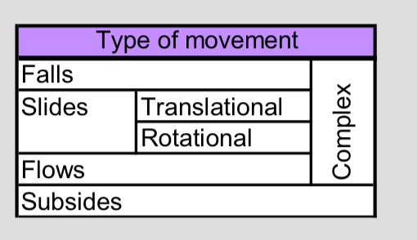
  - Falls
    - Rapid free fall mass movement
    - Happens when material weekend by fractures
  - Slides
    - Mass movement involving motion along a failure surface
    - Remains as a block
    - Planar surface = Translational slide
    - Curved surface = Rotational slide
  - Translational slides
    - Lateral Spreads
      - Special case of translational slide in which movement of earth material results from liquefaction of subjacent material
      - Marine clays deposited in glacial regions
      - Original clay structure is flocculated
        - Bec of pressure of salt in ocean water
      - Clays are leached by fresh water from rain and snow melt
      - Failure is retrogressive – starts on riverbed and moves inland
    - Liquefaction
      - Phenomenon in which the strength of soil is reduced by rapid and violent shaking, or loading

- Material involved
  - Small = earth (fine soil/particles)
  - Medium = Debris
  - Large = Rock
- Speed of movement
- In Ottawa when glaciers first melted up to 100m of marine clay and slit (Leda clays) were deposited

Lecture 16 Mass movements 2
Classification of mass movement cont.
- Rotational slides
  - Slide in which failure occurs on a very steep slope alone a concave rupture surface
  - Multiple blocks often fail
  - Due to natural factors -> Wave erosion
  - Human activity -> road cuts
- Flows
  - Mass movement involving continuous internal deformation of the moving material
  - Main difference between slides and flows:
    - Slides: little deformation within the moving material
    - Flows: material thoroughly deformed during movement
  - Two main types of flows (based on speed)
    - Slow = Creep
    - Fast = Rock, debris or earth flow
  - Creep
    - Gradual slow movement of earth/debris downhill
    - Assisted by change of seasons
  - How creep works
    - Expansion under wet conditions
    - Contraction under dry conditions
    - Net movement is down slope
- Rock debris and earth flows
  - Mixture of rock fragments soil and water flowing downslope as viscous fluid
  - Generally, stays in existing channels
  - Usually due to high water content
- Gelifluction
  - Type of flow in northern regions linked to melting of permafrost
  - Water can’t get into the permanently frozen layer below
  - Soli becomes weak and saturated and begins to flow
Complex events
- Complex events
  - Combination of falls, slides and flows
  - Most mass movements are complex events
    - Ex. Avalanche -> rapid complex event
- Fractures
  - Fractures in the direction of the slope are more unstable
Subsidence
- Subsidence
  - Slow subsidence
    - Gradual sinking of a lad surface
  - Rapid subsidence
    - Surface collapse of underground cavities
    - EX. Man-made tunnels -> Natural sinkholes
- Sinkholes
  - Circular area of subsidence caused by collapse into subterranean void
    - Occur typically in sedimentary rocks that can dissolve in water
    - Ex. limestone
    - Diameter ≈ tens of metres
Mitigation
- Coasts Canada 100-200 million annually
- 600 Canadians killed by mass movement since 1850
  - Major decrease in the last decade
- Mitigation strategies
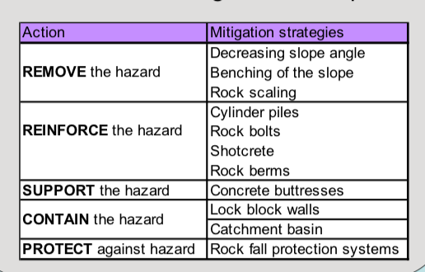

- Remove the hazard
  - Design more stable slopes/decease angle
- Reinforce hazard
  - Insert rock bolts and cylinder piles
- Support the hazard
  - Specially designed buttresses

- Contain the hazard
  - Catchment basin
- Protect against hazard
  - High-energy catchments net direct falling material into the ditch

Lecture 17 Snow Avalanches
Snow
- Cohesion
  - Property of the particles of a material to stick together
  - Low cohesion is powder snow
    - 95% volume is void space
  - Cohesive snow is wet snow
    - Water between partials
  - Compacted snow
    - Snow densely packed
- Snow crystals
  - New snow characterized by 6 sided crystals
    - Diameter = .5mm
- Weak layers
  - In snowpack weak layers are between strong layers
  - Form when wind is high and when oar crystals develop
- Potential failure is between strong and weak layers
- Hoar
  - Large crystals formed by the deposition of water vapor into ice
  - Grow on existing crystals
  - Some are feather shaped
- Hoar Layers are a relatively weak layer
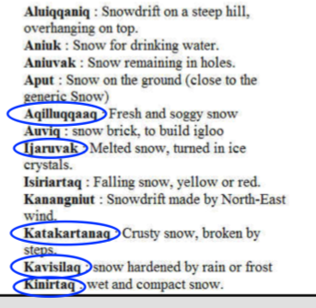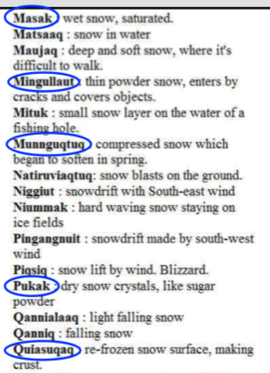

The mechanics of snow and avalanches
- Avala
  - To go down or descend
- Main parts of snow avalanches
  - Morphology similar to mass movements of earth materials
  - Start zone
    - Most volatile part of the slope where unstable snow begins to slide
- Track
  - Path followed by the avalanche moving downhill
- Runout zone
  - Zone where snow and debris stop and are deposited
    - Zone where a victim is most likely to be buried
    - Snow can be as hard as cement
- Sluff
  - Avalanche too small to bury a person
- Dry snow
  - 60-100km/h
- Wet snow
  - 30-65km/h
  - Usually more destructive bec greater force in denser material
- Avalanche size
  - Ranked based on size
    - Log scale based on mass of snow
Point-release and slab avalanches
- Low-cohesion snow = Point-release avalanche
- Cohesive snow = slab avalanche
- Point release avalanches
  - Similar to flows of earths materials
- Slab avalanches
  - Similar to slides of earth materials
  - Most dangerous avalanches are SLAB AVALANCHES
    - Bigger
    - Greater force bec type of snow
  - Involve several layers
  - Start with fracture
Conditions decreasing stability
- Low friction
  - Melt-freeze crust between snow falls
- Weak material
  - Can’t support weight of snow
- Slope of start zone
  - 25-50 degrees
    - Infrequent large dry slab avalanches
    - Recreational use
- Wind …. Its wind
- Most avalanches happened naturally after snow storms
- 90% of recreational accidents the victum or group trigged the avalanche
Avalanche Survival and rescue
- 150 deaths/ year
- 600 in Canada since 1800
  - “early years “ people working in mines or on railways
  - current 15/year since 2001 in Canada
    - mostly 20 year old males
    - skier’s
- rescue
  - get one of those blow up back packs
  - dogs are used for search and rescue
Hazard and mitigation
- Avoidance is the best mitigation strategy
- Some avalanches are set off in a controlled manor by military to avoid people being hurt
Avalanches in Canada
- 1.5 million a year happen in Canada
- only about 100 reported
- economic impact about 5 mill a year

Lecture 18 Severe Weather
Climate and weather
- Climate
  - Averaged over a long period of time
  - Long term Variations
  - 30 years
- Weather
  - Short term variations
  - A few days to a few years
- “climate is what you expect weather is what you get”
Meteorology
- Most weather activity is in the troposphere
  - Air in the below about 20km
- Rising air looses energy and becomes cooler
- Sinking air gains energy and becomes warmer
- Warm air
  - Expands in volume
    - Less dense
    - Less pressure
  - Rises
  - Humid
- Cold air
  - Contracts in volume
    - Denser
  - Sinks
  - Not humid
- Wind
  - Horizontal movement of air from regions of high pressure to regions of lower pressure
  - Flows inward to fill low pressure areas
- Cyclone (in northern hemisphere)
  - Counterclockwise surface winds
  - Forms in low pressure areas
  - Air rising (condenses into rain)
- Anticyclone
  - Clockwise winds
  - Forms in high pressure
  - Air descending (dry)
- Latent heat
  - Energy absorbed or released during a change of state
- Rain is accompanied by a large release of latent heat
Dramatic thunderstorms
- Thunderstorm
  - Meteorological event associated with a localized storm cell, producing thunder and lightning
  - Thunderstorms are composed of individual cells developing over 20-30 minutes
    - As one cell dies, another may develop nearby
    - Typical cell diameter ≈20 km
- Thunderstorm development
  - Cumulus stage
    - Occur when warm and moist air is lifted upwards
  - Mature stage
    - When cloud reaches max vertical development water droplets become to heavy to support
  - Dissipating stage
    - Cloud sinks and shrinks
- Thunderstorms in Canada
  - Frequent in Alberta and east of Rockies
    - Mountains push up clouds and the when they get over it creates storms
  - Frequent in Southern Ontario
Thunder and Lightning
- Why lightning occurs
  - Electrical unbalance
    - Top cloud is positively charged and bottom is negative
- Lightning bolts can travel
  - Danger to people
    - Cloud to ground
    - Ground to cloud
  - Danger to planes
    - Two points in a cloud
    - From cloud to air
    - Cloud to another cloud

Dynamic Tornadoes
- Tornado
  - Funnel cloud coming out of a cumulonimbus and extending toward the ground with air spinning at high speed
    - Strike quick
    - Violet -> wind = 100km/h
- Most tornadoes are associated with supercell thunderstorms
- Cumulonimbus
  - Most tornadoes are produced within cumulonimbus clouds during supercell thunderstorms
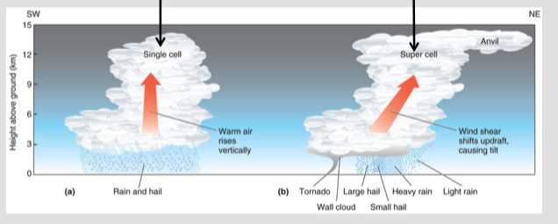

Chilling ice storms
- Freezing rain
  - Precipitation that falls as a liquid but freezes on contact with ground
  - Hard to forecast
  - Layer of warm air sandwiched between two layers of cold air

Lecture 19 Floods
Source of energy: Solar Energy
Natural Hazard: Flood
Lecture objectives
• To be able to summarize the different processes of the hydrologic cycle
• To know which factors, favor runoff over infiltration
• To understand how streams, adapt to excess water
• To describe the different flood styles and flood control structures
Hydrologic Cycle:
- Hydrologic cycle describes the constant exchange of water between
  - Oceans, atmosphere, and continents
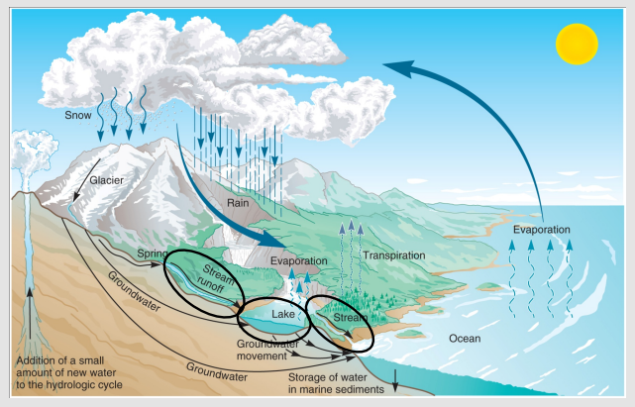
- Energy derived from the sun
- Water is a key factor
  - Change in clay behavior to form sinkholes

- Processes involved in the hydrologic cycle
  - Evaporation and precipitation
  - Runoff and infiltration
  - Transpiration
  - Sedimentation and volcanism
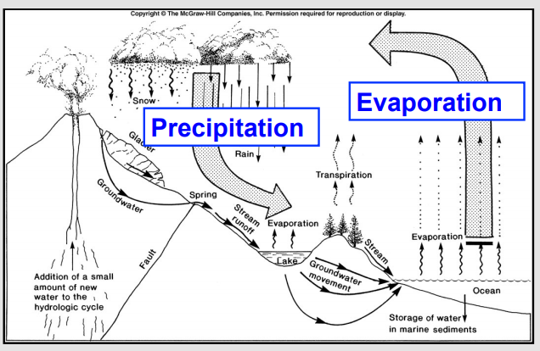
- Hydrologic cycle Runoff and infiltration
  - A portion of water flows across the surface into streams Runoff
  - A portion soaks into the ground Infiltration
  - **More infiltration less flooding hazard

- Hydrologic Cycle Transpiration
  - Water is a critical element for photosynthesis
    - Leaves release water vapour through transpiration
- Hydrologic Cycle Volcanism
  - Water incorporated into marine sediments
  - Sediments are transported on subducting plates
    - Water lowers melting point of rock
    - Water is expelled as a volatile
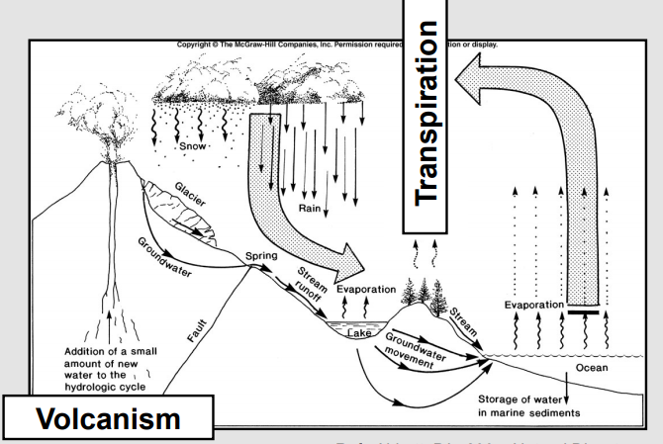
    - ***most abundant volcanic gas
Surface Water:
- Statistics
  - Total volume of water on Earth=1.36billion km³
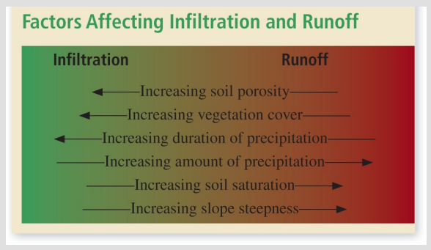
    - 97.20% sea water
    - 2.15% glacier ice
    - 0.62% ground water
    - 0.03% surface water
    - ***0.0001% in rivers
and streams

- Drainage basin (DB)
  - Area of land that convey all runoff into a particular body of water
    - Largest basins
      - World: Amazon basin
      - North-America: Mississipi basin
      - Canada: Hudson Bay basin
  - DB acts as a funnel, evacuating water to a single outlet
    - Hierarchy:
- Subtributaries
- Tributaries
- Main channel
  - Depending on topography and geology*
  - Drainage density
    - Measure of tendency of a drainage basin to flooding
    - $Drainage density=\frac{length of all stream segments}{Area of basin}$
    - Low drainage density
      - Small overall stream segment length
        - More possibility of infiltration
      - ***lower flooding hazard
    - High drainage density
      - Long overall stream segment length
        - Less possibility of infiltration
      - ***Higher flooding hazard
Stream Hydraulics:
- Equilibrium
  - Streams seek equilibrium between the different variables controlling flow
    - Discharge
    - Load
    - channel gradient
    - Sinuosity of stream path
  - Discharge
    - Volume of water flowing in a stream channel per unit time
    - Assuming that channel is rectangular:
      - Q = A x v
        - Q: discharge [m3/s]
        - A: cross-sectional area [m2] (A = width x depth)
        - v: flow velocity [m/s]
  - Load
    - Sediments transported by a stream
      - Fine seds. Are suspended or dissolved
      - Heavy material hops on the stream bed

  - Channel Gradient
    - Slope=delta(elevation) / delta(distance)
      - Higher gradient at the head
      - Lower gradient at the mouth
  - Stream path Sinuosity
    - High or low

  - Excess discharge
    - When discharge increases, streams have excess energy
    - Tries to return to equilibrium
      - Decreases flow velocity
        - Downcutting to decrease gradient
          - Erodes its bottom
        - Increases sinuosity
          - Meandering stream erodes its banks
        - Increases amount of load
      - Inundating its flood plain
- Flooding
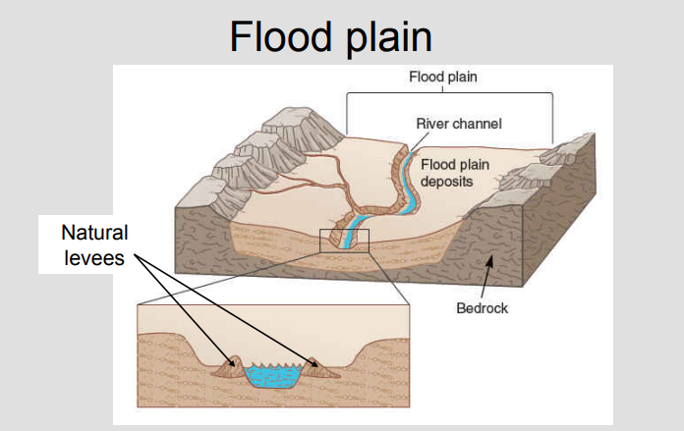
  - Formation of natural levees

Flood Styles:
- Flooding
  - Occurrences:
    - Most often when: due to weather conditions
      - Hydro meteorological floods
    - Less often when: there is a local obstruction to flow
      - Natural dam floods
Hydro meteorological floods:
- In Canada, most floods are related to weather phenomena
- Two mechanisms often acting in combination:
        - Abundant rains
        - Spring melts
- April and May particularly vulnerable
- September particularly lowest vulnerability

Snowmelt-runoff floods:
- Snowmelt-runoff floods
  - Due to snow build up in winter and high discharge in spring
  - Controlling factors:
    - Weather
    - Snowpack conditions
    - Soil conditions
  - Mitigation
    - Evac plan, sand bags
Storm-rainfall floods:
- Storm-rainfall floods
  - Amount and duration of rainfall exceeds infiltration capacity of the ground:
    - Compounding factors:
      - Torrential rains accompanied by:
        - Storm surges moving inland
        - High tides
  - Develop rapid (hours, days) and sometimes unexpectedly
    - Flash flood: flood that rises and falls rapidly (MINUTES) with little or now warning.
      - Intense rainfall over a relatively small area
- Controlling factors
  - Weather
    - Amount and duration of rain
  - Pre-storm soil condition
  - Drainage basin characteristics
    - Topography
    - Vegetation cover
    - Drainage density
- Mitigation
  - Few hours before expected storm warnings
- Thames flood barrier
  - Tide levels rising by 60cm/century
  - Completion in 1986
    - Series of 10 separate movable gates
      - Allowing maritime traffic
      - Raised when storm and high tide
Rain-on-snow floods:
- Combination of (guess)
  - Controlling factors
    - Temp, windspeed, amount of rain, amount of snow
Ice-jam floods:
- Blocked river with ice build up…. Shocker
  - Wow the water levels rise behind the blockage
  - Oh no the river my overflow
- Coincides with spring melt
- Controlling factors:
  - Channel shape, presence of bridges, ice conditions
- More risk with rivers from south to north
Natural dam floods
- Resulting from blockage by
  - Mass movement, glaciers, lava flows
- Downstream:
  - Outburst flood:
  - Peak discharge 10x greater then hydrometerological floods
Jokulhlaup:
- Outburst flood resulting from a volcanic eruption underneath ice
**most expensive natural disaster in Canadian history “2013 Alberata”
- $6billion in losses, 60000evac, 1200soldiers, 4 dead
Mitigation flood risk:
- Urbanization created more hazards
- Flood control structures:
  - Dams
  - Levees:
    - Dikes that confine flood water by increasing the height of the channel
  - Floodway:
    - Artificial channel open to discharge waterflow

LECTURE 20 REDRIVER, MANITOBA: FLOOD HISTORY
- Flat topography
- Meandering river
- Low gradient (7cm per km)
- Infamous for its floods
- Aka “The red Sea”
- Flood facts:
  - Up to 40km wide, covered more than 2000 km²
- Major Canadian flood disaster
  - 28000 people evac, costs $800+ M
- Unique characteristics:
  - Rise and fall slow (weeks)
  - Cause inundation damage and not erosion damage
- Fundamental reasons for flood characteristics:
  - Low slope
  - Shallow river valleys
  - Flat landscape
- Emergency dyking: sandbag ring dyke
- Flood protecting infrastructe
  - Buildings on padded hills
  - Ring dyked towns
- 1997 Red River flood
  - Potential for a multi-billion-dollar flood
- Flood way expansion
  - 5 year proj. increased cap. Of floodway from 17004000m³/s

Lecture 22 Hurricanes
Hurricane Physics
Energy concversion:
Ocean heat (primary energy source) hurricane rain (most energy released) + wind (waves)
Hurricane surface winds:
- 4 fores control the circulation of hurricane surface winds
- Pressure gradient
  - Eye of hurricane is a low pressure region
  - Winds flow inwards towards the eye
- Coriolis effect
  - In the northern hemisphere
    - Surface winds are deflected to the right by the Coriolis effect when flowing towards the eye (c.c. surface winds)
- Centrifugal force
  - Pulls to the right
- Friction
  - Slows wind down
Balance of forces causes surface winds to spiral inward c.c.
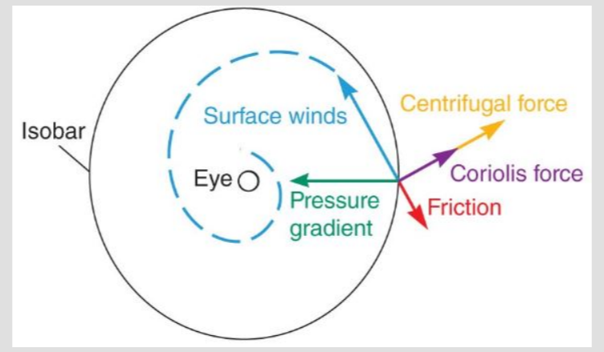
The life cycle of a hurricane
Hurricanes
- Tropical cyclones/typhoons
- Is a means of exporting heat from tropics to mid-latitudes
Birth
Ingredients to form a hurricane
- Water temp=> 27C
- Warm, humid, unstable air
- In the northern hemisphere, surface winds rotating c.c. opp. In southern hem.
- Significant Coriolis effect to sustain rotating surface winds
- Weak high-altitude winds
Development
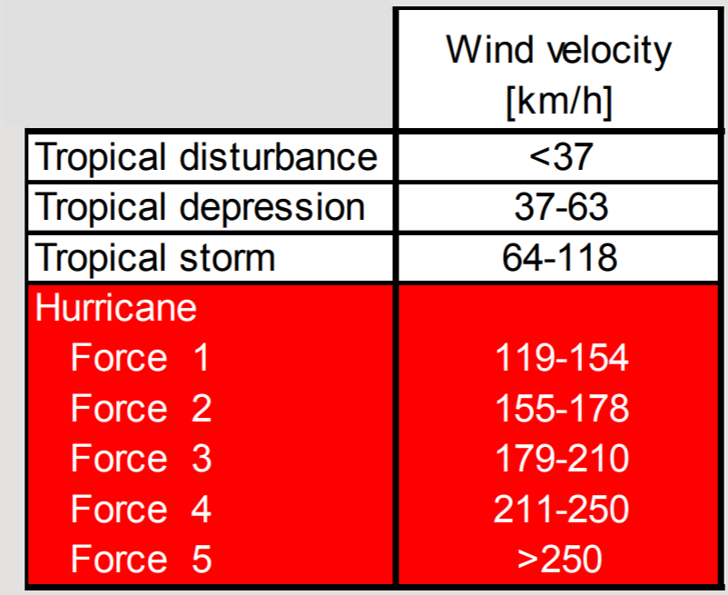
Tropical Disturbance
- Poorly organized cluster of thunderstorms
- Weak surface winds (<37 km/h)
- Diameter 200-600km
- Frequent in tropical regions
Tropical depression
- Clearly defined low pressure central area
- Organized wind circulation initiated
  - Vertically: strong winds lift warm and moist air upward in the central area
  - Laterally: c.c. surface winds
- Depressions are numbered
Tropical storm
- Classical hurricane structure but no eye
- C.c. winds (64-118 km/h)
- Storms are named
Naming convention
- Official list repeats every 6 years
- Bad hurricanes = new names
Maturity
Hurricanes
- Classical hurricane structure with a well-developed eye
  - Eye forms when winds >118km/h
Hurricane structure
- Rain bands: dense clusters of thunderstorms spiralling slowly c.c.
  - Hurricane diameter of 500km
  - Most intense rain fall
- Eye
  - Area of lowest pressure
    - Surface winds converge
  - Winds spiral up along eye wall
    - Strong winds
  - High altitude winds diverge
- Air must overcome gravity
  - Rising air looses energy and cools
  - Sinking air gains energy and warms
- Cool air sinks inside eye
  - Warm core
Decline
- Hurricanes decline rapidly after they make landfall
  - Loss of warm water energy
  - Winds weakens due to increased friction
Winds and storm surges
Storm and wind velocities
- Storm velocity =30 km/h
- Wind strongest on the right side
  - Sum of storm and wind velocities
- See slide 42 43 for northern hemisphere example
Storm surges
- Through suction, low pressure below eye creates a mound of water
- Winds deform and push mound towards land
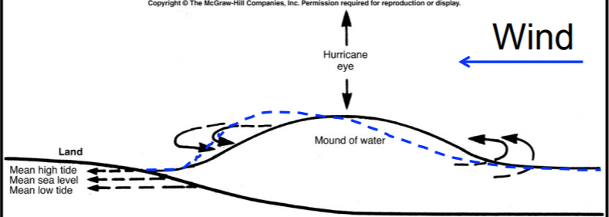
Storm surges in the northern hemisphere
- Surge and strongest winds on the right side of the advancing storm

North Atlantic Ocean Hurricanes
Atlantic hurricane season
- June 1st to nov 30th when seawater temp. is high enough
- September is most active month
- Warmest air in july-august
- Warmest water is September
Formation and path
- Cape Verde-type Hurricanes
  - Thunderstorms forming in the Sehal
    - Wove west with trade winds
  - Intensity increases above Atlantic
    - Energy from warm water
  - Approaching north America, path curves to the right
    - Circle around a zone of high pressure centered on Bermuda
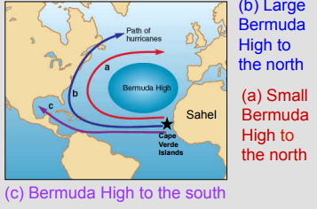
- ITCZ hurricanes
  - Intertropical convergence zone
    - Zone near the equator where northern and southern hemisphere trade winds converge
      - Exact location varies
    - Storms frequent when ICTZ above Caribbean Sea

- Path examples on slide 54
Case study: Joaquin, Bahamas (2015)
- ITCZ hurricane
- Force 4
- Sunk cargo ship “El Faro” w 33 crew members lost
- Damage to the central Carribean
Preparedness
- Rapidly intensified
  - 2 days to prepare
- Cruise ships
  - Redirected to different routes
- Flight cancellations
- Protecting property
  - Securing boats
  - Boarding windows
- Preparing community shelter
  - Hurricane shelter: concrete building within a concrete building
Changes to landscape Boulder field
- Finer material further inland
- Large rock blocks close to shore
Wind and Roofs
- deflecting wind over a steep roof (pitch > 30˚) create:
  - loading on the upwind side
  - suction on the downwind side
- deflecting wind over a flatter roof (pitch < 30˚) create suction on both the upwind and downwind sides
  - hazardous
  - suction highest at eave
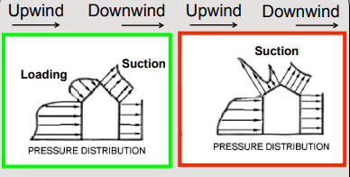
Recovery
Electrical and communication infrastructure:
- not desirable to go back to pre-disaster state
- larger role to solar energy
- cellular network to replace land phone lines

Post-Tropical Transition
In north Atlantic, hurricanes venturing north of 30˚-40˚ latitude micht experience post-tropical transition
- Move into cooler and faster air streams
- Accelerate
- Deform
  - Heaviest rain on the west side (land)
  - Strongest winds on the east side (ocean)
Hurricanes experience post-tropical transition might emerge with an existing depression and regain strength
- Example: Hazel (1954)
Hazel, South Ontario (1954)
- 183 mm of rain in 24 hours
- 81 fatalities
- Particularly vulnerable: Residential areas on floodplains of rivers and creeks flowing into lake Ontario
  - Disaster changed zoning
  - Similar disaster wouldn’t occur today
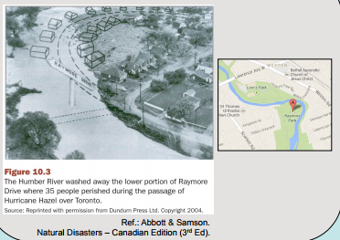
The Atlantic Multidecadal Oscillation and Hurricane Frequency
Climate Change
- Increase in sea surface temperatures AND
- Increase in hurricane frequency and magnitude
Lazy and idk what its saying for slides 77-84

