Chapter 15:RAISING CAPITAL
15.1: The financing life cycle of a firm: Early stage financing and venture capital
Venture capital
-Financing for a new often high-risk venture.
-Private financing for relatively new businesses in exchange for stock
-Usually entails some hands-on guidance
-The ultimate goal is usually to take the company public and the VC will benefit from the capital raised in the IPO
-Many VC firms are formed from a group of investors that pool capital and then have partners in the firm decide which companies will receive financing
-Some large corporations have a VC division
Some venture capital realities
-Access to venture capital is limited. So personal contacts are important
-Venture capitalists often demand
1. 40% of equity of the company
2. Several seats on the company’s board of directors
Choosing a venture capitalist
-start-up companies demand
1. financial strength
2. style
3refrence
4contacts
5 exit strategy
15.2 : The public issue
-Public issue – the creation and sale of securities that are intended to be traded on the public markets
-a firm must satisfy requirements set out by provincial regulations and statues and enforced by provincial securities commissions
-All companies on the Toronto Stock Exchange come under the Ontario Securities Commission’s jurisdiction
-Rules seek to ensure that investors receive all material information on new issues. Gather and publish all insider reports
15.3: The basic procedure for a new issue
-issuing securities to the public
1. Management must obtain permission from the Board of Directors
2.Firm must prepare and distribute copies of a preliminary prospectus (red herring) to the OSC and to potential investors.OSC studies the preliminary prospectus and notifies the company of required changes (usually takes 2 weeks)
3.When the prospectus is approved, the price is determined and security dealers can begin selling the new issue
Red herring- A form of preliminary prospectus
Prospectus – legal document describing details of the issuing firm and proposed offering.
Seasoned new issue- a new issue of securities by a firm that has already issued securities in the past
IPO- first equity issue made public. This is a unseasoned new issue

Alternative issue methods
For equity sales, there are two kinds of public issues:
1.General Cash Offer – New securities offered for sale to the general public on a cash basis.
2.Rights Offer – New securities are first offered to existing shareholders. These are more common outside North America.

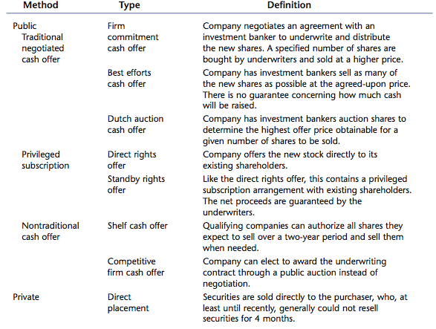
15.4: The cash offer
-Services provided by underwriters
  - Formulate method used to issue securities
  - Price the securities
  - Sell the securities
  - Price stabilization by lead underwriter
-Syndicate – group of underwriters that market the securities and share the risk associated with selling the issue
-Spread – difference between what the syndicate pays the company and what the security sells for in the market
Types of underwriting
1.First commitment underwriting
- also called a “bought deal”
-Issuer sells entire issue to 1 dealer or group that tries to resell it
- -The underwriter makes money on the spread between the price paid to the issuer and the price received from investors when the stock is sold
-The syndicate bears the risk of not being able to sell the entire issue for more than the cost
-Most common type of underwriting in Canada
2. Best efforts underwriting
-Underwriter must make their “best effort” to sell the securities at an agreed-upon offering price
-The company bears the risk of the issue not being sold
-The offer may be pulled if there is not enough interest at the offer price. In this situation, the company does not get the capital and they have still incurred substantial flotation costs
3. Dutch auction
-Underwriter conducts an auction and investors bid for shares. Offer price is determined based on the submitted bids
-More commonly used in bond markets.Also called uniform price auction
4.Overallotment Option / Green Shoe provision
-Allows syndicate to purchase an additional 15% of the issue from the issuer
-Allows the issue to be oversubscribed
-Provides some protection for the lead underwriter as they perform their price stabilization function
-Is a cost to issuer but benefit to underwriting syndicate
5. Additional
-Lockup Agreements – Specify how long insiders must wait after an IPO before they can sell stock, usually 180 days
-Quiet Period – For 40 days following an IPO, the OSC requires that all communications with the public are limited to ordinary announcements
-Syndicate- A group of underwriters formed to reduce risk and held to sell an issue
-Underwriter- is someone whose job involves agreeing to provide money for a particular activity or to pay for any losses that are made.
15.5 : IPOs and underpricing
-May be difficult to price an IPO because there isn’t a current market price available
-Additional asymmetric information associated with companies going public
-Underwriters want to ensure that their clients earn a good return on IPOs on average
-Underpricing causes the issuer to “leave money on the table”
15.6: New equity sales and the value of a firm
-Stock prices tend to decline when new equity is issued.Possible explanations:
1.Managerial information- management know too much and knows when itll be overvalued
2.Debt usage- company has too much debt and too little liquidity
3.Issue costs
-Since the drop in price can be significant and much of the drop may be attributable to negative signals, it is important for management to understand the signals that are being sent and try to reduce the effect when possible
15.7: The cost of issuing securities
-Spread
-Other direct expenses – legal fees, filing fees, etc.
-Indirect expenses – opportunity costs, i.e., management time spent working on issue
-Abnormal returns – price drop on existing stock
-Underpricing – below market issue price on IPOs
-Over allotment (Green Shoe) option – cost of additional shares that the syndicate can purchase after the issue has gone to market
~~Overall 3 conclusions about underwriting
-underwriting is the act of undertaking to purchase at an agreed price any unsold portion of a public issue of shares
1. larger firms can raise equity more easily
2. the cost associated with underpricing can be substantial and can exceed the direct costs.
3.The issue costs are higher for an IPO than for a seasoned offering
15.8: Rights
-Issue of common stock offered to existing shareholders
-Allows current shareholders to avoid the dilution that can occur with a new stock issue
The mechanics of a rights offering
-“Rights” are given to the shareholders
Specify number of shares that can be purchased
Specify purchase price
Specify time frame
What is the likely effect of the rights offering on the per share value of the existing stock
-Rights usually traded on the same exchange as the company’s stock
-The difference between a rights offering and general cash is:
Cash-shares are sold to retail and institutional investors thru investment dealers.
Rights-existing shareholders are informed that they own one right for each share of stock they own
-To take advantage of the rights offering. Shareholders can (1) exercise and subscribe to the entitled shares (2) sell the rights (3) do nothing and let the rights expire
Number of rights needed to purchase a share
-Shareholders always get 1 right for each share they own
Number of new shares= funds to be raised / subscription price
# of rights needed to buy a share of stock= old shares / new shares
The value of a right
-The price specified in a rights offering is generally less than the current market price
-The share price will adjust based on the number of new shares issued
-The value of the right is the difference between the old share price and the “new” share price
- a right is essentially a call option. A call option gives the shareholders of the option the ability to buy a particular asset at a fixed price for a particular period of time.
-The difference between a right and call option is that rights are issued by a firm and resemble warrants
-Suppose a company wants to raise $10 million. The subscription price is $20 and the current stock price is $25. The firm currently has 5,000,000 shares outstanding.
- How many shares have to be issued?

- How many rights will it take to purchase one share?

- What is the value of a right?
Ex-rights
-Period when stock is selling without a recently declared right, normally beginning 2 business days before the holder-of-record date
-Ex-rights – the price of the stock will drop by the value of the right on the day that the stock no longer carries the “right”
-the standard procedure for issuing rights involves setting a holder of record date
-Holder of record date- the date on which existing shareholders on company records are designated as the receivers of stock rights.
-if the stock is sold before the ex-right date the new owner receives the rights if done after they won’t receive the rights
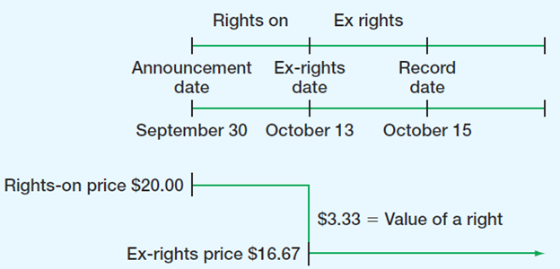
-Standby underwriting – underwriter agrees to buy any shares that are not purchased through the rights offering
-Stockholders can either exercise their rights or sell them – they are not hurt by the rights offering either way
-Rights offerings are generally cheaper
-Until the early 1980’s, rights offerings were the most popular method of raising new equity in Canada
-Bought deals have replaced rights offers as the prevalent form of equity issue
-oversubscription privilege- allows shareholders to purchase unsubscribed shares in a rights offering at the subscription price
-standby fee- amount paid to underwriter participating I standby underwriting agreement
-how do we set the subscription price in a rights offering? It has to be less than the market price of the stock for the rights to have value. Can be as low as you want but not zero. But in practice its usually 20 to 25 %
  - Dilution
-Dilution is a loss in value for existing shareholders
3 types:
1. proportionate (Percentage) ownership – shares sold to the general public without a rights offering
2.Market value – firm accepts negative NPV projects
3.Book value and EPS – occurs when market-to-book value is less than one
Negative NPV causes market price to drop and the accountoing dilution has nothing to do with it. Not market to book ratio is 1 is not the cause.
15.10: Issuing long term debt
-Bonds – public issue of long-term debt
-Syndicated loans- loans made by a group of banks or other institutions.
-Private issues
  - Term loans
    - Direct business loans from commercial banks, insurance companies, etc.
    - Maturities 1 – 5 years
    - Repayable during life of the loan
  - Private placements
    - Similar to term loans with longer maturity
    - Easier to renegotiate than public issues
    - Lower costs than public issues
-the interest rates on both are higher than those on an equivalent public issue.this reflecs the tradeoff between a higher interest rate and more flexible arrangements in the event of financial distress as well as the lower costs associated with private placements.
-also consider flotation costs associated with selling debt are mich less than costs associated with selling equity.
Summary
-Venture capital is first-stage financing
-Costs of issuing securities can be quite large
-Bought deals are far more prevalent for large issues than regular underwriting
-Direct and indirect costs of going public can be substantial
-In Canada, the bought deal is cheaper and dominates the new issue market

