Chapter 4 – September 18, 2017
Learning Objectives:
- What consumer surplus (refers to both individual and total consumer surplus) is and its relationship to the demand curve
- What producer surplus (refers to both individual and total producer surplus) is and its relationship to the supply curve
- What total surplus (the total net gain to consumers and producers from trading in a market; the sum of the producer surplus and the consumer surplus) is and how it can be used both to measure the gains from trade and to illustrate why markets work so well
- Why property rights (the rights of owners of valuable items, whether resources or goods, to use, rent, or dispose of those items as they choose). and prices as economic signals (any piece of information that helps people make better economic decisions) are critical to smooth functioning of a market
- Why markets typically lead to efficient outcomes despite the fact that they sometimes fail
Consumer Surplus and the Demand Curve
The key point, as we’ll see in a minute, is that the demand curve is derived from buyers’ tastes or preferences - and that those same preferences also determine how much they gain from the opportunity to buy used books.
- A consumer’s willingness to pay for a good is the maximum price at which he or she would buy that good.

- Individual consumer surplus is the net gain to an individual buyer from the purchase of a good.
- It is equal to the difference between the buyer’s willingness to pay and the price paid.
Willingness to Pay and the Demand Curve
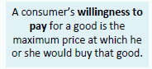
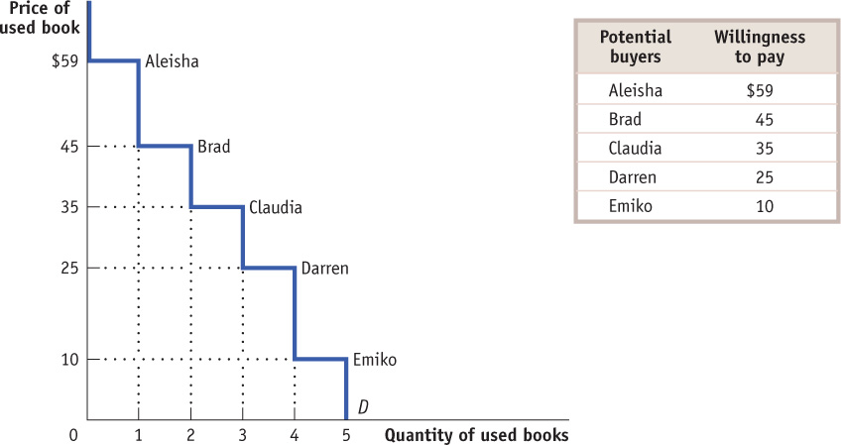
The Demand Curve for Used Textbooks
With only five potential consumers in this market, the demand curve is step-shaped. Each step represents one consumer, and its height indicates that consumer’s willingness to pay—the maximum price at which he or she will buy a used textbook—as indicated in the table. Aleisha has the highest willingness to pay at $59, Brad has the next highest at $45, and so on down to Emiko with the lowest willingness to pay at $10. At a price of $59, the quantity demanded is one (Aleisha); at a price of $45, the quantity demanded is two (Aleisha and Brad); and so on until you reach a price of $10, at which all five students are willing to purchase a used textbook.

How many of these five students will actually buy a used book? It depends on the price. If the price of a used book is $55, only Aleisha will buy one; if the price is $40, both Aleisha and Brad will buy used books, and so on. So the information in the table can be used to construct the demand schedule for used textbooks.
Willingness to Pay and Consumer Surplus
- Total consumer surplus is the sum of the individual consumer surpluses of all the buyers of a good.
- The term consumer surplus is often used to refer to both individual and total consumer surplus.
Suppose that the campus bookstore makes used textbooks available at a price of $30. In that case Aleisha, Brad, and Claudia will buy used books. Do they gain from their purchases, and if so, how much?
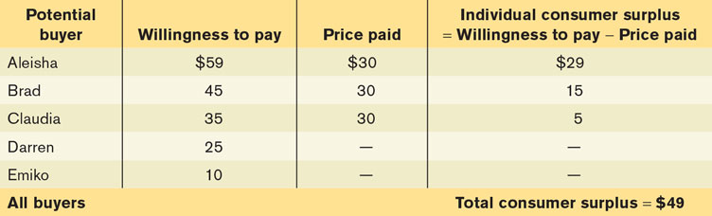
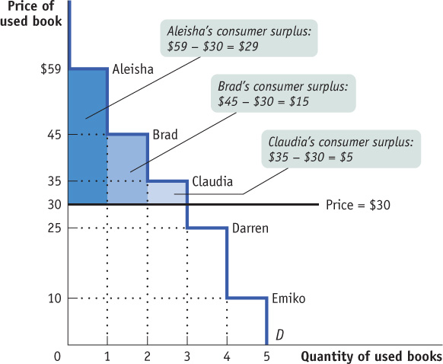
Consumer Surplus in the Used-Textbook Market At a price of $30, Aleisha, Brad, and Claudia each buy a used book but Darren and Emiko do not. Aleisha, Brad, and Claudia receive individual consumer surpluses equal to the difference between their willingness to pay and the price, illustrated by the areas of the shaded rectangles. Both Darren and Emiko have a willingness to pay less than $30, so they are unwilling to buy a used book in this market; they receive zero consumer surplus. The total consumer surplus is given by the entire shaded area—the sum of the individual consumer surpluses of Aleisha, Brad, and Claudia, which is equal to $29 + $15 + $5 = $49.
Consumer Surplus
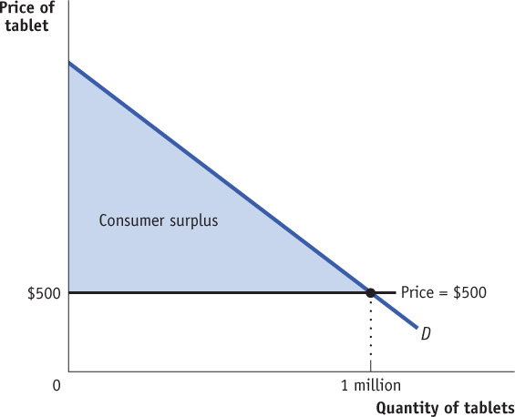
Consumer Surplus The demand curve for tablets is smooth because there are many potential buyers. At a price of $500, 1 million tablets are demanded. The consumer surplus at this price is equal to the shaded area: the area below the demand curve but above the price. This is the total net gain to consumers generated from buying and consuming tablets when the price is $500.
All other things equal, a shift in the demand curve will lead to a change in the consumer surplus. For example, an increase in the demand for tablets increases the consumer surplus for any given price level, as the maximum willingness to pay rises. In the graph, as the demand curve shifts right, the shaded area gets larger.
The actual area can be calculated by the formula for area of a triangle.
How Changing Prices Affect Consumer Surplus
A fall in the price of a good increases consumer surplus through two channels:
1. a gain to consumers who would have bought at the original price
2. a gain to consumers who are persuaded to buy by the lower price

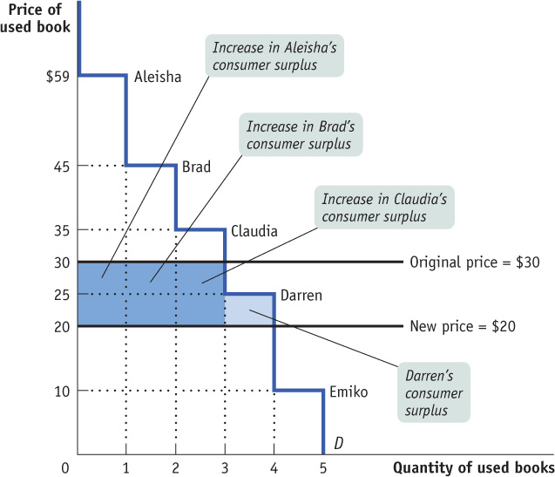
Consumer Surplus and a Fall in the Price of Used Textbooks There are two parts to the increase in consumer surplus generated by a fall in price from $30 to $20. The first is given by the dark blue rectangle: each person who would have bought at the original price of $30—Aleisha, Brad, and Claudia—receives an increase in consumer surplus equal to the total reduction in price, $10. So the area of the dark blue rectangle corresponds to an amount equal to 3 × $10 = $30. The second part is given by the light blue area: the increase in consumer surplus for those who would not have bought at the original price of $30 but who buy at the new price of $20—namely, Darren. Darren’s willingness to pay is $25, so he now receives consumer surplus of $5. The total increase in consumer surplus is (3 × $10) + $5 = $35, represented by the sum of the shaded areas. Likewise, a rise in price from $20 to $30 would decrease consumer surplus by $35, the amount corresponding to the sum of the shaded areas.
A Fall in the Market Price Increases Consumer Surplus
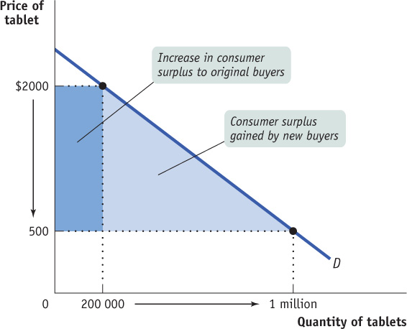
A Fall in the Price Increases Consumer Surplus All other things equal, a fall in the price of a tablet from $2000 to $500 leads to an increase in the quantity demanded and an increase in consumer surplus. The change in total consumer surplus is given by the sum of the shaded areas: the total area below the demand curve and between the old and new prices. Here, the dark blue area represents the increase in consumer surplus for the 200 000 consumers who would have bought a tablet at the original price of $2000; they each receive an increase in consumer surplus of $1500. The light blue area represents the increase in consumer surplus for those willing to buy at a price equal to or greater than $500 but less than $2000. Similarly, a rise in the price of a tablet from $500 to $2000 generates a decrease in consumer surplus equal to the sum of the two shaded areas.
Producer Surplus and the Supply Curve
Just as some buyers of a good would be willing to pay more for their purchase than the price they actually pay, some sellers of a good would be willing to sell it for less than the price they actually receive. So just as there are consumers who receive consumer surplus from buying in a market, there are producers who receive producer surplus from selling in a market.
- A potential seller’s cost is the lowest price at which he or she is willing to sell a good.

- Individual producer surplus is the net gain to a seller from selling a good. It is equal to the difference between the price received and the seller’s cost.
  - Andrew sells his used book for $30. Clearly he has gained from the transaction: he was willing to sell for only $5, so he has gained $25. This net gain, the difference between the price he actually gets and his cost—the minimum price at which he would have been willing to sell—is known as his individual producer surplus.
- Total producer surplus in a market is the sum of the individual producer surpluses of all the sellers of a good.
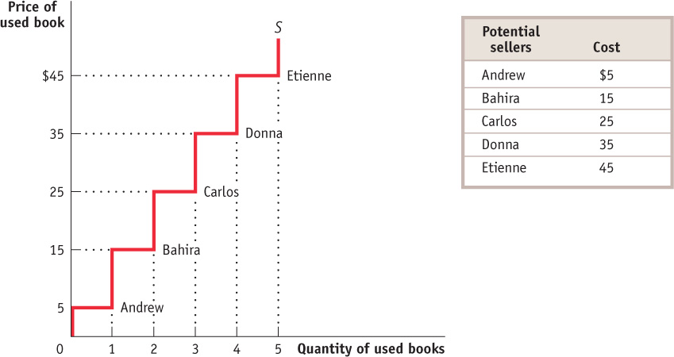
The Supply Curve for Used Textbooks The supply curve illustrates seller’s cost, the lowest price at which a potential seller is willing to sell the good, and the quantity supplied at that price. Each of the five students has one used book to sell and each has a different cost, as indicated in the accompanying table. At a price of $5 the quantity supplied is one (Andrew), at $15 it is two (Andrew and Bahira), and so on until you reach $45, the price at which all five students are willing to sell.
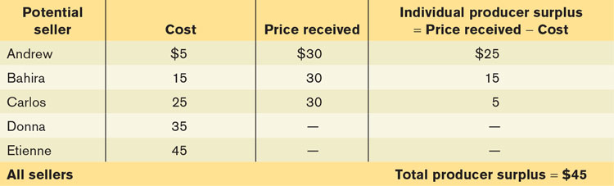
Producer Surplus in the Used-Textbook Market At a price of $30, Andrew, Bahira, and Carlos each sell a used book but Donna and Etienne do not. Andrew, Bahira, and Carlos get individual producer surpluses equal to the difference between the price and their cost, illustrated here by the shaded rectangles. Donna and Etienne each have a cost that is greater than the price of $30, so they are unwilling to sell a used book and so receive zero producer surplus. The total producer surplus is given by the entire shaded area—the sum of the individual producer surpluses of Andrew, Bahira, and Carlos, which is equal to $25 + $15 + $5 = $45.
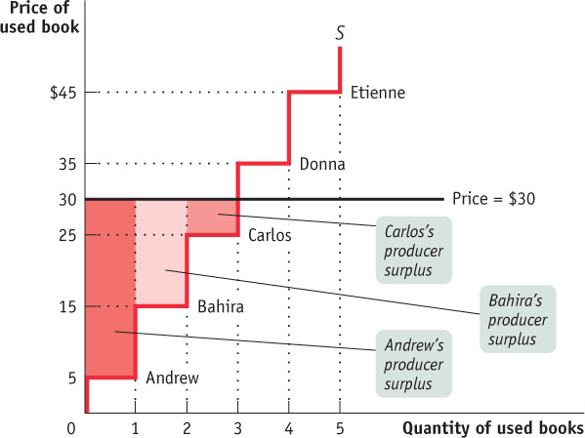
Again, as with consumer surplus, we have a general rule for determining the total producer surplus from sales of a good: The total producer surplus from sales of a good at a given price is the area above the supply curve but below that price.
Producer Surplus
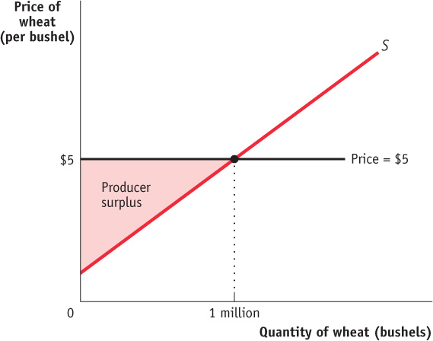
Producer Surplus Here is the supply curve for wheat. At a price of $5 per bushel, farmers supply 1 million bushels. The producer surplus at this price is equal to the shaded area: the area above the supply curve but below the price. This is the total gain to producers—farmers in this case—from supplying their product when the price is $5.
All other things equal, a shift in the supply curve will lead to a change in the producer surplus. For example, after an increase in the supply of wheat (i.e., a rightward shift of the supply curve), the producer surplus increases.

How Changing Prices Affect Producer Surplus
As with the case of consumer surplus, a change in price alters producer surplus. But the effects are opposite. While a fall in price increases consumer surplus, it reduces producer surplus. And a rise in price reduces consumer surplus but increases producer surplus.
When the price of a good rises, producer surplus increases through two channels:
1. the gains of those who would have supplied the good even at the original, lower price
2. the gains of those who are induced to supply the good by the higher price
To see this, let’s first consider a rise in the price of the good. Producers of the good will experience an increase in producer surplus, though not all producers gain the same amount. Some producers would have produced the good even at the original price; they will gain the entire price increase on every unit they produce. Other producers will enter the market because of the higher price; they will gain only the difference between the new price and their cost.
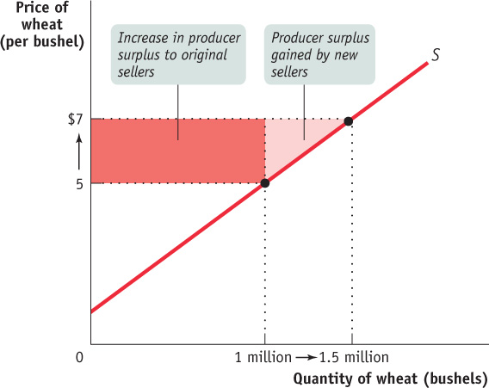
A Rise in the Price Increases Producer Surplus All other things equal, a rise in the price of wheat from $5 to $7 leads to an increase in the quantity supplied and an increase in producer surplus. The change in total producer surplus is given by the sum of the shaded areas: the total area above the supply curve but between the old and new prices. The dark red area represents the gain to the farmers who would have supplied 1 million bushels at the original price of $5; they each receive an increase in producer surplus of $2 for each of those bushels. The triangular light red area represents the increase in producer surplus achieved by the farmers who supply the additional 500 000 bushels because of the higher price. Similarly, a fall in the price of wheat from $7 to $5 generates a reduction in producer surplus equal to the sum of the shaded areas.
Consumer Surplus, Producer Surplus, and the Gains from Trade
One of the 12 core principles of economics we introduced in Chapter 1 is that markets are a remarkably effective way to organize economic activity: they generally make society as well off as possible given the available resources. The concepts of consumer surplus and producer surplus can help us deepen our understanding of why this
Putting It Together: Total Surplus
- The total surplus generated in a market is the total net gain to consumers and producers from trading in the market. It is the sum of the producer and the consumer surplus.
- The concepts of consumer surplus and producer surplus can help us understand why markets are an effective way to organize economic activity.

The Gains from Trade
Let’s return to the market in used textbooks but now consider a much bigger market—say, one at a large university like the University of British Columbia (UBC). There are many potential buyers and sellers, so the market is quite competitive. Let’s line up incoming students who are potential buyers of a used book in order of their willingness to pay, so that the entering student with the highest willingness to pay is potential buyer number 1, then the student with the next highest willingness to pay is number 2, and so on. Then we can use their willingness to pay to derive a demand curve like the one below.
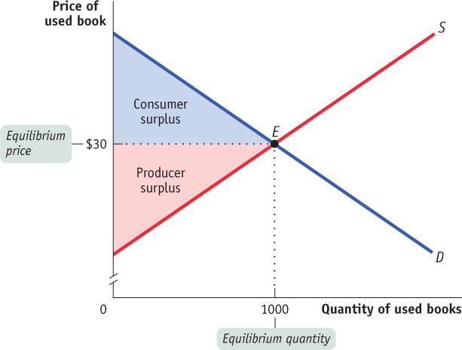
Total Surplus In the market for used textbooks, the equilibrium price is $30 and the equilibrium quantity is 1000 used books. Consumer surplus is given by the blue area, the area below the demand curve but above the price. Producer surplus is given by the red area, the area above the supply curve but below the price. The sum of the blue and the red areas is total surplus, the total benefit to society from the production and consumption of the good.
- The previous graph shows that both consumers and producers are better off because there is a market in this good; i.e., there are gains from trade.
- These gains from trade are the reason everyone is better off participating in a market economy than they would be if each individual tried to be self-sufficient.
- But are we as well off as we could be? This brings us to the question of the efficiency of markets.
Similarly, we can line up outgoing students, who are potential sellers of the used book, in order of their (opportunity) cost—starting with the student with the lowest cost, then the student with the next lowest cost, and so on—to derive a supply curve like the one shown in the same figure.
As we have drawn the curves, the market reaches equilibrium at a price of $30 per book, and 1000 used books are bought and sold at that price. The two shaded triangles show the consumer surplus (blue) and the producer surplus (red) generated by this market. The sum of consumer and producer surpluses is known as the total surplus generated in a market.
The striking thing about this picture is that both consumers and producers gain—that is, both consumers and producers are better off because there is a market for this good. But this should come as no surprise—it illustrates another core principle of economics: There are gains from trade. These gains from trade are the reason everyone is better off participating in a market economy than they would be if each individual tried to be self-sufficient.
But are we as well off as we could be? This brings us to the question of the efficiency of markets.
The Efficiency of Markets
- Claim: The maximum possible total surplus is achieved at market equilibrium.
- The market equilibrium allocates the consumption of the good among potential consumers and sales of the good among potential sellers in a way that achieves the highest possible gain to society.
- Compare total surplus in the market equilibrium to alternative allocations by a fictitious ‘central planning authority’.
Three ways to try to increase the total surplus
- Reallocate consump6on among consumers—take the good away from buyers who would have purchased the good in the market equilibrium, and give it to potential consumers who wouldn’t have bought it in equilibrium.
- Reallocate sales among sellers—take sales away from sellers who would have sold the good in the market equilibrium, and instead compel potential sellers who would not have sold the good in equilibrium to sell it.
- Change the quan6ty traded—compel consumers and producers to transact either more or less than the equilibrium quantity.
Reallocate Consumption Among Consumers The committee might try to increase total surplus by selling used books to different consumers. The chart below shows why this will result in lower surplus compared to the market equilibrium outcome. Points A and B show the positions on the demand curve of two potential buyers of used books, Ana and Bob. As we can see from the figure, Ana is willing to pay $35 for a used book, but Bob is willing to pay only $25. Since the market equilibrium price is $30, under the market outcome Ana buys a used book and Bob does not.
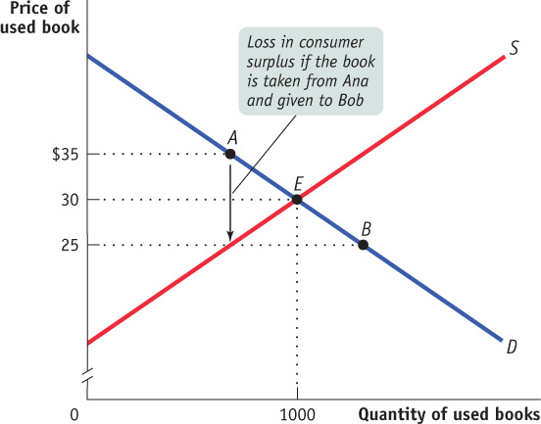
Reallocating Consumption Lowers Consumer Surplus Ana (point A) has a willingness to pay of $35. Bob (point B) has a willingness to pay of only $25. At the market equilibrium price of $30, Ana purchases a used book but Bob does not. If we rearrange consumption by taking a used book from Ana and giving it to Bob, consumer surplus declines by $10 and, as a result, total surplus declines by $10.
Now suppose the committee reallocates consumption. This would mean taking the used book away from Ana and giving it to Bob. Since the used book is worth $35 to Ana but only $25 to Bob, this change reduces total consumer surplus by $35 – $25 = $10. Moreover, this result doesn’t depend on which two students we pick. Every student who buys a used book at the market equilibrium has a willingness to pay of $30 or more, and every student who doesn’t buy a used book has a willingness to pay of less than $30. So reallocating the good among consumers always means taking a used book away from a student who values it more and giving it to one who values it less. This necessarily reduces total consumer surplus.
Reallocate Sales Among Sellers The committee might try to increase total surplus by altering who sells their used books, taking sales away from sellers who would have sold their used books at the market equilibrium and instead compelling those who would not have sold their used books at the market equilibrium to sell them.
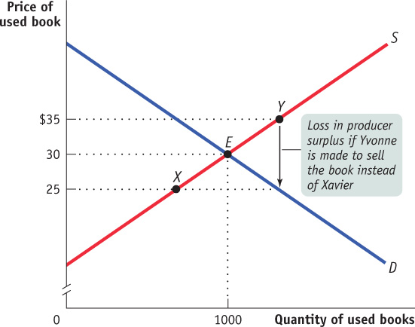
Reallocating Sales Lowers Producer Surplus Yvonne (point Y) has a cost of $35, $10 more than Xavier (point X), who has a cost of $25. At the market equilibrium price of $30, Xavier sells a used book but Yvonne does not. If we rearrange sales by preventing Xavier from selling his used book and compelling Yvonne to sell hers, producer surplus declines by $10 and, as a result, total surplus declines by $10.
Again, it doesn’t matter which two students we choose. Any student who sells a used book at the market equilibrium has a lower cost than any student who keeps a used book. So reallocating sales among sellers necessarily increases total cost and reduces total producer surplus.

Changing the Quantity Traded
The committee might try to increase total surplus by compelling students to trade either more used books or fewer used books than the market equilibrium quantity.
The figure below shows why this will result in lower surplus. It shows all four students: potential buyers Ana and Bob, and potential sellers Xavier and Yvonne. To reduce sales, the committee will have to prevent one or more transactions that would have occurred in the market equilibrium—for example, they might prevent Xavier from selling to Ana. Since Ana is willing to pay $35 and Xavier’s cost is $25, preventing this transaction reduces total surplus by $35 – $25 = $10.
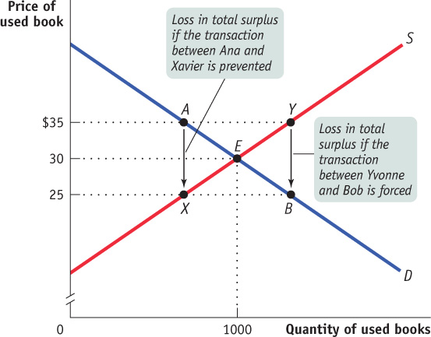
Changing the Quantity Lowers Total Surplus If Xavier (point X) were prevented from selling his used book to someone like Ana (point A), total surplus would fall by $10, the difference between Ana’s willingness to pay ($35) and Xavier’s cost ($25). This means that total surplus falls whenever fewer than 1000 used books—the equilibrium quantity—are transacted. Likewise, if Yvonne (point Y) were compelled to sell her book to someone like Bob (point B), total surplus would also fall by $10, the difference between Yvonne’s cost ($35) and Bob’s willingness to pay ($25). This means that total surplus falls whenever more than 1000 used books are transacted. These two examples show that at market equilibrium, all mutually beneficial transactions—and only mutually beneficial transactions—occur.
Once again, this result doesn’t depend on which two students we pick: any student who would have sold the used book at the market equilibrium has a cost of $30 or less, and any student who would have purchased the used book at the market equilibrium has a willingness to pay of $30 or more. So preventing any sale that would have occurred in the market equilibrium necessarily reduces total surplus.
Finally, the committee might try to increase sales by forcing Yvonne, who would not have sold her used book at the market equilibrium, to sell it to someone like Bob, who would not have bought a used book at the market equilibrium. Because Yvonne’s cost is $35, but Bob is only willing to pay $25, this transaction reduces total surplus by $10. And once again it doesn’t matter which two students we pick—anyone who wouldn’t have bought the used book has a willingness to pay of less than $30, and anyone who wouldn’t have sold has a cost of more than $30.
The key point to remember is that once this market is in equilibrium, there is no way to increase the gains from trade. Any other outcome reduces total surplus.
Market Equilibrium Maximizes Total Surplus
1. Market equilibrium allocates consumption of the good to the potential buyers who value it the most, as indicated by the fact that they have the highest willingness to pay.
2. It allocates sales to the potential sellers who most value the right to sell the good, as indicated by the fact that they have the lowest cost.
3. It ensures that every consumer who makes a purchase values the good more than every seller who makes a sale, so that all transactions are mutually beneficial.
4. It ensures that every potential buyer who doesn’t make a purchase values the good less than every potential seller who doesn’t make a sale, so that no mutually beneficial transactions are missed.
As a result of these four functions, any way of allocating the good other than the market equilibrium outcome lowers total surplus.
There are three caveats, however.
- First, although a market may be efficient, it isn’t necessarily fair. In fact, fairness, or equity, is often in conflict with efficiency. Because society cares about equity, government intervention in a market that reduces efficiency while increasing equity can be justified.
- The second caveat is that markets sometimes fail. Under some well-defined conditions, markets can fail to deliver efficiency. When this occurs, markets no longer maximize total surplus.
- Third, even when the market equilibrium maximizes total surplus, this does not mean that it results in the best outcome for every individual consumer and producer.
  - For instance, a price floor that kept the price up would benefit some sellers.
  - But in the market equilibrium there is no way to make some people better off without making others worse off - and that’s the definition of efficiency.
Why Markets Typically Work So Well
Markets owe their effectiveness to two powerful features: property rights and the role of prices as economic signals.
- Property rights are the rights of owners of valuable items, whether resources or goods, to dispose of those items as they choose.
- An economic signal is any piece of information that helps people make better economic decisions.
A Few Words of Caution
A market or an economy is inefficient if there are missed opportunities: some people could be made better off without making other people worse off.
The three principal sources of market failure are:
- attempts to capture more resources that produce inefficiencies,
- side effects from certain transactions, and
- problems in the nature of the goods themselves.

